选修三Unit 1 Art Listening and Talking: Talk about works of art

-by 李婷婷

1. **Teaching Material and Students Analysis:**

This unit discusses art and this section is to talk about works of art. The listening text is a speech about Chinese ink washing animation films which brought life to ink wash painting. The ink wash painting animation films were firstly created by great Chinese artists of Shang Hai Animation Film Studio, an old brand of Chinese animation. This creation combined animation with Chinese ink wash painting and displayed the beauty of Chinese ink washing painting. This topic will certainly stir up Ss’ interests in Chinese painting and give them a deeper insight into Chinese painting, during which their cultural confidence can be raised. For listening skills, Ss have master some like prediction and viewing, but they have difficulty in listening for a speech and its structure and details. Thus, listening for signpost markers will help them to overcome this difficulty. For talking part, Ss are interested in the topic: art but they lack information about paintings and have difficulty in organizing a speech. Thus, language for presentation and relevant info about paintings will be offered. Based on the analysis, the teaching objectives are as follow:

1. **Teaching Objectives:**
2. To understand the main idea and identify the structure of the presentation.
3. To apply the strategy of listening for signpost markers to get the main idea and structure.
4. To talk about works of art by making a presentation and use the language properly.
5. **Teaching Procedures:**

**Step1: Lead-in**

An ink wash painting and an ink wash animation

(**Aims:** to elicit the topic and enable ss to know the key concepts we are going to talk about today.)

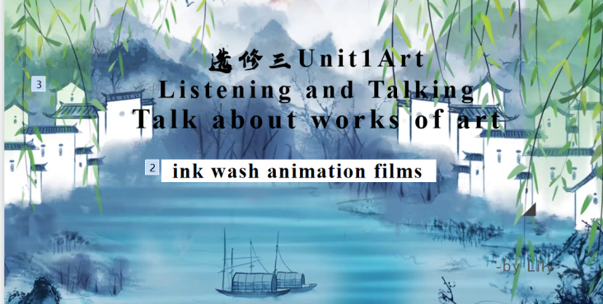

**Step2: Pre-listening**

Offer background info about ink wash animation and ask ss to describe the pics about some representative ink wash animation films.

(**Aims:** to learn some keys word in the listening and get ss familiar with the topic and content so that their anxiety would be eased. )

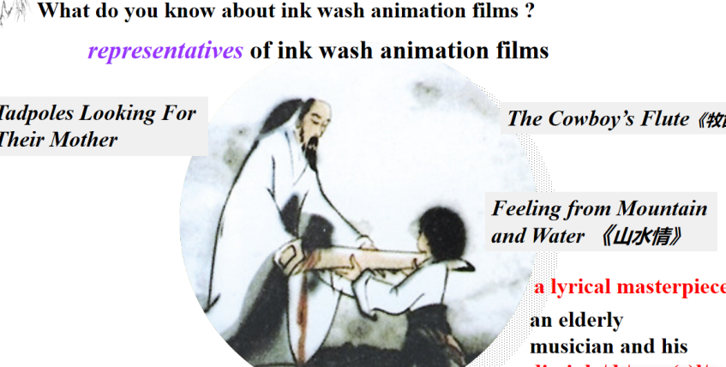

**Step3: While-listening**

1. **Listen for main idea and structure**

To put the main ideas of each part into right order.

(**Aims:** to figure out the main idea and structure of the speech.)

1. **Listen for signpost markers**

Listen for signpost markers and analyze its functions

(**Aims:** to practice the strategy of listening for signpost markers and understand the functions of these discourse markers.)

1. **Listen for details and language.**

Listen for two questions: Why is it regarded as a masterpiece?

What is the speaker’s attitude to the ink wash animation?

(**Aims:** to fully understand the topic, focus on the vivid descriptions of the painting and get Ss for the talking activity.)

**Step4: Appreciation**

Enjoy a clip of *Feeling from Mountains and Rivers*.

(**Aims:** to appreciate the great works of art and stir up their motivation for learning and talking more about Chinese painting.)

**Step4: Post-listening**

Talking works of art:

Work in groups to make a presentation to introduce a painting.

**(Aims:** to talk about works of art by making a presentation, apply the language properly and raise their awareness of art. )

