**2024年9月名校协作体考试应用文之便条写作讲评教学设计**

**Step 1 The format（格式）of a note**

1.称呼：可以写“Hey，my friend”等类似于便条开头的称呼，虽然不建议完全仿照信件类的称呼，但写Dear Chris也对；

2.落款：因为如果不落款会导致对方不知道这份礼物是谁送的。

3.文章分为开头、主题和结尾三部分。

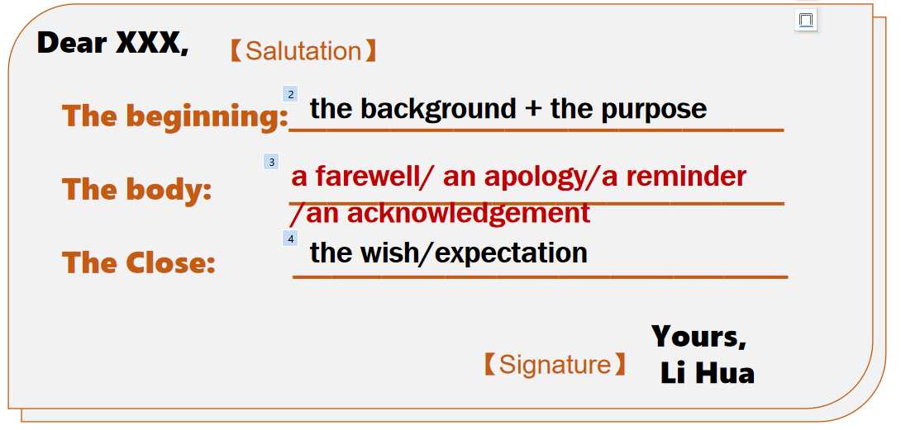

**Step 2 A glimpse of a note**

**定义：**便条/留言条是一种简单形式的书信.

**特点：**格式简单，内容简短。

**要求：**内容简明扼要，文字简洁明了。讲清谁写的，写给谁，什么事以及什么时候写的等。留言条的日期可以写上年、月、日，也可以写上星期几或星期几上、下午，或者只写几日，几点钟也行。日期多写在正文右上角。

**分类：**便条根据其用途可分成祝贺便条、慰问便条、致谢便条、道歉便条、邀请便条、约会便条、请求便条。

**Step 3 A deep insight into the writing**

假定你是李华，即将结束在巴黎的暑期交换学习。离别之际，你为一起学习的英国室友 Chris 准备了一份礼物。请为这份礼物附上一张便条， 内容包括：

1.礼物简介；2.意义阐述；3. 临别祝福

Genre： ____________________________________

Tense： ____________________________________

Person：_____________________________________

Key points：__________________________________

**Part1:** The beginning: the background + the purpose

**写便条的背景：**根据“即将结束在巴黎的暑期交换学习”

**写便条的目的：**告知“准备了一份道别礼物”

1.临近离别之时，我精心挑选了一份礼物送给你，它象征着我们共同度过的美好时光。

With the time of departure around the corner, I ________________________

___________, which _____________________________________.

2.面对面地挥手告别对我来说真的很难。所以，这份礼物是为你准备的，它提醒着我们真挚的友谊。

It’s really hard for me to ________________________________. Thus, this gift

is in store for you as _________________________________.

**Part2: The body: the brief introduction + the meaning**

▲What gift to choose?

▲How to introduce?

**The source:**___________________________, the teapot has accompanied me for five years.

**The material:** It is made of ________________________.

**The appearance:** Graceful and elegant, the teapot is ______________________(它们外观精美、品质上乘)/ with _______________（精致的曲线）.

**...**

**Group work:**

How do you introduce your gift ? (训练学生的创新思维能力）

【话题词块】

●追溯到 ____________________ ●原产于；...的家园________________

●...的象征/象征着...________________ ●捕捉到画面 _____________________

●闪亮的红色织物_________________ ●精美的瓷器 ____________________

●作为提醒__________________ ●承载着丰富的文化内涵___________________

Appreciation 1（小组合作作品）

Appreciation 2（名校高分作文）

The gift, a piece of traditional Chinese calligraphy written by myself, contains renowned Chinese poems dating from Tang dynasty to Qinq dynasty, all of which conveys emotional feelings, ranging from broad aspirations to the genuine relationship with friends. 【镇海中学】

▲What’s the gift’s meaning?

围绕“礼物本身”，从“个人意义”与“社交意义”两个角度出发讨论。

You might as well _______________________________________, escaping pressure

from _______________. Most important of all, the teapot symbolizes ___________

________________, from which you can gain a glimpse of ____________________.

It is not only _____________________but also _____________________________.

**此处学生可以创造性分享自己的表达。例如：**它不仅是泡茶的工具，更承载着深厚的文化底蕴和人们对美好生活的祈愿翻.

**Party 3: The close: wish/expectation+隐藏要点**

1. No matter where life takes us, we will always have Paris — the bond that

was forged under its iconic skyline.

无论生活把我们带到哪里，我们都会永远拥有巴黎——在它的标志性天际线

下建立起来的纽带。【挖掘隐藏要点抒发情感】

2.Presenting the gift, I bid my earnest farewell to you and may you a bright

future!献上这份礼物，我诚挚地向您道别，愿您前程似锦！【首位呼应+祝福】

**范文：**

Dear Chris,

As our unforgettable summer exchange in Paris comes/draws to a close, I’ve compiled a handmade photo album that captures our shared experiences during this summer as a farewell gift.

The album is a mosaic of our friendship, with each photo a piece of our story. From our first awkward introductions to our deep conversations over coffee, from our collaborative projects to our exhilarating cheers at the Olympic games, these images document not only our growth but also the bond we’ve formed. It's a visual diary of our laughter, our triumphs, and the memories we’ve created side by side.

I extend my best wishes for your future and also eagerly anticipate the day you visit China. May this album be a treasured reminder of our time together and the friendship we’ve built.

Yours, Li Hua