***Magic Backpack Rescued Sisters Trapped in the Storm***

--2024-10 强基联盟 读后续写

A high-pitched scream stopped Laura Douglas in her tracks. Spinning around on the narrow dirt path, she thought that her cousin Cassie was in danger. **Instead, Cassie was knee-deep in flowers that covered the meadow (草地) like a quilt.**

“Cassie! **You scared me to death!”** Laura scolded, **her voice echoing through the meadow**. “I am sorry,” Cassie, absorbed in her photography, didn’t notice the thick fog rolling in, consuming the nearby mountains. “Not again!” Laura complained, **her eyes shifting to the approaching clouds.** “We gotta go!”

Cassie’s focus remained on her camera, capturing the short-lived beauty of the moment. **Laura tied a red scarf around her hair.** “Let’s go back to the campsite.” **The girls quickly ran down the winding path, the meadow now covered by a thick fog and a steady, cold rain. The road turned slippery, and they had to move slowly to avoid sliding down.**

“It’s dangerous! **We need shelter now!**” **Cassie screamed after a loud crack of thunder, the storm’s strength increasing rapidly.** Laura’s keen eyes found a small cave in the rock face, **partly hidden by overhanging branches.** It wasn’t much, **but it offered a chance to escape the rain.**

“Cassie, over here!” Laura called out, her voice barely carrying over the wind.

Cassie, wet and shaking, stumbled towards the place of Laura’s voice. **As she approached, she could see the shelter. It wasn’t perfect, but it was better than nothing.**

“Smart thinking, Laura,” Cassie said, her teeth chattering (打颤) with cold as she pressed her backpack close to her chest. **The backpack, a tough and waterproof (防水的) model, had been a gift from her father, an experienced hiker who had insisted on its numerous pockets and sections for emergency supplies. Little did they know, his advice would prove invaluable on this day.**

注意:

续写词数应为150左右；

请按如下格式在答题纸的相应位置作答。

Para1: “Check your backpack,” Laura instructed, her voice being hopeful.

Para2：As night fell, the storm finally began to die down.

一、设计理念：

1. 本文人物：主角：Laura Cassie 从原文叙述可推 Laura 更像是个领导者，caring and loving ， considerate

配角： Cassie’s father

2. 所给原文内容： 这对小姐妹在山上游玩，Cassie 痴迷于摄影。天气突变，狂风暴雨电闪雷鸣。Laura 提议要躲雨，恰好发现附近有个小山洞可以避雨。

3. 续写构思： 结合Para1: “Check your backpack,” Laura instructed, her voice being hopeful. 设计Laura让 Cassie 打开背包，结合原文最后一段emergency supplies 可知应该包里有很多应急物品。考生可以结合chattering with cold ， 以及Para2：As night fell, the storm finally began to die down. 去想象一下包里有哪些物品可以帮到他们：如地图，指南针，毯子，巧克力棒，手电筒，水，火柴，便携式燃气灶等等。根据故事情节需要来设计。第二段的设计可以结合： Let’s go back to the campsite 可以推知最终要回到campsite. 既可以考虑当晚风雨变小就赶往露营地，夜可以考虑两人在山洞过了一夜第二天早上再回。考生可以自主创作。

二、教学过程

**Step1: Analyze characters** ：Major roles: Laura Cassie Minor roles: Cassie’s father

**Step2: Sort through the plot of the story**

Conflict : Laura and Cassie were stuck in a storm in a mountain.

Solution: Using the emergency supplies, the cousins survived the storm.

**Step3: Read for clues for the new plot of the continuation writing**

Use hidden clues to create logical and reasonable details for the continuation.

**Step4: Design plots for each paragraph**

**Para1: “Check your backpack,” Laura instructed, her voice being hopeful.**

Link1: Who opened the backpack? What supplies were in it?

Body: What did they do with the supplies? How did they feel?

Link2: What was the situation in the cave now ?

**Para2：As night fell, the storm finally began to die down.**

Link3: What about the circumstances? What did they do?

Body: How did they get back to the campsite? How about their feeling?

Ending: What was the ending of the adventure?// What lessons did they learn?

**Possible Version**

Para1: “Check your backpack,” Laura instructed, her voice being hopeful. Cassie, still quivering with cold, unzipped the tough and waterproof backpack in the hope of finding something invaluable. It was pouring cats and dogs , the wind howling even more mercilessly. Wearing a worried look on her face, Cassie rummaged through the bag. What astonished the cousins was that the magic backpack contained a wide variety of invaluable emergency supplies. Cassie grabbed a flashlight, some chocolate bars and compressed biscuits and a blanket. Relief overwhelmed the cousins, their eyes sparkling with a glimmer of hope. Exhausted and hungry, they shared some chocolate and biscuits to boost their energy. To keep warm, they huddled together in the corner of the cave, covered with the blanket and praying for good luck。 （119）

Para2：As night fell, the storm finally began to die down.

Darkness swallowing the foggy mountain, the cousins’ panic gave way to hope. In the weak glow of the flashlight, they exchanged a determined look. “ We’d better find our way back.” Laura said firmly, holding Cassie’s hand tightly. Leaving the temporary shelter, Laura and Cassie walked down the slippery winding path leading to their campsite, struggling to keep their balance to avoid sliding down. After what seemed an eternity, a familiar tent came into their vision. No sooner had they made it to their campsite than they hugged each other tightly, tears of joy welling up in their eyes. It dawned on them that a backpack with emergency supplies did make all the difference to their lives. (118)

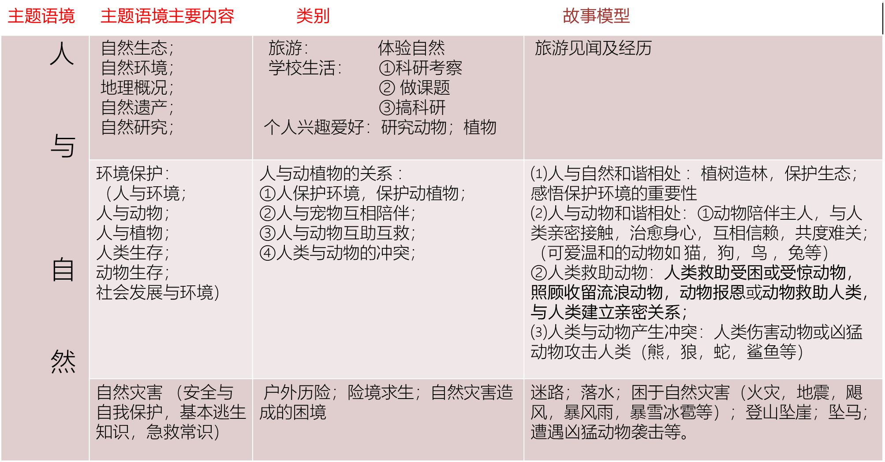

**人与自然之脱困篇：**

**脱困类叙事模型简析：**

1. **从历险者角度叙事：**

①遭遇危险（恶劣环境&危险描写&情感描写）—出现转机（想到办法&**历险者自救）** ---**自救脱险** （过程&情感描写）---感悟升华

②遭遇危险（恶劣环境&危险描写&情感描写）—出现转机（想到办法&呼救求助&**他人救助**） —救援脱险（救援描述&情感描写）—感悟升华 或对救援人员表达谢意并致敬；

**2. 从救援者角度叙事 （如消防员，警察，专业救援人员等）**

接到警情（恶劣环境&危险描写&情感描写）—抵达现场（评估险情&想办法实施救援）—救援脱险（救援描述&情感描写）—可以从职业角度感悟升华 ，体现救援工作的价值和崇高的职业精神。

**遇险脱困类 （自然灾难& 历险）**

**附：历届模拟考以及高考真题**

2023-7 浙江绍兴高二期末考试 Anna雨夜骑马救牛仔 （施救者角度助他人脱困）

2023-9 浙江高三七彩联盟 雨夜迷路森林 （受困者角度—自主脱困）

2023-11 浙江金华高三十校联考 困于水库 （先施救者角度助他人脱困+后受困者角度被救助+后主动助人）

2024-2 浙江名校协作体 惊心救援 （施救者角度助他人脱困）

2024-3 浙江高二精诚联盟 铁轨惊魂 （施救者角度助他人脱困）

2024-4 T8联考 电梯惊魂 （受困者角度叙事+被专业救援人员救助）

2024-8 浙江省七彩联盟 Emily迷路森林 （受困者角度叙事+被好心陌生人救助）

高考真题：

2018年6月浙江省高考真题 骑马遇兔迷路森林 （受困者角度 —自主脱困）

2016-10 浙江省高考真题 Jane林中迷路 （受困者角度 —自主脱困）

**人与自然 （守护自然，保护环境 ）**

**附：历届模拟考**

2023-12 浙江高三精诚联盟 街角花园 （守卫街角花园 为周围的百姓保留自然美景）

**人与自然之动物篇**

人与动物类读后续写题的故事模型主要有三个出题方向：

**一：人与动物和谐相处；**人与动物和谐相处，体现在人与动物的亲密互助方面。文章内容主要有圈养动物、家养宠物的趣事囧事；家养宠物陪伴、治愈主人；旅途偶遇动物、救助动物等。

**附：历届模拟考以及高考真题**

1. **人与动物和谐的关系& 动物帮人or 救人**

2020年1月 浙江省高考真题 波比的小狗 （人与动物和谐共处）

2023年11月 浙江省稽阳卷 莱利太太的金丝雀 （人与动物和谐共处）

2024-2 浙江省七彩联盟 再见，狐狸 （人与动物和谐共处）

2024-2 浙江省浙南联盟 人狗奇缘 （人与动物和谐共处 动物对人的信赖）

2024-3 浙江宁波十校 Rufus的寻家之旅 （狗救迷路女孩）

2024-3 浙江强基联盟 漫长的重逢 （父亲找到多年流浪在外的狗）

2024-4 广东一模 企鹅暖宝宝 （企鹅助孩子取暖）

2023年7月 浙江宁波高二期末联考 森林精灵护女婴 （精灵帮忙救女婴）

1. **人救助动物**

2023年1月 浙江省高考真题 人鸟情未了 （救助动物）

2023年 浙江四省联考 救助红松鼠 （救助动物）

2023年3月 浙南联盟 雪中救马 （救助动物）

2023年4月 浙江温州联考 女孩救隧道鳟鱼 （救助动物）

2023年5月 浙江北斗联考 为建蜜蜂小屋筹款 （救助动物）

2024-10 浙江天域名校联盟 干草棚里的小猫 （救助动物）

**二：人与动物发生冲突（与历险故事类有重合）。**

人与动物发生冲突往往以人类成功脱险为结局。人类偶遇凶猛动物，遇到危险，设法脱困。在解决问题的过程中，我们注意保护动物的理念，即不能伤害野生动物、不能私自圈养野生动物。

**附：历届模拟考以及高考真题**

**遇险脱困类 （ 凶猛动物： 蛇 熊 狼 鲨鱼等）**

2024-4 浙江湖丽衢二模 蟒蛇和我的一场虚惊

高考真题：

2017年6月 浙江省高考真题 阿拉斯加与狼骑行

2020年7月 浙江省高考真题 不速之客北极熊

**三： 人与动物 趣事类**

**附：历届模拟考以及高考真题**

2023年5月 浙江十校联盟 教室里的蛙

2023年7月 浙江金华市高二十校联考 离家出逃的猫

2024年4月 浙江宁波二模 臭鼬与我家的奇妙缘分

2023年12月 浙江四校联考 小黑狗洗澡历险记

2023年12 月 浙江嘉兴一模 莫索普先生的鸡

2024年1月20 九省联考 淘气海豚的秘密

脱困类语料：

**一、环境描写（**恶劣环境描写&困境危险描写）

1. The stars disappeared under a blanket of clouds. The wind whistled and bent the prairie grass.

星星消失在一层乌云之下。风呼啸着吹弯了草原上的草。 （雨夜前）

2. A flash of lightning lit up the whole sky, followed by a loud crack of thunder.

一道闪电照亮天空，接着一声巨雷。 (雷雨）

3. Minutes later, there came a downpour/It began to rain cats and dogs, violently beating against the window.

几分钟之后，大雨倾盆而下，大雨猛烈地打在窗户上。（暴雨）

4. The storm strength/ power lessened gradually, with the weak crack of the rumbling thunder in the distant.

暴风雨的强度逐渐减弱，远处传来微弱的轰隆雷声。

5. Black clouds gathered over our head in the sky and the sun hid behind them. A blaze of lightning flashed across the night sky, with deafening thunder roaring violently. It rained cats and dogs, which made visibility poor.

天空中乌云聚集在我们头上，太阳躲在乌云后面。一道闪电划过夜空，伴随着震耳欲聋的雷鸣。雨下得很大，能见度很低。

6. The water kept rising, as if it would engulf me alive.

水不断上涨，仿佛要把我活活淹没。（洪水）

7. Flames consumed everything in the way like a monster, a thick burning smell filling the air.

火焰像个怪兽一样吞噬着一切，空气中弥漫着浓烈的烧焦的气味。 （火灾）

8. The house was flaming ， thick clouds of smoke shooting up into the air. （室外）

房子着火了，浓烟直冲云霄。

Thick smoke filled the room. （室内）

房间里充满了浓烟。

9. The wind was howling mercilessly/ relentlessly and the waves smacked repeatedly against her face.

风无情地呼啸着，海浪不停地拍打着她的脸。（风&海浪）

10. The wall caved in, deep cracks opened up in the roads and huge buildings collapsed, sending clouds of dust into the air. (地震）

墙塌了，道路上出现了深深的裂缝，巨大的建筑物倒塌了，空气中弥漫着灰尘。