**The World**（**1201-1215**）材料分析和教学目标：

本次选用的材料：①*Daily Express*的*Hospitals ban visitors as norovirus spreads*

（由于诺如病毒的传播，医院禁止访客）、②*Science*的*Climate change puts Amur leopard at risk* （东北豹深受气候变化之害）、③*The Wall Street Journal*的*Is it true that shopping carts are full of germs?*（购物车里真的充满了细菌吗?）、④*National Geographic*的*New Angle on Manners*（会排队的鱼）和⑤Newsweek的新闻报道。通过语法填空、阅读理解、分析长难句、翻译句子、听力填空和词汇拓展等方式，让学生从多角度提升学习兴趣，提高分析句子、运用词块和听力能力。外媒英语新闻可以让学生体验真实语境下的语言运用，拓展学生的国际视野，了解时事，逐步提升跨文化沟通能力，形成正确的世界观、人生观和价值观。

**教学思路：**

**Part 1: News Report 1 *Daily Express* (9th December 2023 Page 10)**

**Hospitals ban visitors as norovirus spreads**

**由于诺如病毒的传播，医院禁止访客**

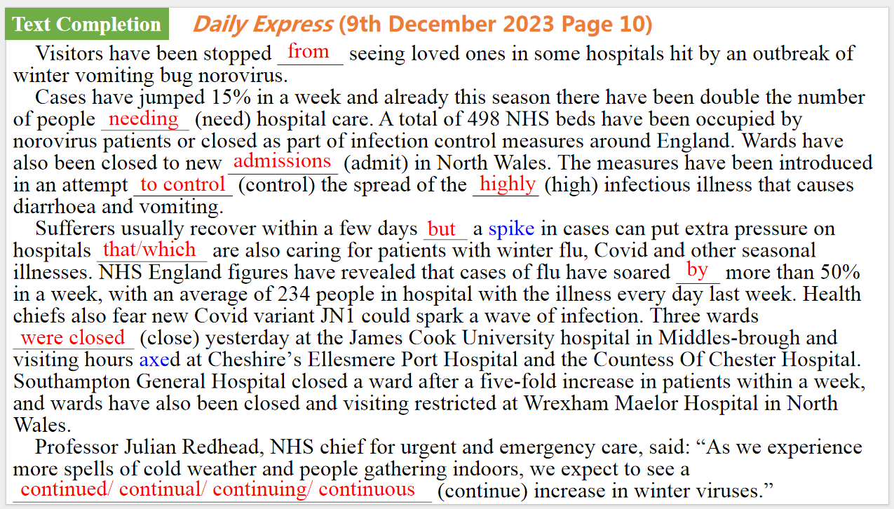

【设计意图】通过语篇填空的形式帮助学生理解新闻的主要内容，同时训练语言语法的运用能力：在语篇的视角下如何正确使用所给词汇，根据语法规则确定词汇的正确形式，使得文章通顺，激活学生的思维和语言。该新闻主题语境是关于“人与社会”中“社会热点问题”这一子主题，通过学习让学生了解由于诺如病毒的传播，医院禁止访客的事件。



【设计意图】对文本中的词汇进行解读，并通过翻译句子对其进行巩固。

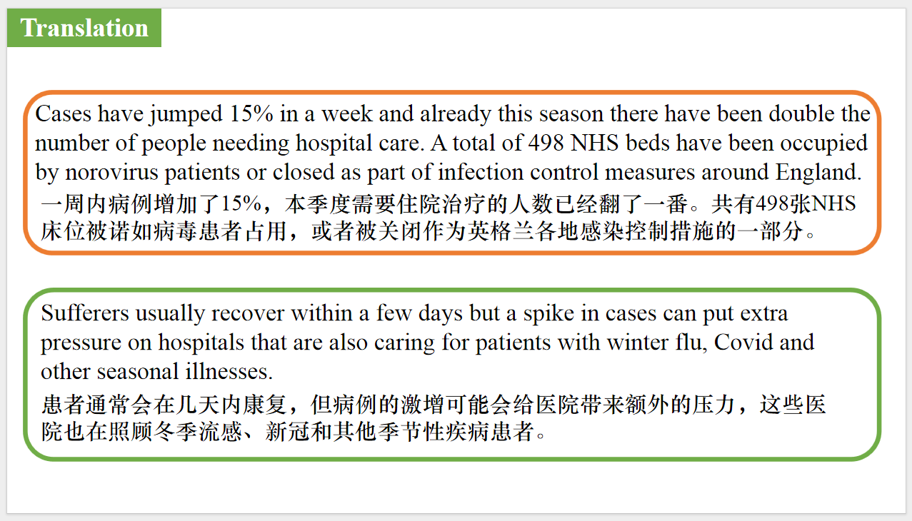

【设计意图】对文中的两个句子进行翻译练习，对其中单词、词组、句法进行巩固并关注句子结构。

**Part 2: News Report 2 *Science (1st December 2023 Page 1007)***

**Climate change puts Amur leopard at risk 东北豹深受气候变化之害**

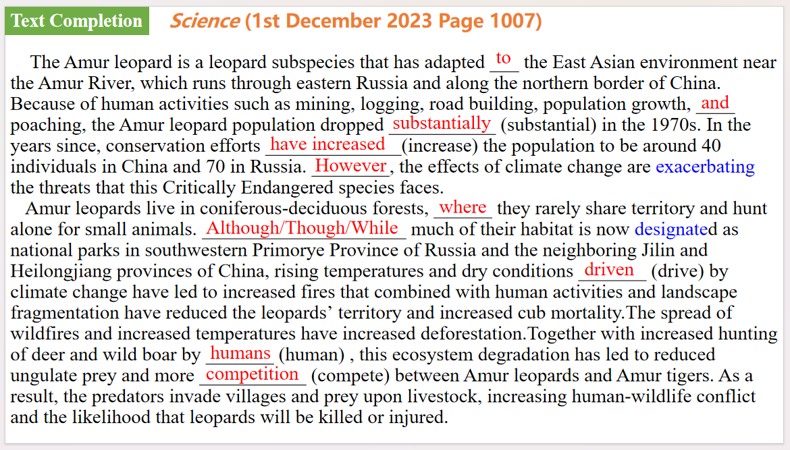

【设计意图】通过语篇填空的形式帮助学生理解新闻的主要内容，同时训练语言语法的运用能力：在语篇的视角下如何正确使用所给词汇，根据语法规则确定词汇的正确形式，使得文章通顺，激活学生的思维和语言。该新闻主题语境是关于“人与自然”中“人与动植物”这一子主题，通过学习让学生了解东北豹深受气候变化之害的现状。

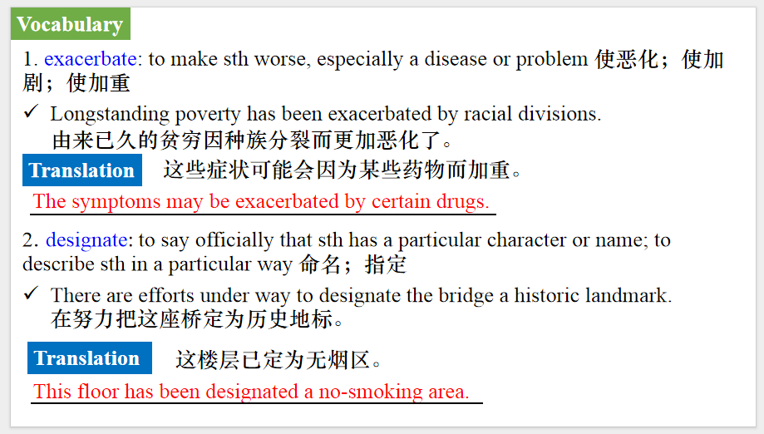

【设计意图】对文本中的词汇进行解读，并通过翻译句子对其进行巩固。

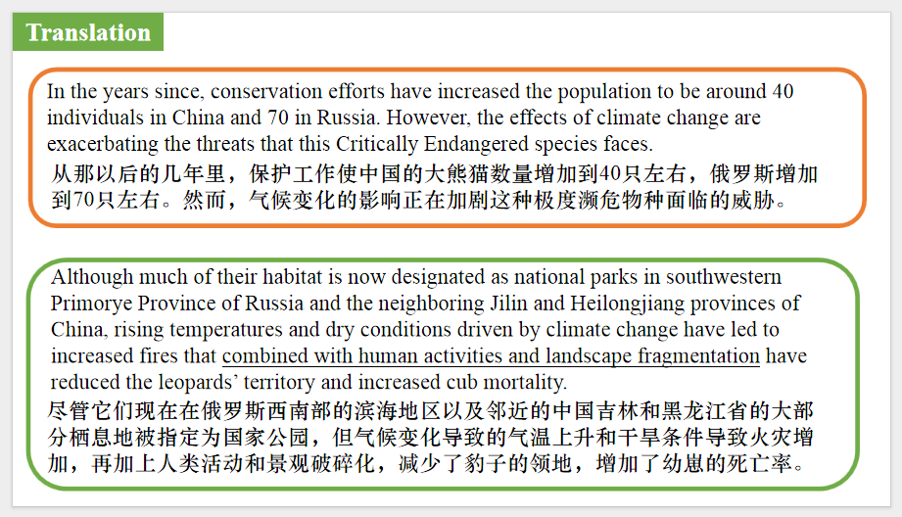

【设计意图】对文中的两个句子进行翻译练习，对其中单词、词组、句法进行巩固并关注句子结构。

**Part 3: News Report 3 *The Wall Street Journal*  (5th December 2023 E5)**

**Is it true that shopping carts are full of germs? 购物车里真的充满了细菌吗?**

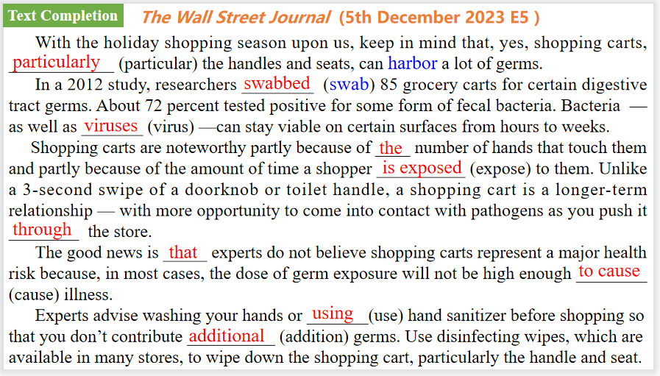

【设计意图】通过语篇填空的形式帮助学生理解新闻的主要内容，同时训练语言语法的运用能力：在语篇的视角下如何正确使用所给词汇，根据语法规则确定词汇的正确形式，使得文章通顺，激活学生的思维和语言。该新闻主题语境是关于“人与自然”中“自然科学研究成果”这一子主题，通过学习让学生了解购物车上的细菌及其危害。

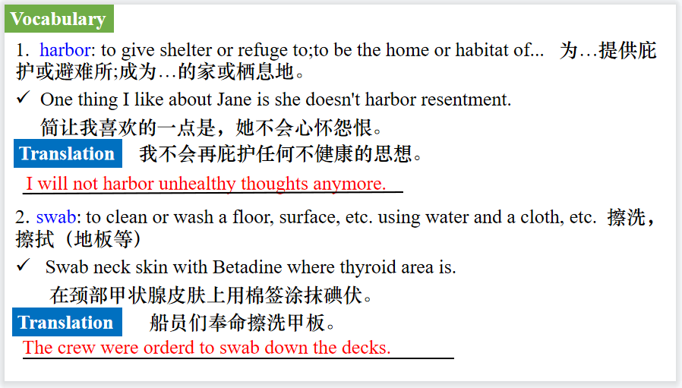

【设计意图】对文本中的词汇进行解读，并通过翻译句子对其进行巩固。

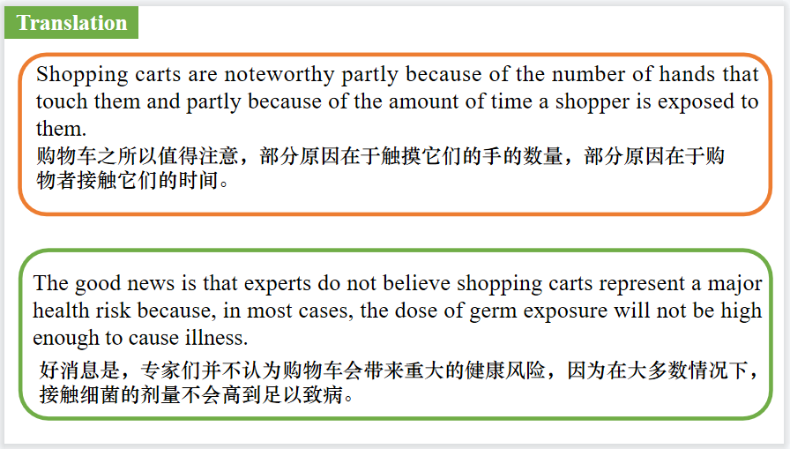

【设计意图】对文中的两个句子进行翻译练习，对其中单词、词组、句法进行巩固并关注句子结构。

**Part 4: News Report 4 *National Geographic* (December 2023 BREAKTHROUGHS)**

**New Angle on Manners 会排队的鱼**

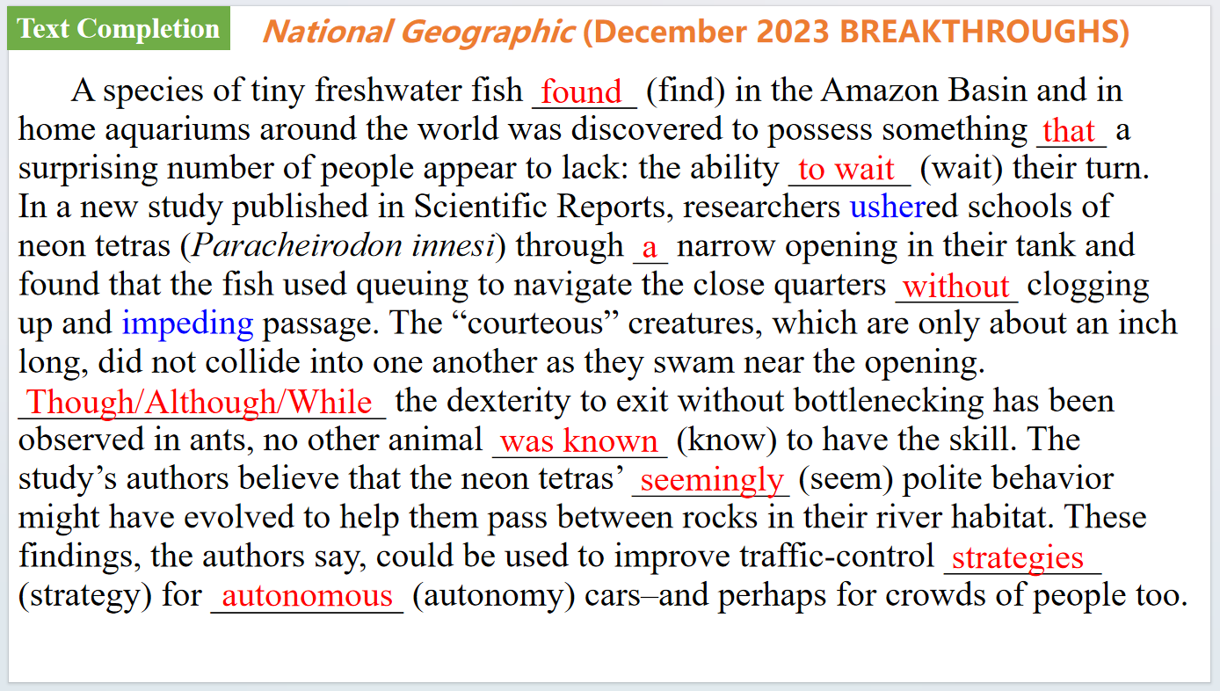

【设计意图】通过语篇填空的形式帮助学生理解新闻的主要内容，同时训练语言语法的运用能力：在语篇的视角下如何正确使用所给词汇，根据语法规则确定词汇的正确形式，使得文章通顺，激活学生的思维和语言。该新闻主题语境是关于“人与自然”中“自然科学研究成果”这一子主题，通过学习让学生了解一种会排队通过狭窄缝隙的鱼类。

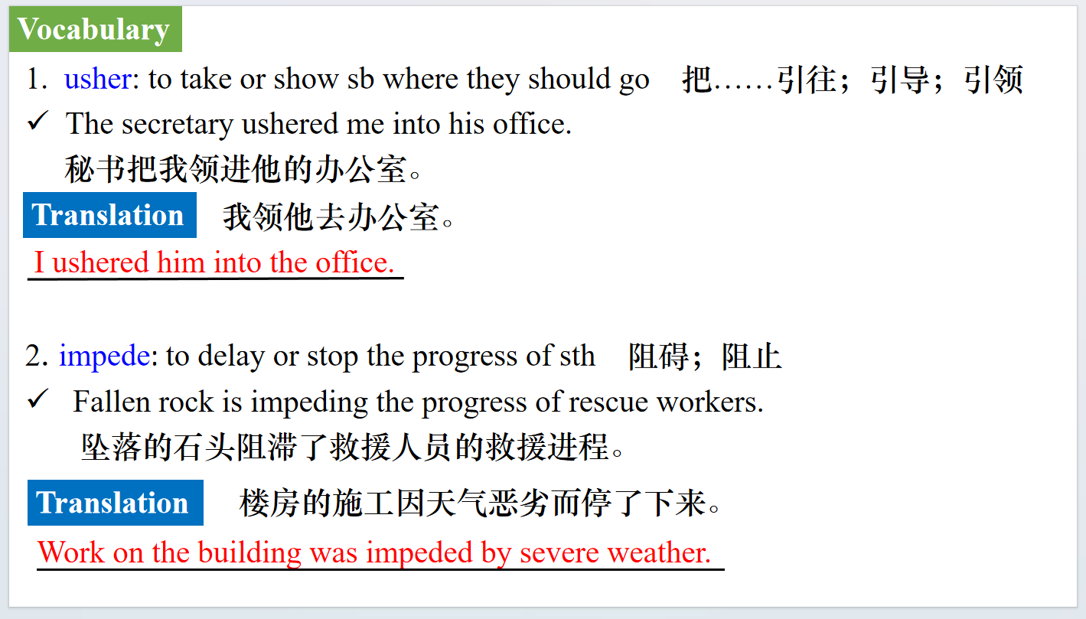

【设计意图】对文本中的词汇进行解读，并通过翻译句子对其进行巩固。

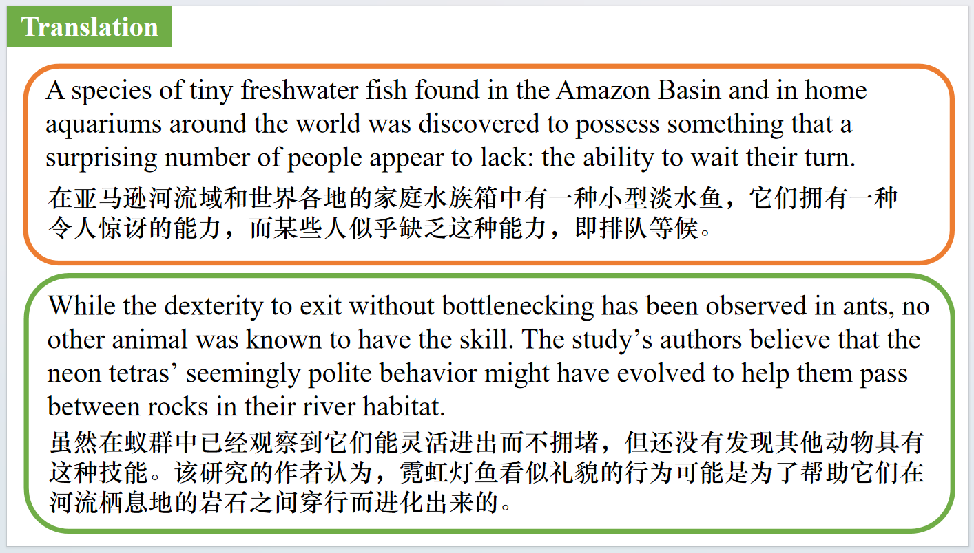

【设计意图】对文中的两个句子进行翻译练习，对其中单词、词组、句法进行巩固并关注句子结构。

**Part 5: Newsweek 12/05/2023**



【设计意图】听一则材料，通过听力填空的方式理解文本，考察听力辨识词汇的能力。

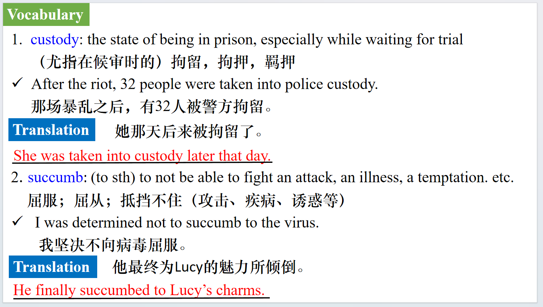

【设计意图】对文本中的词汇进行解读，并通过翻译句子对其进行巩固。

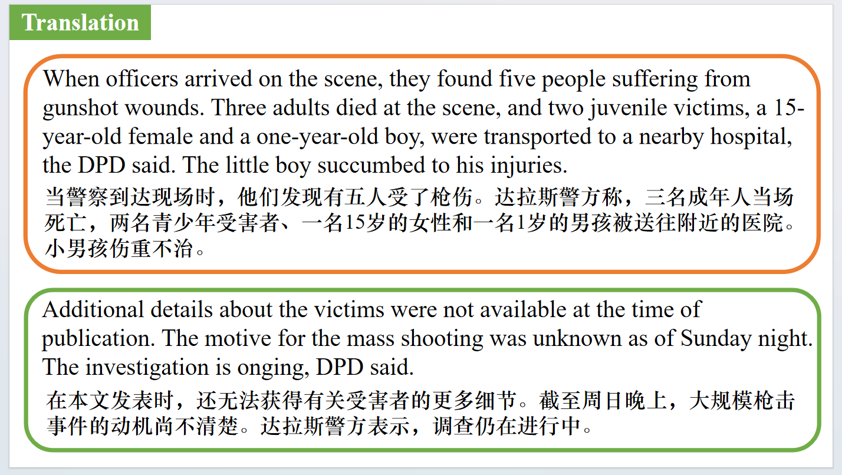

【设计意图】对文中的两个句子进行翻译练习，对其中单词、词组、句法进行巩固并关注句子结构。

附：外刊原文

**Part 1: News Report 1 *Daily Express* (9th December 2023 Page 10)**

**Hospitals ban visitors as norovirus spreads**

**由于诺如病毒的传播，医院禁止访客**

Visitors have been stopped from seeing loved ones in some hospitals hit by an outbreak of winter vomiting bug norovirus.

Cases have jumped 15% in a week and already this season there have been double the number of people needing hospital care.

A total of 498 NHS beds have been occupied by norovirus patients or closed as part of infection control measures around England.

Wards have also been closed to new admissions in North Wales. The measures have been introduced in an attempt to control the spread of the highly infectious illness that causes diarrhoea and vomiting.

Sufferers usually recover within a few days but a spike in cases can put extra pressure on hospitals that are also caring for patients with winter flu, Covid and other seasonal illnesses. NHS England figures have revealed that cases of flu have soared by more than 50% in a week, with an average of 234 people in hospital with the illness every day last week.

Health chiefs also fear new Covid variant JN1 could spark a wave of infection.

Three wards were closed yesterday at the James Cook University hospital in Middles-brough and visiting hours axed at Cheshire’s Ellesmere Port Hospital and the Countess Of Chester Hospital.Southampton General Hospital closed a ward after a five-fold increase in patients within a week, and wards have also been closed and visiting restricted at Wrexham Maelor Hospital in North Wales.

Professor Julian Redhead, NHS chief for urgent and emergency care,said:“As we experience more spells of cold weather and people gathering indoors,we expect to see a continued increase in winter viruses.”

**Part 2: News Report 2 *Science* (1st December 2023 Page 1007)**

**Climate change puts Amur leopard at risk 东北豹深受气候变化之害**

The Amur leopard (Panthera pardus ori-entalis) is a leopard subspecies that has adapted to the East Asian environment near the Amur River, which runs through eastern Russia and along the northern border of China. Because of human activities such as mining, logging, road building, population growth, and poaching, the Amur leopard population dropped substantially in the 1970s. In the years since, conservation efforts have increased the population to be around 40 individuals in China and 70 in Russia. However, the effects of climate change are exacerbating the threats that this Critically Endangered species faces.

Amur leopards live in coniferous-deciduous forests, where they rarely share territory and hunt alone for small animals. Although much of their habitat is now designated as national parks in southwestern Primorye Province of Russia and the neighboring Jilin and Heilongjiang provinces of China, rising temperatures and dry conditions driven by climate change have led to increased fires that combined with human activities and landscape fragmentation have reduced the leopards’ territory and increased cub mortality.The spread of wildfires and increased temperatures have increased deforestation.Together with increased hunting of deer and wild boar by humans, this ecosystem degradation has led to reduced ungulate prey and more competition between Amur leopards and Amur tigers (Panthera tigrisaltaica). As a result, the predators invade villages and prey upon livestock, increasing human-wildlife conflict and the likelihood that leopards will be killed or injured.

Climate change has also increased the Amur leopard’s vulnerability to disease. Increased temperatures, humidity,and frequency and intensity of extreme weather events have reshaped interactions between species, facilitating the spread of viruses.

In addition,the loss of habitat and stop-over migration areas has caused birds to alter migration patterns, leading to more contact between birds and mammals in East Asia. Cross-species transmission of disease has increased by an estimated 4000-fold. Amur leopards have contracted the potentially lethal canine distemper virus as well as the highly pathogenic avian influenza H5N1 virus (II).To protect Amur leopards from extinction, future demographic models should include climate change-driven wildfires, inter species competition,human conflicts,and infectious diseases when predicting population declines. Conservation responses,including vaccination programs,should take these factors into account. In addition,a multi-pathogen surveillance system should be used to speed up the detection of highly virulent viral strains that infect felids. Together,these efforts would mitigate the risk of Amur leopard extinction.

**Part 3: News Report 3 *The Wall Street Journal*  (5th December 2023 E5)**

**Is it true that shopping carts are full of germs? 购物车里真的充满了细菌吗?**

Is it true that shopping carts are full of germs?

BY LINDSEY BEVER

The question Is it true that shopping carts are covered in an unusual amount of germs?

The science

With the holiday shopping season upon us, keep in mind that, yes, shopping carts, particularly the handles and seats, can harbor a lot of germs.

Research has shown there can be more bacteria on shopping carts than on surfaces in public restrooms, airports, bus stations and shopping malls.

In a 2012 study, researchers swabbed 85 grocery carts for certain digestive tract germs. About 72 percent tested positive for some form of fecal bacteria. The bacteria may have originated from many things, including children with dirty diapers riding in the cart, cross-contamination from handling raw meat products while shopping or bird droppings while sitting in the grocery store parking lots, said Charles Gerba, a microbiologist at the University of Arizona and senior author of the study.

Bacteria — as well as viruses —can stay viable on certain surfaces from hours to weeks.

Shopping carts are noteworthy partly because of the number of hands that touch them and partly because of the amount of time a shopper is exposed to them. Unlike a 3-second swipe of a doorknob or toilet handle, a shopping cart is a longer-term relationship — with more opportunity to come into contact with pathogens as you push it through the store.

The good news is that experts do not believe shopping carts represent a major health risk because, in most cases, the dose of germ exposure will not be high enough to cause illness.

For instance, with shigella, a gastrointestinal bacterium, it may take 10 organisms to cause illness; whereas, with salmonella, it may take 100,000, said John Swartzberg, an infectious-disease professor at the University of California at Berkeley School of Public Health.

“The dose makes the poison,” he said.

William Schaffner,a professor of infectious diseases and preventive medicine at Vanderbilt University, said he is not especially concerned about germ exposure from shopping carts but, to be safe, he practices good hand hygiene and encourages others to do the same.

Experts advise washing your hands or using hand sanitizer before shopping so that you don’t contribute additional germs. Use disinfecting wipes, which are available in many stores, to wipe

down the shopping cart, particularly the handle and seat.

Avoid touching your eyes, nose or mouth during your shopping trip and use hand sanitizer after you leave the store.

What else you should know

Self-checkout touch screens can be germy, too. In one test of 17 touch screens, researchers detected fecal bacteria, including E. coli, on more than half of them. one was even contaminated with methicillin-resistant Staphylococcus aureus, or MRSA.

The bottom line

Shopping carts are known to be contaminated with bacteria and viruses. While it’s not a major health risk, it makes sense to use hand sanitizer and clean the handle and seat with a disinfecting wipe. Avoid touching your face until you can wash your hands.

**Part 4: News Report 4 *National Geographic* (December 2023 BREAKTHROUGHS)**

**New Angle on Manners 会排队的鱼**

A species of tiny freshwater fish found in the Amazon Basin and in home aquariums around the world was discovered to possess something that a surprising number of people appear to lack: the ability to wait their turn. In a new study published in Scientific Reports, researchers ushered schools of neon tetras (*Paracheirodon innesi*) through a narrow opening in their tank and found that the fish used queuing to navigate the close quarters without clogging up and impeding passage. The “courteous” creatures, which are only about an inch long, did not collide into one another as they swam near the opening. While the dexterity to exit without bottlenecking has been observed in ants, no other animal was known to have the skill. The study’s authors believe that the neon tetras’ seemingly polite behavior might have evolved to help them pass between rocks in their river habitat. These findings, the authors say, could be used to improve traffic-control strategies for autonomous cars–and perhaps for crowds of people too.