选修2 Bridging Cultures
Reading and Thinking - “ Welcome Xie Lei ! ” Business Student Building Bridges
-by Lily
- Teaching Analysis:
The topic of this unit is “Bridging Cultures”, which is involved with crossing-cultural interaction. And going abroad for further education is a way for ss to learn the cultures around the world and promote Chinese culture. The reading text just shows the experience of an exchange student, Xie Lei in adapting to the new environment. In a new cultural surrounding, exchange ss may find it hard to adapt to the new life and academic requirements. To overcome all kinds of cultural shocks, they will try to fit into the new culture through learning new things and asking for helps. In this process, they will embrace the new culture and share their own culture. Then, they will just function as a cultural messenger who are building a bridge among cultures. For ss, they are interested about it since it’s related to their future development. But they know few about cultural shocks and some tips in crossing-cultural interactions. Thus, the teaching objectives are designed as follow:
- Teaching Objectives:
- To summarize the problems and cultural shocks of exchange students in adapting to the new life abroad and the strategies for crossing-cultural interaction by analyzing the challenges of Xie Lei.
- To analyze the role of exchange students in promoting culture and crossing-cultural communication by reading for the experience of Xie Lei.
- To evaluate the significance of crossing-cultural communication by thinking about why people choose to joining in exchange programmes.
- Teaching Procedures:
Step1: Lead-in
A vlog of the first day as an exchange student
Brainstorm the problems he might meet.
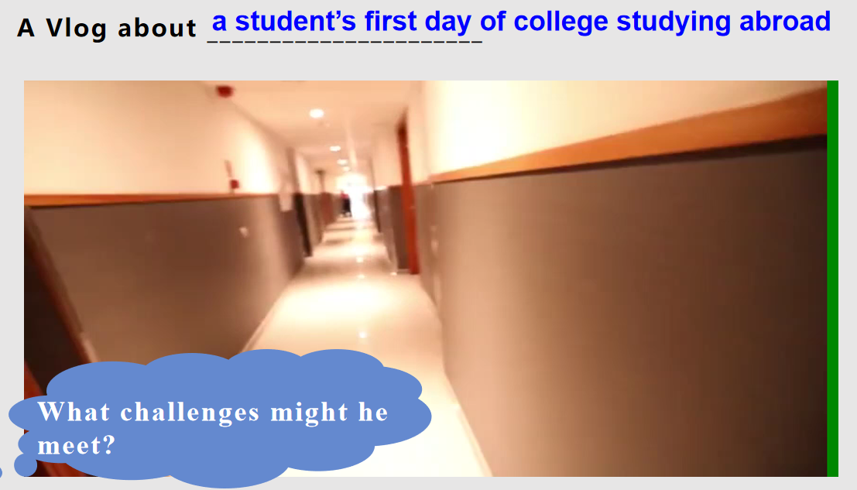
【Aims: to elicit the topic and prepare for the following reading.】
Step2: Prediction
Read the title and form for genre.
Read to raise questions about the possible content.
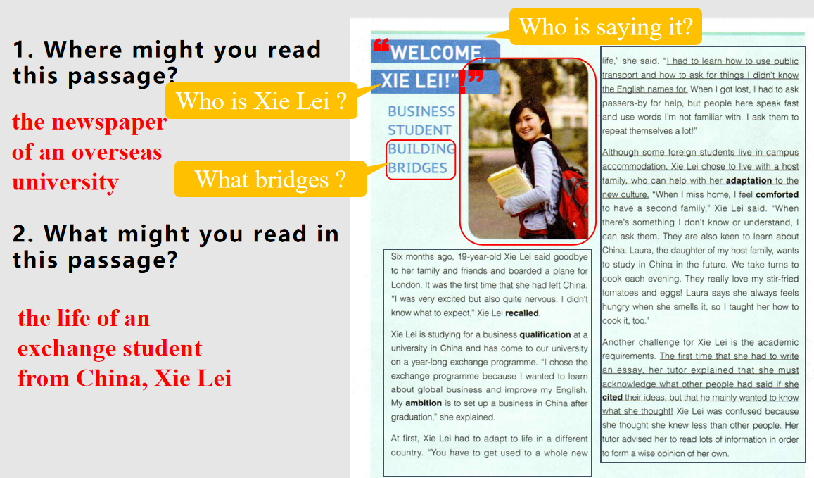
【Aims: to stimulate ss’ motivation for reading and set contexts for automatic reading.】
Step3: Read for Main idea and structure.
Summarize the main idea of each paragraph by listing key words.
【Aims: to practise ss’ summary skills like locating key words.】
Step 4: Read for the answers to the questions.
- Figure out the background information about Xie Lei.
- Read for the challenges and feeling s of Xie Lei by drawing the form.
- Analyze what helped Xie Lei adapt to the new culture.
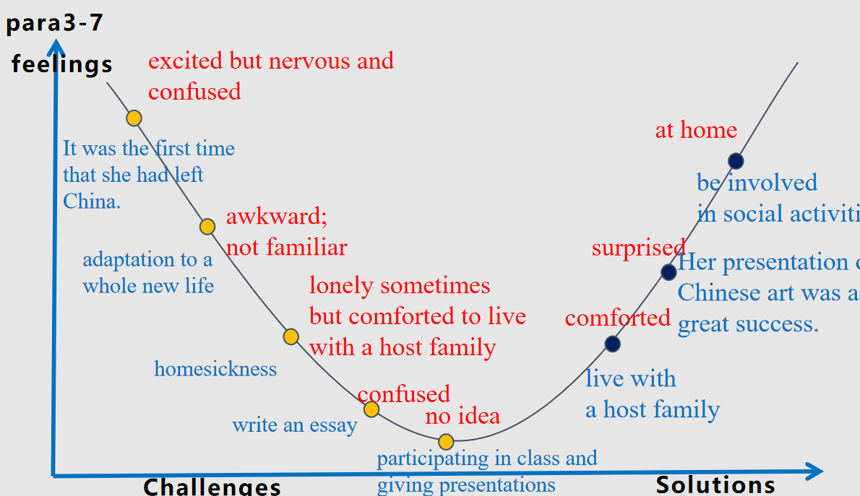
【Aims: to work out the experience of Xie Lei and analyze the role of exchange students in promoting culture and crossing-cultural communication by reading for the experience of Xie Lei.】
Step5: Thinking
Why do people choose to study abroad?
【Aims: to develop ss’ critical thinking ability by evaluating the reasons of ss going abroad.】
Step6: Homework
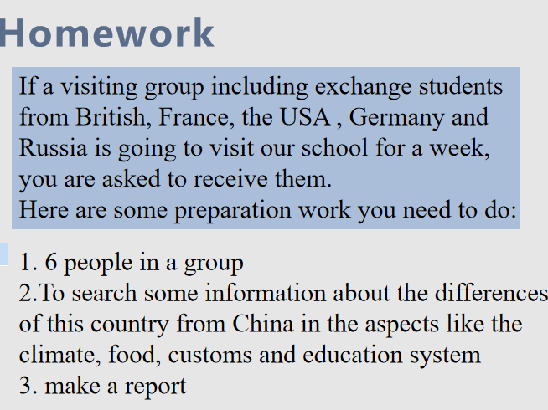
【Aims: to develop ss’ cultural awareness and extend their horizons about cultures around the world.】

