Unit 2 Healthy Lifestyle
Reading and Thinking:
课时目标
1. 整体阅读文本、梳理语篇宏观结构、明确文本主要内容。
2. 提炼习惯的关键特征，包括重复性、选择性、自发性和不易改变性，正确建构习惯的概念。
3. 通过同伴互助，阐述习惯运转原理，运用“习惯周期”分析坏习惯，思考其对改变坏习惯的作用。
教学过程
Activity 1: Brainstorm
1.Think about unhealthy/bad habits of teenagers as many as they can.
(staying up late; alcohol abuse(drinking) tobacco; abuse(smoking)
absorbed in computer games;excessive(adj.过多的，极度的) diet)
2. Q1:Do you think bad habits are easy to change?
Q2:What can you do to correct these bad habits?
Now, let's read a passage to find out the answer.
Activity 2: Read the genre
Skim the title and the passage quickly .
1.What is text type of the passage? A. Narration B.Exposition C.Argumentation
2.Who are the target audience of the text and what is the purpose of the author's writing the passage?
Activity 3: Figuring out the main idea
Read the passage and match the main idea with the paragraph accordingly.
- How to change a bad habit and create good ones
- The cycle of how habits are formed
- Young people have the power to build a healthy life full of good habits.
- Changing habits gradually
E. No easy way to change bad habits
F. Why bad teenage habits should be changed
Para1_____ Para 2_____ Para3_____ Para4_____ Para 5_____ Para6_____
Tips：Find the main idea of a paragraph The main idea is sometimes stated in either the opening or closing sentence. If not, look for another “standout” sentence, or summarise the paragraph in your mind by asking yourself, “What is it mainly about?”
Activity4:Reading for structure
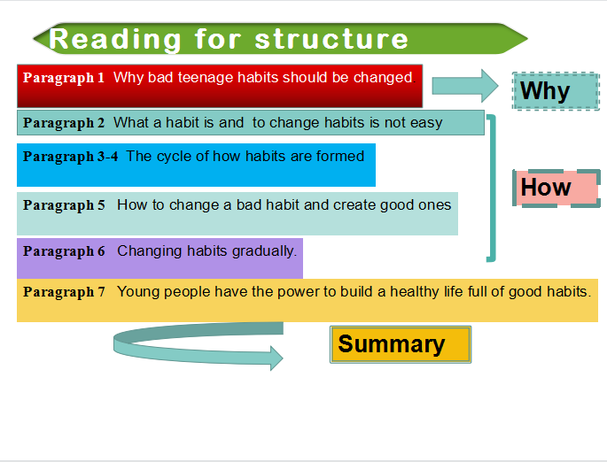
Summary about the structure
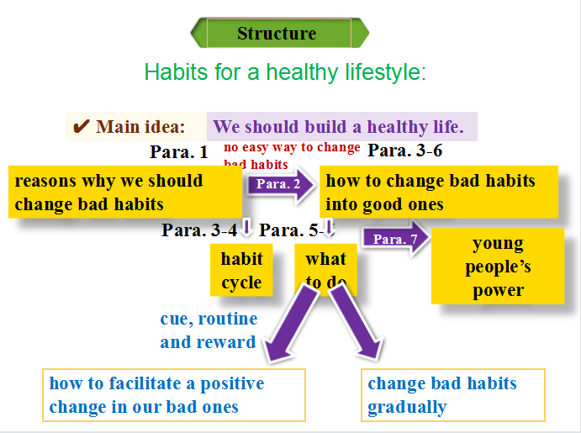
Activity5: Reading for the details
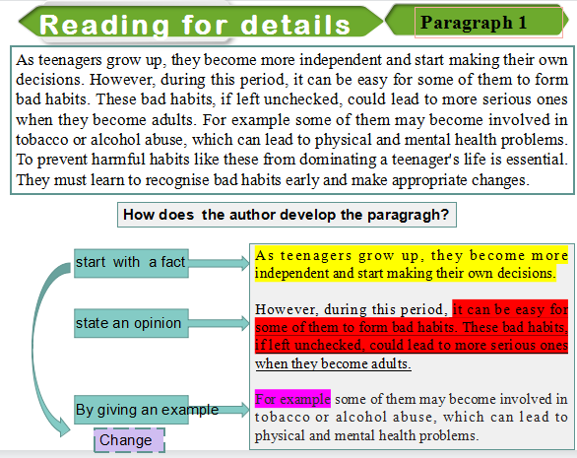
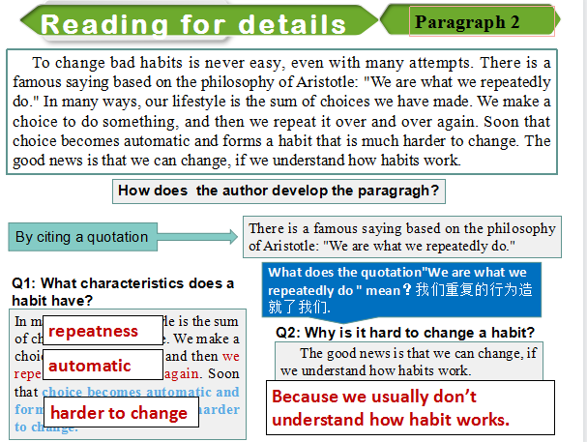
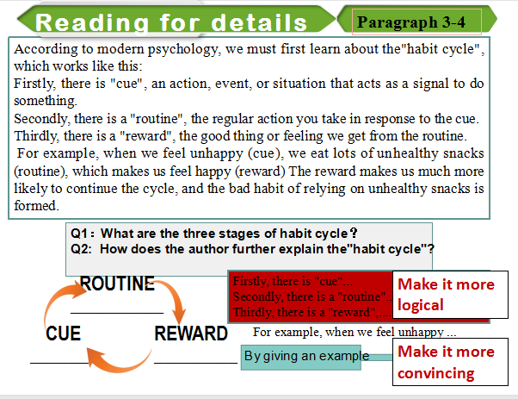
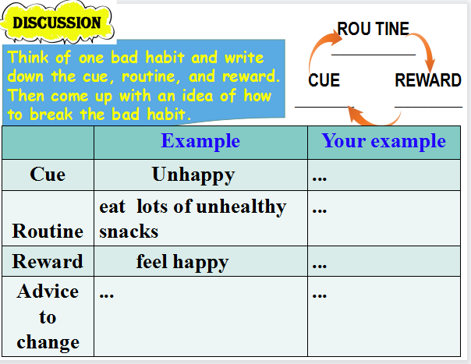
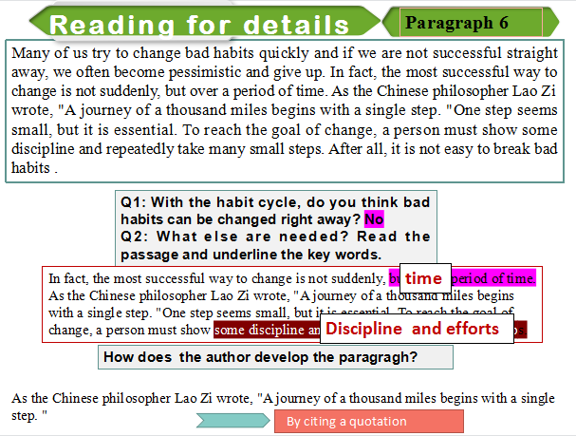

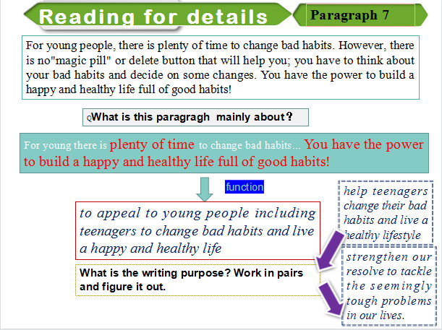
Activity6: Interview
- Suppose you are the reporter of school newspaper， you are interviewing an expert named Oscar Wilde on teenager problems , make a dialogue between you and the expert on how to change bad habits and live a happy life.
S: Hello, everyone ,I’m the host of Sophia. Today, it is a great honor for us to invite the famous expert in teenager problems .Welcome , Doctor Oscar.
Oscar: Hi ,Sophia, thank you for inviting me .
S: We have been expecting to ask you some questions on how to change some bad habits and live a happy life , shall we start?
- ….

