**Unit 2 Book 2 导案**

1. **poster ['pəʊstə] n. 海报,广告;招贴画**

The purpose of this poster is to invite more people to enjoy the landscape of Pembroke shire National Park.(2011江苏)

这张海报的目的是邀请更多的人来欣赏彭布罗克郡国家公园的风景。

**post [pəʊst] n. 岗位;邮件;标杆;帖子vt. 张贴;公布;邮递**

The post has since gained the attention of social media users all over the world, receiving more than 184,000 shares and 61,500 likes in just three days.(2018全国III)

这条微博吸引了全球社交媒体用户的关注,短短三天内就获得了超过18.4万次转发和6.15万个赞。

Where will you post a notice if you need someone to look after your children?(2009浙江)

如果你需要有人照顾你的孩子,你会把通知贴在哪里?

When you join the team in our Revenue Administration Unit, you will be providing assistance within all parts of the Revenue Division, dealing with post and other general duties.(2011全国I)

当你加入我们的税收管理小组时,你将在税收司的所有部门内提供协助,履行岗位和其他的一般职责。

I hate coming home every evening and a pile of junk mail in my post box.(2008浙江)

我讨厌每天晚上回家,一堆垃圾邮件在我的邮箱。

I made a turn at the comer and drove past the post office and across the railroad tracks to our house.(2012浙江)

我在拐角处转了个弯,开车经过邮局,穿过铁路来到我家。

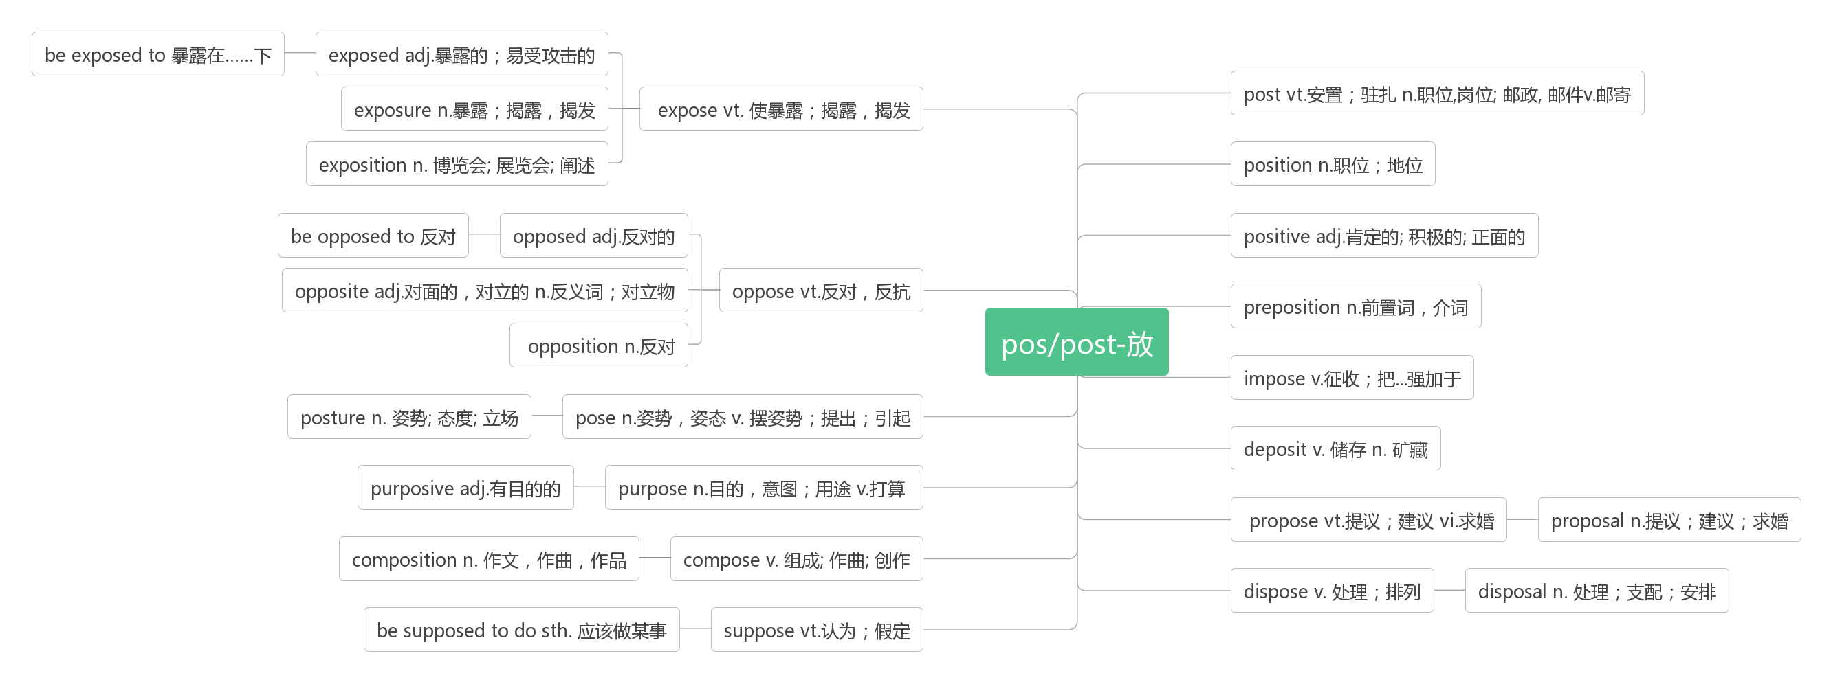**2. illegal [ɪ'liːg(ə)l] adj.非法的;违法的**

By-laws are to make it illegal to smoke in public. 地方法规将规定在公共场合抽烟为非法。

Discrimination by employers on the grounds of race and nationality was illegal.

雇主以种族或国籍为由歧视员工是非法的。

**legal ['liːg(ə)l]adj. 法律的;合法的;法定的**

But legal experts are not sure if such a charge can stick. 但法律专家们不能肯定这一指控是否成立。

We are taking advice on legal steps to recover the money. 我们正在就追回该款项所需的法律程序咨询律师。

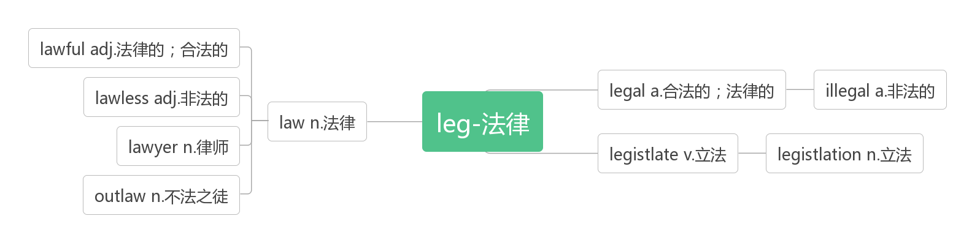

1. **hunt[hʌnt]vt.vi.&n.打猎;搜寻**

**hunt for搜寻,寻找**

People in the wilderness also hunt deer for food.(2010江苏) 荒野里的人也猎取鹿作为食物。

Of course,there are some who truly believe that the killing is not really the important thing,and that the chief pleasure lies in the joy of the hunt and the beauties of the wild countryside.(2007北京)

当然,也有一些人真的相信,猎杀并不是真正重要的事情,主要的乐趣在于狩猎的乐趣和野外美景。

The hungry hunter began to hunt for wild animals that were in hunger in the forest.

饥饿的猎人开始在森林里寻找处于饥饿中的野生动物。

**hunter['hʌntə] n. 猎人;猎犬;搜寻者**

1. **immediately [ɪ'miːdɪətlɪ] adv. 立即,立刻conj. 一…就**

**词根词缀：im(in-没有)+media(中介,中间)+te(adj.)+ly(adv.):没有中间耽搁的——立即,立刻**

If the red light is not blinking (闪动), contact residence hall staff immediately.(2018天津)

如果红灯不亮,请立即联系宿舍工作人员。

He finds that if babies aged 18 months see an unrelated adult with hands full trying to open a door, almost all will immediately try to help.(2016江苏)

他发现,如果18个月大的婴儿看到一个没有血缘关系的成年人正忙着开门,几乎都会立即伸出援手。

Tickets will be emailed to you immediately after purchase or you can download and print your ticket once payment has been accepted.(2014北京) 购票后会立即以电邮方式通知您,或您可以在接受付款后下载及打印门票。

Let me know immediately she arrives. 她一到就告诉我。

**immediate [ɪ'mi:dɪət] adj. 立即的;直接的**

If you have somewhere you want to go, something you want to accomplish, someone you want to become...take immediate action.(2014全国I) 如果你有你想去的地方,你想完成的事情,你想成为的人……立即采取行动。

One morning, I had to book an immediate flight home for a family emergency. (2016全国II)

一天早上,因为家里有急事,我不得不预订了立即回家的航班。

1. **species['spiʃiz]n.物种**

Some animal and plant species cannot accommodate(适应) to the rapidly changing conditions.

某些种类的动植物不能适应迅速变化的环境。

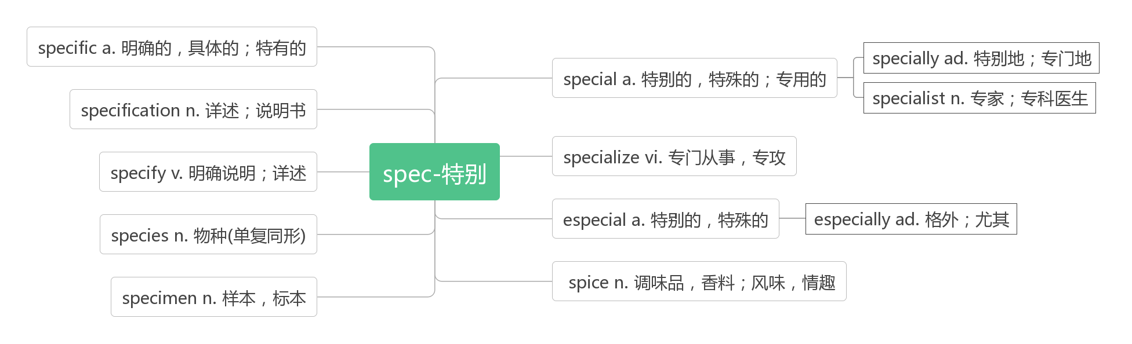

1. **shark [ʃɑːk]n. 鲨鱼;骗子vt.&vi. 诈骗, 敲诈**
2. **fin [fin] n.鱼鳍**
3. **on earth 在世界上;（放在疑问词之后表示强调）究竟;到底**

Her journey to becoming the fastest woman on earth has been anything but smooth and effortless.(2016江苏)

她成为世界上跑得最快的女人的旅程绝非一帆风顺。

How on earth was he going to get the rest of the money?(2009北京) 他究竟怎样才能搞到其余的钱呢?

He now began to inkle what was going on. 他现在开始有点明白究竟在发生什么事了。

1. **die out灭亡;灭绝;彻底消失**

|  |  |
| --- | --- |
| die out | 灭绝,灭亡,彻底消失：强调最终彻底消失的结果。（风住尘香花已尽） |
| die down | 减弱,渐渐消失：由强到弱逐渐减弱而消亡,如风,火等。（思君如满月,夜夜减清辉） |
| die away | 减弱,消失：由近及远逐渐远去而消失。（笑渐不闻声渐消,多情却被无情恼） |
| die off | 相继死去,一一凋零。（无边落木萧萧下） |

In fact, half of the 6 0007 000 languages spoken around the world today will likely die out by the next century, according to the UNESCO. (2014全国I) 事实上,根据联合国教科文组织的统计,目前世界上使用的60007000种语言中,有一半可能在下个世纪就会消失。

The wind has died down a little since last night. 自昨晚起风势就开始平息了。

The noise of the car died away and disappeared.汽车的声音渐渐远去,最终消失了。

After a couple of months, the new cells start acting like the older cells, although they do not die off.

几个月后,新的细胞开始表现得和旧的细胞一样,虽然这些细胞没有并死亡。

1. **alarm [ə'lɑːm]n. 闹钟;警报;警铃vt. 警告;使警觉**

**破拆法：al(all)+arm(武装)：敌人来临,所有人都武装起来——警报,警告**

If a smoke detector sets off an alarm and there is no fire or smoke, inform your hall staff.(2018天津)

如果烟雾探测器触发了警报,而没有火灾或烟雾,请通知您的大厅工作人员。

Set your alarm clock an hour early and push yourself to work out!(2018全国II)

把你的闹钟设为提前一个小时,强迫自己去锻炼!

The floors of all campus buildings are equipped with manual(手动的) fire alarm systems which include fire alarm pull stations and pipes.(2018天津) 所有校园建筑的楼层都配备了手动火灾报警系统,包括火灾报警拉站和管道。

**alarming[ə'lɑːmɪŋ] adj. 令人担忧的;使人惊恐的**

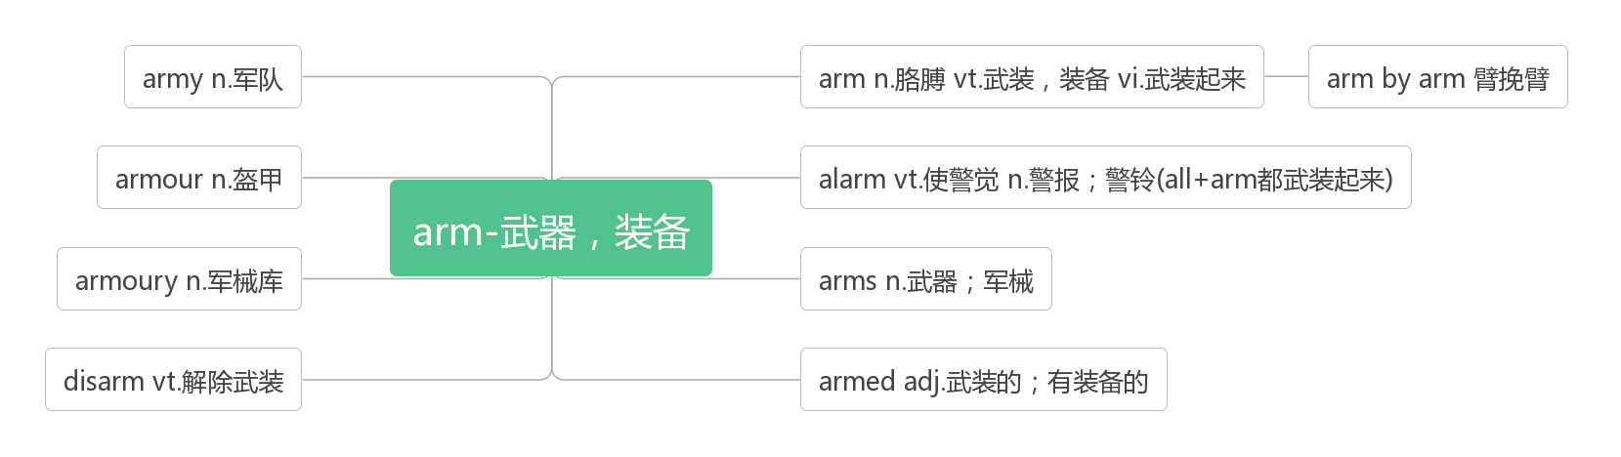

1. **rate[reit]n.速度;比率vt.划分等级**

The steam-powered printing press was still in its early stages; the literacy(识字) rate in England was under 50%.(2018浙江)

蒸汽印刷机仍处于早期阶段;英国的识字率不到50%。

But while increasing health was a typical feature of the 20th century, declining birth rate could be a defining one of the 21st.(2017江苏) 虽然健康状况的改善是20世纪的一个典型特征,但出生率的下降可能成为21世纪的一个标志性特征。

Declining birth rate is a major problem in many developing regions too, which might cause catastrophic global shortages of work force within a few decades.(2017江苏) 出生率下降也是许多发展中地区的一个主要问题,这可能在几十年内造成全球劳动力的灾难性短缺。

**rating ['reiting]n.等级;级别**

It is a ship with a rating of 500, 000 tons. 这是一艘五十万吨级的船。

1. **extinct [ɪk'stɪŋkt]vt. 使熄灭;使灭绝adj. 灭绝的,绝种的;熄灭的**

**词根词缀：ex(外)+stin(stand站)+ct：站到历史舞台的外面——灭绝的**

American pikas or rock rabbits, a relative of rabbits and hares, might be the first of these species to go extinct due to climate change.(2012浙江) 美洲鼠兔,是兔子和野兔的近亲,可能是这些物种中第一个因气候变化而灭绝的物种。

Several populations, such as the Columbia Basin pygmy(侏儒), almost went extinct and were saved by zoo breeding programs. (2012浙江)一些种群,如哥伦比亚盆地侏儒兔,几乎灭绝,并被动物园的繁殖计划所拯救。

**extinction [ɪk'stɪŋkʃən] n. 消失;灭绝;废止**

Already well over 400 of the total of, 6,800 languages are close to extinction, with only a few elderly speakers left.(2018全国I)

在总共6800种语言中,已经有400多种濒临灭绝,只剩下一些会说这些语言的老年人。

1. **mass [mæs]n. 团块;民众;大量;质量adj. 群众的,民众的;大规模的**

In addition, most newspapers had little in them that would appeal to a mass audience.(2019全国III)

此外,大多数报纸几乎没有吸引大众读者的内容。

14 hours later the films had lost 13% of their mass — apparently broken down by enzymes (酶) from the worms’ stomachs.(2018北京) 14个小时后,这些薄膜的质量减少了13%——显然是被蠕虫胃里的酶分解了。

Recent development has made possible machines that print, cook, and serve foods on a mass scale.(2018天津)

最近的发展使大规模印刷、烹调和提供食物的机器成为可能。

**a mass of/masses of 许多的,大量的**

Using his skis, Nicholas built a snow cave. He gathered a huge mass of snow and dug out a hole in the middle.(2015北京)

尼古拉斯用他的滑雪板建了一个雪洞。他收集了一大堆雪,在中间挖了一个洞。

Some people may think that a garden is no more than plants, flowers, patterns and masses of colors.(2016全国II)

有些人可能认为花园只不过是植物、花朵、图案和大量的颜色。

1. **habitat ['hæbɪtæt]n. 栖息地**

The National Wildlife Federation reports that they might not be able to stand the new temperatures as their habitat heats up.(2012浙江) 国家野生动物联合会报告说,随着栖息地温度升高,它们可能无法忍受新的温度。

One day he met Professor Mattoni, who was working to rebuild the habitat(栖息地) for an endangered butterfly called El Segundo blue.(2007浙江) 有一天,他遇到了Mattoni教授,当时Mattoni教授正在为一种叫做El Segundo blue的濒危蝴蝶重建栖息地。

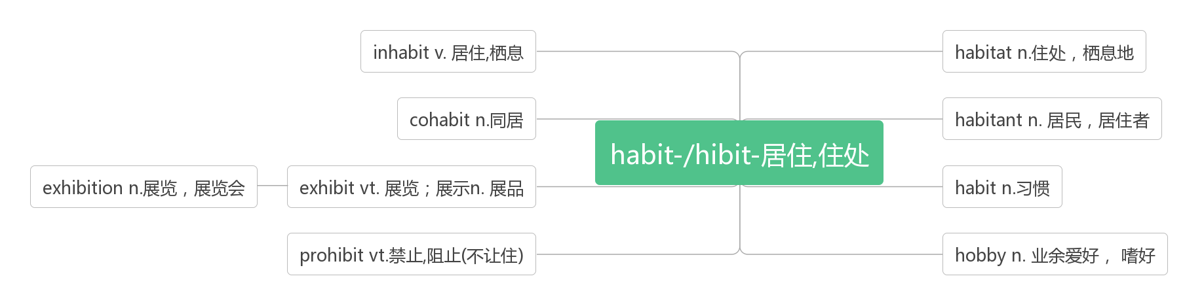

1. **aware [ə'weə] adj. 意识到的;知道的**

**aware of 知道,意识到**

Everybody can buy takeaway food, but sometimes we’re not aware how cheaply we can make this food ourselves.(2018全国I) 每个人都可以买外卖食品,但有时我们并没有意识到自己做这些食品有多便宜。

Emerald Valley is only one community that is becoming aware of the negative effects of light pollution.2013天津)

翡翠谷只是意识到光污染的负面影响的社区之一。

By the time they started secondary school—at age 11—children were already far more aware of their image online and felt under huge pressure to ensure their posts were popular.(2018江苏) 到他们11岁开始上中学的时候,孩子们已经对自己在网上的形象有了更多的认识,并感到了确保自己的帖子受欢迎的巨大压力。

1. **endanger [ɪn'deɪn(d)ʒə] vt. 危及;使遭到危险**

 It is illegal and could endanger other people's lives. 这是非法的,可能会危及他人的生命。

You will endanger your health if you smoke. 你如果吸烟,就会危及健康.

**endangered [ɪn'deɪndʒəd] adj. 濒临灭绝的;有生命危险的**

Chris and Tim work at a zoo, helping endangered cranes with their reproduction.(2019江苏)

克里斯和蒂姆在动物园工作,帮助濒危的鹤进行繁殖。

Thanks to digital technology and the widely available Internet, Turin notes, the endangered languages can be saved and reconnected with speech communities.(2014全国I)

图灵指出,由于数字技术和广泛使用的互联网,濒危语言可以得到拯救,并与语言社区重新建立联系。

1. **average ['æv(ə)rɪdʒ]n. 平均;平均数adj. 平均的;普通的**

**破拆法：aver(every每个)+age(名词后缀)：每个人都一样的——平均的**

In 1900, people died at the average age of 30. By 2000 the average age was 65.(2017江苏)

1900年,人们的平均寿命为30岁。到2000年,平均死亡年龄为65岁。

The average number of electronic devices rose from four per household in 1992 to 13 in 2007.(2018全国I)

电子设备的平均数量从1992年的每户4台上升到2007年的13台。

Mammals(哺乳动物)weighing sixty kilograms have an average brain size of 200 cm2. (2019江苏)

体重60公斤的哺乳动物平均大脑面积为200平方厘米。

**on average 平均**

We offer an excellent education to our students.On average, we expect students to work hard.(2017天津)

我们为学生提供良好的教育。一般来说,我们希望学生努力学习。

1. **prince [prɪns]n. 王子,王孙;亲王**

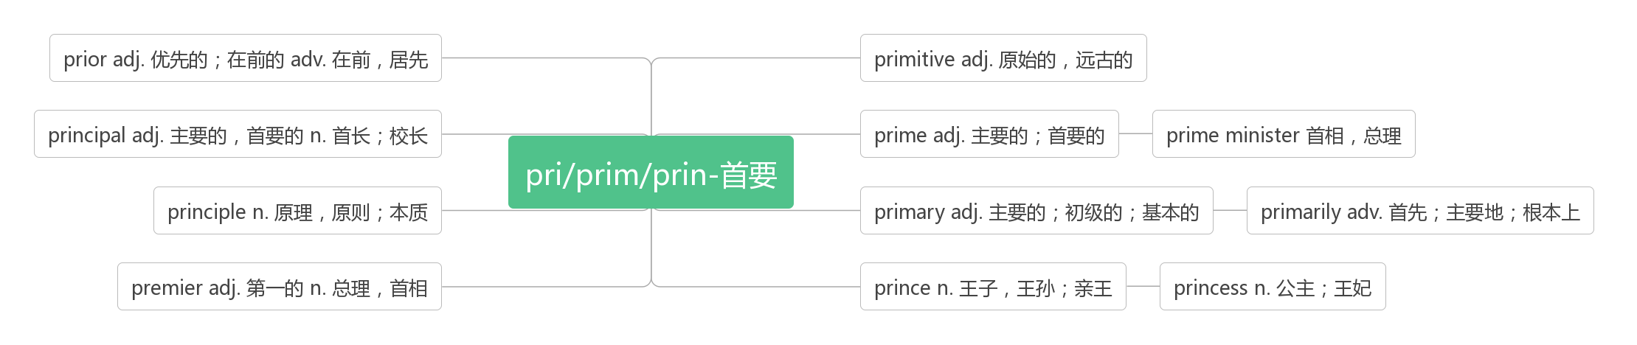

1. **progress ['prəʊgres]vi.&n. 进步,发展;前进**

As a result, in the last twenty years or so, many people have come to believe that whatever change is happening today is the result of great technological progress.(2019江苏)

因此,在过去的二十年左右,许多人开始相信,无论今天发生什么变化,都是伟大的技术进步的结果。

My progress in reading raised my curiosity, and I wanted to know everything.(2019天津)

我在阅读方面的进步引起了我的好奇心,我想了解一切。

There is no absolute success in the world, only constant progress.(Jonathan Swift)

世界上的事没有绝对成功,只有不断的进步。

**make progress 取得进步,取得进展**

How often do you have something you want to achieve (e.g. lose weight, start a business, travel more)—only to end up confused by all of the options in front of you and never make progress?(2014全国I) 你是否经常有一些你想要完成的事情(比如减肥、创业、多旅行),结果却被摆在你面前的选择搞得晕头转向,永远无法取得进展?

If you’re walking down the right path and you’re willing to keep walking, eventually you’ll make progress.

如果你走的道路正确,并坚持走下去,最终你会成功的。

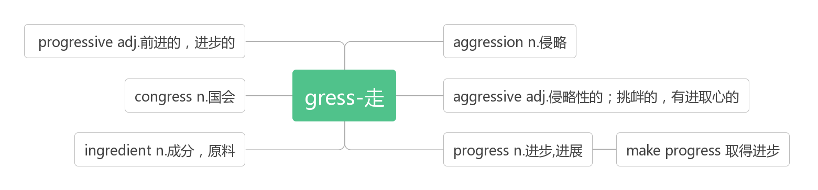

1. **concern [kən'sɜ:n]vt. 涉及,关系到;使担心n. 担忧;关心;关心的事**

As for driverless cars, what is the author’s major concern?(2018北京)

关于无人驾驶汽车,作者最关心的是什么?

If we could show concern to others on need, the world would be a better place to live in.(2014浙江)

如果我们能关心他人的需求,世界将成为一个更美好的家园。

I voiced my biggest concern to my mother. "How will I make friends?"(2019北京)

我向母亲表达了我最大的担忧。"我怎么交朋友?"

The large color decisions in your rooms concern the walls, ceilings, and floors.(2018全国I)

你房间里的主要颜色选择与墙壁、天花板和地板有关。

**be concerned about/for/with 关心,担忧,在意**

He felt concerned about his illness.(2019江苏)他担心他的病。

It can be concluded that restaurant keepers need not "be overly concerned about ‘bad' tables," given that they're profitable.(2018江苏) 我们可以得出这样的结论:考虑到餐馆是盈利的,餐馆老板们不必"过分担心‘差’桌"

However, those in the 10 to 12 age group were "concerned with how many people like their posts"(2018江苏)

然而,那些10到12岁的人"关心的是有多少人喜欢他们的帖子"。

They follow the rules, help out, and are concerned about the people they work with.(2013江苏)

他们遵守规则,帮助他人,关心同事。

To be happy, we cannot be too concerned with others. 要幸福快乐的话,我们就不要太在意别人的意见。

**as far as...be concerned 就……而言**

As far as we're concerned, there are basically no hard and fast rules about public speaking.(2013全国II)

就我们所知,关于公开演讲基本上没有硬性规定。

Because our bodies adapt to everything we do to them ,And as far as your body is concerned, it’s "use it, or lose it"!(2013浙江) 因为我们的身体适应我们对它们所做的一切,而就你的身体而言,"要么使用它,要么失去它！"

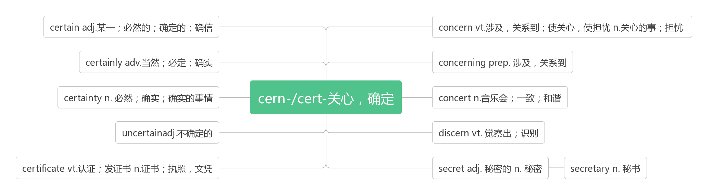

1. **living ['lɪvɪŋ]adj. 活的;现存的;n. 生活;生存;生计**

|  |  |
| --- | --- |
| living | 意为"健在的",为live的现在分词,强调存在在世界上,可用来指人或物,作[定语](http://www.so.com/s?q=%E5%AE%9A%E8%AF%AD&ie=utf-8&src=internal_wenda_recommend_textn" \t "https://wenda.so.com/q/_blank)或表语。 |
| alive | 意为"活的",表示活着的状态,侧重说明没死,既可指人,也可[指物](http://www.so.com/s?q=%E6%8C%87%E7%89%A9&ie=utf-8&src=internal_wenda_recommend_textn" \t "https://wenda.so.com/q/_blank);可作[表语](http://www.so.com/s?q=%E8%A1%A8%E8%AF%AD&ie=utf-8&src=internal_wenda_recommend_textn" \t "https://wenda.so.com/q/_blank),[后置定语](http://www.so.com/s?q=%E5%90%8E%E7%BD%AE%E5%AE%9A%E8%AF%AD&ie=utf-8&src=internal_wenda_recommend_textn" \t "https://wenda.so.com/q/_blank)或宾补。 |
| live  [laɪv] | live 意为"活着的"时,通常指物,不指人,常用来作定语放名词的前面。还指"实况转播的"。 例如:a live wire 有电的电线,a live fish 一条活鱼,a live broadcast 现场直播 |
| lively | 意为"活泼的","活跃","充满生气的",可作定语、表语或宾补,既可指人,又可指物。 |

Young children are usually lively.  小孩子们通常是活泼的。

He told a very lively story.  他讲了一个生动的故事。

No man alive is greater than he. 在活着的人中[没有人](http://www.so.com/s?q=%E6%B2%A1%E6%9C%89%E4%BA%BA&ie=utf-8&src=internal_wenda_recommend_textn" \t "https://wenda.so.com/q/_blank)比他更伟大的了。

He was still alive when I reached the hospital. 当我赶到医院时他还活着。

My first teacher is still living/alive . 我的启蒙老师仍健在。   
English is a living/live language . 英语是活的语言。

He bought some live fish. 他买了几条活鱼。

Only a few live trees were left after the fire. 火灾之后只剩下几棵树还活着。

It costs money to go to a football match, why not to watch a live broadcast?

去看足球赛可是要花钱的,为啥不看实况转播？

**make a living谋生**

Many people who live along the coast make a living on fishing industry.(2017北京卷) 许多住在海边的人以捕鱼为生。

Artists make a living through their creative work.(2018江苏卷) 艺术家通过他们的创造性工作谋生。

1. **adapt [ə'dæpt]vt. 使适应;改编vi. 适应**

Ideally, the system would tell us when to adapt human activities that are pushing an ecosystem toward a breakdown or would even allow us to pull an ecosystem back from the borderline. (2019天津) 理想情况下,该系统将告诉我们该何时调整正在将生态系统推向崩溃的人类活动,甚至允许我们将生态系统从崩溃边缘拉回来。

After all, if we adapt in that way, we may avoid the need to change in so many others.(2017江苏)

毕竟,如果我们以这种方式适应,我们可能会避免改变许多其他方面的需要

As with any film that is adapted from a novel, the movie often does not do the book justice.

与任何改编自小说的电影一样,这部电影通常也不符合原著。

**adapt to适应**

Human beings will continue to adapt to the changing climate in both ordinary and astonishing ways.(2017江苏)

人类将继续以一般或惊人的方式适应气候变化。

Because our bodies adapt to everything we do to them. And as far as your body is concerned, it’s "use it. or lose it"!(2013浙江) 因为我们的身体会适应我们对它们所做的一切。就你的身体而言,它就是"利用它,或失去它"!

**adaptation [ædəp'teɪʃ(ə)n] n. 适应;改编;改编本**

But the most sensible form of adaptation is surely to adapt our energy systems to emit less carbon pollution.(2017江苏)

但最明智的适应方式无疑是调整我们的能源系统,以减少碳污染的排放。

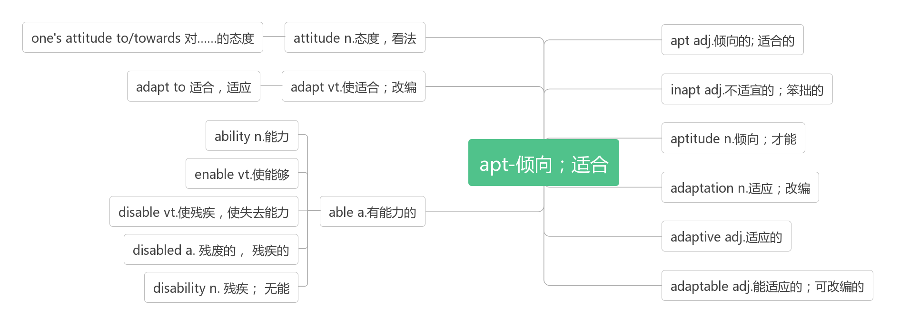**22. measure ['meʒə]n. 测量;措施;程度;尺寸vt. 测量;权衡vi. 尺寸达到**

**词源：与meter同源,me=>mea, s=>t(字母顺位迁移),er=>ure(同音同意)：meter即测量的尺度。**

In some cases, releasing fish is a good measure that will help keep fish variety and build their population size.(2008全国I) 在某些情况下,放生鱼类是一个很好的措施,这将有助于保持鱼类的多样性,并扩大其种群规模。

No matter how harsh the present or unpredictable the future, there's almost always some measure of joy to be extracted from the moment.(2015浙江) 无论现在有多艰难,未来有多不可预测,我们总能从当下获得一些快乐。

It found many youngsters(少年）now measure their status by how much public approval they get online, often through "like".(2018江苏) 调查发现,许多年轻人现在用他们在网上得到多少公众认可来衡量自己的地位,通常是通过"点赞"。

This is a well－specified action－based goal for which you can measure your success easily.(2014北京)

这是一个明确的基于行动的目标,你可以很容易地衡量你的成功。

It is so wet there that the trees are extremely tall, some measuring over 90 meters.

那里非常潮湿,所以树特别高,有些高达90多米。

**take measures to do sth.采取措施做某事**

We are ready to help all African countries take measures to reduce the risks of H5N1.

我们准备帮助所有的非洲国家采取措施降低H5N1型病毒的风险。

1. **pressure ['preʃə]n. 压力;压迫,压强**

It turns out that just looking at green,growing things can reduce stress,lower blood pressure,and put people into a better mood(情绪).(2019全国I)事实证明,仅仅看看绿色的生物,可以减少压力,降低血压,让人心情更好。

This smart keyboard precisely measures the cadence(节奏)with which one types and the pressure fingers apply to each key.(2019全国I) 这款智能键盘可以精确地测量你打字的节奏,以及手指按压每个按键的力度。

But what starts as fun usage of apps turns into tremendous pressure in real social media interaction at secondary school.(2018江苏卷) 但一开始只是好玩的应用,到了中学就变成了真正的社交媒体互动的巨大压力。

**under pressure在压力下;承受压力**

When [I](https://cn.bing.com/dict/search?q=I&FORM=BDVSP6&mkt=zh-cn) [feel](https://cn.bing.com/dict/search?q=feel&FORM=BDVSP6&mkt=zh-cn) under [pressure](https://cn.bing.com/dict/search?q=pressure&FORM=BDVSP6&mkt=zh-cn) [and](https://cn.bing.com/dict/search?q=and&FORM=BDVSP6&mkt=zh-cn) [wish](https://cn.bing.com/dict/search?q=wish&FORM=BDVSP6&mkt=zh-cn) to get [away](https://cn.bing.com/dict/search?q=away&FORM=BDVSP6&mkt=zh-cn) from it [all](https://cn.bing.com/dict/search?q=all&FORM=BDVSP6&mkt=zh-cn)[,](https://cn.bing.com/dict/search?q=,&FORM=BDVSP6&mkt=zh-cn) [I](https://cn.bing.com/dict/search?q=I&FORM=BDVSP6&mkt=zh-cn) simply [pick](https://cn.bing.com/dict/search?q=pick&FORM=BDVSP6&mkt=zh-cn) [up](https://cn.bing.com/dict/search?q=up&FORM=BDVSP6&mkt=zh-cn) [one](https://cn.bing.com/dict/search?q=one&FORM=BDVSP6&mkt=zh-cn)[of](https://cn.bing.com/dict/search?q=of&FORM=BDVSP6&mkt=zh-cn) these [novels](https://cn.bing.com/dict/search?q=novels&FORM=BDVSP6&mkt=zh-cn)[.](https://cn.bing.com/dict/search?q=.&FORM=BDVSP6&mkt=zh-cn)

当我感到压力,并希望摆脱这一切时,我会拿起其中一本小说。

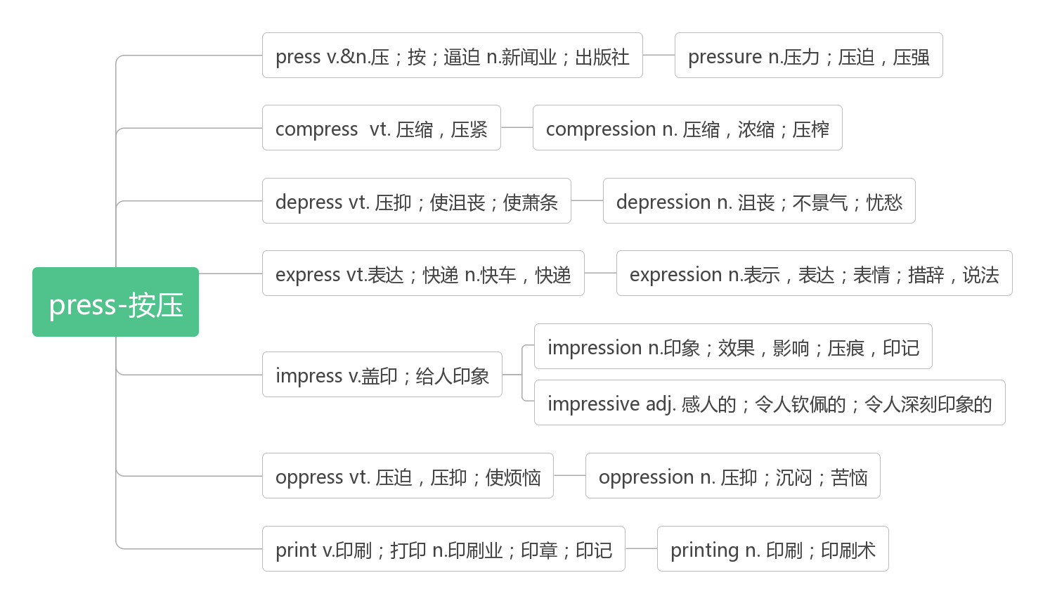

1. **whale [weɪl]n.鲸鱼**

**破拆法：w(我)+h(喝)+al(all一切)+e：鲸吞 助记：作为地球上最大的动物,我可以喝下一切。**

1. **antelope ['æntɪləʊp]n. 羚羊**

**破拆法：ante(前)+lope(slope斜坡)：斜坡前面 助记：羚羊通常生活在斜坡前面的高原上。**

Tibetan antelope 藏羚羊

1. **reserve [rɪ'zɜːv] n.（动植物）保护区;储藏（量）vt.预订;预留;保留**

Reserve your spot before availability — the cherry blossoms—disappear!(2018全国I)

在有效期之前预定您的位置——樱花可是会谢的！

If you order after that, we reserve the right to either accept or reject order requests at the discounted price.(2013北京)

如果您在此之后订购,我们保留以折扣价格接受或拒绝订单请求的权利

I seek friends whose qualities illuminate（照亮）me and train me up for love. It is for these people that I reserve the glowing hours, too good not to share.(2008北京)

我寻找那些能够照亮我的人生,使我学会爱的朋友。正是为这些人,我保留着我美妙的,不愿与外人分享的时刻。

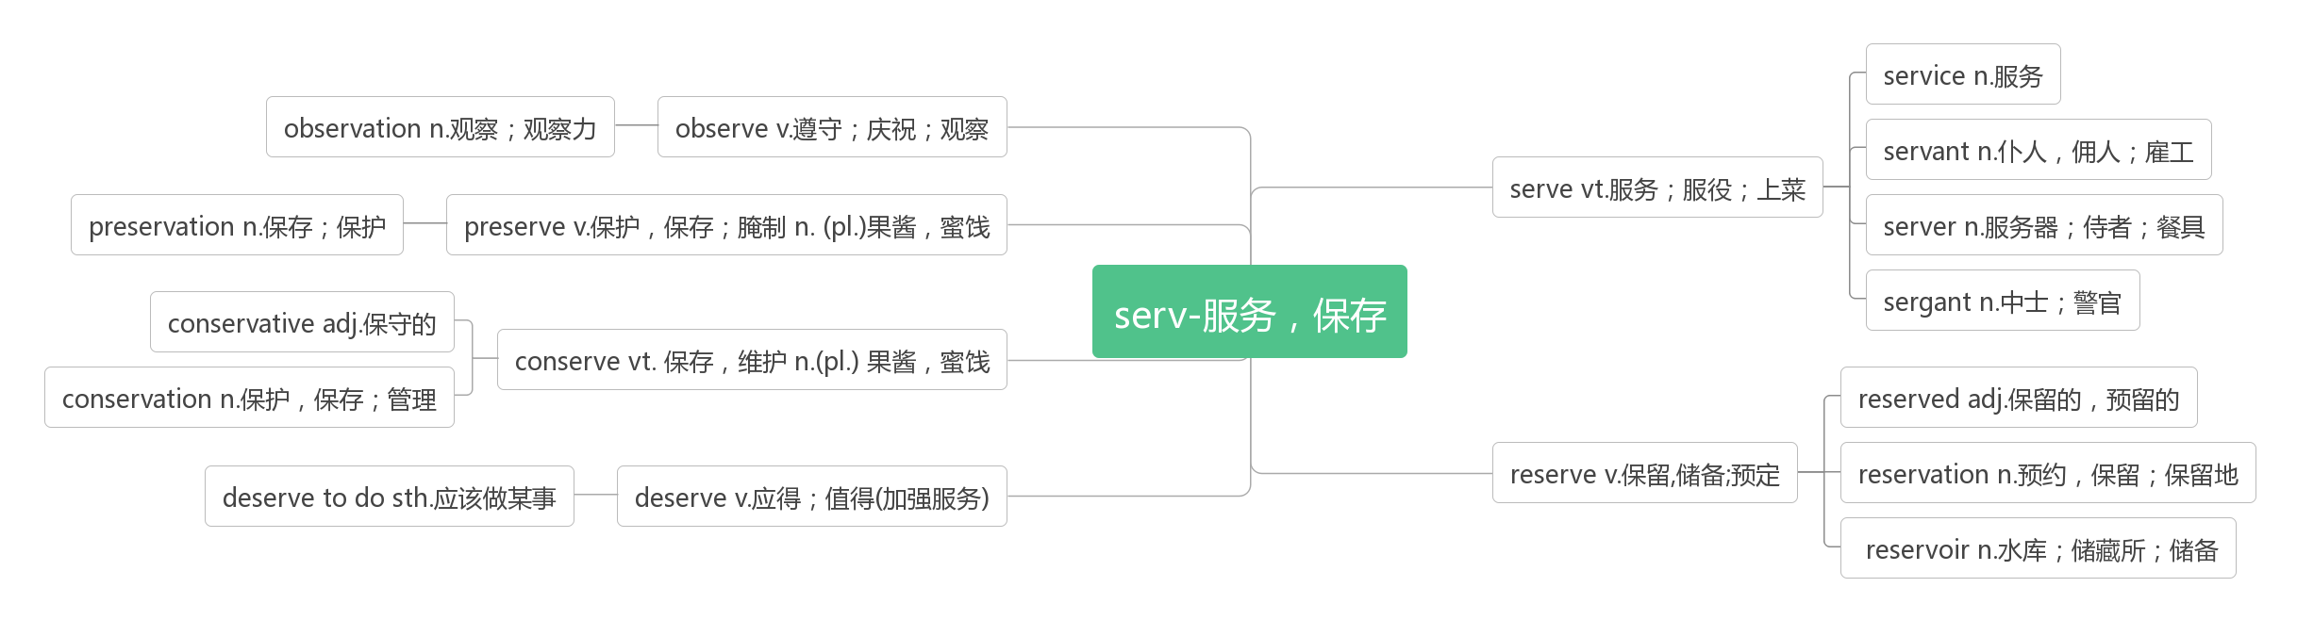

1. **plain [pleɪn]adj. 平的;简单的;朴素的n. 平原**

He wore a plain blue shirt, open at the collar. 他穿一件朴素的蓝色衬衫,领口敞着。

A plain style was commended. 提倡朴素的风格。

He advocates plain living. 他提倡过简朴的生活。

For that which you love most in him may be clearer in his absence, as the mountain to the climber is clearer from the plain.

因为当他不在身边时,他身上最为你所珍爱的东西会显得更加醒目,就像山峰对于平原上的登山者显得格外清晰。

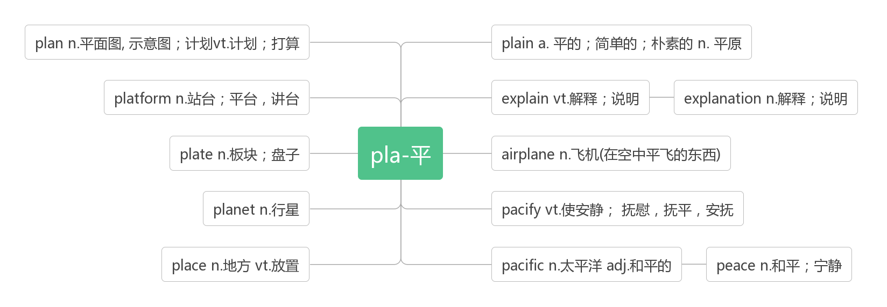

1. **make out看清;听清;弄明白**

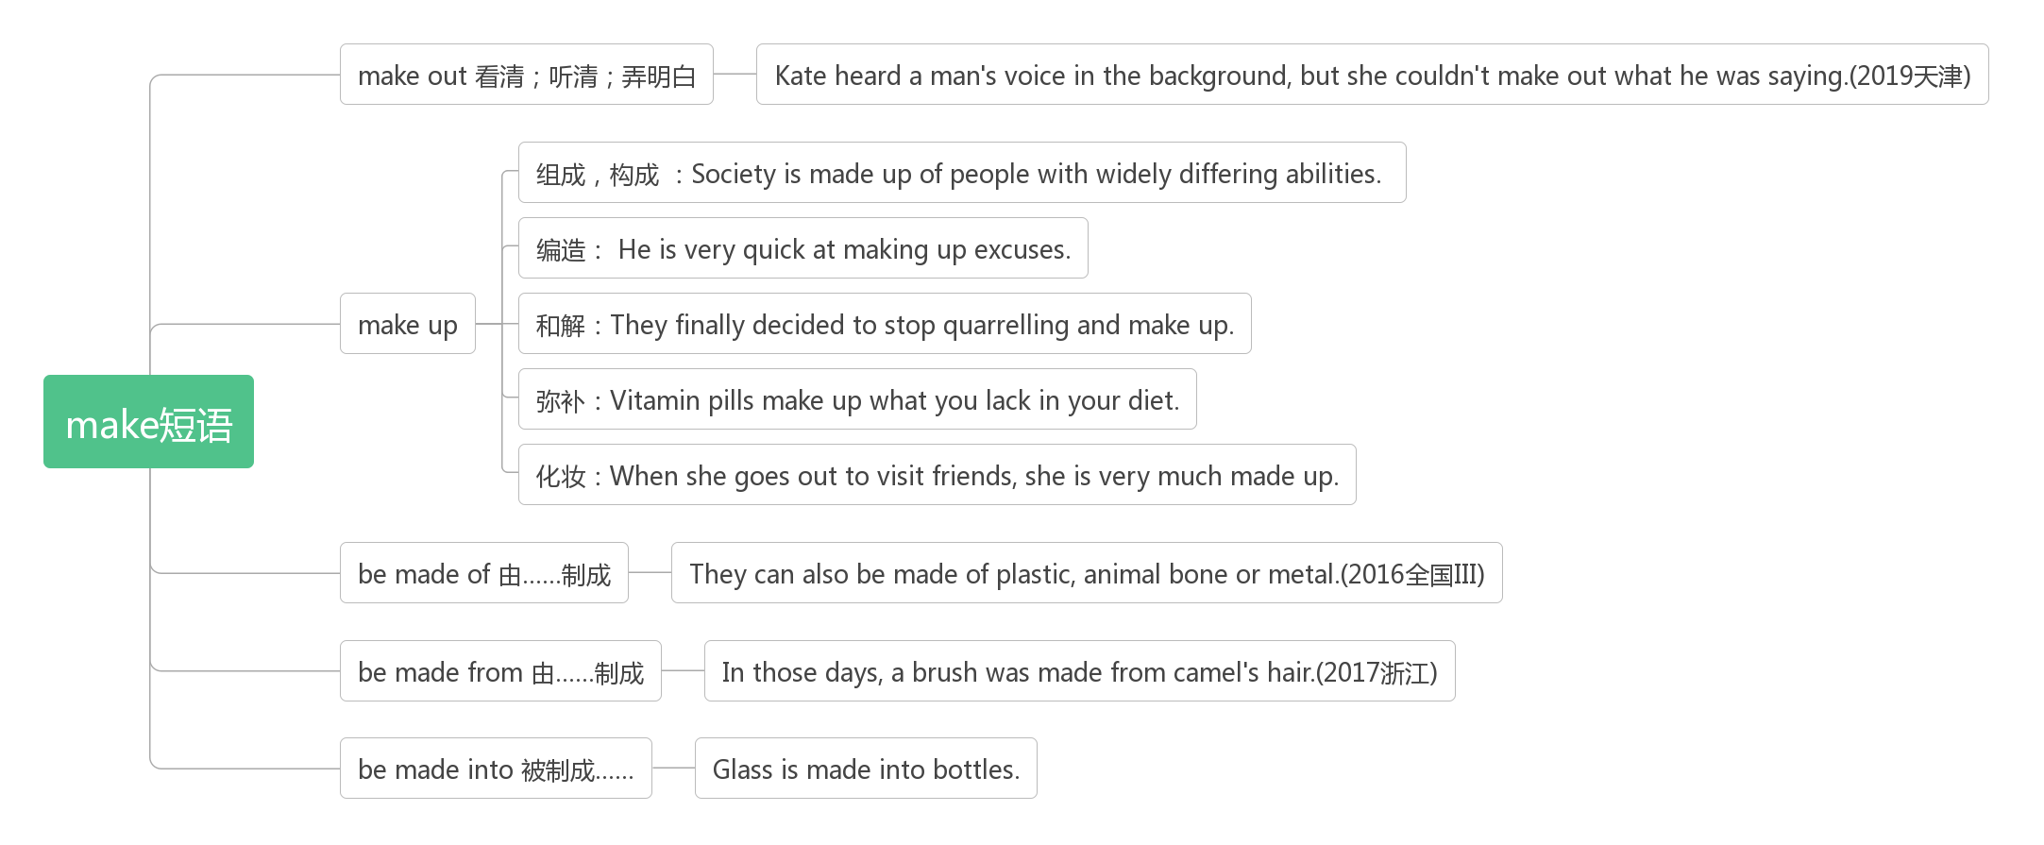

1. **herd [hɜːd]n. 兽群,牧群;放牧人**

**破拆法：her+d:她的 助记：整个牧群都是她的**

But herd immunity works only when nearly the whole herd joins in. (2017北京)

但是群体免疫只有在几乎整个群体都加入的情况下才有效。

A herd of elephants dragged across the plains towards a watering hole.

一群大象缓慢而笨拙地穿过平原,朝水潭走去。

1. **observe [əb'zɜːv] vt. 观察;遵守;庆祝;评论**

Observe carefully if any change occurs when doing experiments in the lab.(2014北京)

在实验室做实验时,仔细观察是否有变化。

Always observe district fire bans.(2015江苏) 要一直遵守地区防火规定。

When driving, minimize noise and observe no smoking signs.(2015江苏)

开车时,尽量减少噪音,遵守禁止吸烟的标志。

We can observe that artificial intelligence has already made an impact on our lives in many ways.(2019天津)

我们可以看到,人工智能已经在很多方面对我们的生活产生了影响。

Scientists and babies seem to observe the world differently.(2016浙江) 科学家和婴儿似乎以不同的方式观察世界。

To observe the past is to take warning for the future. 观察过去就是对未来的警告。



1. **beauty ['bju:ti] n.美;美人;美好的东西**

Chinese models are the faces of beauty and fashion campaigns that sell dreams to women all over the world, which means Chinese women are not just consumers of fashion — they are central to its movement.(2019全国III)

中国模特是美容和时尚活动的代言人,她们向世界各地的女性推销梦想,这意味着中国女性不仅是时尚的消费者——她们是时尚运动的核心。

he ideals which have lighted my way, and time after time have given me new courage to face life cheerfully have been kindness, beauty and truth.(Albert Einstein)

有些理想曾为我们引过道路,并不断给我新的勇气以欣然面对人生,那些理想就是——真、善、美。

Real beauty comes from learning, growing, and loving in the ways of life. That is the Art of Life.

真正的美丽源于生命里的学习、成长和热爱。这就是生命的艺术。

Beauty without virtue is a rose without fragrance. 无德之美犹如没有香味的玫瑰,徒有其表。

**beautiful [ˈbjuːtɪf(ə)l] a. 美的,美丽的**

If the evening sun is still beautiful, why should I become sad for its being setting. 但得夕阳无限好,何须惆怅近黄昏。

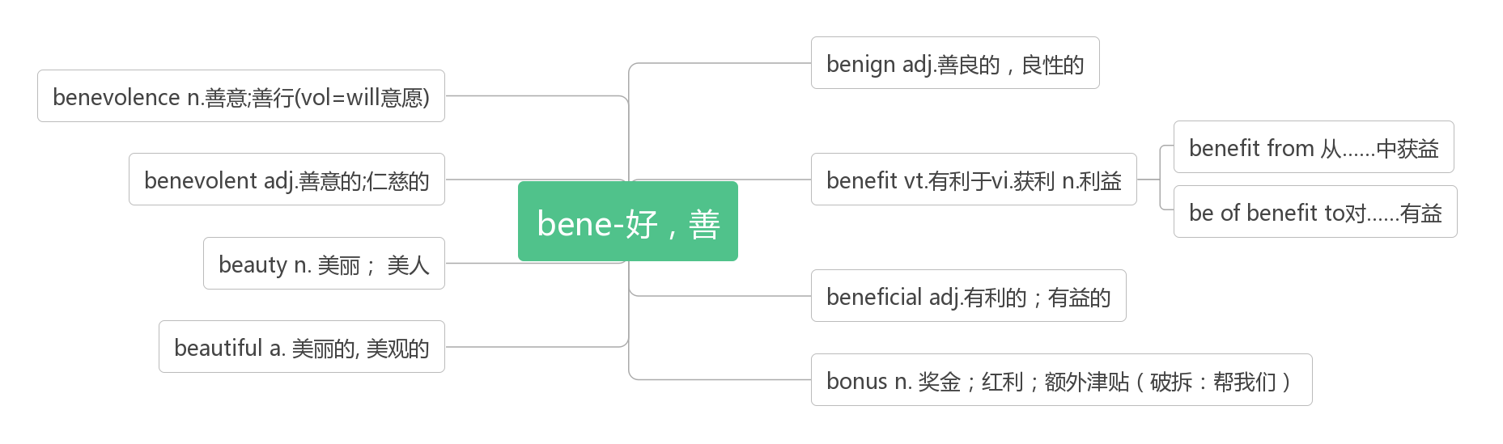

1. **remind [ri'maind] vt.提醒;使想起**

Perhaps we all live in each others' spaces. Perhaps this is what photos are for: to remind us that we all appreciate beauty, that we all share a common desire for pleasure, for connection, for something that is greater than us.(2017天津)

也许我们都生活在彼此的空间里。也许这就是照片的作用：提醒我们所有人都欣赏美,我们有一个共同的渴望,那就是快乐,就是沟通,就是比我们本身更伟大的东西。

**remind sb of sb/sth 使某人想起**

Confucius believed knives would remind people of killings and be too violent for use at the table.(2016全国III)

孔子认为刀会让人联想到杀戮,太暴力而不能在餐桌上使用。

We continue to listen to and remind ourselves of words such as "Twinkle, twinkle, little star" and childhood tales such as Cinderella and Goldilocks.(2012全国II) 我们一直听到并想起诸如"一闪一闪亮晶晶"之类的词语,以及诸如灰姑娘和金发姑娘之类的儿童故事。

**remind sb. to do sth.提醒某人做某事**

Similar efforts have been made worldwide,and a movement is underway to remind us to turn off lights when we are not using them,so that other creatures can share the night.(2013天津) 全世界都在做着类似的努力,并且一项运动正在进行中,提醒我们在不使用电灯的时候关掉它们,这样其他生物就可以共享夜晚。

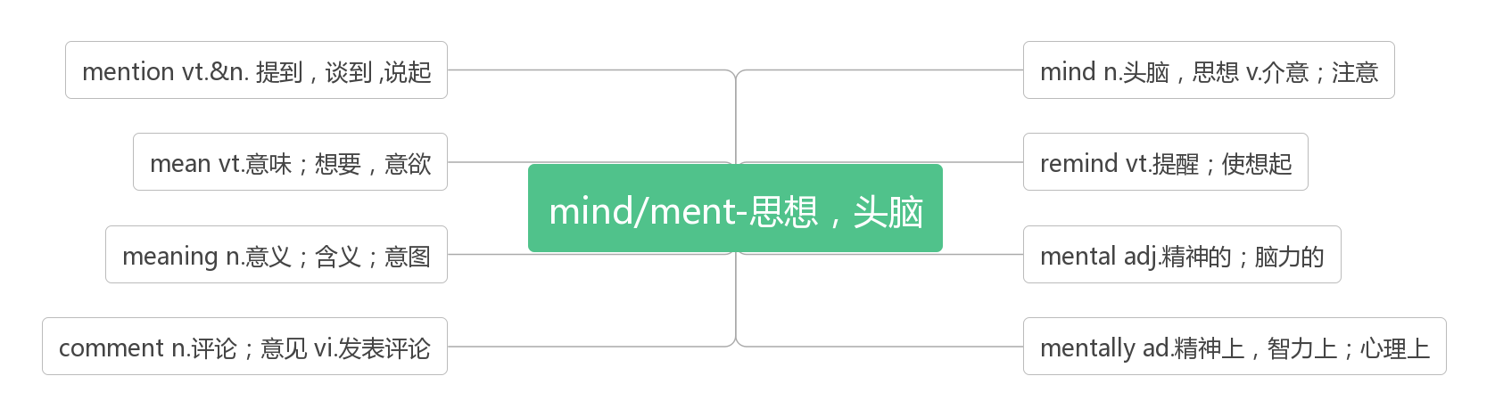

1. **fur [fɜː]n.毛皮;皮草**

破拆法：fu(富)+r(人)：富人 助记：富人才穿得起皮草

1. **sacred ['seikrid]adj.神圣的**

They believe their dance with each sacred moment of life is a gift and that storms are a natural part of life which can bring the rain needed for emotional and spiritual growth.(2012天津) 他们相信他们与生命中每一个神圣的时刻共舞是一份礼物,风暴是生命中自然的一部分,它能带来情感和精神成长所需的雨水。

The eagle is the animal most sacred to the Native Americans. 对印第安人来说,鹰是最神圣的动物。

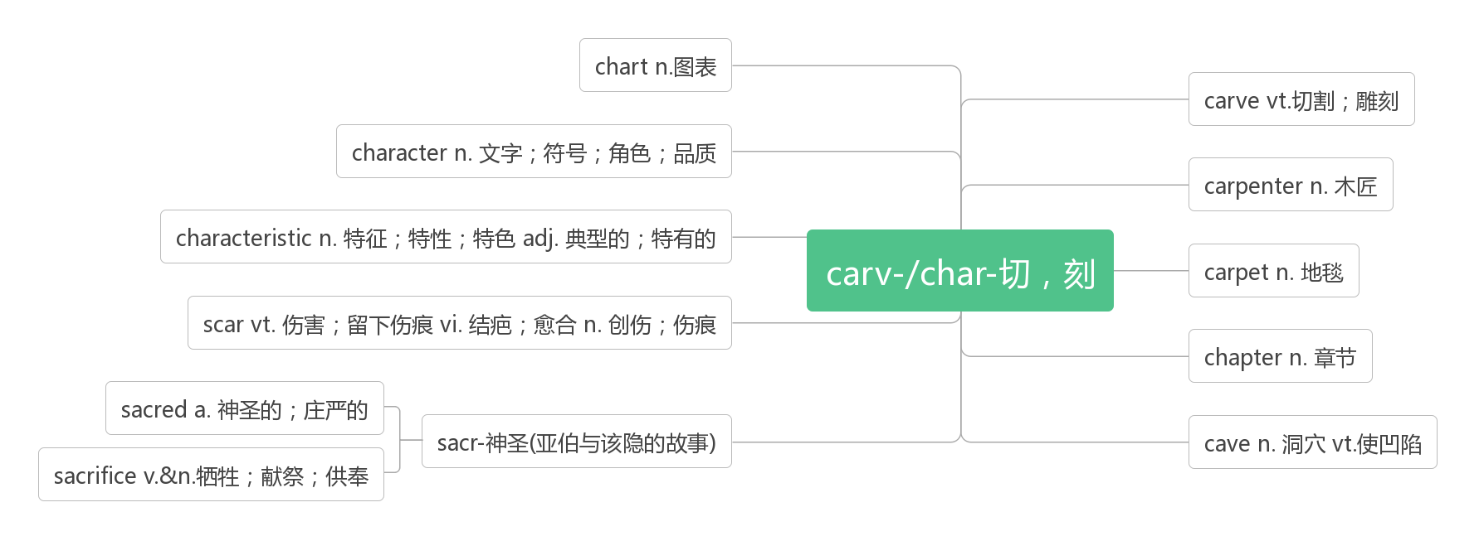

1. **shoot [fu:t] vt. & vi.射杀;射伤;投篮;拍摄(shot, shot)**

**音意相通：射他**

Several of Shelly－Ann's friends and family were caught up in the killings; one of her cousins was shot dead only a few streets away from where she lived.(2016江苏)

谢莉-安的几个朋友和家人被卷入了这场杀戮;她的一个表亲在离她家只有几条街的地方被枪杀。

In fact, they were shot from 1914 through 1916, most of them after a disastrous shipwreck(海难), by a cameraman who had no reasonable expectation of survival.(2016全国II) 事实上,他们是从1914年到1916年拍摄的,大部分是在一场灾难性的海难之后,由一个没有合理生存希望的摄影师拍摄的。

The last confirmed wild pigeon in the United States was shot by a boy in Pike County, Ohio, in 1900.(2014全国I)

美国最后一只确认的野鸽是1900年在俄亥俄州派克县被一名男孩射杀的。

**shot [ʃɒt] n.发射;投篮;拍摄;尝试**

If a basketball star is, for example, trying to gain a high personal point total, he may take a shot himself when it would be better to pass the ball to a teammate, affecting the team's performance.(2019北京) 例如,如果一个篮球明星想要获得很高的个人得分,当把球传给队友会更好时,他可能会自己投篮,从而影响球队的表现。

Give everything a shot. You never know what is going to change your life.

任何事情都应该去尝试一下,因为你无法知道什么样的事将会改变你的一生。

1. **profit ['prɒfɪt]n. 利润;利益vi. 获利;有益vt. 有益于**

**词根词缀：pro-(向前)+fit(做)：向前做的动力——利润,利益**

You can improve your chances of profit by sensible planning.你可以通过合理计划来提高盈利的机会。

But the profit from these sites is limited. 但是从这些网站得到的利润是有限的。

The outside world showed it would sacrifice principle for profit. 外界迹象显示它将会为利益而牺牲原则。

They have deliberately declined to recall faulty products endangering lives in pursuit of profit.

他们故意拒绝召回伪劣产品以追求利润。

**make a profit 盈利**

They are set to make a big fat profit. 他们下定决心要大赚一笔。

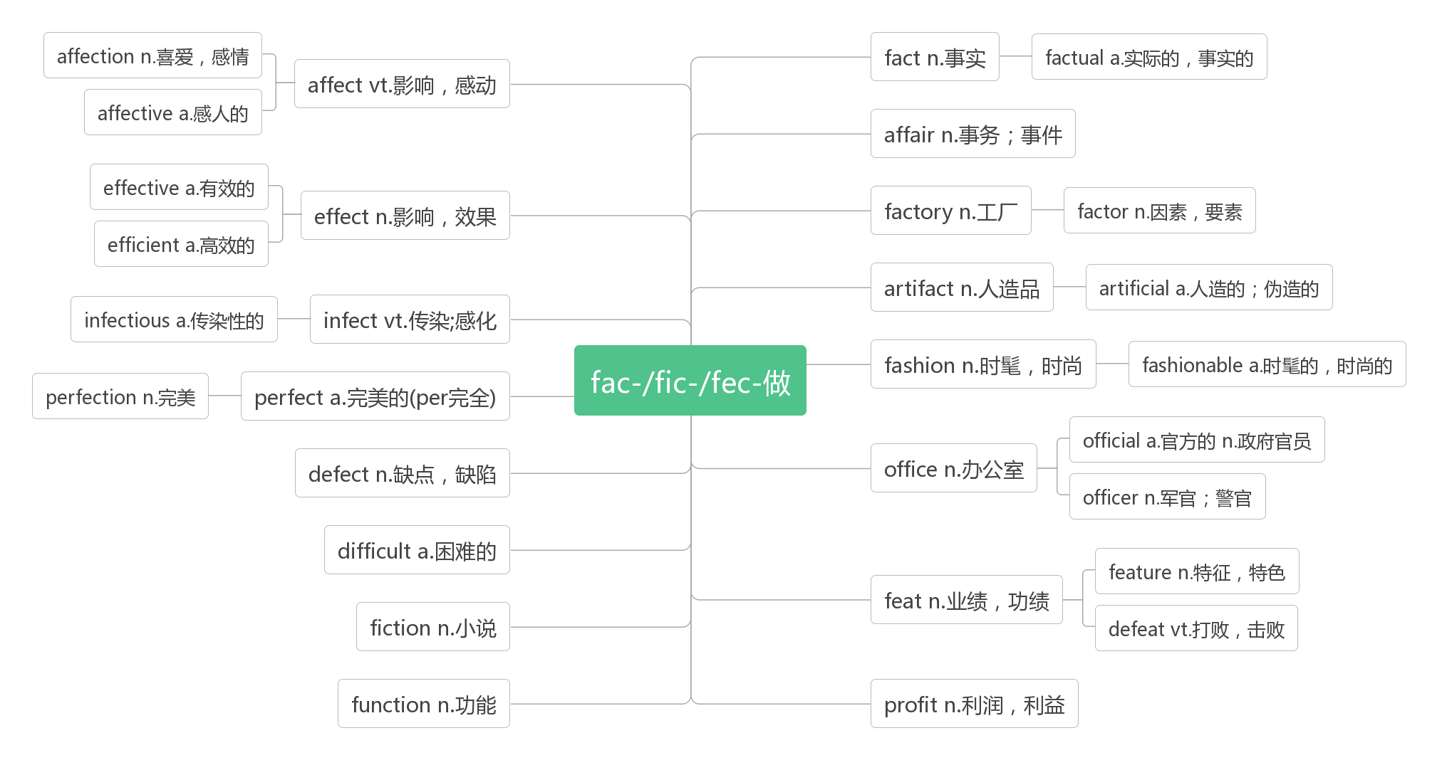

1. **watch [wɒtʃ]vt.&vi. 观看;注视;看守;警戒n. 手表;监视;守护**

Say you intend to watch a football match but the tickets are expensive and it will take you a couple of hours to get to and from the stadium.(2014江苏)假设你打算去看一场足球比赛,但是门票很贵,而且从体育场来回需要几个小时。

Men can either talk or watch the screen -- they can' t do both -- and they don' t understand that women can.(2009江苏)

男人可以说话,也可以看电视,但他们不能同时做这两件事。他们不明白女人可以做到。

Nature seems to unfold to people who watch and wait.(2018天津) 大自然似乎向那些观察和等待的人展现自己。

It is twenty to one by my watch, but it is a little fast.(2011全国I) 我的表是12点40,但它有点快。

One psychological effect of diet products is that people tend to watch their weight rather than their diet.(2008北京)

减肥产品的一个心理效应是,人们倾向于关注自己的体重,而不是饮食。

Good watch prevents misfortune. 谨慎消灾。

**watch over照管, 看守, 保护**

 They use specially trained dogs to watch over their sheep at night.  夜间他们用受过特殊驯练的狗看守羊群。

**watch out (for)当心,注意,警惕**

Watch out for sharp bends and adjust your speed accordingly. 当心急转弯并相应调整车速。

**watch for寻找,等待**

Carefully read the text and watch for words that can show main points and supporting facts.(2008全国II)

仔细阅读课文,寻找能表达要点和论据的词语。

**on watch 值班,守望**

Apart from two men on watch in the engine-room, everyone was asleep.

除了两个人在机房值班外,其他人都在睡觉。

1. **day and night日日夜夜;夜以继日**

The [soldiers](https://cn.bing.com/dict/search?q=soldiers&FORM=BDVSP6&mkt=zh-cn) [have](https://cn.bing.com/dict/search?q=have&FORM=BDVSP6&mkt=zh-cn) been struggling [against](https://cn.bing.com/dict/search?q=against&FORM=BDVSP6&mkt=zh-cn) the [flood](https://cn.bing.com/dict/search?q=flood&FORM=BDVSP6&mkt=zh-cn) [day](https://cn.bing.com/dict/search?q=day&FORM=BDVSP6&mkt=zh-cn) [and](https://cn.bing.com/dict/search?q=and&FORM=BDVSP6&mkt=zh-cn) [night](https://cn.bing.com/dict/search?q=night&FORM=BDVSP6&mkt=zh-cn) for [a](https://cn.bing.com/dict/search?q=a&FORM=BDVSP6&mkt=zh-cn) [week](https://cn.bing.com/dict/search?q=week&FORM=BDVSP6&mkt=zh-cn)[.](https://cn.bing.com/dict/search?q=.&FORM=BDVSP6&mkt=zh-cn)

[战士](https://cn.bing.com/dict/search?q=%E6%88%98%E5%A3%AB&FORM=BDVSP6&mkt=zh-cn)[们](https://cn.bing.com/dict/search?q=%E4%BB%AC&FORM=BDVSP6&mkt=zh-cn)夜以继日[地](https://cn.bing.com/dict/search?q=%E5%9C%B0&FORM=BDVSP6&mkt=zh-cn)[和](https://cn.bing.com/dict/search?q=%E5%92%8C&FORM=BDVSP6&mkt=zh-cn)[洪水](https://cn.bing.com/dict/search?q=%E6%B4%AA%E6%B0%B4&FORM=BDVSP6&mkt=zh-cn)[抗战](https://cn.bing.com/dict/search?q=%E6%8A%97%E6%88%98&FORM=BDVSP6&mkt=zh-cn)[已经](https://cn.bing.com/dict/search?q=%E5%B7%B2%E7%BB%8F&FORM=BDVSP6&mkt=zh-cn)[一个](https://cn.bing.com/dict/search?q=%E4%B8%80%E4%B8%AA&FORM=BDVSP6&mkt=zh-cn)[星期](https://cn.bing.com/dict/search?q=%E6%98%9F%E6%9C%9F&FORM=BDVSP6&mkt=zh-cn)[了](https://cn.bing.com/dict/search?q=%E4%BA%86&FORM=BDVSP6&mkt=zh-cn)[。](https://cn.bing.com/dict/search?q=%E3%80%82&FORM=BDVSP6&mkt=zh-cn)

**day in and day out 日复一日地** [Motivation](https://cn.bing.com/dict/search?q=Motivation&FORM=BDVSP6&mkt=zh-cn) [is](https://cn.bing.com/dict/search?q=is&FORM=BDVSP6&mkt=zh-cn) the [key](https://cn.bing.com/dict/search?q=key&FORM=BDVSP6&mkt=zh-cn)[,](https://cn.bing.com/dict/search?q=,&FORM=BDVSP6&mkt=zh-cn) [but](https://cn.bing.com/dict/search?q=but&FORM=BDVSP6&mkt=zh-cn) [it](https://cn.bing.com/dict/search?q=it&FORM=BDVSP6&mkt=zh-cn)'s [not](https://cn.bing.com/dict/search?q=not&FORM=BDVSP6&mkt=zh-cn) [always](https://cn.bing.com/dict/search?q=always&FORM=BDVSP6&mkt=zh-cn) [easy](https://cn.bing.com/dict/search?q=easy&FORM=BDVSP6&mkt=zh-cn)[,](https://cn.bing.com/dict/search?q=,&FORM=BDVSP6&mkt=zh-cn) [day](https://cn.bing.com/dict/search?q=day&FORM=BDVSP6&mkt=zh-cn) in and [day](https://cn.bing.com/dict/search?q=day&FORM=BDVSP6&mkt=zh-cn) out, [to](https://cn.bing.com/dict/search?q=to&FORM=BDVSP6&mkt=zh-cn) find that [motivation](https://cn.bing.com/dict/search?q=motivation&FORM=BDVSP6&mkt=zh-cn)[.](https://cn.bing.com/dict/search?q=.&FORM=BDVSP6&mkt=zh-cn)

[动机](https://cn.bing.com/dict/search?q=%E5%8A%A8%E6%9C%BA&FORM=BDVSP6&mkt=zh-cn)[是](https://cn.bing.com/dict/search?q=%E6%98%AF&FORM=BDVSP6&mkt=zh-cn)[关键](https://cn.bing.com/dict/search?q=%E5%85%B3%E9%94%AE&FORM=BDVSP6&mkt=zh-cn)[,](https://cn.bing.com/dict/search?q=%EF%BC%8C&FORM=BDVSP6&mkt=zh-cn)[但](https://cn.bing.com/dict/search?q=%E4%BD%86&FORM=BDVSP6&mkt=zh-cn)[要](https://cn.bing.com/dict/search?q=%E8%A6%81&FORM=BDVSP6&mkt=zh-cn)[每天](https://cn.bing.com/dict/search?q=%E6%AF%8F%E5%A4%A9&FORM=BDVSP6&mkt=zh-cn)[都](https://cn.bing.com/dict/search?q=%E9%83%BD&FORM=BDVSP6&mkt=zh-cn)[有](https://cn.bing.com/dict/search?q=%E6%9C%89&FORM=BDVSP6&mkt=zh-cn)[动力](https://cn.bing.com/dict/search?q=%E5%8A%A8%E5%8A%9B&FORM=BDVSP6&mkt=zh-cn)[却](https://cn.bing.com/dict/search?q=%E5%8D%B4&FORM=BDVSP6&mkt=zh-cn)[非](https://cn.bing.com/dict/search?q=%E9%9D%9E&FORM=BDVSP6&mkt=zh-cn)[一件](https://cn.bing.com/dict/search?q=%E4%B8%80%E4%BB%B6&FORM=BDVSP6&mkt=zh-cn)[易](https://cn.bing.com/dict/search?q=%E6%98%93&FORM=BDVSP6&mkt=zh-cn)[事](https://cn.bing.com/dict/search?q=%E4%BA%8B&FORM=BDVSP6&mkt=zh-cn)[。](https://cn.bing.com/dict/search?q=%E3%80%82&FORM=BDVSP6&mkt=zh-cn)

**day after day 日复一日地**

And she swallow her words, accompany with him in silence, share the happy moment, and grow up with him, day after day. [她](https://cn.bing.com/dict/search?q=%E5%A5%B9&FORM=BDVSP6&mkt=zh-cn)[什么](https://cn.bing.com/dict/search?q=%E4%BB%80%E4%B9%88&FORM=BDVSP6&mkt=zh-cn)[都](https://cn.bing.com/dict/search?q=%E9%83%BD&FORM=BDVSP6&mkt=zh-cn)[没](https://cn.bing.com/dict/search?q=%E6%B2%A1&FORM=BDVSP6&mkt=zh-cn)[说](https://cn.bing.com/dict/search?q=%E8%AF%B4&FORM=BDVSP6&mkt=zh-cn)[,](https://cn.bing.com/dict/search?q=%EF%BC%8C&FORM=BDVSP6&mkt=zh-cn)只是日复一日[默默](https://cn.bing.com/dict/search?q=%E9%BB%98%E9%BB%98&FORM=BDVSP6&mkt=zh-cn)[的](https://cn.bing.com/dict/search?q=%E7%9A%84&FORM=BDVSP6&mkt=zh-cn)[陪](https://cn.bing.com/dict/search?q=%E9%99%AA&FORM=BDVSP6&mkt=zh-cn)[在](https://cn.bing.com/dict/search?q=%E5%9C%A8&FORM=BDVSP6&mkt=zh-cn)[他](https://cn.bing.com/dict/search?q=%E4%BB%96&FORM=BDVSP6&mkt=zh-cn)[身边](https://cn.bing.com/dict/search?q=%E8%BA%AB%E8%BE%B9&FORM=BDVSP6&mkt=zh-cn)[,](https://cn.bing.com/dict/search?q=%EF%BC%8C&FORM=BDVSP6&mkt=zh-cn)[和](https://cn.bing.com/dict/search?q=%E5%92%8C&FORM=BDVSP6&mkt=zh-cn)[他](https://cn.bing.com/dict/search?q=%E4%BB%96&FORM=BDVSP6&mkt=zh-cn)[一起](https://cn.bing.com/dict/search?q=%E4%B8%80%E8%B5%B7&FORM=BDVSP6&mkt=zh-cn)[分享](https://cn.bing.com/dict/search?q=%E5%88%86%E4%BA%AB&FORM=BDVSP6&mkt=zh-cn)快乐的时刻[,](https://cn.bing.com/dict/search?q=%EF%BC%8C&FORM=BDVSP6&mkt=zh-cn)[一起](https://cn.bing.com/dict/search?q=%E4%B8%80%E8%B5%B7&FORM=BDVSP6&mkt=zh-cn)[成长](https://cn.bing.com/dict/search?q=%E6%88%90%E9%95%BF&FORM=BDVSP6&mkt=zh-cn)[。](https://cn.bing.com/dict/search?q=%E3%80%82&FORM=BDVSP6&mkt=zh-cn)

**day by day 逐日地,渐渐的**

It is [Only](https://cn.bing.com/dict/search?q=Only&FORM=BDVSP6&mkt=zh-cn) [by](https://cn.bing.com/dict/search?q=by&FORM=BDVSP6&mkt=zh-cn) struggling in [such](https://cn.bing.com/dict/search?q=such&FORM=BDVSP6&mkt=zh-cn) [a](https://cn.bing.com/dict/search?q=a&FORM=BDVSP6&mkt=zh-cn) [way](https://cn.bing.com/dict/search?q=way&FORM=BDVSP6&mkt=zh-cn) [that](https://cn.bing.com/dict/search?q=that&FORM=BDVSP6&mkt=zh-cn) [mankind](https://cn.bing.com/dict/search?q=mankind&FORM=BDVSP6&mkt=zh-cn) [will](https://cn.bing.com/dict/search?q=will&FORM=BDVSP6&mkt=zh-cn) see [a](https://cn.bing.com/dict/search?q=a&FORM=BDVSP6&mkt=zh-cn) [world](https://cn.bing.com/dict/search?q=world&FORM=BDVSP6&mkt=zh-cn) [getting](https://cn.bing.com/dict/search?q=getting&FORM=BDVSP6&mkt=zh-cn) more [glorious](https://cn.bing.com/dict/search?q=glorious&FORM=BDVSP6&mkt=zh-cn) day [by](https://cn.bing.com/dict/search?q=by&FORM=BDVSP6&mkt=zh-cn) day[.](https://cn.bing.com/dict/search?q=.&FORM=BDVSP6&mkt=zh-cn)

[只有](https://cn.bing.com/dict/search?q=%E5%8F%AA%E6%9C%89&FORM=BDVSP6&mkt=zh-cn)[通过](https://cn.bing.com/dict/search?q=%E9%80%9A%E8%BF%87&FORM=BDVSP6&mkt=zh-cn)[这种](https://cn.bing.com/dict/search?q=%E8%BF%99%E7%A7%8D&FORM=BDVSP6&mkt=zh-cn)[方式](https://cn.bing.com/dict/search?q=%E6%96%B9%E5%BC%8F&FORM=BDVSP6&mkt=zh-cn)[的](https://cn.bing.com/dict/search?q=%E7%9A%84&FORM=BDVSP6&mkt=zh-cn)[竞争](https://cn.bing.com/dict/search?q=%E7%AB%9E%E4%BA%89&FORM=BDVSP6&mkt=zh-cn)[,](https://cn.bing.com/dict/search?q=%EF%BC%8C&FORM=BDVSP6&mkt=zh-cn)[人类](https://cn.bing.com/dict/search?q=%E4%BA%BA%E7%B1%BB&FORM=BDVSP6&mkt=zh-cn)[才能](https://cn.bing.com/dict/search?q=%E6%89%8D%E8%83%BD&FORM=BDVSP6&mkt=zh-cn)[拥有](https://cn.bing.com/dict/search?q=%E6%8B%A5%E6%9C%89&FORM=BDVSP6&mkt=zh-cn)[一个](https://cn.bing.com/dict/search?q=%E4%B8%80%E4%B8%AA&FORM=BDVSP6&mkt=zh-cn)[日益](https://cn.bing.com/dict/search?q=%E6%97%A5%E7%9B%8A&FORM=BDVSP6&mkt=zh-cn)[辉煌](https://cn.bing.com/dict/search?q=%E8%BE%89%E7%85%8C&FORM=BDVSP6&mkt=zh-cn)[的](https://cn.bing.com/dict/search?q=%E7%9A%84&FORM=BDVSP6&mkt=zh-cn)[世界](https://cn.bing.com/dict/search?q=%E4%B8%96%E7%95%8C&FORM=BDVSP6&mkt=zh-cn)[。](https://cn.bing.com/dict/search?q=%E3%80%82&FORM=BDVSP6&mkt=zh-cn)

**daily [ˈdeɪlɪ] a. 每日的;日常的 ad. 每天 n. 日报**

**daylight [ˈdeɪlaɪt] n. 日光,白昼;黎明**

1. **attack[ə'tæk] n., vi. & vt.攻击,袭击;抨击**

**词根词缀：at(去,在)+tack(大头钉,钉住)：用钉子扎某人——攻击,袭击**

In the 1960s,scientists proposed that predators(捕食者) at the top of a food web had a surprising amount of control over the size of populations of other species---including species they did not directly attack.(2019天津) 在20世纪60年代,科学家们提出,处于食物链顶端的捕食者对其他物种的数量有着惊人的控制——包括那些它们没有直接攻击的物种。

Although we allow tomato plants to grow in the same place year after year, but we have never had any disease or insect attack problems. (2014全国I)虽然我们让番茄年复一年地在同一个地方生长,但我们从未遇到过任何疾病或虫害。

**under attack 受到攻击**

When a leafy plant is under attack, it doesn't sit quietly. (2017全国II) 当叶子植物受到攻击时,它不会静静地坐着。

1. **effective[ɪ'fektɪv] adj.有效的;生效的**

**词根词缀：ef(向外)+fect(做)+ive(adj.后缀)：做到对外面产生影响的——生效的,有效的**

They are extremely important in the safe and effective running of our programmes. (2019北京)

它们对安全和有效地执行我们的方案极为重要。

So far there is no effective way to get rid of it, but a new study suggests an answer may lie in the stomachs of some hungry worms. (2018北京) 到目前为止还没有有效的方法来摆脱它,但是一项新的研究表明答案可能在一些饥饿的蠕虫的胃里。

While running regularly can't make you live forever, the review says it is more effective at lengthening life than walking, cycling or swimming.(2018全国I) 虽然经常跑步不能让你长命百岁,但这篇评论说,跑步在延年益寿方面比走路、骑自行车或游泳更有效。

同源词：见35 profit

1. **recover [rɪ'kʌvə]vi. 恢复,康复vt.重新获得,找回**

Do [not](https://cn.bing.com/dict/search?q=not&FORM=BDVSP6&mkt=zh-cn) [fear](https://cn.bing.com/dict/search?q=fear&FORM=BDVSP6&mkt=zh-cn) the [setback](https://cn.bing.com/dict/search?q=setback&FORM=BDVSP6&mkt=zh-cn)[,](https://cn.bing.com/dict/search?q=,&FORM=BDVSP6&mkt=zh-cn) one [time](https://cn.bing.com/dict/search?q=time&FORM=BDVSP6&mkt=zh-cn) [tumbles](https://cn.bing.com/dict/search?q=tumbles&FORM=BDVSP6&mkt=zh-cn) did [not](https://cn.bing.com/dict/search?q=not&FORM=BDVSP6&mkt=zh-cn) [mean](https://cn.bing.com/dict/search?q=mean&FORM=BDVSP6&mkt=zh-cn) on the [forever](https://cn.bing.com/dict/search?q=forever&FORM=BDVSP6&mkt=zh-cn) [defeat](https://cn.bing.com/dict/search?q=defeat&FORM=BDVSP6&mkt=zh-cn)[,](https://cn.bing.com/dict/search?q=,&FORM=BDVSP6&mkt=zh-cn)unable to recover after [a](https://cn.bing.com/dict/search?q=a&FORM=BDVSP6&mkt=zh-cn) [setback](https://cn.bing.com/dict/search?q=setback&FORM=BDVSP6&mkt=zh-cn) [is](https://cn.bing.com/dict/search?q=is&FORM=BDVSP6&mkt=zh-cn) the [true](https://cn.bing.com/dict/search?q=true&FORM=BDVSP6&mkt=zh-cn) [defeat](https://cn.bing.com/dict/search?q=defeat&FORM=BDVSP6&mkt=zh-cn)[.](https://cn.bing.com/dict/search?q=.&FORM=BDVSP6&mkt=zh-cn)

[不要](https://cn.bing.com/dict/search?q=%E4%B8%8D%E8%A6%81&FORM=BDVSP6&mkt=zh-cn)[怕](https://cn.bing.com/dict/search?q=%E6%80%95&FORM=BDVSP6&mkt=zh-cn)[挫折](https://cn.bing.com/dict/search?q=%E6%8C%AB%E6%8A%98&FORM=BDVSP6&mkt=zh-cn)[,](https://cn.bing.com/dict/search?q=%EF%BC%8C&FORM=BDVSP6&mkt=zh-cn)[一次](https://cn.bing.com/dict/search?q=%E4%B8%80%E6%AC%A1&FORM=BDVSP6&mkt=zh-cn)[跌倒](https://cn.bing.com/dict/search?q=%E8%B7%8C%E5%80%92&FORM=BDVSP6&mkt=zh-cn)[并不](https://cn.bing.com/dict/search?q=%E5%B9%B6%E4%B8%8D&FORM=BDVSP6&mkt=zh-cn)[意味](https://cn.bing.com/dict/search?q=%E6%84%8F%E5%91%B3&FORM=BDVSP6&mkt=zh-cn)[就](https://cn.bing.com/dict/search?q=%E5%B0%B1&FORM=BDVSP6&mkt=zh-cn)[永远](https://cn.bing.com/dict/search?q=%E6%B0%B8%E8%BF%9C&FORM=BDVSP6&mkt=zh-cn)[的](https://cn.bing.com/dict/search?q=%E7%9A%84&FORM=BDVSP6&mkt=zh-cn)[失败](https://cn.bing.com/dict/search?q=%E5%A4%B1%E8%B4%A5&FORM=BDVSP6&mkt=zh-cn)[,](https://cn.bing.com/dict/search?q=%EF%BC%8C&FORM=BDVSP6&mkt=zh-cn)[一蹶不振](https://cn.bing.com/dict/search?q=%E4%B8%80%E8%B9%B6%E4%B8%8D%E6%8C%AF&FORM=BDVSP6&mkt=zh-cn)[才是](https://cn.bing.com/dict/search?q=%E6%89%8D%E6%98%AF&FORM=BDVSP6&mkt=zh-cn)[真正](https://cn.bing.com/dict/search?q=%E7%9C%9F%E6%AD%A3&FORM=BDVSP6&mkt=zh-cn)[的](https://cn.bing.com/dict/search?q=%E7%9A%84&FORM=BDVSP6&mkt=zh-cn)[失败](https://cn.bing.com/dict/search?q=%E5%A4%B1%E8%B4%A5&FORM=BDVSP6&mkt=zh-cn)[。](https://cn.bing.com/dict/search?q=%E3%80%82&FORM=BDVSP6&mkt=zh-cn)

It took [some](https://cn.bing.com/dict/search?q=some&FORM=BDVSP6&mkt=zh-cn) [time](https://cn.bing.com/dict/search?q=time&FORM=BDVSP6&mkt=zh-cn) for [her](https://cn.bing.com/dict/search?q=her&FORM=BDVSP6&mkt=zh-cn) to [recover](https://cn.bing.com/dict/search?q=recover&FORM=BDVSP6&mkt=zh-cn) [from](https://cn.bing.com/dict/search?q=from&FORM=BDVSP6&mkt=zh-cn) the [shock](https://cn.bing.com/dict/search?q=shock&FORM=BDVSP6&mkt=zh-cn) [and](https://cn.bing.com/dict/search?q=and&FORM=BDVSP6&mkt=zh-cn) pull [herself](https://cn.bing.com/dict/search?q=herself&FORM=BDVSP6&mkt=zh-cn) together[.](https://cn.bing.com/dict/search?q=.&FORM=BDVSP6&mkt=zh-cn)

[过](https://cn.bing.com/dict/search?q=%E8%BF%87&FORM=BDVSP6&mkt=zh-cn)[了](https://cn.bing.com/dict/search?q=%E4%BA%86&FORM=BDVSP6&mkt=zh-cn)[好](https://cn.bing.com/dict/search?q=%E5%A5%BD&FORM=BDVSP6&mkt=zh-cn)[一段](https://cn.bing.com/dict/search?q=%E4%B8%80%E6%AE%B5&FORM=BDVSP6&mkt=zh-cn)[时间](https://cn.bing.com/dict/search?q=%E6%97%B6%E9%97%B4&FORM=BDVSP6&mkt=zh-cn)[,](https://cn.bing.com/dict/search?q=%EF%BC%8C&FORM=BDVSP6&mkt=zh-cn)[她](https://cn.bing.com/dict/search?q=%E5%A5%B9&FORM=BDVSP6&mkt=zh-cn)[才](https://cn.bing.com/dict/search?q=%E6%89%8D&FORM=BDVSP6&mkt=zh-cn)[从](https://cn.bing.com/dict/search?q=%E4%BB%8E&FORM=BDVSP6&mkt=zh-cn)[震惊](https://cn.bing.com/dict/search?q=%E9%9C%87%E6%83%8A&FORM=BDVSP6&mkt=zh-cn)[中](https://cn.bing.com/dict/search?q=%E4%B8%AD&FORM=BDVSP6&mkt=zh-cn)[恢复](https://cn.bing.com/dict/search?q=%E6%81%A2%E5%A4%8D&FORM=BDVSP6&mkt=zh-cn)[过来](https://cn.bing.com/dict/search?q=%E8%BF%87%E6%9D%A5&FORM=BDVSP6&mkt=zh-cn)[,](https://cn.bing.com/dict/search?q=%EF%BC%8C&FORM=BDVSP6&mkt=zh-cn)[重新](https://cn.bing.com/dict/search?q=%E9%87%8D%E6%96%B0&FORM=BDVSP6&mkt=zh-cn)[镇静](https://cn.bing.com/dict/search?q=%E9%95%87%E9%9D%99&FORM=BDVSP6&mkt=zh-cn)[下来](https://cn.bing.com/dict/search?q=%E4%B8%8B%E6%9D%A5&FORM=BDVSP6&mkt=zh-cn)[。](https://cn.bing.com/dict/search?q=%E3%80%82&FORM=BDVSP6&mkt=zh-cn)

Tess [had](https://cn.bing.com/dict/search?q=had&FORM=BDVSP6&mkt=zh-cn) [her](https://cn.bing.com/dict/search?q=her&FORM=BDVSP6&mkt=zh-cn) [mother](https://cn.bing.com/dict/search?q=mother&FORM=BDVSP6&mkt=zh-cn)['s](https://cn.bing.com/dict/search?q='s&FORM=BDVSP6&mkt=zh-cn) [energy](https://cn.bing.com/dict/search?q=energy&FORM=BDVSP6&mkt=zh-cn) [and](https://cn.bing.com/dict/search?q=and&FORM=BDVSP6&mkt=zh-cn) the energy [of](https://cn.bing.com/dict/search?q=of&FORM=BDVSP6&mkt=zh-cn) her [youth](https://cn.bing.com/dict/search?q=youth&FORM=BDVSP6&mkt=zh-cn) [to](https://cn.bing.com/dict/search?q=to&FORM=BDVSP6&mkt=zh-cn) [help](https://cn.bing.com/dict/search?q=help&FORM=BDVSP6&mkt=zh-cn) her [recover](https://cn.bing.com/dict/search?q=recover&FORM=BDVSP6&mkt=zh-cn) [from](https://cn.bing.com/dict/search?q=from&FORM=BDVSP6&mkt=zh-cn) her [experience](https://cn.bing.com/dict/search?q=experience&FORM=BDVSP6&mkt=zh-cn)[.](https://cn.bing.com/dict/search?q=.&FORM=BDVSP6&mkt=zh-cn)

[苔](https://cn.bing.com/dict/search?q=%E8%8B%94&FORM=BDVSP6&mkt=zh-cn)[丝](https://cn.bing.com/dict/search?q=%E4%B8%9D&FORM=BDVSP6&mkt=zh-cn)[有](https://cn.bing.com/dict/search?q=%E6%9C%89&FORM=BDVSP6&mkt=zh-cn)[从](https://cn.bing.com/dict/search?q=%E4%BB%8E&FORM=BDVSP6&mkt=zh-cn)[母亲](https://cn.bing.com/dict/search?q=%E6%AF%8D%E4%BA%B2&FORM=BDVSP6&mkt=zh-cn)[那儿](https://cn.bing.com/dict/search?q=%E9%82%A3%E5%84%BF&FORM=BDVSP6&mkt=zh-cn)[获得](https://cn.bing.com/dict/search?q=%E8%8E%B7%E5%BE%97&FORM=BDVSP6&mkt=zh-cn)[的](https://cn.bing.com/dict/search?q=%E7%9A%84&FORM=BDVSP6&mkt=zh-cn)[力量](https://cn.bing.com/dict/search?q=%E5%8A%9B%E9%87%8F&FORM=BDVSP6&mkt=zh-cn)[和](https://cn.bing.com/dict/search?q=%E5%92%8C&FORM=BDVSP6&mkt=zh-cn)[自己](https://cn.bing.com/dict/search?q=%E8%87%AA%E5%B7%B1&FORM=BDVSP6&mkt=zh-cn)[年轻](https://cn.bing.com/dict/search?q=%E5%B9%B4%E8%BD%BB&FORM=BDVSP6&mkt=zh-cn)[生命](https://cn.bing.com/dict/search?q=%E7%94%9F%E5%91%BD&FORM=BDVSP6&mkt=zh-cn)[的](https://cn.bing.com/dict/search?q=%E7%9A%84&FORM=BDVSP6&mkt=zh-cn)[力量](https://cn.bing.com/dict/search?q=%E5%8A%9B%E9%87%8F&FORM=BDVSP6&mkt=zh-cn)[来](https://cn.bing.com/dict/search?q=%E6%9D%A5&FORM=BDVSP6&mkt=zh-cn)[帮助](https://cn.bing.com/dict/search?q=%E5%B8%AE%E5%8A%A9&FORM=BDVSP6&mkt=zh-cn)[她](https://cn.bing.com/dict/search?q=%E5%A5%B9&FORM=BDVSP6&mkt=zh-cn)[从](https://cn.bing.com/dict/search?q=%E4%BB%8E&FORM=BDVSP6&mkt=zh-cn)[过去](https://cn.bing.com/dict/search?q=%E8%BF%87%E5%8E%BB&FORM=BDVSP6&mkt=zh-cn)[的](https://cn.bing.com/dict/search?q=%E7%9A%84&FORM=BDVSP6&mkt=zh-cn)[经历](https://cn.bing.com/dict/search?q=%E7%BB%8F%E5%8E%86&FORM=BDVSP6&mkt=zh-cn)[中](https://cn.bing.com/dict/search?q=%E4%B8%AD&FORM=BDVSP6&mkt=zh-cn)[恢复](https://cn.bing.com/dict/search?q=%E6%81%A2%E5%A4%8D&FORM=BDVSP6&mkt=zh-cn)[过来](https://cn.bing.com/dict/search?q=%E8%BF%87%E6%9D%A5&FORM=BDVSP6&mkt=zh-cn)[。](https://cn.bing.com/dict/search?q=%E3%80%82&FORM=BDVSP6&mkt=zh-cn) [I](https://cn.bing.com/dict/search?q=I&FORM=BDVSP6&mkt=zh-cn) [pray](https://cn.bing.com/dict/search?q=pray&FORM=BDVSP6&mkt=zh-cn) that some [news](https://cn.bing.com/dict/search?q=news&FORM=BDVSP6&mkt=zh-cn) of [him](https://cn.bing.com/dict/search?q=him&FORM=BDVSP6&mkt=zh-cn) [will](https://cn.bing.com/dict/search?q=will&FORM=BDVSP6&mkt=zh-cn) [come](https://cn.bing.com/dict/search?q=come&FORM=BDVSP6&mkt=zh-cn) [to](https://cn.bing.com/dict/search?q=to&FORM=BDVSP6&mkt=zh-cn) [us](https://cn.bing.com/dict/search?q=us&FORM=BDVSP6&mkt=zh-cn)[,](https://cn.bing.com/dict/search?q=,&FORM=BDVSP6&mkt=zh-cn) either [calming](https://cn.bing.com/dict/search?q=calming&FORM=BDVSP6&mkt=zh-cn) our [fears](https://cn.bing.com/dict/search?q=fears&FORM=BDVSP6&mkt=zh-cn) [or](https://cn.bing.com/dict/search?q=or&FORM=BDVSP6&mkt=zh-cn) setting [us](https://cn.bing.com/dict/search?q=us&FORM=BDVSP6&mkt=zh-cn) into action to recover [him](https://cn.bing.com/dict/search?q=him&FORM=BDVSP6&mkt=zh-cn)[.](https://cn.bing.com/dict/search?q=.&FORM=BDVSP6&mkt=zh-cn)

[我](https://cn.bing.com/dict/search?q=%E6%88%91&FORM=BDVSP6&mkt=zh-cn)[祈祷](https://cn.bing.com/dict/search?q=%E7%A5%88%E7%A5%B7&FORM=BDVSP6&mkt=zh-cn)[他](https://cn.bing.com/dict/search?q=%E4%BB%96&FORM=BDVSP6&mkt=zh-cn)[的](https://cn.bing.com/dict/search?q=%E7%9A%84&FORM=BDVSP6&mkt=zh-cn)[消息](https://cn.bing.com/dict/search?q=%E6%B6%88%E6%81%AF&FORM=BDVSP6&mkt=zh-cn)[会](https://cn.bing.com/dict/search?q=%E4%BC%9A&FORM=BDVSP6&mkt=zh-cn)[传](https://cn.bing.com/dict/search?q=%E4%BC%A0&FORM=BDVSP6&mkt=zh-cn)[回来](https://cn.bing.com/dict/search?q=%E5%9B%9E%E6%9D%A5&FORM=BDVSP6&mkt=zh-cn)[,](https://cn.bing.com/dict/search?q=%EF%BC%8C&FORM=BDVSP6&mkt=zh-cn)[或者](https://cn.bing.com/dict/search?q=%E6%88%96%E8%80%85&FORM=BDVSP6&mkt=zh-cn)[平息](https://cn.bing.com/dict/search?q=%E5%B9%B3%E6%81%AF&FORM=BDVSP6&mkt=zh-cn)[我们](https://cn.bing.com/dict/search?q=%E6%88%91%E4%BB%AC&FORM=BDVSP6&mkt=zh-cn)[的](https://cn.bing.com/dict/search?q=%E7%9A%84&FORM=BDVSP6&mkt=zh-cn)[担心](https://cn.bing.com/dict/search?q=%E6%8B%85%E5%BF%83&FORM=BDVSP6&mkt=zh-cn)[,](https://cn.bing.com/dict/search?q=%EF%BC%8C&FORM=BDVSP6&mkt=zh-cn)[或者](https://cn.bing.com/dict/search?q=%E6%88%96%E8%80%85&FORM=BDVSP6&mkt=zh-cn)[促使](https://cn.bing.com/dict/search?q=%E4%BF%83%E4%BD%BF&FORM=BDVSP6&mkt=zh-cn)[我们](https://cn.bing.com/dict/search?q=%E6%88%91%E4%BB%AC&FORM=BDVSP6&mkt=zh-cn)[上路](https://cn.bing.com/dict/search?q=%E4%B8%8A%E8%B7%AF&FORM=BDVSP6&mkt=zh-cn)[去](https://cn.bing.com/dict/search?q=%E5%8E%BB&FORM=BDVSP6&mkt=zh-cn)[把](https://cn.bing.com/dict/search?q=%E6%8A%8A&FORM=BDVSP6&mkt=zh-cn)[他](https://cn.bing.com/dict/search?q=%E4%BB%96&FORM=BDVSP6&mkt=zh-cn)[找](https://cn.bing.com/dict/search?q=%E6%89%BE&FORM=BDVSP6&mkt=zh-cn)[回来](https://cn.bing.com/dict/search?q=%E5%9B%9E%E6%9D%A5&FORM=BDVSP6&mkt=zh-cn)[。](https://cn.bing.com/dict/search?q=%E3%80%82&FORM=BDVSP6&mkt=zh-cn)

**recovery [rɪ'kʌv(ə)rɪ]n. 恢复,复原;痊愈;重获**

Interest rates would come down as the recovery gathered pace. 随着复苏的加速,利率会降下来。

In many sectors of the economy the recovery has started. 许多经济领域已经开始复苏。

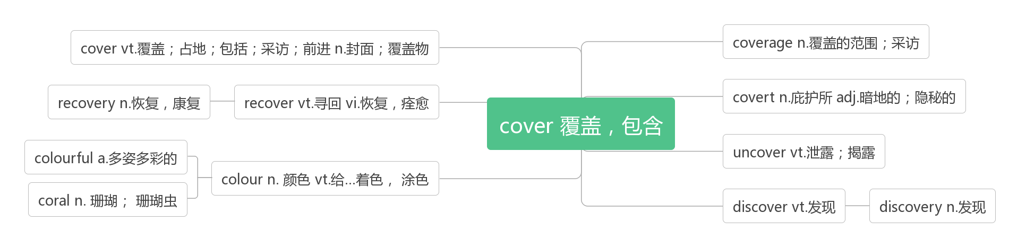

1. **remove [rɪ'muːv] vt.vi. &n.去除;迁移;解雇**

What has led many governments to remove necessary regulations?(2019江苏)

是什么导致许多政府取消了必要的监管?

When fat and salt are removed from food, the food tastes as if it is missing something.(2017全国I)

当脂肪和盐从食物中去除时,食物尝起来就好像少了什么东西。

Directions are very specific."Bring three cups of water to boil, add mix, simmer three minutes, remove from heat, let stand five minutes."(2017天津) 说明非常具体："取三杯水烧开,加入混合物|,小火煮三分钟,熄火,静置五分钟。"

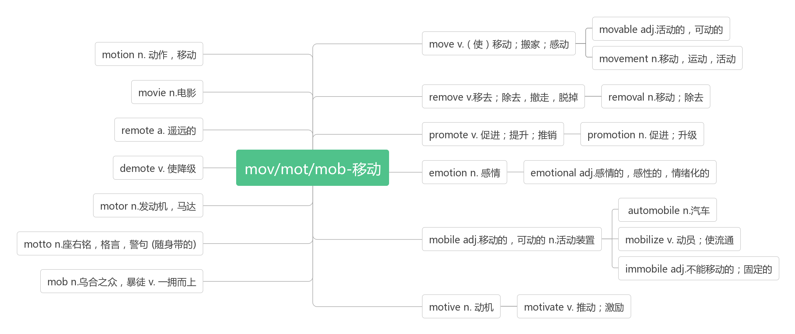**42. intend [ɪn'tend]vt.&vi. 打算;想要;意图**

What does the author intend to tell us in Paragraph 5？(2019天津)作者在第5段中打算告诉我们什么？

Say you intend to watch a football match but the tickets are expensive and it will take you a couple of hours to get to and from the stadium.(2014江苏) 假设你打算去看一场足球比赛,但是门票很贵,而且从体育场来回需要几个小时。

Even if the other person did not intend a message for you. you gather observations and draw specific conclusions.(2009江苏) 即使对方并不想给你透露信息,你也可以收集观察的结果并得出具体的结论。

A failure is something from which we intend to learn. 我们希望从失败中学到东西。

**be intended for 专为……而设**

The book, intended for children aged 5-7, sells well. 这本专为5-7岁儿童设计的书销路很好。

**intention [ɪnˈtenʃ(ə)n] n. 打算, 计划, 意图**

Make the most of today. Translate your good intentions into actual deeds. 充分利用今天,把你美好的意愿转化为行动。

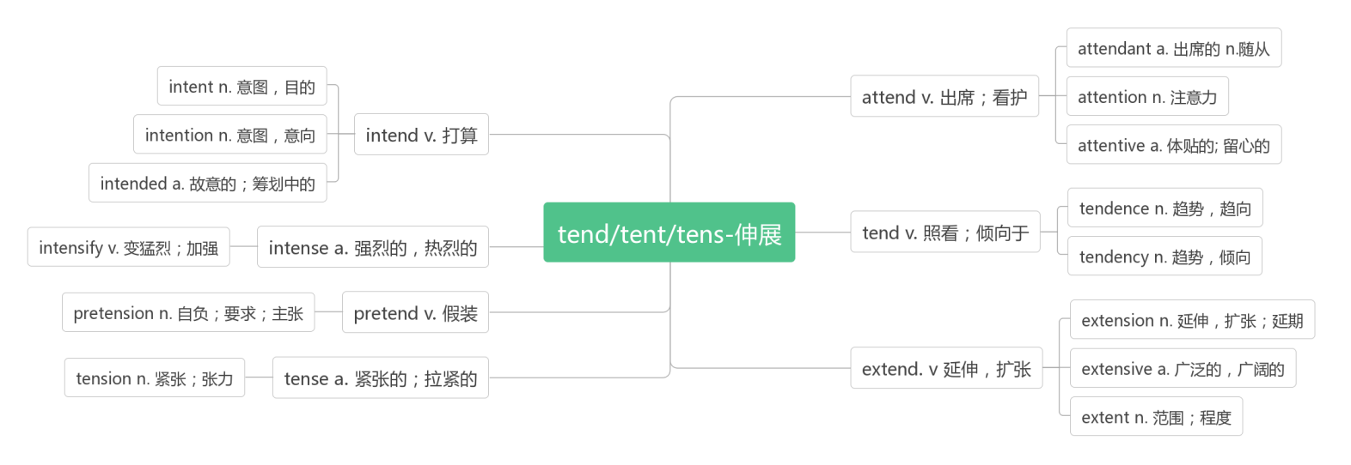

1. **threat [θret]n. 威胁,恐吓**

**破拆法：t(他)+h(喊)+re(再次)+at(attack): 他喊着要再次攻击我们——威胁**

The loss of glaciers(冰川) there due to global warming represents an enormous threat to agriculture. (2017江苏)

由于全球变暖,那里冰川的消失对农业构成了巨大的威胁。

Conscientiousness(良心) also offers a buffer (缓冲) against the threat of job loss in today’s constantly changing market, because employees with this quality are among the most valued.(2013江苏)

在今天这个不断变化的市场中,责任心也可以缓冲失业的威胁,因为具有这种品质的员工是最有价值的。

**threaten ['θret(ə)n]vt.&vi. 威胁;恐吓;危及**

Chinese is borrowing an increasing number of English words but are also concerned that the inclusion may hurt the dignity of the Chinese language. However, others are in favor of the inclusion because it is hard to say whether it will threaten the Chinese language.(2014江苏) 中国正在借用越来越多的英语单词,但也担心这可能会损害汉语的尊严。然而,也有一些人支持这些借用,因为很难说它是否会威胁到汉语。

1. **exist [ɪg'zɪst]vi. 存在;生存**

Dismissing small talk as unimportant is easy, but we can’t forget that deep relationships wouldn’t even exist if it weren’t for casual conversation.(2018全国II)

不把闲聊当一回事很容易,但我们不要忘记,如果不是因为闲聊,深厚的关系甚至都不会存在。

Great things happen when you step out of your comfort zone, and you would be surprised on how many chances exist if you just ask.(2016浙江) 当你走出你的舒适区,了不起的事情发生了：只要你去找,你就会惊讶于有多少机会存在。Everyone enjoys the life－saving benefits vaccines provide, but they'll exist only as long as everyone shares in the risks.(2017北京) 人人都享有疫苗提供的挽救生命的好处,但只有人人都分担风险,疫苗才能存在。

**existence [ɪɡ'zɪstəns]n. 存在,实在;生存;存在物**

So scientists are trying their best to save the species from going out of existence.(2019江苏)

因此,科学家们正在尽最大努力拯救这个物种,使其免于灭绝。

A machine with a specific purpose has another quality, one that we usually associate with living things: a wish to preserve its own existence.(2017北京)

一台有特定用途的机器还有另一种特性,我们通常把它与生物联系在一起：即希望维持其自身的存在。

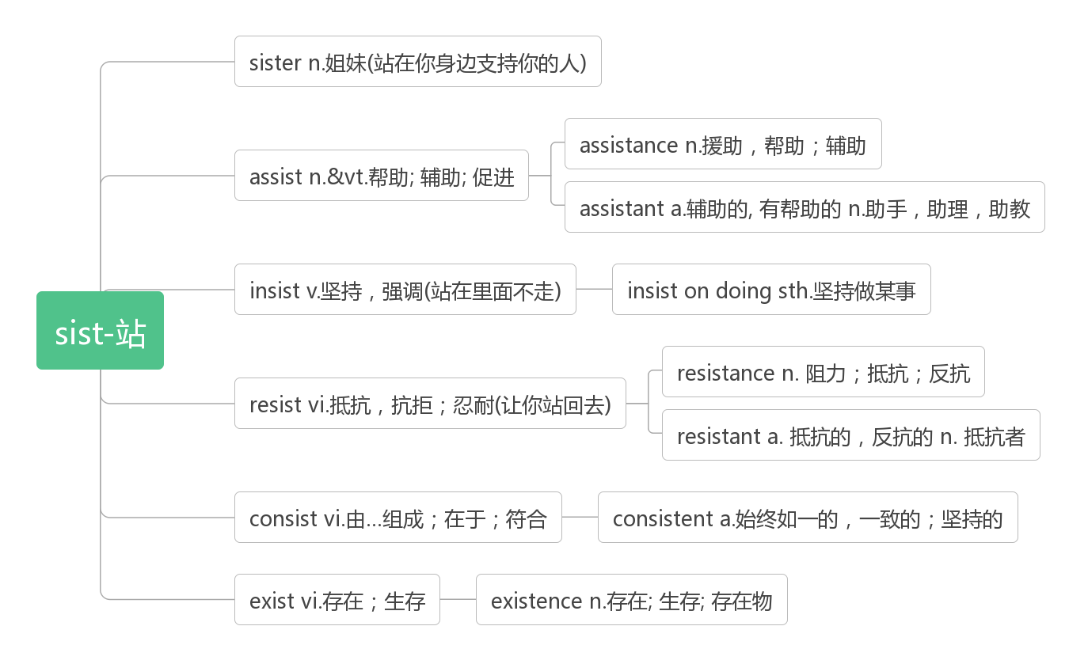

1. **harmony['hɑːmənɪ]n. 和谐;和睦;融洽**

**破拆法：harm(伤害)+mony(money钱)：谈钱伤感情——谈到钱就有损和谐。**

A successful apology can turn hate into personal and organizational harmony.(2011江苏)

一个成功的道歉可以把仇恨转化为个人和组织的和谐。

**in harmony with 与……和谐相处**

He who lives in harmony with himself lives in harmony with the universe.~Marcus Aurelius

一个人可以融洽地和自己相处,那么他就可以与世界相处了。—奥里利乌斯

**harmonious [hɑ:'məʊnɪəs]adj. 和谐的,和睦的;协调的**

An important new study into teenage attitudes surprisingly shows that their family life is more harmonious than it has ever been in the past.(2007北京)

一项关于青少年态度的重要新研究出人意料地显示,他们的家庭生活比以往任何时候都更加和谐。

词源故事：哈尔摩尼亚的项链——不幸之源

少女哈尔摩尼亚是爱神阿芙洛狄特与战神阿瑞斯阿瑞斯偷情所生,这让爱神的丈夫火神赫淮斯托斯大为恼火,于是火神打造了一条精致华美的项链,并在上面打下了诅咒的烙印,在哈尔摩尼亚结婚的这天送给了她。表面上看,戴上这条项链的的人会变得更年青美丽,但事实上这条项链却会给其拥有者及其家人带来各种可怕的厄运。后来,哈尔摩尼亚的小女儿塞墨勒死于宙斯的雷电,大女儿伊诺被丈夫追杀投海自尽;外孙阿克泰翁被狩猎女神阿尔忒弥斯变成了鹿并被猎狗杀死;后来项链被忒拜王后伊娥卡斯特继承,她的儿子就是悲剧的俄狄浦斯王。

1. **goods [ɡʊdz] n.商品;货物**

Believing in such a world, many governments have put an end to some of the very necessary regulations on cross-border flows of capital, labour and goods, with poor results.(2019江苏) 相信有这样一个世界,许多国家的政府已经终止了对资本、劳动力和商品跨境流动的一些非常必要的监管,但收效甚微。

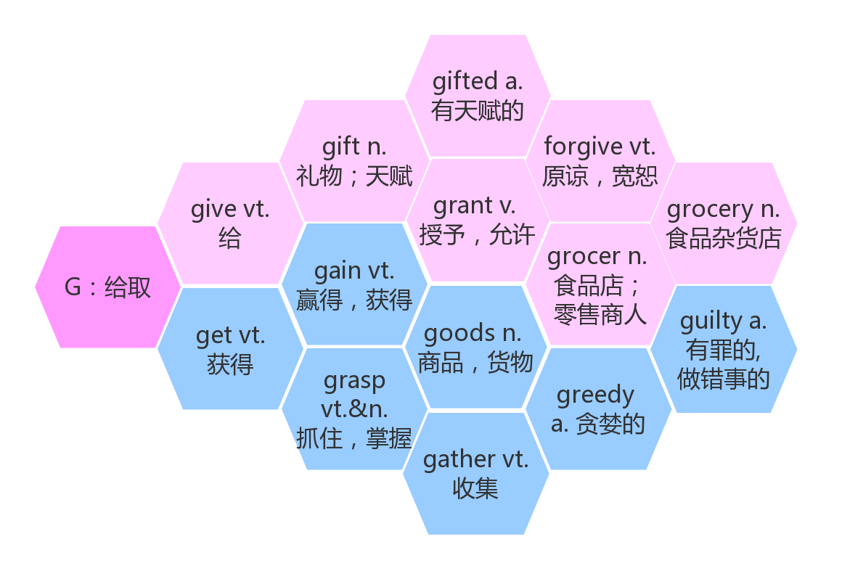

1. **creature ['kriːtʃə]n. 动物,生物;创造物**

The bone structure of our ancestors developed for millions of years to support a creature that walked on all fours and has a relatively small head.(2019江苏)

我们祖先的骨骼结构已经进化了数百万年,以支持一种靠四肢行走、头部相对较小的生物。

But humans enjoyed all of these advantages for a full 2 million years during which they remained weak and marginal(边缘的) creature.(2019江苏)

但在整整200万年的时间里,人类享受着所有这些优势,在这期间,他们一直处于弱势和边缘状态。

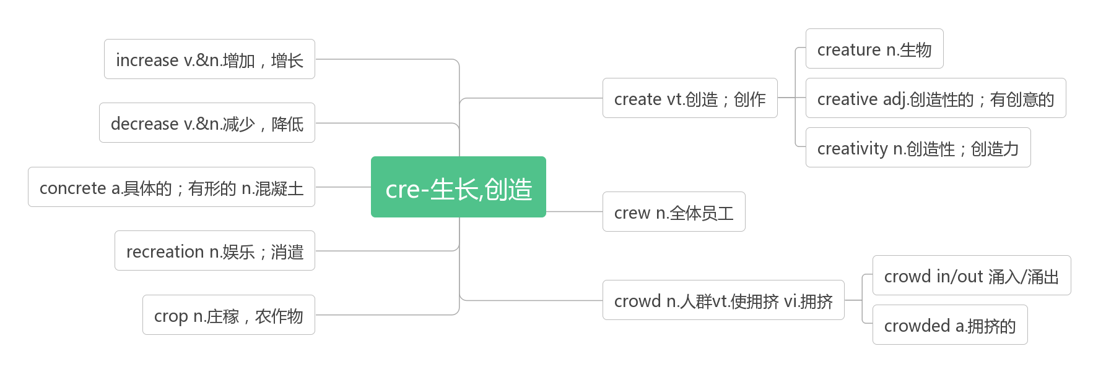

1. **deer[dɪə]n. 鹿(pl:deer)**
2. **kangaroo[,kæŋgə'ruː]n. 袋鼠**

**破拆法：kan(看)+ga(gather收集)+roo(root树根):看,那只袋鼠在收集树根。**

1. **reduce [ri'dju:s] vt.减少**

3D printing can reduce fuel use and emissions.(2018天津) 3D打印可以减少燃料的使用和排放。

His strange habit makes sense when you consider that he’s an environmental scientist who studies how to reduce litter, including things that fall off garbage trucks as they drive down the road. (2018浙江)

他这个奇怪的习惯是有道理的,因为他是一个环境科学家,专门研究如何减少垃圾,包括垃圾车上掉下来的东西。

A study from the University of California at Davis suggested that replacing petrol-powered private cars worldwide with electric, self-driving and shared systems could reduce carbon emissions from transportation 80% and cut the cost of transportation infrastructure(基础设施) and operations 40% by 2050. (2018北京) 加州大学戴维斯分校的一项研究表明,在全球范围内用电动、自动驾驶和共享系统取代汽油驱动的私家车,可以减少80%的交通碳排放,并在2050年前将交通基础设施和运营成本降低40%。

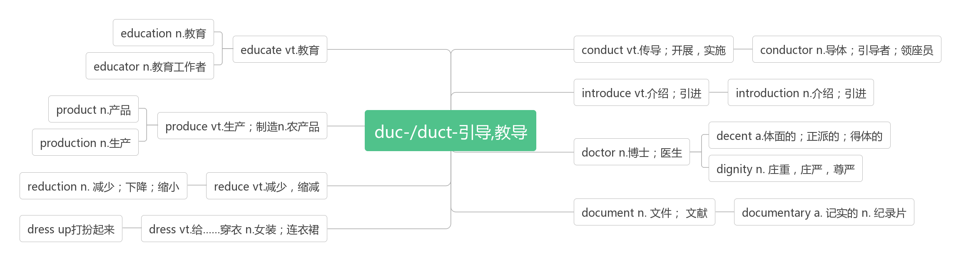

1. **due [dju:] adj.到期的;注定的;应付的**

When is the woman's report due?(2016浙江) 这位女士的报告什么时候到期?

The paper is due next month, and I am working seven days a week, often long into the night.(2014浙江)

下个月就要交论文了,所以我一周工作七天,常常工作到深夜。

If you leave your work until the night before it's due, you give up the possibility of getting input from your professor. (2013浙江 )如果你把作业留到交作业的前一天晚上,你就放弃了从你的教授那里获得信息的机会。

**due to由于,因为(prep.)**

It does point out that many parents still limit electronic reading, mainly due to concerns about increased screen time.(2018全国II) 它确实指出,许多父母仍然限制电子阅读,主要是因为担心屏幕时间增加。

Raynor Winn and her husband Moth became homeless due to their wrong investment.(2018江苏)

雷诺·韦恩和她的丈夫莫丝由于错误的投资而无家可归。

The reason why someone is triggered(触发,引起) by something and others are not is often due to one’s personal history and psychological traits. (2018北京)

一个人被某事影响而其他人没有被影响的原因通常是由于一个人的个人历史和心理特征。

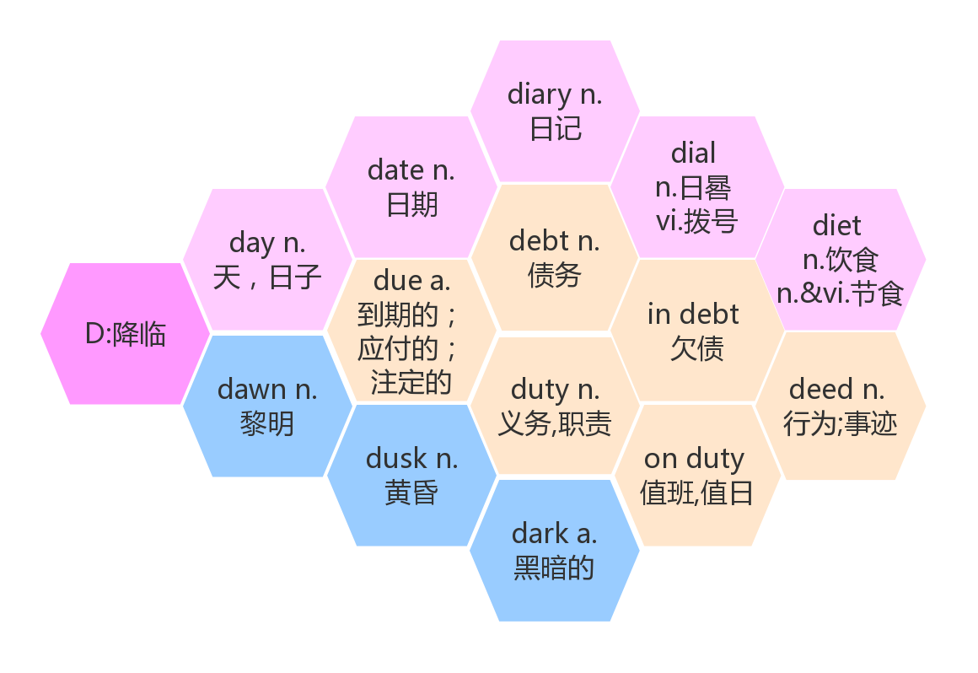

1. **blog [blɒɡ]n. 博客,网络日志vi.写博客**

**blog post博文;博客帖子**

**blogger[ˈblɒɡə(r)]n.博客作者;博主**

1. **engine ['endʒɪn]n. 引擎,发动机;火车头**

It sounds like something is wrong with the car’s engine. If so, we’d better take it to the garage immediately.(2011江苏)

听起来好像是汽车引擎出了问题。如果是这样的话,我们最好马上把它送到修车厂去。

Approach no closer than 100 metres,then stop the boat but keep the engine on.(2008全国II)

接近不超过100米,然后停船,但保持引擎运转。

**engineer [endʒɪ'nɪə]n. 工程师;火车司机**

**search engine（互联网上的）搜索引擎**

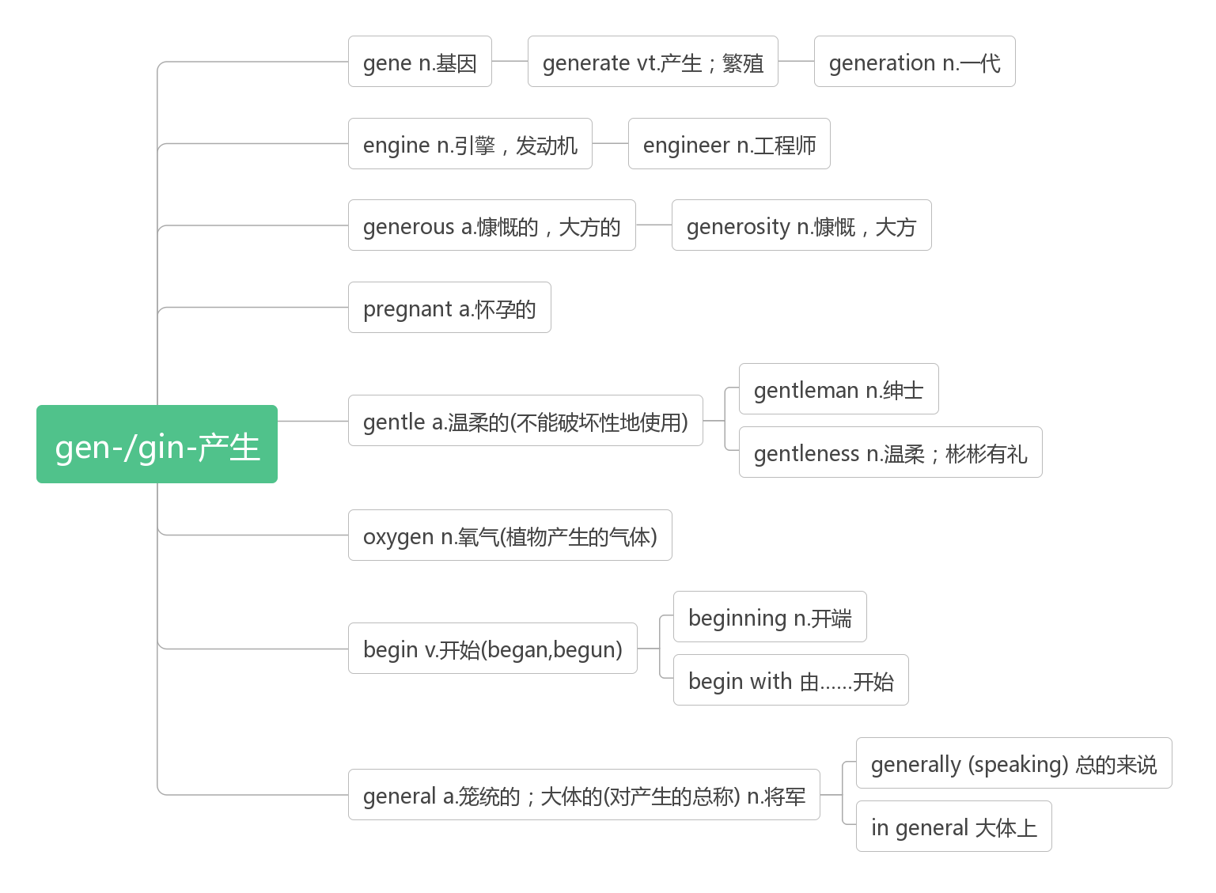

1. **chat [tʃæt]vi.&n. 聊天;闲谈vt. 搭讪;与…攀谈**

He likes that he can sit and check his phone in peace or chat up the barkeeper with whom he's on a first-name basis if he wants to have a little interaction(交流).(2019全国II)

他喜欢安静地坐着看手机,或者如果他想和酒吧老板有一点交流,可以直呼其名和他聊天。

While they chat, my father would lift my sister and me up to sit in the top of the fridge.(2016浙江)

在他们聊天的时候,我父亲会把我和妹妹举起来坐在冰箱的顶部。

Deliver the invitations in person to everyone who lives on your street and chat with each for five minutes before moving on to the next house.(2014浙江)

亲自把邀请函发给住在你这条街上的每一个人,和他们聊五分钟,然后再去下一个房子。

Today we can talk, text, e-mail, chat and blog (写博客), not only from our computers, but from our mobile phones as well.(2012江苏) 今天,我们不仅可以通过电脑,还可以通过手机来聊天、发短信、发电子邮件、聊天和写博客。

1. **stream [stri:m]vt.流播(不用下载直接在互联网上播放音视频);流出vi.流动 n.小河;溪流**

One chilly night when I was hiking in the Rocky Mountains with some students, I mentioned that we were going to cross a mountain stream.(2018天津)

一个寒冷的夜晚,我和一些学生在落基山脉徒步旅行。我跟学生们提到我们要横穿一条山间的小溪。

Feeling stronger now, Jane began to walk along the stream and hope it would lead her to the lake.(2016浙江)

简感到自己的身体好多了,她开始沿着小溪走,希望小溪能把她带到湖边。

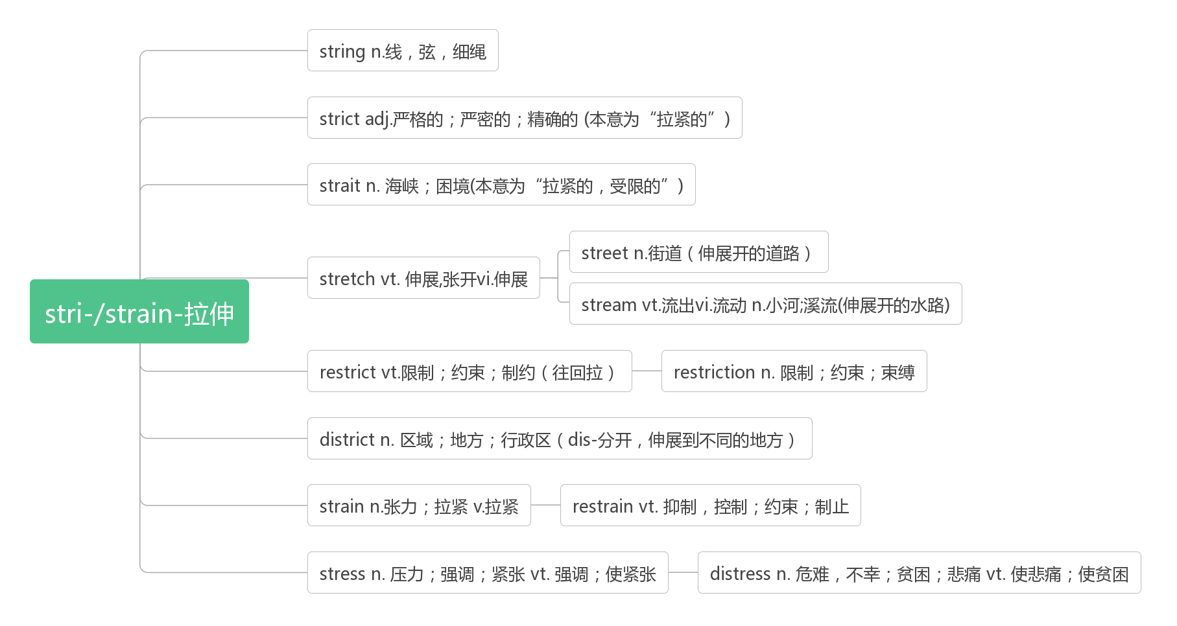

1. **identity [aɪ'dentɪtɪ] n. 身份;同一性,一致;特性**

**词根词缀：ident-(等同)+ity(名词后缀)：等同于一个人的属性——身份**

As data and identity theft becomes more and more common, the market is growing for biometric(生物测量) technologies —like fingerprint scans—to keep others out of private e-spaces.(2019全国I) 随着数据和身份盗窃变得越来越普遍,像指纹扫描这样的生物识别技术的市场正在增长,以防止其他人进入私人电子空间。

The college years are supposed to be a time for important growth in autonomy(自主性) and the development of adult identity. (2016北京) 大学应该是一个重要的自主成长和发展成人身份的时期。

If students rely on administrators to regulate their social behavior and thinking pattern, they are not facing the challenge of finding an identity within a larger and complex community.(2016北京) 如果学生依赖管理者来规范他们的社会行为和思维模式,他们就不会面临在一个更大、更复杂的社区中寻找身份的挑战。

**ID Card= Identity Card身份证**

**identify [ai'dentifai] vt.识别,鉴别; 确认**

**identification [aɪdentɪfɪˈkeɪʃ(ə)n]n. 鉴定,辨别**

1. **convenient [kən'viːnɪənt] adj. 方便的,便利的**

**词根词缀：con-(都)+veni(来)+ent(形容词后缀)：大家都来到一起做事——方便的,便利的**

While much of the debate so far has been focused on the safety of driverless cars(and rightfully so), policymakers also should be talking about how self-driving vehicles can help reduce traffic jams, cut emissions(排放) and offer more convenient, affordable mobility options. (2018北京)

虽然到目前为止,大部分争论都集中在无人驾驶汽车的安全性上(这是合理的),但政策制定者也应该讨论一下,无人驾驶汽车如何能够帮助减少交通堵塞、减少排放,并提供更方便、更实惠的出行选择。

Hopefully in 2025 we will no longer be e-mailing each other, for we will have developed more convenient electronic communication tools by then.(2018江苏)

希望到2025年,我们将不再互相发电子邮件,因为那时我们将会开发出更方便的电子通讯工具。

The car is a convenient means of transport, but we have made it our way of life.(2014天津)

汽车是一种方便的交通工具,但我们已使它成为我们的生活方式。

The secretary arranged a convenient time and space for the applicants to have an interview.(2012天津)

秘书为申请人安排了方便的面试时间和地点。

**convenience [kən'viːnɪəns]n. 便利;厕所;便利的事物**

The convenience even leads fewer people to take public transport — an unwelcome side effect researchers have already found in ride-hailing(叫车) services.(2018北京)

这种便利甚至导致更少的人乘坐公共交通工具——研究人员已经在叫车服务中发现了一个不受欢迎的副作用。

To enjoy the convenience of digital payment, many senior citizens started to use smart phones.(2019江苏)

为了享受数字支付的便利,许多老年人开始使用智能手机。

**for convenience 为了方便起见**

They don't [flatter](https://cn.bing.com/dict/search?q=flatter&FORM=BDVSP6&mkt=zh-cn)(奉承) [somebody](https://cn.bing.com/dict/search?q=somebody&FORM=BDVSP6&mkt=zh-cn) [for](https://cn.bing.com/dict/search?q=for&FORM=BDVSP6&mkt=zh-cn) [convenience](https://cn.bing.com/dict/search?q=convenience&FORM=BDVSP6&mkt=zh-cn) [and](https://cn.bing.com/dict/search?q=and&FORM=BDVSP6&mkt=zh-cn) [personal interest](https://cn.bing.com/dict/search?q=personal interest&FORM=BDVSP6&mkt=zh-cn) and echo(附和) [the](https://cn.bing.com/dict/search?q=the&FORM=BDVSP6&mkt=zh-cn) [opinion](https://cn.bing.com/dict/search?q=opinion&FORM=BDVSP6&mkt=zh-cn) of [a](https://cn.bing.com/dict/search?q=a&FORM=BDVSP6&mkt=zh-cn) [few](https://cn.bing.com/dict/search?q=few&FORM=BDVSP6&mkt=zh-cn) [man](https://cn.bing.com/dict/search?q=man&FORM=BDVSP6&mkt=zh-cn) of high [position](https://cn.bing.com/dict/search?q=position&FORM=BDVSP6&mkt=zh-cn).[他们](https://cn.bing.com/dict/search?q=%E4%BB%96%E4%BB%AC&FORM=BDVSP6&mkt=zh-cn)[绝对](https://cn.bing.com/dict/search?q=%E7%BB%9D%E5%AF%B9&FORM=BDVSP6&mkt=zh-cn)[不会](https://cn.bing.com/dict/search?q=%E4%B8%8D%E4%BC%9A&FORM=BDVSP6&mkt=zh-cn)[为了](https://cn.bing.com/dict/search?q=%E4%B8%BA%E4%BA%86&FORM=BDVSP6&mkt=zh-cn)[方便](https://cn.bing.com/dict/search?q=%E6%96%B9%E4%BE%BF&FORM=BDVSP6&mkt=zh-cn)[,](https://cn.bing.com/dict/search?q=%EF%BC%8C&FORM=BDVSP6&mkt=zh-cn)[或](https://cn.bing.com/dict/search?q=%E6%88%96&FORM=BDVSP6&mkt=zh-cn)[为了](https://cn.bing.com/dict/search?q=%E4%B8%BA%E4%BA%86&FORM=BDVSP6&mkt=zh-cn)[个人利益](https://cn.bing.com/dict/search?q=%E4%B8%AA%E4%BA%BA%E5%88%A9%E7%9B%8A&FORM=BDVSP6&mkt=zh-cn)[而](https://cn.bing.com/dict/search?q=%E8%80%8C&FORM=BDVSP6&mkt=zh-cn)[拍](https://cn.bing.com/dict/search?q=%E6%8B%8D&FORM=BDVSP6&mkt=zh-cn)[某些](https://cn.bing.com/dict/search?q=%E6%9F%90%E4%BA%9B&FORM=BDVSP6&mkt=zh-cn)[人](https://cn.bing.com/dict/search?q=%E4%BA%BA&FORM=BDVSP6&mkt=zh-cn)[的](https://cn.bing.com/dict/search?q=%E7%9A%84&FORM=BDVSP6&mkt=zh-cn)[马](https://cn.bing.com/dict/search?q=%E9%A9%AC&FORM=BDVSP6&mkt=zh-cn)[屁](https://cn.bing.com/dict/search?q=%E5%B1%81&FORM=BDVSP6&mkt=zh-cn)[,](https://cn.bing.com/dict/search?q=%EF%BC%8C&FORM=BDVSP6&mkt=zh-cn)附和[少数](https://cn.bing.com/dict/search?q=%E5%B0%91%E6%95%B0&FORM=BDVSP6&mkt=zh-cn)[专权](https://cn.bing.com/dict/search?q=%E4%B8%93%E6%9D%83&FORM=BDVSP6&mkt=zh-cn)[人士](https://cn.bing.com/dict/search?q=%E4%BA%BA%E5%A3%AB&FORM=BDVSP6&mkt=zh-cn)[的](https://cn.bing.com/dict/search?q=%E7%9A%84&FORM=BDVSP6&mkt=zh-cn)[主张](https://cn.bing.com/dict/search?q=%E4%B8%BB%E5%BC%A0&FORM=BDVSP6&mkt=zh-cn)。

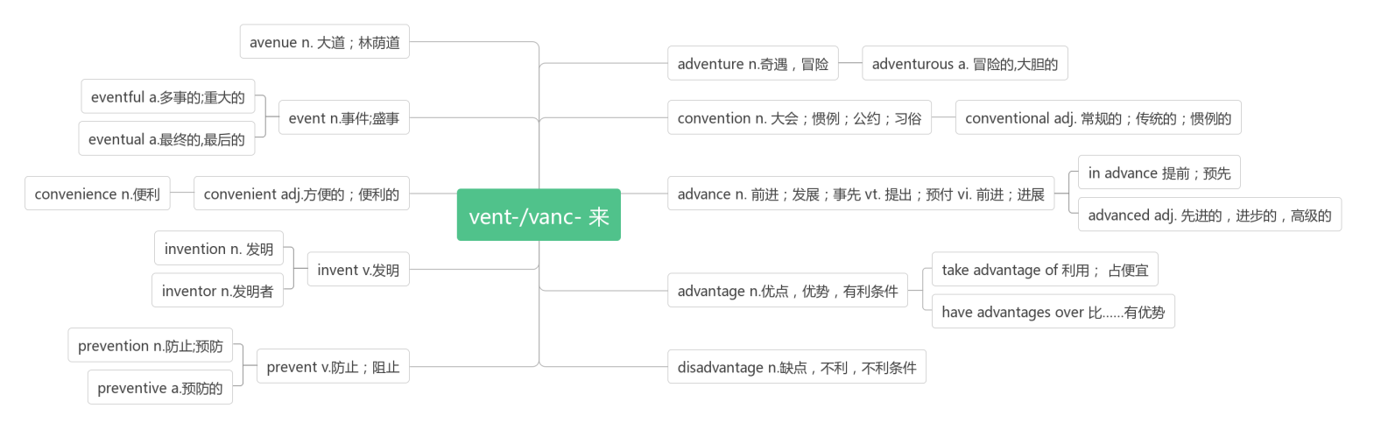

1. **cash [kæʃ]n. 现款,现金vt. 兑现;支付现款**

For many, finding an unattended wallet filled with £400 in cash would be a source of temptation(诱惑).(2018北京)

对许多人来说,发现一个无人看管的钱包,里面装满了400英镑现金,将会是一个诱惑的来源。

Yesterday is a canceled check; tomorrow is a promissory note;  today is the only cash you have.

昨天是一张作废的支票;明天是一张期票;今天是你拥有的现金。

**pay in cash/by check 用现金/支票支付**

**cash a check 兑换支票**

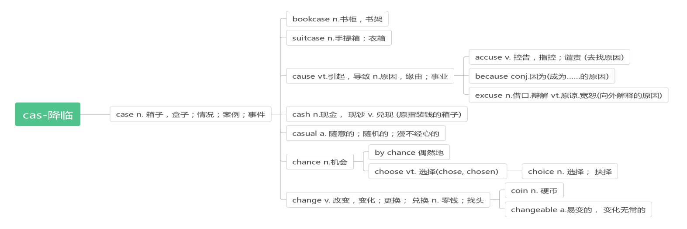

1. **update [ʌp'deɪt]vt. 更新;提供最新消息n. 更新;最新信息**

 I would just update them on any news we might have.我们一有新消息我就会告诉他们。

 They decided to update the computer systems.他们决定更新计算机系统.

**data ['deɪtə]n. 数据;资料**

**database ['deɪtəbeɪs]n. 数据库,资料库**

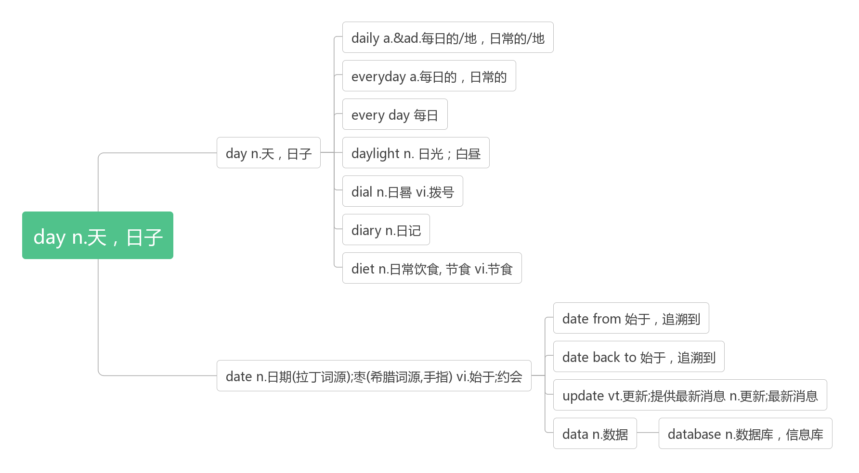

1. **ware [weə]n.制品;器具;货物**

**software ['sɒf(t)weə]n. 软件**

**hardware ['hɑːdweə]n. 硬件;五金器具**

1. **network ['netwɜːk] n. 网络;人际网;网状物**
2. **stick[stɪk]vt. 刺,戳;伸出;粘贴vi. 坚持;伸出;粘住n. 棍;手杖(stuck, stuck)**

To construct a working still, use a sharp stick or rock to dig a hole four feet across and three feet deep.(2017全国I)

要造一个管用的蒸馏器,要用一根尖锐的棍子或石头挖一个四英尺宽三英尺深的洞。

BookCrossing provides an identification number to stick inside the book.(2016全国II)

BookCrossing提供了一个识别号码,可以贴在书里。

In the spring, Dad delivered boxes full of baby chickens, and when I was a boy it was such fun to stick your fingers through one of the holes of the boxes and let the baby birds peck on your fingers.(2012浙江)

在春天,爸爸送来装满小鸡的盒子,当我还是个孩子的时候,把手指伸进盒子的一个洞里,让小鸡啄你的手指,这是多么有趣的事啊。

**stick to坚持**

If you work out bright and early in the morning, you will be more likely to stick to healthy food choices throughout the day. (2018全国II) 如果你在早上早起锻炼,你将更有可能坚持选择健康的食物。

Think about an actionable habit that you could adopt and stick to, like a family movie night every Wednesday.(2014北京)

想一个你可以采取并坚持的可行的习惯,比如每周三的家庭电影之夜。

Road trips felt risky,so I would drive fast,stopping only when I had to.We would stick to the freeways and arrive tired.(2013天津) 在路上开车有风险,所以我会开快车,只有在必要的时候才停下来。我们会坚持沿着高速公路行驶,于是到达时很疲劳。

**be stuck in 卡在,陷入,受困于**

After two days stuck in the snow, Nicholas was saved.(2015北京)困在雪里两天之后,尼古拉斯得救了。

I don’t become a serious climber until the fifth grade, when I went up to rescue a kite that was stuck in the branches of a tree.(2014浙江)直到五年级,我才成为一个真正的爬树者,那时我去救一只被卡在树枝上的风筝。

But there are not suitable plants for them to move higher, so they are stuck in the middle.(2012浙江)

但是没有合适的植物让它们向上移动,所以它们被困在中间。

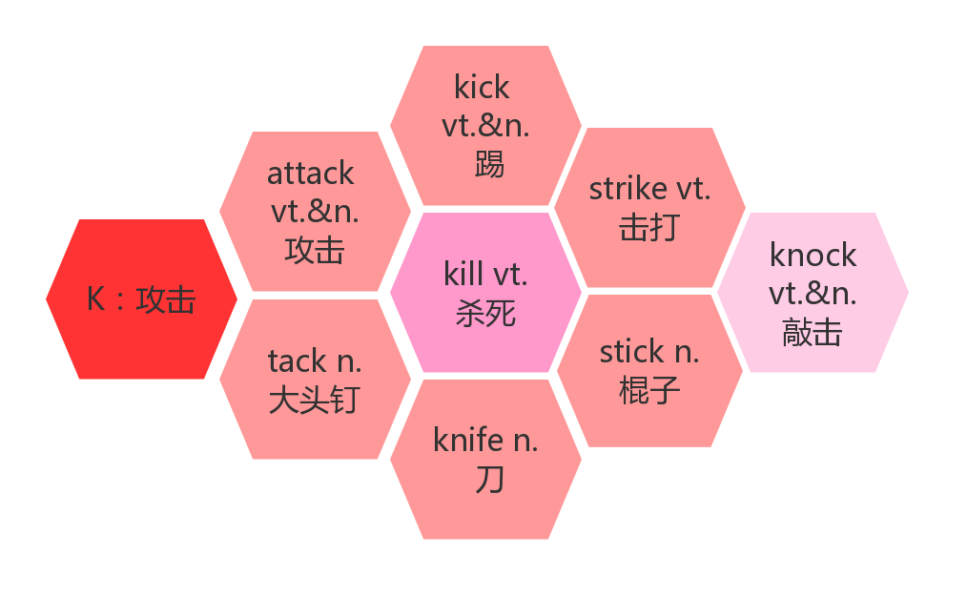

1. **company ['kʌmp(ə)nɪ]n. 公司;陪伴,同伴;连队**

**词根词缀：com-共同+pan(平底锅)+y：共同在一个锅里吃饭的人——同伴——陪伴——公司**

No road is long with good company. 良友为伴,不觉路远。

Although she founded her company early on in life, she wasn't driven primarily by profit.(2019北京)

虽然她很早就创立了自己的公司,但她的主要动力不是利润。

**keep sb. company 陪伴某人**

Keep good men company and you shall be of the number.近朱者赤,近墨者黑。

Now,we have our smartphones to keep us company at the table.(2019全国II)

现在,我们有了智能手机来陪伴我们。

**accompany [ə'kʌmpənɪ]vt. 陪伴,伴随;伴奏vi. 伴奏,伴唱**

When I was a little girl, I would often accompany you as you modeled for fashion photographers．

当我还是个小女孩的时候,我经常在你为时尚摄影师当模特的时候陪着你。

**companion [kəm'pænjən]n. 同伴**

A man knows his companion in a long journey and a little inn. 路遥知马力,日久见人心。

The dog may be a good companion for the old. However, the need to take it for walks may be a disadvantage.(2012天津) 狗可能是老年人的好伙伴。然而,需要带着它散步可能是一个缺点。

1. **surf [sɜːf]vt.&vi.冲浪;浏览**

**surf the internet 网上冲浪**

1. **benefit ['benɪfɪt]vt. 有益于vi. 受益,获益n. 利益,好处;救济金**

**词根词缀：bene-(好)+fit-(做)：做对别人有好处的事——有益于;好处**

However, it does not provide the same family atmosphere as an ordinary homestay and may not benefit those who need to practice English at home quite as much．(2011天津) 然而,它并不能提供与普通寄宿家庭相同的家庭氛围,而且对于那些需要在家里练习英语的人来说可能也没有那么多好处。

Another side benefit of getting fresh air is sunlight.(2019全国I) 获得新鲜空气的另一个好处是阳光。

However, if others benefit in the process, and I get some reward too, does it really matter where my motivation lies?(2019全国II) 然而,如果其他人在这个过程中受益,而我也得到了一些奖励,那么我的动机在哪里真的重要吗?

A university education is of huge and direct benefit to the individual.(2010北京)

大学教育对个人有巨大而直接的好处。

**benefit from 得益于;从……中获益**

Today we benefit from countless inventions and innovations( 创新).(2011江苏)

今天,我们受益于无数的发明和创新。

Many of the things we now benefit from would not be around but for Thomas Edison.(2015江苏)

如果没有托马斯·爱迪生,我们现在所受益的许多东西将不复存在。

**be of benefit to 对...有好处**

Moderate exercise will be of benefit to you.适度运动对你有益。

**beneficial [benɪˈfɪʃ(ə)l] adj.有利的,有益的;有帮助的**

First of all, having lived in China for sixteen years and having learnt English since I was a child , I have a good command of English and Chinese, which is beneficial for introducing Chinese paintings.(2019全国I书面表达)

首先,我在中国生活了16年,从小就学习英语,英语和汉语都很好,这对介绍中国画很有帮助。

In fact, music education is beneficial and important for all students.(2009北京)

事实上,音乐教育对所有学生都是有益和重要的。

**词群：见30.beauty**

1. **distance ['dɪst(ə)ns]n. 距离;远方**

**词根词缀：dis-(分开)+stan(站)+ce：站得很开——有了"距离"**

Regardless of the weather or the distance, Paul Wilson will make sure low-income students in his neighbourhood arrive at their college classes on time.(2019北京)

不管天气如何,不管距离有多远,保罗·威尔逊都会确保附近低收入家庭的学生按时到达他们的大学课堂。

During the first week, do not think about distance, but run five minutes longer each day.(2015全国II)

在第一周,不要考虑距离,而是每天多跑5分钟。

**in the distance在远处,在远方**

Farther in the distance, I could not enjoy the view of snowy mountains.(2015浙江)

在更远的地方,我欣赏不到雪山的景色。

I saw a car in the distance and jumped up as I recognized the car.(2010浙江)

我看到远处有一辆车,我一认出那辆车就跳了起来。

**at a distance从远处,从较远的距离**

Jane rose at the break of day, hungry and thirsty. She could hear water trickling(滴落) somewhere at a distance.(2016浙江)

简天刚亮就起床了,又渴又饿。她能从远处听到有水滴落的声音

He fell in love with her at once. He followed behind her at a distance, putting his feet in the very places where she had stepped.

[他](https://cn.bing.com/dict/search?q=%E4%BB%96&FORM=BDVSP6&mkt=zh-cn)对她[一见钟情](https://cn.bing.com/dict/search?q=%E4%B8%80%E8%A7%81%E9%92%9F%E6%83%85&FORM=BDVSP6&mkt=zh-cn)[,](https://cn.bing.com/dict/search?q=%EF%BC%8C&FORM=BDVSP6&mkt=zh-cn)[于是](https://cn.bing.com/dict/search?q=%E4%BA%8E%E6%98%AF&FORM=BDVSP6&mkt=zh-cn)[就](https://cn.bing.com/dict/search?q=%E5%B0%B1&FORM=BDVSP6&mkt=zh-cn)[远远](https://cn.bing.com/dict/search?q=%E8%BF%9C%E8%BF%9C&FORM=BDVSP6&mkt=zh-cn)[地](https://cn.bing.com/dict/search?q=%E5%9C%B0&FORM=BDVSP6&mkt=zh-cn)[踏](https://cn.bing.com/dict/search?q=%E8%B8%8F&FORM=BDVSP6&mkt=zh-cn)[着](https://cn.bing.com/dict/search?q=%E7%9D%80&FORM=BDVSP6&mkt=zh-cn)[她](https://cn.bing.com/dict/search?q=%E5%A5%B9&FORM=BDVSP6&mkt=zh-cn)[的](https://cn.bing.com/dict/search?q=%E7%9A%84&FORM=BDVSP6&mkt=zh-cn)[足迹](https://cn.bing.com/dict/search?q=%E8%B6%B3%E8%BF%B9&FORM=BDVSP6&mkt=zh-cn)[一](https://cn.bing.com/dict/search?q=%E4%B8%80&FORM=BDVSP6&mkt=zh-cn)[步](https://cn.bing.com/dict/search?q=%E6%AD%A5&FORM=BDVSP6&mkt=zh-cn)[一](https://cn.bing.com/dict/search?q=%E4%B8%80&FORM=BDVSP6&mkt=zh-cn)[步](https://cn.bing.com/dict/search?q=%E6%AD%A5&FORM=BDVSP6&mkt=zh-cn)[地](https://cn.bing.com/dict/search?q=%E5%9C%B0&FORM=BDVSP6&mkt=zh-cn)[跟随](https://cn.bing.com/dict/search?q=%E8%B7%9F%E9%9A%8F&FORM=BDVSP6&mkt=zh-cn)[在](https://cn.bing.com/dict/search?q=%E5%9C%A8&FORM=BDVSP6&mkt=zh-cn)[她](https://cn.bing.com/dict/search?q=%E5%A5%B9&FORM=BDVSP6&mkt=zh-cn)[身后](https://cn.bing.com/dict/search?q=%E8%BA%AB%E5%90%8E&FORM=BDVSP6&mkt=zh-cn)[。](https://cn.bing.com/dict/search?q=%E3%80%82&FORM=BDVSP6&mkt=zh-cn)

**distant ['dɪst(ə)nt] adj. 遥远的**

To many people, technology means computers, hand-held devices, or vehicles that travel to distant planets.(2019天津)

对许多人来说,科技意味着电脑、手持设备或前往遥远星球的交通工具。

I was only four when she passes away. She is just a distant memory for me now.(2013全国)

她去世时我才四岁。现在对我来说,她只是一个遥远的记忆。

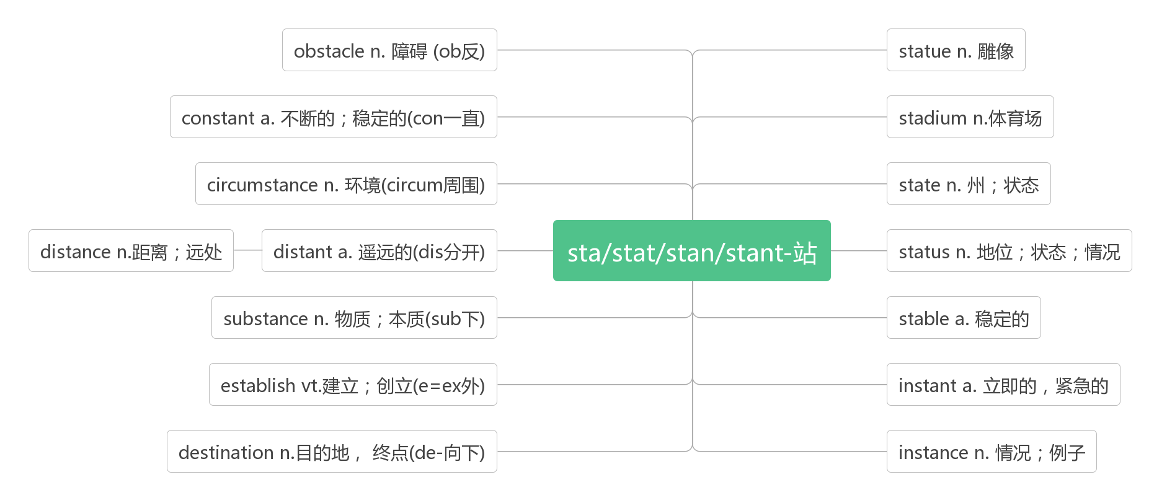

1. **inspire [ɪn'spaɪə]vt. 激发;鼓舞;启示;使产生灵感**

词根词缀：in-(里)+-spire(呼吸,气息)：智慧女神向你脑中吹了口气——启发,鼓舞,使有灵感

It is to inspire people to learn more about water-related problems.(2020浙江一月)

它是为了激励人们更多地了解与水相关的问题。

The Center offers programs designed to challenge and inspire with hands-on tasks and lots of fun.(2018北京)

该中心提供的项目旨在利用实践任务和诸多乐趣提供挑战和启发。

How does the author's story inspire you to overcome difficulties in life?(2016天津)

作者的故事如何激励你克服生活中的困难?

**inspiring [ɪn'spaɪərɪŋ]adj. 鼓舞人心的;启发灵感的**

One thing I’ve learned is that surrounding yourself with inspiring people is now just as important as being talented or working hard. 我学到的一件事是,与可以激励你的人在一起,现在跟才华与努力一样重要。

**inspiration [ɪnspɪ'reɪʃ(ə)n] n. 灵感;鼓舞**

For Western designers, China and its rich culture have long been an inspiration for Western creative.(2019全国III)

对于西方设计师来说,中国及其丰富的文化一直是西方创意的灵感来源。

Inspiration is only the award of hard work. 灵感不过是艰苦的努力而获得的奖赏。

1. **now that既然;由于**

Yet, now that I'm growing and the world I once knew as being so simple is becoming more complex, I find myself needing a way to escape. (2019天津)

然而,随着我的成长,曾经简单的世界变得越来越复杂,我发现自己需要一种逃避的方式。

Now that you know why you want to wake up, consider re－arranging your morning activities. (2017全国III)

现在你知道为什么你想要醒来,那就考虑重新安排你的早晨活动。

But now that information is being spread and monitored(监控) in different ways, researchers are discovering new rules.(2016全国III)但是由于现在信息正在以不同的方式传播和监控,研究人员发现了新的规则。

1. **access ['ækses]vt. 使用;接近;存取n. 进入;使用权;通道**

Depending on which role you choose, you could help to increase a community's access to safe drinking water, or help to protect valuable local cultures. (2019北京)

根据您所选择的角色,您可以帮助增加社区获得安全饮用水的机会,或者帮助保护有价值的当地文化。

It was really annoying; I couldn’t get access to the data bank you had recommended.(2016天津)

这真的很烦人,我无法使用你推荐的数据库。

**have access to可接近,可获得,可利用**

Kids shouldn’t have access to violent films because they might imitate the things they see.(2018浙江)

孩子们不应该接触暴力电影,因为他们可能会模仿他们看到的东西。

People have better access to health care than they used to, and they're living longer as a result.(2017北京)

人们比以前更容易获得医疗保健,因此他们的寿命更长。

**accessible [ək'sesɪb(ə)l] adj.可进入的;可获得的;可利用的**

As the Kennedy Center's artistic adviser for jazz, Moran hopes to widen the audience for jazz, make the music more accessible, and preserve its history and culture.(2017全国I) 作为肯尼迪中心的爵士乐艺术顾问,莫兰希望扩大爵士乐的听众范围,使爵士乐更容易被人接受,并保护爵士乐的历史和文化。

**be accessible to可（为某人所）获得/利用/进入**

TOKNOW makes complex ideas attractive and accessible to children, who can become involved in advanced concepts and even philosophy.(2017北京)

TOKNOW杂志使复杂的理论对孩子们有吸引力,而且容易理解,使他们可以涉猎一些高级的概念甚至哲学.

The House may present difficulties but the Visitors' Centre, its exhibition, and the garden are accessible to wheelchair users.(2010全国) 主屋可能会有困难,但是游客中心、展览和花园是轮椅使用者可以进入的。

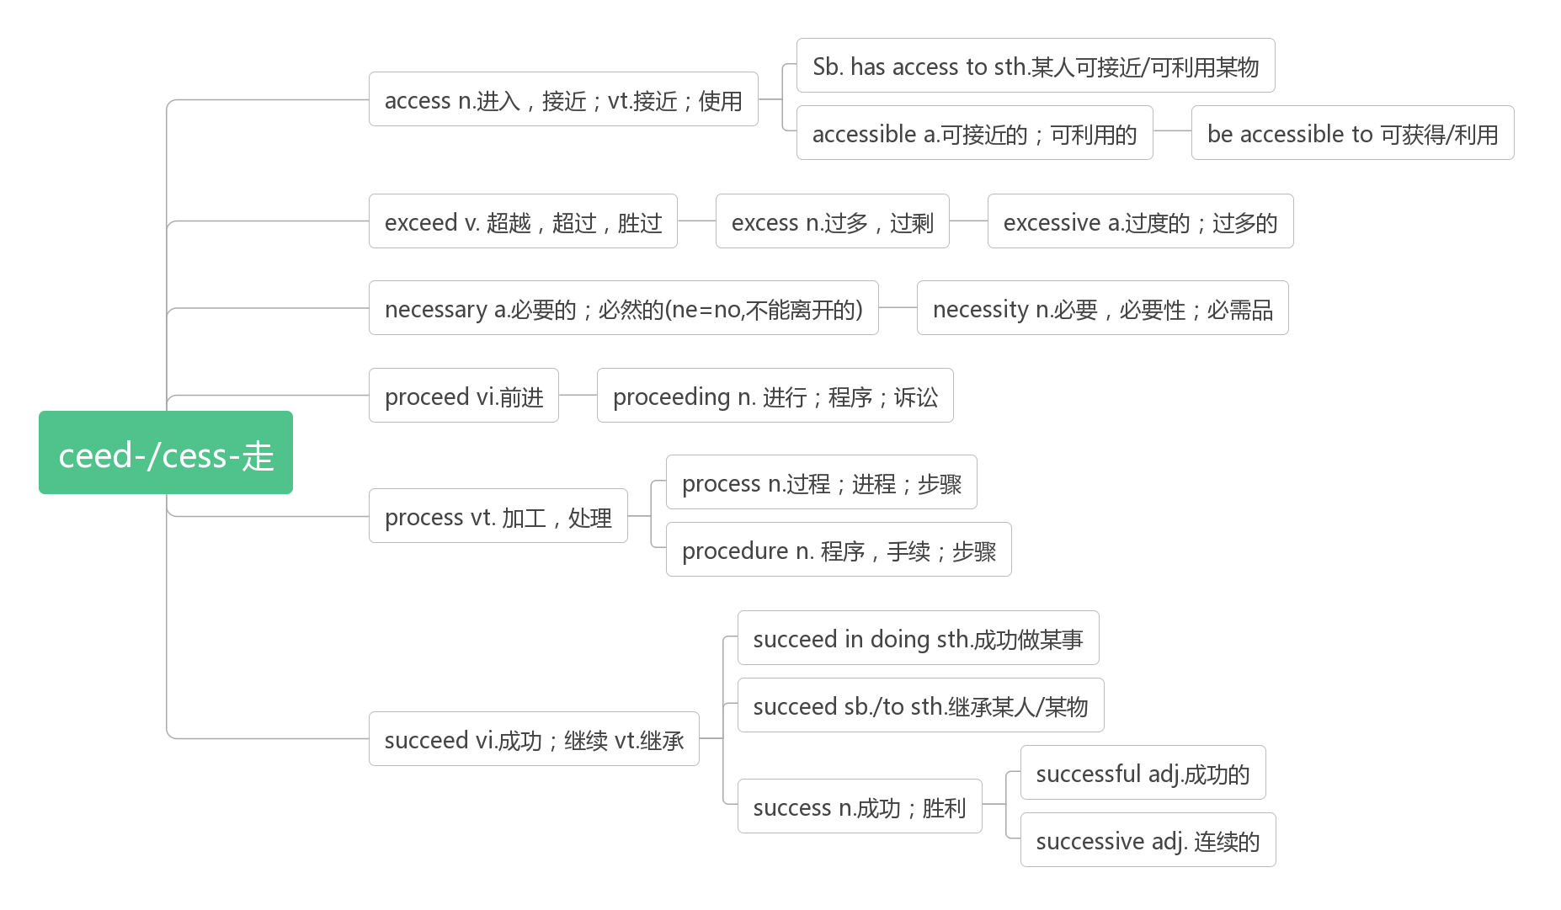

1. **charity ['tʃærɪtɪ]n. 慈善;施舍;慈善团体**

When your mother gets the gift, she will be told that she has helped the chosen charity.(2013全国II)

当你母亲收到礼物时,她会被告知她已经帮助了选定的慈善机构。

I love charity shops and so do lots of other people in Britain because you find quite a few of them on every high street. (2008天津) 我喜欢慈善商店,在英国也有很多人喜欢慈善商店,因为你在每条大街上都能找到这样的商店。

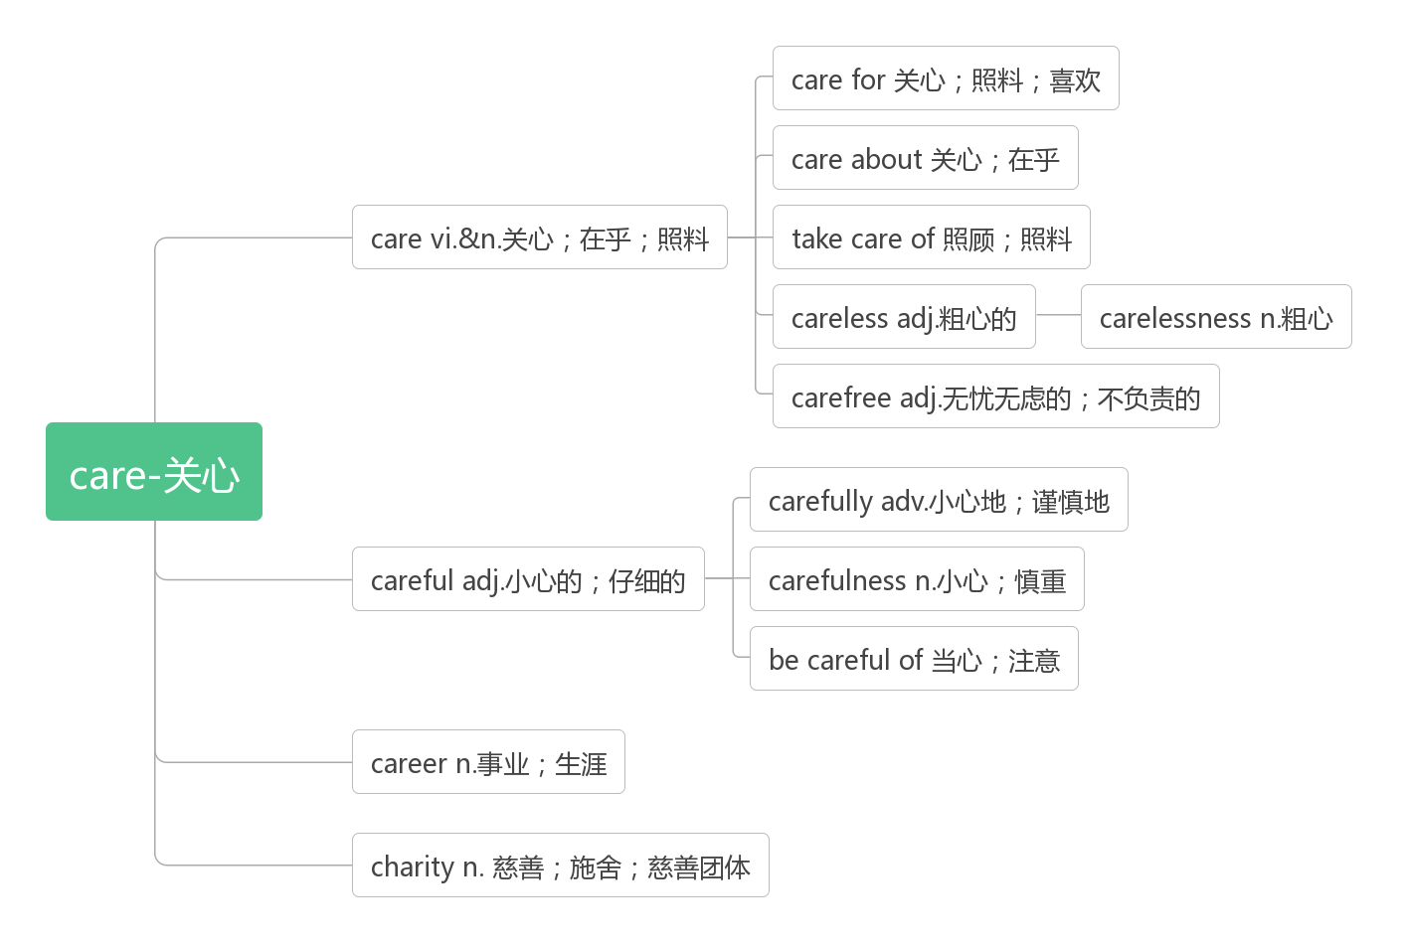

1. **insect ['ɪnsekt]n. 昆虫**

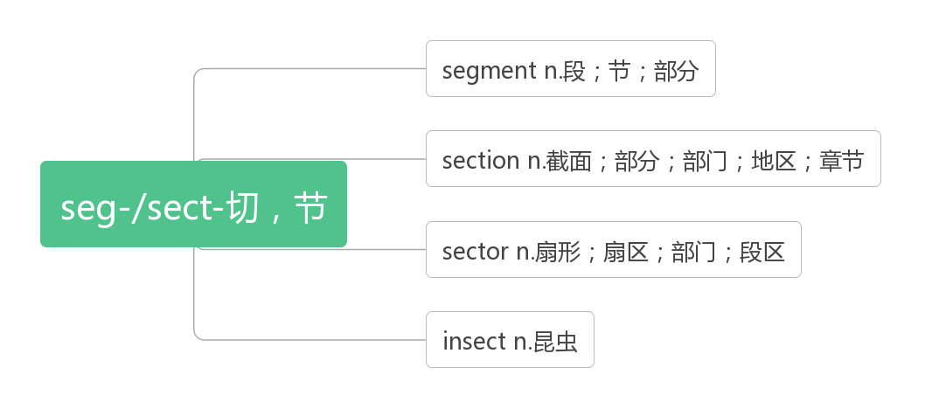

1. **neighbourhood ['neɪbəhʊd]n. 邻里;邻居关系;街区;附近一带**

破拆法：n(弄)+eigh(eight)+b(保护)+our(我们的)+hood(名词后缀)：弄八个人保护我们的邻里街区。

Regardless of the weather or the distance, Paul Wilson will make sure low-income students in his neighbourhood arrive at their college classes on time.(2019北京)

With a friendly wave and smiling face he had changed the 35 of the whole neighbourhood.(2009天津)

**neighbour [ˈneɪbə(r)] n.邻居**

Better good neighbours near than relations far away. 远亲不如近邻。

1. **binoculars [bɪ'nɒkjʊləz]n.双筒望远镜**

**词根词缀：bi-(双)+ocul-(看)+-ar(名词后缀)+-s(复数后缀)：用双眼看的东西——双筒望远镜**

1. **bird field guide 鸟类图鉴**
2. **search [sɜ:tʃ]vt. vi.&n.搜索;搜查;探求**

破拆法：s(see)+ear(耳朵)+ch(查)：既要用眼看,又要用耳听,才是搜查。

After a long and careful search Greg saw, across a field, the dog moving cautiously away. (2019全国II)

经过长时间的仔细搜寻,格雷格看到那只狗穿过田野,小心翼翼地走开了。

**search (sp.) for sth.(搜查某处)寻找某物**

Dogs have a very good sense of smell and are often used to search for survivors in an earthquake.(2008浙江)

狗有很好的嗅觉,常被用来搜寻地震中的幸存者。

Continue to search, and you will find. Continue to knock, and the door will open for you.

不断寻找,你必将有所发现;不停敲门,门必将为你打开。

Errors, like straws, upon the surface flow; he who would search for pearls must dive below.

错误像稻草,漂浮在水面。欲觅珍珠者,须往水下潜。

**in search of 以寻找**

A department store has even opened a new lab, inviting customers on a journey into the store's windows to smell books, pots and drawers, in search of their perfect scent.(2014北京) 一家百货商店甚至开设了一个新的实验室,邀请顾客到商店的橱窗里闻一闻书籍、罐子和抽屉,以寻找他们心中的完美气味

**research [rɪˈsɜːtʃ] vt.vi.& n. 研究,调查**

This research also helps to prove that characteristics such as persistence - which can be taught - are key to a child’s life success. (2020浙江一月)

这项研究还有助于证明,诸如毅力之类的品质——这是可以教给孩子的——是孩子一生成功的关键。

Today, scholars have generated large amounts of instructive research about restaurants.(2018江苏)

今天,学者们已经产生了大量关于餐馆的有益研究。

I was delighted to have been able to research in the area for my degree.(2008天津)

我很高兴能够在这个领域进行我的学位研究。

1. **dolphin ['dɒlfɪn] n. 海豚**

破拆法：dol(doll玩偶)+phin(phone手机)：这个海豚状的玩偶实际上是一部手机。

Yangtze River dolphin 白鳍豚

1. **koala [kəʊ'ɑ:lə]n. 树袋熊,考拉**
2. **stir [stɜː]vt.vi.&n. 搅拌;激起;轰动**

Remove the bowl from the ice and stir in the cream. 从冰里把碗取出,搅入奶油。

Stir the sauce and pour it over the top. 搅拌调味汁,把它浇在上面。

**stir up激起**

To [me](https://cn.bing.com/dict/search?q=me&FORM=BDVSP6&mkt=zh-cn) [he](https://cn.bing.com/dict/search?q=he&FORM=BDVSP6&mkt=zh-cn) was [only](https://cn.bing.com/dict/search?q=only&FORM=BDVSP6&mkt=zh-cn) trying to stir up [a](https://cn.bing.com/dict/search?q=a&FORM=BDVSP6&mkt=zh-cn) storm [in](https://cn.bing.com/dict/search?q=in&FORM=BDVSP6&mkt=zh-cn) [a teacup](https://cn.bing.com/dict/search?q=a%20teacup&FORM=BDVSP6&mkt=zh-cn)[.](https://cn.bing.com/dict/search?q=.&FORM=BDVSP6&mkt=zh-cn) [我](https://cn.bing.com/dict/search?q=%E6%88%91&FORM=BDVSP6&mkt=zh-cn)[认为](https://cn.bing.com/dict/search?q=%E8%AE%A4%E4%B8%BA&FORM=BDVSP6&mkt=zh-cn)[他](https://cn.bing.com/dict/search?q=%E4%BB%96&FORM=BDVSP6&mkt=zh-cn)[只不过](https://cn.bing.com/dict/search?q=%E5%8F%AA%E4%B8%8D%E8%BF%87&FORM=BDVSP6&mkt=zh-cn)[在](https://cn.bing.com/dict/search?q=%E5%9C%A8&FORM=BDVSP6&mkt=zh-cn)[小题大做](https://cn.bing.com/dict/search?q=%E5%B0%8F%E9%A2%98%E5%A4%A7%E5%81%9A&FORM=BDVSP6&mkt=zh-cn)[。](https://cn.bing.com/dict/search?q=%E3%80%82&FORM=BDVSP6&mkt=zh-cn)

[Nevertheless](https://cn.bing.com/dict/search?q=Nevertheless&FORM=BDVSP6&mkt=zh-cn)[,](https://cn.bing.com/dict/search?q=,&FORM=BDVSP6&mkt=zh-cn) a [few](https://cn.bing.com/dict/search?q=few&FORM=BDVSP6&mkt=zh-cn) [lone](https://cn.bing.com/dict/search?q=lone&FORM=BDVSP6&mkt=zh-cn) [voices](https://cn.bing.com/dict/search?q=voices&FORM=BDVSP6&mkt=zh-cn) [are](https://cn.bing.com/dict/search?q=are&FORM=BDVSP6&mkt=zh-cn) [trying](https://cn.bing.com/dict/search?q=trying&FORM=BDVSP6&mkt=zh-cn) to [stir](https://cn.bing.com/dict/search?q=stir&FORM=BDVSP6&mkt=zh-cn) up more [debate](https://cn.bing.com/dict/search?q=debate&FORM=BDVSP6&mkt=zh-cn)[.](https://cn.bing.com/dict/search?q=.&FORM=BDVSP6&mkt=zh-cn)

[尽管如此](https://cn.bing.com/dict/search?q=%E5%B0%BD%E7%AE%A1%E5%A6%82%E6%AD%A4&FORM=BDVSP6&mkt=zh-cn)[,](https://cn.bing.com/dict/search?q=%EF%BC%8C&FORM=BDVSP6&mkt=zh-cn)[还](https://cn.bing.com/dict/search?q=%E8%BF%98&FORM=BDVSP6&mkt=zh-cn)[是](https://cn.bing.com/dict/search?q=%E6%98%AF&FORM=BDVSP6&mkt=zh-cn)[有一些](https://cn.bing.com/dict/search?q=%E6%9C%89%E4%B8%80%E4%BA%9B&FORM=BDVSP6&mkt=zh-cn)孤立[的](https://cn.bing.com/dict/search?q=%E7%9A%84&FORM=BDVSP6&mkt=zh-cn)[声音](https://cn.bing.com/dict/search?q=%E5%A3%B0%E9%9F%B3&FORM=BDVSP6&mkt=zh-cn)[在](https://cn.bing.com/dict/search?q=%E5%9C%A8&FORM=BDVSP6&mkt=zh-cn)[试图](https://cn.bing.com/dict/search?q=%E8%AF%95%E5%9B%BE&FORM=BDVSP6&mkt=zh-cn)[激起](https://cn.bing.com/dict/search?q=%E6%BF%80%E8%B5%B7&FORM=BDVSP6&mkt=zh-cn)[更多](https://cn.bing.com/dict/search?q=%E6%9B%B4%E5%A4%9A&FORM=BDVSP6&mkt=zh-cn)[的](https://cn.bing.com/dict/search?q=%E7%9A%84&FORM=BDVSP6&mkt=zh-cn)[争论](https://cn.bing.com/dict/search?q=%E4%BA%89%E8%AE%BA&FORM=BDVSP6&mkt=zh-cn)[。](https://cn.bing.com/dict/search?q=%E3%80%82&FORM=BDVSP6&mkt=zh-cn)

1. **emotion [ɪ'məʊʃ(ə)n]n. 情感;情绪**

**词根词缀：e-(外)+mot-(动)+ion(名词后缀)：向外迸发的东西——情感;情绪**

I am a writer. I spend a great deal of my time thinking about the power of language—the way it can evoke(唤起) an emotion, a visual image, a complex idea, or a simple truth.(2009天津) 我是个作家。我花了很多时间思考语言的力量——它是如何唤起一种情感、一幅视觉图像、一个复杂的想法或一个简单的事实的。

To base an important decision more on emotion than on reason, you will regret it sooner or later.(2012江苏)

把一个重要的决定建立在感情上而不是理性上,你迟早会后悔的。

**emotional [ɪ'məʊʃ(ə)n(ə)l]adj. 情感的;情绪化的;易激动的;感人的**

**同源词：见41.remove**

1. **skin [skin] n.皮;皮肤**
2. **usual ['juːʒʊəl]adj. 通常的,惯例的;平常的**

**词根词缀：us-(use)+-ual(形容词后缀)：常用的,惯常的。**

They offered the dog some of her favorite peanut butter treats. They even let her sit on the sofa, but the old girl just wasn’t her usual cheerful self. (2020浙江一月)

他们给狗狗一些她最喜欢吃的花生酱。他们甚至让她坐在沙发上,但这个老女孩就是不像往常那样快乐。

**as usual像往常一样**

When the polluting industries argue that we've lost the battle to control carbon pollution and have no choice but to adapt, it's a nonsense designed to make the case for business as usual.(2017江苏) 当污染行业认为我们已经输掉了控制碳污染的战斗,除了适应之外别无选择,这是一种无稽之谈,目的是为了使生意一如既往。

**usually ['juʒuəli]adv. 通常**

Usually, the stranger the idea is, the more it gets noticed. (2019浙江)

通常情况下,越奇怪的想法,越容易引起注意。

**unusual [ʌn'juːʒʊəl]adj. 不寻常的;与众不同的;不平常的**

This time, we stayed together, in case anything else unusual happened. (2018天津)

这一次,我们呆在一起,以防有什么不寻常的事情发生。

This type of wait is unusual in that it is for the most part voluntary.(2017天津)

这种类型的等待是不寻常的,因为它大部分是自愿的。

1. **Tibet [tɪ'bet]n. 西藏**

词源谐音：吐蕃

**Tibetan [ti'betən]adj. 西藏的;藏族的n. 藏语;西藏人**