**The World**（**0101-0115**）材料分析和教学目标：

本次选用的材料：①*Reader’s Digest*的*GLAD TO HEAR IT 2 Stories to Make Your Day*（暖心故事两则）、②*Science Illustrated Australia*的Take the stairs-they keep you alive（走楼梯——它们能让你活下去）、③*Country Life UK*的Watch the birdie（数小鸟）、④*The Washington Post的**Will* *Yellowstone have an eruption? Scientists read the magma to find out.* （黄石公园会喷发吗？岩浆可以给你答案。）、和⑤BBC的新闻报道。通过语法填空、阅读理解、分析长难句、翻译句子、听力填空和词汇拓展等方式，让学生从多角度提升学习兴趣，提高分析句子、运用词块和听力能力。外媒英语新闻可以让学生体验真实语境下的语言运用，拓展学生的国际视野，了解时事，逐步提升跨文化沟通能力，形成正确的世界观、人生观和价值观。

**教学思路：**

**Part 1: News Report 1 *Reader’s Digest* (December 2024/January 2025 P11)**

**GLAD TO HEAR IT 2 Stories to Make Your Day**

**暖心故事两则**

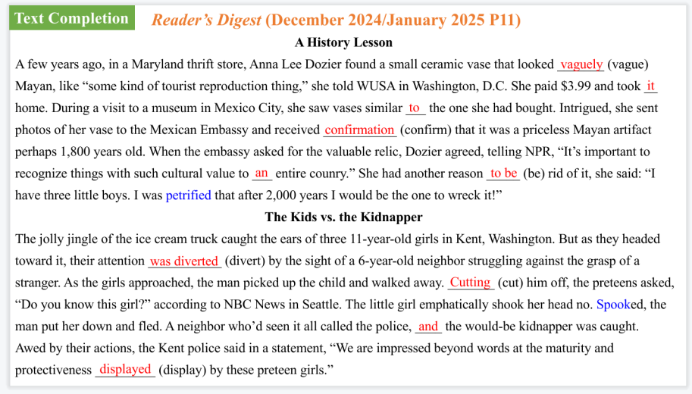

【设计意图】通过语篇填空的形式帮助学生理解新闻的主要内容，同时训练语言语法的运用能力：在语篇的视角下如何正确使用所给词汇，根据语法规则确定词汇的正确形式，使得文章通顺，激活学生的思维和语言。该新闻主题语境是关于“人与社会”中“社会热点问题”这一子主题，让学生阅读两则暖心故事。

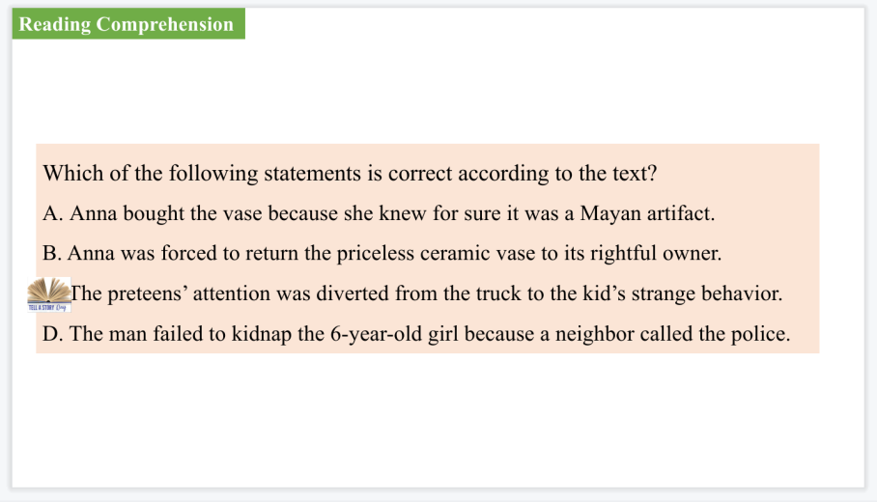

【设计意图】通过阅读理解的形式帮助学生理解新闻的主要内容。

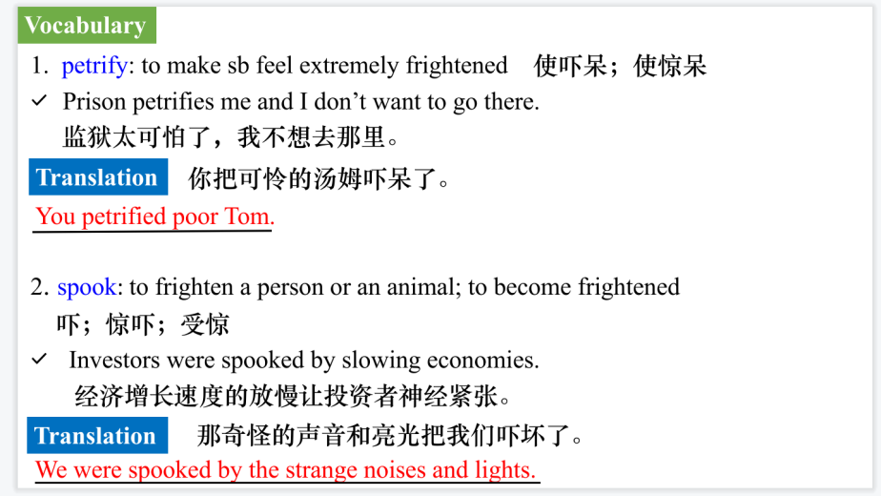

【设计意图】对文本中的词汇进行解读，并通过翻译句子对其进行巩固。



【设计意图】对文中的两个句子进行翻译练习，对其中单词、词组、句法进行巩固并关注句子结构。

**Part 2: News Report 2 Science Illustrated Australia（Issue 112, 2025 P11)**

**Take the stairs-they keep you alive走楼梯——它们能让你活下去**

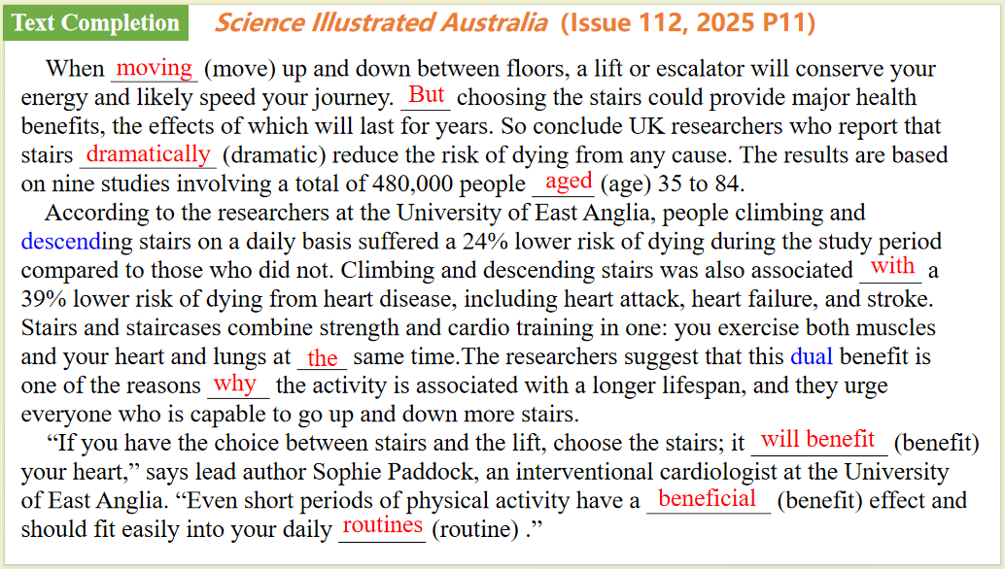

【设计意图】通过语篇填空的形式帮助学生理解新闻的主要内容，同时训练语言语法的运用能力：在语篇的视角下如何正确使用所给词汇，根据语法规则确定词汇的正确形式，使得文章通顺，激活学生的思维和语言。该新闻主题语境是关于“人与社会”中“社会热点问题”这一子主题，让学生通过阅读了解走楼梯的对身体的益处。



【设计意图】对文本中的词汇进行解读，并通过翻译句子对其进行巩固。



【设计意图】对文中的两个句子进行翻译练习，对其中单词、词组、句法进行巩固并关注句子结构。

**Part 3: News Report 3 *Country Life UK*（January 1, 2025 P21)**

**Watch the birdie数小鸟**

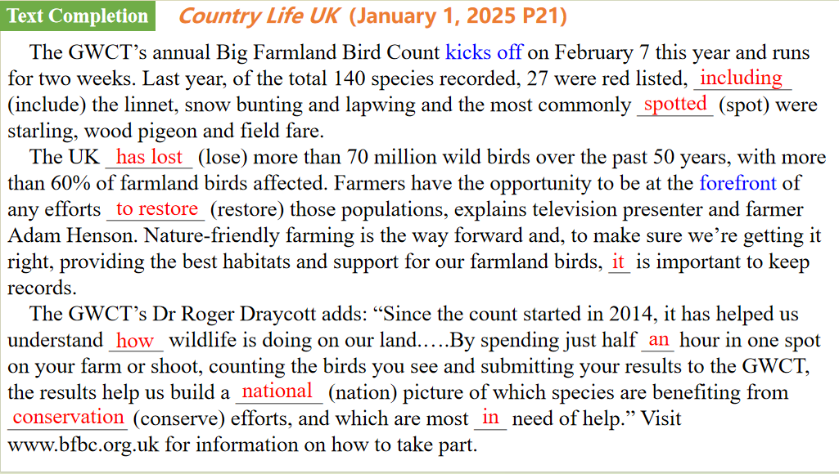

【设计意图】通过语篇填空的形式帮助学生理解新闻的主要内容，同时训练语言语法的运用能力：在语篇的视角下如何正确使用所给词汇，根据语法规则确定词汇的正确形式，使得文章通顺，激活学生的思维和语言。该新闻主题语境是关于“人与自然”中“人与动植物”这一子主题，让学生通过阅读了解农田鸟类统计活动。



【设计意图】对文本中的词汇进行解读，并通过翻译句子对其进行巩固。

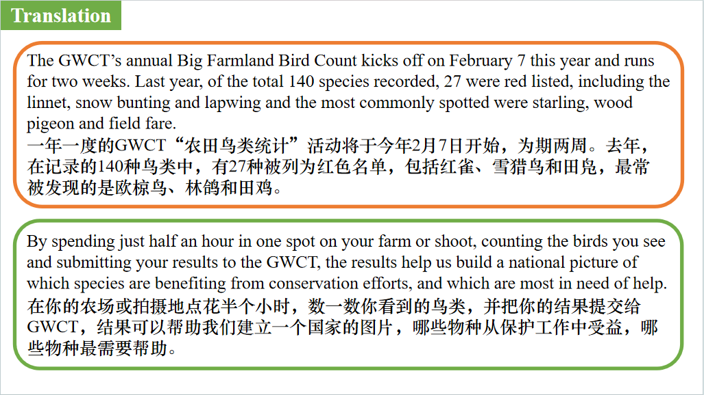

【设计意图】对文中的两个句子进行翻译练习，对其中单词、词组、句法进行巩固并关注句子结构。

**Part 4: News Report 4 *The Washington Post* (January 3 ,2025 A3)**

**Will Yellowstone have an eruption? Scientists read the magma to find out.**

**黄石公园会喷发吗？岩浆可以给你答案。**

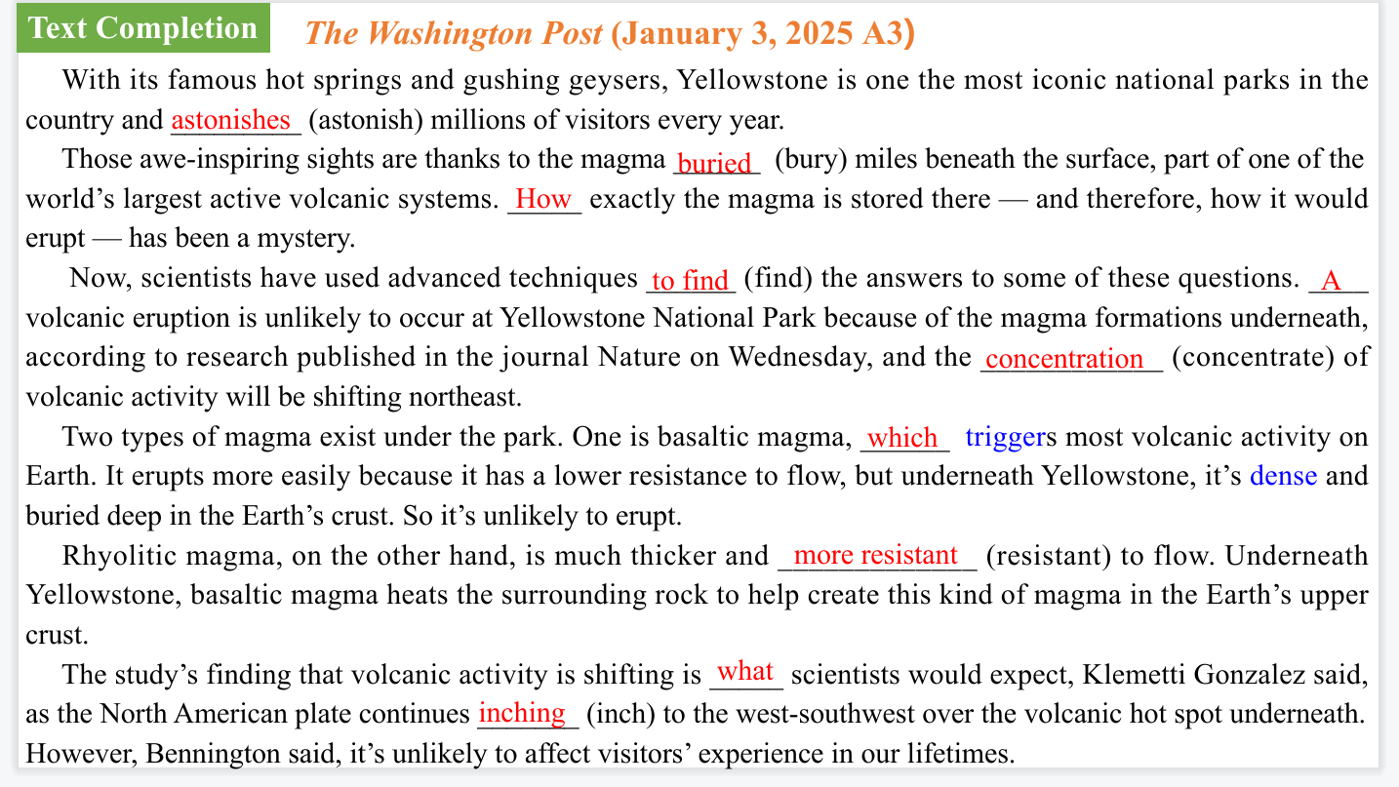

【设计意图】通过语篇填空的形式帮助学生理解新闻的主要内容，同时训练语言语法的运用能力：在语篇的视角下如何正确使用所给词汇，根据语法规则确定词汇的正确形式，使得文章通顺，激活学生的思维和语言。该新闻主题语境是关于“人与社会”中“社会热点问题”这一子主题，让学生通过阅读了解黄石公园不会喷发的原因。

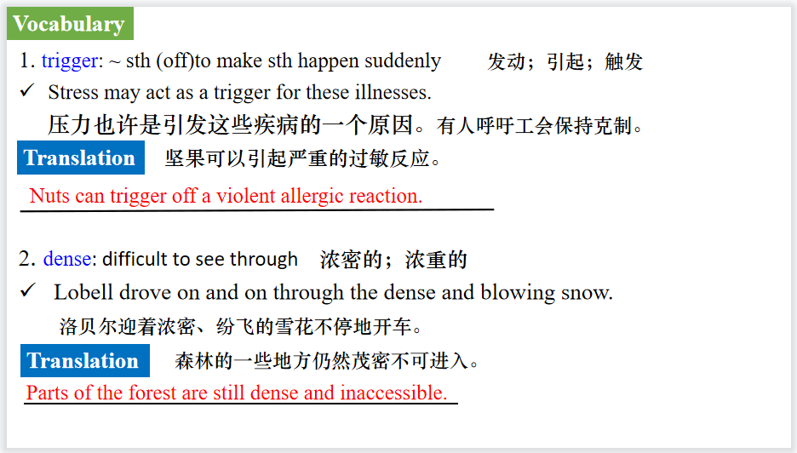

【设计意图】对文本中的词汇进行解读，并通过翻译句子对其进行巩固。

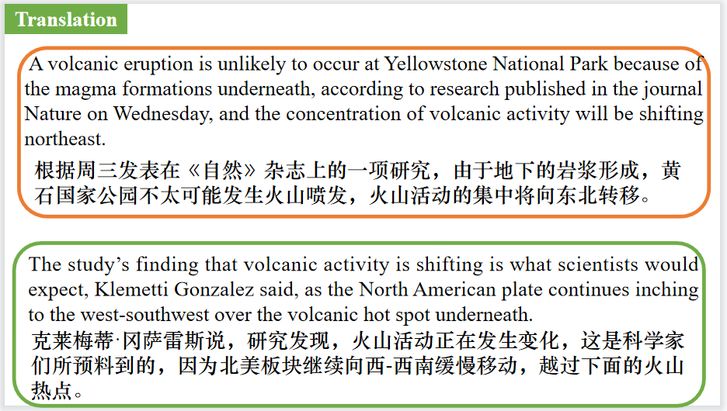

【设计意图】对文中的两个句子进行翻译练习，对其中单词、词组、句法进行巩固并关注句子结构。

**Part 5: BBC News 01/03/2025**

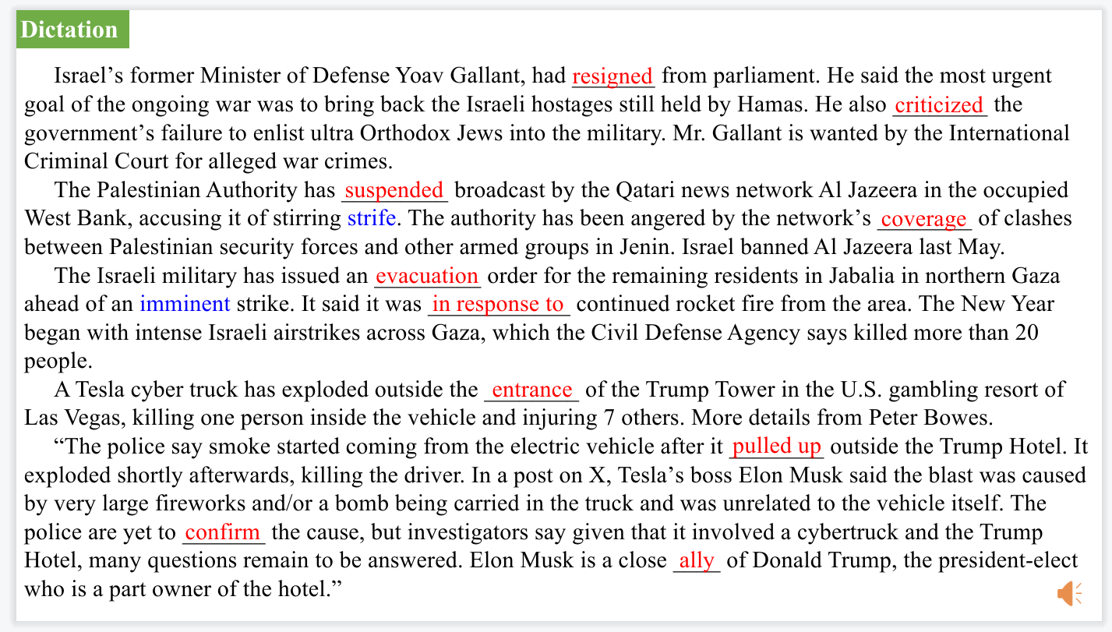

【设计意图】听一则材料，通过听力填空的方式理解文本，考察听力辨识词汇的能力。



【设计意图】对文本中的词汇进行解读，并通过翻译句子对其进行巩固。

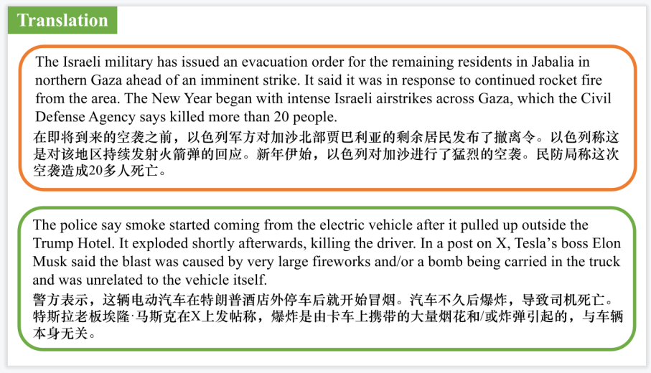

【设计意图】对文中的两个句子进行翻译练习，对其中单词、词组、句法进行巩固并关注句子结构。

附：外刊原文

**Part 1: News Report 1 *Reader’s Digest* (December 2024/January 2025 P11)**

**GLAD TO HEAR IT 2 Stories to Make Your Day**

**暖心故事两则**

**A History Lesson**

A few years ago, in a Maryland thrift store, Anna Lee Dozier found a small ceramic vase that looked vaguely Mayan, like “some kind of tourist reproduction thing,” she told WUSA in Washington, D.C. She paid $3.99 and took it home. During a visit to a museum in Mexico City, she saw vases similar to the one she had bought. Intrigued, she sent photos of her vase to the Mexican Embassy and received confirmation that it was a priceless Mayan artifact perhaps 1,800 years old. When the embassy asked for the valuable relic, Dozier agreed, telling NPR, “It’s important to recognize things with such cultural value to an entire country.” She had another reason to be rid of it, she said: “I have three little boys. I was petrified that after 2,000 years I would be the one to wreck it!”

**The Kids vs. the Kidnapper**

The jolly jingle of the ice cream truck caught the ears of three 11-year-old girls in Kent, Washington. But as they headed toward it, their attention was diverted by the sight of a 6-year-old neighbor struggling against the grasp of a stranger. As the girls approached, the man picked up the child and walked away. Cutting him off, the preteens asked, “Do you know this girl?” according to NBC News in Seattle. The little girl emphatically shook her head no. Spooked, the man put her down and fled. A neighbor who’d seen it all called the police, and the would-be kidnapper was caught. Awed by their actions, the Kent police said in a statement, “We are impressed beyond words at the maturity and protectiveness displayed by these preteen girls.

**Whatta Fish Tale!**

People flock to Grenada Lake in Mississippi to fish for crappie. Bob Gist, Brad Carlisle and Jordan Chrestman had barely gotten their lures wet when they saw dozens of hounds treading water a mile from shore. The men pulled up to the dogs and hauled them up by the collars until they’d filled the small boat with as many dogs as would fit. They motored back to shore, dropped them off and repeated their mission, twice, rescuing all 38 tired dogs. The hounds’ predicament was their own fault: They were a part of a fox hunt that went haywire when they chased a deer into the lake and just kept going.

**Part 2: News Report 2 *Science Illustrated Australia*（Issue 112, 2025 P11)**

**Take the stairs-they keep you alive**

**走楼梯——它们能让你活下去**

When moving up and down between floors, a lift or escalator will conserve your energy and likely speed your journey.But choosing the stairs could provide major health benefits, the effects of which will last for years.

So conclude UK researchers who report that stairs dramatically reduce the risk of dying from any cause. The results are based on nine studies involving a total of 480,000 people aged 35 to84.

According to the researchers at the University of East Anglia, people climbing and descending stairs on a daily basis suffered a 24%lower risk of dying during the study period compared to those who did not. Climbing and descending stairs was also associated with a 39% lower risk of dying from heart disease, including heart attack, heart failure, and stroke.

Stairs and staircases combine strength and cardio training in one: you exercise both muscles and your heart and lungs at the same time.The researchers suggest that this dual benefit is one of the reasons why the activity is associated with a longer lifespan,and they urge everyone who is capable to go up and down more stairs.

“If you have the choice between stairs and the lift, choose the stairs; it will benefit your heart,” says lead author Sophie Paddock, an interventional cardiologist at the University of East Anglia. “Even short periods of physical activity have a beneficial effect-and should fit easily into your daily routines.”

**Part 3: News Report 3 *Country Life UK*（January 1, 2025 P21)**

**Watch the birdie数小鸟**

The GWCT’s annual Big Farmland Bird Count kicks off on February 7 this year and runs for two weeks. Last year, of the total 140 species recorded, 27 were red listed, including the linnet, snow bunting and lapwing and the most commonly spotted were starling, wood pigeon and field fare.

The UK has lost more than 70million wild birds over the past 50 years,with more than 60% of farmland birds affected. Farmers have the opportunity to be at the forefront of any efforts to restore those populations, explains television presenter and farmer Adam Henson. Nature-friendly farming is the way forward and,to make sure we’re getting it right, providing the best habitats and support for our farmland birds, it is important to keep records.

The GWCT’s Dr Roger Draycott adds: “Since the count started in 2014, it has helped us understand how wildlife is doing on our land.….By spending just half an hour in one spot on your farm or shoot, counting the birds you see and submitting your results to the GWCT,the results help us build a national picture of which species are benefiting from conservation efforts, and which are most in need of help.”Visit [www.bfbc.org.uk](http://www.bfbc.org.uk) for information on how to take part.

**Part 4: News Report 4 *The Washington Post* (January 3 ,2025 A3)**

**Will Yellowstone have an eruption? Scientists read the magma to find out.**

**黄石公园会喷发吗？岩浆可以给你答案。**

With its famous hot springs and gushing geysers, Yellowstone is one the most iconic national parks in the country and astonishes millions of visitors every year.

Those awe-inspiring sights are thanks to the magma buried miles beneath the surface, part of one of the world’s largest active volcanic systems. How exactly the magma is stored there — and therefore, how it would erupt — has been a mystery.

Now, scientists have used advanced techniques to find the answers to some of these questions. A volcanic eruption is unlikely to occur at Yellowstone National Park because of the magma formations underneath, according to research published in the journal Nature on Wednesday, and the concentration of volcanic activity will be shifting northeast.

“Nowhere in Yellowstone do we have regions that are capable of eruption,” said lead author Ninfa Bennington, a research geophysicist at the Hawaiian Volcano Observatory. “It has a lot of magma, but the magma is not connected enough.”

Because there’s so much magma, Bennington said, the region will stay volcanically active. But that magma is stored in segregated reservoirs, so it is not concentrated enough to lead to a volcanic eruption, at least within our lifetimes, she added.

Two types of magma exist under the park. One is basaltic magma, which triggers most volcanic activity on Earth. It erupts more easily because it has a lower resistance to flow, but underneath Yellowstone, it’s dense and buried deep in the Earth’s crust. So it’s unlikely to erupt.

Rhyolitic magma, on the other hand, is much thicker and more resistant to flow. Underneath Yellowstone, basaltic magma heats the surrounding rock to help create this kind of magma in the Earth’s upper crust.

But this formation is also unlikely to cause a volcanic eruption in the park because a lot of pressure needs to build up to erupt rhyolitic magma. The sort of massive upheaval required to cause such an eruption is very different from the day-to-day activity that delights tourists. If the rhyolite does erupt, Bennington said, it could lead to very explosive eruptions with lots of ash.

Recent volcanic eruptions in Hawaii, including one on the Big Island in late December, have primarily been caused by basaltic magma. But it was a rhyolite eruption that created the Yellowstone Caldera.

The rhyolitic magma that erupted explosively at Yellowstone in the past had the same consistency as asphalt, said Michael Manga, professor of earth and planetary science at the University of California at Berkeley who was not involved with the study.

In the past 2.1 million years, Yellowstone has had three major eruptions, the most powerful ones in the world’s recorded history and producing enough ash and lava to fill the Grand Canyon.

But the last eruption was a small one nearly 70,000 years ago, and the last major one was hundreds of thousands of years before that.

“By no means is Yellowstone ‘due for an eruption,’” said Erik Klemetti Gonzalez, an associate professor of earth and planetary sciences at Denison University who was not involved with the study. “There will be eruptions, but it will probably be thousands of years before we can expect an eruption.”

The study’s finding that volcanic activity is shifting is what scientists would expect, Klemetti Gonzalez said, as the North American plate continues inching to the west-southwest over the volcanic hot spot underneath. However, Bennington said, it’s unlikely to affect visitors’ experience in our lifetimes.

Reaching definitive conclusions about Yellowstone is challenging, Manga said, because there aren’t frequent volcanic eruptions there, like in Hawaii or Iceland.

Much of the scientific literature surrounding volcanoes uses seismic data — seismic waves that can map geologic structures — to measure the magma under the surface. Waves move more slowly through molten rock than solid rock, but they could also be affected by factors like pressure and temperature.

This study used the less common method of magnetotellurics, a geophysical technique that uses the Earth’s electromagnetic field to image what lies beneath the surface. It’s most sensitive to magma, Bennington said, so the brightest anomalies will show magma formations. With this mapping method, scientists can track the basaltic magma, which is the power source fueling volcanic activity in Yellowstone.

“They put together a really compelling story about what’s happening underground and the relationship between the past and future volcanic activity,” Manga said.