***BOOK 3 Unit 3 Diverse Cultures***

***Discovering Useful Structures: Student Sheet***

***Activity 1: Appreciating & Guessing***

*1. When you feel like giving up,* ***don’t****.*

*2. When you’re thinking about giving up,* ***don’t****.*

*3. When it look like you ain’t gonna make it,* ***keep going****.*

*4.* ***No matter how rough the sea****, you keep standing.*

*5.* ***No matter what****, you don’t give up.*

*6. If there’s something that you want ..., you’ve got to do whatever is necessary* ***until****.*

*7. I’m going to do it* ***until****.*

343435383138323b333633373732313bbcfdcdb7*Grammar:_____________________ Functions*

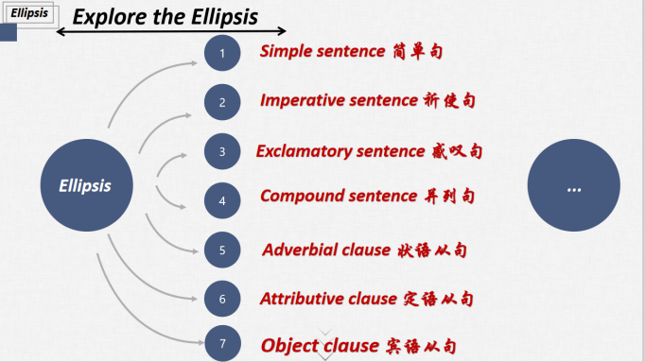

***What has been left out?***

***Activity 2: Cases of ellipsis in the speech video***

***Sentence Pattern***

*1. When you feel like giving up, don’t.*

*2. When you’re thinking about giving up, don’t.* 343435383138323b333633373732313bbcfdcdb7___________ ___________

*3. When it look like you ain’t gonna make it, keep going.*

*4. No matter how rough the sea, you keep standing.*

*5. No matter what, you don’t give up.* 343435383138323b333633373732313bbcfdcdb7__________ ___________

*6. If there’s something that you want ..., you’ve got to do*

*whatever is necessary until.* 343435383138323b333633373732313bbcfdcdb7_________ ___________

*7. I’m going to do it until.*

***Practice of Ellipsis:***

1. 如果你想要体验古城的魅力，来绍兴吧。

_______________________________________________________________________________

2. 当你想要了解更多关于绍兴文化的时候，别犹豫，尽管问我。

_______________________________________________________________________________

***Activity 3: Cases of ellipsis in the travel journal***

***What has been left out？***

***Sentence Pattern***

1. *What a city—a city that was able to rebuild itself after*

*the earthquake.* 343435383138323b333633373732313bbcfdcdb7_____________ _____________

*2. What great food!*

*3.This district used to be a poor area of town, but is now*

*a centre for art, music, and food.* 343435383138323b333633373732313bbcfdcdb7_____________ _____________

1. *A real mix of cultures here!* 343435383138323b333633373732313bbcfdcdb7_____________ _____________
2. *When these immigrants ..., they carried a bit of home*

*in their hearts, and built a new home here.* 343435383138323b333633373732313bbcfdcdb7_____________ _____________

*6. Can’t wait!* 343435383138323b333633373732313bbcfdcdb7_____________ _____________

***Practice of Ellipsis:***

1. 多么令人难忘的一次旅途——一次体验和探索绍兴之旅。

_________________________________________________________________________

2. 我强烈推荐你来绍兴游玩，并且来尝尝绍兴的美食。_________________________________________________________________________

3. 这儿有古代与现代文明的完美融合。

_________________________________________________________________________

***Activity 4: Cases of ellipsis in the dialogues***

*1. A: Oh, I just love nachos! Mexican corn chips covered in cheese!*

*B: Me, too.*

*2. A: We have gumbo, the spicy stew. It was invented in New Orleans over 200 years ago, and mixes French, African, Native American, and Spanish cooking.*

*B: So it’s the food of many different cultures, all in one dish?*

*A: Exactly.*

***What has been left out？***

***Sentence Pattern***

343435383138323b333633373732313bbcfdcdb7_______________________ ____________________________

***Practice of Ellipsis:***

*Here is a conversation between Mr Green and his good friend Mr Smith, a fisherman. Do you know what they are talking about? Can you understand what they are talking about?*

*Mr Green: Going?          Mr Smith: Been.*

*Mr Green: Any?  Mr Smith: Some.*

*Mr Green: Big? Mr Smith: Small.*

***Activity 5: Cases of ellipsis in the public signs***

_________________ _________________ _________________ _________________

***Sentence Pattern***

***What has been left out？***

343435383138323b333633373732313bbcfdcdb7______________________________ _________________________________

***Activity 6: Cases of ellipsis in the diary***

*Saturday, May 15, 2021 Sunny*

*After learning the passage about San Francisco, I feel fascinated by the attractive city that LiLan visited. If it is possible, I would like to pay a visit to it myself. I can imagine that when I am wandering around the Chinatown there, I will try a lot of delicious food. What an amazing experience it is! If it is necessary, I’ll write a report on San Francisco as soon as it is possible to record my journey.*

***What can be left out？***

***Sentence Pattern***

343435383138323b333633373732313bbcfdcdb7_____________________ _______________________

343435383138323b333633373732313bbcfdcdb7_____________________ _______________________

343435383138323b333633373732313bbcfdcdb7_____________________ _______________________

***Practice of Ellipsis:***

1. 当你漫步在绍兴时，你会感受到深刻而持久的多元文化。

________________________________________________________________________________

2. 这个城市是我参观过的最优雅的城市。

________________________________________________________________________________

3. 我相信你的绍兴之旅会不虚此行。

________________________________________________________________________________

***Activity 7: Cases of ellipsis in the famous sayings***

*1. Reading makes a full man, conference a ready man, and writing an exact man.*

*2. Histories make men wise; poets, witty; the mathematics, subtle; natural philosophy, deep; moral, grave; logic and rhetoric, able to contend.*

***What has been left out？***

***Sentence Pattern***

343435383138323b333633373732313bbcfdcdb7________________________ ________________________________________

***Practice of Ellipsis:***

学习使人聪慧，音乐使人优雅，旅游使人博学。

________________________________________________________________________________

***Activity 8: Cases of ellipsis in the letters***

*There is a famous story that the world's shortest correspondence took place between Victor Hugo and his publisher. After LES MISÉRABLES was published for the first time, Hugo, inquiring about the status of sales, sent a telegram to his publisher.*

*Victor Hugo's telegram:* ***?***

*publisher's telegram:* ***!***

***Can you understand what they meant?***

________________________________________________________________________________

***Activity 9: Assignment of ellipsis***

你的美国朋友Alex对中国文化很感兴趣，想要了解你所在城市的文化元素，请你用课堂所学的含有省略的句子向他介绍绍兴古城，并邀请他来绍兴游玩，感受古城的魅力。

1. 学习使人聪慧，音乐使人优雅，旅游使人博学。

2. 如果你想要体验古城的魅力，来绍兴吧。/如果你想要领略中国文化，我强烈推荐你来

绍兴游玩，并且来尝尝绍兴的美食。

3. 这儿有古代与现代文明的完美融合。

4. 当你漫步在绍兴时，你会感受到深刻而持久的多元文化。

5. 这个城市是我参观过的最优雅的城市。

6. 如果你想要了解更多关于绍兴古城的文化，别犹豫，尽管问我。

7. 相信你会拥有一次难忘的旅行——一次体验和探索绍兴之旅。/相信你的绍兴之旅会不

虚此行。