**B1U5 Reading and thinking教学设计**

**Teaching Aims:**

By end of the lesson, students will be able to:

(1). **Figure out the structure and summarize the main idea** of each para. With one word or phrase.

(2). **Make clear of the wiring techniques** of contrast by identifying the transitional expressions.

(3). **Conclude the personality of** Yuan Longping and state the **supporting evidence.**

(4). Summarize the topic-based expressions.

(5). **Recommend other pioneers** and give the reason.

**Teaching procedures：**

**Step1：Lead in**

Activity1：Review the great people we have learnt before.

Activity2：Watch a video and fill in the blanks.

(通过复习学过的伟大人物，帮助学生形成人物传记题材的迁移，同时为读后任务作铺垫，埋下伏笔；视频的设置帮助学生快速了解袁隆平的一生，为文章的理解和学习有促进作用）

**Step2：Pre-reading**

Activity：Make a prediction based on the picture and title.

（链接考试阅读中的主旨标题题，通过标题关键词推测文章内容，训练阅读中主旨题思维；同时激发学生阅读兴趣）

**Step3：While reading**

Activity1：Read for gist（主旨） and genre（文体）

1.Read the text. Match the main idea with each paragraph.

2.Figure out the type of the passage.

3.Brainstorm the information covered in the biography.

Activity2：Read for detailed information

Read para.1 &2 to fill in the blanks.

|  |  |
| --- | --- |
| Birthdate & birthplace |  |
| Appearance |  |
| Identity |  |
| Major |  |

Read para.3 and retell the research process based on the key words.

Q: What qualities of Yuan Longping contributes to the success?

Read for para.4 and answer the following questions.

Q1: What is the evidence to show the achievement of the reseach?

Q2: How does the author show the achievement?

Read for para.6 and find out Yuan Longping’s dreams.

(此部分精读，聚焦文章内容层面，同时第三段问题的设置在于帮助学生深度思考，通过研究过程推断袁隆平成功的原因，为后面小组活动中总结袁老的品格作铺垫；第四段问题的设置在于聚焦写作方法，通过数据来例证观点。）

Activity3： Group work

Find out the the writing technique（写作技巧） used in each paragraph, and figure out the personalities of Yuan Longping.

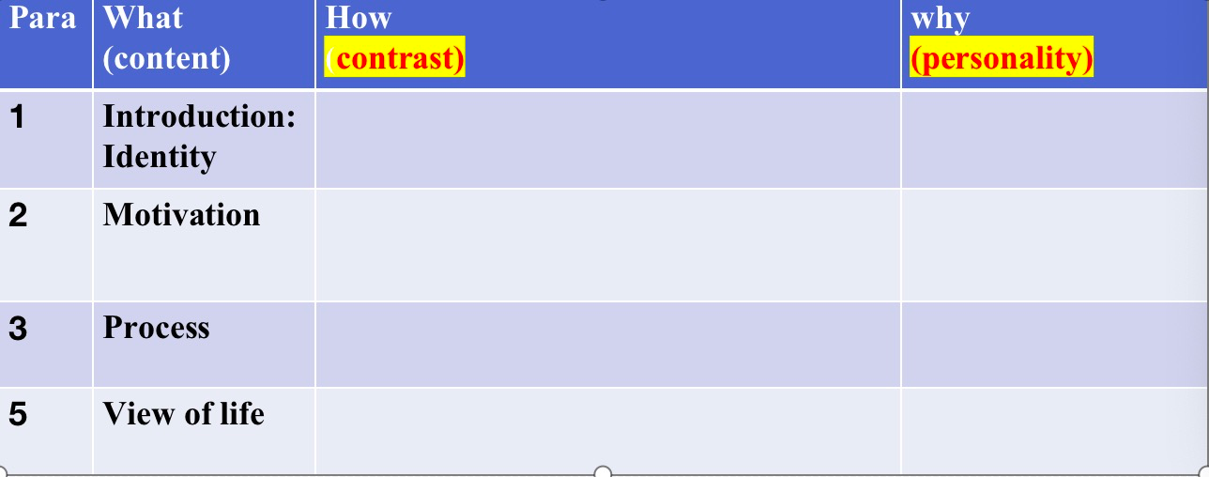

（通过小组合作，完成表格，此处老师先以第一段为例示范，找出转折词however，instead，yet...，从而找出对比内容，同时通过对比的写作方法总结人物性格特点）

**Step4：Post reading**

Activity1：Can you give your own definition of “a pioneer”? And why is Yuan Longping called a pioneer？

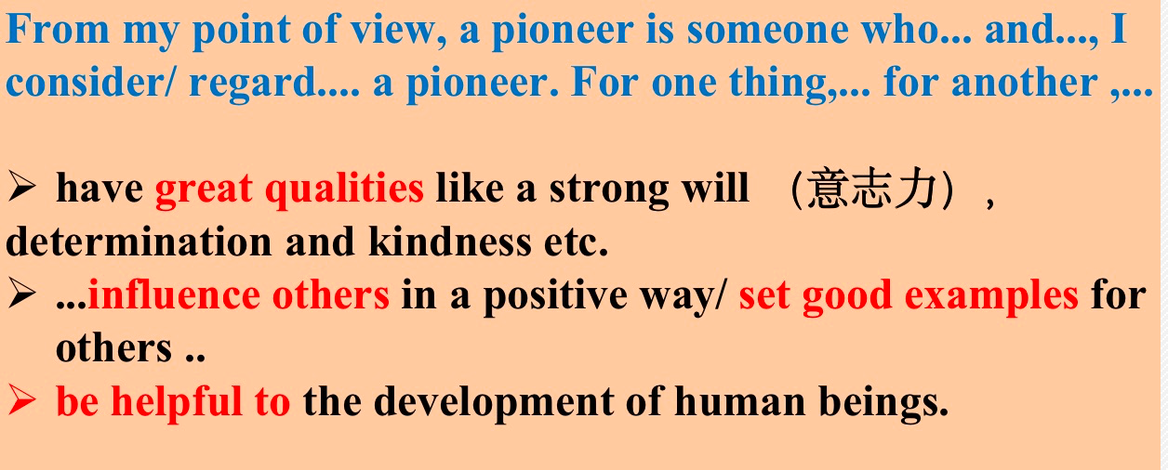

(通过语言支架，对文章的内容进行自主整合，从成就以及性格品质两个角度回答。提高学生的整合能力。）

Activity2：Make a speech

As a student，How to be well prepared to be a pioneer in our own life?

（此部分，通过对于pioneer的学习，启发学生进行迁移，运用到自己的实际学习和生活中，培养学生的迁移和运用能力）

Step 5：Homework

Recommend another pioneer with 80 words and share it with your classmates.

（与开头的导入部分呼应，同时加强学生对于已学知识的运用）