**人教版高中英语Book 3 Unit 1 Festivals and Celebrations**

**Reading for Writing**

**教 学 设 计**

**湖北省应城市第一高级中学 范静静老师 13789957350**

**课型**：读写课 **主题语境**：人与社会 **语篇类型**：日记 **授课时长**：40分钟

**I. 文本分析**

作者以第一人称的视角与读者分享了自己的“那达慕大会”节日体验，以时间顺序展开叙述。文章以作者的所见所闻所思为线索，展现了“那达慕大会”的基本信息、主要活动、节日内涵等事实性信息；同时，作者也在描述所见所闻所思的过程中，增加了活动和心理细节描写，暗藏了对中国传统文化节日延续性的喜爱、思考和赞叹。

**II. 学情分析**

总体来说，高一学生已经具备了一定的英语词汇和语法知识，对于篇章有了一定的理解能力。作为高一新生，他们对于英语学习的兴趣较高，也比较愿意表达自己的想法。对于单元主题的内容，学生相对较为熟悉，但是对于“那达慕大会”了解得相对较少。而且这可能是他们第一次写关于节日体验的记叙文（日记），由于词汇相对比较贫乏、语法知识也相应有所欠缺，对他们来说要写一篇结构清晰、要点全面、句式合理的文章可能相对较难。在文章结构的挖掘和与场景描写动作描写等专项的训练和辅导较少，所以学生在挖掘文本结构能力并将其迁移到文章写作方面还有所欠缺，需要老师进一步进行指导，同时这也是本节课教学的重难点所在。

**III. 课时目标**

学生通过本课时的学习，能够：

1. 丰富节日相关信息与语言知识
2. 阅读“那达慕大会”日记，并能够说出节日见闻的内容要素及文本语言特点;

c．能够准确描述节日经历中的情绪，如兴奋、高兴、厌烦、失望等；

d.能够提炼写作技能与步骤，用熟悉的语言与逻辑写一篇有关节日经历的记叙文（日记）；

e.根据checklist对他人的文章给出合理、有逻辑的建议，培养自我修正意识，实现有效交流和共同进步。

**IV. 教学重难点**

**教学重点：**

1.认真阅读所给日记的文章，掌握节日相关关键信息和篇章结构、语言特色等相关信息；

2.引导学生根据视频体验首届楚文化节，介绍节日活动，激发节日自己的感受，引导学生在写作中自觉运用本单元的篇章结构及写作技巧写一篇节日日记。

3. 根据checklist对他人的文章给出合理、有逻辑的建议，培养自我修正意识，实现有效交流和共同进步。

**教学难点：**根据阅读文章所获取的信息与写作技巧，写出结构清晰、内容详实生动的节日经历记叙文。

**V.教学方法**

学案导学法、任务型教学法、点---面结合写作模式

**VI.课堂模式**

湖北卫视新栏目 《中国节日大会》 楚文化大使选拔现场

栏目由四个活动板块构成：1.节日知多少 （节日知识快检） 2. 节日初体验（文本故事浏览）

3.节日我来说（节日经历写作） 4. 节日大使颁奖（测评与总结）

(设计意图：设置情景，激发学生的探索欲望，积极参与知识答题，阅读体验，写作分享的活动，为最后进行文化大使颁奖提供情景，激发学生的文化自信，承担传播文化的责任。)

**VII.教学过程**

**Activity 1. A quiz about festivals (4 minutes)**

|  |  |  |
| --- | --- | --- |
| elements | Festival knowledge | Useful expressions |
| (**match**)  Name&Time | Lantern Festival the 15th day of the 8th lunar month  Dragon Boat Festival the 15th day of the 1st lunar month  Mid-Autumn Festival the 5th day of the 5th lunar month | …takes place on…  …falls on…, ( lasting.....) |
| Celebrations  (activities) | What do people do to celebrate Mid-Autumn Festival?  _______________________________________________ | The celebrations involve....  It is a time of ... when... ... |
| Purpose | The following festivals are to honor people. Who are they ?  A. Dragon Boat Festival ___________  B. Columbus Day ___________  C. Teachers’ Day__________ | ... is in honor of …  ...is to look forward to... |
| Place | Circle the province where the following ethnic festival is mainly celebrated.  A.the Water Splashing Festival （___族）  B. the Torch Festival（___族）  C. the Sanyuesan Festival (_____族） | |

\*\***设计意图**\*\*\*

从大单元整体教学观出发，分别从节日的5个基本要素方面进行知识的小检测，激活学生本单元前面已学板块的对节日的基本要素的表达，迅速形成节日基本框架，并激发学生对少数民族节日的探索欲望，帮助顺利自然进入下面的阅读，并且为最后面的综合写作涉及的节日基本介绍提供思路与语言基础。

**Activity 2. Read for basic information of the festival and the structure of the text . (3minutes)**

1. Go through para1. and find out the basic information about the festival in this text.

|  |  |
| --- | --- |
| Festival introduction | Basic information |
| Name of the festival |  |
| Where (place) |  |
| When (time) |  |
| How(celebrations) |  |

2.Skim the whole passage for the structure of the whole passage.

Task: Underline the topic sentence of each paragraph and then answer.

**Question1**:In brief, what activities did the writer experience ? (Find answers from the topic sentences)

①________________ ②____________________ ③_________________ ④____________________

**Question2**: The activities were written in the order of __________.(Mark the key words in the topic sentences)

\*\*\***设计意图**\*\*\*

引导学生略读，获取作者关于“那达慕大会”节日的基本信息，能够通过找段落中心句，把握文章主要时间与写作顺序，整体把握篇章结构，从而感知第一个写作微技能： 利用段落中心句，与时间顺序，使文章篇章结构逻辑清晰合理，为最后的综合写作的拟提纲能力打基础。

**Activity3&4. Explore the experience & Spot writing skills (15minutes)**

Scan the dairy for the experience descriptions and skills of writing a diary.

**Question3**: ( Para2:)What did the writer **see** when he arrived at the games?

“I saw a lot of people wearing fancy Mongolian robes. Some __________________, some ___________

archery, and others_____________ or taking photographs. ”

**Question4**: ( Para.3)The writer **saw** some wrestling competitors. How did they appear onto the green field?

After singing some songs, the competitors___________ onto the green field, ___________ their arms in the air

as if ___________.

|  |
| --- |
| **Micro-writing 1:** 场景描写仿写**:**(句式：**some..... some...., and others.....)**  美食街(The snack street)里挤满了来自五湖四海的游客。一些在品尝美食，一些  在忙于拍照，其他的一些在兴奋地挑礼品。  The snack street __________________tourists from all over the world. Some __________  delicious food , some ____________photos and others ____________gifts excitedly.  **Micro-writing 2:** 动作链描写+比喻：（**After doing...., sb did..., doing as if......）**  在发表完获奖感言后，张译和吴京分别举起左右手放头顶，做了个比心的动作，好像两  只可爱的小兔子在给大家送祝福。  After _____________ the acceptance speech in turn ,Zhang Yi and Wu Jing _______ their  hands ,_________a shape of heart on the head as if ________________________________. |

\*\*\***设计意图**\*\*\*

通过引领学生查读，从记叙文的作者“所见”的方面展开对主要情节的阅读，品味记叙文的生动性，并学会场面描写的一些方法与句式，进行场面描写与动作描写的微写作仿写训练，让学生感知并训练提升第二个写作微技能：场景描写与动作描写使文章生动，并为后面的综合写作素材做铺垫，减轻后面综合写作的细节难度。

**Question5:** How did the writer’s **feelings** develop in this experience? (underline the emotion descriptions)

He felt excited

(para1.) (performance) (wresting) (archery) (horse races)

but and (back home now)

|  |
| --- |
| **Micro-writing 3:** 情绪描写 **（doing...， I was filled with .....)**  看着开幕式上……的楚风楚韵的表演，我的内心充满着….。  When watching the _____ performances of Chu style in the opening ceremony, I was filled with _____. |

\*\*\***设计意图**\*\*\*

引导学生从记叙文中作者的“所感”的发展线索梳理，品味记叙文的丰富性与共鸣性，接着进行生动具体的开幕式观感句式训练，让学生感知并训练提升第三个写作微技能：情绪描写的应用，并为最后面的“楚文化节经历”综合写作板块提供素材做准备。

**Question6**:(para5 )What did he think of his experience? Use some adjectives to remark on this experience.

His festival experience was ________ / __________ /_________/____________/.....

|  |
| --- |
| **Micro-writing 4:**全文中心句（第一段第一句） 升级：应用以上评价类的词语  1.I will never forget the experience of celebrating the Naadam Festival in China’s Inner Mongolia Autonomous Region, because it was truly __________________ .  总结段扩写升级：应用以下评价收获类句式  2.Celebrating the festival not only _______________, but also made me realize ______________. |

\*\*\***设计意图**\*\*\*

引导学生从经历中学会思考总结评价，训练发散思维，对事件进行总的点评，从而学会有意识的在记叙文的开头段与结束段进行恰当的点评与评价，提升文章的思想性。让学生感知并训练提升第四个写作微技能：中心评价与概括能力，为最后面的综合写作板块提供素材做准备。

**Activity5. Integrated writing and Presentation ( 15minutes)**

**请观看节日视频再结合节日介绍，以一名参加者的视角写一篇日记来介绍首届楚文化节的经历以及感想，参加文化大使选拔。**

|  |
| --- |
| **名称**：首届楚文化节 The First Chu Culture Festival  **举办时间**：3月18日至4月9日  **地点**：湖北荆州 古城东门宾阳楼护城河  （By the moat of Binyang Tower at the East Gate of the ancient city）  **主要活动**：  1. 楚文化节开幕式： 4月8日晚各类楚风楚韵类文艺汇演  2. 2022中国电影大数据盛典（The ceremony of Chinese movie data）: 4月9日晚, 众多明星齐聚荆州，演员张译和吴京也上台领奖了，发表完获奖感言后，张译和吴京分别举起手放头顶，合做成了个心的形状，好像两只可爱的小兔子在给大家送祝福  3. 游历美食街 ：美食街The snack street里挤满了来自五湖四海的游客。一些在津津有味的尝美食，一些在忙于地标处拍照打卡，还有一些在兴奋地挑礼品。 |

**Writing steps:**

1. Draw the structure by choosing elements for each paragraph first:

① first person ②past tense & present tense ③time linking words

④general introduction to the whole experience ⑤ basic information of the festival （time; place …）

⑥topic sentence of the activity ⑦ scene description ⑧ emotion description

⑨ the ending of the experience ⑩comments

|  |  |  |  |
| --- | --- | --- | --- |
| Title | My first Chu Culture Festival Experience | | |
| Diary features  ①②③ | Structure | Opening paragraph | ④⑤⑧⑩ |
| Body paragraphs | ⑥⑦⑧ |
| Closing paragraph | ⑨⑩⑧ |

1. Draft the content for each part according to the main information.
2. Combine the parts using some linking words.

\*\*\***设计意图**\*\*\*

通过视频给出鲜活的情景，体验首届楚文化节的盛况，即使学生没有真正去经历过，也能让其感同身受。根据前面已经对篇章结构，中心概括，语言描写，思想提升等几方面进行了训练，在此设置综合写作任务，并给出总结写作的框架与要素，引导学生整合应用刚学到的篇章结构与语言技能，并且结合微写作的训练素材，能迅速熟练的完成一篇结构合理，语言丰富的节日体验日记，让学生感受一篇庞大的作文，是怎么从一点一点小细节的训练积累而来，从而让其感受写作的成就感。

**Show Time**

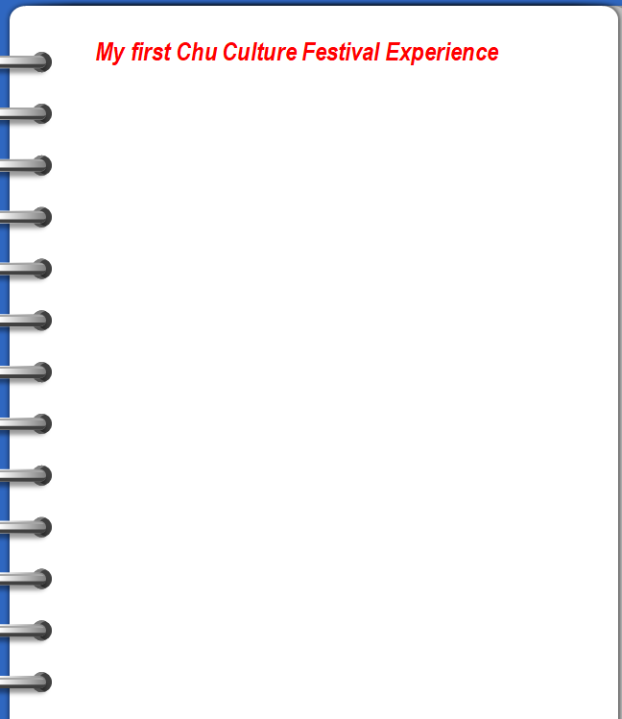

**Assess & appreciate---Checklist**

 *Is the writing well-organised (topic sentence+ time line)?

 *Is there an opening sentence in the first paragraph?

 *Does each paragraph include the necessary details?

 *Does the writer describe his/her feelings and emotions?

 *Does the writer use vivid language descriptions correctly in the writing?

 *Are there any grammar, spelling, or punctuation errors?

\*\*\***设计意图**\*\*\*

引导学生敢于表达，畅谈经历与感受，并且在互评与自评和欣赏美文中查找问题进行提升。

**Activity 6: Summary (1 minute)**

1. What do festivals mean? What should we learn to do?

**festivals**

**framework experience skills theme imitate value a__________ l_____ s__________**

**activity culture We should shoulder our _______**

\*\*\***设计意图**\*\*\*

通过读、写、评的训练，增加了对节日的体验，从而引导进行深入学生思考，节日的意义是什么，背后的真正的文化内涵是什么，引导学生欣赏各民族文化，热爱中华文化，增强文化自信，从而积极传播文化。

**Activity 7: Homework (1 minute)**

1.Finish your writing of the experience and revise the draft according to the checklist .

2.Explore more information about ethnic festivals as well as Chu culture.

\*\*\***设计意图**\*\*\*

启发学生将学习由课堂延伸至课外，继续进行节日探索，并且规范完成整体写作。

**Activity 8: Self-assessment (1minute)**

|  |  |
| --- | --- |
| Yes or No | Learning aims |
|  | 1. enrich your knowledge about festivals |
|  | 2. figure out the structure and language features of a festival experience. |
|  | 3.write your own festival experience using the structure and skills of this passage. |
|  | 4.appreciate and treasure the colourful national cultures and cultivate the cultural awareness. |

\*\*\***设计意图**\*\*\*

引导学生对学习过程进行及时细致的评估与反思，从而查找本课时的掌握情况，便于完善后面的学习与提升。

**The design of the Blackboard**

