**“五四三法”在读后续写中的运用**

**Mary和Lucy重归于好，共同成长**

**—2025届高三金太阳9月开学联考读后续写**

**陕西省礼泉县第一中学 高小聪**

**Contents：**

**Ⅰ.《新课标》命题建议**

**Ⅱ. 读后续写题型特点**

**Ⅲ. 解析五四三法则**

**Ⅳ. 五四三法则应用**

**Ⅴ. 评价你的作品**

**Ⅵ. 读后续写备考启示**

**Ⅰ.《新课标》命题建议**

**1.根据普通高中英语课程的目标和理念确定命题导向和原则**

**2. 全面考查英语学科核心素养**

**3.根据英语语言的实际使用情况命题**

**4.充分考虑学生的生活经验和认知发展水平**

**5.确保试题的信度和效度**

**6.合理制定评分标准**

**—《高中英语新课标》P93-98**

**Ⅱ. 读后续写题型特点**

**读后续写是一种将阅读与写作紧密结合的考查形式，提供的语言材料以故事类记叙文为主。读后续写的要求：提供一段350词左右的语言材料，要求考生依据该材料内容、所给段落开头语进行续写(150词左右)。**

**读后续写考查考生四个方面的能力：①把握短文关键信息和语言特点的能力。②语言运用的准确性和丰富性的能力。③上下文的衔接能力。 ④对语篇结构把控的能力。⑤ 创造性思维的能力。**

**Problems：**

**How to read the given text?**

**How to write the creative continuance?**

**Ⅲ. 解析五四三法则**

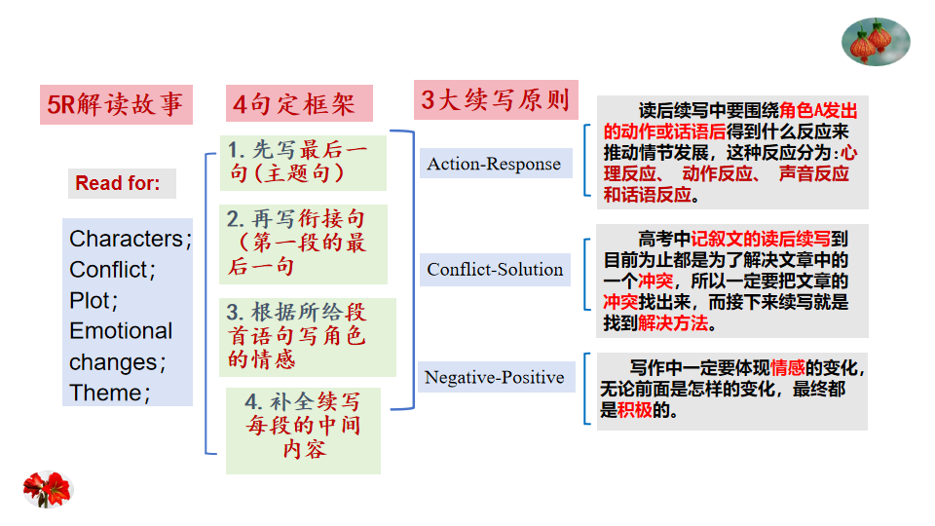

**Ⅳ. 五四三法则应用**

**第二节 （满分25分） 2025届高三金太阳9月开学联考读后续写**

**阅读下面材料，根据其内容和所给段落开头语续写两段，使之构成一篇完整的短文。**

**Mary was a high school girl with a strong sense of style. Her fashionable clothes and trendy hairstyles often set her apart from her classmates. Despite occasional misunderstandings, she remained true to herself.**

**One day, Mary arrived at school with a new hairstyle again. Her classmates surrounded her, asking why she had changed her hair to an ordinary haircut. Mary said that she decided to give up following fashion and devoted herself to studying. Their teacher, Mr Green, happened to hear this and smiled.**

**Once Lucy had a conflict with Mary because she criticized Mary’s strange hairstyle. However, this time, she praised Mary’s ordinary hairstyle and suggested they wear the same style as a sign of solidarity （团结） and friendship. But thinking of their last disagreement, Mary refused.**

**Later, Mary’s mother learned of her daughter’s trouble with Lucy. Recognizing the potential for a positive outcome, Mary’s mother reached out to Lucy’s mother with a heartfelt apology and a kind gesture. Mary’s mother offered to treat both girls to a day of relaxation and self- care, allowing them to choose the same hairstyle that made them feel confident and happy.**

**The experience brought the two families closer, and Mary’s mother taught her daughter the importance of empathy（同理心） and kindness. Together, they selected a book to give it to Lucy as a peace offering and a symbol of their shared sweetness in life.**

**On Sunday, Mary and her mother visited Lucy’s house, where they exchanged gifts. Mary’s sincerity touched Lucy, and they finally forgave each other. During the conversation, the two girls discovered that they shared a common passion for painting. As they painted together, they found themselves sharing stories and laughter.**

**“Mary, your use of colors is amazing!” Lucy screamed, admiring Mary’s work.**

**“Thanks, Lucy,” Mary replied, smiling. “I love the details of your work. We make a great team!”**

**Finally, they agreed to meet up after school to work on an art project, aiming to bring students who had an interest in art and exchange ideas together.**

**注意：**

**1. 续写词数应为150个左右；**

**2. 请按如下格式在答题卡的相应位置作答。**

**Mary and Lucy’s art project soon became a school- wide initiative.**

**One day, Mary entered the classroom to find Lucy wearing the same hairstyle as hers.**

**Step1 5R解读故事**

**Read the material carefully to finish the tasks below.**

**1. Underline the characters in the reading material with the red oil pen.**

**2. What’s the conflict between the characters?**

**3. Use the story mountain model to describe the development/plot of the story and emotional changes.**

**4. What’s the theme of the story（underline the words involved with the theme)?**

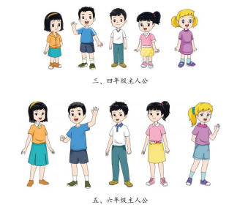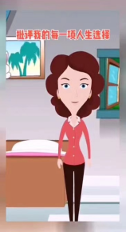

**Her classmates**

**Their teacher,**

**Mr Green**

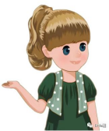

**Mary**

**Lucy**

**Mary’s**

**mother**

**Lucy’s**

**mother**

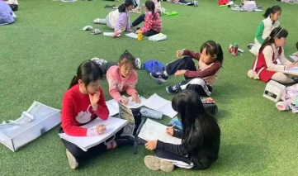

**students who had an interest in art**



**★Read for characters and conflict：**

**Having criticized Mary’s strange hairstyle, Lucy had a ________ with Mary. However, this time, she ________ Mary’s ordinary hairstyle and suggested they wear the same style as a sign of solidarity 团结） and friendship. But thinking of their last _______________, Mary _________.**

**refused**

**disagreement**

**praised**

**conflict**

**★Read for plot and emotional changes:**

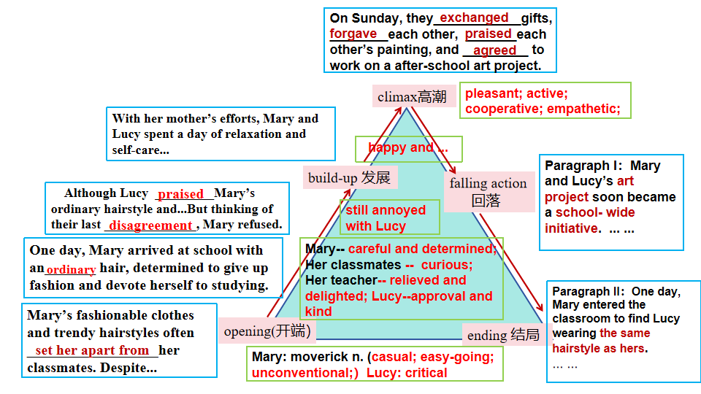

**Predict the story:**

**Interpret the first sentence of every given paragraph**

**Para1. Mary and Lucy’s art project soon became a school- wide initiative.**

**1. How did Mary and Lucy feel about the present situation?**

**2. Who took part in the art project? And What are the characteristics of their works?**

**3. How was the relationship between Mary and Lucy developing?**

**Para2. One day, Mary entered the classroom to find Lucy wearing the same hairstyle as hers.**

**1. Seeing Lucy wearing the same hairstyle as hers, how did Mary feel? What did Mary say and do ? What about Lucy?**

**2. How did the other classmates and Mr Green react to the scene？**

**3. What have we learned from the story?**

**★Read for theme**

**Please underline the words/ phrases reflecting the theme of the passage.**

**Different expressions of the same theme:**

**1.The beauty of life lies in its 1_________ (diverse); we should embrace ___________ (different) and learn from each other.**

**2. Every form of beauty has its __________ (unique), it’s precious to appreciate other forms of beauty with __________(open) .**

**3. Only by putting yourself in others’ shoes and respecting others, will we be able to work and study _________ (effect) in a warm and ___________ (harmony)atmosphere.**

**... ...**

**Step2.4句定框架**

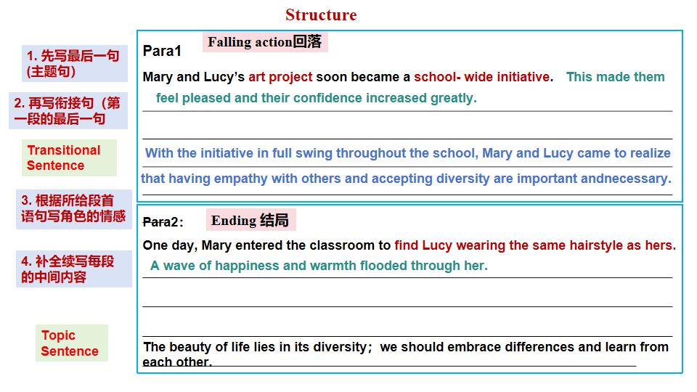

**Step3.完成续写(补全续写每段的中间内容)**

**Possible version1（教师下水作文）：**

**Mary and Lucy’s art project soon became a school-wide initiative. 1_________(please) and confident, they held a painting exhibition，2__________ (appeal) to many students fond of painting. They expressed the love for life and 3___________(highlight) their true-selves with paintbrushes. The exhibition was such a great 4_________(succeed) that Mary and Lucy gained Mr. Green and the classmates’ 5__________(approve) and appreciation. Mary and Lucy’s mothers became 6__________(overjoy). With the initiative in full swing throughout the school, their boat of friendship 7_______________（advance).**

**One day, Mary entered the classroom to find Lucy wearing the same hairstyle 8_____hers. Happiness and warmth 9_________(flood) her, she hugged Mary with both wide arms, , exclaiming in delight, “10_______a pretty and considerate girl!”. A thrill of 11_________(applaud) burst through the classroom and Mr. Green watched Mary and Lucy, 12__________(remark), “Although you both the same hairstyle, your own 13__________(identity) are unique as your work.” As a saying goes, the beauty of life lies in its14__________(diverse); we should embrace differences and 15________(learn) from each other.**

**Possible version2（教师下水作文）：**

**Mary and Lucy's art project soon became a school-wide initiative. Much to their 1_________ (happy), an increasing number of schoolmates 2____________ (participate) in their project, where the students could create their works and exchange ideas about arts or 3___________(person) stories. 4_____________(cooperate) with each other led to their mutual understanding and respect. Furthermore, the majority of 5______________(participate) got to have a sense of community and started to respect each other’s uniqueness. Lucy was also anxious 6__________ (present) a big surprise to Mary.**

**One day, Mary entered the classroom to find Lucy wearing the same hairstyle as hers. She was so 7___________(surprise) that she couldn't believe her eyes, saying excitedly, " How beautiful you look today!" A gentle smile 8__________ (spread) over her face, she expressed joyfully, " I 9_______(prefer) this hairstyle, too." Witnessing their heartfelt scene, the other classmates erupted in 10_________(cheer). Mr. Green spoke earnestly,“Every form of beauty has its 11____________ (unique) , it’s precious to appreciate other forms of beauty with openness. Only in this way, will we be able to work and study 12____________(effect) in a warm and harmonious atmosphere.”**

**Possible version3（教师下水作文）：**

**Mary and Lucy's art project soon became a school-wide initiative. Many painting 1___________ (enthusiastic) showed great interest in the project. Encouraged by so many students, Mary and Lucy 2_________(host) /mounted a painting exhibition themed “ My Story, My Dream”, 3________ the two girl’s talent and potential were not only fully 4__________(bring) out but the other classmates’ contributions had their own characteristics. The 5______________(mean) and successful painting exhibition deepened their mutual understanding and empathy.**

**One day, Mary entered the classroom to find Lucy wearing the same hairstyle hers. Moved and 6_________(excite), Mary stepped up to Lucy and gave her a warm hug, knowing that the same hairstyle was 7_____sign of solidarity and friendship. Mary and Lucy set such a good example to the class that the classmates 8________(learn) from them. The two mothers smiles a 9__________(relief) smile while Mr. Green gave them a thumbs up. From Mary and Lucy's story, we learn that a deep friendship is based on understanding and 10________________(communicate) with each other.**

**Possible version4(范文）：**

**Mary and Lucy’s art project soon became a school- wide initiative. They organized an art exhibition 1_____________(showcase) their work, and invited students to contribute pieces 2______ expressed their unique identities and personal stories. The event was a huge 3_________(succeed) , fostering a sense of community, collaboration, and 4__________ (create) among the students. Meanwhile, Mary and Lucy’s friendship grew 5________(strong), and they became role 6__________(model) for their classmates. They 7_____________(demonstrate) the beauty of embracing one’s true self and the joy that came from supporting and 8_________ (inspire) others.**

**One day, Mary entered the classroom to find Lucy wearing the same hairstyle as 9_____(she) . They smiled at each other. The classmates 10___________ (exclaim), “How beautiful you look!”They erupted in cheers, celebrating the two girls’ 11______ (unit) and newfound friendship. 12 ___________(witness) this heartwarming scene, Mr Green said, “13_________ your hairstyle is simple, its meaning is not. It represents your friendship.”He encouraged the whole class14____________ (embrace) diversity and mutual respect. Everybody present caught the meaning of the teacher’s words. Then the entire classroom turned into a more 15__________ (include) and welcoming place.**

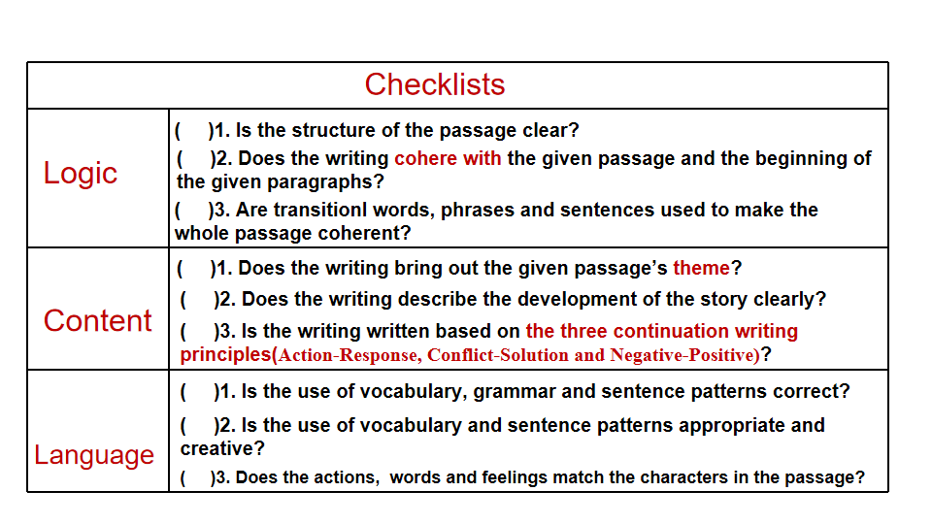**Ⅴ. 评价你的作品**

**Ⅵ.读后续写备考启示**

**1.丰富词汇做基础**

在课堂教学中，将听、说、读、看与写结合，让学生通过多种形式，在不同的语境中反复使用同一“语义场”的词汇，能够灵活的使用课标要求掌握的词汇。

**2.大量阅读拓思路**

加强课外阅读，坚持做阅读笔记，识别文体，概括大意，画出思维导图，摘录语块、精彩的句型并在理解结构的基础上背诵，拓展写作思路。

**3.师生共写优思路**

师生同写一篇作文，老师写下水作文，感受学生写作时的难点，只有这样，才能这正做到有理、有据、有法指导学生进行写作训练，优化写作思路。

**4.三方点评促提升**

自评、互评、师评，对作文从三个角度进行评价，促进学生写作水平提升。

**夫学者，犹种树也，春玩其华，秋登其实。**

**—北齐·颜之推《颜氏家训·勉学篇》**