Chapter 9-10

词汇赏析：

What goes around comes around.善有善报，恶有恶报。

You reap what you sow.种瓜得瓜，种豆得豆

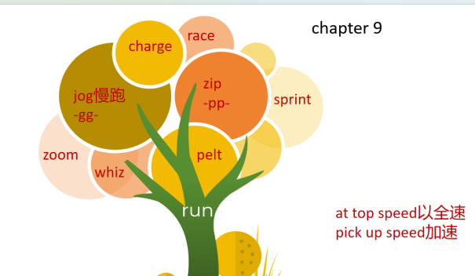

* He slapped Jake on the back.

slap  /slæp/ ( -pp- )

1.to hit sb/sth with the flat part of your hand（用手掌）打，拍，掴

•She slapped his face hard.她狠狠给了他一个耳光。

Underline sentences indicating Kevin’s arrogance.

* He was still boasting to anyone who would listen
* One moment, Beadle was bragging about how easy the race had been.

boast  /bəʊst/ 1. too much pride about sth that you have or can do自夸；自吹自擂

•She is always boasting about how wonderful her children are.她总是夸耀她的孩子们多么出色。

1. to have sth that is impressive and that you can be proud of有（值得自豪的东西）

Chunhui High school boasts many amazing sites.

brag  /bræɡ/ ( -gg- ) ~ to sb (about/of sth)

to talk too proudly about sth you own or sth you have done吹嘘；自吹自擂

•He bragged to his friends about the crime.他向朋友炫耀他的罪行。

* with a dazed look一脸茫然地    on his face, he staggered away in his socks

stagger v.  /ˈstæɡə(r)/ 摇摇晃晃地走

1. [ + adv./prep.]to walk with weak unsteady steps, as if you are about to fall

摇摇晃晃地走；蹒跚；踉跄

•The injured woman staggered to her feet.受伤的女人摇摇晃晃地站起身来。

•He staggered home, drunk.他喝醉酒，踉跄着回了家

* The trainers hopped up into his arms. 跳到他怀里

hop  /hɒp/ ( -pp- )

1.[ + adv./prep.] ( of a person/animal ) to move by jumping on one foot/both feet单脚跳行

He hurt one leg and had to hop everywhere.

A robin was hopping around on the path.一只知更鸟在小路上跳来跳去。

* Jake pulled a face and Anna grinned.做鬼脸=make a face