**Book 2 Unit1 导案**

1. **heritage/'herɪtɪdʒ/ n. 遗产**

**词根词缀：herit-(继承)+age(名词后缀)：继承的东西——遗产**

Living in a glare of our making, we have cut ourselves off from our evolutionary and cultural heritage—the light of the stars and the rhythms of day and night.(2015全国卷II)

生活在我们制造的强光下，我们已经与我们的进化和文化遗产——星星的光和昼夜的节奏——切断了联系。

Organizations that promote traditional Chinese music have preserved the rich musical heritage of many national minorities.

推广中国传统音乐的组织保存了许多少数民族丰富的音乐遗产。

Together, we must help each other preserve the national heritage for future generations.

我们必须携起手来，互相帮助，为后代保护民族遗产。

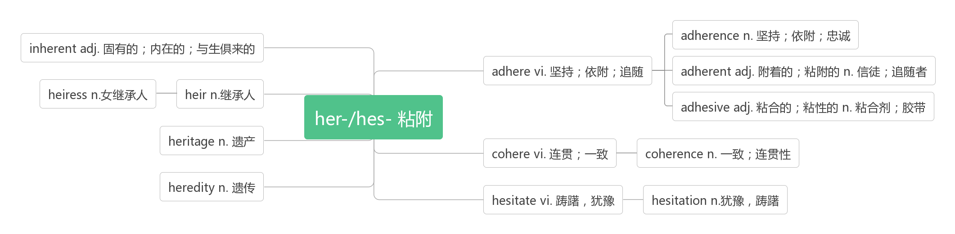

1. **create /kri:'eɪt/ vt. 创造，创作；造成**

Nearpod is a software program that creates a rich context for students to learn vocabulary.(2015安徽)

Nearpod是一个软件程序，为学生学习词汇创造了丰富的上下文环境。

Kahoot software can be used to create grammar tests which can be graded on a network.（2015安徽）

Kahoot软件可以用来创建能在网络上进行评分的语法测试。

Additionally, group exercise creates a community feel and the shared common goal motivates participants to work hard.

此外，集体运动创造了一种社区感，共同的目标激励着参与者努力工作。(2015福建)

**creative /kri:'eitiv/adj.创造性的；有创意的**

Artists make a living through their creative work.(2018江苏卷) 艺术家通过他们的创造性工作谋生。

Here I will stress some smarter and more creative examples of climate adaptation.(2017江苏)

这里我将着重介绍一些更聪明、更有创意的适应气候变化的例子

**creatively /kri:'eitivli/adv.创造性地；有创造力地**

A far better approach would be to teach children to think creatively so that they could learn to interpret and apply the knowledge available online.

更好的方法是教孩子们创造性地思考，这样他们就能学会解释和应用网上的知识

**creativity /,kri:ei'tiviti/ n.创造性；创造力**

His presence meant that I had an unexpected teaching assistant in class whose creativity would infect other students.(2016全国I)

他的出现意味着我在课堂上有了一个意想不到的助教，他的创造力会感染其他学生。

True creativity is the ability to take something existing and create something new from it.(2014新课标I)

真正的创造力是把现有的东西创造成新的东西的能力。

**creature /ˈkriːtʃə(r)/n.生物**

Like most other creatures, we do need darkness.(2015浙江卷) 就像其他的生物一样，我们也的确需要黑暗。

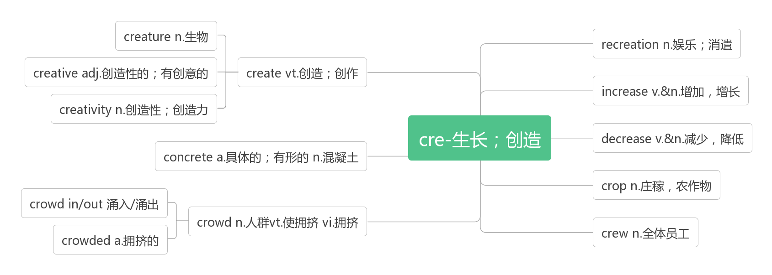

1. **temple /'templ/ n.寺庙**

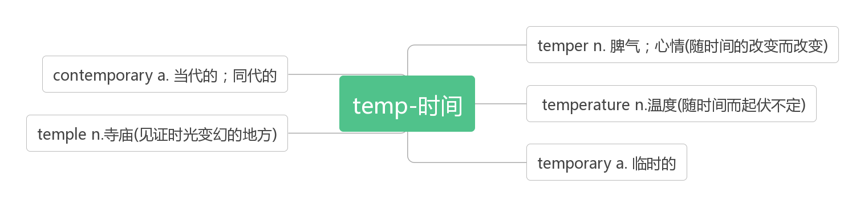

1. **relic /'relik/ n.遗物；遗迹**

**破拆法：re(再次)+li(lie躺)+c(形容词后缀)：再次躺在你面前的——遗物，遗迹**

**cultural relics 文化遗产**

It's loaded with ceramic artifacts and historical relics.

里面装满了陶瓷制品和历史文物。

1. **mount /maunt/ n.山峰vt.爬上；骑上;登上vi.上升；上涨**

Why did they choose to conquer Mount Kilimanjaro?(2015上海) 为什么他们选择征服乞力马扎罗山?

Grazing goats ignored us as we mounted the hill toward the church. 当我们登上小山前往教堂时，吃草的山羊无视了我们。

he took the bicycle, mounted it, and rode to the station. 他取了自行车，上了车，然后骑到了车站.

Jonathan nodded and began to mount the stairs, feeling his excitement grow with each step.

乔纳森点点头，开始上楼梯，感觉他的兴奋随着每一步而增长。

The costs mount up when you buy a home. 买房时成本上升。

His anxiety mounted as messages were left unanswered. 由于未得到答复，他的焦虑加剧了。

**mountain/'maʊntn/ n. 山；山脉**

**mountainous /ˈmaʊntənəs/ adj. 多山的；巨大的；山一般的**

1. **former/ˈfɔ:mə/adj.以前的; (两者中)前者的**

Maurice Ashley was kind and smart, a former graduate returning to teach.

Through the years, I'd run into former students who would provide updates on old classmates.

The former.... The latter....前者……后者……

Work and play are both necessary to health; the latter gives us rest, and the former gives us energy.

工作和娱乐对健康都是很必要的，后者让我们获得休息，前者赋与我们精力。

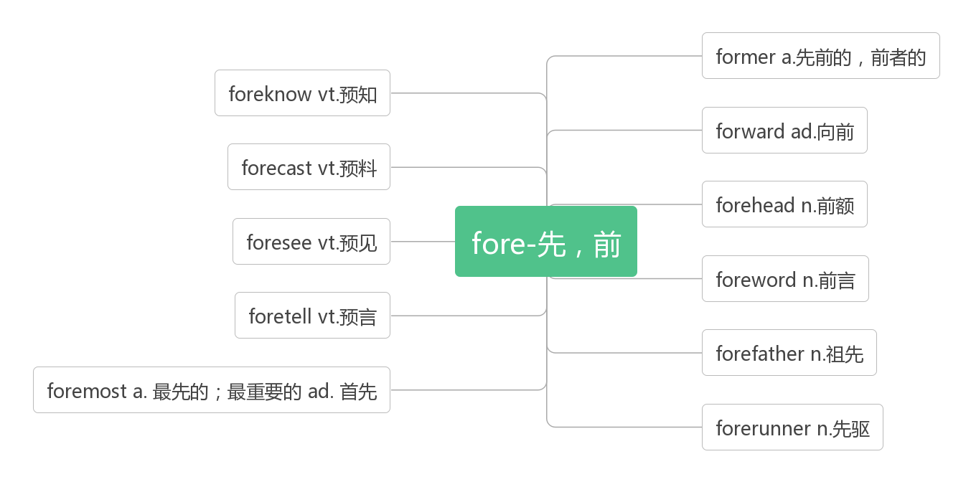

1. **clue /klu:/ n.线索；提示**

There is no clue to the identity of the thief. 没有确定窃贼身分的线索。

We have no clue as to where she went after she left home. 我们对她离家後去往何处毫无线索。

1. **preserve /prɪ'zɜːv/ vt. 保存；保护；维持；腌制n. 保护区**

You don’t preserve a plane by keeping it on the ground. You preserve it by keeping it in service.

保养飞机不是让它停留在地面，而是要把它投入使用。

As the Kennedy Center's artistic adviser for jazz, Moran hopes to widen the audience for jazz, make the music more accessible, and preserve its history and culture.(2017全国I) 作为肯尼迪中心的爵士乐艺术顾问，莫兰希望扩大爵士乐的听众范围，使爵士乐更容易被人接受，并保护爵士乐的历史和文化。

A machine with a specific purpose has another quality, one that we usually associate with living things: a wish to preserve its own existence.(2017北京)

一台有特定用途的机器还有另一种特性，我们通常把它与生物联系在一起：希望保持其自身的存在。

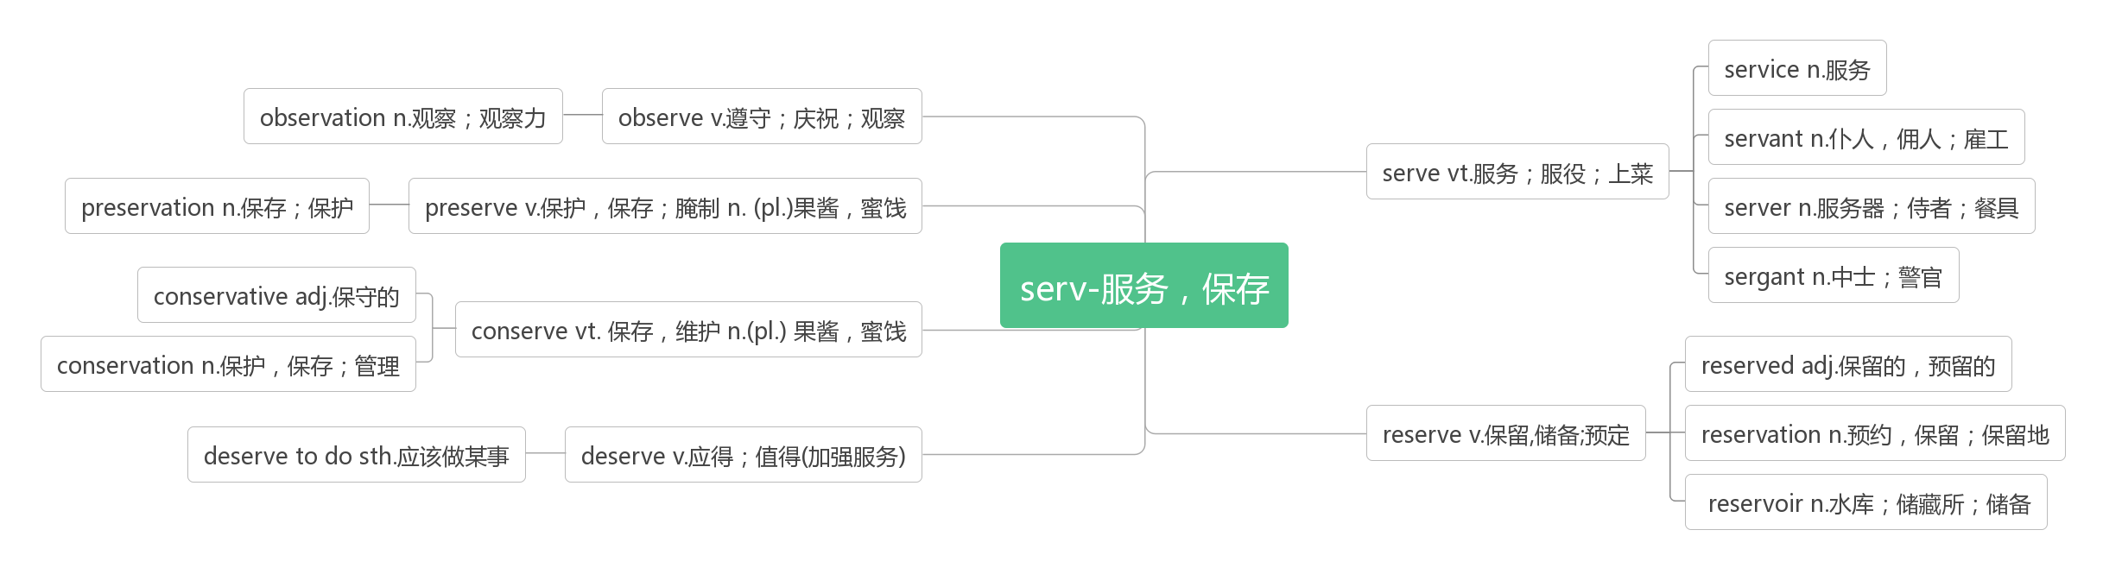

1. **promote /prəˈməʊt/vt.促进；提升；推销；发扬**

The governments argue that this will help foreigners better join the society and promote understanding across cultures.(2017浙江)

政府认为这将帮助外国人更好地融入社会，促进不同文化之间的理解。

They could help promote other industries whether they lie inside or outside arts.(2018江苏)

他们可以有助于促进其他行业，不管他们是在艺术内部还是外部。

Painters, digital media experts, photographers, booking agents and promoters are hired to sell tickets and promote the event.(2018江苏)他们聘请了画家、数字媒体专家、摄影师、票务代理和推广人员来售票和推广活动

**promotion/prəˈməʊʃn/ n.促进；提升；推销；发扬**

Joining the firm as a clerk, he got rapid promotion,and ended up as a manager.(2010天津)

他进公司当职员，很快就升职了，最后当上了经理。

“Once I get a promotion, I’ll be happy,” they think.(2012江苏)

“一旦我升职了，我就会很开心。”他们想。

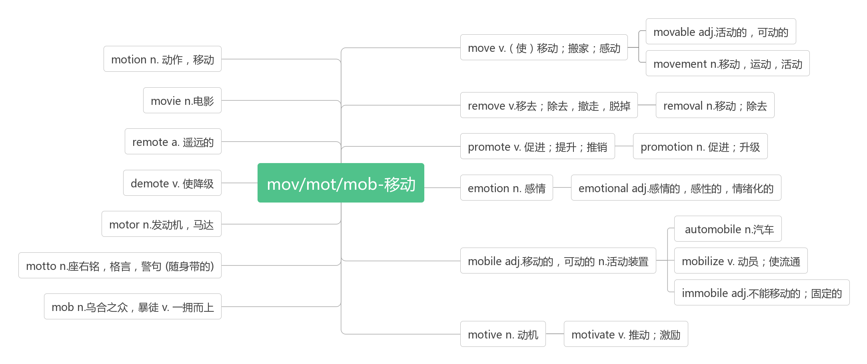

1. **cypress /'saipres/ n.柏树**

破拆法：cy(处于)+press(按压) 助记：松柏处于风刀霜剑的逼压之下依然傲然挺立。

1. **apply /əˈplaɪ/vi.申请 vt.应用**

**apply to sb. for sth. 向某人申请……**

**apply sth to …把……应用于**

**apply to 适用于**

**apply oneself to 致力于**

In order to pass the class ,among other criteria, we had to write a paper on how we plan to apply what we would learn in class to our future professions.(2018全国I) 为了通过这门课，在其他标准中，我们必须写一篇论文，关于我们如何计划将课堂上学到的知识应用到未来的职业中。

The solution is obvious though perhaps not easy to apply: always handle the most difficult job first.(2016天津)

解决方案显而易见，但可能并不容易应用:总是先处理最困难的工作。

When the time came to make the final decision for a course, I decided to apply for the one that reflected my interest.(2016浙江)

当我要为一门课程做最后的决定时，我决定申请一门反映我兴趣的课程

Later I decided to apply my previous experience to learning how to read and write.(2016天津)

后来我决定用我以前的经验来学习如何读和写。

What do the classic rules mentioned in the text apply to?(2016全国III)

课文中提到的经典规则适用于什么?

Apply these principles in your everyday life in a conscious way.(2012浙江)

有意识地将这些原则运用到你的日常生活中。

When Shaw lost his sight, his wife suggested he apply for a guide dog. (2010天津)

肖失明后，他的妻子建议他去申请一只导盲犬。

A great man once said it is necessary to drill as much as possible, and the more you apply it in real situations, the more natural it will become.

一位伟人曾说，尽可能多的操练是非常必要的，你越多地将它用到实际生活中，它就变得越自然。

**application [æplɪˈkeɪʃ(ə)n] n. 申请；应用**

**app n.应用程序；应用软件**

In my application letter, I was careful to express how much I wanted to see France.(2013浙江)

在我的求职信中，我很谨慎地表达了我有多想去法国看看。

The second aspect relates to the application of these policies by departments.(2013全国I)

Knowledge is a fruit tree, and the application of knowledge is just like the fruit in the tree.

知识是果树，知识的应用就是果树结的果实。

**applicant [ˈæplɪkənt] n.申请人**

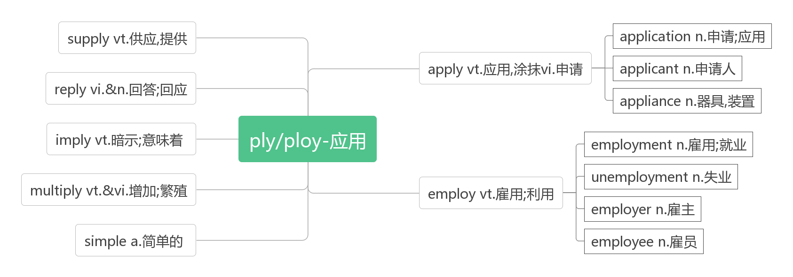

1. **take part in参与（某事）；参加（某活动）**

|  |  |
| --- | --- |
| join | 指加入某个组织成为其中一员；还可表示加入某人一起。 |
| join in | 指参加正在进行的活动。 |
| take part in | 指参加群体性活动并在其中起积极作用。part前有[形容词](http://www.so.com/s?q=%E5%BD%A2%E5%AE%B9%E8%AF%8D&ie=utf-8&src=internal_wenda_recommend_textn" \t "https://wenda.so.com/q/_blank)修饰时，要用不定冠词。 |
| attend | 意为“出席”, 是正式用语，指出席会议、婚礼、典礼；听报告、讲座等。 |

When did your brother join the army? 你哥哥什么时候参军的？

She joined the Young Pioneers. 她加入了少先队。

Will you join us in the discussion? 你参加我们的讨论吗？

He'll join us in singing the song. 他将和我们一道唱歌。

Come along, and join in the ball game. 快，来参加球赛。

Why didn't you join in the talk last night? 昨晚你为什么没加入座谈？

We'll take part in social practice during the summer vacation.  暑假期间我们将参加社会实践。

Lincoln took an active part in polities and was strongly against slavery. 林肯积极参加政治活动，强烈反对奴隶制。

He'll attend an important meeting tomorrow. 他明天要参加一个重要的会议。   
I attended his lecture. 我听了他的讲座。

1. **give way to让步于；屈服于**

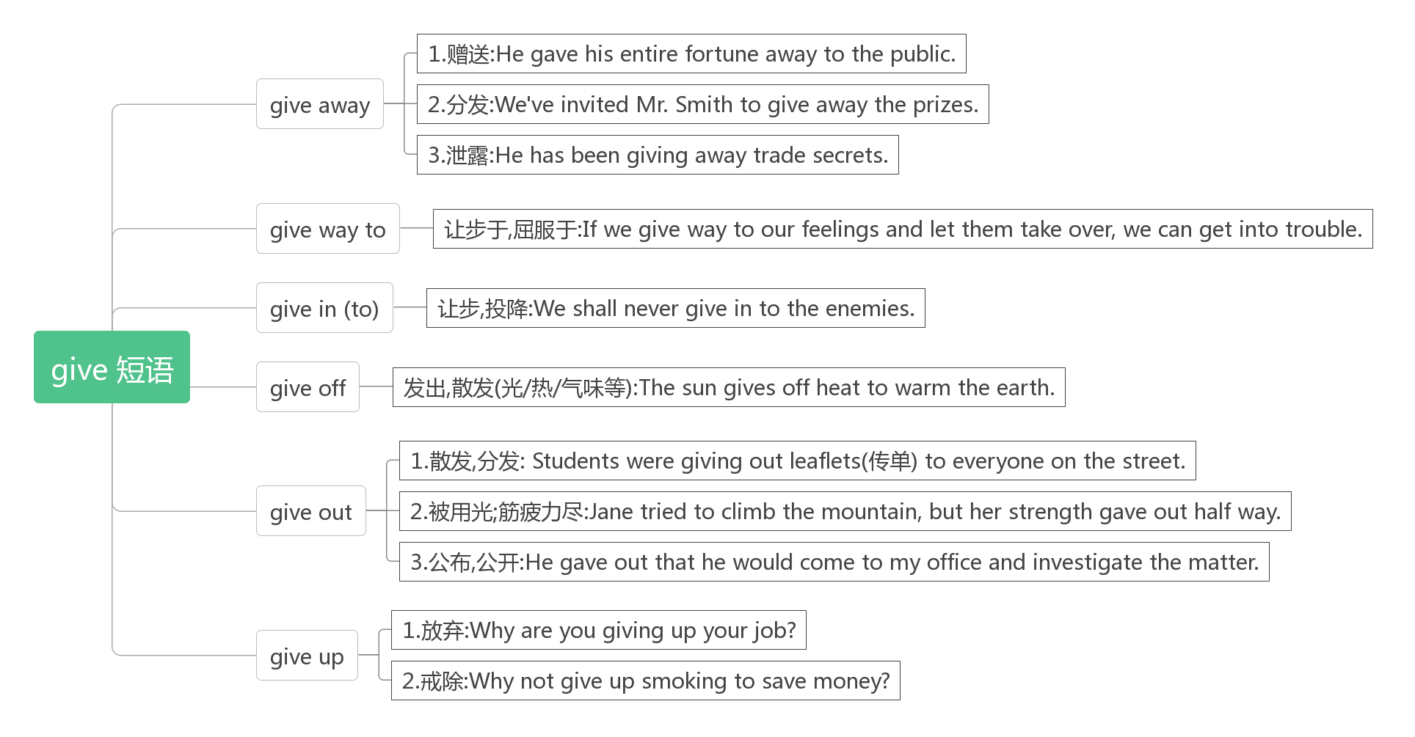

1. **balance /ˈbæləns/ n.天平；平衡 vt.平衡, 权衡**

**词根词缀：ba(bi-二)+lance(盘子)：架在天平上的两个盘子——平衡**

**on balance 总地来说**

**keep (a) balance 保持平衡**

**lose one’s balance 失去平衡**

**balance A against B 权衡A与B的利弊**

Freddy was an average student, but not an average person. He had the rare balance of fun and compassion(同情). (2017全国II) 弗雷迪是一个普通的学生，但不是一个普通人。他拥有罕见的快乐与同情心的之间的平衡。

Rich countries gain more from powerful Nios, on balance, than they lose.(2016江苏)

总的来说，发达国家从强大的厄尔尼诺现象中得到的比失去的要多。

The writer strongly believes that we should set ambitious goals that can balance the input and output.(2014北京)

作者强烈认为，我们应该设定雄心勃勃的目标，以平衡投入和产出。

Over the past two centuries, the Industrial Revolution has broken this balance between the city and the country.(2013北京)

在过去的两个世纪里，工业革命打破了城市和乡村之间的平衡。

Some people are against killing wolves because wolves help to keep the ecological balance in the wilderness.(2010江苏)

有些人反对捕杀狼，因为狼有助于保持荒野的生态平衡。

The wolves keep the deer population from becoming too large,and that keeps a balance in the wilderness plant life.(2010江苏) 狼群使鹿的数量不致过多，这就使野生植物保持了平衡。

**balanced adj.平衡的**

keep a balanced diet保持平衡的膳食

It makes sense to eat a reasonably balanced diet when slimming. 在减肥过程中保持饮食的营养相对均衡是明智的。

1. **lead/liːd/ vt. 领导；带领；引导n. 领导，领头；铅**

**lead...to 把……领到……**

**lead to 导致；通向**

A man may lead a horse to the water, but he cannot make it drink. 一个人可以把马带到河边，但他不能令它饮水。

Dreams are like stars, you may never touch them, but if you follow them they will lead you to your destiny.

梦想就像星星，你永远无法触碰，但如果你跟随它们，它们将引领你抵达自己的命运之路。

Fear and anger always lead to the dark side. 恐惧和愤怒总会带来黑暗。

No road of flowers leads to glory. 没有一条通往光荣的道路是铺满鲜花的。

It is a rough road that leads to the heights of greatness. 崎岖不平的道路将通往伟大崇高之地。

The rough road often leads to the top. 艰难的道路经常通往高处。

**leader [ˈliːdə(r)] n. 领袖，领导人**

Innovation distinguishes between a leader and a follower.(Steve Jobs) 领袖和跟风者的区别就在于创新。

**leading [ˈliːdɪŋ] a. 最主要的，第一位的**

a leading actor 主角

1. **dam /dæm/ n.水坝；大坝**

The flood damaged the dam. 洪水损坏了大坝

1. **propose [prə'pəʊz/ vt.提议；建议vi.求婚**

And where do you propose building such a huge thing? 那么你打算在哪里建这么一个庞然大物呢？

Britain is about to propose changes to some institutions. 英国将提议对一些机构进行改革。

We propose an early start tomorrow. 我们建议明天一早就出发。

When I know, I will fly directly to her, and propose. 当我知道的时候，就会直接飞向她，向她求婚。

**proposal /prə'pəʊz(ə)l/ n.提议；建议; 求婚**

**make a proposal 提出建议**

I had my proposal turned again.(2011江苏)

The proposal put forward by Dobrindt aims to help promote fully automatic driving(2017天津)

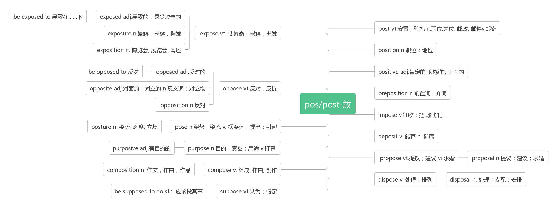

1. **protest/'prəʊtest/vt.vi.&n. 抗议；声明**

**词根词缀：pro-(前，未)+test(验证)：未通过验证——抗议**

[Satire](https://cn.bing.com/dict/search?q=Satire&FORM=BDVSP6&mkt=zh-cn) [is](https://cn.bing.com/dict/search?q=is&FORM=BDVSP6&mkt=zh-cn) [often](https://cn.bing.com/dict/search?q=often&FORM=BDVSP6&mkt=zh-cn) [a](https://cn.bing.com/dict/search?q=a&FORM=BDVSP6&mkt=zh-cn) [form](https://cn.bing.com/dict/search?q=form&FORM=BDVSP6&mkt=zh-cn) of [protest](https://cn.bing.com/dict/search?q=protest&FORM=BDVSP6&mkt=zh-cn) [against](https://cn.bing.com/dict/search?q=against&FORM=BDVSP6&mkt=zh-cn) [injustice](https://cn.bing.com/dict/search?q=injustice&FORM=BDVSP6&mkt=zh-cn)[.](https://cn.bing.com/dict/search?q=.&FORM=BDVSP6&mkt=zh-cn)

[讽刺](https://cn.bing.com/dict/search?q=%E8%AE%BD%E5%88%BA&FORM=BDVSP6&mkt=zh-cn)[往往](https://cn.bing.com/dict/search?q=%E5%BE%80%E5%BE%80&FORM=BDVSP6&mkt=zh-cn)[是](https://cn.bing.com/dict/search?q=%E6%98%AF&FORM=BDVSP6&mkt=zh-cn)[一种](https://cn.bing.com/dict/search?q=%E4%B8%80%E7%A7%8D&FORM=BDVSP6&mkt=zh-cn)[对](https://cn.bing.com/dict/search?q=%E5%AF%B9&FORM=BDVSP6&mkt=zh-cn)[不公正](https://cn.bing.com/dict/search?q=%E4%B8%8D%E5%85%AC%E6%AD%A3&FORM=BDVSP6&mkt=zh-cn)[的](https://cn.bing.com/dict/search?q=%E7%9A%84&FORM=BDVSP6&mkt=zh-cn)[抗议](https://cn.bing.com/dict/search?q=%E6%8A%97%E8%AE%AE&FORM=BDVSP6&mkt=zh-cn)[形式](https://cn.bing.com/dict/search?q=%E5%BD%A2%E5%BC%8F&FORM=BDVSP6&mkt=zh-cn)[。](https://cn.bing.com/dict/search?q=%E3%80%82&FORM=BDVSP6&mkt=zh-cn)

When the cry of protest is sounded, there are those who will hear it and act.

当抗议的呼声传播开来的时候，有人会听见，有人会采取行动的。

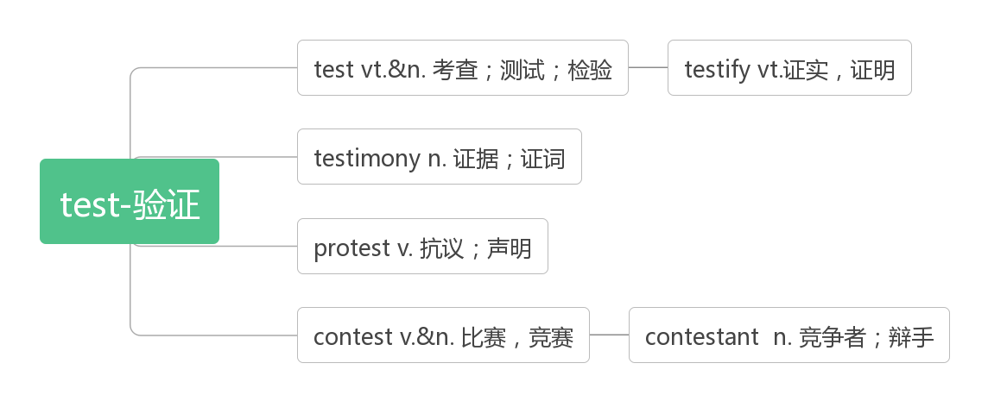

1. **likely /'laikli/ adj.&adv.可能的/地**

[likely outcome](https://cn.bing.com/dict/search?q=likely outcome&FORM=BDVSP6&mkt=zh-cn)/cost/[effec](https://cn.bing.com/dict/search?q=likely effect&FORM=BDVSP6&mkt=zh-cn)t可能的结果/花费/影响

At the last moment Tom decided to put in a new character to make the story seem more likely.(2013全国I)

在最后一刻，汤姆决定加入一个新角色，使故事看起来更有可能

The more positive an article, the more likely it was to be shared.(2016全国III)

一篇文章越积极，就越有可能被分享。

His efforts most likely saved the woman's life.(2016全国I)

他的努力很可能救了那个女人的命。

**Sb. be likely to do sth. 某人有可能做某事**

If you find something you love doing outside of the office, you'll be less likely to bring your work home.(2016全国II)

如果你在办公室之外找到了你喜欢做的事情，你就不太可能把工作带回家了。

By cramming(死记硬背), a student may learn the subject well enough to get by on the examination, but he is likely soon to forget almost everything he learned. (2012全国II)

通过死记硬背, 学生可以学好这门学科, 足以通过考试, 但他很可能很快会忘记几乎所有他学习的知识。

So it seems that this generation of parents is much more likely than parents of 30 years ago to treat their children as friends. (2007北京) 所以这一代的父母似乎比30年前的父母更有可能把他们的孩子当作朋友。

**It is like that... 有可能……**

It is likely that babies are not born knowing this basic fact of the universe.(2016浙江)

婴儿出生时可能不知道这个宇宙的基本情况。

While it is likely that he understood very little of the books, they were his introduction to classical paintings.(2017浙江)

虽然他可能对这些书知之甚少，但它们是他对古典绘画的入门指导。

It’s more likely that none of us start a conversation because it’s awkward and challenging, or we think it’s annoying and unnecessary.(2018全国II)

更有可能的情况是，我们中没有人会因为尴尬和有挑战性而开始一场对话，或者我们认为这是恼人和不必要的。

1. **turn to转向；求助于**

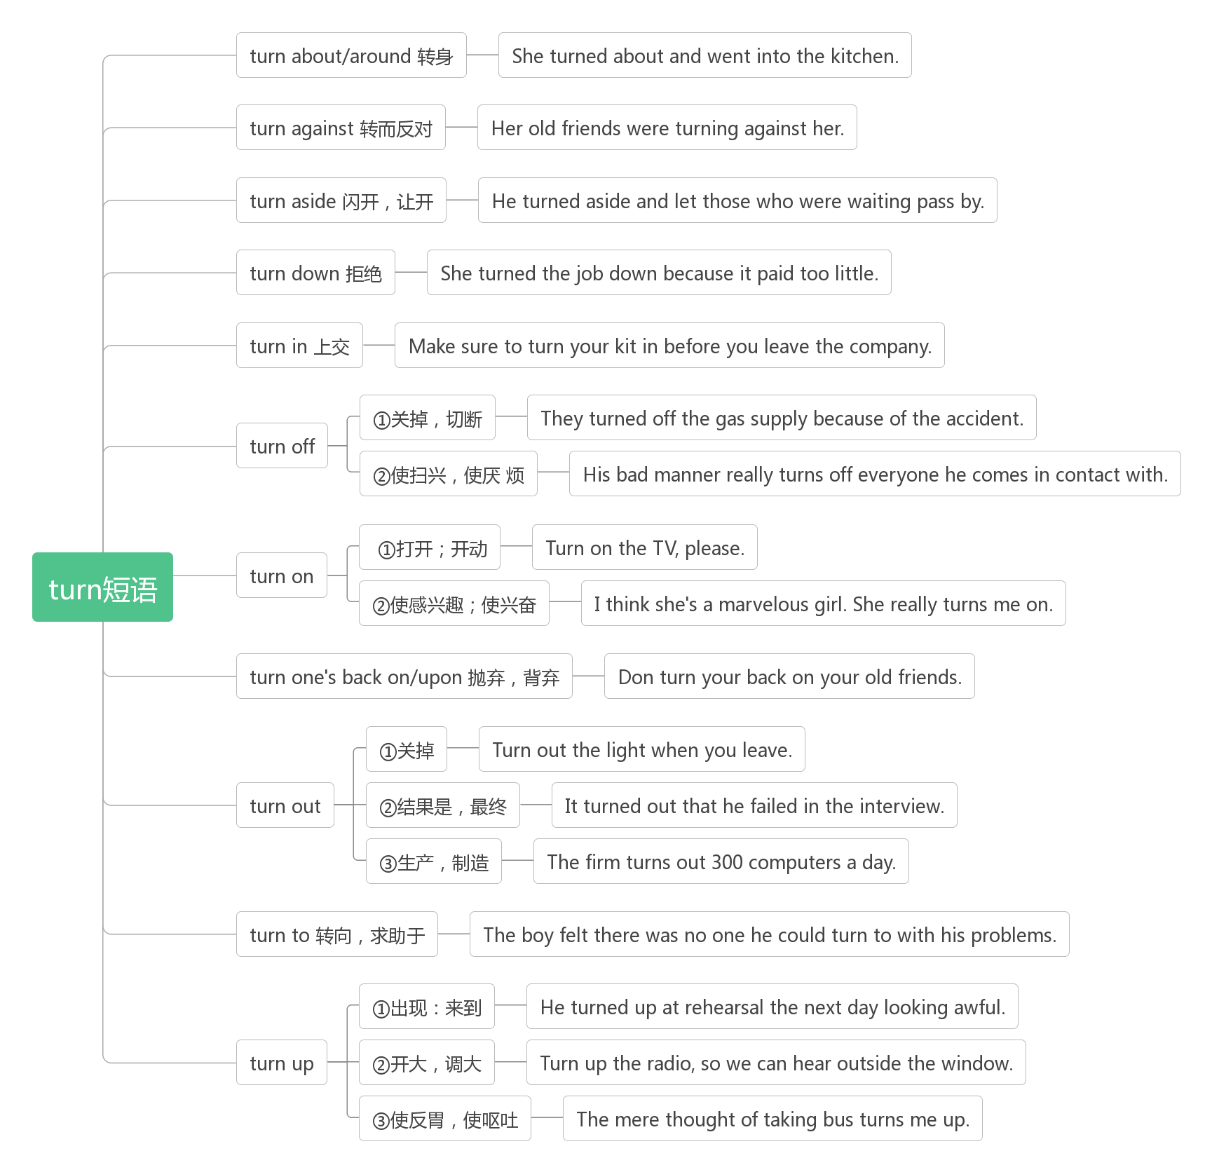

1. **committee /kə'mɪti/ n.委员会**

**词根词缀：com(共同)+mit(送)+ee(人)：共同送来的人选——委员会**

You'll get in more questions, the discussion will be tailored to what you need most help on, and two-party communication is almost always more productive than committee work.(2015浙江)

你会遇到更多的问题，讨论将根据你最需要的帮助进行调整，两党沟通几乎总是比委员会工作更有成效。

1. **establish/ɪˈstæblɪʃ/vt.建立；创立**

**词根词缀：e(=ex外)+stab(stand站)+ish(动词后缀)：使……站到外面来——建立，创立**

Banks, for example, encourage staff at call centers to use customer data to establish instant and good relationship with them. (2011浙江) 例如，银行鼓励呼叫中心的员工利用客户数据与他们建立即时的良好关系。

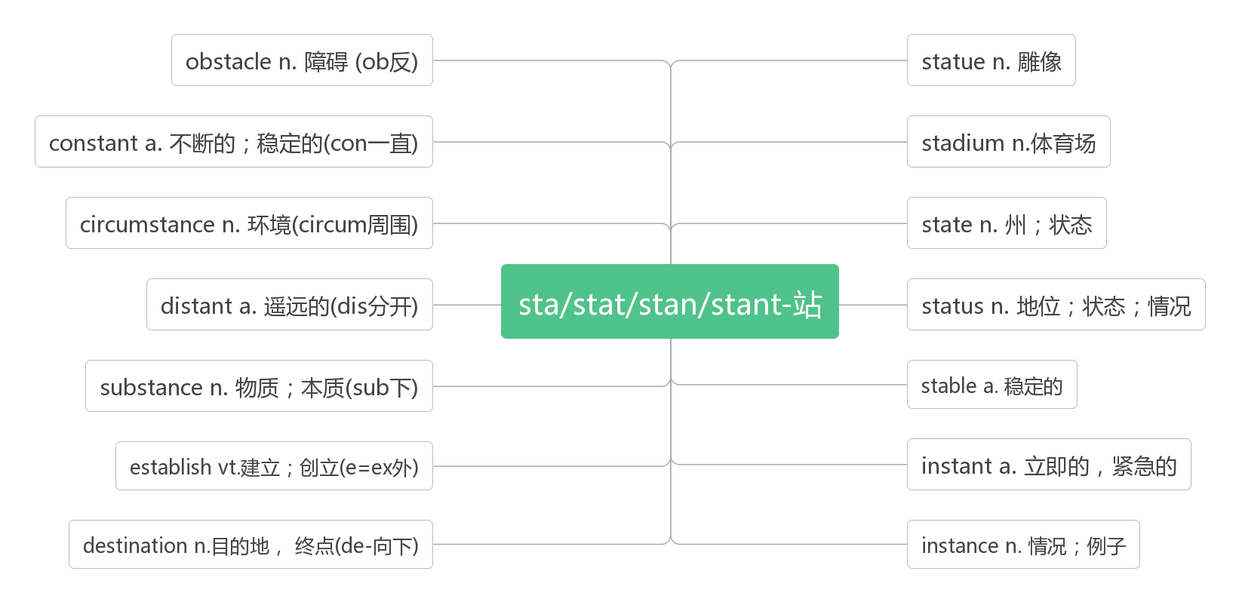

1. **limit /'limit/ vt.&n.限制；限定**

It does point out that many parents still limit electronic reading, mainly due to concerns about increased screen time.(2018全国II) 它确实指出，许多父母仍然限制电子阅读，主要是因为担心屏幕时间的增加。

The speed limit for bicycles on campus is 15mph, unless otherwise posted.(2012天津)

校园里自行车的速度限制是每小时15英里，除非另有规定。

The only limit to our realization of tomorrow will be our doubts of today.

实现明天理想的唯一障碍是今天的疑虑。

The limits of my language are the limits of my world.

语言的限制就是对我的世界的限制。

**limit...to... 把……限制在……范围内**

Don’t limit yourself. Many people limit themselves to what they think they can do. You can go as far as your mind lets you.

不要束缚自己脚步，很多人只做那些自己认为可以做的事情，其实，心有多大，舞台就有多大。

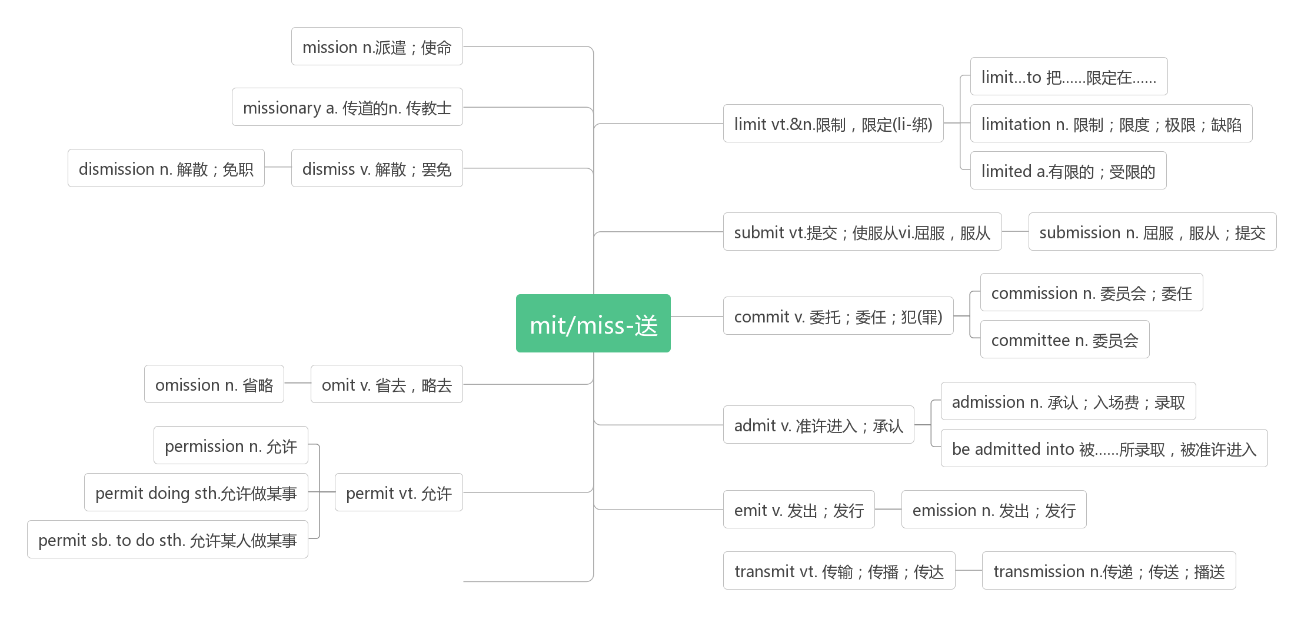

1. **prevent /prɪ'vent/ vt.防止；阻止；阻碍**

**词根词缀：pre-(前)+vent(走)：走到前挡住——防止，阻止**

Good watch prevents misfortune. 谨慎消灾。

Learn from the mistakes of others and prevent your own.前人犯错，后人戒之。

However, anger can easily turn violent, and it is best to know the reasons for anger to appear in order to prevent its presence. (2018北京) 然而，愤怒很容易转化为暴力，最好知道愤怒产生的原因，以防止它的出现。

The fats in fish are thought to help prevent heart disease.(2016全国III) 鱼中的脂肪被认为有助于预防心脏病。

As always, you should stretch(伸展) at least ten minutes before each run to prevent injuries.(2015全国II)

像往常一样,你应该每次运行前至少伸展十分钟,以防止受伤。

**prevent...(from) doing sth.**

If you like, a squeeze of fresh lemon juice on the bananas will prevent them turning brown. (2018全国II)

如果你喜欢，在香蕉上挤一点新鲜的柠檬汁可以防止香蕉变黄。

These gases act like the glass of a greenhouse in that they allow energy from the Sun to enter but prevent energy from leaving. (2008江苏) 这些气体就像温室的玻璃，它们允许来自太阳的能量进入，但阻止能量离开。

Don’t use a net in landing the fish and release it quickly to prevent it from dying.(2008全国I)

不要用渔网捞鱼，迅速将它们放掉，以免其死亡。

You can prevent this happening by following a few careful steps.(2007江苏)

您可以通过以下几个谨慎的步骤来防止这种情况的发生。

**prevention/prɪ'venʃn/ n. 预防；阻止；妨碍**

Prevention is better than cure. 预防胜于治疗。

What is the main duty of the fire prevention professionals?(2018天津) 消防专业人员的主要职责是什么?

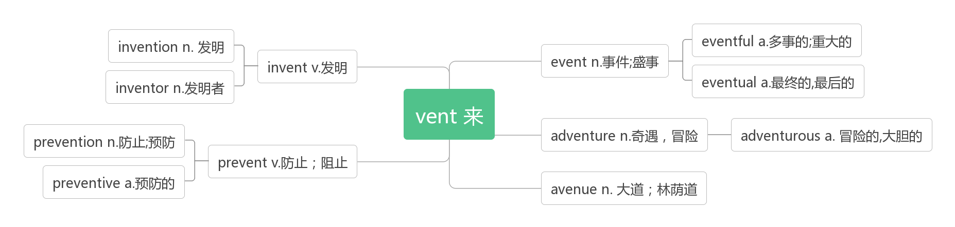

1. **loss n. 损失；遗失；迷茫**

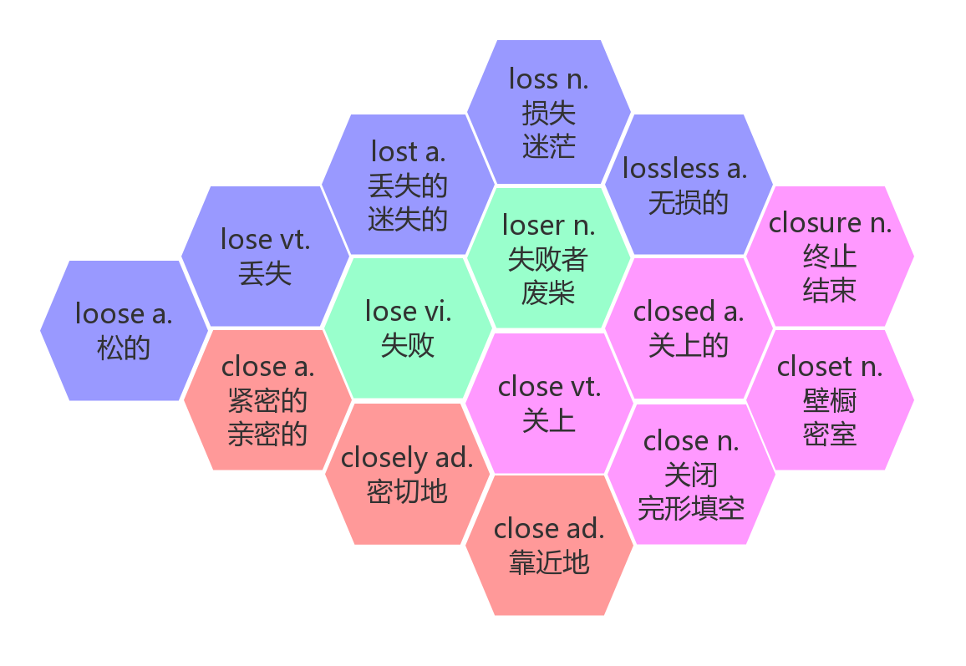

**lose one’s way 迷路**

**at a loss 怅然若失，迷茫**

**get lost 迷路**

**be lost in 沉迷于，迷失于**

Grasp all, lose all.贪多必失。

You've got to lose face many times before you can make it. 你在成功之前总会多次丢脸。

If you were wrong, admit it. You won't lose dignity, but will gain respect.

如果你错了，那就承认。你不会因此而失去尊严，反而会赢得尊重。

One never loses anything by politeness.讲礼貌不吃亏。

Success is the ability to go from one failure to another with no loss of enthusiasm.(Winston Churchill)

成功是，你一次又一次失败，却仍没有失去热情。

The fatal enemy of heart is the loss of time.心灵的致命的仇敌就是时间的腐蚀。

Visit the palace and its various historic gardens, which include the famous maze(迷宫) where it is easy to get lost!(2015全国) 参观一下宫殿和它的各种历史园林,其中包括著名的很容易迷路的迷宫。

[When](https://cn.bing.com/dict/search?q=When&FORM=BDVSP6&mkt=zh-cn) [a](https://cn.bing.com/dict/search?q=a&FORM=BDVSP6&mkt=zh-cn) [child](https://cn.bing.com/dict/search?q=child&FORM=BDVSP6&mkt=zh-cn) [has](https://cn.bing.com/dict/search?q=has&FORM=BDVSP6&mkt=zh-cn) become [conditioned](https://cn.bing.com/dict/search?q=conditioned&FORM=BDVSP6&mkt=zh-cn) [to](https://cn.bing.com/dict/search?q=to&FORM=BDVSP6&mkt=zh-cn) [life](https://cn.bing.com/dict/search?q=life&FORM=BDVSP6&mkt=zh-cn) [in](https://cn.bing.com/dict/search?q=in&FORM=BDVSP6&mkt=zh-cn) [a](https://cn.bing.com/dict/search?q=a&FORM=BDVSP6&mkt=zh-cn) [city](https://cn.bing.com/dict/search?q=city&FORM=BDVSP6&mkt=zh-cn) [,](https://cn.bing.com/dict/search?q=,&FORM=BDVSP6&mkt=zh-cn) [he](https://cn.bing.com/dict/search?q=he&FORM=BDVSP6&mkt=zh-cn) [may](https://cn.bing.com/dict/search?q=may&FORM=BDVSP6&mkt=zh-cn) [feel](https://cn.bing.com/dict/search?q=feel&FORM=BDVSP6&mkt=zh-cn) quite at [a](https://cn.bing.com/dict/search?q=a&FORM=BDVSP6&mkt=zh-cn) [loss](https://cn.bing.com/dict/search?q=loss&FORM=BDVSP6&mkt=zh-cn)in [any](https://cn.bing.com/dict/search?q=any&FORM=BDVSP6&mkt=zh-cn) [other](https://cn.bing.com/dict/search?q=other&FORM=BDVSP6&mkt=zh-cn) [environment](https://cn.bing.com/dict/search?q=environment&FORM=BDVSP6&mkt=zh-cn)[.](https://cn.bing.com/dict/search?q=.&FORM=BDVSP6&mkt=zh-cn)

[当](https://cn.bing.com/dict/search?q=%E5%BD%93&FORM=BDVSP6&mkt=zh-cn)[一个](https://cn.bing.com/dict/search?q=%E4%B8%80%E4%B8%AA&FORM=BDVSP6&mkt=zh-cn)[孩子](https://cn.bing.com/dict/search?q=%E5%AD%A9%E5%AD%90&FORM=BDVSP6&mkt=zh-cn)[对](https://cn.bing.com/dict/search?q=%E5%AF%B9&FORM=BDVSP6&mkt=zh-cn)[城市](https://cn.bing.com/dict/search?q=%E5%9F%8E%E5%B8%82&FORM=BDVSP6&mkt=zh-cn)[生活](https://cn.bing.com/dict/search?q=%E7%94%9F%E6%B4%BB&FORM=BDVSP6&mkt=zh-cn)[习惯](https://cn.bing.com/dict/search?q=%E4%B9%A0%E6%83%AF&FORM=BDVSP6&mkt=zh-cn)[以后](https://cn.bing.com/dict/search?q=%E4%BB%A5%E5%90%8E&FORM=BDVSP6&mkt=zh-cn)[，](https://cn.bing.com/dict/search?q=%EF%BC%8C&FORM=BDVSP6&mkt=zh-cn)[他](https://cn.bing.com/dict/search?q=%E4%BB%96&FORM=BDVSP6&mkt=zh-cn)[在](https://cn.bing.com/dict/search?q=%E5%9C%A8&FORM=BDVSP6&mkt=zh-cn)[任何](https://cn.bing.com/dict/search?q=%E4%BB%BB%E4%BD%95&FORM=BDVSP6&mkt=zh-cn)[其他](https://cn.bing.com/dict/search?q=%E5%85%B6%E4%BB%96&FORM=BDVSP6&mkt=zh-cn)[环境](https://cn.bing.com/dict/search?q=%E7%8E%AF%E5%A2%83&FORM=BDVSP6&mkt=zh-cn)[里](https://cn.bing.com/dict/search?q=%E9%87%8C&FORM=BDVSP6&mkt=zh-cn)[都](https://cn.bing.com/dict/search?q=%E9%83%BD&FORM=BDVSP6&mkt=zh-cn)[可能](https://cn.bing.com/dict/search?q=%E5%8F%AF%E8%83%BD&FORM=BDVSP6&mkt=zh-cn)[感到](https://cn.bing.com/dict/search?q=%E6%84%9F%E5%88%B0&FORM=BDVSP6&mkt=zh-cn)[不知所措](https://cn.bing.com/dict/search?q=%E4%B8%8D%E7%9F%A5%E6%89%80%E6%8E%AA&FORM=BDVSP6&mkt=zh-cn)[。](https://cn.bing.com/dict/search?q=%E3%80%82&FORM=BDVSP6&mkt=zh-cn)

1. **contribute /kənˈtrɪbjuːt/ vt. 贡献，出力；投稿；捐献**

**contribute...to对……做出贡献**

Located where the Belt meets the Road, Jiangsu will contribute more to the Belt and Road construction.(2017江苏)

江苏地处“一带一路”的交汇处，将为“一带一路”建设作出更大贡献。

**contribute to 有利于，有助于，向……投稿**

Arts contribute to cultural development when people gather together to share their experience and renew their energy.(2018江苏)

当人们聚集在一起分享他们的经验和更新他们的能量时，艺术有助于文化的发展。

Many graduates clearly do contribute to national wealth, but so do all the businesses that invest and create jobs.(2010北京)

许多毕业生当然对国家财富做出了贡献,但所有的投资和创造就业机会的企业也是如此。

Positive emotions not only contribute to our success, they don't just contribute to our feeling good; they also contribute to our well-being. 积极情绪不仅有助成功，让我们感觉好，还有助我们获得幸福。

3D food printing could probably contribute to the solution.(2018天津) 3D食物打印可能有助于解决这个问题。

**contribution /kɒntrɪˈbjuːʃn/n.贡献；捐献；投稿**

What comes first is to keep an open mind, because everyone’s ideas deserve consideration and each group member can make his or her own contribution.(2008江苏)首先要保持开放的心态，因为每个人的想法都值得考虑，每个人都可以做出自己的贡献。

**make a contribution to 对……做出贡献**

Who made a great contribution to the civil－rights movement in the U.S.? (2016全国I) 谁对美国的民权运动做出了巨大贡献?

Chris Lewis will explain how Brindley made such a positive contribution to the education of that group of early “civil engineers”.(2015全国I) 克里斯·刘易斯将解释布林德利如何对早期“土木工程师”的教育做出如此积极的贡献。

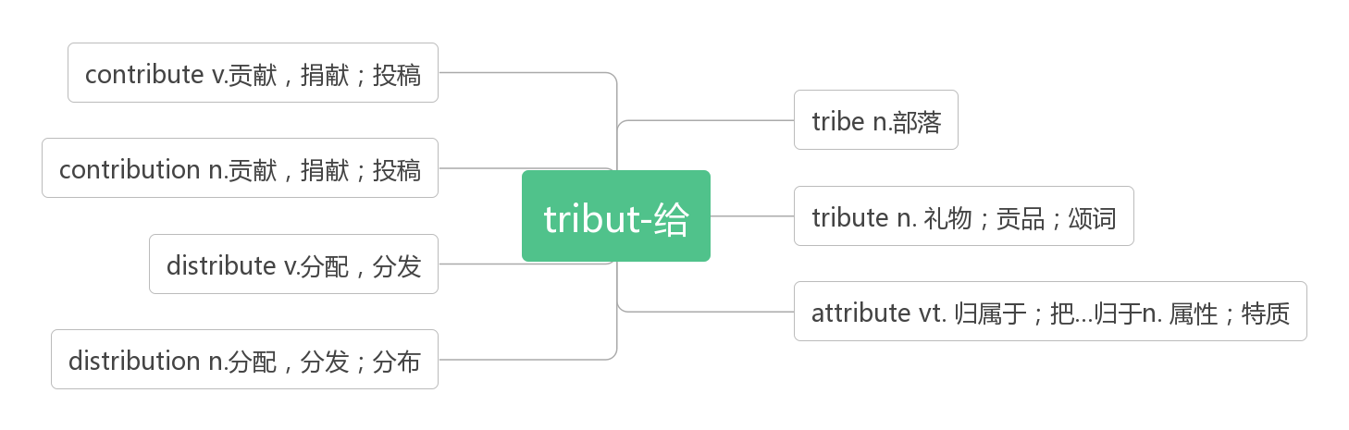

1. **fund /fʌnd/n. 基金；资金vt. 投资；资助**

We contributed 5000 yuan to the earthquake fund.

我们捐了5000元给地震基金。

My fund－raising focus also gave me new motivation to exercise regularly.(2017天津)

我对筹款的关注也让我有了定期锻炼的新动力。

She chose to sell a few larger objects that were less often used when we promised to put the money into her school fund.(2018全国)

当我们答应把钱投入她的学校基金时，她选择卖掉一些不常用的大物件。

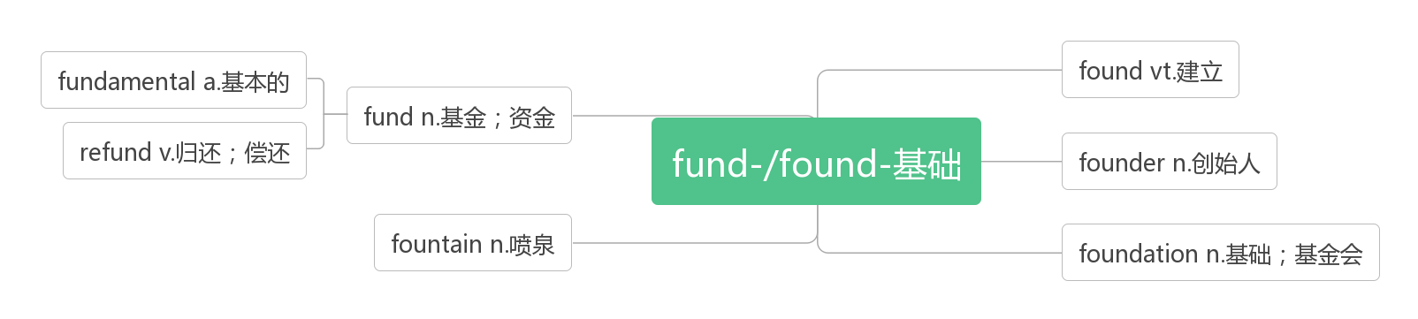

1. **within /wɪˈðɪn/prep. & adv. 在（某段时间、距离或范围）之内**
2. **investigate /in'vestigeit/ vi. & vt. 调查；研究**

**词根词缀：in(里)+vesti(衣服,vest马夹)+gate(get): 到衣服里面去获得信息——调查**

If you swim in a river or lake, be sure to investigate what is below the water surface.(2015浙江)

如果你在河里或湖里游泳，一定要调查一下水面以下的情况。

What he particularly wanted to investigate was how ichthyosaurs(鱼龙) adapted to the problem of decompression(减压) over the 150 million years.(2013江苏) 他特别想调查的是鱼龙是如何在在1.5亿年里适应减压问题的。

**investigation /ɪnˌvestɪˈɡeɪʃn/ n.调查；研究**

They were abroad during the months when we were carrying out the investigation, or they would have come to our help.(2014浙江)在我们进行调查的那几个月里，他们在国外，否则他们会来帮助我们的。

Viewing childhood development as a scientific investigation throws light on how children learn.(2016浙江)

把儿童的发展看作是一项科学调查，有助于了解儿童的学习方式

1. **issue /ˈɪʃu;ˈɪsju/ n. 问题；发行；期刊 vt. 发行，发布**

**破拆法：is(意思)+sue(说)：大规模说出你的意思——发行期刊；(提出)问题**

The liability(法律责任) issue is the biggest one of them all.(2017天津) 法律责任问题是最大的问题之一。

To understand the issue, let's take a look at three types of “waits”.(2017天津) 为了理解这个问题，我们来看一下三种类型的“等待”。

As the issue becomes clearer, the conflict often simply becomes smaller.(2012浙江)

随着问题变得越来越清晰，冲突往往会变得越来越小。

When we issue a command, we are specifying the verb—the action of the statement.

当我们发起命令时，便指定了动词——所陈述的行为。

1. **conduct /kənˈdʌkt/v.实施，开展；指挥（音乐）；传导（热或电）n.行为；举止**

**conduct oneself 表现; 为人**

conduct an experiment 做实验

conduct a concert 指挥一场音乐会

conduct electricity 导电

The police officers decided to conduct a thorough and comprehensive(全面的) review of the case.(2015江苏)

警方决定对该案件进行彻底而全面的审查。

A study of travelers conducted by the website TripAdvisor names Yangshuo as one of the top 10 destinations in the world. (2015全国I)

TripAdvisor网站对游客进行的一项调查显示，阳朔是全球十大旅游目的地之一。

The easiest way to accomplish this is to make sure you conduct yourself as a good neighbor should.(2018浙江)

要做到这一点，最简单的方法就是做一个好邻居

Rules governing student conduct relaxed somewhat in recent years. 近年来约束学生行为的规定有所放宽。

The newspaper breached the code of conduct on privacy. 该报违反了保护隐私的行为准则。

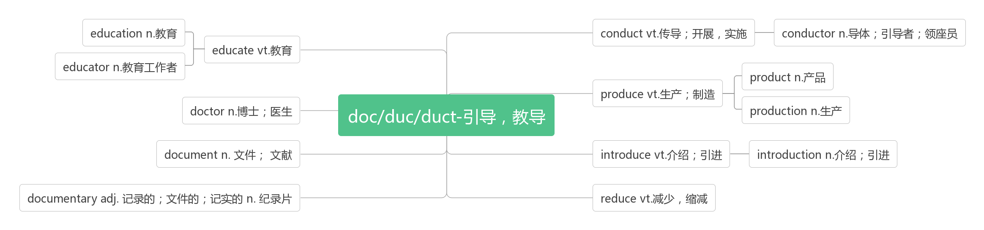

1. **document/ˈdɒkjumənt/n.文件，文献，文档，公文vt.记录，记载**

**词根词缀：docu(教导)+ment(名词后缀)：用于教导的工具——文件，文档**

Most photographers document only family history—birthdays, weddings, graduations, or holidays. Others expand to nature or sporting events. A few make art. And some make art of all their pictures, no matter the subject.（National Geographic）

大部分摄影者都只记录家庭的故事—生日、婚礼、毕业抑或节日。另外一些人则会延伸到拍摄自然风景或者体育赛事。极少数的摄影者创造艺术。还有一些摄影者，他们的每一张照片，无论题材，都是艺术。《美国国家地理杂志》

To close your document, press CTRL+W on your keyboard. 关闭文件时要同时按键盘上的CTRL键和W键。

The deadline to publish the document is a week tomorrow. 一周后的明天是公布这份文件的最后期限。

1. **donate/dəʊˈneɪt/v.捐赠；捐献**

**donate ... to ... 向……捐赠……**

They used to donate large sum of money to the Red Cross every year. 他们过去每年都向红十字会捐献大笔的钱。

I found the pre-holidays a good time to encourage young children to donate less-used things, and it worked.(2018全国III)

我发现节前是鼓励孩子们捐赠较少使用的物品的好时机，而且效果不错。

Because of our efforts, our daughter Georgia did decide to donate a large bag of toys to a little girl whose mother was unable to pay for her holiday due to illness.(2018全国IIII)

由于我们的努力，我们的女儿乔治亚决定捐赠一大包玩具给一个小女孩，她的母亲因病无法支付她的假期费用。

**donation /dəʊˈneɪʃn/ n.捐赠；捐款；捐赠物**

For just a small donation you can take a tour with our garden guide.(2018全国III)

只需一笔小小的捐款，你就可以和我们的园艺向导一起参观。

You can of course help by giving them a donation directly. 你当然可以通过直接向他们捐款来帮助他们。

I'll be sending them a donation in appreciation of their help. 我将送给他们一笔捐款以感谢他们的帮助。

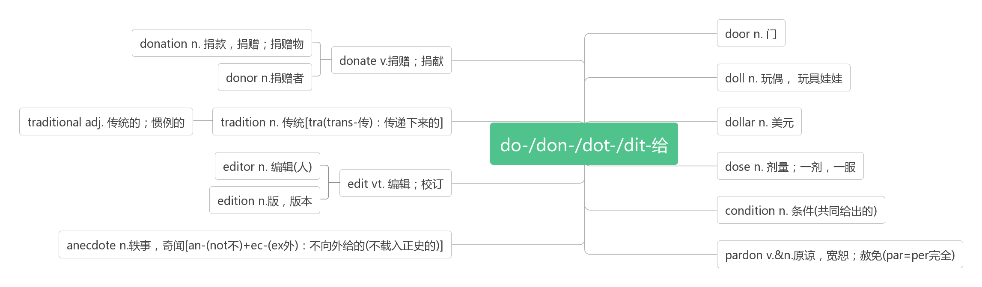

1. **disappear /ˌdɪsəˈpɪə(r)/vi. 消失；失踪**

Especially globalization and better communications in the past few decades, all have caused many Languages to disappear.(2018全国I)

尤其是全球化和过去几十年更好的交流，所有这些都导致了许多语言的消失。

The man insisted, so I gratefully accepted the offer, thanked him and watched the truck disappear down the road.(2009浙江)。

那人坚持要我接受，所以我感激地接受了他的好意，谢过他，看着卡车消失在路上。

By the 1920s, wolves had practically disappeared from the Yellowstone area.(2017全国III)

到20世纪20年代，黄石地区的狼几乎已经消失了。

**appear /əˈpɪə(r)/ vi.出现，露面link.v.显得**

However, anger can easily turn violent, and it is best to know the reasons for anger to appear in order to prevent its presence.(2018北京)

然而，愤怒很容易转化为暴力，最好知道愤怒产生的原因，以防止它的出现。

If your news station or school requires interviewees to sign release forms to appear on the air, don't leave work without them.(2017浙江) 如果你的新闻电台或学校要求被采访者在节目中签署发布表格，那么不要在没有表格的情况下离开工作岗位。

Though their ranges and tools differ, the baby's investigation and the scientist's experiment appear to share the same aim (to learn about the natural world).(2016浙江)虽然他们的范围和工具不同，婴儿的调查和科学家的实验似乎有相同的目的(了解自然世界)。

Its difficulties appear so great that, however hard we work, we fail again and again. (2016浙江)

它的困难似乎是如此之大，无论我们多么努力工作，我们还是一次又一次地失败了。

Warm colors like yellow make food appear more appetizing, while cold colors make us feel less hungry.(2015全国II)

像黄色这样的暖色让食物看起来更美味，而冷色让我们感觉不那么饿。

**disappearance /ˌdɪsəˈpɪərəns/n.消失，不见**

The disappearance of the wolves had many unexpected results.(2017全国III)

狼群的消失带来了许多意想不到的结果。

The disappearance of dinosaurs is not necessarily caused by astronomical incidents. But alternative explanations are hard to find.(2017江苏) 恐龙的消失不一定是天文事件造成的, 但是其他的解释很难找到。

**appearance /əˈpɪərəns/n. 外貌，外观；出现，露面**

Miss Longfield warned that a generation of children risked growing up “worried about their appearance and image” as a result of the unrealistic lifestyles they follow on platforms.(2018江苏) 朗菲尔德小姐警告说，由于他们在平台上过着不现实的生活，一代孩子在成长过程中可能会“担心自己的外表和形象”。

And the appearance of new－born giants suggests that newcomers can make waves, too.(2017江苏)

新生巨头的出现意味着新来者也能掀起波澜

Second, take the overall appearance of the neighborhood seriously.(2018浙江) 第二，认真对待小区的整体面貌

**apparent /əˈpærənt/ adj. 显然的；表面上的**

A rethink is required—and as a new approach starts to become apparent, two ideas stand out.(2017江苏)

我们需要重新思考——当一种新的方法开始显现时，有两个想法脱颖而出。

**apparently/əˈpærəntli/adv. 显然地；似乎，表面上**

Apparently satisfied that we caused no further threat, the bear moved off, destroying a fence as it went.(2014北京)

这只熊显然对我们没有造成进一步的威胁感到满意，它离开了，临走时毁坏了围墙。

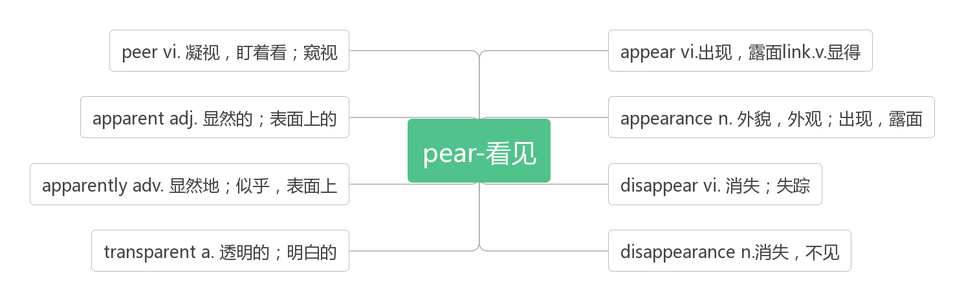

1. **attempt /ə'tem(p)t/ n. & vt.企图；试图；尝试**

It’s Honda’s latest attempt to create a tiny footprint for a new urban vehicle.（2010浙江）

这是本田公司为一款新型城市交通工具创造微小足迹的最新尝试。

And body language is particularly important when we attempt to communicate across cultures.（2012全国II）

当我们尝试跨文化交流时，肢体语言尤为重要。

The more you insist, the more likely that he’ll clam up(保持沉默). Instead, let him attempt to solve things by himself.（2009全国I）

你越坚持，他就越有可能保持沉默。相反，让他尝试自己解决问题。

Only those who attempt the absurd can achieve the impossible.––Albert Einstein

只有那些努力完成荒谬的事才有可能实现不可能。——爱因斯坦

Nothing is too small to know, and nothing is too big to attempt.

没有事情是小到不值得了解的，也没有什么事情会大到无法去尝试。

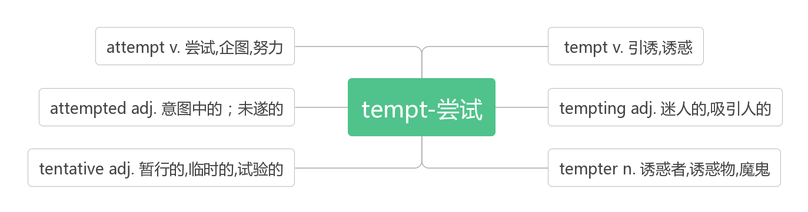

1. **make sure确保；确定**

Of course, you want to make sure that you become an acceptable and valuable part of your neighborhood. The easiest way to accomplish this is to make sure you conduct yourself as a good neighbor should.（2018浙江）当然，你要确保你成为你的邻居中可接受和有价值的一部分。要做到这一点，最简单的方法就是确保自己像一个好邻居那样行事。

In the years of my growing up, Dad was strict with me. He made sure I made my bed and did my homework. He would call in advance to make sure there was no alcohol at the party.（2017天津）

在我的成长过程中，爸爸对我要求很严格。他确保我整理床铺，做作业。他会事先打电话确认聚会上没有酒。

Every month the magazine introduces a fresh new topic with articles, experiments and creative things to make—the magazine also explores philosophy and well-being to make sure young readers have a balanced take on life.（2017北京）

每个月，该杂志都会推出一个全新的主题，包括文章、实验和创造性的东西——杂志还探讨了哲学和幸福，以确保年轻读者对生活有一个平衡的看法。

1. **worthwhile /wɜːθ'waɪl/adj. 值得做的，值得花时间的**

|  |  |
| --- | --- |
| worth | 值得，本质上是个介词，所以不能做定语，也不能被very等副词修饰；后接名词或动名词作宾语 |
| worthy | 值得的，值得尊敬的，形容词，可做定语，也可被very等副词修饰；形容词不能直接加宾语，故用be worthy of+名词或be worthy to do sth. |
| worthwhile | 由worth+while构成，故本意为“值得花时间的”，后引申为“值得做的；有价值的”；做表语时，通常主语为值得做的“事”,故通常用It’s worthwhile doing sth./to do sth. |

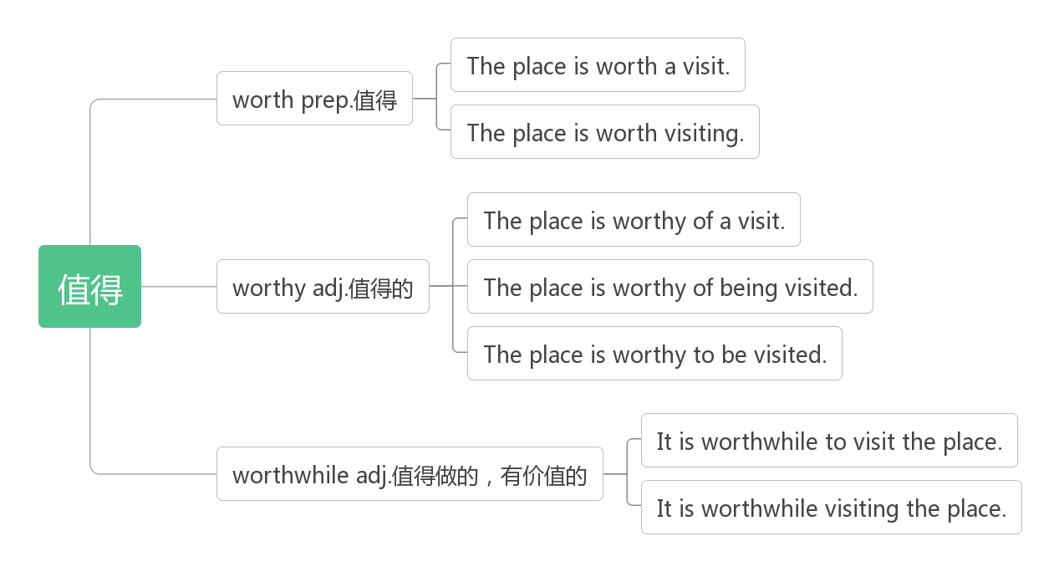

**worth prep.值得**

Whatever is worth doing at all is worth doing well. 凡是值得做的事，就值得做好。

Although it doesn't taste of anything special, it's still worth a try.（2016全国III）虽然它没有什么特别的味道，但仍然值得一试。

The most recent powerful Nio, in 1997-98, killed around 21 000 people and caused damage worth $36 billion around the globe.(2016江苏)

最近一次厄尔尼诺现象发生在1997-98年，造成约21000人死亡，全球损失达360亿美元。

They are truly good birds that are worth every effort we put into recovering them.（2016北京）

它们是真正的好鸟，值得我们付出一切努力来恢复它们

**worthy adj.值得的，值得尊敬的，有价值的**

He did not easily compromise, but was willing to accept any constructive advice for a worthy cause.（2016江苏）

他不轻易妥协，但为了一个有价值的事业，他愿意接受任何建设性的建议。

Make something worthy out of your experience.（2016浙江）根据你的经验，做一些有价值的事

The suggestion is worthy of being considered./to be considered. 这个建议值得考虑。

**worthwhile ad.值得做的，有价值的**

What made the author's getting up early worthwhile?（2015全国I）是什么让作者早起变得有意义?

Boys who worked in the home or community gained competence, and came to feel they were worthwhile members of society.（2016天津）

男孩在家庭或社区获得能力, 感到他们是有价值的社会成员。

1. **download/daʊn'ləʊd/vt.下载**

Tickets will be emailed to you immediately after purchase or you can download and print your ticket once payment has been accepted.（2014北京）购票后会立即以电邮方式通知您，或于接受付款后下载及打印门票。

**upload  /ʌpˈləʊd/ vt.上载，上传**

You can't upload love and you can't download time. You can't google all of life's answers.You must actually live some of your life.

你不能上传爱，也没法下载时间。你也搜索不到所有关于生活的答案。有一部分生活，事实上只能靠自己。

1. **republic /rɪˈpʌblɪk/n.共和国**

I'm walking on a path in the forest in the Central African Republic.（2018全国III）我走在中非共和国森林中的一条小路上。

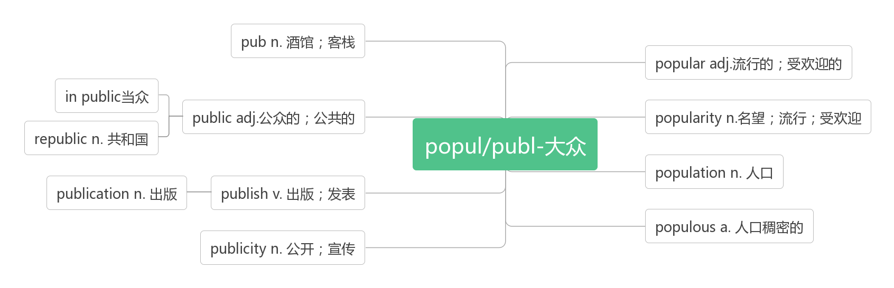

1. **professional /prəˈfeʃənl/adj. 专业的；职业的；职业性的n. 专业人员**

These people earn a living wage for their professional knowledge and skills.（2018江苏）

这些人凭借他们的专业知识和技能赚取薪水。

In 1870, when Dickens died, the world mourned him as its first professional writer and publisher, famous and beloved, who had led an explosion in both the publication of novels and their readership and whose characters — from Oliver Twist to Tiny Tim— were held up as moral touchstones(试金石). （2018浙江）

1870年，当狄更斯去世时，全世界都为他哀悼，因为他是第一个著名的、受人爱戴的专业作家和出版人，他引起了小说出版量和读者人数的激增，他笔下的人物——从《雾都孤儿》到《小蒂姆》——被奉为道德标杆。

There is yet a population besides professional and amateur star observers that suffers even more from light pollution.（2013天津）

除了专业和业余的天文爱好者外，还有很多人受到光污染的影响。

I set out to live my life filled with hope ,seeing endless possibilities for personal and professional achievements.（2011天津）

我开始了充满希望地生活，看到了个人和职业成就的无限可能。

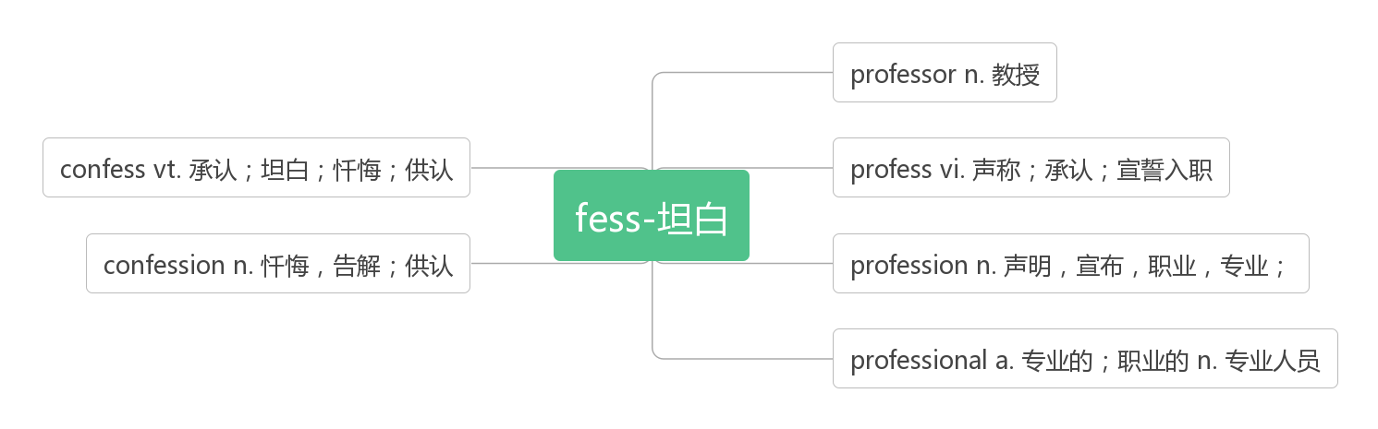

1. **archaeologist /ɑːkiˈɒlədʒɪst/ n.考古学家**

**词根词缀：archae(ance-先前)+ology(学科)+ist(人): 研究以前事物的人——考古学家**

 My uncle is a nonprofessional archaeologist.我叔叔是个业余考古学家

**archaeology /ɑːkiˈɒlədʒi/ n.考古学**

1. **entrance /'entrans/n. 入口；进入**

**the entrance to ……的入口**

The older collections of the gallery are reached through the main entrance while the more modern works in the East Wing are most easily reached from Trafalgar Square by a ground floor entrance.（2013全国I）

画廊的老藏品通过主入口进入，而东翼的现代作品最容易通过底层入口进入特拉法加广场。

What is the first thing you notice when you walk into a shop? The products displayed at the entrance? （2014北京）

当你走进一家商店时，你首先注意到的是什么?门口展示的产品吗?

Tours depart at regular intervals throughout the day from the Courtyard and finish at the entrance to the State Apartments.（2010天津）

游览从宫廷开始，每隔一段时间就有一趟行程，最后在国家大厦的入口处结束。

**enter /ˈentə(r)/vt.进入**

Excuse me, did you ever enter a residence, long ago, thinking it was the McNay Museum?（2018天津）

对不起，很久以前，你是否曾走进过一个住宅，以为那是麦克奈博物馆?

Adolescents enter high school with great excitement but are soon looking forward to graduation. (2014全国I)

青少年们带着极大的兴奋进入高中，但很快就盼着毕业了。

**entry /ˈentri/n.进入；入口；条目；登记**

Please print out all tickets purchased and present at the front entrance of Sea Life Melbourne Aquarium. No ticket, no entry!（2014北京）

请将所有已购买的门票打印出来，并在墨尔本海洋生物水族馆正门出示。没有票，就进不去!

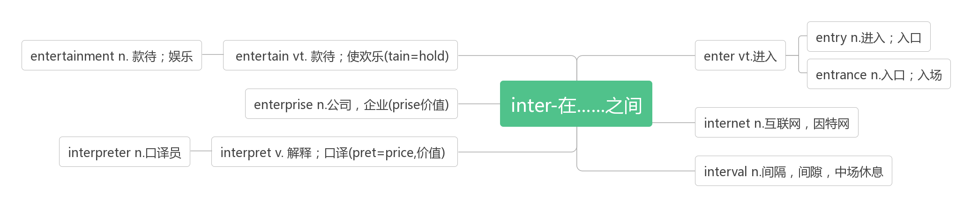

1. **pyramid /ˈpɪrəmɪd/ n. 金字塔；棱锥体**

音意相通：陪我们的 助记：金字塔就是埃及法老陪我们的地方。

1. **process /prəˈses/vt.处理；加工**

On every single move you have to analyze a situation, process what your opponent (对手) is doing and evaluate the best move from among all your options.(2018全国) 每下一步，你都要分析情况,估算你的对手在做什么，评估你的选项里最佳的一步棋。

They are required to process the food that we eat, to recover from injury and for several other bodily functions. (2017全国I)

它们被要求处理我们摄入的食物，帮助我们从伤势中恢复过来，以及应用于一些其他的身体功能。

**process/ˈprəʊses/ n.过程；进程；步骤**

When it comes to adaptation, it is important to understand that climate change is a process. (2017江苏)

在适应方面，重要的是要理解气候变化是一个过程。

But she expects using the chemical in some kind of industrial process — not simply “millions of worms thrown on top of the plastic.” (2018北京) 但她希望在某种工业过程中使用这种化学物质——而不是简单地“在塑料上扔上几百万只虫子”。

**procedure /prəˈsiːdʒə(r)/n.程序，手续；步骤**

—So what is the procedure? —All the applicants are interviewed before a final decision is made by the authority. (2013北京)

——程序是什么?——在当局作出最后决定之前，所有的申请人都要经过面试。

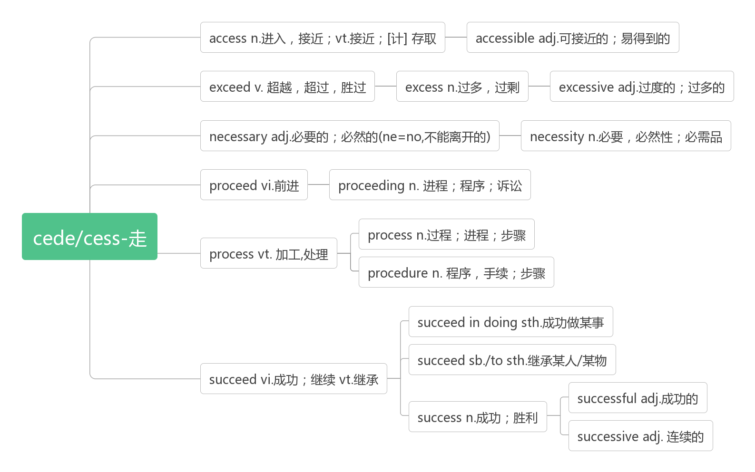

1. **overseas /əʊvə'siːz/adv. 在海外，海外adj. 海外的，国外的 n.海外，国外**

His uncle tells him that if his cousin wins the competition, the family will win an overseas tour for free.（2016江苏）

他的叔叔告诉他，如果他的表弟赢得比赛，他的家人将赢得一次免费的海外之旅。

If you are arriving from overseas, bring no food, animal or plant material into the country.（2015江苏）

如果你是从海外来的，不要带任何食物、动物或植物进入这个国家。

**46.exit /'eksit/ m 出口；退场vt.& vi. 离开；退场**

Exit immediately from the nearest emergency exit; do not use a lift.(2018天津) 从最近的紧急出口立即离开;不要使用电梯。

In the Jurassic and Cretaceous, they were prey(猎物) as well as predator—and often had to make a speedy exit as a result.(2013江苏)

在侏罗纪和白垩纪,他们即是猎物也是猎手——因此往往要迅速撤离。

Keep your phone on silent as if you were in a lecture and exit the library if you need to receive calls.(2013天津)

把手机调成静音，就像在听讲座一样；如果需要接电话，就离开图书馆

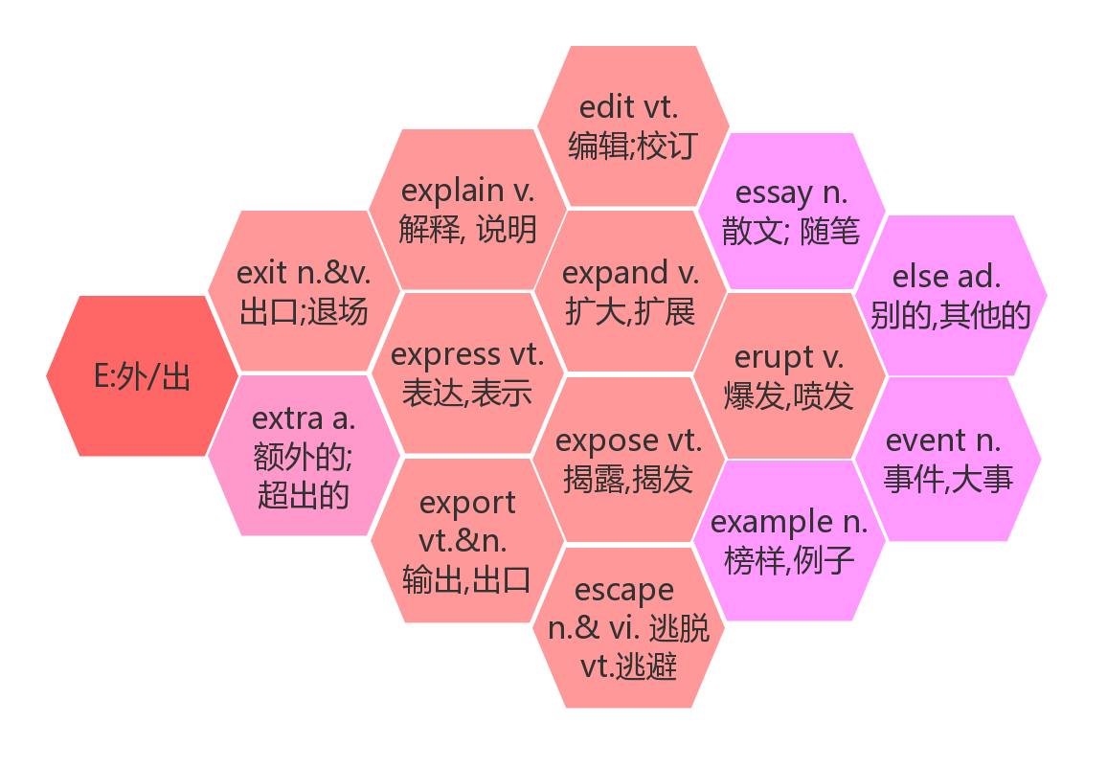

1. **sheet  /ʃi:t/n. 薄片，纸片；薄板；床单**

Next, cover the hole with the plastic sheet, securing the edges of the plastic with dirt and weighting the sheet's center down with a rock. (2017全国I) 接下来，用塑料布盖住洞口，用泥土把塑料布的边缘固定住，然后用石头把塑料布的中心压下来。

You can sign up for an appointment on the sign-up sheet outside the door.(2014天津) 你可以在门外的签到单上报名。

I say to her, walking back into the living-room with a sheet of paper and the pencil.(2010天津)

我对她说着，拿着一张纸和一支铅笔走回了客厅。

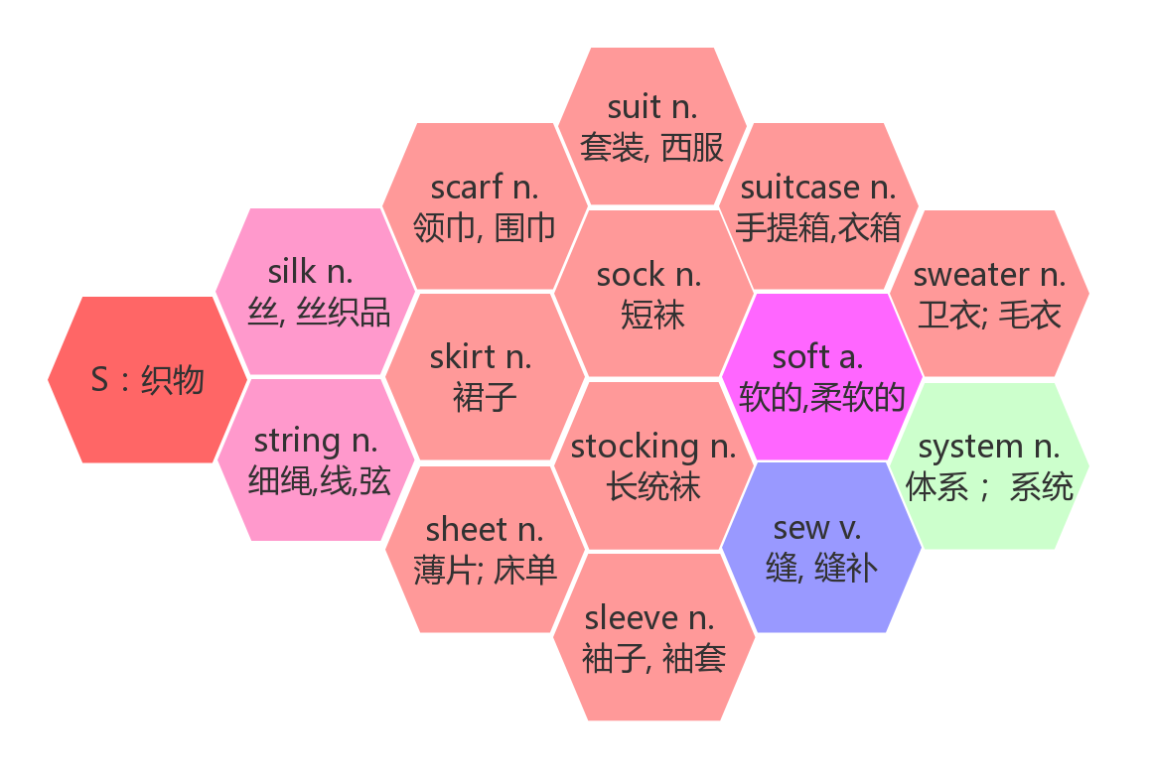

1. **parade /pə'reid/ *n.*游行；检阅vi.游行；列队前进**

Thursday sees us make the short journey to Paris where we will visit Disneyland Paris park, staying until late to see the parade and the fireworks.（2018全国II）周四我们将前往巴黎，在那里我们将参观巴黎迪斯尼乐园，直到很晚才去看游行和烟花。

The military parade on National Day marched grandly and solemnly down Chang’an Street. 国庆阅兵沿长安街威武而庄严地进行。

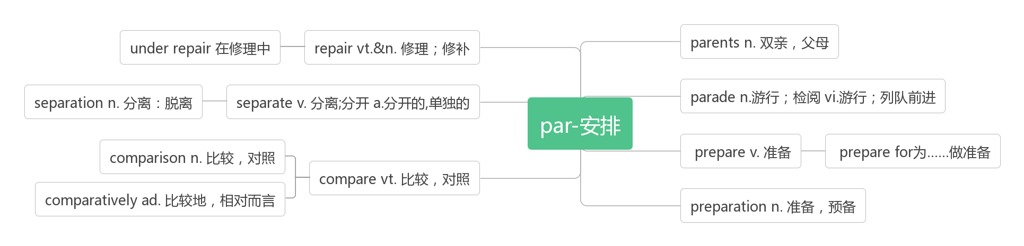

1. **mirror/'mirə/n.镜子**

Awareness can be tested by studying whether the animal recognizes itself in the mirror, that is, its own reflected image.(2011全国)

意识可以通过研究动物是否在镜子中认出自己，也就是它自己的镜像来测试。

Only humans, and some intelligent animals like apes and dolphins, have shown to recognize that the image in the mirror is of themselves. (2011全国) 只有人类，以及一些聪明的动物，如猿和海豚，表现出能认出镜子里的影像是他们自己的。

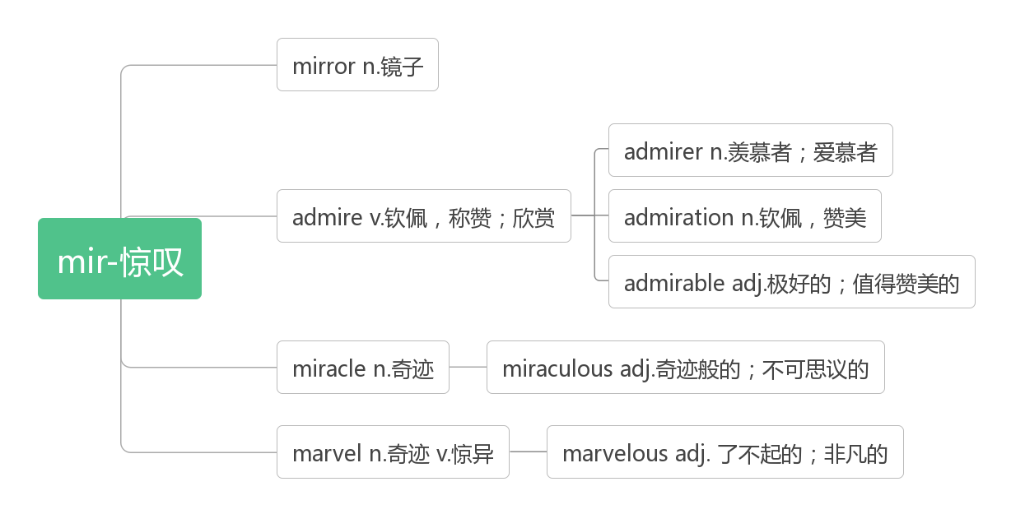

1. **roof /ru:f/n.屋顶；顶部**

a roof over the head 栖身之所

roof of the mouth 上颚

This included digging up the road, laying the track and then building a strong roof over the top.(2017全国II)

这包括挖掘道路，铺设轨道，然后在上面建一个坚固的顶。

1. **dragon/ 'dræɡən/n. 龙**

Legend has it that the origin of the Dragon Boat Festival is to recall the soul of Qu Yuan. (2014江苏)

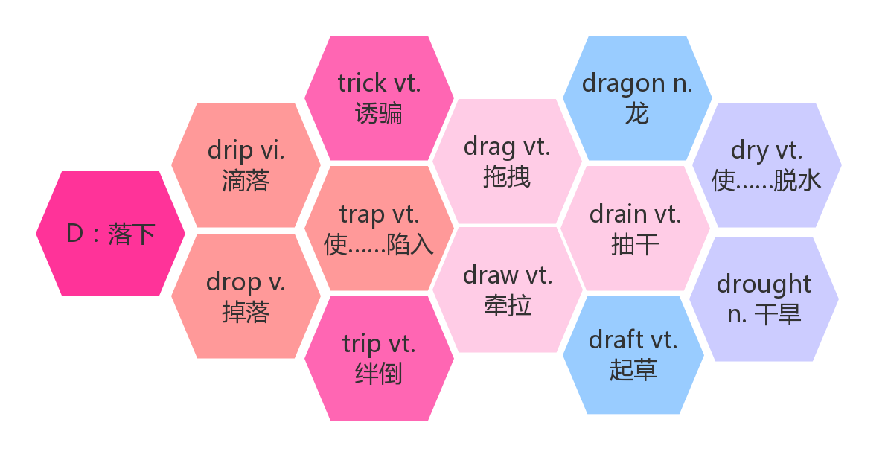

1. **forgive /fəˈɡɪv/ vt&vi. 原谅；免除(债务、义务等)**

**词根词缀：for(彻底，完全)+give(给): 彻底给予宽恕——****原谅**

The original quote about human nature went like this:“To err is human, to forgive, divine（神圣的）.” (2010天津)

关于人性的原话是这样说的:“犯错是人之常情，宽恕是神圣之举。”

Weak people revenge; strong people forgive; intelligent people ignore. 弱者选择报复，强者选择原谅，智者选择无视。

The first to apologize is the bravest. The first to forgive is the strongest. The first to forget is the happiest.

最先道歉的人最勇敢；最先原谅的人最坚强；最先释怀的人最幸福。

I'll forgive myself if I fail. But I won't forgive myself if I don't try.

如果我失败了，我会原谅自己；但如果我没有尝试，我是不会原谅自己的。

**forgiveness/fəˈɡɪvnis/n.原谅，宽恕**

The most important thing that I learned in growing up is that forgiveness is something that, when you do it, frees yourself to move on.

我成长中学到最重要的是，当你原谅他人时，你也解脱自己再往前走。

Friendship means understanding, not agreement. It means forgiveness, not forgetting. It means the memories last, even if contact is lost.

友情是理解，不是妥协；是原谅，不是遗忘。即使不联系，感情依然在。

Learn to let go of your worry and fear. Spread joy where there is a grief. Love where there is hate. Forgive where forgiveness is absent.

学会放弃担忧与害怕，在悲伤之处播撒快乐，在仇恨之处播撒仁爱，在缺少宽容之处播撒宽恕。

1. **digital/ 'dɪdʒɪtl/ adj. 数字的；数码的；手指的**

**破拆法：dig(挖)+it(它)+al(形容词后缀)：用来挖它的——手指的——掰手指数的——数字的**

Digital cameras arrived on the scene (到场) in 1997. (2018全国I)

数码相机于1997年问世。

Painters, digital media experts, photographers, booking agents and promoters are hired to sell tickets and promote the event. (2018江苏)

他们聘请了画家、数字媒体专家、摄影师、票务代理和推广人员来售票和推广活动。

Digital technology—email and smart phones especially—have vastly improved workers' ability to be productive outside of a traditional office.(2016江苏) 数字技术——尤其是电子邮件和智能手机——极大地提高了员工在传统办公室之外工作的能力。

1. **image / 'ɪmɪdʒ/n. 形象；影像；画面**

By the time they started secondary school—at age 11—children were already far more aware of their image online and felt under huge pressure to ensure their posts were popular. (2018江苏) 到他们11岁开始上中学的时候，孩子们已经对自己在网上的形象有了更多的认识，并感到了确保自己的帖子受欢迎的巨大压力。

Some change their behavior in real life to improve their image on the web.(2018江苏)

一些人改变他们在现实生活中的行为，以改善他们在网上的形象。

And now when I look at it, I think her presence in the photo is what makes the image interesting.(2017天津)

现在当我看着它的时候，我觉得她在照片里的出现使这张画面变得有趣。

Lacking a mirror image in the mother who raised me, I had to seek my identity as a woman on my own.(2014江苏)

由于缺少养育我的母亲的镜像，我不得不自己寻找作为一个女人的身份。

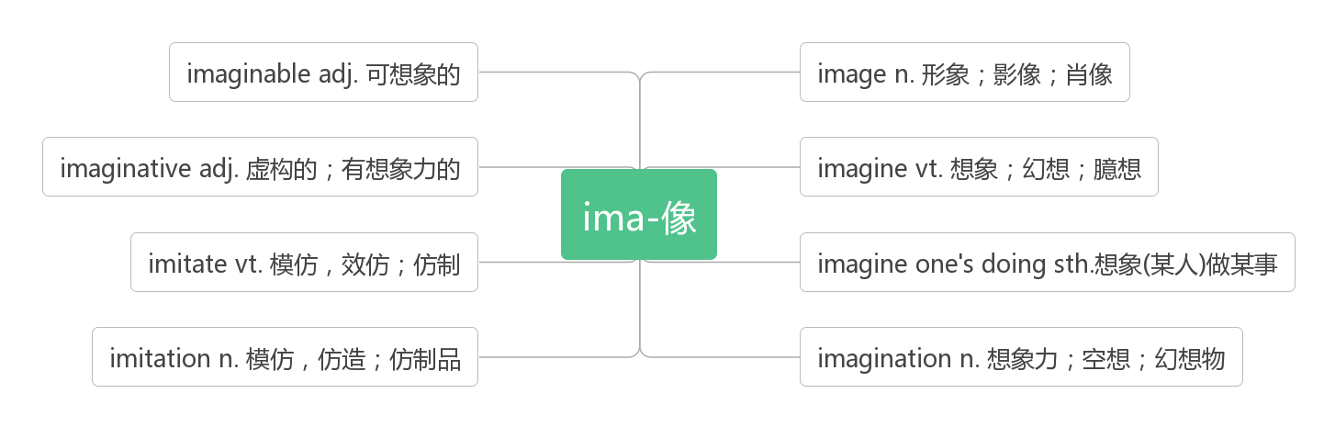

1. **cave /keiv/ n.山洞；洞穴**

Not knowing how much longer he could last, Nicholas did the only thing he could—he huddled(蜷缩) in his cave and slept.(2015北京)

不知道他能够坚持多久,尼古拉斯做了他唯一他能做的事——蜷缩在他的洞穴里睡着了。

He followed his tracks and returned to the snow cave, because without shelter, he could die that night.(2015北京)

他循着自己的足迹回到了雪洞，因为没有避难所，那天晚上他可能会死去。

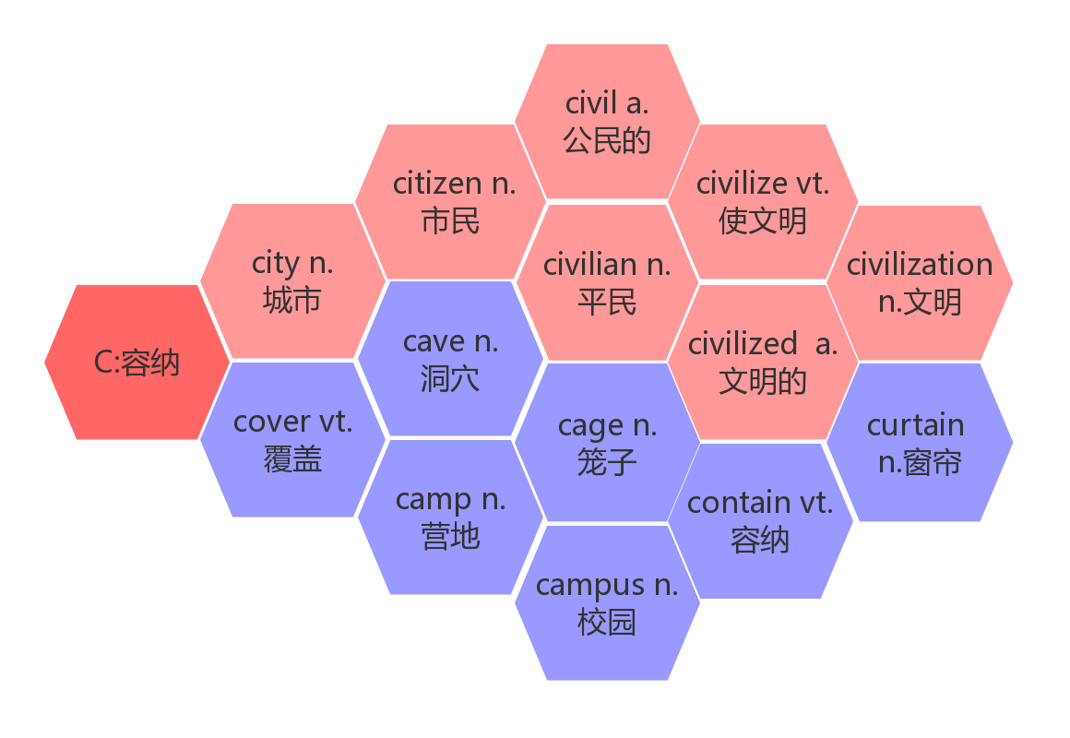**55. throughout /θruː'aʊt/ prep. 贯穿，遍及adv. 自始至终，到处；全部**

A successful arts neighborhoods creates a ripple effect (连锁反应) throughout a community.(2018江苏)

一个成功的艺术社区创建了一个遍及整个社区的连锁反应。

With these main reasons in mind, we can evaluate our level of anger throughout the day and prevent cases of outbursts by comprehending the reasons for our feelings.(2018北京)

有了这些主要的原因，我们可以评估我们一整天的愤怒程度，并通过理解我们情绪的原因来防止情绪爆发。

If you work out bright and early in the morning, you will be more likely to stick to healthy food choices throughout the day.(2018全国II) 如果你在早上锻炼，你会更有可能在一整天坚持选择健康的食物。

I had advised the kids that while verb may seem dull, most of the fun things they do throughout their lives will be verbs.(2017全国II)

我曾告诉孩子们，虽然动词可能看起来很枯燥，但他们一生中做的大多数有趣的事情都将是动词。

1. **quality/'kwɒlɪtɪ/n. 质量，品质；特性；才能adj. 高品质的**

**词根词缀：qual(性质)+ity(名词后缀)：质量，品质**

The government encourages farmers to grow corn instead of rice to improve water quality. (2018全国II)

政府鼓励农民种植玉米而不是水稻来改善水质。

A machine with a specific purpose has another quality, one that we usually associate with living things: a wish to preserve its own existence.(2017北京) 一台有特定用途的机器还有另一种特性，我们通常把它与生物联系在一起：希望保持自身的存在。

Every day he makes sure that fresh vegetables and high quality oil are used for cooking. (2016全国I)

他每天确保用新鲜的蔬菜和高质量的油进行烹饪。

**qualify/'kwɒlɪfaɪ/vt. 使有资格；使合格vi.有资格**

Never at a loss for words, I tried to find things in my life that might qualify for growth. (2016江苏)

我从未无话可说，我试着在我的生活中寻找可能适合成长的东西。

He's been informed that he doesn't qualify for the scholarship because of his academic background.(2017江苏)

他被告知由于他的学术背景，他没有资格获得奖学金。

**qualified/'kwɒlɪfaɪd/ adj. 合格的；有资格的**

Here, qualified volunteers will work with you on written work, grammar, vocabulary, and other academic skills. (2014天津)

在这里，合格的志愿者将与你一起完成书面作业、语法、词汇和其他学术技能。

We know that there aren’t enough qualified graduates to fill the jobs that are out there in American agriculture.(2012江苏)

我们知道没有足够的合格的毕业生来填补美国农业的工作岗位。

Michael Fish is not qualified for his job.(2008天津) 迈克尔·菲什不能胜任他的工作。

**qualification/,kwɒlɪfɪ'keɪʃ(ə)n/ n. 资格，资质；条件**

You will never truly know yourself, or the strength of your relationships, until both have been tested by adversity. Such knowledge is a true gift, for all that it is painfully won, and it has been worth more to me than any qualification I ever earned.

只有在逆境来临的时候，你才会真正认识你自己，了解身边的人。这种了解是真正的财富，虽然是用痛苦换来的，但比我以前得到的任何资格证书都有用。

1. **all over the world 在世界各地**

The post has since gained the attention of social media users all over the world, receiving more than 184,000 shares and 61,500 likes in just three days.(2018全国III) 这条微博吸引了全球社交媒体用户的关注，短短三天内就获得了超过18.4万次转发和6.15万个赞。

My eldest son，whose work takes him all over the world, is in New York at the moment.(2017天津)

我的大儿子现在在纽约，他的工作使他走遍了全世界。

They discussed various matters all over the world. (2017浙江)

他们讨论世界各地的各种问题。

1. **tradition/trə'dɪʃ(ə)n/ n. 惯例，传统**

**词根词缀：tra(trans-传递)+dition(名词后缀)：传递下来的——传统，惯例**

Wang’s works show a deep understanding of modern architecture and a good knowledge of traditions.(2018全国III)

王的作品表现了对现代建筑的深刻理解和对传统的深刻了解。

Wang believes traditions should not be sealed in glass boxes at museums. (2018全国III)

王认为传统不应该被封在博物馆的玻璃盒子里。

The study of traditions should be combined with practice. Otherwise, the recreation of traditions would be artificial and empty. (2018全国III) 对传统的研究应与实践相结合。否则，对传统的再创造将是虚假和空洞的。

It was a tradition for the school's old team to play against the new team at the end of spring practice.(2018天津)

学校的老队在春季训练结束时与新队比赛是一个传统。

**traditional /trə'dɪʃ(ə)n(ə)l/ adj. 传统的；惯例的**

He asked the workers to use traditional techniques to make the bricks into walls, roofs and corridors.(2018全国III)

他要求工人们用传统技术把砖做成墙、屋顶和走廊。

This creation attracted a lot of attention thanks to its mixture of modern and traditional Chinese elements.(2018全国III)

这个作品因为融合了现代和中国传统元素而备受关注。

1. **further/ 'fɜ:ðə/adj.&adv. 进一步的/地；更深入的/地(far的比较级) vt. 促进，助长；增进**

The pressures of "time" and "destination" are further blocks to awareness.(2018天津)

“时间”和“目的地”的压力进一步阻碍了我们的意识。

Meet outside of your residence hall and wait for further instructions.(2018天津)

在宿舍外面见面，等待进一步的指示。

In a further twist, birth rate is highest in poorly educated rural areas and lowest in highly educated urban areas.(2017江苏)

此外，受教育程度低的农村地区的生育率最高，而受教育程度高的城市地区的生育率最低。

After that, feeling the need to explore further, I decided to drop in on one of ASL club's meetings. (2017全国I)

在那之后，觉得有必要进一步探索，我决定去参加美国手语俱乐部的会议。

**farther/'fɑːðə/ ad.&adv. 更远的/地**

They went farther north into the deep forests of Canada, where there were fewer humans around.(2017全国III)

他们向北深入到加拿大的森林深处，那里的人比较少。

By tracking people's e－mails and online posts, scientists have found that good news can spread faster and farther than disasters and sob stories.(2016全国III) 通过跟踪人们的电子邮件和在线帖子，科学家发现好消息比灾难和悲伤的故事传播得更快更远。

**高中常见不规则变化形容词：**

good/well——better——best

little/few——less——least

many/much——more——most

1. **opinion /ə'pɪnjən/ n. 意见；主张**

**in one’s opinion 依某人看**

In the author's opinion, what makes the photo so alive?(2017天津) 在作者看来，是什么让这张照片如此生动?

Excuse me, I work for XYZ News, and I was wondering if you could share your opinion about this topic.(2017浙江)

不好意思，我是XYZ新闻的工作人员，我想知道您能否分享一下您对这个话题的看法。

What can we infer about Moran's opinion on jazz?(2017全国I) 我们能从莫兰对爵士乐的看法中推断出什么?

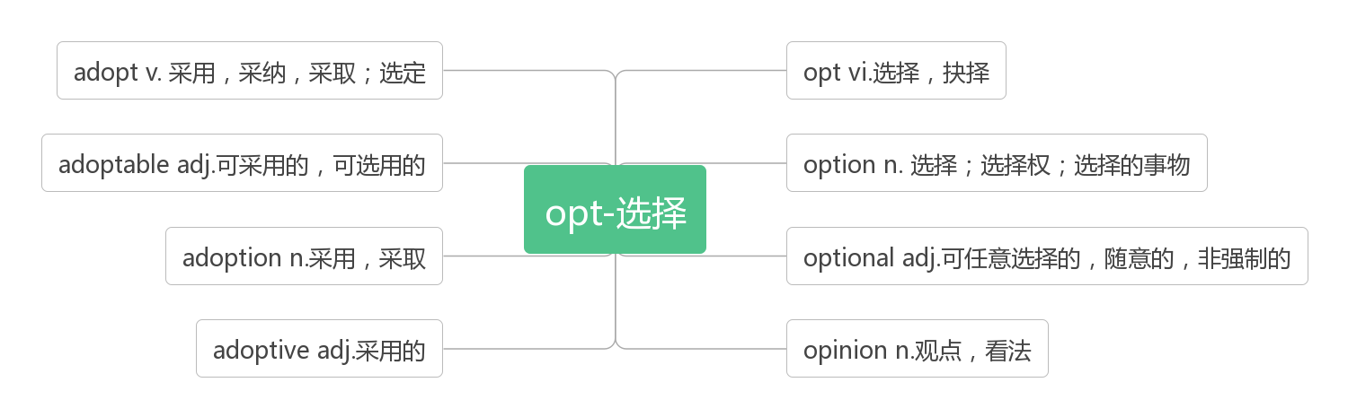

1. **quote /kwəʊt/vt. & n.引用，引述，引言**

In the English Reading Week, one of my classmates recommended a quote to us, which goes like this: " Your future depends on many things, but mostly on you.（2012浙江）

在英语阅读周，我的一位同学向我们推荐了一句话:“你的未来取决于很多事情，但主要取决于你自己。”

The original quote about human nature went like this:“To err is human, to forgive, divine（神圣的）.” （2010天津）

关于人性的原话是这样说的:“犯错是人之常情，宽恕是神圣之举。

**quotation /kwə(ʊ)'teɪʃ(ə)n/n. 引用语，语录**

The book began with a quotation from Goethe. 这本书一开头引用了歌德的隽语。

He finished his speech with a quotation from Shakespeare. 他讲话结束时引用了莎士比亚的语录.

1. **paraphrase /'pærəfreɪz/ vt.&n. 释义；改述**

**词根词缀：para-(在旁边)+phrase(说)：在旁边说——释义，改述**

The following is a paraphrase of what was said. 下面是对刚才说过的话的阐释。

Paraphrase the ancient Chinese prose in vernacular(本国的) language. 把这篇古文译成白话文。

What it means is that in understanding a text, we are attempting to grasp it in paraphrase.

它是说，在理解文章时，我们在试着给它释义，并掌握它。

1. **compare /kəm'peə/vt. 比较；比作**

**compare...with拿……与……作比较**

**compare...to...拿……与……相比；把……比作……**

**compared with/to 与……相比**

But more than that, I now regularly compare my views with those of many others.(2016江苏)

但更重要的是，我现在经常将自己的观点与许多人的观点进行比较。

And I then compare what I think with what others have thought. (2016江苏)

然后我把自己的想法和别人的想法进行比较。

A [teacher](https://cn.bing.com/dict/search?q=teacher&FORM=BDVSP6&mkt=zh-cn) [is](https://cn.bing.com/dict/search?q=is&FORM=BDVSP6&mkt=zh-cn) [often](https://cn.bing.com/dict/search?q=often&FORM=BDVSP6&mkt=zh-cn) [compare](https://cn.bing.com/dict/search?q=compare&FORM=BDVSP6&mkt=zh-cn)d [to](https://cn.bing.com/dict/search?q=to&FORM=BDVSP6&mkt=zh-cn) [a](https://cn.bing.com/dict/search?q=a&FORM=BDVSP6&mkt=zh-cn) [candle](https://cn.bing.com/dict/search?q=candle&FORM=BDVSP6&mkt=zh-cn)[.](https://cn.bing.com/dict/search?q=.&FORM=BDVSP6&mkt=zh-cn) [教师](https://cn.bing.com/dict/search?q=%E6%95%99%E5%B8%88&FORM=BDVSP6&mkt=zh-cn)[常](https://cn.bing.com/dict/search?q=%E5%B8%B8&FORM=BDVSP6&mkt=zh-cn)[被](https://cn.bing.com/dict/search?q=%E8%A2%AB&FORM=BDVSP6&mkt=zh-cn)[比作](https://cn.bing.com/dict/search?q=%E6%AF%94%E4%BD%9C&FORM=BDVSP6&mkt=zh-cn)[一](https://cn.bing.com/dict/search?q=%E4%B8%80&FORM=BDVSP6&mkt=zh-cn)[支蜡烛](https://cn.bing.com/dict/search?q=%E6%94%AF%E8%9C%A1%E7%83%9B&FORM=BDVSP6&mkt=zh-cn)[。](https://cn.bing.com/dict/search?q=%E3%80%82&FORM=BDVSP6&mkt=zh-cn)

Film has a much shorter history, especially when compared to such art forms as music and painting.(2012全国II)

电影的历史要短得多，尤其是与音乐和绘画等艺术形式相比。

**comparative /kəm'pærətɪv/adj. 比较的；相对的**

After many hardships, he now lives in comparative ease. 经过许多困难之后, 他现在的生活相对舒适。

Let's make a comparative study of the two languages. 让我们将这两种语言作一下比较研究.

**comparatively /kəm'pærətɪvlɪ/ adv. 比较地；相对地**

The past few days have seemed comparatively flat and empty. 过去这几天似乎比较平淡无聊。

She has been comparatively successful in maintaining her privacy. 在保护自己的隐私方面她一直都做得比较成功。

**comparison/kəm'pærɪs(ə)n/n. 比较；对照；比喻**

A Swiss study reported that while the weight of electronic goods represented by precious metals was relatively small in comparison to total waste, the concentration(含量) of gold and other precious metals was higher in so－called e－waste than in naturally occurring minerals.(2015江苏) 瑞士的一份研究报告表明，以贵金属为代表的电子产品垃圾总重量相对较轻，但此类所谓电子垃圾中的金和其他贵金属的含量依旧要比天然的矿物含量要高。

Swimming is the perfect comparison to learning English. You can't learn to swim by sitting in a room and reading books about swimming skills. 游泳是学习英语的最佳比喻。坐在一个房间里，读一些关于游泳技巧的书是学不会游泳的。

**词群：见47 parade**

1. **contrast /'kɒntrɑːst/vt.vi.&n.对比，对照**

**词根词缀：contra-(反)+st(stand站)：站在相反的方向——对比，对照**

**by contrast 相比之下；与之相比**

**in contrast to 与……形成对比**

Most people work because it's unavoidable. By contrast, there are some people who actually enjoy work.(2015浙江)

大多数人工作是因为这是不可避免的。相比之下，有些人确实喜欢工作。

Most positive emotions are associated with approach behaviour: we move closer to people we like. Most negative emotions, in contrast, are associated with avoidance behaviour.(2014江苏)

大多数积极情绪都与亲近行为有关:我们更接近我们喜欢的人。相反，大多数负面情绪与回避行为有关。

One of the features of Jurassic oceans was an abundance of large sharks and crocodiles, both of which were fond of ichthyosaur(鱼龙) lunches. Triassic oceans, by contrast, were mercifully shark- and crocodile-free.(2013江苏)

侏罗纪海洋的一大特色是大量的大鲨鱼和鳄鱼，它们都喜欢吃鱼龙午餐。相比之下，三叠纪海洋幸运地没有鲨鱼和鳄鱼

In contrast [to](https://cn.bing.com/dict/search?q=to&FORM=BDVSP6&mkt=zh-cn) her [elder brother](https://cn.bing.com/dict/search?q=elder brother&FORM=BDVSP6&mkt=zh-cn)[,](https://cn.bing.com/dict/search?q=,&FORM=BDVSP6&mkt=zh-cn) [she](https://cn.bing.com/dict/search?q=she&FORM=BDVSP6&mkt=zh-cn) [was](https://cn.bing.com/dict/search?q=was&FORM=BDVSP6&mkt=zh-cn) [always](https://cn.bing.com/dict/search?q=always&FORM=BDVSP6&mkt=zh-cn) [considerate](https://cn.bing.com/dict/search?q=considerate&FORM=BDVSP6&mkt=zh-cn) in her treatment of [others](https://cn.bing.com/dict/search?q=others&FORM=BDVSP6&mkt=zh-cn)[.](https://cn.bing.com/dict/search?q=.&FORM=BDVSP6&mkt=zh-cn) [和](https://cn.bing.com/dict/search?q=%E5%92%8C&FORM=BDVSP6&mkt=zh-cn)[她](https://cn.bing.com/dict/search?q=%E5%A5%B9&FORM=BDVSP6&mkt=zh-cn)[哥哥](https://cn.bing.com/dict/search?q=%E5%93%A5%E5%93%A5&FORM=BDVSP6&mkt=zh-cn)[完全](https://cn.bing.com/dict/search?q=%E5%AE%8C%E5%85%A8&FORM=BDVSP6&mkt=zh-cn)[不](https://cn.bing.com/dict/search?q=%E4%B8%8D&FORM=BDVSP6&mkt=zh-cn)[一样](https://cn.bing.com/dict/search?q=%E4%B8%80%E6%A0%B7&FORM=BDVSP6&mkt=zh-cn)[，](https://cn.bing.com/dict/search?q=%EF%BC%8C&FORM=BDVSP6&mkt=zh-cn)[她](https://cn.bing.com/dict/search?q=%E5%A5%B9&FORM=BDVSP6&mkt=zh-cn)[对](https://cn.bing.com/dict/search?q=%E5%AF%B9&FORM=BDVSP6&mkt=zh-cn)[别人](https://cn.bing.com/dict/search?q=%E5%88%AB%E4%BA%BA&FORM=BDVSP6&mkt=zh-cn)[总是](https://cn.bing.com/dict/search?q=%E6%80%BB%E6%98%AF&FORM=BDVSP6&mkt=zh-cn)[很](https://cn.bing.com/dict/search?q=%E5%BE%88&FORM=BDVSP6&mkt=zh-cn)[体贴](https://cn.bing.com/dict/search?q=%E4%BD%93%E8%B4%B4&FORM=BDVSP6&mkt=zh-cn)[。](https://cn.bing.com/dict/search?q=%E3%80%82&FORM=BDVSP6&mkt=zh-cn)

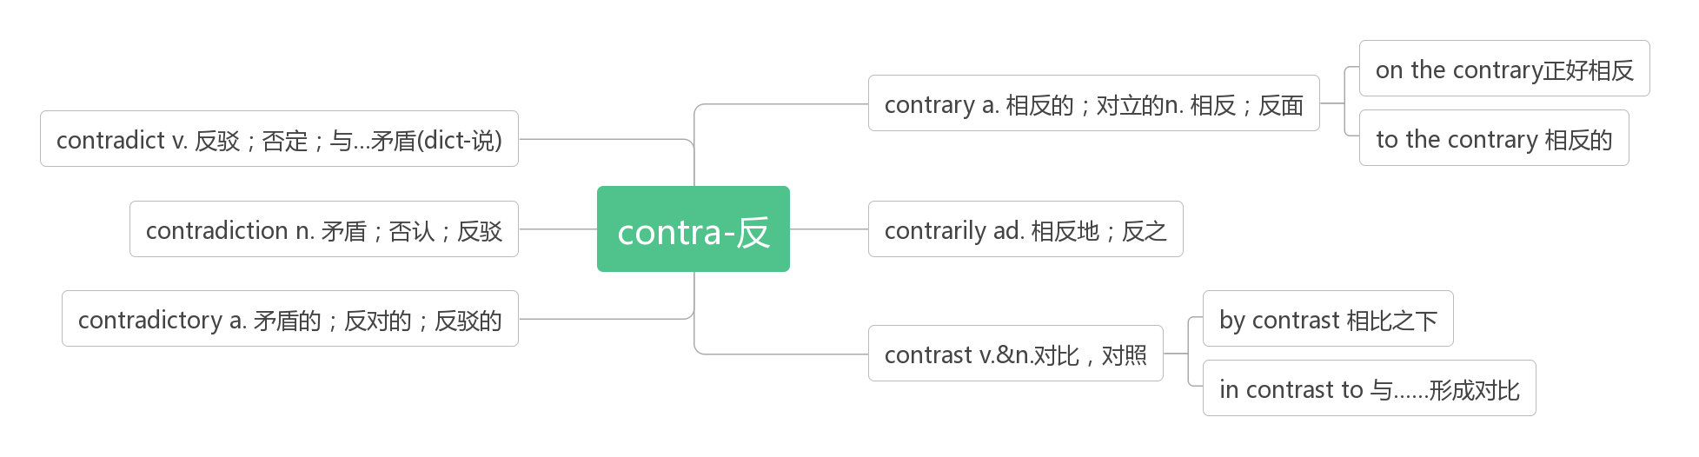

1. **identify /ai'dentifai/ vt.识别，鉴别; 确认**

**词根词缀：ident-(相同)+ify(动词后缀)：发现与……一样——识别，鉴别；确认**

The next step, DeBruyn says, will be to identify the cause of the breakdown.(2018北京)

下一步，DeBruyn说，将是确定故障的原因。

Embryonic learning(胎教) helps mother birds to identify the baby birds which fit the environment better.(2017江苏)

胎教帮助母鸟识别更适合环境的幼鸟。

1 in 10 Canadians have a learning disability, and doctors must be able to identify, diagnose, treat, and manage children...(2016浙江)

十分之一的加拿大人有学习障碍，医生必须能够识别、诊断、治疗和管理儿童……

If you feel stressed by responsibilities at work, you should take a step back and identify those of greater and less importance.(2016全国II)

如果你在工作中感到责任的压力，你应该退一步，找出那些更重要和不那么重要的。

**identity /aɪˈdentɪtɪ/ n. 身份**

**ID Card= Identity Card身份证**

It was assumed that those people for whom the role of volunteer was most part of their personal identity would also be most likely to continue volunteer work.(2015江苏)

人们认为，那些志愿者的角色是他们个人身份的主要部分的人也最有可能继续志愿者工作。

Consistent with the researchers' expectations, they found a positive correlation(正相关) between the strength of role identity and the length of time people continued to volunteer. (2015江苏)

与研究人员的预期一致的是，他们发现角色认同的强度与人们继续做志愿者的时间长短呈正相关。

**identification /aɪdentɪfɪˈkeɪʃ(ə)n/ n. 鉴定，辨别**

BookCrossing provides an identification number to stick inside the book.(2016全国II)

BookCrossing提供了一个识别号码，可以贴在书里。

1. **forever /fə'revə/ adv. 永远；不断地**

**词根词缀：for(持续)+ever(永远)：持续到永远**

Eventually the couple found that their bodies turned for the better, with re-found strong muscles that they thought had lost forever.(2018江苏)

最终，这对夫妇发现他们的身体变得更好了，重新长出了他们认为永远失去的强健肌肉。

While running regatesalstly cann't make you live forever, the review says it is more effective at lengthening life than walking, cycling or swimming.(2018全国I) 虽然跑步并不能让你长命百岁，但这篇评论说，跑步在延年益寿方面比走路、骑自行车或游泳更有效。

Climate change is a continuing process, so Norphel's ice reserves will not last forever.(2017江苏)

气候变化是一个持续的过程，所以Norphel的冰储备不会永远持续下去。

Years ago, a critical event occurred in my life that would change it forever. (2016江苏)

几年前，我生活中发生了一件重要的事，它将永远改变我的生活。