**Follow-up: Your Article on Canadian Sports**

**－2025年高考全国Ⅱ卷应用文分析**

**礼泉县教育局教研室 高小聪**

1. **教学目标**

**At the end of the class, the students will be able to:**

1. Compose an English email of approximately 80 words using functional language. **(Language Ability)**
2. Make your language friendly but professional, which fits the target writer Chris. **(Cultural Awareness)**
3. Make sure your writing is well-organized with smooth transitions. **(Thinking Quality)**
4. Apply the "ask + remind" pattern to other types of writing, like an inquiry letter（咨询信） or Reminder for Submission（催稿信）**(Learning Capacity)**

Ⅱ.析透情境

Task1. Read the writing task carefully, analyse the problem context and then complete the following table.

第一节（满分15分）假定你是校英文报编辑李华，外教Chris上个月答应写一篇介绍加拿大体育运动的文章。请给 Chris写一封邮件，内。.容包括：

（1）询问进展；（2）提醒交稿时间。

注意：

1. 写作词数应为80个左右；（2）请按如下格式在答题卡的相应位置作答。

Dear Chris,

Best wishes,

Li Hua

|  |  |
| --- | --- |
| Theme | Human and Society (coordinate and communicate) |
| Text type | Letter of inquiry + Follow-up letter |
| Writer | Li Hua, Editor of the School English Newspaper |
| Target Readers | like Chris, foreign teachers, featured Writer（特邀作者） |
| Pron. | The 1st, 2nd, 3rd pron |
| Tenses | Simple Past Tense; Simple Present Tense; Simple Future Tense; |
| Key points | 1. Inquire about progress   ② Remind of the submission deadline |
| Mood | Polite; Friendly; Professional; |

Ⅲ. 立稳框架

Task2. Draw a framework diagram on scratch paper, paying attention to the key points of each part.

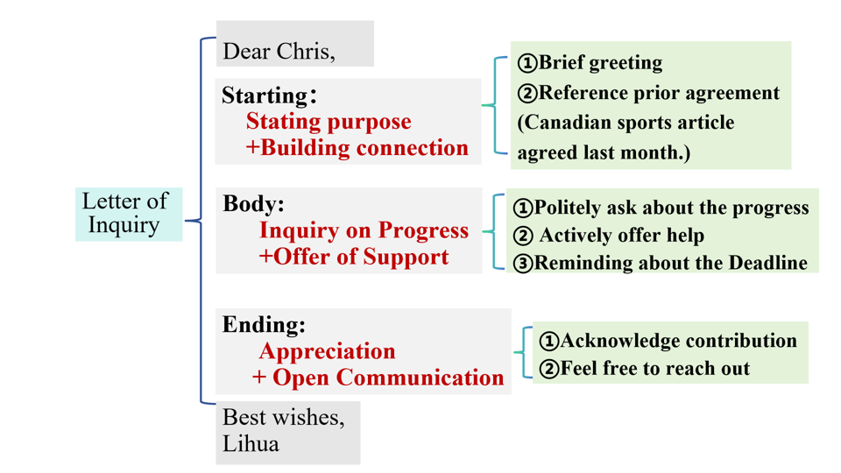

**Ⅳ.铸造语料**

**Task3.**

Please build up the 'corpus'. We will accumulate expressions by module.

**Brief greeting：**

① Hope you're doing well.

② Hope everything is going well with you these days.

③ I hope this email finds you well.

④How are things going with you recently?

⑤Warm greetings from the school newspaper team!

⑥Trust this message finds you in good spirits.

⑦I hope you’re having a productive week.

**Asking about progress:**

①Could you give me a quick update on how it's going?

②I was wondering how the article is coming along.

③Would you mind letting me know about the progress?

④How is the article progressing?

⑤Could you kindly update me on the status of your article about

Canadian sports?

⑥May I ask how far along you are with the article?

⑦Have you had a chance to make progress on the sports feature?

**Offering Help:**

1. Please don't hesitate to reach out if you need help.

②Please let me know if there's anything I can assist you with.

③Feel free to contact me if you have any questions.

④I’d be glad to assist with research or fact-checking.

⑤Should you encounter writer’s block, I can share some references.

⑥If photos or data would help, I can compile them for you.

⑦Please feel free to ask if you need any background materials.

**Reminding Sb.of the Deadline:**

①Just a friendly reminder that the final deadline for submission is [Date].

②We hope to finalize the next edition soon, so we'd appreciate it if you could submit the article by [Date].

③Could you please ensure the article is submitted by [Date]?

④To meet our publishing schedule, we need the article by [Date].

⑤Just a gentle reminder: the final submission is due by July 7th.

⑥May we request the article no later than 5 PM this Friday?

⑦We’d appreciate receiving your draft by end of day Thursday.

五、动笔成文（5分钟）

Task4. Complete the writing according to the requirements of the question.

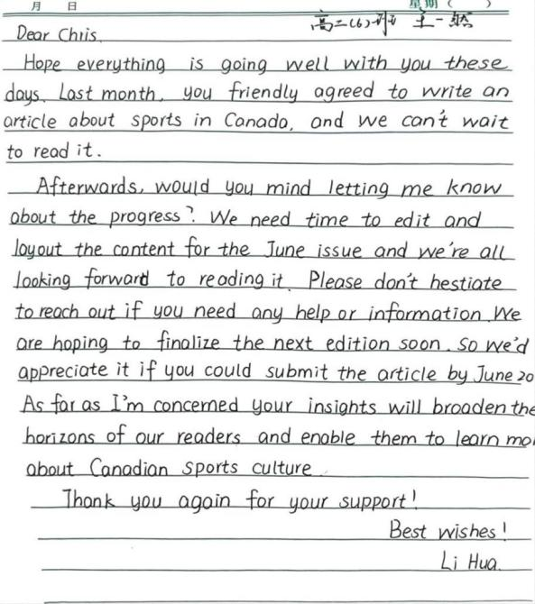

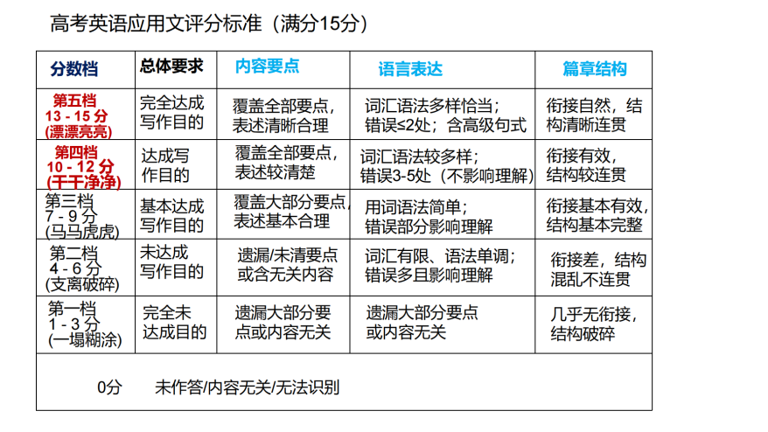

**Ⅴ.四元评价**

Please evaluate the work using the scoring criteria for practical writing in the college entrance examination.

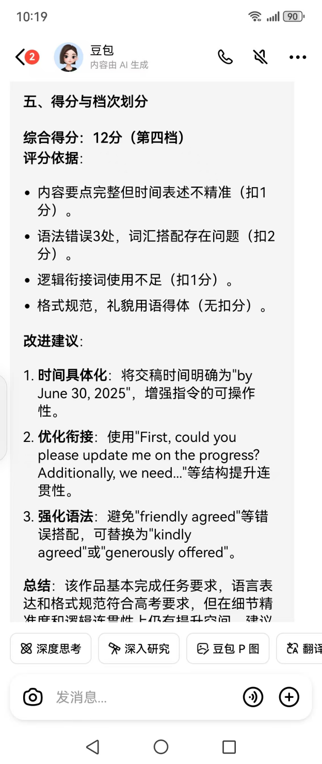

**一然自评：（第四档：12分）**

任务完成度高（询问文章进度、提醒截稿日期），语言表达准确、礼貌得体，结构清晰。

改进：提升词汇多样性和上下文连贯性。

**同伴互评：**（第四档 10 - 12 分 ）

覆盖任务要点且表述清，语言有多样尝试但存小瑕疵,如 are hoping，篇章衔接自然、结构清晰，修正小错误可冲击第五档 。

**教师评价：（第四档：11.5分）**

要点覆盖完整、语言基础扎实、格式规范。

建议：针对 “高级句式运用” 和 “情境化交际策略”进行专项突破。

Improve and Polish

Dear Chris,

Hope everything is going well with you these days. Last month, you 1 ______ (kind) agreed to write an article about sports in Canada, and we can't wait to read it.

2 _____ could you please 3________(update) me on the progress? We need time to edit and layout the content for the June issue and we're all looking forward to reading it. 4____________(addition) , please don't hesitate to reach out if you need any help or information. We 5______ to finalize the next edition soon, so we'd appreciate it if you could submit the article by June 30, 2025. As far as I'm concerned, your insights will broaden the horizons of our readers and enable them to learn more about Canadian sports culture.

Thank you again for your support!

Best wishes!

Li Hua

官方范文：

Dear Chris,

Hope this email finds you well! Last month, you kindly agreed to write an article about sports in Canada, and we’re all looking forward to 1_______(read) it.

I’m writing to politely inquire about the 2_________(progress) of the article. Would you mind letting me know 3______ it’s going? Also, could I remind you that the deadline for submission is this Friday, June 14th? Your insights into 4_________(Canada) sports will surely enrich our readers’ understanding of global sports culture, which will be of 5________(benefit) to us.

Thank you again for your support!

Best wishes,

LiHua Ⅵ. 迁移运用

Task5. Apply what we have learned to another new writing task. First watch and answer.

**2025年“东恒盛杯”中国公路自行车联赛**

**the 2025 "Dong Hengsheng Cup" China Road Cycling League**

Writing Task

假设你是来自英国的交换生Jack，同时也是校英文报的编辑。李华（Li Hua）答应写一篇介绍2025年“东恒盛杯”中国公路自行车联赛第五站（陕西礼泉站）的文章。请给李华写一封邮件，内容包括：

(1) 询问进展；(2) 提醒交稿时间。

注意：

(1) 写作词数约为80词；(2) 请按以下格式在答题卡的相应位置作答。

提示：

2025年“东恒盛杯”中国公路自行车联赛第五站（陕西礼泉站）

the 2025 "Dong Hengsheng Cup" China Road Cycling League (Liquan Station)

**Sample writing：**

Follow-up: Article on Dong Hengsheng Cup Cycling League

Dear Li Hua,

I hope this email finds you 1_____(good) ! As 2 ____ editor of our school’s English newspaper, I 3____________ (write) to check on the progress of your article about the 2025 "Dong Hengsheng Cup" China Road Cycling League (Liquan Station, June 11–15).

Our readers are eager 4_________ (read) your insights on how the event 5________(blend) competitive cycling with local cultural highlights—particularly its 6____________(connect) to the Tang Dynasty heritage. Could you let me know how the draft 7___________ along? To ensure smooth publication, please 8_________(submit）the final version by this Friday, July 4. This 9___________(allow) sufficient time for editing and layout adjustments.

Thank you for 10_________ (capture) this vibrant sports-cultural event through your writing!

Best regards,

Chris

Conclusion：

星光不问赶路人，时光不负有心人。希望你的成绩会照亮整个夏天，然后带着你的期许，去见从未见过的风景。

Starlight doesn’t ask of travelers on the way;

Time rewards those who persist day by day.

May your achievements light up your summer days,

Then lead you on with hopes and dreams ablaze,

To see the wonders beyond familiar gaze.

七、板书设计

2025全国Ⅱ卷应用文写作

Letter of Inquiry

Analyse

Draw

Accumulate

Accumulate

Write

Transfer

Evaluate