**The World**（**0501-0515**）材料分析和教学目标：

本次选用的材料：①、*The Week*的*The World at a Glance* （世界观察两则）、②*The Times 的Orcas venture near and Farne*（虎鲸冒险靠近法恩岛）、③*BBC Science Focus*的*The worst coffee types for your cholesterol levels*（对胆固醇水平影响最大的咖啡类型）、④*The Time*s的*What ￡1.8 million buys you in...*（180万英镑能买到什么？）和⑤BBC的新闻报道。通过语法填空、阅读理解、分析长难句、翻译句子、听力填空和词汇拓展等方式，让学生从多角度提升学习兴趣，提高分析句子、运用词块和听力能力。外媒英语新闻可以让学生体验真实语境下的语言运用，拓展学生的国际视野，了解时事，逐步提升跨文化沟通能力，形成正确的世界观、人生观和价值观。

**教学思路：**

**Part 1: News Report 1 *The Week* (May 9 2025 P8&9)**

**The World at a Glance 世界观察两则**

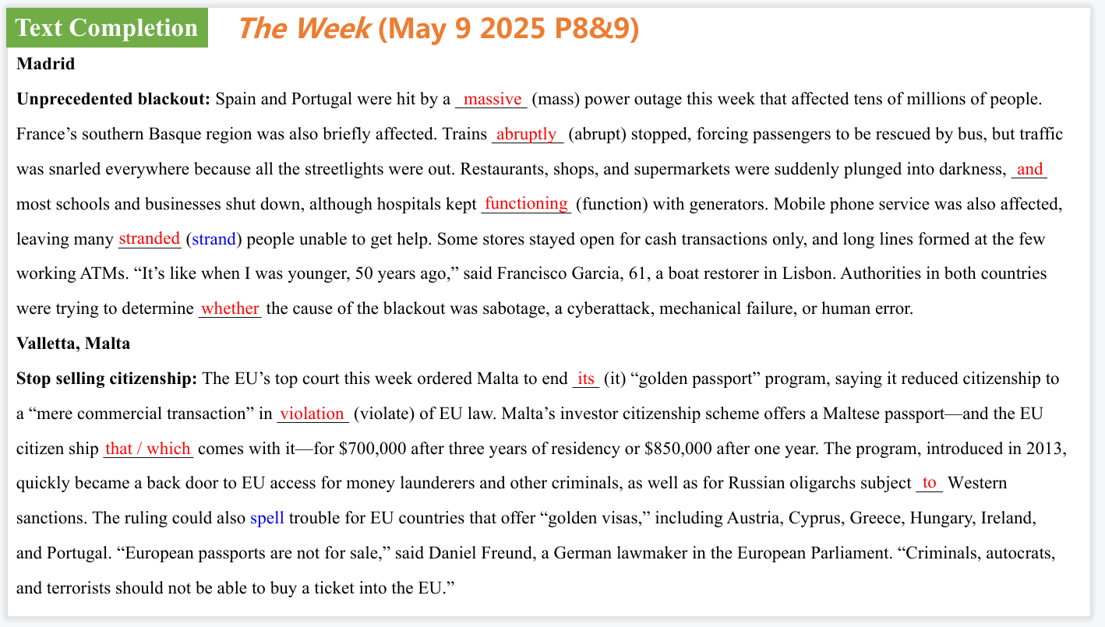

【设计意图】通过语篇填空的形式帮助学生理解新闻的主要内容，同时训练语言语法的运用能力：在语篇的视角下如何正确使用所给词汇，根据语法规则确定词汇的正确形式，使得文章通顺，激活学生的思维和语言。该新闻主题语境是关于“人与社会”中“社会热点问题”这一子主题，通过学习让学生了解两则世界新闻。

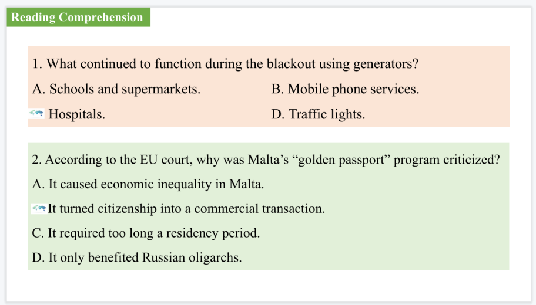

【设计意图】通过阅读理解的形式帮助学生理解新闻的主要内容。

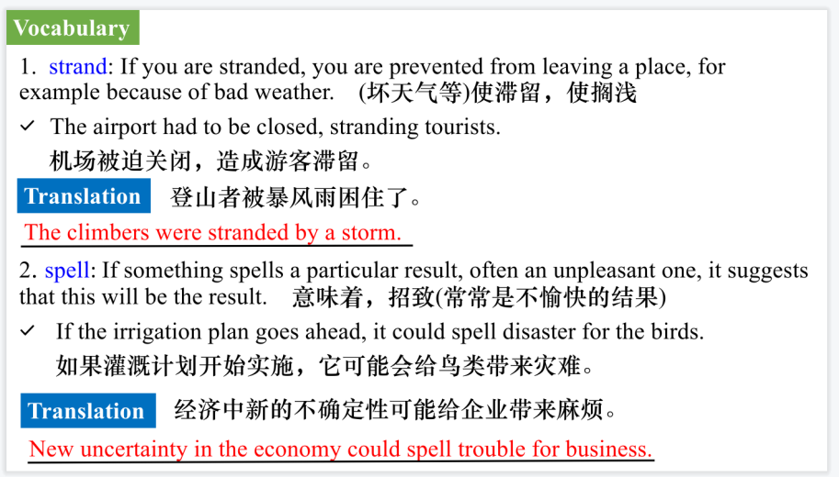

【设计意图】对文本中的词汇进行解读，并通过翻译句子对其进行巩固。

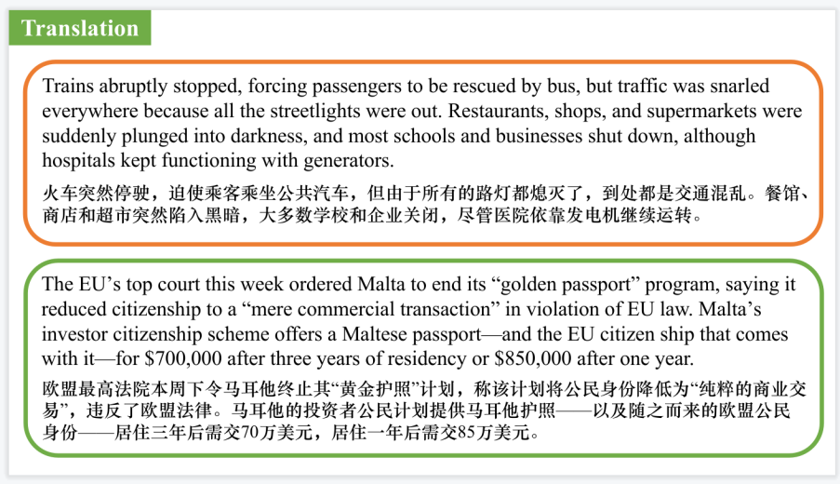

【设计意图】对文中的两个句子进行翻译练习，对其中单词、词组、句法进行巩固并关注句子结构。

**Part 2: News Report 2 *The Times* ((May 8, 2025 P5 )**

**Orcas venture near and Farne 虎鲸冒险靠近法恩岛**

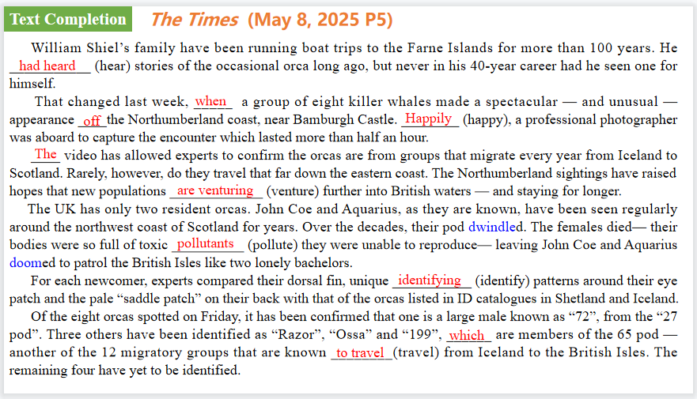

【设计意图】通过语篇填空的形式帮助学生理解新闻的主要内容，同时训练语言语法的运用能力：在语篇的视角下如何正确使用所给词汇，根据语法规则确定词汇的正确形式，使得文章通顺，激活学生的思维和语言。该新闻主题语境是关于“人与自然”中“自然生态中人与环境，人与动植物”这一子主题，通过学习让学生了解虎鲸重现在法恩岛。

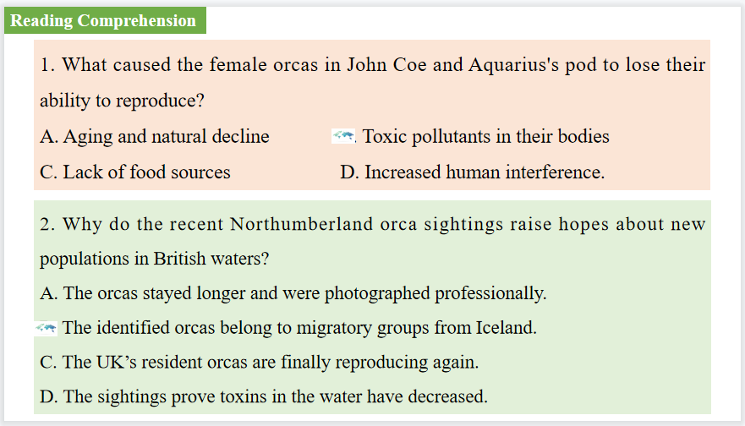

【设计意图】通过阅读理解的形式帮助学生理解新闻的内容的细节，提升学生的根据上下文的猜词能力。

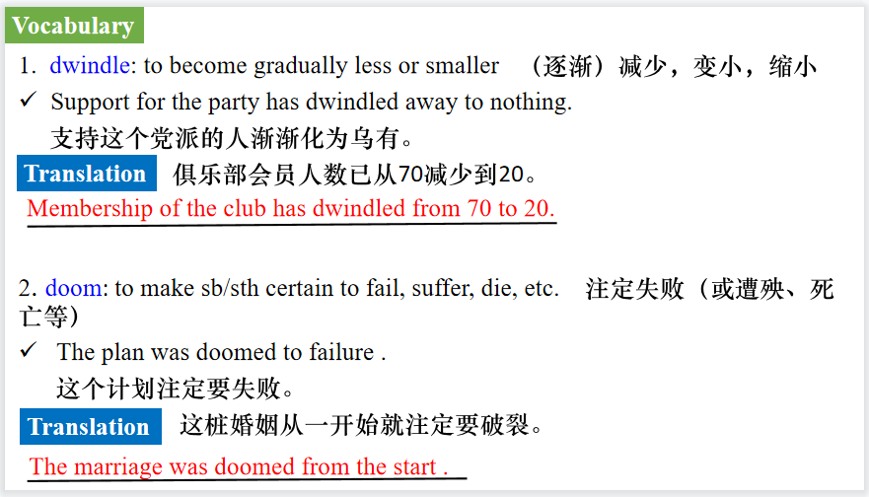

【设计意图】对文本中的词汇进行解读，并通过翻译句子对其进行巩固。

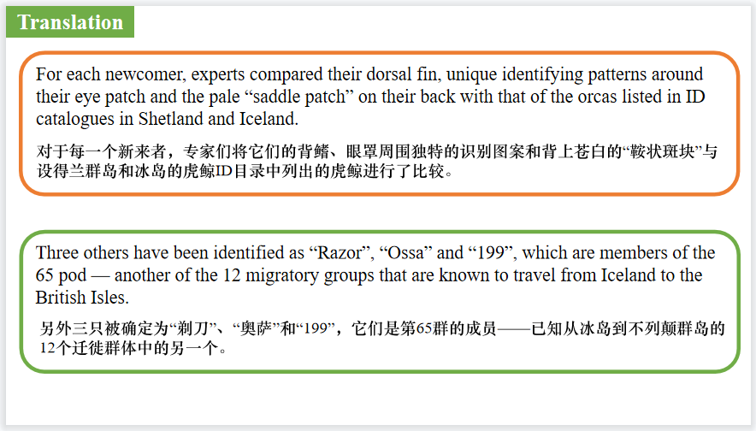

【设计意图】对文中的两个句子进行翻译练习，对其中单词、词组、句法进行巩固并关注句子结构。

**Part 3: News Report 3 BBC Science Focus（May, 2025 P22)**

**The worst coffee types for your cholesterol levels**

**对胆固醇水平影响最大的咖啡类型**

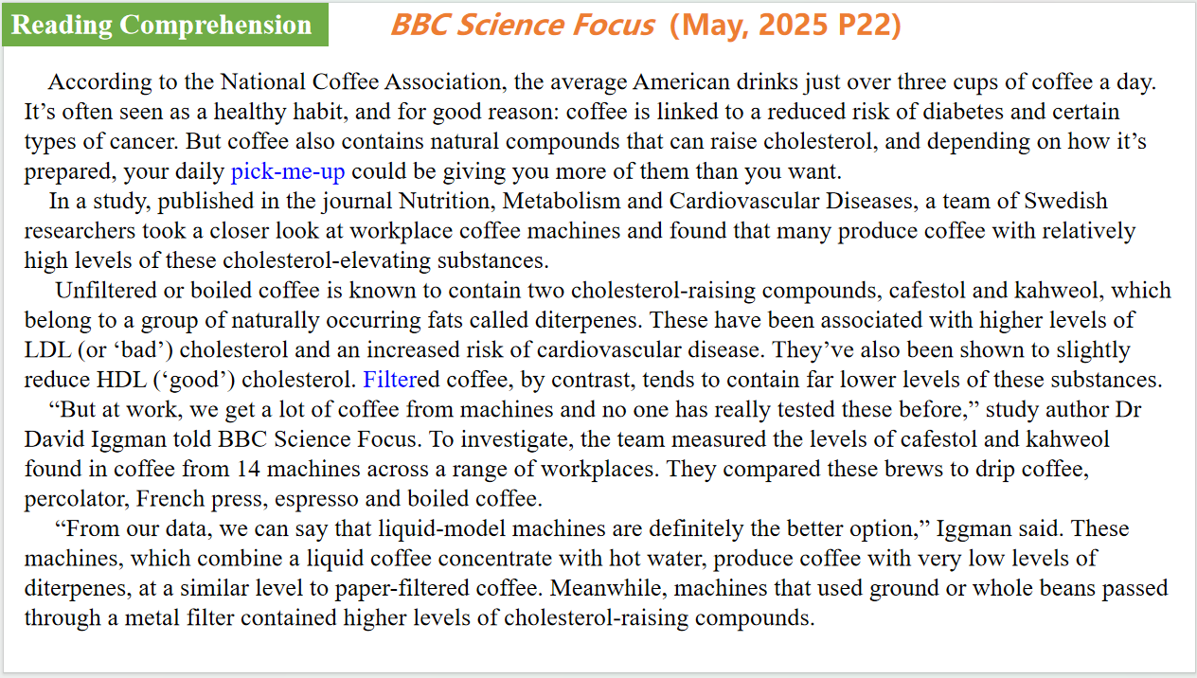

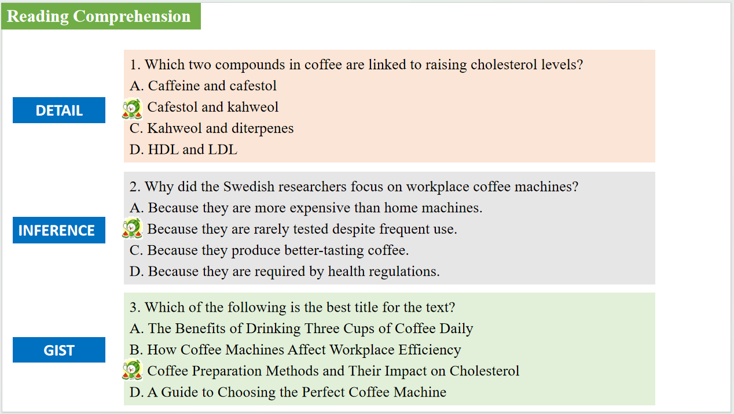

【设计意图】通过阅读理解的形式帮助学生理解新闻的主要内容，同时训练语言语法的运用能力：在语篇的视角下如何正确使用所给词汇，根据语法规则确定词汇的正确形式，使得文章通顺，激活学生的思维和语言。该新闻主题语境是关于“人与社会”中“社会热点问题”这一子主题，通过学习让学生了解对胆固醇水平影响最大的咖啡类型。

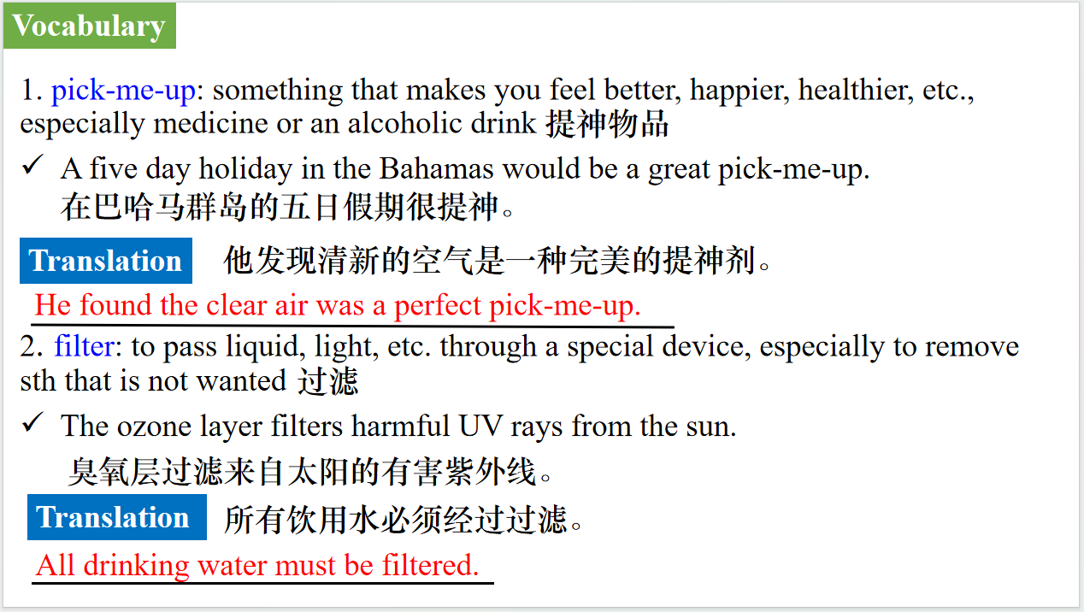

【设计意图】对文本中的词汇进行解读，并通过翻译句子对其进行巩固。

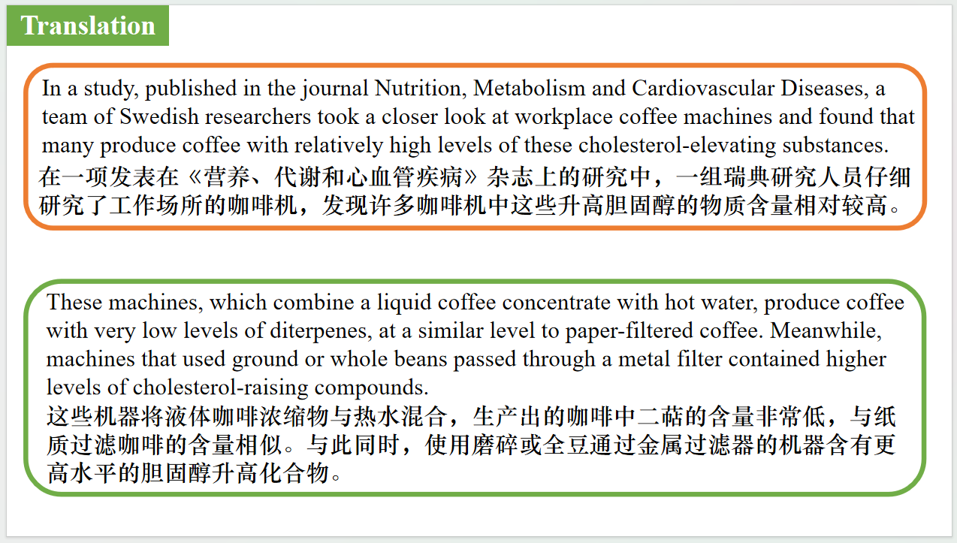

【设计意图】对文中的两个句子进行翻译练习，对其中单词、词组、句法进行巩固并关注句子结构。

**Part 4: News Report 3 The Times（May 9, 2025 P3)**

**What ￡1.8 million buys you in...**

**180万英镑能买到什么？**

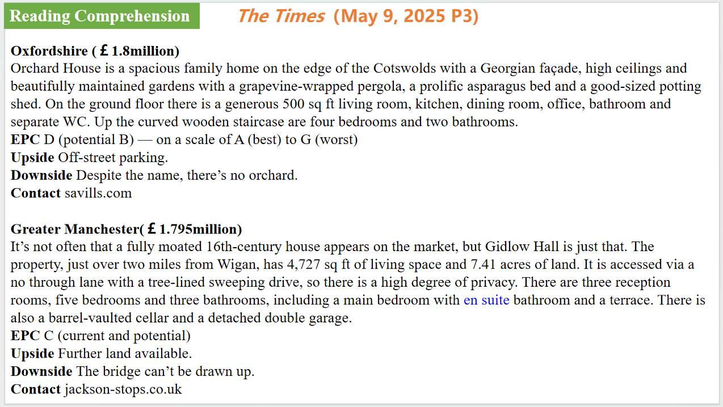

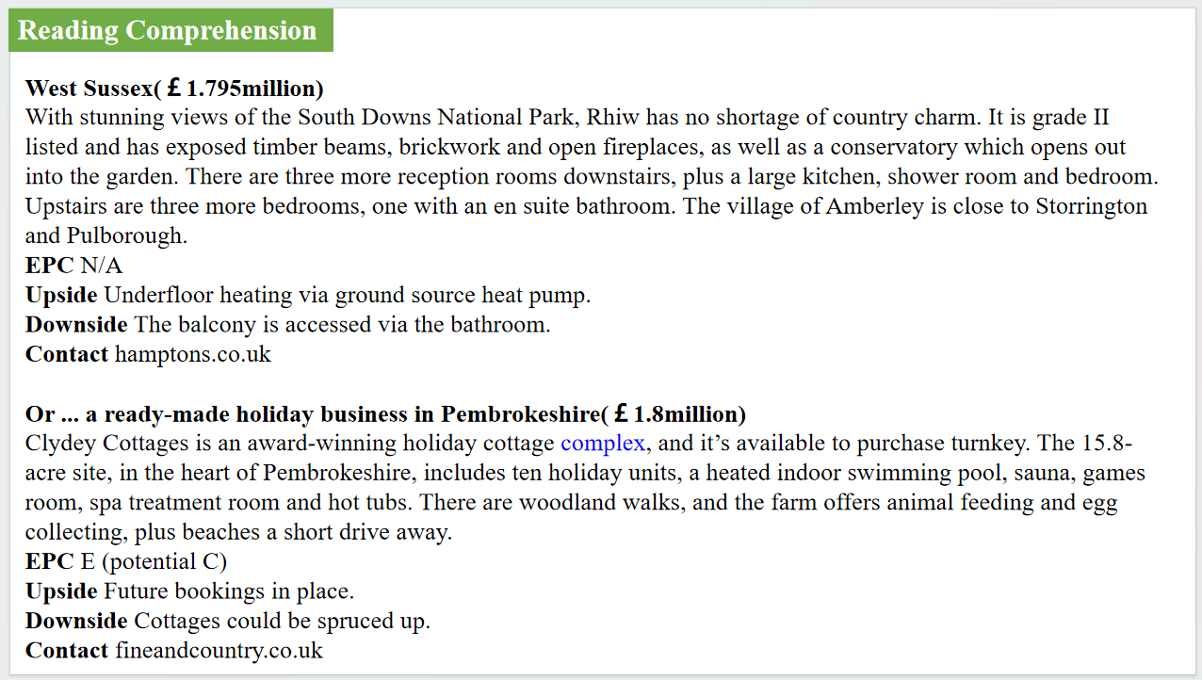

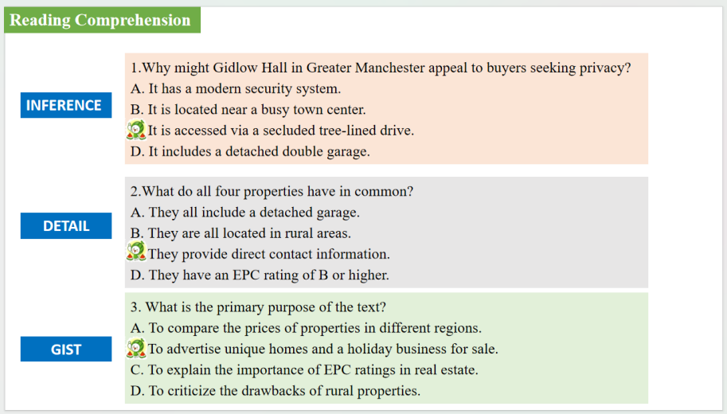

【设计意图】通过阅读理解的形式帮助学生理解新闻的主要内容，同时训练语言语法的运用能力：在语篇的视角下如何正确使用所给词汇，根据语法规则确定词汇的正确形式，使得文章通顺，激活学生的思维和语言。该新闻主题语境是关于“人与社会”中“社会热点问题”这一子主题，通过学习让学生了解180万英镑在英国可以买到的房产。

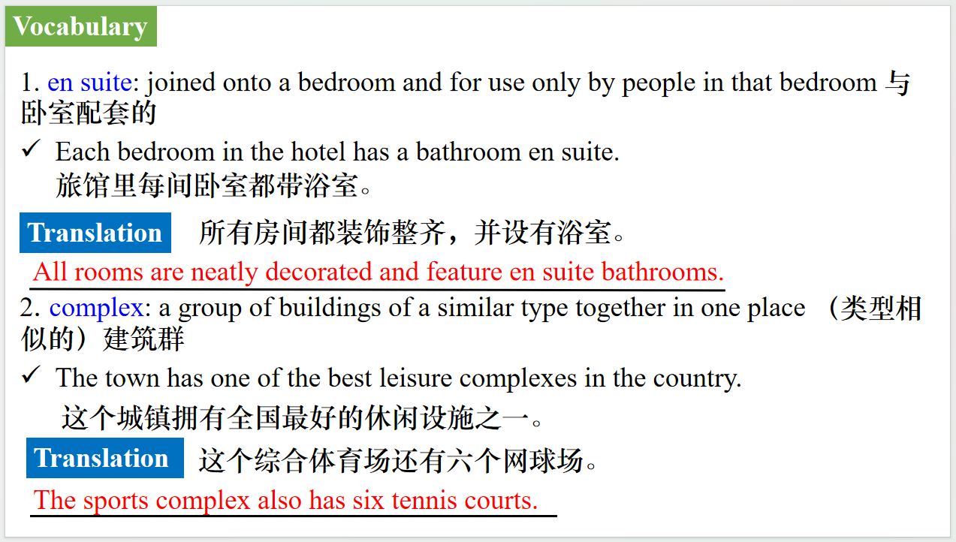

【设计意图】对文本中的词汇进行解读，并通过翻译句子对其进行巩固。

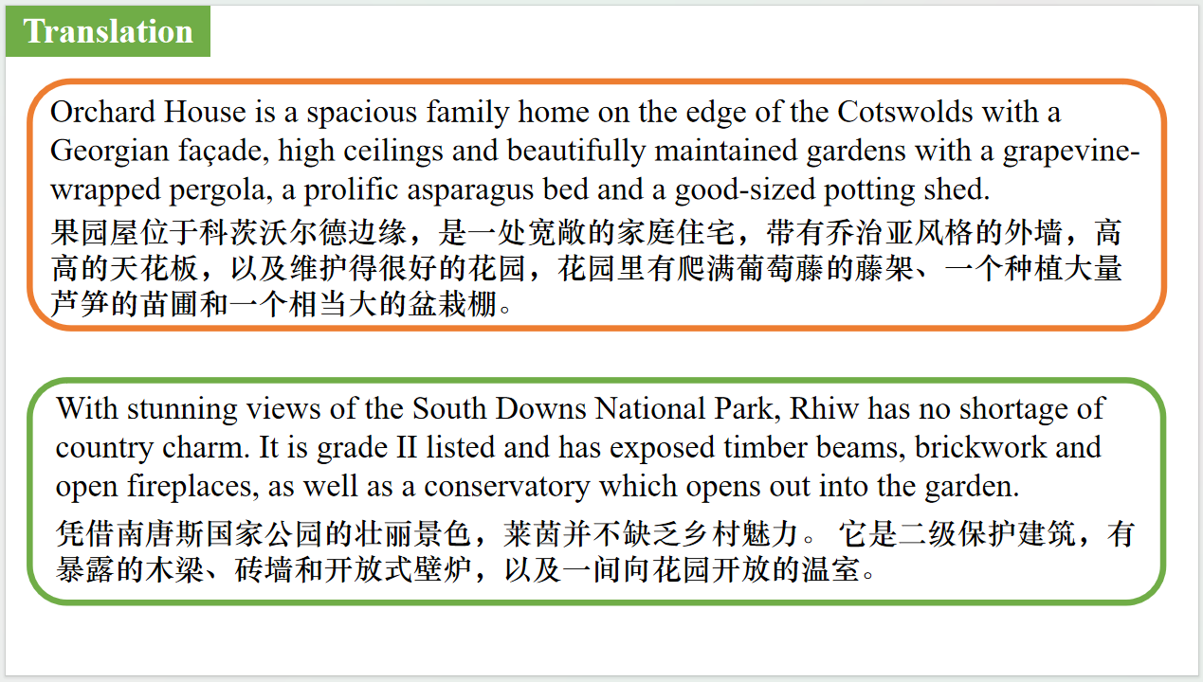

【设计意图】对文中的两个句子进行翻译练习，对其中单词、词组、句法进行巩固并关注句子结构。

**Part 5: BBC News 05/13/2025**

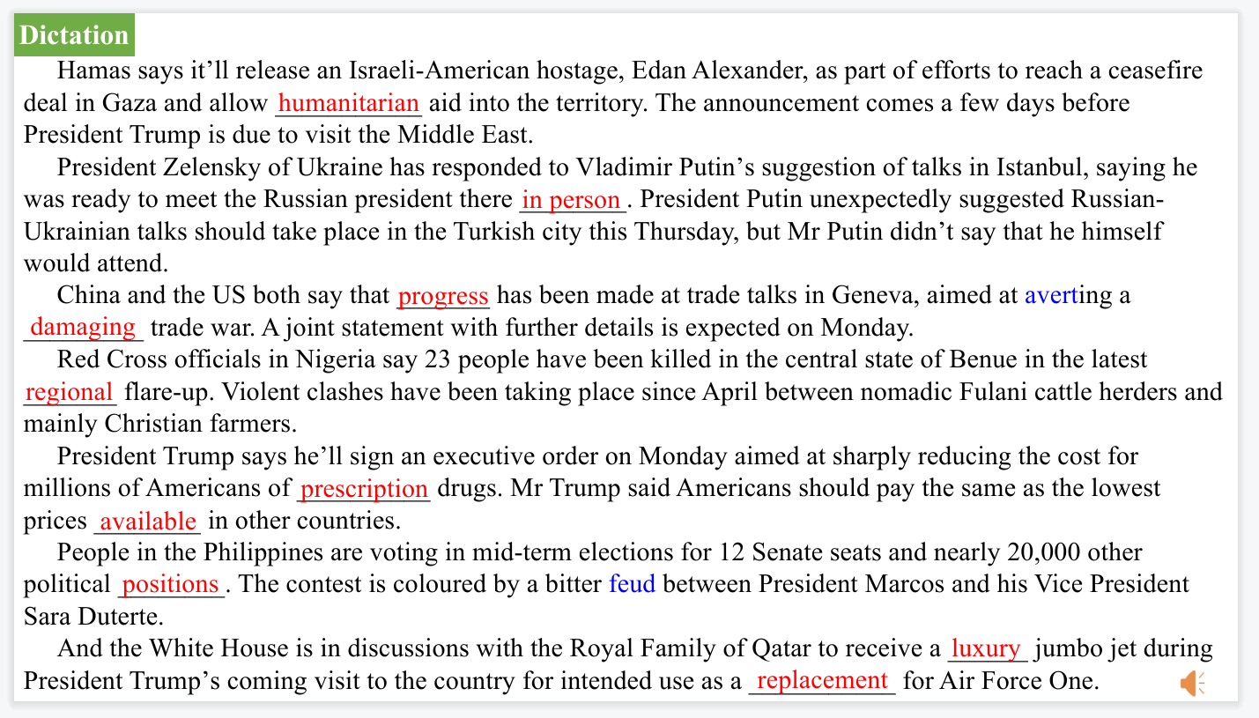

【设计意图】听一则材料，通过听力填空的方式理解文本，考察听力辨识词汇的能力。

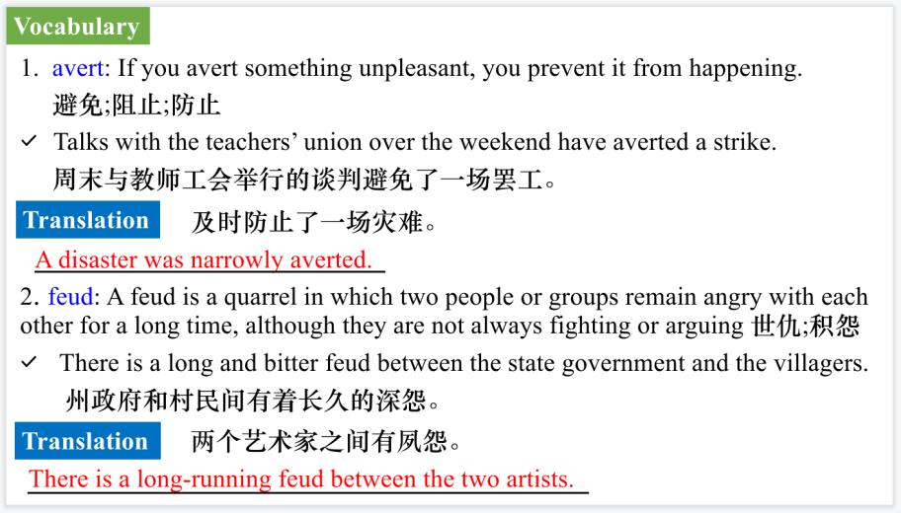

【设计意图】对文本中的词汇进行解读，并通过翻译句子对其进行巩固。



【设计意图】对文中的两个句子进行翻译练习，对其中单词、词组、句法进行巩固并关注句子结构。

附：外刊原文

**Part 1: News Report 1 *The Week* (May 9 2025 P8&9)**

**The World at a Glance 世界观察两则**

**Madrid**

Unprecedented blackout: Spain and Portugal were hit by a massive power outage this week that affected tens of millions of people. France’s southern Basque region was also briefly affected. Trains abruptly stopped, forcing passengers to be rescued by bus, but traffic was snarled everywhere because all the streetlights were out. Restaurants, shops, and supermarkets were suddenly plunged into darkness, and most schools and businesses shut down, although hospitals kept functioning with generators. Mobile phone service was also affected, leaving many stranded people unable to get help. Some stores stayed open for cash transactions only, and long lines formed at the few working ATMs. “It’s like when I was younger, 50 years ago,” said Francisco Garcia, 61, a boat restorer in Lisbon. Authorities in both countries were trying to determine whether the cause of the blackout was sabotage, a cyberattack, mechanical failure, or human error.

**Valletta, Malta**

Stop selling citizenship: The EU’s top court this week ordered Malta to end its “golden passport” program, saying it reduced citizenship to a “mere commercial transaction” in violation of EU law. Malta’s investor citizenship scheme offers a Maltese passport—and the EU citizen ship that comes with it—for $700,000 after three years of residency or $850,000 after one year. The program, introduced in 2013, quickly became a back door to EU access for money launderers and other criminals, as well as for Russian oligarchs subject to Western sanctions. The ruling could also spell trouble for EU countries that offer “golden visas,” including Austria, Cyprus, Greece, Hungary, Ireland, and Portugal. “European passports are not for sale,” said Daniel Freund, a German lawmaker in the European Parliament. “Criminals, autocrats, and terrorists should not be able to buy a ticket into the EU.”

**Part 2: News Report 2 *The Times* ((May 8, 2025 P5 )**

**Orcas venture near and Farne**

**虎鲸冒险靠近法恩岛**

William Shiel’s family have been running boat trips to the Farne Islands for more than 100 years. He had heard stories of the occasional orca long ago, but never in his 40-year career had he seen one for himself.

That changed last week, when a group of eight killer whales made a spectacular — and unusual — appearance off the Northumberland coast, near Bamburgh Castle.

Shiel, 52, said: “It was quite a sight. The dorsal fins were the size of a bloody garage door. My father Billy told me that while out crab fishing, he once saw a killer whale near Longstone Lighthouse [on Farne].” The lighthouse was made famous by Grace Darling and her father, when they rescued shipwreck survivors. “I’ve been doing this for 40 years and that’s the first time I’ve seen a killer whale,” he added.

Happily, a professional photographer was aboard to capture the encounter which lasted more than half an hour.

The video has allowed experts to confirm the orcas are from groups that migrate every year from Iceland to Scotland. Rarely, however, do they travel that far down the eastern coast. The Northumberland sightings have raised hopes that new populations are venturing further into

British waters — and staying for longer.

The UK has only two resident orcas. John Coe and Aquarius, as they are known, have been seen regularly around the northwest coast of Scotland for years. Over the decades, their pod dwindled. The females died— their bodies were so full of toxic pollutants they were unable to reproduce— leaving John Coe and Aquarius doomed to patrol the British Isles like two lonely bachelors.

For each newcomer, experts compared their dorsal fin, unique identifying patterns around their eye patch and the pale “saddle patch” on their back with that of the orcas listed in ID catalogues in Shetland and Iceland.

Of the eight orcas spotted on Friday, it has been confirmed that one is a large male known as “72”, from the “27 pod”. His brother has been recorded as reaching the Northumberland area, but it is the first time 72 has been spotted this far south. Three others have been identified as “Razor”, “Ossa” and “199”, which are members of the 65 pod — another of the 12 migratory groups that are known to travel from Iceland to the British Isles. The remaining four have yet to be identified.

Lucy Babey, director of programmes at Orca, a body that monitors whales and dolphins in UK waters, said they could be known individuals or “they could be orca that are completely new to UK waters. That’s exciting.”

On April 29 a fisherman reported seeing what is believed to be the same group spotted by Shiel, further down the Northumberland coast, off the village of Beadnell. On the same day, more than 200 miles north, another group of orcas was spotted near Aberdeen.

The flurry of sightings has prompted a rush of bookings at local restaurants and hotels. Tom Leslie, owner of The Whittling House in Alnmouth, said:“We saw a surge in last-minute bookings after the sightings.” Rachel Shiel, who runs Billy Shiel’s Boat Trips with her husband in Seahouses, said the “phone has been red hot”.

“It could be a one in a lifetime sighting,” William Shiel said. “[But] I would like to think it will be a regular thing.”

**Part 3: News Report 3 BBC Science Focus（May, 2025 P22)**

**The worst coffee types for your cholesterol levels**

**对胆固醇水平影响最大的咖啡类型**

According to the National Coffee Association, the average American drinks just over three cups of coffee a day. It’s often seen as a healthy habit, and for good reason: coffee is linked to a reduced risk of diabetes and certain types of cancer.

But coffee also contains natural compounds that can raise cholesterol, and depending on how it’s prepared, your daily pick-me-up could be giving you more of them than you want.

In a study, published in the journal Nutrition, Metabolism and Cardiovascular Diseases, a team of Swedish researchers took a closer look at workplace coffee machines and found that many produce coffee with relatively high levels of these cholesterol-elevating substances.

Unfiltered or boiled coffee is known to contain two cholesterol-raising compounds, cafestol and kahweol, which belong to a group of naturally occurring fats called diterpenes. These have been associated with higher levels of LDL (or ‘bad’) cholesterol and an increased risk of cardiovascular disease. They’ve also been shown to slightly reduce HDL (‘good’) cholesterol. Filtered coffee, by contrast, tends to contain far lower levels of these substances.

“But at work, we get a lot of coffee from machines and no one has really tested these before,” study author Dr David Iggman told BBC Science Focus.

To investigate, the team measured the levels of cafestol and kahweol found in coffee from 14 machines across a range of workplaces. They compared these brews to drip coffee, percolator, French press, espresso and boiled coffee.

“From our data, we can say that liquid-model machines are definitely the better option,” Iggman said. These machines, which combine a liquid coffee concentrate with hot water, produce coffee with very low levels of diterpenes, at a similar level to paper-filtered coffee. Meanwhile, machines that used ground or whole beans passed through a metal filter contained higher levels of cholesterol-raising compounds.

**Part 4: News Report 3 The Times（May 9, 2025 P3)**

**What ￡1.8 million buys you in...**

**180万英镑能买到什么？**

Oxfordshire

Orchard House is a spacious family home on the edge of the Cotswolds with a Georgian façade, high ceilings and beautifully maintained gardens with a grapevine-wrapped pergola, a prolific asparagus bed and a good-sized potting shed. On the ground floor there is a generous 500 sq ft living room, kitchen, dining room, office, bathroom and separate WC. Up the curved wooden staircase are four bedrooms and two bathrooms.

EPC D (potential B) — on a scale of A (best) to G (worst)

Upside Off-street parking.

Downside Despite the name, there’s no orchard.

Contact savills.com

Greater Manchester

It’s not often that a fully moated 16th-century house appears on the market, but Gidlow Hall is just that. The property, just over two miles from Wigan, has 4,727 sq ft of living space and 7.41 acres of land. It is accessed via a no through lane with a tree-lined sweeping drive, so there is a high degree of privacy. There are three reception rooms, five bedrooms and three bathrooms, including a main bedroom with en suite bathroom and a terrace. There is also a barrel-vaulted cellar and a detached double garage.

EPC C (current and potential)

Upside Further land available.

Downside The bridge can’t be drawn up.

Contact jackson-stops.co.uk

West Sussex

With stunning views of the South Downs National Park, Rhiw has no shortage of country charm. It is grade II listed and has exposed timber beams, brickwork and open fireplaces, as well as a conservatory which opens out into the garden. There are three more reception rooms downstairs, plus a large kitchen, shower room and bedroom. Upstairs are three more bedrooms, one with an en suite bathroom. The village of Amberley is close to Storrington and Pulborough.

EPC N/A

Upside Underfloor heating via ground source heat pump.

Downside The balcony is accessed via the bathroom.

Contact hamptons.co.uk

Or ... a ready-made holiday business in Pembrokeshire

Clydey Cottages is an award-winning holiday cottage complex, and it’s available to purchase turnkey. The 15.8-acre site, in the heart of Pembrokeshire, includes ten holiday units, a heated indoor swimming pool, sauna, games room, spa treatment room and hot tubs. There are woodland walks, and the farm offers animal feeding and egg collecting, plus beaches a short drive away.

EPC E (potential C)

Upside Future bookings in place.

Downside Cottages could be spruced up.

Contact fineandcountry.co.uk