1. **倒金字塔结构定义**

倒金字塔结构一般用于新闻报道，是按照[新闻价值](https://baike.baidu.com/item/%E6%96%B0%E9%97%BB%E4%BB%B7%E5%80%BC/684597?fromModule=lemma_inlink" \t "https://baike.baidu.com/item/%E5%80%92%E9%87%91%E5%AD%97%E5%A1%94%E7%BB%93%E6%9E%84/_blank)的大小，即[新闻事实](https://baike.baidu.com/item/%E6%96%B0%E9%97%BB%E4%BA%8B%E5%AE%9E/8205496?fromModule=lemma_inlink" \t "https://baike.baidu.com/item/%E5%80%92%E9%87%91%E5%AD%97%E5%A1%94%E7%BB%93%E6%9E%84/_blank)的重要程度、新鲜程度，以及读者感兴趣的程度等，依次将新闻事实写出的一种结构形式。由于这种结构格局前边重、后边轻，上头大、下头小，所以称之为“倒金字塔”或“倒三角”结构。

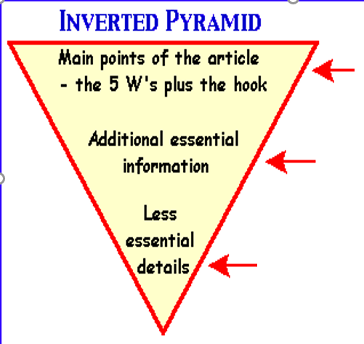

**1.Event** (**who /what/why)**:

**2. Details**：

**3. Background information and significance**

1. **文本结构复习与回顾**

**人教版必修1 Unit4 Reading for Writing教材文本**

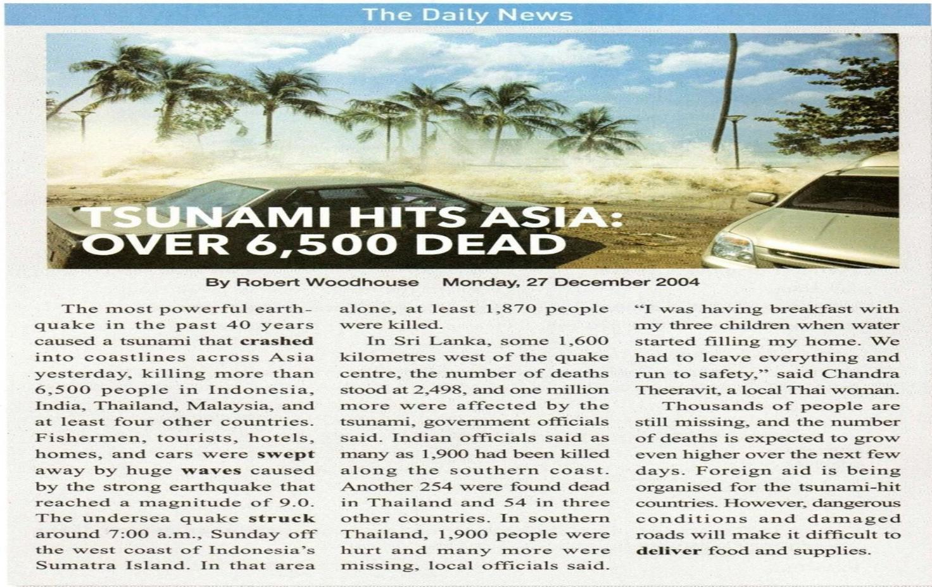

**Lead**

**Body**

**Para 2** Details of the event and its effects

**End**

**Para 3** Possible effects and other imformation about the event, or a conclusion

**Para 1** What(event)____________________

Where______________________

Why（Reason)___________________

Effect______________________________

1. **“倒金字塔结构”语篇结构高考真题总结**

|  |  |  |  |  |  |
| --- | --- | --- | --- | --- | --- |
| 年份 | 试卷 | 主题语境 | 主题内容 | 主题意义 | 语篇类型 |
| 2024年 | 全国甲卷C篇 | 人与社会 | 俄罗斯政府开展医疗援助 | 培养学生的理想信念和社会责任感 | 说明类新闻报道 |
| 2023年 | 全国新高考II卷B篇 | 人与自我 | 校园菜园项目 | 增强学生劳动意识和劳动观念 | 记叙类新闻报道 |
| 2022年 | 全国新高考I卷C篇 | 人与社会 | 养老院老人养鸡 | 引导学生关爱老年人，热心公益事业 | 记叙类新闻报道 |
| 2021年 | 全国甲卷B篇 | 人与自然 | 保护黑犀牛所实施的繁殖计划 | 保护野生动物，人与自然和谐相处 | 说明类新闻报道 |
| 2021年 | 全国新高考II卷C篇 | 人与社会 | 一位英国女教师让艺术家走进课堂，引发课堂变革 | 重视艺术教育，提高中和文化素养 | 议论类新闻报道 |
| 2021年 | 全国乙卷C篇 | 人与自然 | 艺术家将塑料做成引人深思的雕塑 | 保护生态环境，关注并参与人类命运共同体的构建 | 说明类新闻报道 |

1. **梳理高考真题新闻报道类语篇结构，助力阅读理解**

**(一)记叙类新闻报道**

## **2023.6新高考II卷B篇**

|  |
| --- |
| ①Turning soil, pulling weeds, and harvesting cabbage sound like tough work for middle and high school kids. And at first it is, says **Abby Jaramillo**, who with another teacher **started Urban Sprouts**, a school garden program at four low-income schools. The program **aims to** help students develop science skills, environmental awareness, and healthy lifestyles.  Para 1  **What (event)**  **who**  **purpose**    ②Jaramillo’s students live in neighborhoods where fresh food and green space are not easy to find and fast food restaurants outnumber grocery stores. “The kids literally come to school with bags of snacks and large bottles of soft drinks,” she says. “They come to us thinking vegetables are awful, dirt is awful, insects are awful.” Though some are initially scared of the insects and turned off by the dirt, most are eager to try something new.  Para 2  **background information**  ③Urban Sprouts’ classes, at two middle schools and two high schools, include **hands-on experiments** such as soil testing, flower-and-seed dissection, tastings of fresh or dried produce, and work in the garden. Several times a year, students cook the vegetables they grow, and they occasionally make salads for their entire schools.  Para 3  **implementation**  ④Program evaluations **show that kids eat more vegetables** as a result of the classes. “We have students who say they went home and talked to their parents and now they’re **eating differently**,” Jaramillo says.  Para 4  **evaluation/**  **significance 1**    ⑤She adds that the program’s benefits go beyond nutrition. Some students get **so interested in gardening that they bring home seeds to start their own vegetable gardens.** Besides, working in the garden seems to have a calming effect on Jaramillo’s special education students, many of whom **have emotional control issues.** “They get outside,” she says, “and they feel successful.  Para 5  **significance2** |

4. What do we know about **Abby Jaramillo**?

**Para 1**

**who**

A. She used to be a health worker.

B. She grew up in a low-income family.

C. She owns a fast food restaurant.

D. She is an initiator of Urban Sprouts.

**background information**

**Para 2**

5. What was **a problem** facing Jaramillo at the start of the program?

A. The kids’ parents distrusted her.

B. Students had little time for her classes.

C. Some kids disliked garden work.

**significance**

**Para 4&5**

D. There was no space for school gardens.

6. Which of the following best describes the **impact** of the program?

A. Far-reaching. B. Predictable.

C. Short-lived. D. Unidentifiable.

**Main idea**

**Summarize the whole passage**

**Purpose para 1**

7. What can be **a suitable title** for the text?

A. Rescuing School Gardens B. Experiencing Country Life

C. Growing Vegetable Lovers D. Changing Local Landscape

## **2. 2022.6新高考1卷C篇**

①The elderly residents (居民) in care homes in London are being given hens to look after to stop them feeling lonely.

②The project was dreamed up by a local charity (慈善组织) **to reduce loneliness and improve elderly people’s wellbeing.** It is also being used to help patients suffering dementia, a serious illness of the mind. Staff in care homes have reported a reduction in the use of medicine where hens are in use.

③Among those taking part in the project is 80-year-old Ruth Xavier. She said: “I used to keep hens when I was younger and had to prepare their breakfast each morning before I went to school.

④“I like the project a lot. I am down there in my wheelchair in the morning letting the hens out and down there again at night to see they’ve gone to bed.

⑤“It’s good to have a different focus. People have been bringing their children in to see the hens and residents come and sit outside to watch them. I’m enjoying the creative activities, and it feels great to have done something useful.”

⑥There are now 700 elderly people looking after hens in 20 care homes in the North East, and the charity has been given financial support to roll it out countrywide.

⑦Wendy Wilson, extra care manager at 60 Penfold Street, one of the first to embark on the project, said: “Residents really welcome the idea of the project and the creative sessions. We are looking forward to the benefits and fun the project can bring to people here.”

⑧Lynn Lewis, director of Notting Hill Pathways, said: “We are happy to be taking part in the project. It will really help connect our residents through a shared interest and creative activities.”

语篇结构图

**Hens for the elderly people**

Para 1:

Para 2:

Para 3-6:

Para 7-8:

**_____________Para_______**

28.What is the **purpose** of the project?

A. To ensure harmony in care homes. B. To provide part-time jobs for the aged.

C. To raise money for medical research. D. To promote the elderly people’s welfare.

29.How has the project **affected Ruth Xavier**?

**_____________Para_______**

A. She has learned new life skills. B. She has gained a sense of achievement.

C. She has recovered her memory. D. She has developed a strong personality.

30.What do the underlined words “embark on” mean in paragraph 7?

**_____________Para_______**

A. Improve. B. Oppose. C. Begin. D. Evaluate.

31.What can we learn about the project from the last two paragraphs?

**_____________Para_______**

A. It is well received. B. It needs to be more creative.

C. It is highly profitable. D. It takes ages to see the results.

**(二)说明类新闻报道**

## **2021.6全国乙卷C篇**

①You’ve heard that plastic is polluting the oceans—between 4.8 and 12.7 million tonnes enter ocean ecosystems every year. But does one plastic straw or cup really make a difference? **Artist Benjamin Von Wong** wants you to know that it does. He builds massive sculptures out of plastic garbage, forcing viewers **to re-examine their relationship to single-use plastic products**.

②**At the beginning of the year**, the artist built a piece called “Strawpocalypse,” a pair of 10-foot-tall plastic waves, frozen mid-crash. Made of 168,000 plastic straws collected from several volunteer beach cleanups, the sculpture **made its first appearance** at the Estella Place shopping center in Ho Chi Minh City, Vietnam.

③Just 9% of global plastic waste is recycled. Plastic straws are by no means the biggest source (来源)of plastic pollution, but they’ve **recently** come under fire because most people don’t need them to drink with and, because of their small size and weight, they cannot be recycled. Every straw that' s part of Von Wong's artwork likely came from a drink that someone used for only a few minutes. Once the drink is gone, the straw will take centuries to disappear.

④**In a piece from 2018**, Von Wong wanted to illustrate (说明) a specific statistic: Every 60 seconds, a truckload's worth of plastic enters the ocean. For this work, titled “Truckload of Plastic,” Von Wong and a group of volunteers collected more than 10,000 pieces of plastic, which were then tied together to look like they’d been dumped(倾倒)from a truck all at once.

⑤Von Wong **hopes that** his work will also help pressure big companies to reduce their plastic footprint.

**Truckload of plastic garbage**

Para 1:

Para 2-4:

Para 5:

28. What are Von Wong’s artworks **intended for**?

**_____________Para_______**

A. Beautifying the city he lives in.

B. Introducing eco-friendly products.

C. Drawing public attention to plastic waste.

D. Reducing garbage on the beach.

29. Why does the author **discuss plastic straws** in paragraph 3?

**_____________Para_______**

A. To show the difficulty of their recycling.

B. To explain why they are useful.

C. To voice his views on modern art.

D. To find a substitute for them.

**_____________Para_______**

30. What effect would "**Truckload of Plastic**" have on viewers?

A. Calming. B. Disturbing C Refreshing D. Challenging.

31. Which of the following can be the best title for the text?

**_____________Para_______**

A. Artists' Opinions on Plastic Safety

B. Media Interest in Contemporary Art

C. Responsibility Demanded of Big Companies

D. Ocean Plastics Transformed into Sculptures

## **2021.全国甲卷B篇**

①Port Lympne Reserve, which runs a breeding(繁育) programme, has welcomed the arrival of a rare black rhino calf(犀牛幼崽）. When the tiny creature arrived on January 31, she became the 40th black rhino to be born at the reserve. And officials at Port Lympne were delighted with the new arrival, especially as black rhinos are known for being difficult to breed in captivity(圈养).

②Paul Beer, head of rhino section at Port Lympne, said:“Obviously we're all absolutely delighted to welcome another calf to our black rhino family. She's healthy, strong and already eager to play and explore. Her mother, Solio, is a first-time mum and she is doing a fantastic job. It's still a little too cold for them to go out into the open, but as soon as the weather warms up, I have no doubt that the little one will be out and about exploring and playing every day.”

③The adorable female calf is the second black rhino born this year at the reserve, but it is too early to tell if the calves will make good candidates to be returned to protected areas of the wild. The first rhino to be born at Port Lympne arrived on January 5 to first-time mother Kisima and weighed about 32kg. His mother, grandmother and great grandmother were all born at the reserve and still live there.

④According to the World Wildlife Fund, the global black rhino population has dropped as low as 5500, giving the rhinos a “critically endangered” status.

语篇结构图

**A breeding program**

Para 1:

Para 2:

Para 3-4:

**_____________Para_______**

4.Which of the following best describes the breeding programme?

A.Costly. B.Controversial. C.Ambitious. D.Successful.

**_____________Para_______**

5.What does Paul Beer say about the new-born rhino?

A.She loves staying with her mother. B.She dislikes outdoor activities.

C.She is in good condition. D. She is sensitive to heat.

6. What similar experience do Solio and Kisima have?

**_____________Para_______**

A.They had their first born in January.

B. They enjoyed exploring new places.

C.They lived with their grandmothers.

D.They were brought to the reserve young.

7. What can be inferred about Port Lympne Reserve?

**_____________Para_______**

A.The rhino section will be open to the public.

B.It aims to control the number of the animals.

C.It will continue to work with the World Wildlife Fund.

D.Some of its rhinos may be sent to the protected wild areas.

## **2024.全国甲卷C篇**

①The Saint Lukas train doesn’t accept passengers — it accepts only the sick. The Saint Lukas is one of five government-sponsored medical trains that travel to remote towns in central and eastern Russia. Each stop lasts an average of two days, and during that time the doctors and nurses on board provide rural (乡村) populations with basic medical care, X-ray scans and prescriptions.

②“People started queuing to make an appointment early in the morning,” says Emile Ducke, a German photographer who traveled with the staff of the Saint Lukas for a two-week trip in November through the vast regions (区域) of Krasnoyarsk and Khakassia.

③Russia’s public health care service has been in serious need of modernization. The government has struggled to come up with measures to address the problem, particularly in the poorer, rural areas east of the Volga River, including arranging doctor’s appointments by video chat and expanding financial aid programs to motivate doctors to practice medicine in remote parts of the country like Krasnoyarsk.

④The annual arrival of the Saint Lukas is another attempt to improve the situation. For 10 months every year, the train stops at about eight stations over two weeks, before returning to the regional capital to refuel and restock (补给). Then it starts all over again the next month. Most stations wait about a year between visits.

⑤Doctors see up to 150 patients every day. The train’s equipment allows for basic checkups. “I was very impressed by the doctors and their assistants working and living in such little space but still staying focused and very concerned,” says Ducke. “They were the best chance for many rural people to get the treatment they want. ”

语篇结构图

**A breeding program**

Para 1:

Para 2-3:

Para 4:

Para 5:

8. How is the Saint Lukas different from other trains?

**_____________Para_______**

A. It runs across countries. B. It reserves seats for the seniors.

C. It functions as a hospital. D. It travels along a river.

9. What can we infer from paragraph 3 about Krasnoyarsk?

**_____________Para_______**

A. It is heavily populated. B. It offers training for doctors.

C. It is a modern city. D. It needs medical aid.

10. How long can the Saint Lukas work with one supply?

**_____________Para_______**

A. About a year. B. About ten months.

C. About two months. D. About two weeks.

11. What is Ducke’s attitude toward the Saint Lukas’ services?

**_____________Para_______**

A. Appreciative. B. Doubtful C. Ambiguous. D. Cautious.

**(三)议论类新闻报道**

## **2021新高考2卷C篇**

①A British woman who won a＄1 million prize after she was named the World's Best Teacher will use the cash to bring inspirational figures into UK schools.

②Andria Zafirakou, a north London secondary school teacher, said she wanted to bring about a classroom revolution （变革）. “We are going to make a change,＂she said.＂I’ve started a project to promote the teaching of the arts in our schools."

③The project results from the difficulties many schools have in getting artists of any sort - whether an up-and-coming local musician or a major movie star - into schools to work with and inspire children.

④Zafirakou began the project at Alperton Community School, her place of work for the past twelve years. “I've seen those magic moments when children are talking to someone they are inspired by - their eyes are shining and their faces light up,” she said. “We need artists more than ever in our schools."

⑤Artist Michael Craig-Martin said: “Andria's brilliant project to bring artists from all fields into direct contact with children is particularly welcome at a time when the arts are being downgraded in schools." It was a mistake to see the arts as unnecessary, he added.

⑥Historian Sir Simon Schama is also a supporter of the project. He said that arts education in schools was not just an add-on. “It is absolutely necessary. The future depends on creativity and creativity depends on the young. What will remain of us when artificial intelligence takes over will be our creativity, and it is our creative spirit, our visionary sense of freshness,that has been our strength for centuries."

语篇结构图

**A British woman teacher**

Para 1-2:

Para 3-4:

Para 5-6:

28.What will Zafirakou do with her prize money?

**_____________Para_______**

A. Make a movie. B.Build new schools.

C.Run a project. D. Help local musicians.

29.What does Craig-Martin think of the teaching of the arts in UK schools?

**_____________Para_______**

A. It is particularly difficult. B. It increases artists' income.

C. It opens children's mind. D.It deserves greater attention.

30.What should be stressed in school education according to Schama?

**_____________Para_______**

A. Moral principles. B. Interpersonal skills.

C.Creative abilities. D.Positive worldviews.

**_____________Para_______**

31.Which of the following is a suitable title for the text?

A.Bring Artists to Schools B.When Historians Meet Artists

C.Arts Education in Britain D.The World's Best Arts Teacher

## **四．检测习题**

## **6.2022年惠州市一模C篇**

From crystal-blue lakes to snow-capped mountains and thousand-year-old trees, Canada’s nature is admired around the world. Now it might also be just what the doctor ordered. An ambitious new programme allows doctors to write prescriptions (处方) for free annual passes to Canada’s national parks, encouraging their patients to improve their health — both mental and physical — by taking a stroll in nature.

The prescriptions are provided by PaRX, in partnership with Parks Canada. The first passes were handed out last month, giving holders access to more than 80 national parks, historic sites and nature reserves. PaRX, a health initiative (倡议) launched in 2019 by the British Columbia Parks Foundation, notes on its website that spending time in nature can lead to longer lives, increased energy, reduced stress and anxiety, improved heart health, less pain and better mood. Vitamin D from the sun’s rays has proven health benefits. The organization also hopes that the prescriptions will boost investment in conservation in Canada.

The initial provision covers four Canadian provinces: British Columbia, Saskatchewan, Ontario and Manitoba. Participating doctors have only 100 annual passes to hand out for now, but PaRX hopes that the programme will be expanded.

“Medical research now clearly shows the positive health benefits of connecting with nature,” Steven Guilbeault, the environment minister, said. “I am confident this programme will quickly show its enormous value to the well-being of patients as it continues to expand throughout the country.”

Canada’s physicians are already in the habit of prescribing “nature therapy” as a treatment for anxiety, depression, high blood pressure, immune function and insomnia (失眠). Previously, though, they would write more general prescriptions, such as spending time in nature twice a week, for at least 20 minutes at a time. This is the first time that they have been able to equip their patients with tickets.

28. Why does the author mention Canada’s nature in paragraph 1?

A.To recommend doctors’ prescriptions.

B. To advertise Canada’s natural scenery.

C. To introduce a health initiative program.

D. To demonstrate health benefits of nature.

29. What makes the prescriptions significant?

A. boom in park visiting.

B. A rise in economy.

C. Investment in conservation.

D. Improvement in health.

30. What can we infer from the last paragraph?

A. Patients doubt the general prescriptions.

B. The previous “nature therapy” is popular.

C. It is a tradition to offer patients park tickets.

D. “Nature therapy” is no longer just on paper.

31. Which of the following can be the best title for the text?

A. Nature Heals Mental Diseases

B. Canada Possesses Admirable Nature

C. Doctors Order A Walk in The Wilderness

D. Canadian Doctors Have Free Access to Parks