**Handout for Unit 2 Morals and Virtues**

**Period 2 Reading and Thinking**

**Activity 1 Guessing Game - match the pictures with the introductions**

Q:What do they have in common?

1.They made wise choices when they were .

2.They kept on chasing（追逐） their .

3.They made great achievements that made the world a place.

**Activity 2 Analyzing the structure of the passage**

1.From the title and the pictures, we can know the passage might be about a female _______ who______________________.

2. What is the purpose of the text ?

A.To prove a point B. To describe a job C. To introduce a person (The type of the text: )

3. How is the passage developed?

A.By following time order B.By comparing facts C.By listing numbers

4.How can the passage be divided into?

A. 123/456 B. 1/2/3456

5.Choose the key words to complete the main idea of each part

Part 1:The that led to her life choices.

Part 2:The that made her life choices possible.

Part 3:The she chose.

1. career B. education C. belief

**Activity 3 Learning more information about Lin's life**

|  |  |
| --- | --- |
| Name | Lin Qiaozhi |
| Nationality | China |
| Job |  |
| Events | At age 5, Lin Qiaozhi’s mother , which affected her a lot. |
| At age 18, she made up her mind to . |
| At age 26, she from PUMC and was named a chief resident physician. |
| After a few years, she went to study in . |
| At age 38, she the offer from the US and returned to China. |
| At age 40, she was director of the OB-GYN department of the Hospital, but a few months later, she opened a . |
| At age 53, she was to the first National People's Congress. However, she was more interested in patients.... |
| At age 82, she passed away. |

**Activity 4 Learning about Lin’s hard choices**

Choose the right answers from A to L to fill in the form.

|  |  |  |
| --- | --- | --- |
| **Choices** | **Difficulties** | **Results** |
| **A.**Holding important positions  **B.**To study medicine  **C.**To focus more on work  **D.**Marrying  **E.**To open a clinic  **F.**Working in the US | **G.** Facing the danger of losing life or getting hurt  **H.** Living a hard life in China  **I.** Being objected by her brother | 1. Continued to provide medical care for the people in need of help 2. Served the women and children at home 3. Known as “the mother of ten thousand babies” |

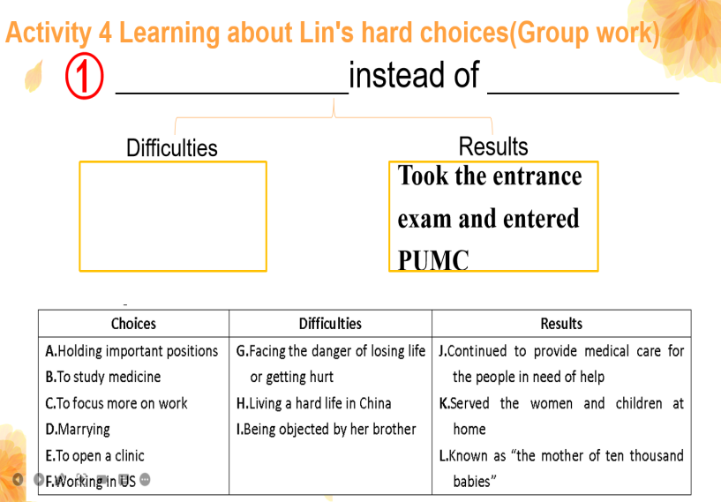 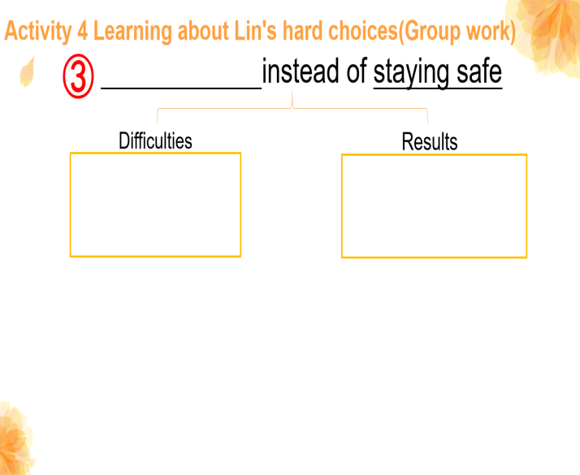

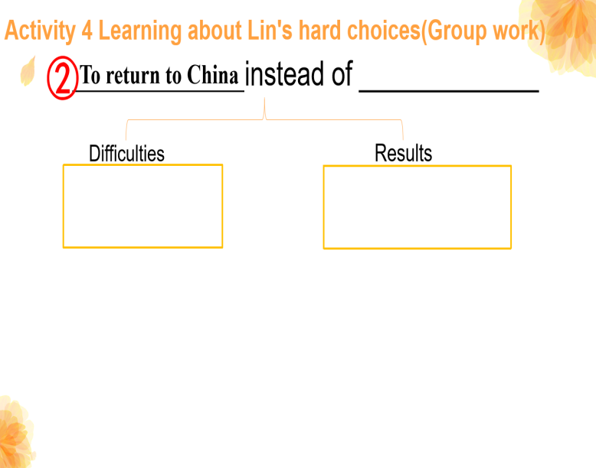 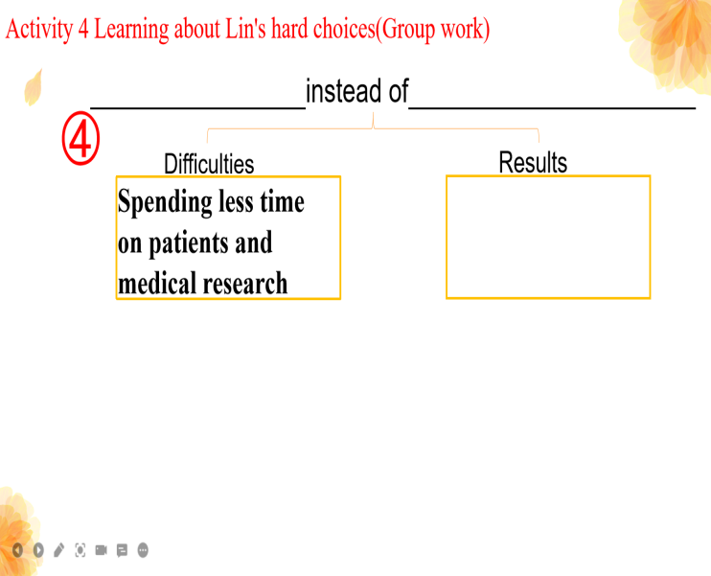

**The first choice:**

At age 18, Lin Qiaozhi chose to instead of , which meant the difficulties she faced was . Finally, she .

**The second choice:**

At age 38, Lin Qiaozhi chose to instead of , which meant the difficulties she faced was . And she .

**The third choice:**

At age 40, Lin Qiaozhi chose to instead of , which meant she might . And she .

**The fourth choice:**

At age 53, Lin Qiaozhi chose to instead of , which meant she would . And she .

**Activity 5 Drawing conclusions**

We all choices, but in the end our choices us.

**Assignments**

1.What are your expectations for life? What life choices will you make? What would you do? Please write a short passage to share it with us.

2.（Optional）What would Lin Qiaozhi's life have been if she had made another choice? Please rewrite her life in a short paragraph.