**M1Unit 5 Listening and Speaking**

**Teaching Analysis:**

The topic of unit 5 is “languages around the world”. And in the listening and speaking period, learners are going to listen to a speech about learning foreign languages and reasons why people study a foreign language. And learners have certain interests in this topic since they have been in a globalized and connected world where all kinds of cultures and languages are available to them. And as an EFL learner, ss have the related experience of learning a foreign language so this unit provides a good opportunity for them to make a reflection on the foreign language learning by thinking about their reasons of learning a foreign language.

Teaching Aims:

1. To explore the languages around the world by discussing on the open page and listening to the speech.
2. To practice listening skills like listening for the gist and details.
3. To summarize the language features of a speech by listening for some functional words used in a speech.
4. To activate the motives of learning foreign language through discussing and evaluating their own foreign language learning process.

Teaching procedures:

Step1: Lead-In

Activity: Look and Discuss: The Open page and the importance of learning a foreign language.



To learn some quotes about learning foreign languages.

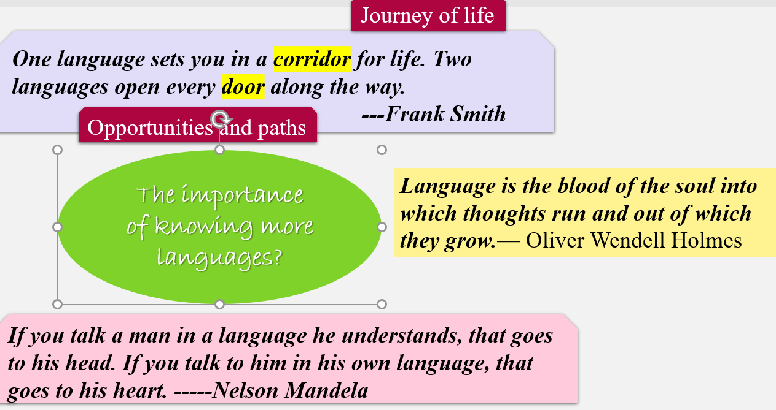

Step2: Before listening

Activity 1: Watch a video about different expressions of greeting in all kinds of languages.

Match the picture with the right countries and tell the official language spoken in these countries.

（Aims: To provide some background information and prepare for the listening.）

Step3：While-listening

First listening：Listen for gist: the main topic.

Second Listening: Listen for details:

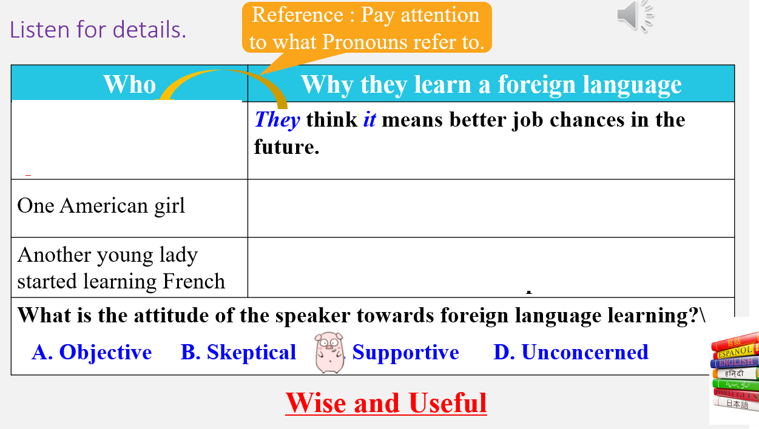

Third Listening: Listen for language



(Aims: to guide ss to learn to get the main idea by listening for the topic sentences and listen for the details by focusing on the what the pronounces refer to. And ss are also guided to summarize the features of a speech through listening for the functional words.)

Step4: Post-listening

Discuss with your partners: What language will you choose to learn and why?



Thinking: What kind of roles do languages paly in our life?

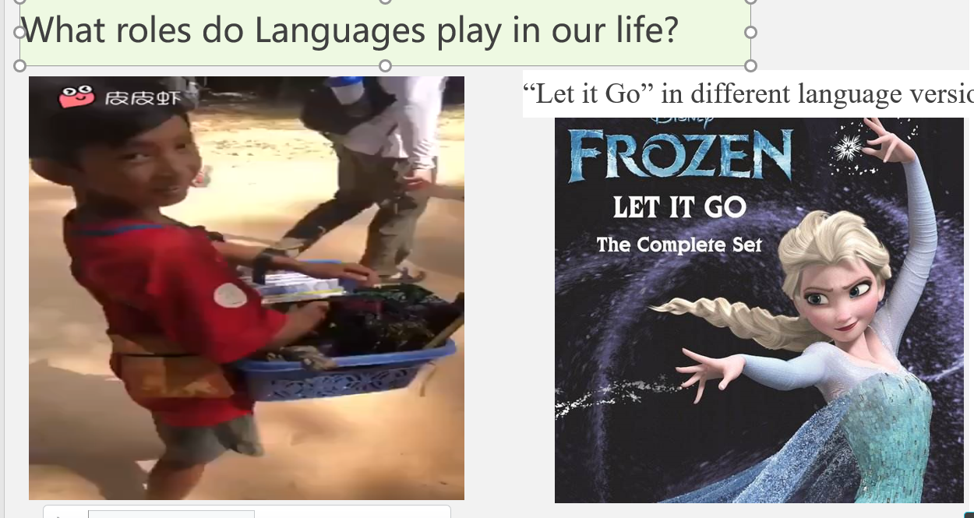

(Aims: to enable ss to evaluate their language learning by thinking about motives of learning a foreign language.)

Step5: Homework

You can make a dubbing video in the language you want to learn or learn some basic expressions in the language you want to learn.

(Aims: to extend Ss’ horizons and activate their learning motives)