**20220414台州二模读后续写讲评学案**

It was a cold yet sunny Saturday morning in February. Dad’s New Year’s resolution had been to get fit. Mum pushed him out of bed and told him to go jogging by the river. Later, after a nice lie-in, she went downstairs in her dressing gown and found the kids watching TV. She turned it off and said she was going to do something really special for Dad’s birthday. If they overheard anything, just promised to keep it secret.

Jenny looked at Mum with a puzzled expression on her forehead and promised they wouldn’t say anything whatever happened. But Jenny reminded Dad’s birthday was in June and it might be a little too early to get all steamed up about it.

Silent for a moment, Mum said she was not getting everything ready but just wanted to spare enough time for preparation as this year it’s a bigger deal than usual. Dad was going to be 50.

“50! Gosh, that’s half a century,” spluttered Gerry. “I knew he was old, but I didn’t realize he was ancient!?”

Indeed, that was why Mum started planning a special party for him. Mum talked with grandma about the plan because her house was the only one in the family that is spacious enough for all friends and relatives. Grandma quite agreed and also started preparing.

“But you know how Dad feels guilty to bother others. You’ve got to admit,” reminded Jenny. Thinking over the special occasion, Mum was continuing with her secret when one evening, Dad was sitting at the dinner table and he suddenly slapped his forehead, “I just realized that I am going to be 50 in June. Le’s just quietly forget about it. I want to mourn (哀悼) the passing of my youth in private.”

“Oh, come on Dad, don’ t be such a spoil-sport!” begged the kids, hoping to give mum a hand.

Realizing no more chance to hide the secret, Mum carefully worded her thought and shared her plan of having a little party at grandma’s house. Dad was stunned(震惊的) to no reply.

*Paragraph 1: Frustrated, Mum made a call to Grandma.__________________*

*Paragraph 2: They got everything ready as planned when June finally came.___*

**语言学习：**

1.新年决心 1.New Year’s resolution

2.去慢跑 2.go jogging

3.下楼 3.do downstairs

4.保守秘密 4.keep... a secret (from...)

5.一副迷惑的表情 5.a puzzled look/expression

6.抽出足够的时间 6.spare enough time

7.对...感到内疚 7.be guilty about...

8.在这个特殊的场合 8.on the special occasion

9.坐在餐桌旁 9.at the dinner table

10.私下地 10.in private

**Understand the story 1：Fill in the blanks.**

Dad _______________(approach) 50. Mum intended to prepare a special birthday party _____ the important moment. As her house was not __________(space) enough for all the friends and relatives, she consulted with Grandma and decided to have the party at ____________(Grandma).

As Dad, whose New Year’s Resolution was ________(stay) fit, was always g______ about bothering others. To achieve her plan, she started early and shared the plan with her kids. Though ______(ask) to keep it a secret from Dad, the two kids accidentally let it _____ to Dad. Full of __________(frustrate), she made a call to Grandma...

**Understand the story 2：plot line and emotion line.**

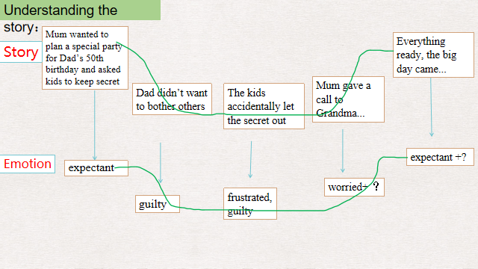

**Understand the story 3：Answer questions.**

Q1: Why was Dad’s New Year’s resolution was mentioned at the beginning?

_______________________________________________________________

Q2: Some hints showing that party would be special.

1. _______________________________ 2.____________________________

3.________________________________ 4._____________________________

Q3: What made the party go abortive?

1. _______________________________________________________
2. _______________________________________________________

**Design the plot:Foreshadowing**

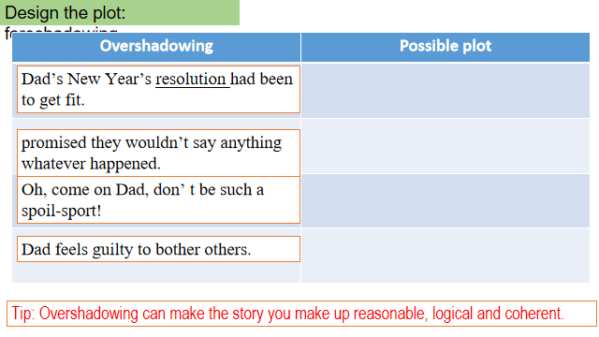

**Design the plot: Q-A**

*Paragraph 1: Frustrated, Mum made a call to Grandma._______*

Q1:What did she say on the phone? What was Grandma’s reaction?

Q2: About the party did they finally make a new decision?

Q3: Did they share the new decision with the kids? Why?

*Paragraph 2: They got everything ready as planned when June finally came. ______________________________________*

Q1:How did Dad feel at the new plan?

Q2:How was the new plan going on, as expected?

Q3:How did the family feel about the special birthday?

Q1:What did she say on the phone? What was Grandma’s reaction?

|  |
| --- |
| * Explaining the disturbing situation, Mom gave off a disappointed sigh, feeling quite sad that   her idea and efforts would just go against dad’s thoughts. What a shame that all her plans for dad’s birthday would smash to ash if dad didn't want to announce his old ages to people around.   * Hardly had Mum disappointedly explained the situation to grandma when grandma burst into   laughter, comforting, “My son always feels too guilty to bother others but he will be happy if our family prepare the party together."   * On the phone, she poured out all that happened to Grandma, at a loss about what to do next   as she wanted to give Dad a sweet memory and at the same time not go against his will. At this, Grandma smiled, comforting that she might try an alternative way to celebrate the special moment. |

Q2: About the party did they finally make a new decision?

|  |
| --- |
| * And the next quarter witnessed the two talking excitedly and brainstorming the possible   ways. Finally given his New Year’s Resolution of getting fit, they decided to organize a hiking trip and buy a membership card from a nearby gym.   * Sensing Mum’s sorrow, grandma comforted and advised, “Why not just prepare a simple yet   special get-together?”   * After pondering for a while, she suggested that they continue to do the preparation ans   promised that she would talk to Dad about it.   * Then Jenny broke up the atmosphere with a special idea coming up- celebrating the day as   Dad fulfilled his resolution. |

Q3: Did they share the new decision with the kids? Why?

|  |
| --- |
| * This time, she even kept it a secret from her kids for fear that they would once more let the   secret out.   * Hearing the news, the kids sprung to their feet, welling up with wild joy.The next several   months witnessed the warm family making plans and buying gifts excitedly, waiting for the big day with broad smiles on faces.   * Suddenly, it all clicked and they merrily reached an agreement to plan a secret hiking trip to   the hill they once frequented and a family picnic at the top. |

Q1:How did Dad feel at the new plan?

|  |
| --- |
| * As usual, Dad got up, ready for his regular workout when a sweet voice “darling, Happy   birthday!” came from behind. Handing over the membership card to her dear, she shared her plan for his birthday.   * That morning, when Dad was about to jog as usual, Mum hurried to tell him about their new   plan. Seeing the three in sportswear , Dad realized something, and this time he nodded.   * It seemed as if nothing happened when dad’s 50 birthday quietly fell.The only difference   was that dad's lonely jogging was accompanied by his energetic kids, who never stopped their curious eyes on everything around them. |

Q2:How was the new plan going on, as expected?

|  |
| --- |
| * All the way, the two kids bounced around, laughing and chatting. He, along with Mum,   recalled a lot of sweet memories in their youth. Upon arriving at the top, the three just pitched into the picnic in sheer pleasure.   * And the next moment Dad found himself on a totally different hike, with his wife and his   kids for company. All the way, they enjoyed the natural beauty, gossiping abut the sweet and fun memories. It didn’t take long before they arrived at the hilltop - their destination, where they spread a cloth on the grass.   * The moment Dad stepped into the house, he was greeted with broad smiles and warm   “Happy birthday” from his old friends and relatives. Though informed in advance, he had never expected that, a warm current surging through his body. |

Q3:How did the family feel about the special birthday?

|  |
| --- |
| * With the cool breeze, Dad gazed at them reflectively and suddenly realized that it’s no longer   disturbing to celebrate birthday with the love of family.   * Bathed in the warm sunshine and enjoying the company and the love of the family, Dad   smiled, his mind travelling back to his youth times, dynamic.   * At the party Dad chatted as if travelling back to his youth times, his face glowing with   excitement. For him, it was a sweet moment that would never fade away in his mind.   * “Happy birthday! Mom beamed a bright smile, hugging dad in her warm arms. “You see,   50 is only another start of your life, youth is never gone." Dad would witness his resolution in his “old”50. |

**下水作文：**

*Frustrated, Mum made a call to grandma.* On the phone, she poured out all that happened to Grandma, at a loss about what to do next as she wanted to give Dad a sweet memory and at the same time not go against his will. At this, Grandma smiled, comforting that she might try an alternative way to celebrate the special moment. And the next quarter witnessed the two talking excitedly and brainstorming the possible ways. Finally given his New Year’s Resolution of getting fit, they decided to organize a hiking trip and buy a membership card from a nearby gym. This time, she even kept it a secret from her kids for fear that they would once more let the secret out. 116

*They got everything ready as planned when June finally came*. As usual, Dad got up, ready for his regular workout when a sweet voice “darling, Happy birthday!” came from behind. Handing over the membership card to her dear, she shared her plan for his birthday. And the next moment Dad found himself on a totally different hike, with his wife and his kids for company. All the way, they enjoyed the natural beauty, gossiping abut the sweet and fun memories. It didn’t take long before they arrived at the hilltop - their destination, where they spread a cloth on the grass. Bathed in the warm sunshine and enjoying the company and the love of the family, Dad smiled, his mind travelling back to his youth times, dynamic. 116

**参考范文：**

*Frustrated, Mum made a call to grandma.* Sensing Mum’s sorrow, grandma comforted and advised, “Why not just prepare a simple yet special get-together?” Slapped awaken by Mum’s new plan, the two kids both burst into deafening cheers and skipped round and round. Together, they brainstormed a list of ideas when suddenly Jenny murmured, “What’s Dad’s resolution for the new year?” Suddenly, it all clicked and they merrily reached an agreement to plan a secret hiking trip to the hill they once frequented and a family picnic at the top.

*They got everything ready as planned when June finally came*. That morning, when Dad was about to jog as usual, Mum hurried to tell him about their new plan. Seeing the three in sportswear , Dad realized something, and this time he nodded. All the way, the two kids bounced around, laughing and chatting. He, along with Mum, recalled a lot of sweet memories in their youth. Upon arriving at the top, the three just pitched into the picnic in sheer pleasure. With the cool breeze, Dad gazed at them reflectively and suddenly realized that it’s no longer disturbing to celebrate birthday with the love of family.