人教版新教材选择性必修四Unit 4 Using language (2) 教学设计
- 主题语境
人与社会 —— 中国对外援助
- 语篇类型
该文本是一篇演讲稿，主题是宣传我国对其他国家的援助。
三、语篇分析
演讲稿以学生的视角，讲述了一位医生母亲作为我国政府派驻非洲坦桑尼亚的医疗队的一员，开展志愿服务工作的经历。全文分为Topic—Content—Theme三个部分，首段用一个Rhetorical question抛出演讲者对援助工作的价值的思考；然后，使用了“I had the same question myself, But for me …,To be honest,”等表达，从个人的角度展现自己从一开始的不理解到后来的完全认同并引以为傲的心路历程；最后，通过肯定母亲的国外志愿者事例，表达自己未来投身国际援助事业的决心。在语言表达上，运用了“Today, I want to relay to you that …, In the future, I pray that …”等句型提出倡议，号召更多的人加入国际志愿者的行列。
四、教学重点
内化演讲稿的语篇特点和结构特征，完成演讲稿的写作并展示，讲好中国故事，传播中国声音。
五、教学目标
在本课学习结束时，学生能够：
1. 观察词汇云图等多模态语篇，预测文本内容。
2. 通过跳读和略读，提炼演讲稿的文本结构和语言特征。
4. 小组内自评和互评，培养批判性思维。
5. 结合我校举办主题为“中国对外援助”的英语演讲比赛，指导学生撰写演讲稿，参加班级迷你演讲比赛。把所学的知识进行迁移、创新。鼓励学生联系实际，用英语讲好中国故事，传播中国声音，实现学科育人功能。
六、教学过程
Stage 1 Lead-in
Step 1：Question Time
Ss watch some pictures related to the topic.
1.Do you know what kind of aids does China offer to other countries?
2.Why does China offer aids?
设计意图：利用图片创设语境，导入主题；讨论中国对外援助事例，激活学生背景知识，为探究主题做认知准备。
Stage 2 Pre-reading
Step 2: View and predict
T asks Ss to look at the word cloud of the text. Predict the main idea of the text.
设计意图：利用多模态词汇云图进一步激活图式，引导学生预测文本内容，形成阅读期待。
Stage 3 While-reading
Step 3: Read for structure
1.What type of text is it?
2.What is the structure of the text?
设计意图：判断语篇体裁和文本结构。
Step 4：Read for details
1.What is the rhetorical question used in this speech?
2. What is the answer to this rhetorical question?
3. What does the speaker use to get her message across?
◻ a case study ◻ a joke ◻ a personal story ◻ facts and data
◻ a hypothetical example ◻ an analysis of the history and causes of the issue
4. How did Bingbing’s feelings about the topic change?
5. How does the speech end?
设计意图：引导学生深度阅读文本，帮助学生获取并梳理演讲稿细节内容，为后面的写作输出做好铺垫。
Step 5：Read for language
Ss read the speech and summarize the useful expressions. Brainstorm more in groups.
Structure of the speech | Language feature | Way of writing | Function
Rhetorical question
Answer to the question
Ending
More rhetorical questions for reference:
1. You don't expect me to go along with that crazy scheme, do you?
2. Why is the Belt and Road beneficial to the promotion of economy?
3. The amount of plastic in the ocean is rising at a considerable rate. How many efforts will it take you to help reduce this?
4. If Winter comes, can Spring be far behind? (O Wind)
5. Remember how things used to be 10 years ago?
More expressions for opening a speech :
1. Many of you may ask what the Belt and Road is. Well, to begin with, I want to tell stories behind it.
2. It'd like to begin by asking you to imagine a world where ...
3. Let's start by giving yourselves a round of applause.
4. As the saying goes “First impressions are lasting; you never get a second chance to create a good first impression.”
设计意图：提炼语言特征，获取语言支撑，为后面的写作任务做好铺垫。
Stage 4 Pre-writing
Step 6: Set a background
To color campus life, our school will organize an oral English contest next week. Write a speech about China’s aid to other countries.
设计意图：创设语境，培养学生的创造性思维，增强语言实用性，实现学生的能力迁移。
Step 7: Brainstorm for ideas
1.T asks Ss to brainstorm for more ideas in groups and then share their ideas in groups.
2. T provides more ideas for Ss’ reference.
设计意图：发散思维，以头脑风暴为突破手段，引导学生对迁移话题进行逻辑性和批判性地探讨。
Stage 5 While-writing
Step 8: Design your draft
Write your speech, following the structure and using the expressions you have learnt.
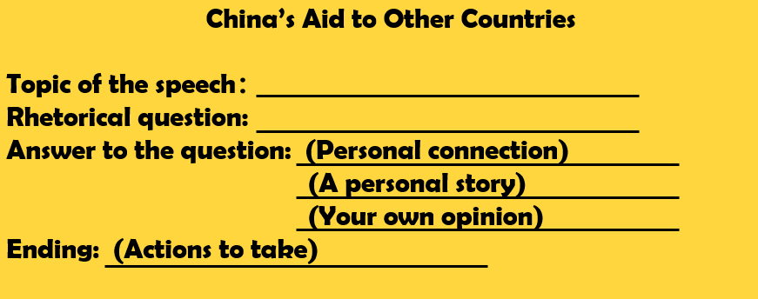
设计意图：综合运用所学话题内容、语篇结构、语言特点进行输出，体现学生综合运用语言的能力。
Step 9: Self-assess & peer-assess
- After writing, T draws Ss’ attention to the evaluation chart.
- T shares Ss’ writing with the whole class and demonstrate how to assess the writing by referring to the chart.
- Ss evaluate their own writing and peer-assess their group members’.
设计意图：师生共评，结合学生作品的特点，肯定学生的创新意识和积极的态度。
Stage 6 Post-writing
Step 10: Attend the min-oral English contest
1.Organize the min-contest in your class and share your speech orally.
2.Listen to your classmates’ speeches. Take notes on the sheet and vote on the best one.
设计意图：教师引导学生认真倾听同伴演讲并记录信息，从演讲情境、主题、主要内容和自身感受几个维度进行分享讨论。在模拟演讲比赛的过程中，实现能力迁移。
Stage 7 Summary and Assignment
Step 11: Make a summary
Summarize the topic and stress the importance of China's aid to other countries.
Assignment
Compulsory: Polish your speech according to your classmates’ comment.
Optional: Shoot a video while you are giving a speech, upload it on the social media and share with others.
设计意图：对本堂课和本单元的学习进行归纳总结，深化主题意义，号召更多人加入到志愿者的行列，加强德育浸润。

