B3U3 Reading and Thinking

**1.Teaching Material Analysis:**

And the theme of this section is to learn about a city that has diverse cultures. The reading text is a travel journal about the trip in San Francisco, which records the what the writer did and saw in the city. And this trip also changes the impression of the writer on this city and enables the writer to feel the cultural diversity of San Francisco. San Francisco is a vibrant city with diverse culture and ethnic diversity which is influenced by the historical changes and immigrants’ culture. For ss, they may have known sth about this city, but they don’t know the features of this city and the historical reasons behind it. Thus, the teaching aims are as follow:

**2. Teaching Aims:**

1. To know some basic information about San Francisco through getting the features of a travel journal.
2. To summarize the features of this city through analyzing the writer’s feeling and some facts the writer has seen in this city.
3. To raise awareness of cultural diversity through evaluating the benefits and the challenges of cultural diversity.

**3.Teaching Procedures:**

Step1: Lead-in

Find San Francisco in the map and talk about what you know about this city.

(Aims: to activate the Ss’ previous knowledge about this city.)

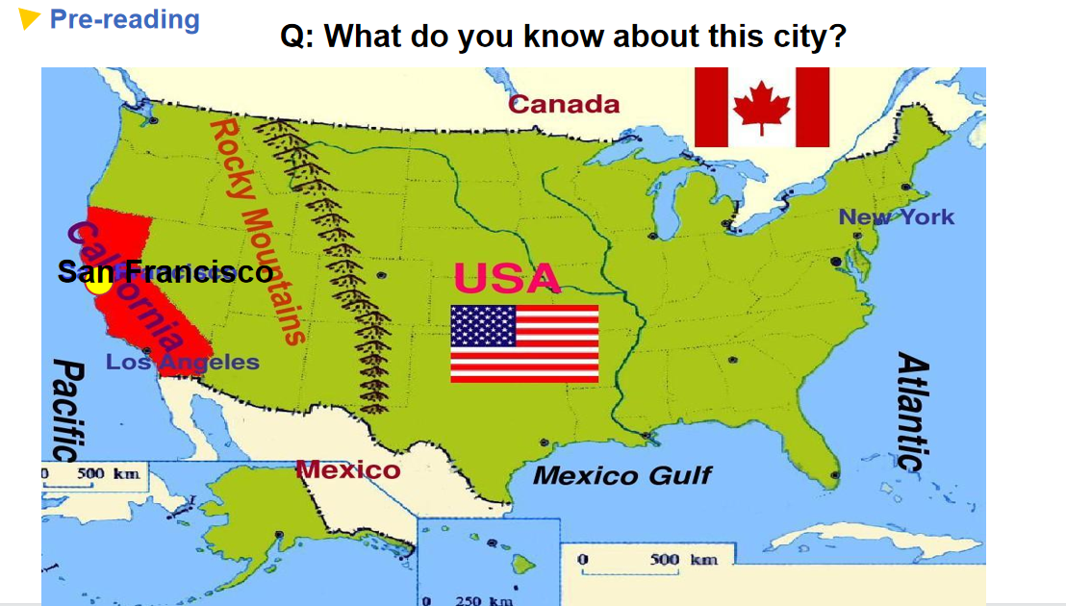

Step2: Pre-reading

Group work: list what you want to know about this city.

(Aims: To activate Ss’ reading motives and train Ss’ critical thinking through brainstorming the questions.)

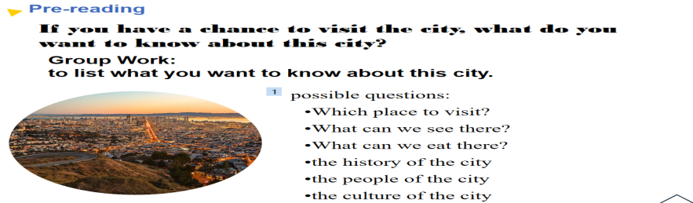

Step3: Skimming

Read for the genre of the text and main structure.

(Aims: to know the features of a travel journal and set up the whole structure of reading content.)

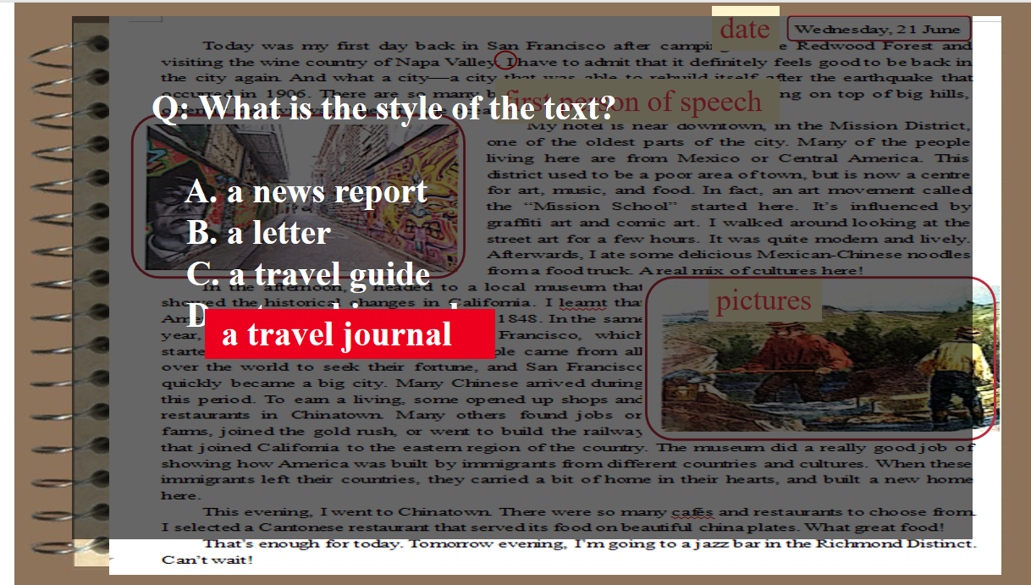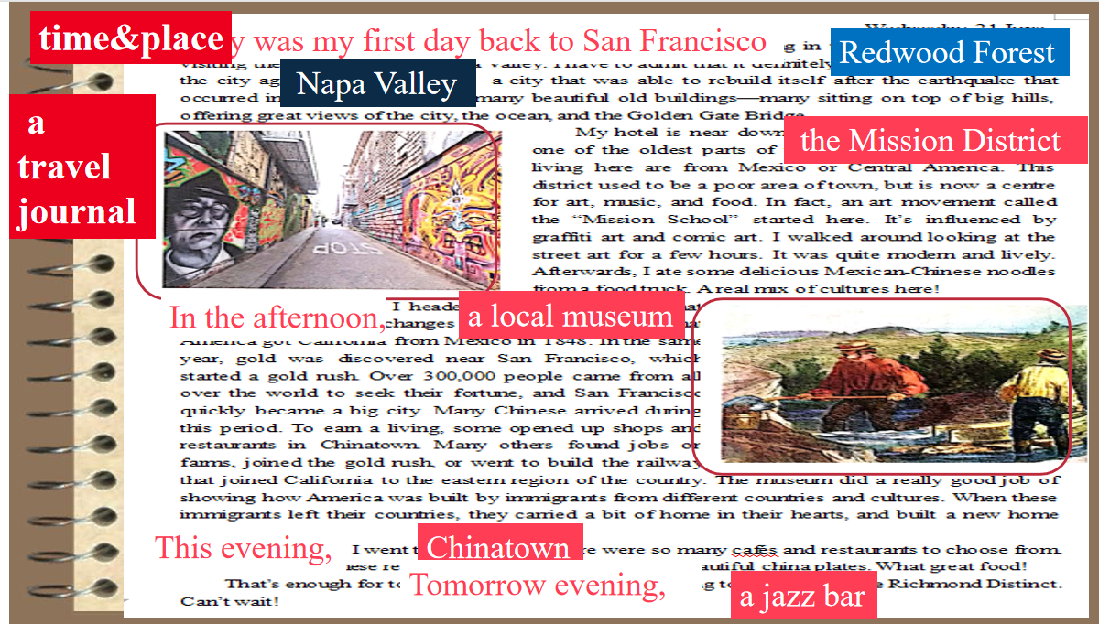

Step2: Scanning

1. Comb the basic information of a travel journal like what the writer did and saw.
2. Analyze the deep information of a travel journal like the feeling through analyzing what the writer did and saw.
3. Check if the text solves your questions.

(Aims: to understand the content, get the feeling track of the writer, and develop Ss’ logical thinking.)

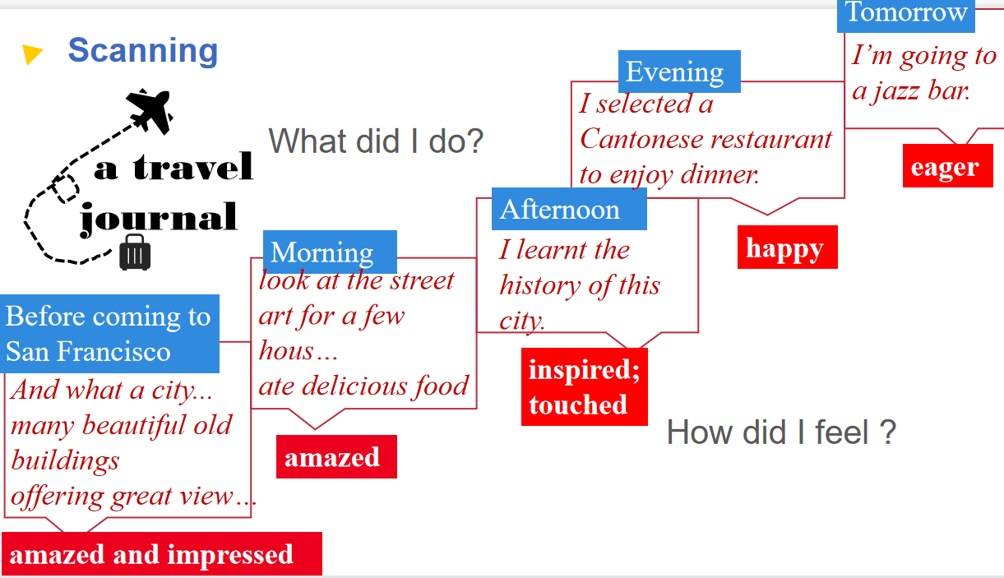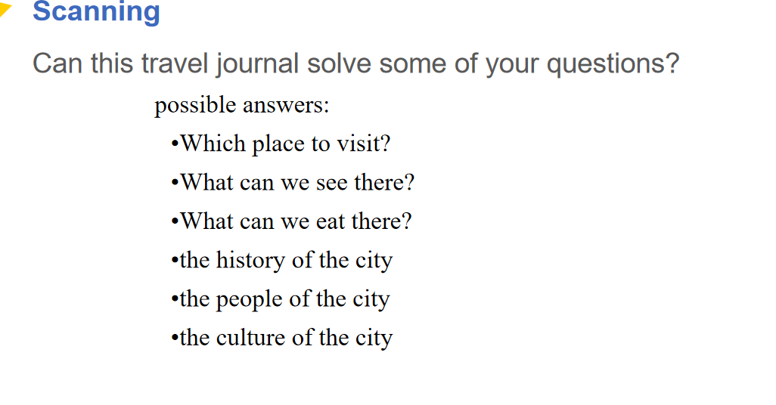

Step3: Thinking

Summarize what kind of city the San Francisco is and what makes it such a city through analyzing some detailed facts in the text.

(Aims: to fully understand the text, develop Ss’ critical thinking ability and prepare for the theme exploration.)

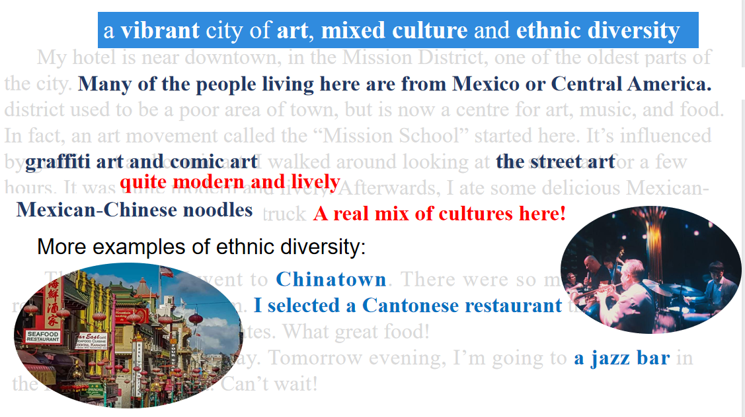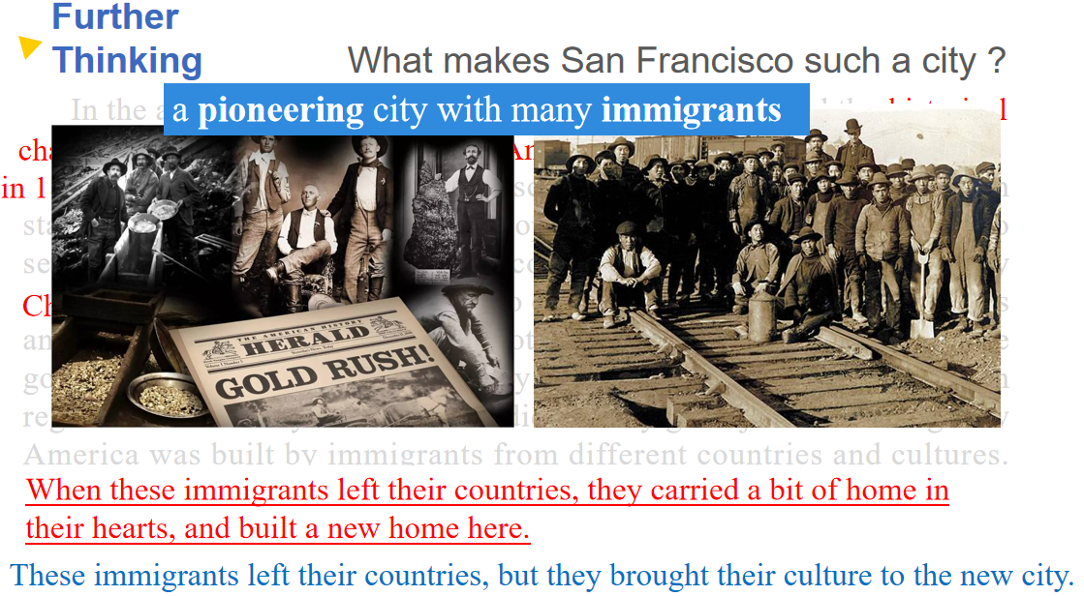

Step 4: Discussion

What are the benefits and challenges of cultural diversity?

(Aims: to develop ss evaluation ability and critical thinking.)

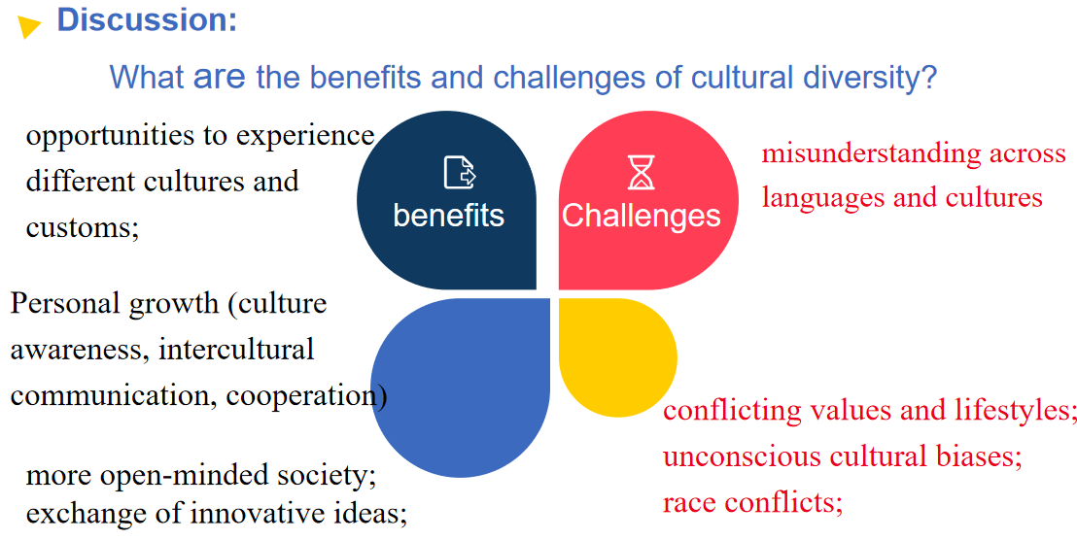

Step5: Extensive Activity

Related with the latest news.

Record a vlog to speak up for cultural diversity and voice for the Asians who are biased.

(Aims: to raise awareness of cultural diversity and tolerance through expressing their opinions.)

