Unit 2 Healthy Lifestyle
Reading and Thinking教学设计
教学内容分析
主题语境：本节课的教学内容为新版人教版选择性必修三第二单元，Reading and Thinking部分。文本的主题语境为人与自我：探讨个体如何改变不良生活习惯、养成良好生活习惯从而能够培养健康的生活方式；主题群：生活与学习；子主题群：健康的行为习惯与生活方式。本板块的活动主题是“学会养成良好的健康习惯（Learn to develop good health habits）。引导学生通过阅读语篇，认识不良生活习惯的危害、养成健康的生活习惯，也是为未来的幸福生活奠定坚实的基础，同时能够运用所学知识解决自己在生活方式上存在的问题从而保持身心健康提高幸福感。
语篇类型：说明文
语篇研读：文本第一段旨在提出问题，作者阐述了坏习惯的危害，并指出青少年应学会尽早识别坏习惯并做出恰当改变。第二、三段旨在分析问题，作者阐明了习惯的内涵，并利用现代心理学知识——“习惯周期”，揭示了习惯的运转原理。第四、五段旨在解决问题，第四段阐述了习惯周期的应用价值，第五段则阐述了改变坏习惯的其他关键因素，包括时间和自律等等。第六段作者重申论说点，并呼吁年轻人认真思考并做出改变，从而建立健康快乐的生活方式。
学情分析
本班学生英语基础中等偏下，个体差异较大，用英语表达想法和观点这一能力有待提升，但是部分学生态度认真、思维活跃。
【语篇话题】本节课的话题“ 人与自我——健康的生活方式”较为贴近学生们的生活实际，具备一定的常识，能有自己的见解，因此学生们愿意去探索与本节课主题相关的内容。
【语篇语言】文章结构完整，语言简单易懂，但文章兼具议论文和说明文的特征，使得学生对语篇结构的理解和掌握存在一定难度，所以对语篇的的结构以及深层理解需要加以引导。
【语篇理解】在学习能力上，学生已逐步熟悉阅读教学的流程，掌握了一定的阅读策略。但部分学生可能没法快速提取问题解决型的说明性文本的基本框架，概括段落大意技巧仍停留在找首尾句等较直接、显性的方式。
教学目标与核心素养 | - Understand the topic, structure and the main idea of the text.  理解文章的话题、结构以及段落大意。  - Discover the elements of the habit cycle and understand how the habit cycle works.  发现习惯圈的要素，了解习惯圈的运作方式。  - Reflect on developing good habits for a healthy lifestyle.  思考培养健康生活方式的良好习惯。
教学重点 | 引导学生掌握文段的主要内容和解决问题的说明文的结构特点。
教学难点 | 使学生能够了解习惯圈是如何运作的，并利用它来改变坏习惯和培养好习惯。
教学方法 |  |  | Task-based approaches；  Group cooperation； | 教学仪器 | Multimedia
教学过程
教学环节 |  | 教师活动 |  | 设计意图 | 效果评价
Step 1  Lead-in  & Pre-reading |  | Lead-in:  Show the students a picture and ask students the following questions:  - Why do students sleep during the class break?  - Do they have a healthy lifestyle? What kind of unhealthy habit do they have?  - What other bad habits do you have or do you know?  Task 1：Read for prediction  Students look at the title, find out the key words and predict the content of the text. |  | Introduce the topic and develop students’ reading expectations. | 图片与学生的日常生活息息相关，所问问题与文章话题相关，由预热自然过渡到读前活动。  根据标题和图片的预测方式训练了学生的观察和分析能力。
Step 2  while-reading |  | Fast reading  Task 2：  1. What is text type of the passage?  2. What is the purpose of the author's writing the passage?  Task 3：Analyse the structure  Guide students to divide the passage into several parts and summarize the main idea of each part.  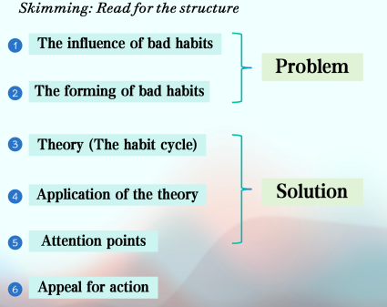  Careful reading  Task 4 Read Para.1 and answer the questions：  Q1：Why do bad habits become a serious problem especially for teenagers?  Q2：Which word did the author use to show the power of bad effects?  Q3：What should teenagers first do to prevent harmful habits from dominating their life?  Task 5 Read Para.2 and answer the questions:  Q4：Why is it hard to change habits?  Q5：How does the author support his idea?  Task 6 Read Para.3 and answer the question:  Q6：What are three stages of ''the habit cycle''?  Q7：How does the author further explain ''the habit cycle''?  Q8：Are there any other cue that will make you eat junk food?  Task 7 Read Para.4 and answer the question:  Q9：Why does the author give two examples?  Q10：With the help of ''the habit cycle'', do you think bad habits can be changed or good habits can be formed immediately?  Task 8 Read Para.5 and answer the question:  Q11：What else are needed to break bad habits?  Read Para.5 and underline the key words.  Task 7 Read Para4 and fill in the blanks with the words in the para.  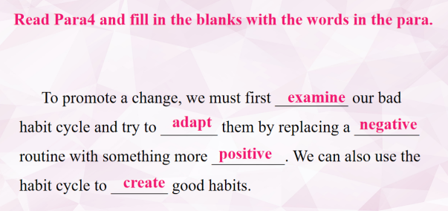  Task 8 Read Para5 and answer the question.  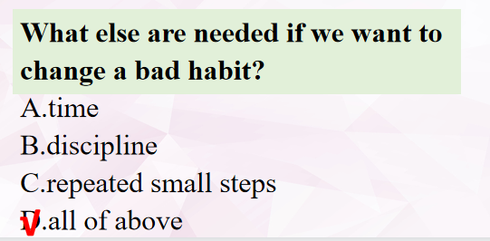  Task 8 Read Para.5 and answer the question.  What is the author’s attitude towards space exploration? |  | Check the answers with the group members and share the reasons with the whole class so that they can learn reading completion skills from each other；  Find out the topic sentences and help students to get the main idea of each paragraph, and prepare themselves for analyzing the structure；  Help students know the detailed information of each paragraph； | 用自己的话总结每一段的大意对于本班学生而言难度较大，因此改用找每一段中心句的方式，学生能够顺利进行，在此基础上，再进行总结和归纳，学生接受起来更容易。  学生在主题句的帮助下可以较为容易的推断出文章的结构，并分析每一部分的内容。  学生细读第一段，通过分析和推断，提炼出坏习惯应该尽早改正的原因。  第二段和第三段中学生可以了解到习惯的特征以及习惯的运转机原理。  通过细读第四段学生可以了解到habit cycle的应用价值，提炼出改变坏习惯的关键在于改变习惯周期中的惯常行为。  第五段中，分析、思考并概括习惯改变的其他关键因素，进一步加深对习惯及其改变的理解，提升逻辑思维能力。
Step 3  Post-reading |  | Task 9 Read Para6 and answer the questions.  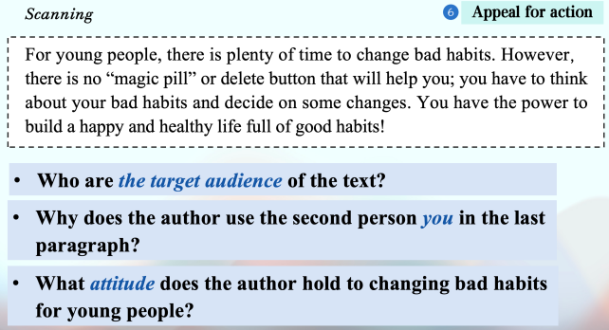 |  | To develop students’ understanding on the “habit cycle”.  The discussion and dialogue will help students express their opinions and enable them to make use of habit cycle to develop good health habits. | 谈论环节，学生既能运用本文学习的habit cycle的工作原理分析自己坏习惯的养成，反思自身是否具备力量改变坏习惯，是否有其他方法来优化自身习惯，学生能够有话可说。
Task 10 Let's deal with more bad habits
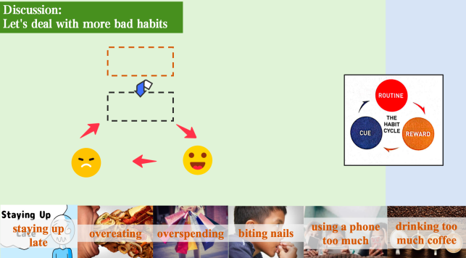

Summary & Homework |  | Collect a bad habit from your desk-mate and write down the cue, routine, and reward. Then come up with an idea of how to break the bad habit. |  | Further consolidate what have been learned in this class and call on students to develop good habits based on the habit cycle. | 学生对文章内容能够进一步清晰，课外也能对克服坏习惯给出具体的建议.
Blackboard design |  | 