**Animal testing**

**教材分析：**

本篇概要写作主要围绕“动物实验”这一有争议性的话题展开，体裁明确，结构清晰。文章共4个自然段，为总分结构。第1段总起全文，引出话题，第2-4段展开论述对用动物做实验的看法。其中2、3两段肯定了用动物做实验的好处，第4段则认为这样做会对动物造成伤害。

**学情分析：**

授课对象为高三年级学生。通过两年多的高中英语学习和概要写作训练，这个阶段的学生有一定的英语学习基础和思维方式，熟悉概要写作的流程，能整体把握文章，找到各段的要点，但对于各段中一些次要点的把握及用自己的语言概述全文的能力还有待提高。

**教学目标：**

At the end of class, students will be able to:

1. have a general understanding of the passage, including the topic, writing style and the structure.
2. find out the major and minor points in each paragraph and draw an outline map to help analyse the passage.
3. Rewrite the key points by using some skills.

**教学重难点：**

1. Guide students to analyze the relationship between paragraphs and sentences to get the main points.
2. Lead students to rewrite the main points by using some skills, such as use synonyms, use converse expression and change the part of speech to replace words and when rewriting, try to diversify the sentence patterns.

**教学过程：**

**Step 1: Lead in**

T: Because of the coronavirus, the year 2020 is really tough for us. But thanks to the effort of scientists, China has developed vaccines against it. How do scientists make sure that the vaccine is safe before it is used by our human beings?

Ss: We use animals to test its safety.

T: What’s your opinion on animal testing?

Ss: ...

**Intentions:** Use the hot topic in recent days to pave the way for the content of the passage. Let students express their opinions about animal testing.

**Step 2: Read for the topic, style and structure**

*Students skim the whole passage and find out the topic, style and structure of the whole passage.*

**Intentions:** Enable students to have a general understanding of the whole passage.

**Step 3: Figure out the key points of each paragraph**

*Read the passage again and underline the main points in each paragraph.*

**Intentions:** Let students find out the main points in each paragraph by themselves, If the answer is right, just move on to the next paragraph. If the answer is wrong or maybe some minor points are left out, stop and analyse together. Para 2&4 may cause a little trouble to students.

**Step 4: Rewrite the sentences by using some skills**

*Use your own words to rewrite the main points found out in each paragraph.*

**Intentions:** Use Para 1&4 as examples to teach students some rewriting skills and then use Para 2&3 to let students have a practice. In paragraph 1, I will lead students to review some sentence patterns about raising arguments and in paragraph 4, I will present some skills of replacing words like using synonyms, use converse expression and changing the part if speech as well as providing some words and phrases relating to cause and effect.

**Step 5: Polish the summary with linking word**

*Pay attention to the relationship between each paragraph by using proper linking words.*

**Sample writing:**

Although animals are used in various researches, it’s controversial whether animals should be used for testing purposes. On the one hand, some advocate animal testing for it not only contributes to the medical development and the improvement of people’s health but also examines the safety of medicine without risking humans’ lives. On the other hand, some oppose it because it causes harm even death to an enormous number of animals due to testing.

**Intentions:** Paragraph 2 and paragraph 3 are about the benefits of animal testing, so students are expected to use some coordinating conjunctions like moreover, besides, additionally to joint paragraph 2 and paragraph 3. While paragraph 4 is in contrast to the former paragraphs, so here students are expected to use some adversative conjunctions like instead, nevertheless, on the on hand and on the other hand.

**Step 6: Summary**

*Make a brief summary of what they have learned in today’s class.*

**板书设计：**

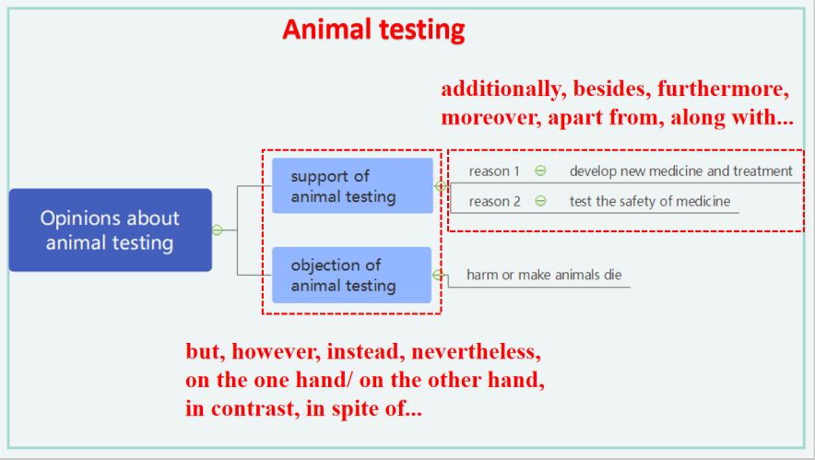

**教学反思：**

There is too much content in this class, so it left little time for students to have an output practice. Maybe I should make the focal points stand out instead of covering the bases in one class.