《完形填空 衔接意识》教学背景与设计

**背景分析 :**根据教育部考试中心《考试说明》，完形填空考查学生在阅读理解的基础上运用词汇知识的能力。在一篇约250词的短文中留出20个空白，要求考生从每题所给的4个选项中选出最佳选项，使补足后的短文意思通顺，前后连贯，结构完整。通过对完形填空考察目标的解读，笔者认为完形填空需要两种能力的培养，即词汇知识+语篇解读。词汇需要日复一日的积累，在科学方法的指导下，学生自身必须下一番苦功夫牢牢抓稳考纲词汇；而语篇解读能力更需要在教师在平时的阅读教学中，针对不同的文体引导学生多角度解读，培养他们的思维品质。本次公开课的主题为完形填空，笔者从语篇分析出发对2019年江苏生高考真题进行了解读，完形填空特别需要学生弄清楚语篇的行文逻辑，因此本节课的重心在于完形语篇里的衔接意识。

**教学目标：**

------By the end of the class ，students will be able to

1.recognize cohesion in form(vocabulary and logical words ) in a cloze reading test

2.emphasize cohesion in content (topic, structure and logic)in a cloze reading test

3.raise awareness of wildlife protection in the world

**教学过程：**

**----Lead in ：**课堂引入环节，采用了著名作家狄更斯的小说《双城记》里的经典片段，这段话的特色在于狄更斯用反义词汇的衔接，短短几行文字生动描绘了一个矛盾的世界。

*It was the best of times,it was the__________of times*

*It was the age of wisdom,it was the age of ___________*

*it was the epoch of belief,it was the epoch of incredulity*

*it was the season of _________,it was the season of darkness*

*it was the spring of _________,it was the winter of despair*

*we had everything before us,we had ________ before us*

*we were all going direct to Heaven,*

*we were all going direct the other way*

*------Charles Dickens A Tale of Two Cities*

设计意图：学生通过自己的感悟，补全这段经典文字，这个过程中他们需要关注词汇衔接

---step 2：该环节从文学片段过渡到真题感悟，笔者查找了近五年的完形填空真题,并挑选出了词汇衔接的案例，要求学生课前练习，课上从衔接的角度进行解答。

**---词汇衔接：**

1.Hearing my story , many students followed with their own ____of heads ,arms ,fingers stuck in places they shouldn't be. A few minutes later ,they came back ,test tube unbroken and finger returning to a lovely shade of pink (2018浙江11月)

A finds B conclusions C stories D news

1. News about our 4 was appealing to me .He was an international grand master,which means I would be learning from one of the game's 6 . I could hardly wait to meet him (2018课标全国卷)

4.A title B competitor C textbook D instructor

6.A fastest B easiest C best D rarest

**----逻辑词衔接**

1.What brought this astonishing change in me ? The desert hadn't changed,_______I had.I had changed my attitude.(2016浙江)

A as B but C for D or

2.The books are in every language — new books ，ancient books ，________ a book on the history of Iraq that is seven hundred years old.(2017浙江)

A then B still C even D rather

3.Looking around ,he continued ,“Cathy has inspired us with her will and enthusiasm .______skills and talents bring great success，the most valuable asset(财产)one can hold is the heart（2016天津)

A .Although B Since C Once D Because

4.The professor was deaf and any talking was prohibited . I soon realized that the silence was not unpleasant ._____, if there had been any talking ,it would have caused us to learn less(2017全国卷)

A Lastly B Thus C Instead D However

设计意图：引导学生在真题中感悟衔接，尤其是词汇（近义词，反义词，复现词)以及逻辑词汇（转折，递进，让步，对比等等）这两处比较明显的衔接。

Step 3：该环节，笔者在幻灯片以及板书里呈现了本节课要阐述的第一种衔接，形式衔接（词汇与逻辑词),但这种题型的在真题中占比例不大，因此带领学生进入本节课的重点,语篇内容衔接，即文章大意，语篇结构，以及文本的行文逻辑。正式分析江苏卷完形填空之前，设计了以下的活动：

----He _________this question while we sit in his office overlooking the yard

A reads B considers C admits D asks

----The yard has gone into a state of ____________in recent years .

A decline B peace C boom D repair

设计意图：要求学生课上选择最佳答案，为下一个练习埋下伏笔。此环节中，学生们确实做出了各种选择，并进行了激烈的讨论，事实上，这里并没有固定答案

Step 4：给纲刚刚两句话的原语境搬入课堂，让大家再一次进行选择

2018浙江金丽衢联考

para1-----I ask my grandpa what it feels like to grow old.**He _______this question while we sit in his office overlooking the yard** ,where an empty bird feeder swings lifelessly from a tree branch.T*he yard has gone into a state of _______in recent years .*Grandpa no longer possesses the energy to maintain its once glory.

设计意图：学生在这个练习片段中，发现了老师的本意，即让他们关注完形填空的语境和行文逻辑，要求他们完形填空要特别在意文中的逻辑，而并非简单的词汇搭配。

Step 5：2019年江苏高考真题分析，这是一篇夹续夹议的文章，呼吁人类关注野生动物保护。笔者要求学生课前完成，课上从形式衔接和内容衔接两个角度，带领大家分析语篇，并对错误较高的题目进行详细解答（错误比例提前读卡统计),分析步骤如下：

---探讨文章大意，邀请学生进行总结 （引导他们拿到题目，先整体感知语篇内容)

----从内容衔接的角度，逐段分析答案与文章已知信息的衔接，引导学生关注语境与行文逻辑。例如：

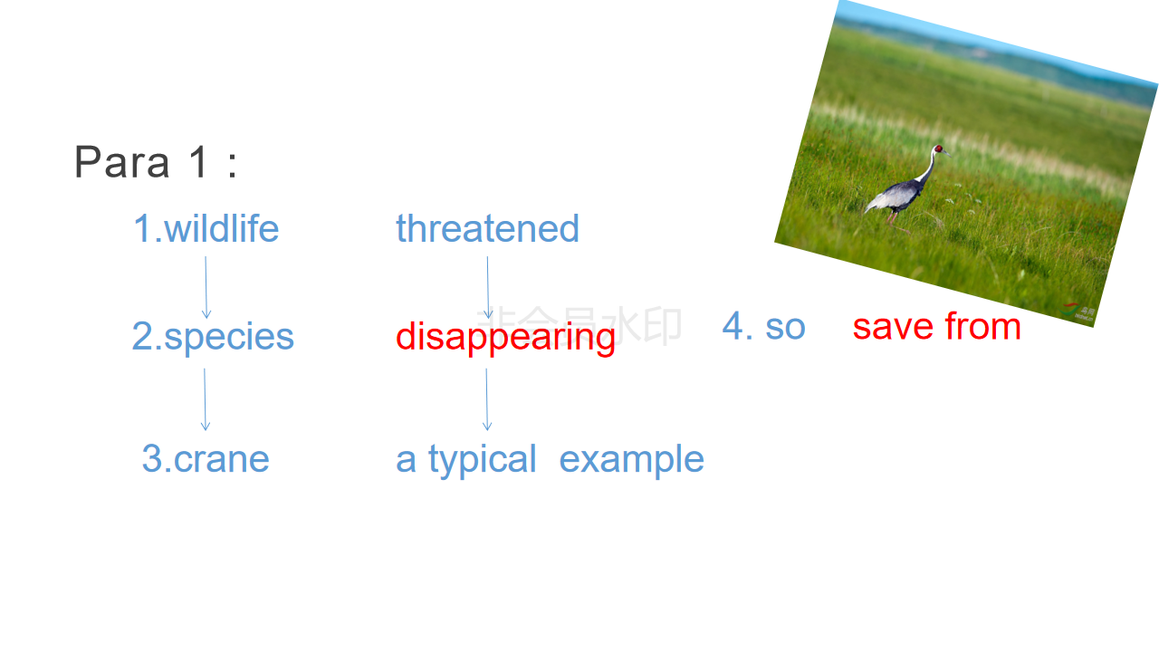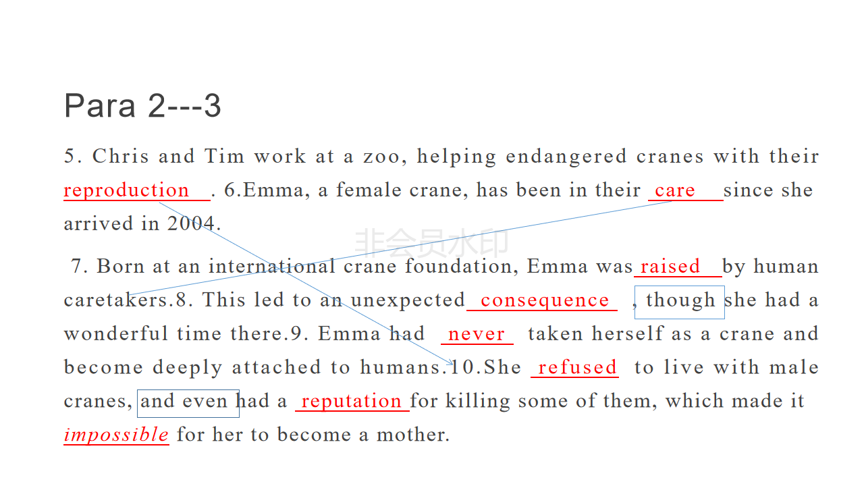

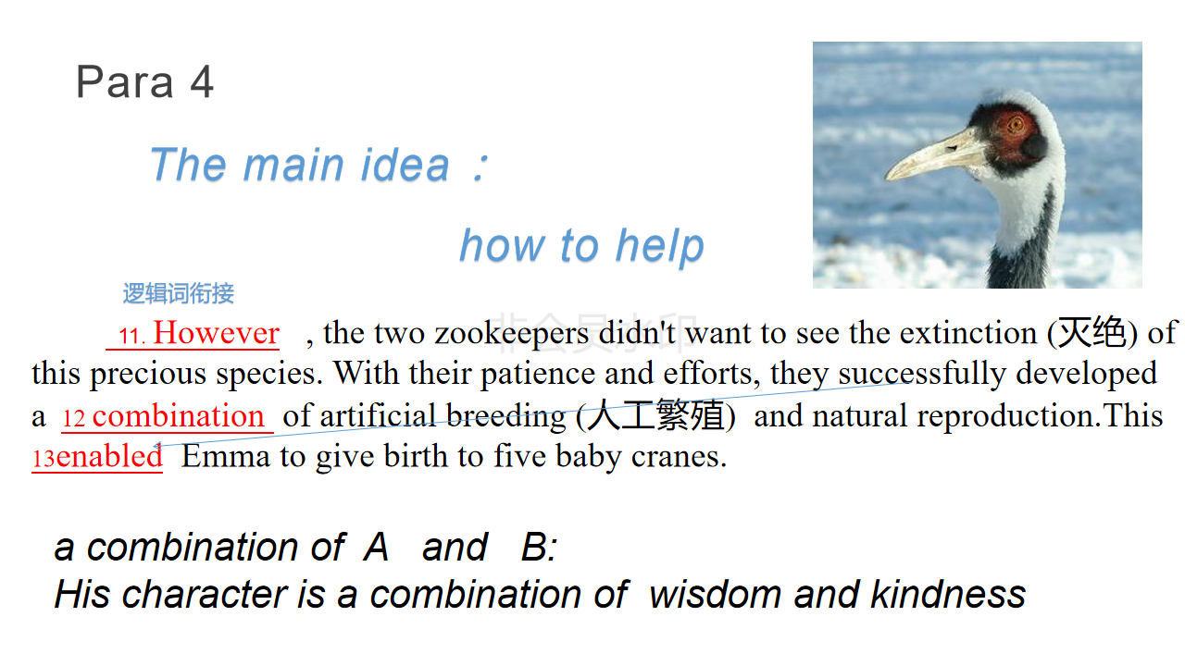

设计意图：对完形填空的分析从语篇到段落再到具体的每一句话。要求学生关注行文逻辑，该环节主要由学生解读正确答案背后的思路，教师通过设问的方式，引导学生从内容衔接的角度进行分析，避免简单的翻译作答。该环节进展过程中，师生一起拟出了文章结构图，即phenomenon---typical example ---solution---reminding ---advice

Step 6：对语篇的主题进行总结，学生自由讨论自己的收获，呼吁大家用心去保护野生动物。