Teaching Design for Reading and Thinking in Unit3
Xu Huihui
Changshan No. 1 High school
Teaching Analysis
The text talks about the relationship between Chinese cuisine and culture. To share with us that food has a close connection with culture and that they go hand and hand, the author describes his personal experiences with different kinds of Chinese food and cultures in different places.
For students in Grade Two, they are interested in this topic, but they just have a basic understanding about the connection between food and culture. It’s difficult for them to infer the implied meaning behind the lines and they lack a deep insight into this topic. Thus, in this class, the teaching aims are designed as follow:
1. To know about the author’s experiences with different Chinese cuisines and to figure out the cultural connotations that he reflects through analyzing and appreciating the language and details.
2. To understand the connection between food and cuisine.
Difficulty and Key Points
1. To appreciate and analyze the language and techniques in the text;
2. To figure out the cause and effect between sentences or facts by means of demonstrative pronouns or linking words
3. To deeply understand the close connection between culture and cuisines or characters and cuisines;
Teaching procedures
Step1: Lead-In (5mins)
Talk about a 1,000-person-Long-Table Banquet in the Miao Stockade Village
Q: What impress you most in this picture?
Q: When and where do you think it was taken?
Q: What are the different levels in the quote ?
Q: What’s YOUR opinion about the relationship between them?
(Aims: to import the topic and offer certain background information about the relationship between food and culture and prepare for reading)
Step2: Reading (25mins)
1. Read for main idea
Analyze the structure and main idea for each part.
2. Read for details
Para.1 (topic: you are what you eat)
Q: Why does the author quote Jean’s words at the beginning?
Q: What does the quote mean ?
Para.2-Para.6 (body: my different experiences with Chinese cuisines)
Take Para.2 as an example to help the students know what the author writes and what he intends to convey and appreciate and analyze the language and techniques in his description.
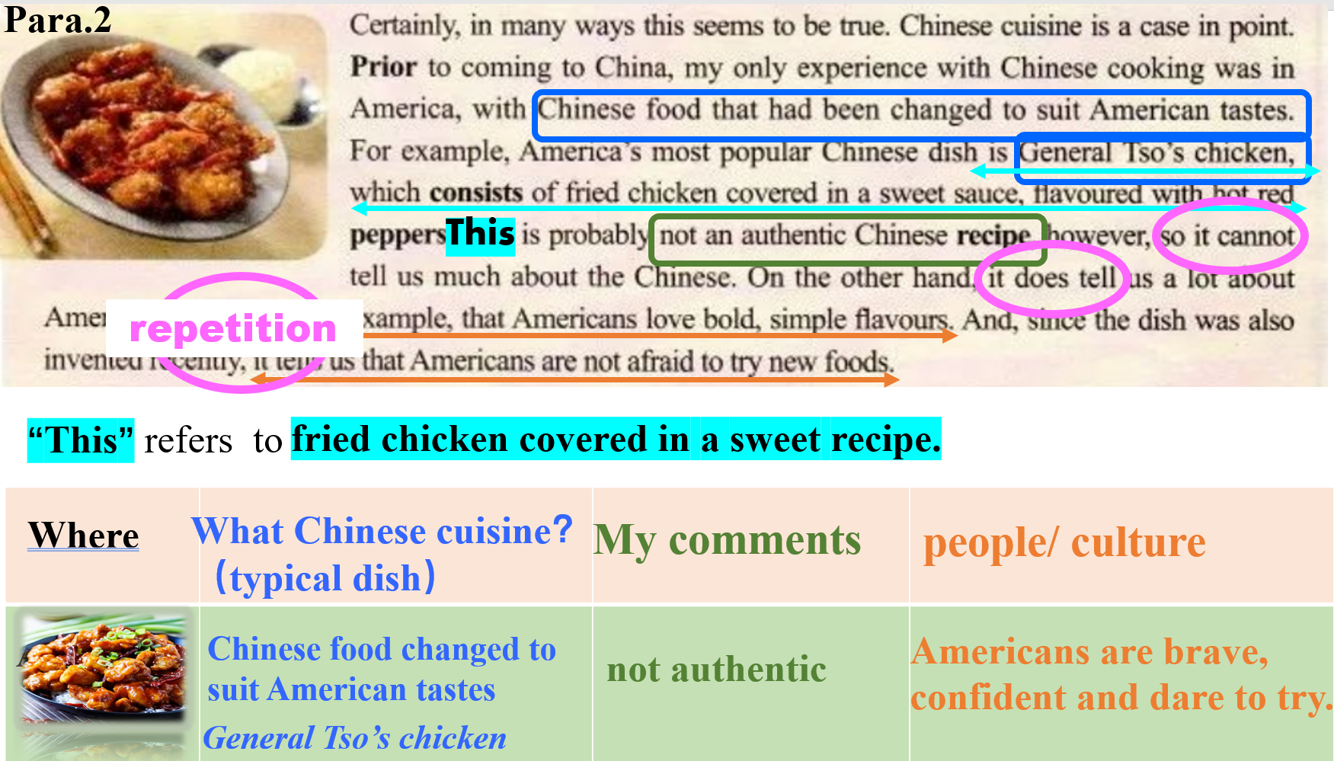
and then get them to finish off the chart in groups.

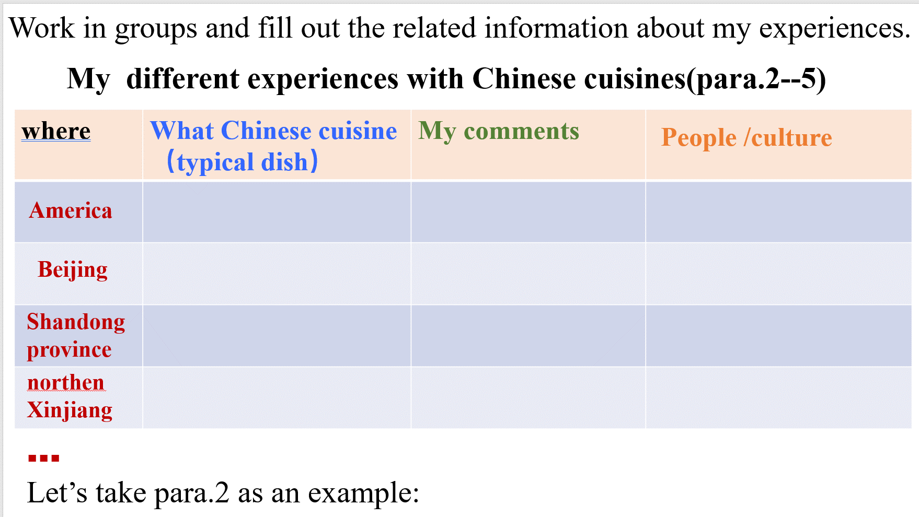
(Aims: to understand the whole passage and know about the connection between food and culture or people’s characters and appreciate the language description and techniques)
Step3: Thinking(10mins)
1. Why does the author use “culture and cuisine” as the title instead of “culture and food”?
2. With the impact of globalization, do you think food can still reflect different cultures? Why (not)?
Homework: write a short passage to share your own experiences with cuisines.

