文本简述
Should We Fight New Technology is an argumentative essay, describing the hot topic “welcome or reject future changes” in order to show different attitudes towards new technology. The author begins the essay by introducing a specific event of a driverless-mode car accident, then presenting the different opinions by giving examples and making comparison and contrast, and finally presenting personal opinion by using own examples.
教学目标
After this class, the students will be able to
- figure out the main idea of each paragraph and the structure of an argumentative passage by using the signposts, which usually come at the beginning of a paragraph;
- summarize how each paragraph is organized,how to support one’s opinion and what argumentative skill is used in each paragraph;
- learn to develop a critical attitude towards the benefits and problems brought by the development of new technology.

教学过程
Step 1 :Lead-in
Latest News about Elon Musk develops a technology designed to use a computer chip (芯片) inside the head to control the brain. Are you willing to have the computer chip implanted (植入) inside your head?
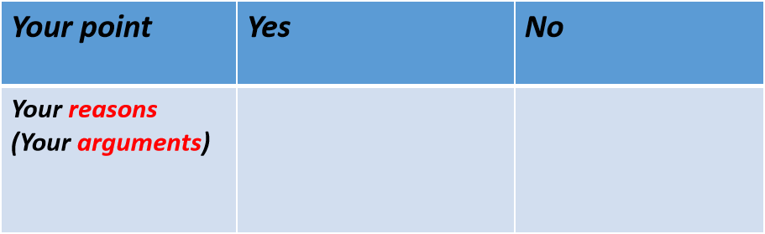
Should We Fight New Technology?
(Aims: to elicit the topic.)
Step 2: Reading for structure
Read for the structure of this text, and identify the main idea by finding signpost.
(Aims: to learn the functions of signpost and identify the structure of the argumentative essay.)
- In which paragraph does the author:
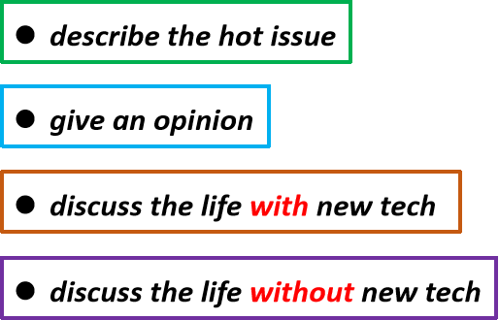
- What is the structure of the passage?
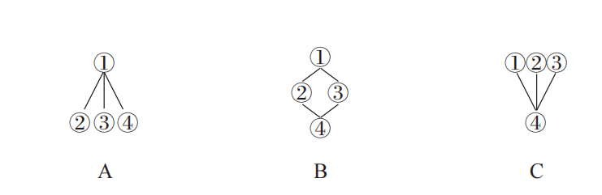
Step 3: Reading for details
- Para.1 Introduction
- What is the hot issue discussed in Para.1?
- Where did the author get this shocking information?
- Who are mentioned in Para.1?
- Find expressions to show their different attitudes.
- How does the author organize Para.1? (a specific event/ accident + different opinions)
- Para.2-3 Pros and Cons
- Where is the topic sentence of Para.2 & Para.3?
- Who are mentioned in Para.2? Why are they mentioned?
- What are the advantages of life without technology? Find supporting expressions.
- What are the advantages of life with technology? Find supporting expressions.
- How does the author organize Para.2 & Para.3? (giving examples and making contrast)
- Para.4 Own opinion
- Where is the topic sentence of Para.4?
- Is there any example mentioned?
- What is the author’s attitude towards the question? Find supporting expressions.
Step 4: Summary
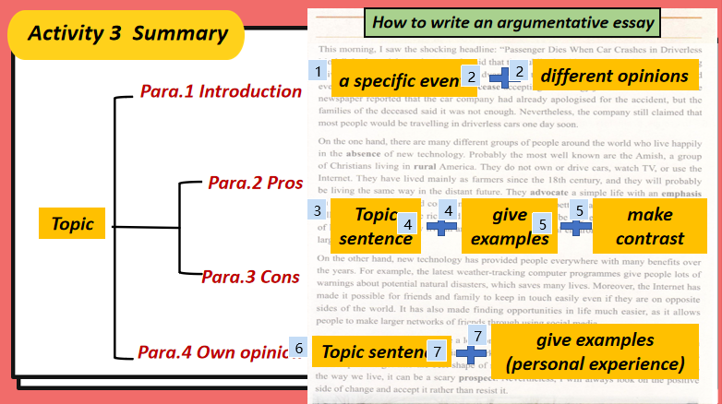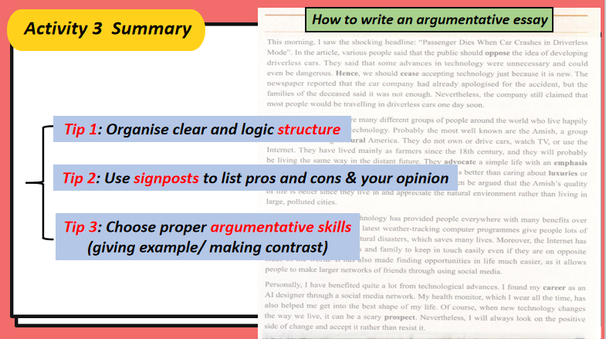
Step 5: Group Discussion
Should We Fight the Computer Chip Implanting?
- Evaluation: Exchange your draft with a partner. Use the checklist to help you comment on their arguments.
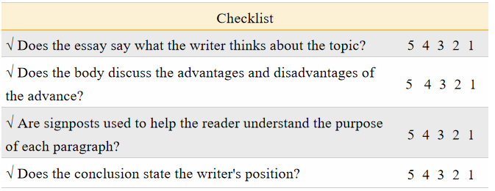
Step 6: Assignment
1. Polish your draft after class according to the check list.
2. Find more articles about new technology from the Internet.

