**长郡中学2023届模拟试卷（一）**

**英语**

注意事项：

1. 答卷前, 考生务必将自己的姓名、考生号、考场号、座位号填写在答题卡上。

2. 回答选择题时, 选出每小题答案后, 用铅笔把答题卡上对应题目的答案标号涂黑。如需改动, 用橡皮擦干净后, 再选涂其他答案标号。回答非选择题时, 将答案写在答题卡上, 写在本试卷上无效。

3. 考试结束后, 将本试卷和答题卡一并交回。

第一部分 听力（共两节, 满分30分）

第一节（共5小题；每小题1. 5分, 满分7. 5分）

听下面5段对话。每段对话后有一个小题, 从题中所给的A、B、C三个选项中选出最佳选项。听完每段对话后, 你都有10秒钟的时间来回答有关小题和阅读下一小题。每段对话仅读一遍。

例：How much is the shirt?

A. £19. 15. B. £9. 18. C. £9. 15.

答案是C。

1. What will the woman do after the class?

A. See a teacher. B. Talk with classmates. C. Go to the beach.

2. Where are the speakers?

A. At a conference room. B. On the plane. C. On the train.

3. Which tourist spot does the woman highly recommend?

A. The Great Wall. B. The Forbidden City. C. The Summer Palace.

4. What does the man tell Anne to do?

A. Meet Mr. Smith. B. Leave at 9 o＇clock. C. Postpone his appointment.

5. How much will the man receive from his father?

A. 400 yuan. B. 600 yuan. C. 800 yuan.

第二节（共15小题；每小题1. 5分, 满分22. 5分）

听下面5段对话或独白。每段对话或独白后有几个小题, 从题中所给的A、B、C三个选项中选出最佳选项。听每段对话或独白前, 你将有时间阅读各个小题, 每小题5秒钟；听完后, 各小题将给出5秒钟的作答时间。每段对话或独白读两遍。

听第6段材料, 回答第6、7题。

6. What did the speakers plan to do?

A. Paint the wall. B. See a film. C. Visit their classmate.

7. Why did the man break his promise?

A. He was busy doing housework.

B. He forgot the phone number.

C. He went to the cinema.

听第7段材料, 回答第8至10题。

8. What does the woman want to know about the swimming pool?

A. Its charge. B. Its length. C. The water temperature.

9. How deep is the swimming pool?

A. 2 meters at most. B. 1. 4 meters at most. C. 1. 5 meters at least.

10. What will the woman do next?

A. Find a swimming trainer.

B. Rest at the edge of the pool.

C. Jump into the pool.

听第8段材料, 回答第11至13题。

11. What does the man say about being a salesman?

A. He didn't enjoy it. B. He wasn't good at it. C. He was satisfied with it.

12. What's the man like according to the conversation?

A. Warm-hearted. B. Outgoing. C. Careful.

13. Which city will the man work in?

A. Paris. B. Chicago. C. Los Angeles.

听第9段材料, 回答第14至17题。

14. How many books does the man want to borrow this time?

A. Two. B. Three. C. Six.

15. Why is the man unable to borrow any books?

A. He has an overdue book.

B. He has used up his quota（限额）.

C. He has lost the library card.

16. What does the woman suggest the man do?

A. Call his friend. B. Copy what he needs. C. Ask a reader for help.

17. What does the man think of the woman's suggestion?

A. Great. B. Confusing. C. Unhelpful.

听第10段材料, 回答第18至20题。

18. What did Milton do?

A. He caught a thief.

B. He went to a theme park.

C. He traveled over 3, 000 miles.

19. What happened on Monday?

A. Some cars were stolen.

B. An interview was conducted.

C. The Johnson family moved to New York.

20. What will viewers see next?

A. An interview. B. A commercial report. C. An advertisement.

第二部分 阅读（共两节, 满分50分）

第一节（共15小题；每小题2. 5分, 满分37. 5分）

阅读下列短文, 从每题所给的A、B、C、D四个选项中选出最佳选项。

A

Need an aitport transfer（换乘）taxi in New Malden？ Call New Malden Airport Transfers now to enjoy the New Malden taxi service. We are best known as the specialists in London's airport transfers. We serve all airports of London with our professional airport transfer service.

**Find Trouble-free Taxi Service at Your Fingertips**

Whether you are new to this city or just want to explore or reach your particular destination in time, hire New Malden cars to save your time. It doesn't matter whether your flight is late or on time, our taxis in the New Malden Airport Transfers team will be there waiting for you.

**New Malden Taxis Hold Many Benefits**

We have been serving for a long time in the same field, and known for introducing reliable, friendly and personal New Malden taxi service to our customers.

We offer a competitive price for airport transfers and are favored by users because of our speedy, cost-effective, efficient and timely service. Our New Malden taxi service is open 24 hours a day, 365 days a year, so you may call us whenever you want.

Our drivers are highly trained and they can guarantee you a first-class journey.

**Get Ready to Have an Amazing Experience**

Do let us know about your taxi-related requirements for the best service. Our expert in the New Malden Airport Transfers team is online to answer questions in case you have any. Visit the official site to get more information.

21. What is New Malden Airport Transfers probably?

A. A taxi producer. B. A small start-up.

C. A transfer station. D. A taxi company.

22. Which is the feature of the New Malden taxi service?

A. It charges the lowest price.

B. It can only be booked online.

C. It is available around the clock.

D. It can be enjoyed all over London.

23. What is the purpose of the text?

A. To advertise the New Malden taxi service.

B. To show the benefits of New Malden taxis.

C. To attract visitors to tour around New Malden.

D. To stress the necessity of airport transfer service.

B

In 1999, John Smyth, a high-school teacher decided it was time to retire. Together with his wife Helen, he set off on a journey around Australia. But when they returned, John found he missed the classroom, so he spent another eight years doing casual teaching.

Then he heard about a program known as Volunteers for Isolated Students' Education （VISE）, which pairs up energetic people with educational experience, usually retired teachers, with children whose schooling is largely done remotely, because they live too far away from towns and cities to attend regular schools. John grew up in the country and as a kid in the bush, he always dreamed of running with circus, but he didn't even have much chance to see the circus in person. Therefore he was immediately interested in the program and got a travelling post as a teacher with Stardust Circus.

The lesson timetable was built around the kids performance schedules. "The eight-year-old I tutored was an awesome gymnast who was part of the teeterboard （跷跷板）act, ”he explains. “A big guy would jump on the other side, he would swing up in the air, do a couple of twirls（旋转） and land on his uncle＇s shoulders. . . and his uncle was standing on the boy＇s father's shoulders!” The circus still includes some animal acts, including lions, monkeys, horses, goats and pigs. John and his wife Helen found it extraordinary enough to sink into sleep to the sound of lions roaring, but one day the lion-trainer, Matt, gave him a very special privilege, inviting him in to meet four 13-month-old lions in person. While it was understandably a little scary at first, for John it was a never-to-be-forgotten experience, which helped him realize his boyhood dream in his 75th year.

24. Why did John Smyth stay in the Stardust Circus?

A. To run the circus.

B. To live far from towns.

C. To educate the children.

D. To conduct a program.

25. What can we learn from the passage?

A. Teachers of the VISE program live too far away.

B. Children in the circus are taught at fixed time.

C. John instructed the gymnast's performance of swinging in the air.

D. The couple enjoyed sleeping with the sound of lions roaring.

26. Which word best describes John's experience of meeting the little lions?

A. Scary. B. Upsetting. C. Boring. D. Memorable.

27. What is the best title for the text?

A. Working for a Living

B. Returning to School

C. Running with the Circus

D. Travelling with Animals

C

Recently, more than 1, 000 researchers and executives signed an open letter calling for a pause in research on artificial intelligence. The letter warns that AI may threaten jobs, spread propaganda（宣传）, and even lead to the “loss of control of our civilization＂.

Many of the signatories（签署者）are thoughtful and experienced AI practitioners. Their concerns should be taken seriously. On balance, though, their approach is likely to evolve into an opposition to progress.

Consider the broader worldview expressed in this document. It said, “Powerful AI systems should be developed only once we are confident that their effects will be positive and risks manageable. ” This is a formula for complete stop, as no one can ever be so confident. The history of innovation is one of trial and error, risk and reward. One reason why the US leads the world in digital technology is that it did not constrain the industry with well-meaning but doubtful regulation. Slowing AI progress, moreover, carries risks all its own. Don't forget that this technology is likely to make the world richer, healthier, smarter and more productive for decades to come. By 2030, it might be contributing more than $15 trillion to the global economy. Advances in medicine, biology, climate science, education, manufacturing, transportation and much more are on the horizon. Any new rules must be balanced against the vast potential of these efforts.

Nor is AI research advancing into a void（空白领域）. The industry already operates within legal parameters（范畴） in response to potential harms. Companies have ensured their products are safe. Trade associations are developing codes of conduct and ethical frameworks. Far from the “out-of-control race”, the AI business is constrained by law and politics and consumer sentiment.

It's natural to worry about new technologies. But the wealth and abundance of American society is due in no small part to risks taken in the past, in a spirit of openness and optimism. The AI revolution deserves no less.

28. Why did the researchers and executives sign the open letter?

A. Because the research on AI had been paused.

B. Because AI had uncontrollably destroyed human civilization.

C. Because they were worried about the potential risks of AI.

D. Because they were more experienced than others in AI field.

29. Why is the US mentioned in paragraph 3?

A. To support that innovation comes from taking risks.

B. To stress that the US is very important in the digital field.

C. To draw attention to the benefits of well-meaning regulations.

D. To reveal those people's real purpose of signing the letter.

30. What can we infer from this passage?

A. AI technology consumes more money than it can earn.

B. Society will hugely benefit from AI technology in the future.

C. The AI industry is now developing without any restrictions.

D. The development of AI technology is just a solo effort.

31. What's the writer's attitude towards AI revolution?

A. Doubtful. B. Supportive. C. Neutral. D. Indifferent.

D

Poison frogs across Central and South America display some of the brightest colors in the animal kingdom. The way such creatures evolved to be just colorful enough to signal their toxic （有毒的）defense-but not so colorful that they become vulnerable to predators（捕食者）-has long been a grey area for scientists. Initially, predators would not have known that bright colors signal toxicity, and therefore would have eaten, and then become ill-these easily-spotted few members of a species with the colorful mutation（突变）. In theory, this should make it virtually impossible for the aposematic （防护色的）pioneers to pass on their genes to their offspring, allowing for the mutation to take hold in the population.

To get to the bottom of **this dilemma**, Karl Loeffler Henry, a researcher at Carleton University launched the new study. Loeffler Henry's team pored over data from the family trees of 1, 100 species of frogs, newts and salamanders, and categorized them into one of five groups. On one end of range are the creatures with bright blues, yellows and reds. On the other are species that blend in perfectly with their surroundings. Between these poles, the scientists place species with camouflaged（伪装的）tops and colorful bottoms in various degrees. These tend to display their dramatic halves only when trying to defend themselves from predators.

The team used nine different computer models to test the potential evolutionary routes the species in the bright aposematic group might have taken to evolve this way. In the end, the researchers realized that they all kind of followed a similar pattern, evolving from species in the middle of that range, those whose colors are hidden unless in danger.

There have also been other theories proposed, but this new theory presents a mechanism that is likely to play a role in the evolution of anti-predator defense in various prey groups and a wide range of different predators. Possibly, it might inspire the exploration of evolution of warning coloration in other animal groups as well.

32. What remained unclear to scientists in the past?

A. How the proper shades of the colors are evolved.

B. How these creatures signal their toxic defence.

C. Which colors are better at scaring predators away.

D. Which creatures are at higher risk of being eaten.

33. What do the underlined words “this dilemma” in paragraph 3 refer to?

A. The predators clearly knew about the toxicity but still feed on them.

B. The first colorful members have bright colors but can avoid predators.

C. The first colorful members were eaten but the mutation was passed on.

D. The predators became seriously ill but their population continued to boom.

34. What do we know about the new study?

A. The colors of all those species were either bright or grey.

B. The aposematic group evolved by following nine routes.

C. The researchers observed these different species in the wild.

D. The origin of the evolution turned out to be the hidden colors.

35. What is the last paragraph mainly about?

A. Other theories of the evolution.

B. Other animals' evolution routes.

C. The drawbacks of the study.

D. The significance of the study.

第二节（共5小题；每小题2. 5分, 满分12. 5分）

阅读下面短文, 从短文后的选项中选出可以填入空白处的最佳选项。选项中有两项为多余选项。

Have you ever had a staring contest? It can be difficult to keep your eyes open for long periods of time because of the natural tendency to blink. But why do we need to blink?

There are two main reasons. First, blinking clears away dust from the eyes. 36 It might be under the eyelid or something that blew in.

Second, blinking lubricates（润滑）the eye-balls. The eyes need a smooth surface for light to properly focus on, so vision becomes clear. Blinking releases a tear film-which mostly consists of water , oil and mucus-to keep the surface of the eyeball smooth. 37 The tear film also supplies oxygen to the eye. The film also helps prevent the eye from becoming infected.

Blinking happens naturally. It takes the average person 400 milliseconds to blink. Most people blink somewhere between 10 and 20 times per minute, usually around 15 or 16 times. 38

For example, you may blink more frequently if there's something in your eye. Certain conditions can make it feel like there's something in your eye, which makes you blink more.

Some people have habitual involuntary movements that lead them to blink frequently. 39 If you have uncorrected vision problems, you may blink more often because your eyes are naturally trying to correct the unclear vision.

If there is damage to the facial nerve, which is responsible for closing the eyelid, a person may blink more slowly or less often. Tiredness and some medications can cause a similar effect. 40 For example, when reading, people tend to blink at the end of a sentence rather than in the middle.

A. It also prevents the eye from drying out.

B. If there's a foreign body, it helps get rid of it.

C. And stress and anxiety can make you blink more, too.

D. Blinking more often than needed can give brain extra stress.

E. Pink eye and other types of infection can also cause damage on eyes.

F. However, there are some circumstances that make people blink more or less often.

G. Focusing on something like watching a movie, you may blink less to strengthen your focus.

第三部分 语言运用（共两节, 满分30分）

第一节（共15小题；每小题1分, 满分15分）

阅读下面短文, 从每题所给的A、B、C、D四个选项中选出可以填入空白处的最佳选项。

This year, hundreds of people around the world are applying for a desired job to run Port Lockroy, the world's most remote post office. The 41 is in Antarctica, and one of the key 42 is the ability to count penguins（企鹅）.

Each year, the UK Antarctic Heritage Trust 43 four postmen to live on the island from November to March. Apart from being a nearly 80-year-old British-owned post office, it 44 as a museum. Although employees each have unique 45 , they are cooperatively responsible for preserving the 46 place and caring for the thousands of tourists. The staff is also 47 environmental data collection and wildlife monitoring.

Applicants are warned there's not much time for relaxation and rest. Still, the job is highly 48. The UK Antarctic Heritage Trust gets hundreds of applications 49 for the position. They are mainly 50 to Port Lockroy, both for its history and its scientific significance. Lucy Dorman succeeded in applying for the 2019-2020 season. It was a real 51 for her. "Even though the job can be hard at times, there's a real sense of community. You've got to 52 , because you can't get away from each other very easily. I really love that sort of _53_, "she said. “And what you can achieve here is _54. The total experience offers both a different 55 towards the world and a new viewpoint on your function on the planet. ”

41. A. centre B. position C. aim D. unit

42. A. requirements B. characteristics C. virtues D. activities

43. A. persuades B. instructs C. encourages D. hires

44. A. exists B. transforms C. doubles D. develops

45. A. tastes B. talents C. roles D. backgrounds

46. A. temporary B. historic C. grand D. magical

47. A. in favor of B. in need of C. in possession of D. in charge of

48. A. paid B. sought-after C. hard-won D. respectable

49. A. annually B. weekly C. monthly D. daily

50. A. invited B. devoted C. related D. drawn

51. A. joy B. lesson C. effort D. shock

52. A. get along B. show off C. break through D. give in

53. A. loneliness B. eagerness C. looseness D. togetherness

54. A. consistent B. rewarding C. potential D. pure

55. A. entrance B. answer C. attitude D. introduction

第二节（共10小题；每小题1. 5分, 满分15分）

阅读下面短文, 在空白处填入1个适当的单词或括号内单词的正确形式。

China is famous not only for its national treasure, the giant pandas, but also for their staple food-bamboo. It grows 56 （large） in south Changjiang River, and 57 （consider） as a material for arts and crafts and a symbol of integrity, it has enriched the traditional Chinese culture.

Throughout the centuries, bamboo has inspired the imagination of artists, while men of letters have written poetry 58 （express） their admiration for the 59 （pure） and elegance of bamboo. They 60 （compare） the qualities of bamboo 61 those of man, and Su Dongpo credited his literary inspiration to bamboo. Bamboo was also 62 favorite subject of noted Chinese painters of past dynasties.

Zheng Banqiao, a celebrated Qing dynasty painter, devoted his whole life to painting bamboo. In his later years, he painted The Bamboo and Stone, 63 there are no bright colors and only simple lines are shown. With all 64 （necessary） details removed, the elegance, beauty and strength of bamboo 65 （see） most effectively on paper.

第四部分 写作（共两节, 满分40分）

第一节（满分15分）

假定你是李华, 你所在社区计划举行中国传统文化节, 并准备在英文网站上邀请外国游客参加。请你给社区写一封邮件申请做文化节志愿者, 内容包括：

1. 写信目的；

2. 个人优势；

3. 希望获准。

注意：

写作词数应为80左右；

2. 请按如下格式在答题卡的相应位置作答。

Dear Sir or Madam,

Yours,

Li Hua

第二节（满分25分）

阅读下面材料, 根据其内容和所给段落开头语续写两段, 使之构成一篇完整的短文。

When I started karate（空手道）class a few years ago, I didn＇t know a single person. I felt ashamed of having no idea how to do any of the moves. Even though I liked the learning part, I did not like the feeling-worse-than-everyone part!

But one day after class while I was putting my shoes on, a girl named Abigail said, “That last kick we practiced is so hard for me, and you're so good at it. ”

“You must have confused me with someone else, ” I replied. “I'm not good at any of it. ”

“In that case, I'm in trouble, ” she joked, “because you're the one I stand behind and copy in class. ”

I laughed, “Seriously?”

"Seriously!” she laughed, too. After that, we became great friends. However, a few months later when Abigail's mom got a job in a different state and she had to move away, I was rather sad. I had a tough time dragging myself to karate for a while after that I missed Abigail so much.

Then, a girl named Ava joined my class. She was always quiet. Until one day we finally had a conversation.

“It must be weird（怪异的）being the new one in class. ” I said.

“So weird！” said Ava. “You do things really differently than we did at my old dojo（柔 道馆）. ”

I suddenly realized she'd been silent only because she was new. We started talking more, and we got along so well that we started hanging out after class. Then, almost a year later, guess who showed up at karate.

“This is so cool. " I said, giving Abigail a huge hug. “What are you doing here?”

“My mom's job in New York didn't work out, ” she explained. “So we got to move back. ”

“That's the best news ever!” I said. “You have to meet my dear friend Ava. And Ava, meet my dear friend Abigail. ”

I put my arms around their shoulders. Feeling very excited, I told them I hoped we could get along well and be close friends, while Abigail and Ava stared at each other with some hesitation and an uncertain smile.

注意：

1. 续写词数应为150词左右；

2. 请按如下格式在答题卡的相应位置作答。

Things seemed all right at first.

One day, I simply could not take it anymore.

**长郡中学2023届模拟试卷（一）**

**英语参考答案**

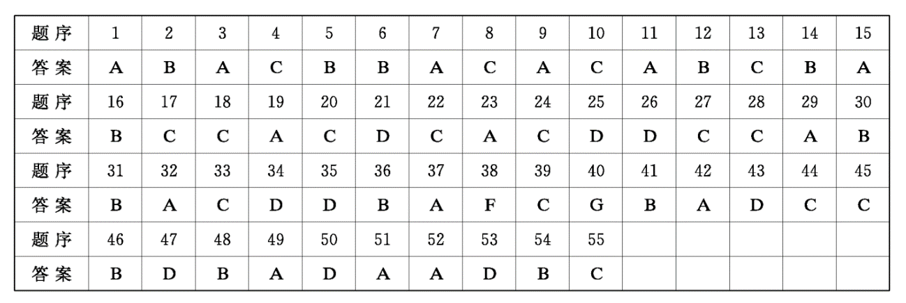

A

【语篇导读本文是应用文, 主题语境是“人与社会”。文章介绍了New Malden Airport Transfers的出租车服务。

21. D, 推断题。解题步骤如下：①明题意－本题问的是“New Malden Airport Transfers 可能是什么”②寻线索－根据第一段中的＂Need an airport transfer（换乘）taxi in New Malden. . . We are best known as the specialists in London＇s airport transfers”可知, New Malden Airport Transfers应该是一个出租车公司。③定答案－A项“出租车生产商”；B项“新创办的小型公司”；C项“中转站”；D项“出租车公司”。故D项正确。

22. C. 理解具体信息题。根据New Malden Taxis Hold Many Benefits部分中的“Our New Malden taxi service is open 24 hours a day, 365 days a year”可知, 该服务是全天候的。

23. A。理解目的题。综观全文可知, 本文主要介绍了New Malden Airport Transfers的出租车服务的特点、服务范围等, 因此, 作者写作本文是为了宣传这一服务。

B

语篇导读】本文是一篇记叙文。John参加了VISE项目, 在马戏团义务教授孩子的同时也免费观看了梦寐以求的马戏表演, 过上了有意义且有趣的生活。

24. C. 细节理解题。根据第二段内容尤其是最后一句可知, John在听说了项目VISE后很感兴趣, 并以一名老师的身份跟随马戏团, 对那里的孩子进行授课。故选C.

25. D. 推理判断题。根据第四段第二句中的＂John and his wife Helen found it extraordinary enough to sink into sleep to the sound of lions roaring”可知, John与妻子都很享受伴着狮声人睡。故选D.

26. D. 推理判断题。根据第四段最后一句可知, John见到小狮子时, 有一点害怕, 但这对John来说, 这是一次无法忘怀的经历, 这帮助他实现了从儿时的梦想。故选D。

27. C. 标题概括题。根据全文内容可知, John在退休之后来到马戏团义务教授孩子的同时也免费观看了梦寐以求的马戏表演, 过上了有意义且有趣的生活。因此C项概括了本文内容, 适合本文内容, 适合作本文的标题。故选C。

C

28. C. 根据文章第一段中的＂The letter warns that AI may threaten jobs, spread propaganda（宣传）, and even lead to the ＇lo ss of control of our civilization＇, ＂可知。句意为“他们在信中警示的就是AI可能会危及就业, 控制舆论, 甚 至导致＊我们的文明失控＇。”

29. A。根据the US的例子所处的位置来看, 是为了证实上一句话“The history of innovation is one of trial and error, risk and reward. ”.

30. B. 根据文章第四段中的＂By 2030, it might be contributing more than S 15 trillion to the global economy. ＂可知A项错误。根据“Advances in medicine, biology, climate science, education, manufacturing, transportation and much more are on the horizon. ”可知B项正确。根据文章第五段中的＂The industry already operates within legal paramcters（范畴）in response to potential harms. ＂可知C项错误。根据“Far from the＇out-of-control race＇, the AI business is constrained by law and politics and consumer sentiment. ”可知D项错误。

31. B. 根据文章作者的观点以及最后一段, 尤其是最后一句“The AI revolution deserves no less. ＂可知。

D

32. A. 根据文章第一段＂The way such creatures evolved to be just colorful cnough to signal their toxic（有毒的） defense-but not so colorful that they become vulnerable to predators（捕食者）-has long been a grey arca for scientists. ”可知。句意为“这些生物将颜色进化得刚刚好来表明它们有毒, 但是又没有颜色艳丽得容易被它们的天敌发现。其方式对于科学家们来说一直就是一个灰色地带。”因此在之前的研究中并没有弄清楚这些恰当的颜色色度是怎样进化来的。

33. C. 词义猜测题。this dilemma 侧重点关注指示代词this所指的前文内容。根据第二段“Initially, predators would not have known that bright colors signal toxicity, and therefore would have eaten, then become ill-these easily- spotted few members of a species with the colorful mutation（突变）. In theory, this should make it virtually impossible for the aposematic（防护色的）pioneers to pass on their genes to their offspring, allowing for the mutation to take hold in the population. ＂”可知。亮丽的颜色成为警戒色是这些天敌在试误后得到的教训, 但既然这些有着亮丽颜色的生物被吃掉了, 那从理论上讲就不可能把这个突变的基因传给后代了。所以 this dilemma指的就是这个矛盾。

34. D. 根据文章第三、四段可知。从“Between these poles, the scientists place species with camouflaged（伪装的） tops and colorful bottoms in various degrees. These tend to display their dramatic halves only when trying to defend themselves from predators. ”可知, 在极鲜亮和极不明显的颜色中间还有半鲜亮半保护色的物种, 所以A项 错误；根据＂In the end, the researchers realized that they all kind of followed a similar pattern, evolving from species in the middle of that range, those whose colors are hidden unless in danger. ”可知, 他们的进化路线只有相似的一条, 所以B项错误。而研究者主要是查阅数据和建模来进行研究, 所以C项错误。根据“evolving from species in the middle of that range, those whose colors are hidden unless in danger＂可知D项正确。

35. D. 根据文章最后一段“. . . but this new theory presents a mechanism that is likely to play a role in the evolution of anti-predator defense in various prey groups and a wide range of different predators. Possibly--evolution of warning coloration in other animal groups as well. ”可知。

【语篇导读】本文语篇类型是说明文, 主题是人与社会。文章介绍了人们为什么眨眼以及什么情况下眨眼多和少。

36. B. 考查上下文的指代关系。后文It指代眼睛里的异物, B项里a foreign body 可以被后文It指代, 因此选B。

37. A. 考查主题照应和上下文的并列逻辑关系。本段主旨是“眨眼可以润滑眼睛”。眨眼可以流出泪液, 泪液对眼睛有很多好的作用, 照应本段主旨, 并且也和后文的also形成了并列逻辑关系, 因此选A。

38. F. 考查主旨概括能力。此处是对后面两段的主旨概括。“在某些情况下, 人们会或多或少地眨眼。”因此选F。

39. C. 考查主题照应。本段主要讲眨眼频繁的情况, 所以选C。干扰项E中, “对眼睛的伤害”与整个文章的主旨不符。

40. G. 考查主旨概括能力。从后面的举例可知, 此处应该选择眨眼少的情况, 因此选G。

【语篇导读】本文是说明文, 主题语境是“人与社会”。位于南极洲的洛克雷港邮局的招聘吸引了很多人, 在那里员工不仅要收集环境数据和监测野生动物, 还要负责数金鹅。

【背景知识洛克雷港（Port Lockroy）曾经是英国的军事基地和南极科考站。这个世界最南端的邮局还有一个可爱的名字“企鹅邮局”, 因为在小屋的周围生活着成百上千只巴布亚企鹅。2006年洛克雷港转交英国南极遗产信托基金管理, 并开始作为博物馆、纪念品商店、邮局, 在每年夏季对外开放, 接待来自世界各地的游客。

41. B. 根据上文中的＂hundreds of pcople around the world are applying for a desired job”可知, 此处表示该职位在南极洲。position“职位”；aim“目的”；unit“单位”。

42. A. 本文讲的是一个职位, 再根据空后的＂is the ability to count penguins（企鹅）”可知, 此处表示其中一个关键的要求是能够数企鹅。requiremcnt“要求, 必要条件”；characteristic＂特征＂；virtue“优秀品质”；activity“活动”。

43. D. 根据上文中的＂applying for a desired job”和下文中的“employees”可知, 此处表示聘用四名邮递员, instruct “吩咐”, hire“聘用”。

44. C. 前面提到洛克雷港是一个邮局, 空后又提到“as a muscum”, 故此处表示该邮局兼作博物馆。double as“兼作”。

45. C. 根据下文中的“they are cooperatively responsible for-. tourists＂可知, 此处表示员工各司其职。taste“爱好, 志 趣”；talent＂才能”；role＂职能, 地位, 角色”；background“背景”。

46. B. 根据上文中的＂a ncarly 80-year-old British-owned＂和空前的“prcserving”可知, 此处表示有历史意义的地方。temporary＂临时的”；historic＂有重要历史意义的, 历史上重要的＂；grand＂壮丽的”；magical“奇妙的”。

47. D. 根据空前的“also”可知, 本空应与前面的＂responsible for＂在含义上接近, 故用in charge of“负责”。in favor of“赞同, 支持”；in need of＂需要”；in possession of＂拥有”。

48. B. 前面提到这份工作没多少放松和休息的时间, 再结合“Still”（但是）可知, 它仍然很抢手。sought-after表示“吃香的, 广受欢迎的”, 符合语境。paid“有偿的, 付费的”；hard-won“来之不易的, 辛苦得来的”；rcspcctable“体面的, 得体的”。

49. A. 根据上文中的“This year, hundreds of people--desired job”和下文中的“the 2019-2020 season”可知, 此处表示英国南极遗产信托基金每年（annually）都会收到大量申请该职位的信。

易错点拨：思维定式会导致一部分考生因为前面提到该职位很抢手而想当然地以为该机构每天都会收到很多申请信, 但是忽略了上下文的解题信息。

50. D. 他们大多是被洛克雷港的历史和科研价值吸引的。draw“吸引”。

51. A. 前面提到该职位很抢手, 而Lucy Dorman申请成功了, 再结合下文中的“I really love”可知, 此处表示对她来说, 获得这个职位很让她开心。joy“令人高兴的人（或事）”；lcsson“经验”；shlock“令人震惊的事”。

52. A. 根据上文中的“there＇s a real sense of community＂和下文中的＂you can＇t get away from each other very easily＂可知, 此处表示你得与人和睦相处（get along）。

53. D. 根据上文中的“a real sense of community＂和＂you can＇t get away from each other very easily＂可知, 此处表示Lucy Dorman 喜欢那种亲密无间。loneliness“孤独”；eagerness＂渴望”；looseness＂松弛”；togetherness“（尤指家庭或朋友的）和睦相处, 亲密无间, 团结友爱”。

54. B. 根据空前的“what you can achieve here＂和下文中的＂The total experience offers. your function on the planet. ”可知, 此处表示你在这里获得的东西很有益。consistent“持续的”；rewarding“有益的, 有意义的”；potential“潜在的”；pure“纯粹的”。

55. C. 这整个经历会让你产生对世界的不同看法（attitude）以及你在这个星球上的职责的新观点。

56. largely. 此处考查副词。表示竹子主要生长在长江南部。largely副词修饰动词 grow。

57. considered。此处考查非谓语动词, 主句谓语动词为has enriched。

58. to express, 此处考查非谓语动词, 表目的。意为表达对竹子纯洁和优雅的赞美。

59. purity. 此处考查名词。

60. compared。此处考查谓语动词。

61. to, 此处考查介词。compare. . to. 意为“把······比作······”。

62. a. 此处考查冠词。竹子也是历代中国知名画家最喜欢的一个题材。

63. where。此处考查非限制性定语从句。晚年, 他画了《竹石图》, 画中没有鲜艳的色彩, 只有简单的线条。

64. unnecessary. 此处考查形容词。

65. arc seen。此处考查谓语动词。去掉了所有不必要的细节, 竹子的优雅、美丽和力量在纸上表现得最为有效。

第四部分

第一节

【参考范文】

Dear Sir or Madam,

Learning that volunteers are needed for the coming Chinese Traditional Culture Festival in our community, I＇m delightedly writing to apply for the job.

Firstly, as a native Chinese equipped with a good knowledge of traditional Chinese cultures, I＇m confident that I＇m qualified to introduce our treasures to visitors. Moreover, I have a good command of English, enabling me to communicate with foreign guests smoothly. Better yet, with many a relevant experience as a volunteer, not only am I enthusiastic and optimistic, but I＇m also patient and responsible.

If given the precious opportunity. I will spare no effort to present the charm of Chinese culture.

Yours,

Li Hua

评分标准：

1. 评分原则

（1）总分为15分, 按5个档次给分。

（2）评分时, 先根据文章的内容和语言初步确定其所属档次, 然后以该档次的要求来衡量、确定或调整档次, 最后给分。

（3）词数少于60或多于100的, 从总分中减去2分。

（4）评分时, 应注意的主要内容为：内容要点、应用词汇和语法结构的丰富性和准确性及上下文的连贯性。作文所写内容要点应包括：①交代写信的目的（2分）：②个人优势（6分）；③希望获准（2分）。语言运用计3分, 上下文衔接计2分, 书写差影响交际扣2分。

（5）拼写与标点符号是语言准确性的一个方面, 评分时, 应视其对交际的影响程度予以考虑。英、美拼写及词汇用法均可接受。

2. 各档次的给分范围和要求

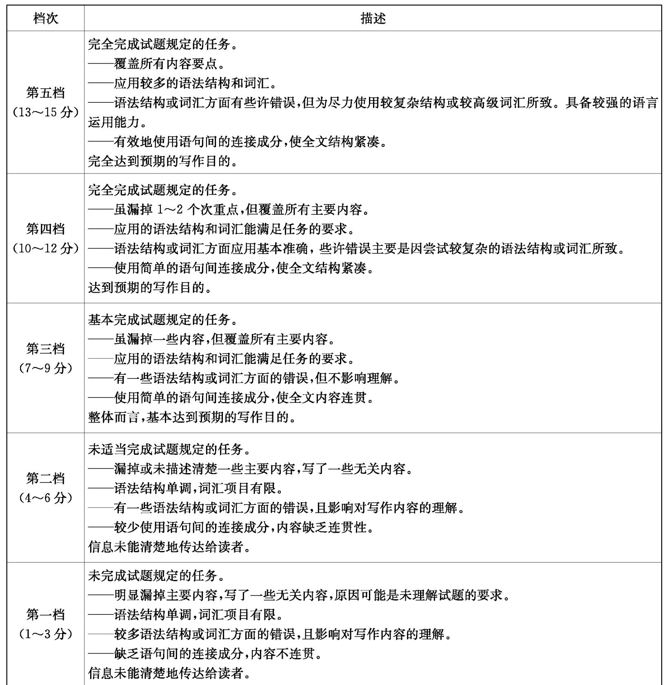



第二节

【参考范文】

Things seemed all right at first. However, with time going by, conflicts emerged. Abigail always complained that every time I hung out with Ava, she was left alone, while Ava said that I paid more attention to Abigail, which drove her crazy, believing that our friendship was not what it used to be. Trapped in the dilemma, I, enveloped by the sense of sadness, still felt confused why things turned out to be that complicated, not knowing how to tackle the problem. Worse still, karate even became the most frightening thing to me.

One day, I simply could not take it anymore. With tears streaming down my cheeks, I stopped them from arguing and said with a deep sigh, “Why can't you get along with each other well? Both of you arc my best friends. "Hearing my words, they didn't utter a single word, sinking into a deep silence. After what seemed like a century, Ava finally placed her arm with apparently unaccustomed affection around Abigail's shoulders. Seeing this scene, I gasped with relief and burst into laughter.

评分标准：

1. 评分原则

（1）本题总分为25分, 按5个档次给分。

（2）评分时, 先根据所续写短文的内容和语言初步确定其所属档次, 然后以该档次的要求来衡量、确定或调整档次, 最后给分。

（3）词数少于130的从总分中减去2分。

（4）评分时, 应主要从以下四个方面考虑：

①与所给短文及段落开头语的衔接程度；

②内容的丰富性和关键信息的利用情况；

③应用语法结构和词汇的丰富性和准确性：

④上下文的连贯性是一个重要方面, 评分时, 应视其对交际的影响程度予以考虑。

（5）若书写较差以致影响交际, 可将分数降低一个档次。

2. 各档次的给分范围和要求

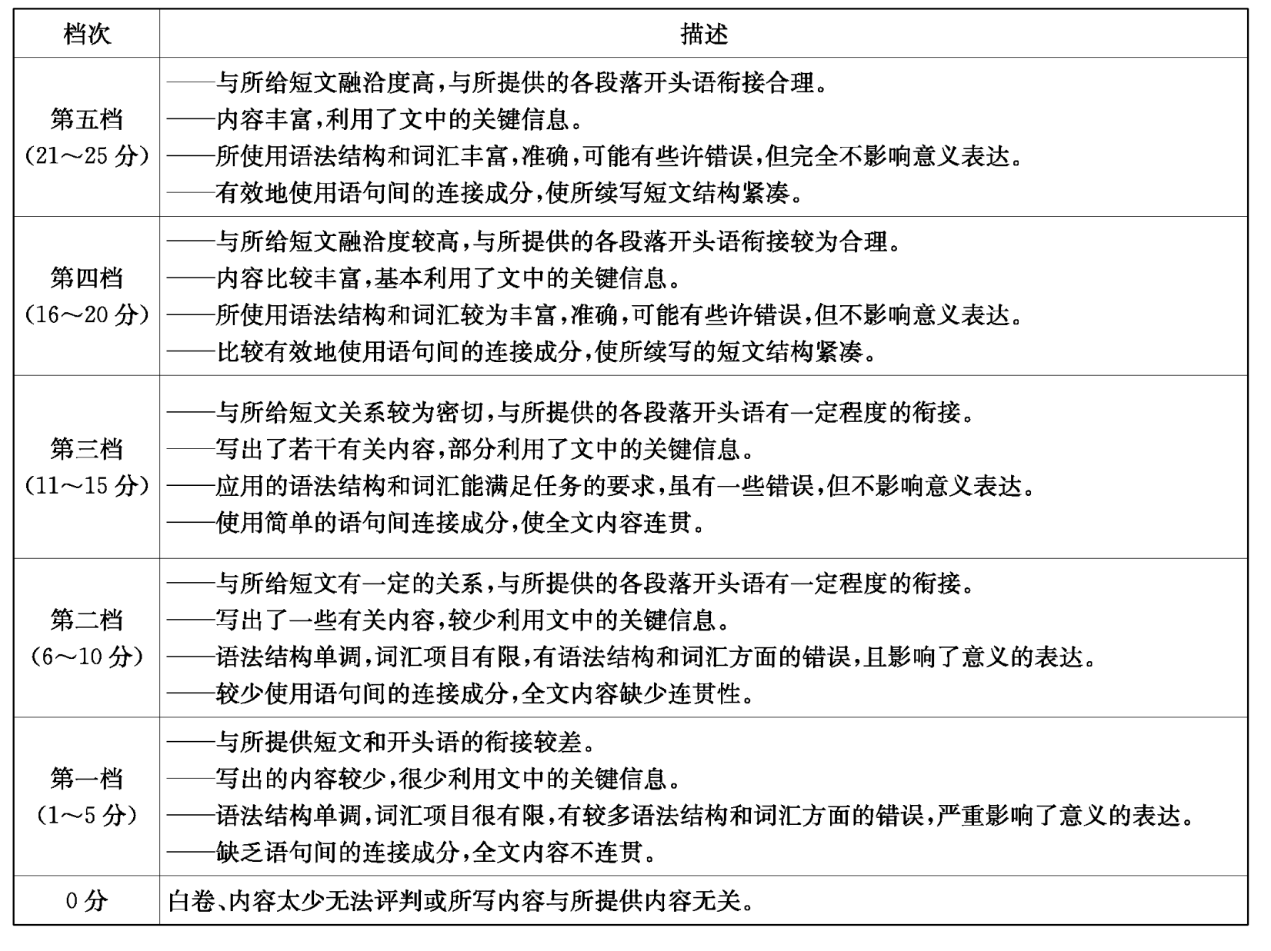

3. 内容要点

（1）文本理解重要信息

主要人物：Abigail, “I”, Ava

（2）写作核心内容：

①Paragraph 1：必写内容：我的两位好朋友Abigail和Ava之间的冲突, 对彼此的不满。

②Paragraph 2：必写内容：在我的劝和之下, 我的两位好朋友Abigail和Ava和解。

③主题：与friendship以及如何处理朋友之间矛盾相关的主题。

听力材料

Text 1

M:We planned to go to the beach after class. Want to come?

W:I'd love to. But professor Jones wants to talk with me. （1）

Text 2

M:Lucky you! You got the window seat!

W:Why don't we change places? I prefer to get up and walk around during the night. Here, come rest by the window. （2）

It's going to be a big conference. You've been looking tired since the meeting yesterday.

Text 3

M:We are planning to visit some places of interest in Beijing. Do you have some advice?

W:The Great Wall is a must, （3） since you have toured around the Forbidden City and the Summer Palace before.

M: Thank you.

Text 4

M:Anne, I'm going out for a while.

W:But you have an appointment with Mr. Smith at 9 o' clock.

M:Well, please make it another day. （4）

Text 5

W:George, have you saved enough for the tablet?

M:I have 800 yuan now, and the tablet costs 1, 400 yuan. My father said he would fill the gap, so I'll get the rest from him. （5）

Text 6

W:Hi, Henry. Where were you yesterday afternoon? Did you remember your promise?

M: Oh, I'm sorry, June. I forgot. Did you go to the cinema alone?（6）

W: No, I didn't go anywhere. You had kept me waiting for hours. What were you doing then?

M: I was busy helping my father. He asked me to paint the wall. （7）

W:But you could ring me up. You know my telephone number. Remember an honorable man must always keep his promise.

Mi I'm so sorry. It's my fault. I'll try to keep my promise next time.

Text 7

M:Welcome to our hotel's indoor swimming pool. What can I do for you?

W, You see, this is my first time to use the swimming pool, and I've got no idea about the water temperature of the pool. （8）I'm afraid it might be a little cold.

Mi You don't need to worry about that, madam. This is a warm massage pool; the temperature is 36 degrees.

W: I see. I'm also not a very good swimmer. Can you tell me how deep the pool is?

M: Certainly, madam. The deepest area is two meters deep, （9） but you can swim in the area at the edge of the pool, which is only 1. 4 meters deep. We have separate locker rooms over there, and they are free of charge.

W:That's great! Can you give me a key to a locker? I can't wait to try the pool. （10）

Text 8

W:Thanks for coming to the studio today, Mr. Larson. Why don't you tell me about your last position?

M: Well, I started working at Smith Electronics in Chicago right after I graduated from college. I was in the sales department, and even though I was good at it. I wasn't really happy. （11） After one year, I was moved to the HR department. W:Was that a better fit?

M:Yes. I prefer talking to people face-to-face, and I enjoy solving problems. I did quite well in that position. （12）

W:So, why did you leave?

M:I had been working at Smith for four years. Then I wanted to take some time off, so I went to Paris. My three-week vacation turned into a two-year stay!

W:Wow! What made you come back to the United States? And why is it a good time for you to join Branson Labs? M: When my father started Branson Labs here in Los Angeles forty years ago, he wanted to pass it down to me. At my graduation dinner, I promised him that I would take over when the time was right. I'm finally ready to make good on that promise. （13）

Text 9

M: I understand I can borrow six books in total at most from this library, right?

W:Yeah.

M: Good. I only borrowed two books before. Now can you help me check out these three books, please?（14）

W:I need your library card.

M:Here.

W:Uh, one of your borrowed books is two weeks overdue. You can't borrow any books until you give it back and pay the fine. （15）

M:What?Oh, I remember. I lent it to a friend, and she didn’t return it to me. She is out of town right now. What should I do? I really need these books for my paper. How I wish I knew some reader here who could help me.

W:There's a copy machine right over there. Why not just copy the sections you need right away?（16）

M: It would be a great idea if the copy machine were free to use. However, the truth is it would cost me more than the fine. So no, thanks, （17）

Text 10

Good morning. This is Michael Jones here with the 10:00 News Report. Earlier this week, we heard about Milton, the dog that traveled over 3, 000 miles to reunite with his family. （18）When the Johnson family moved from California to New York, they couldn't find their dog and they were sad to leave him behind. About a month later, Milton showed up at their doorstep in New York. We cannot believe how far this dog traveled! The family will be doing an interview in the studio tomorrow morning. In other news, there's been an outbreak of car thefts in Orange County this week. About ten cars have been stolen from outside their owners' homes since Monday. （19） If you see or hear anything, please call 911. That's the first 2 pieces of the news. We'll come back soon from a commercial break. （20）