**The Face-down Generation**

**Worksheet**

1. Which one is the correct structure?

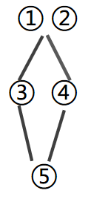 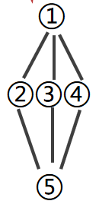 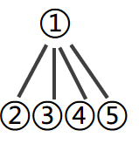

1. Complete the form

|  |  |  |
| --- | --- | --- |
| Topic |  | Reasons |
| Attitudes | Some adults |  |
| Other adults |  |
| The writer |  |
| Conclusion |  |  |

1. Write down the expressions and writing tips you’ve learnt from this text.