**The World**（**0401-0430**）材料分析和教学目标：

本次选用的材料：①*The Wall Street Journal*的Celestial Sight Delights Millions of Spectators （全美盛况！日全食横扫美国大陆！）、②*Reader’s Digest New Zealand*的*World of Medicine* (医学新发现)、③*The Times*的*Gold prices pass $2,400 as global tension rises*（金价突破2400美元大关）、④*The Times*的*Warm winter makes small birds chirpier*（暖冬有利于庭院小鸟）、⑤*USA Today*的*In free and easy Finland, happiness is a warm sweat*（芬兰人的快乐神器——桑拿浴）和⑥CNN的新闻报道。通过语法填空、阅读理解、分析长难句、翻译句子、听力填空和词汇拓展等方式，让学生从多角度提升学习兴趣，提高分析句子、运用词块和听力能力。外媒英语新闻可以让学生体验真实语境下的语言运用，拓展学生的国际视野，了解时事，逐步提升跨文化沟通能力，形成正确的世界观、人生观和价值观。

**教学思路：**

**Part 1: News Report 1 *The Wall Street Journal* (9th April 2024 A3)**

**Celestial Sight Delights Millions of Spectators**

**全美盛况！日全食横扫美国大陆！**

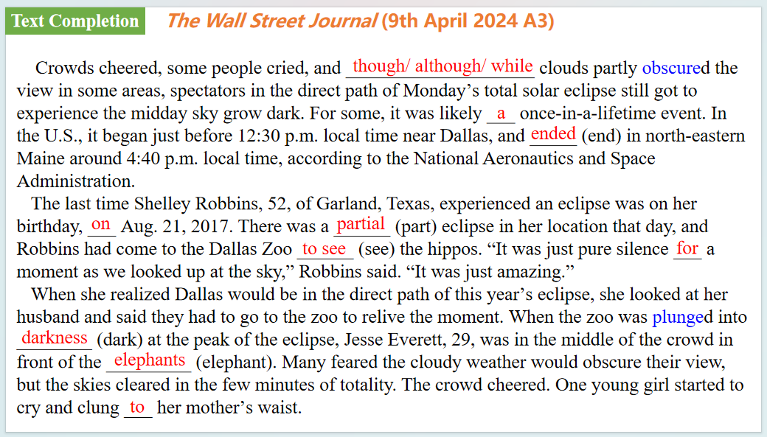

【设计意图】通过语篇填空的形式帮助学生理解新闻的主要内容，同时训练语言语法的运用能力：在语篇的视角下如何正确使用所给词汇，根据语法规则确定词汇的正确形式，使得文章通顺，激活学生的思维和语言。该新闻主题语境是关于“人与社会”中“社会热点”这一子主题，通过学习让学生了解日全食横扫美国大陆的盛况。

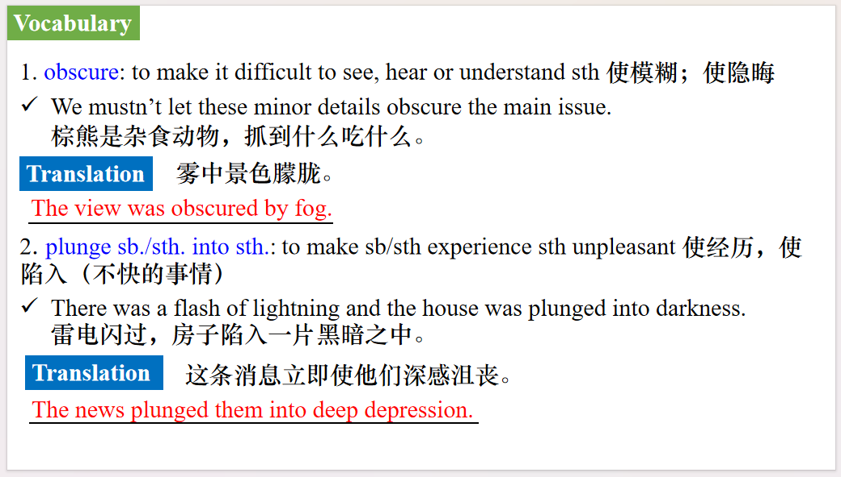

【设计意图】对文本中的词汇进行解读，并通过翻译句子对其进行巩固。

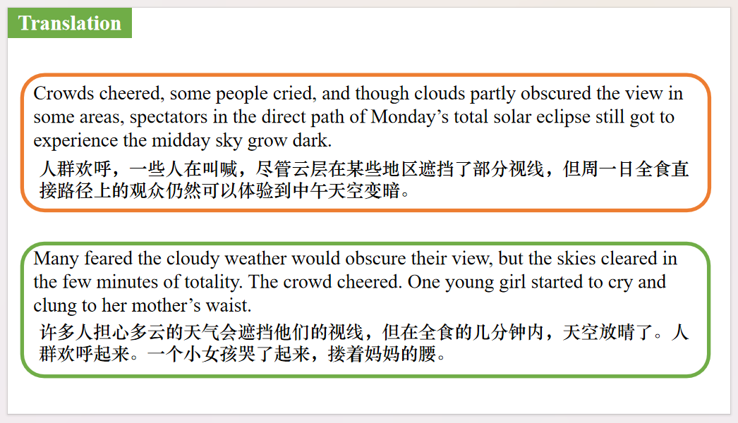

【设计意图】对文中的两个句子进行翻译练习，对其中单词、词组、句法进行巩固并关注句子结构。

**Part 2: News Report 2 *Reader’s Digest New Zealand* (April-May 2024 Page 20)**

**World of Medicine 医学新发现**

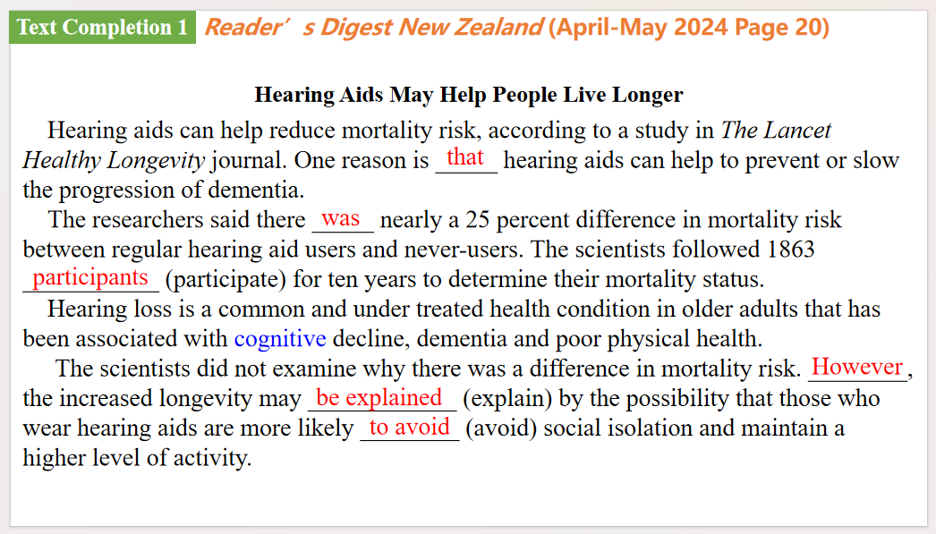

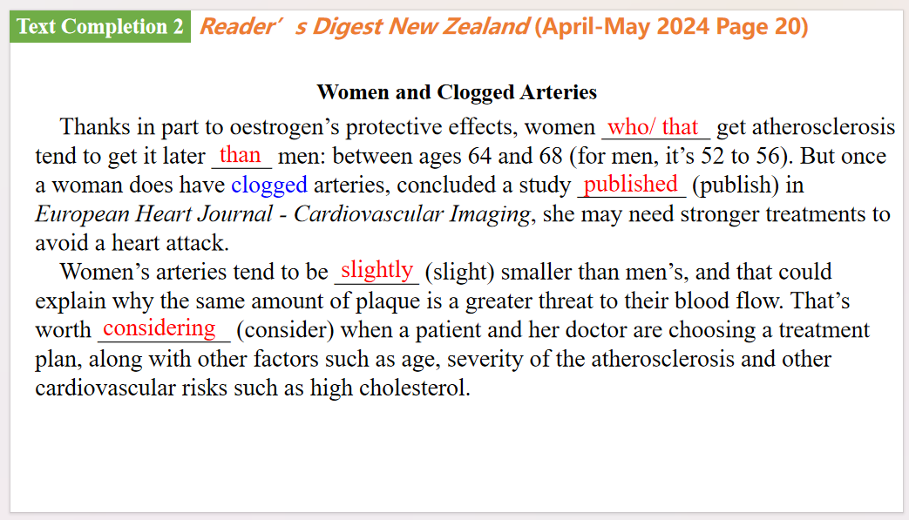

【设计意图】通过语篇填空的形式帮助学生理解新闻的主要内容，同时训练语言语法的运用能力：在语篇的视角下如何正确使用所给词汇，根据语法规则确定词汇的正确形式，使得文章通顺，激活学生的思维和语言。该新闻主题语境是关于“人与社会”中“社会热点”这一子主题，通过学习让学生了解医学新发现。



【设计意图】对文本中的词汇进行解读，并通过翻译句子对其进行巩固。

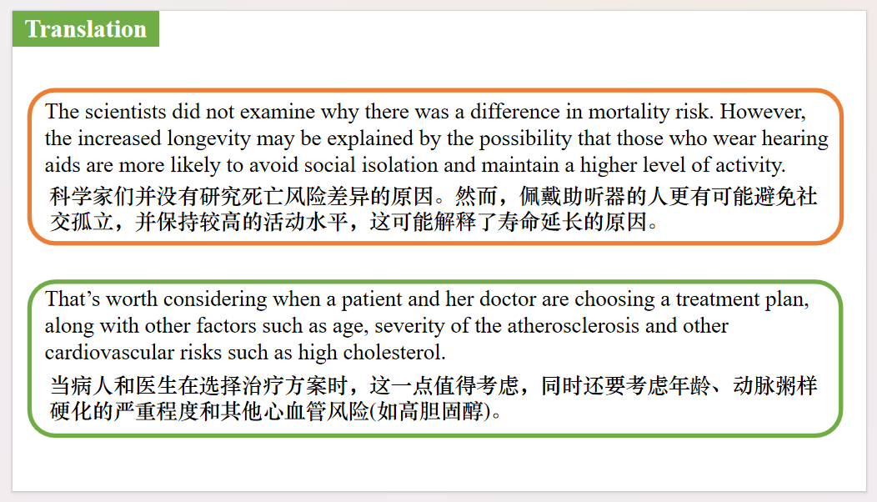

【设计意图】对文中的两个句子进行翻译练习，对其中单词、词组、句法进行巩固并关注句子结构。

**Part 3: News Report 3 *The Times* (April 13 2024 P50)**

**Gold prices pass $2,400 as global tension rises 金价突破2400美元大关**

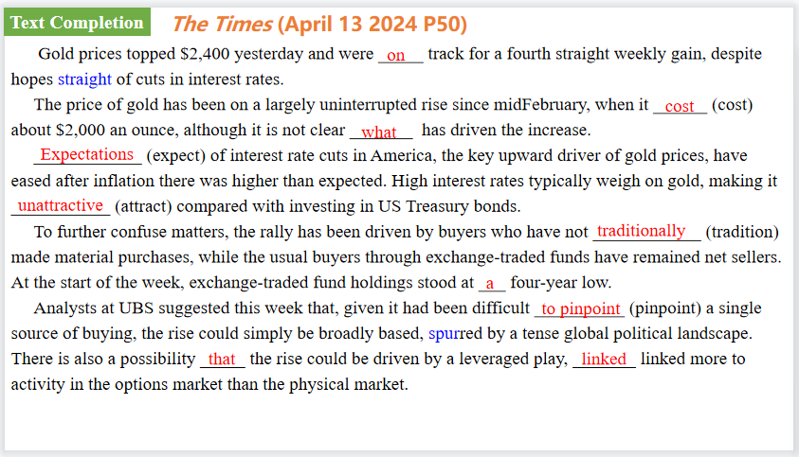

【设计意图】通过语篇填空的形式帮助学生理解新闻的主要内容，同时训练语言语法的运用能力：在语篇的视角下如何正确使用所给词汇，根据语法规则确定词汇的正确形式，使得文章通顺，激活学生的思维和语言。该新闻主题语境是关于“人与社会”中“社会热点”这一子主题，通过学习让学生了解全球金价的变动。



【设计意图】对文本中的词汇进行解读，并通过翻译句子对其进行巩固。

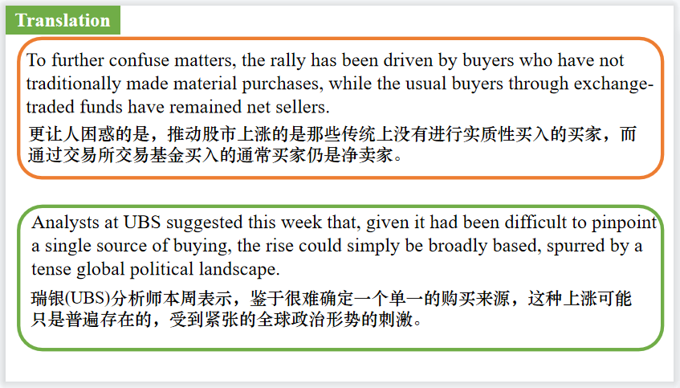

【设计意图】对文中的两个句子进行翻译练习，对其中单词、词组、句法进行巩固并关注句子结构。

**Part 4: News Report 4 *The Times* (April 12 2024 P18)**

**Warm winter makes small birds chirpier 暖冬有利于庭院小鸟**

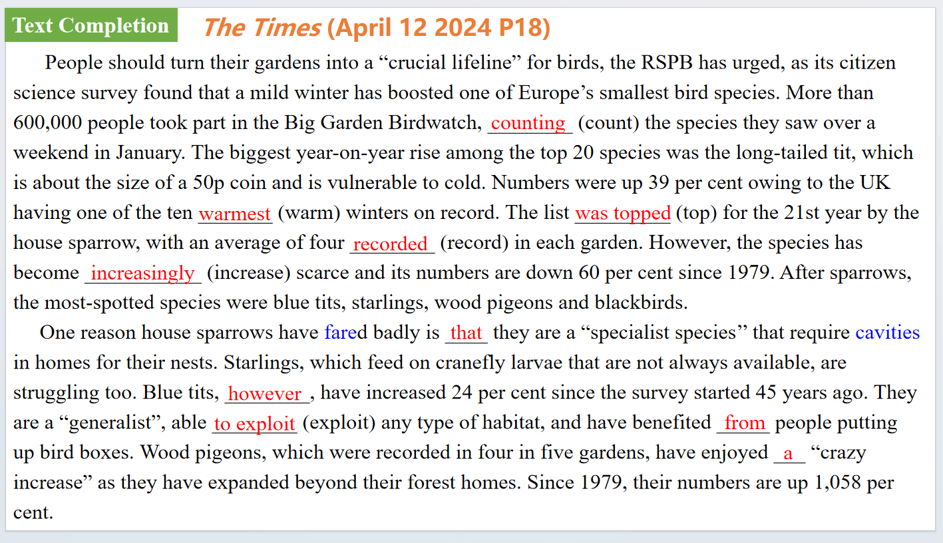

【设计意图】通过语篇填空的形式帮助学生理解新闻的主要内容，同时训练语言语法的运用能力：在语篇的视角下如何正确使用所给词汇，根据语法规则确定词汇的正确形式，使得文章通顺，激活学生的思维和语言。该新闻主题语境是关于“人与自然”中“人与环境、人与动植物”这一子主题，通过学习让学生了解暖冬对英国庭院里的小鸟的影响。

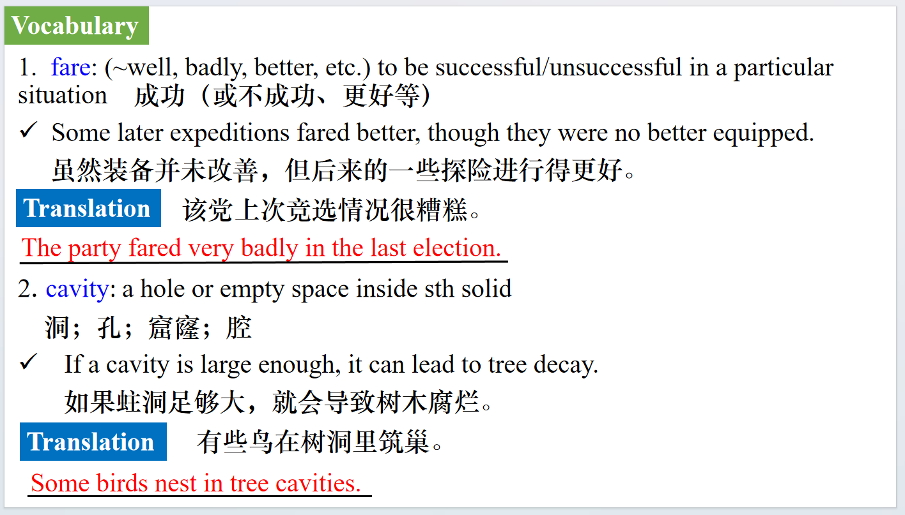

【设计意图】对文本中的词汇进行解读，并通过翻译句子对其进行巩固。

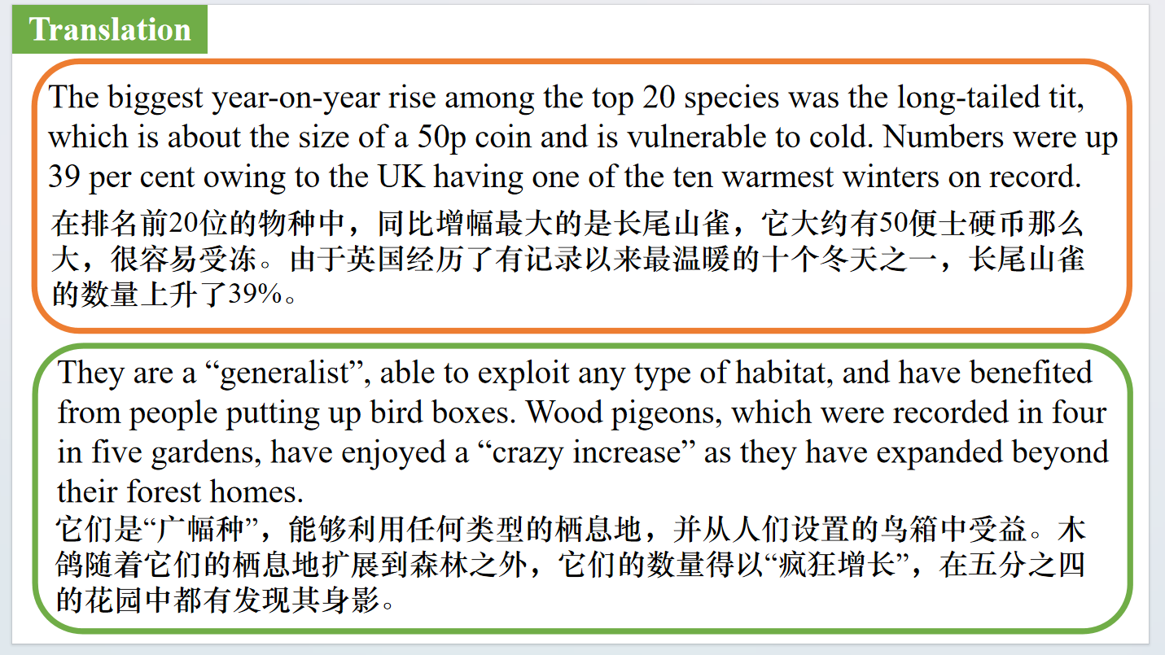

【设计意图】对文中的两个句子进行翻译练习，对其中单词、词组、句法进行巩固并关注句子结构。

**Part 5: News Report 5 *USA Today* (April 16, 2024 P1A&5A)**

**In free and easy Finland, happiness is a warm sweat**

**芬兰人的快乐神器——桑拿浴**

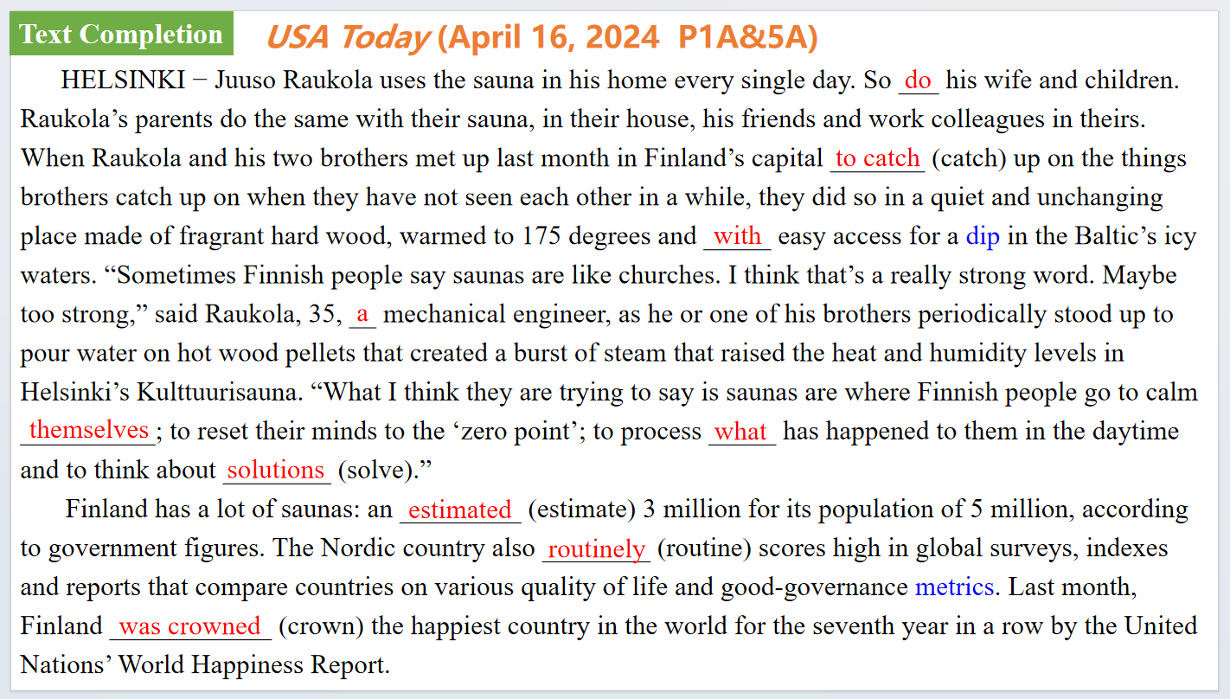

【设计意图】通过语篇填空的形式帮助学生理解新闻的主要内容，同时训练语言语法的运用能力：在语篇的视角下如何正确使用所给词汇，根据语法规则确定词汇的正确形式，使得文章通顺，激活学生的思维和语言。该新闻主题语境是关于“人与社会”中“社会热点问题”这一子主题，通过学习让学生了解芬兰人的快乐神器——桑拿浴。



【设计意图】对文本中的词汇进行解读，并通过翻译句子对其进行巩固。

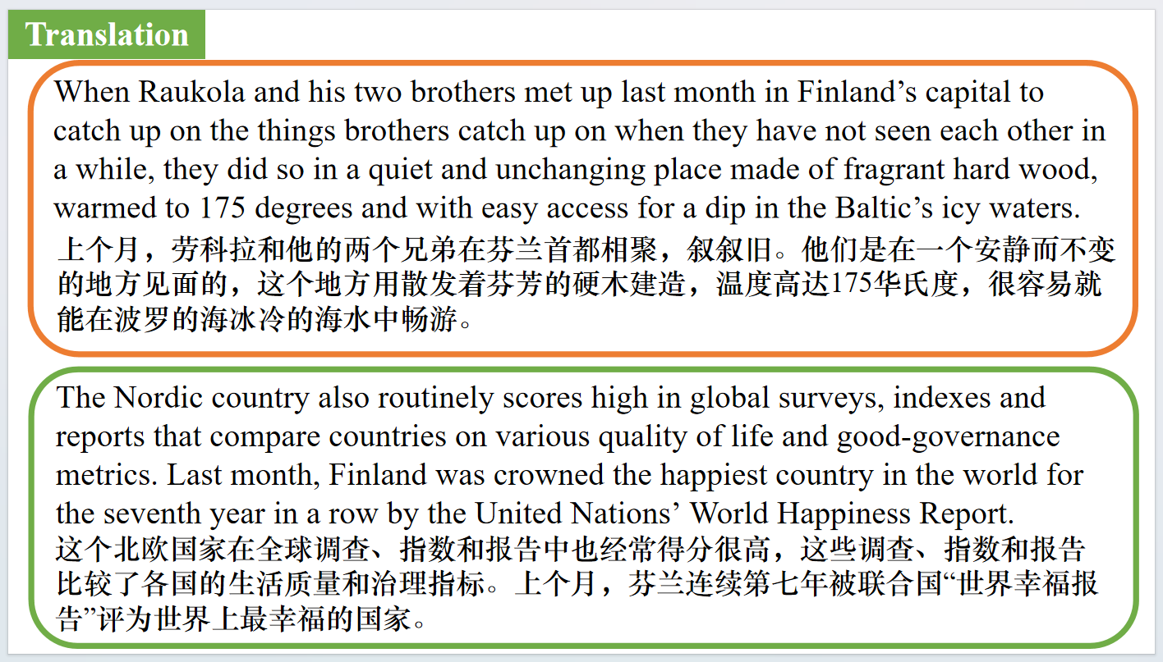

【设计意图】对文中的两个句子进行翻译练习，对其中单词、词组、句法进行巩固并关注句子结构。

**Part 6: CNN News 04/05/2024**

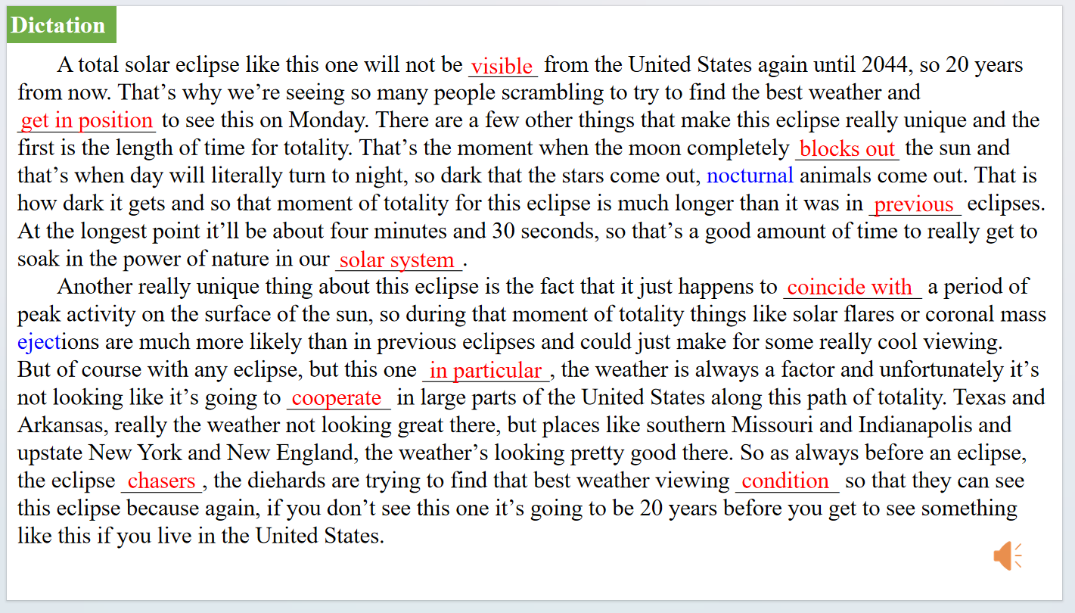

【设计意图】听一则材料，通过听力填空的方式理解文本，考察听力辨识词汇的能力。

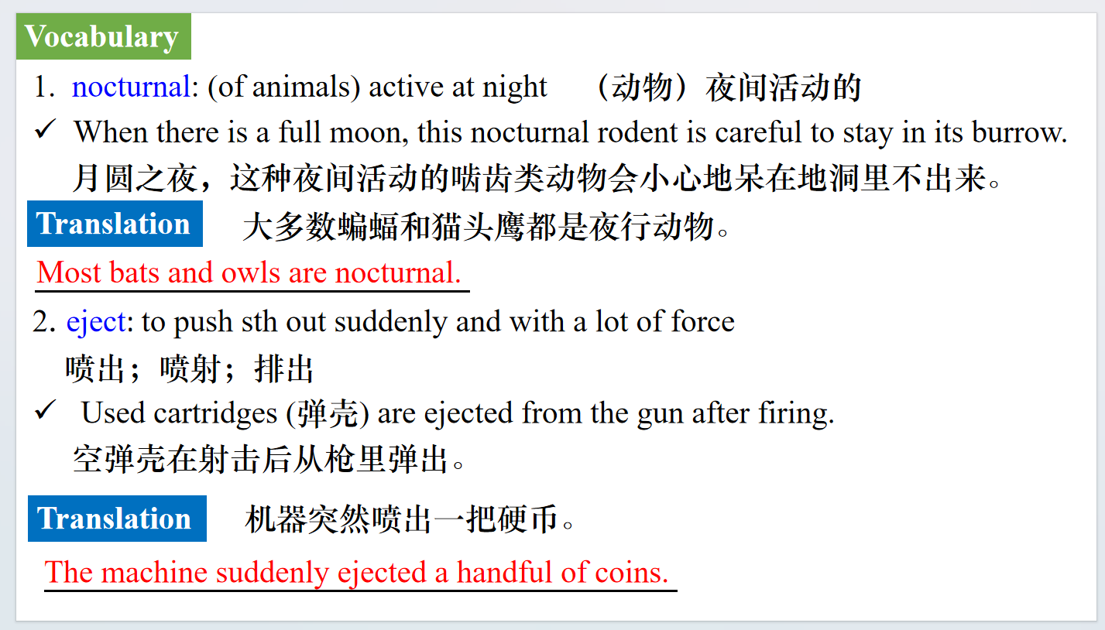

【设计意图】对文本中的词汇进行解读，并通过翻译句子对其进行巩固。

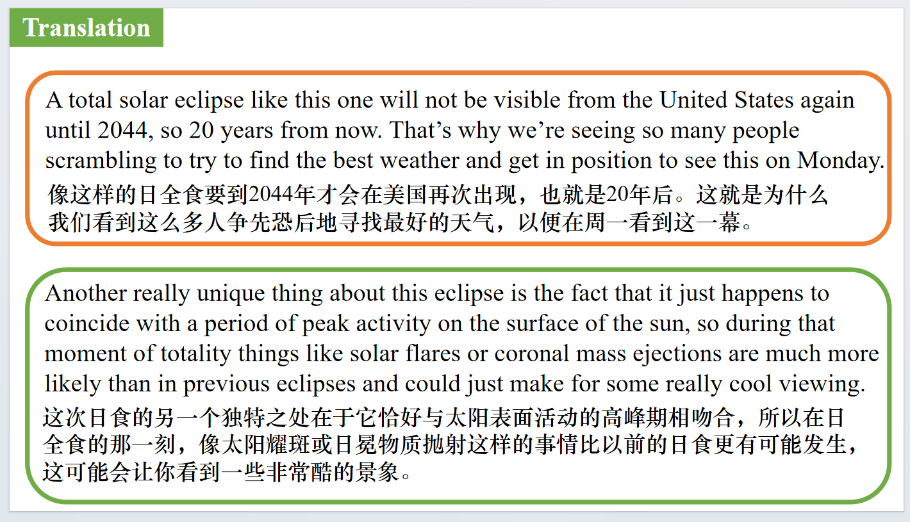

【设计意图】对文中的两个句子进行翻译练习，对其中单词、词组、句法进行巩固并关注句子结构。

附：外刊原文

**Part 1: News Report 1 *The Wall Street Journal* (9th April 2024 A3)**

**Celestial Sight Delights Millions of Spectators**

**全美盛况！日全食横扫美国大陆！**

Crowds cheered, some people cried, and though clouds partly obscured the view in some areas, spectators in the direct path of Monday’s total solar eclipse still got to experience the midday sky grow dark.

For some, it was likely a once-in-a-lifetime event.

In the U.S.,it began just before 12:30 p.m.local time near Dallas,and ended in north-eastern Maine around 4:40 p.m.local time,according to the National Aeronautics and Space Administration.

The last time Shelley Robbins, 52, of Garland, Texas,experienced an eclipse was on her birthday, on Aug.21,2017. There was a partial eclipse in her location that day, and Robbins had come to the Dallas Zoo to see the hippos.

“It was just pure silence for a moment as we looked up at the sky," Robbins said."It was just amazing.”

When she realized Dallas would be in the direct path of this year's eclipse,she looked at her husband and said they had to go to the zoo to relive the moment.

When the zoo was plunged into darkness at the peak of the eclipse, Jesse Everett, 29, was in the middle of the crowd in front of the elephants.

Many feared the cloudy weather would obscure their view, but the skies cleared in the few minutes of totality. The crowd cheered. One young girl started to cry and clung to her mother's waist.

**Part 2: News Report 2 *The Wall Street Journal* (9th April 2024 A3)**

***Reader’s Digest New Zealand (*April-May 2024 Page 20)**

**Hearing Aids May Help People Live Longer**

Hearing aids can help reduce mortality risk, according to a study in *The Lancet Healthy Longevity* journal. One reason is that hearing aids can help to prevent or slow the progression of dementia.

The researchers said there was nearly a 25 percent difference in mortality risk between regular hearing aid users and never-users. The scientists followed 1863 participants for ten years to determine their mortality status.

Hearing loss is a common and under treated health condition in older adults that has been associated with cognitive decline, dementia and poor physical health.

The scientists did not examine why there was a difference in mortality risk. However, the increased longevity may be explained by the possibility that those who wear hearing aids are more likely to avoid social isolation and maintain a higher level of activity.

**Women and Clogged Arteries**

Thanks in part to oestrogen’s protective effects, women who get atherosclerosis tend to get it later than men: between ages 64 and 68 (for men, it’s 52 to 56). But once a woman does have clogged arteries, concluded a study published in *European Heart Journal - Cardiovascular Imaging*, she may need stronger treatments to avoid a heart attack.

Women’s arteries tend to be slightly smaller than men’s, and that could explain why the same amount of plaque is a greater threat to their blood flow. That’s worth considering when a patient and her doctor are choosing a treatment plan, along with other factors such as age, severity of the atherosclerosis and other cardiovascular risks such as high cholesterol.

**Part 3: News Report 3 *The Times* (April 13 2024 P50)**

**Gold prices pass $2,400 as global tension rises 金价突破2400美元大关**

Gold prices topped $2,400 yesterday and were on track for a fourth straight weekly gain, despite hopes fading of cuts in interest rates.

The price of gold has been on a largely uninterrupted rise since midFebruary, when it cost about $2,000 an ounce, although it is not clear what has driven the increase.

Expectations of interest rate cuts in America, the key upward driver of gold prices, have eased after inflation there was higher than expected and President Biden said there was “more to do”on fighting price rises. High interest rates typically weigh on gold, making it unattractive compared with investing in US Treasury bonds.

Ross Norman, a veteran precious metals trader, said: “One of the biggest moves we had in gold was the very day the chances of a June Federal Reserve rate cut was marked below 50 per cent, gold rallied. It went the wrong way. Where are we now, fresh all-time highs? It’s ignoring financial market indicators and who would do that?”

To further confuse matters, the rally has been driven by buyers who have not traditionally made material purchases, while the usual buyers through exchange-traded funds have remained net sellers. At the start of the week, exchange-traded fund holdings stood at a four-year low.

One of the possible culprits could be central banks, with demand from the lenders of last resort reaching 1,037 tonnes in 2023, the second highest level on record, according to the World Gold Council, a trade association.

While information on central bank purchases is reported to the International Monetary Fund and is published every month, buying by other national institutions can go undetected. “There can be an element of sovereign wealth funds, which is [influencing the price] but is rarely if ever declared. Sometimes you don’t even see the movement,” Philip Newman, the managing director of Metals Focus, an independent precious metals consultancy, said. “If a sovereign wealth fund — it doesn’t matter where they are — wants to hold gold, maybe they’ll just do it through a Swiss counter party. You will see a movement within Zurich. It will just move from being unallocated to allocated. It could just be a change in the label of the same vault.”

Analysts at UBS suggested this week that, given it had been difficult to pinpoint a single source of buying, the rise could simply be broadly based, spurred by a tense global political landscape. There is also a possibility that the rise could be driven by a leveraged play, linked more to activity in the options market than the physical market.

In a note from HSBC this week, analysts suggested a “powerful cocktail of safe-haven and hedge-fund purchases, prompted by record-high equities and sticky inflation” was driving gold’s upward march.

HSBC has noted that high prices are beginning to cut into physical demand for gold. The bank said that with falls in demand for jewellery and coins combined with more gold being extracted,investment demand would have to stay “very strong” to keep prices high.

**Part 4: News Report 4 *The Times* (April 12 2024 P18)**

**Warm winter makes small birds chirpier 暖冬有利于庭院小鸟**

People should turn their gardens into a “crucial lifeline” for birds, the RSPB has urged, as its citizen science survey found that a mild winter has boosted one of Europe’s smallest bird species (Adam Vaughan writes).

More than 600,000 people took part in the Big Garden Birdwatch, counting the species they saw over a weekend in January.

The biggest year-on-year rise among the top 20 species was the long-tailed tit, which is about the size of a 50p coin and is vulnerable to cold. Numbers were up 39 per cent owing to the UK having one of the ten warmest winters on record. The list was topped for the 21st year by the house sparrow, with an average of four recorded in each garden. However, the species has become increasingly scarce and its numbers are down 60 per cent since 1979.

After sparrows, the most-spotted species were blue tits, starlings, wood pigeons and blackbirds.

“The fact that the house sparrow is still top is never going to be a surprise,” said Luke Phillips, of the RSPB. “But we know it’s a red list [threatened] species; we know it’s declined significantly.”

One reason house sparrows have fared badly is that they are a “specialist species’’ that require cavities in homes for their nests. Starlings, which feed on cranefly larvae that are not always available, are struggling too.

Blue tits, however, have increased 24 per cent since the survey started 45 years ago. They are a “generalist”, able to exploit any type of habitat, and have benefited from people putting up bird boxes.

Wood pigeons, which were recorded in four in five gardens, have enjoyed a “crazy increase” as they have expanded beyond their forest homes. Since 1979, their numbers are up 1,058 per cent.

Phillips said gardens were an important habitat for birds. He suggested people stop mowing their lawns in May, adopt “messy gardening” with log piles, and avoid the use of chemicals that affect the insects birds eat.

**Part 5: News Report 5 *USA Today* (April 16, 2024 P1A&5A)**

**In free and easy Finland, happiness is a warm sweat**

**芬兰人的快乐神器——桑拿浴**

“Saunas are where Finnish people go to calm themselves; to reset their minds to the ‘zero point’; to process what has happened to them in the daytime and to think about solutions.”

**Juuso Raukola,** 35, mechanical engineer

**Kim Hjelmgaard** USA TODAY

HELSINKI − Juuso Raukola uses the sauna in his home every single day. So do his wife and children. Raukola’s parents do the same with their sauna, in their house, his friends and work colleagues in theirs.

When Raukola and his two brothers met up last month in Finland’s capital to catch up on the things brothers catch up on when they have not seen each other in a while, they did so in a quiet and unchanging place made of fragrant hard wood, warmed to 175 degrees and with easy access for a dip in the Baltic’s icy waters.

“Sometimes Finnish people say saunas are like churches. I think that’s a really strong word. Maybe too strong,” said Raukola, 35, a mechanical engineer, as he or one of his brothers periodically stood up to pour water on hot wood pellets that created a burst of steam that raised the heat and humidity levels in Helsinki’s Kulttuurisauna.

“What I think they are trying to say is saunas are where Finnish people go to calm themselves; to reset their minds to the ‘zero point’; to process what has happened to them in the daytime and to think about solutions.”

**A soak for everyone**

Finland has a lot of saunas: an estimated 3 million for its population of 5 million, according to government figures. The Nordic country also routinely scores high in global surveys, indexes and reports that compare countries on various quality of life and good-governance metrics. Last month, Finland was crowned the happiest country in the world for the seventh year in a row by the United Nations’ World Happiness Report.