**读后续写微专题——衔接和连贯**

**教学目标：**

本节课后，学生将能够：

1. 掌握记叙文体的一些常见的顺序的语言素材积累。
2. 掌握表达时间快慢，心理活动的常见词组和句式。

**教学重难点：**

学生能够掌握常见的表达顺序的语言素材，并且能运用在自己的写作中。

**教学步骤：**

Step 1:

Lead-in: Q: Why do we need coherence and logic while writing?

--- It can make our composition more logical and coherent.

Step 2: 几种不同的顺序

一、时间顺序：① 时间快慢 ②时间先后

时间慢: go slowly; drag on 很慢；日长似岁

after what seems an age/ a century 似乎过了一年、一个世纪

时间快

短语：

1.go fast/quickly

2. tick away (时间)一分一秒地过去

3. for/in an instant; in a spilt second; in a flash; in the blink of an eye; in the twinkling of an eye 刹那间

副词：

1.immediately/instantly 立刻；马上

2.shortly 不久，马上

句型

1.on/upon (doing) sth 一做某事

2. before 还没来得及，常见句式before sb knew what was happening;

3. The moment +句子； no sooner…than..; hardly/scarcely…when…

一…就…

Sentence-appreciation:

◆ The rest of the day went very slowly for Anne.

◆ Why do physics lessons always seem to drag?

◆He had to watch the minutes tick away while the emergency services tried to locate him.

◆In that split second, my surfing days as I had known them were over.

◆ Before I could finish my sentence, she burst into tears and began rocking back and forth.

◆ The moment he finished his speech in a magnetic voice, a storm of applause erupted from the audience.

紧接着、后来

句型：

1.时间（the following weeks/days…）witnessed/saw sth doing 接下来得时间，见证了某事得发生。

2. that’s when sth happened.

3. Everything settling down/everything ready, 主句。一切完成/就绪后，….

4. It 句型：it was /took +时间 before sb did sth 过了一段时间，某人开始做某事

短语：

the next minute; followed by; at that; with that; before doing ; after doing; subsequent to that; after that; then following …

副词：

subsequently; then; afterwards; later

恰好；不料；来不及

just in time to find/see 恰好发现、看到…

…only to do …结果

There is no time do to….

Just as /when sb did…., 主句

◆ The last five minutes saw his dashing to the finish line like wind.

◆ The following weeks saw me dashing home from school each day determined to earn a nickel or dime.

◆Everything ready, the news page was eventually in business.

◆I opened the door just in time to find him watching TV.

◆ With that, she rushed out of the room.

二、空间顺序

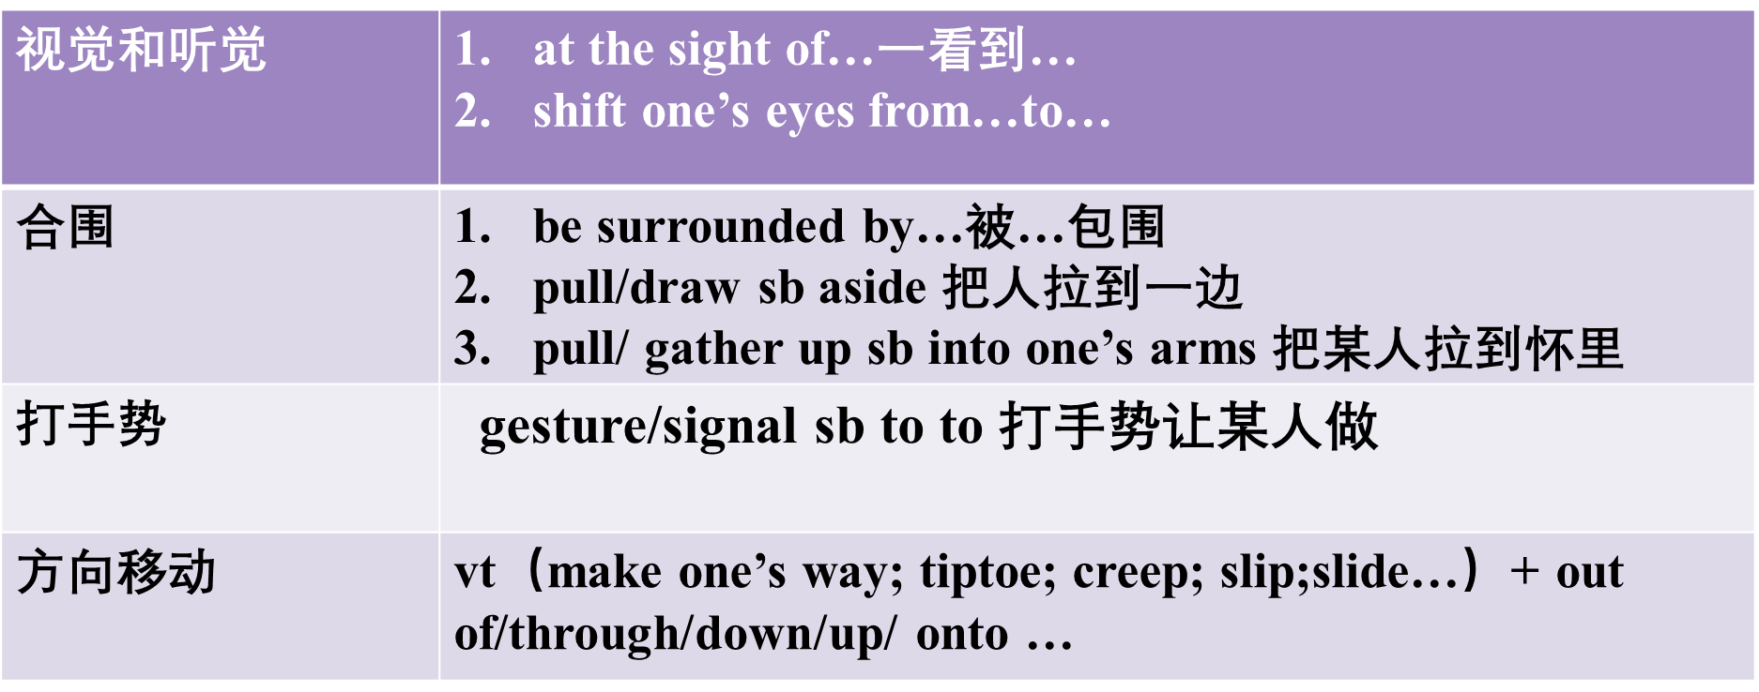

◆ His eyes shifted from face to face.

◆ She laughed, ignoring the stares of everyone around her.

◆She pulled out into the street.

◆ We followed him up the steps into a large hall.

三、意识流动顺序：思维活动推动故事发展

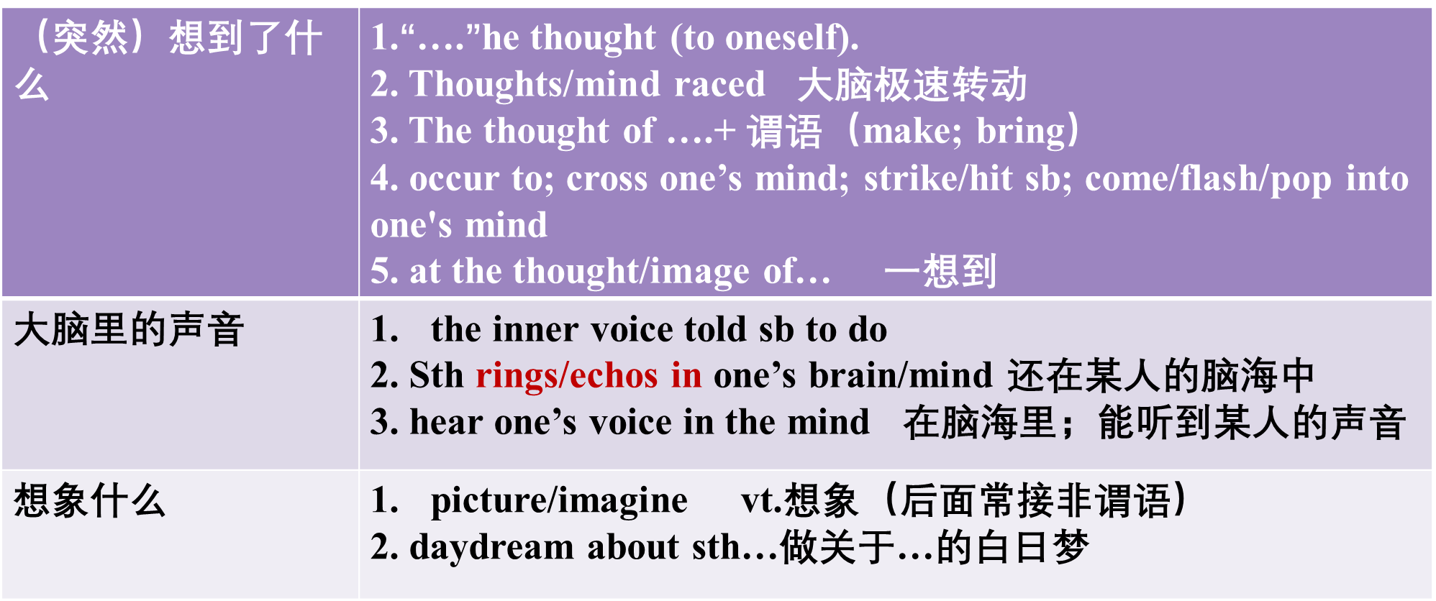

◆ “How strange!’ he thought to himself.

◆The thought of Nick made her throat tighten.

◆ My inner voice told me to be cautious.

◆All at once an idea popped into her head.

◆I said, picturing the fancy brick house that we passed on our way from schoo

四、场景的氛围：其他人群的反应

|  |  |
| --- | --- |
| **人群的反应** | 1. ***A murmur of （approval…） came from the crowd.*** 2. ***…be greeted with cries of…***   ***3. …produced /caused an awkward silence.***  ***4. …found an echo in her own feelings. 引起了她的共鸣。***  ***5. …struck a chord with his audience. 引起了听众的共鸣***  ***6. A thunderous applause burst out from the audience.*** |
| **一片**  **寂静** | **1.*There was a moment of complete silence.***  ***2. Silence falls/descends (on/upon sth)***  ***3. …be met with silence/ …be followed by a very long silence, broken by…*** |

◆ Her question was met with an uneasy silence.

◆A sudden silence fell over the room.

◆ His love for her found an echo in her own feelings.

◆Her remarks produced an awkward silence.

◆The speaker had obviously struck a chord with his audience.

Step 3: Consolidation: fill in the blanks.

1.时间慢慢地过去，我的状况越来越糟了。

As time ________ on, I gradually got worse.

2. 一眨眼的功夫就完成了。

It was done in a ________/in a ________ second.

3. 他们一路跑到转角处，正好看到公共汽车消失在街尽头。

They ran all the way to the corner just _____ ______ to see the bus disappearing up the street.

4. 我们穿过村庄来到了农场。

We made our way_________ the village to the farm.

5.奇怪的念头在他脑子里转动。

Strange thoughts________ around and around in his mind.

6. 那寒冷黑暗的大海，他想想都吓得发抖。

He trembled ____ the thought of the cold, dark sea.

7. 她脑子里有个小小的警钟响了。

A tiny alarm bell began to _______ in her brain.

8. 我试着想象我们像第一次诊断时那样努力与病魔作战。

I try to_____________ us fighting just as hard as we had during the diagnosis.

Step 4: Apply what we learn to continuation writing.

Step 5: Summary

