**The World**（**0901-0915**）材料分析和教学目标：

本次选用的材料：①路透社新闻报道的*China’s Moutai, Luckin launch alcohol-tinged latte to woo young Chinese consumers*（“酱香拿铁”刷屏朋友圈）、②*Mantel's “final book” to showcase collection of writer's best essays*（曼特尔的“最后一本书”展示了作家最好的散文集）、③《泰晤士报》的*2,000 in queue for fjord fine dining*（ 2000人排队为享用峡湾美食）、④《国家地理》的*Scans Under the Sea*（蝠鲼水下超声孕检）和⑤BBC新闻报道。通过语法填空、阅读理解、分析长难句、翻译句子、听力填空和词汇拓展等方式，让学生从多角度提升学习兴趣，提高分析句子、运用词块和听力能力。外媒英语新闻可以让学生体验真实语境下的语言运用，拓展学生的国际视野，了解时事，逐步提升跨文化沟通能力，形成正确的世界观、人生观和价值观。

**教学思路：**

**Part 1: News Report 1路透社 2023年9月4日**

**China’s Moutai, Luckin launch alcohol-tinged latte to woo young Chinese consumers “酱香拿铁”刷屏朋友圈**

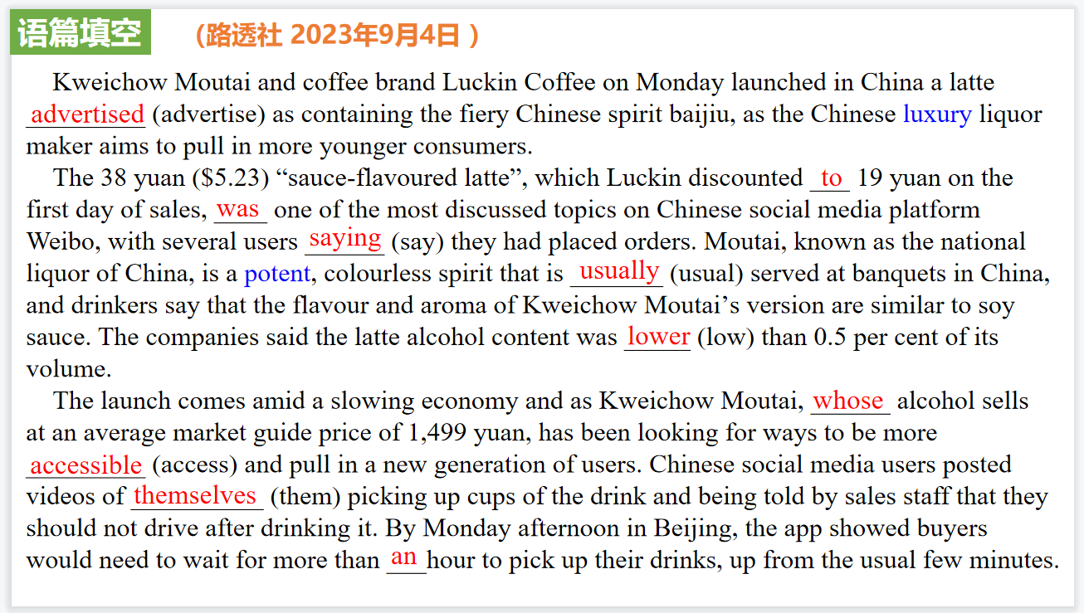

【设计意图】通过语篇填空的形式帮助学生理解新闻的主要内容，同时训练语言语法的运用能力：在语篇的视角下如何正确使用所给词汇，根据语法规则确定词汇的正确形式，使得文章通顺，激活学生的思维和语言。该新闻主题语境是关于“人与社会”中“社会热点问题”这一子主题，通过学习让学生了解茅台和瑞信合作的“酱香拿铁”走红的社会现象。

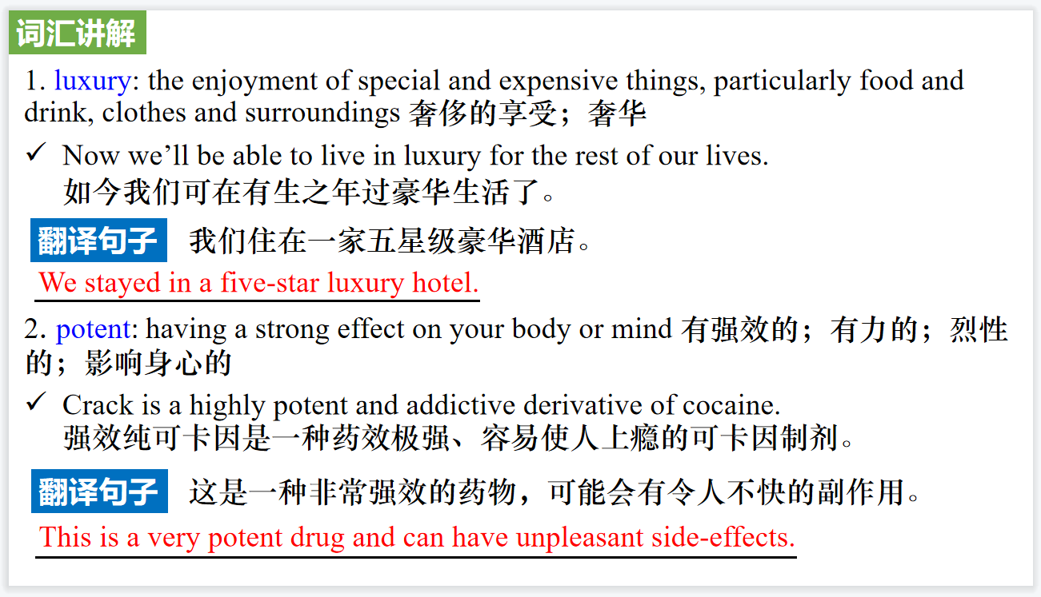

【设计意图】对文本中的词汇进行解读，并通过翻译句子对其进行巩固。

【设计意图】对文中的两个句子进行翻译练习，对其中单词、词组、句法进行巩固并关注句子结构。

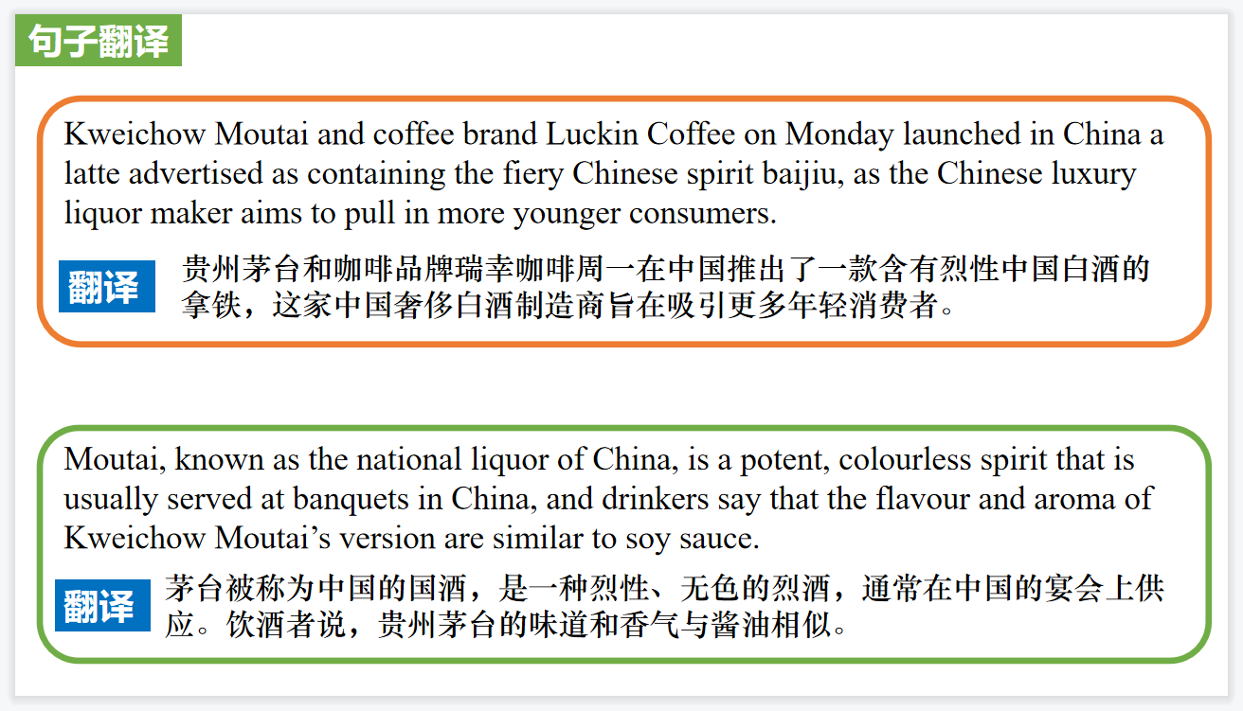

**Part 2: News Report 2《泰晤士报》 2023年9月7日 11页**

**Mantel's “final book” to showcase collection of writer's best essays**

**曼特尔的“最后一本书”展示了作家最好的散文集**

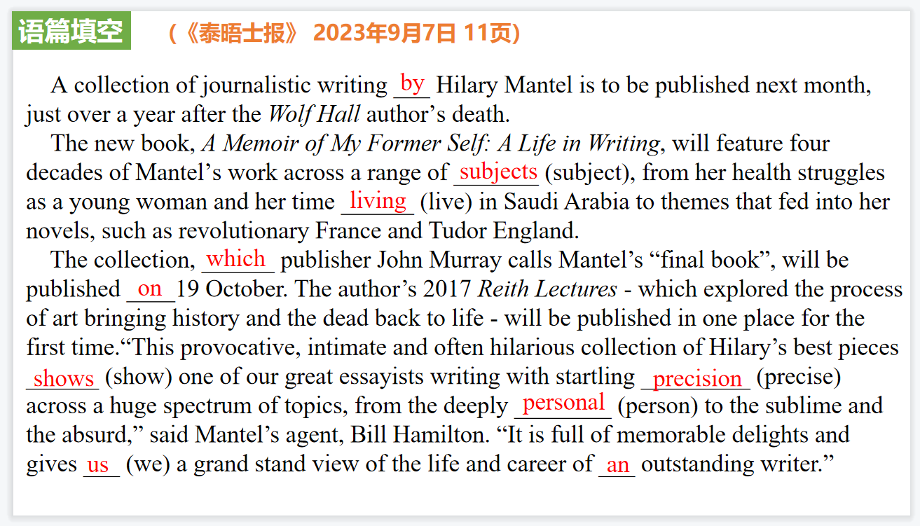

【设计意图】通过语篇填空的形式帮助学生理解新闻的主要内容，同时训练语言语法的运用能力：在语篇的视角下如何正确使用所给词汇，根据语法规则确定词汇的正确形式，使得文章通顺，激活学生的思维和语言。该新闻主题语境是关于“人与社会”中“社会热点问题”这一子主题，通过学习让学生了解作家曼特尔·希拉里新书出版的新闻消息。

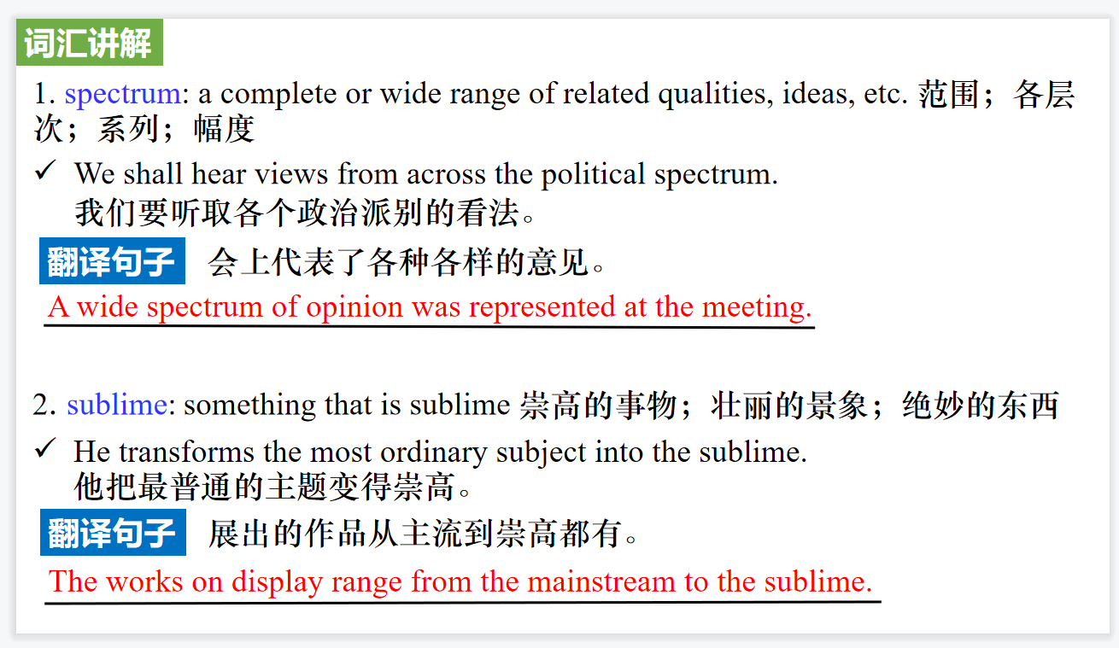

【设计意图】对文本中的词汇进行解读，并通过翻译句子对其进行巩固。

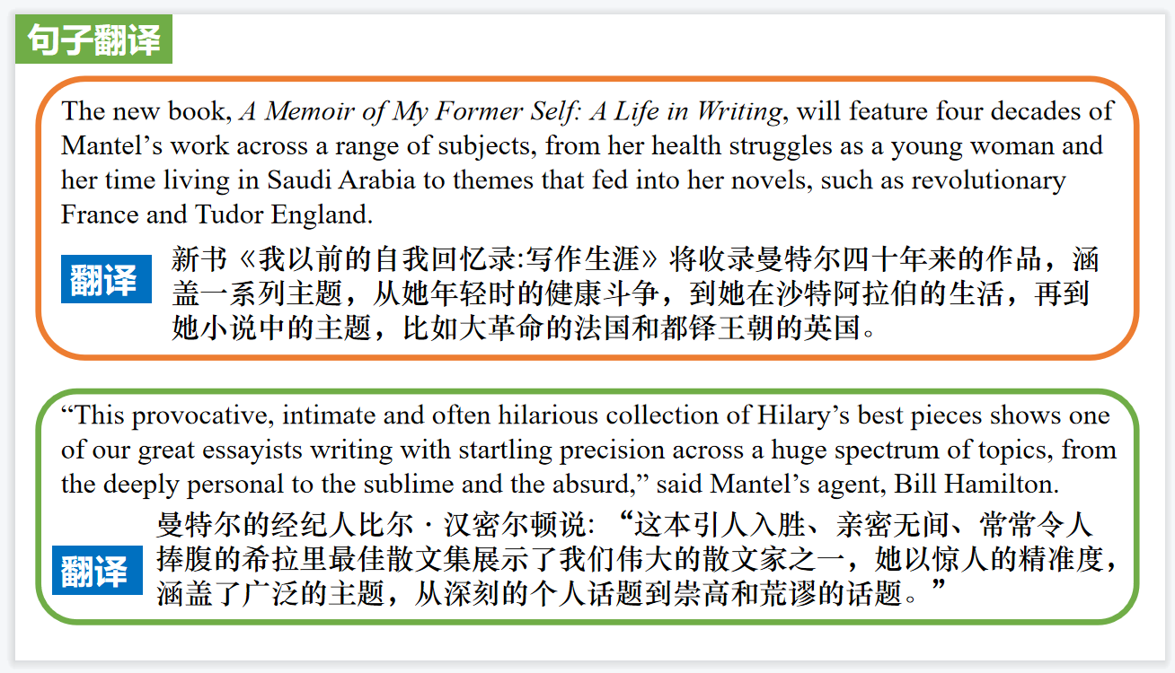

【设计意图】对文中的两个句子进行翻译练习，对其中单词、词组、句法进行巩固并关注句子结构。

**Part 3: News Report 3《泰晤士报》2023年9月2日39页**

**2,000 in queue for fjord fine dining 2000人排队为享用峡湾美食**

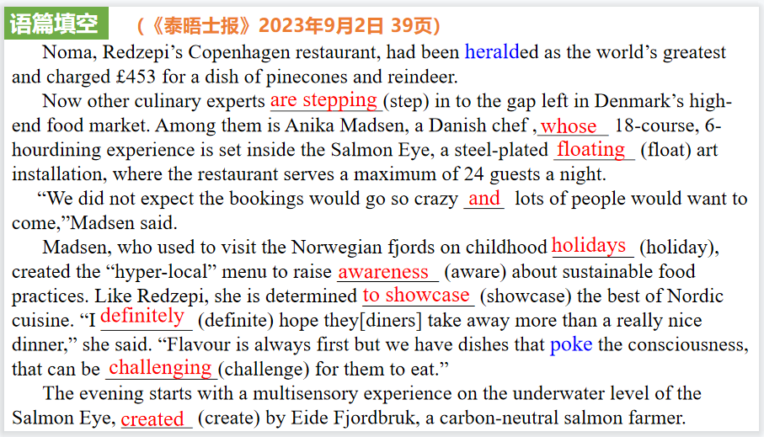

【设计意图】通过语篇填空的形式帮助学生理解新闻的主要内容，同时训练语言语法的运用能力：在语篇的视角下如何正确使用所给词汇，根据语法规则确定词汇的正确形式，使得文章通顺，激活学生的思维和语言。该新闻主题语境是关于“人与社会”中“社会热点问题”这一子主题，通过学习让学生了解关于在镀钢的漂浮艺术装置“鲑鱼眼”(Salmon Eye)内的用餐体验。

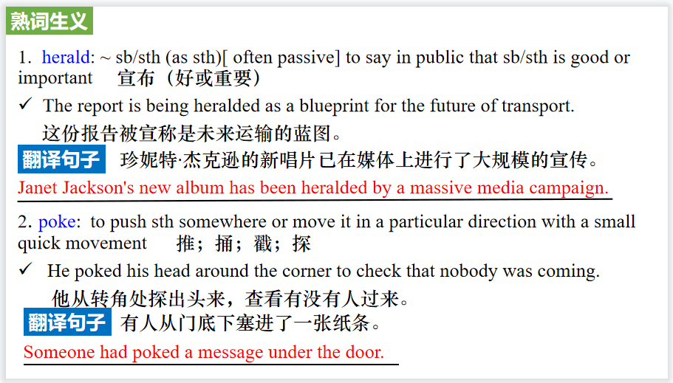

【设计意图】对文本中的词汇进行解读，并通过翻译句子对其进行巩固。

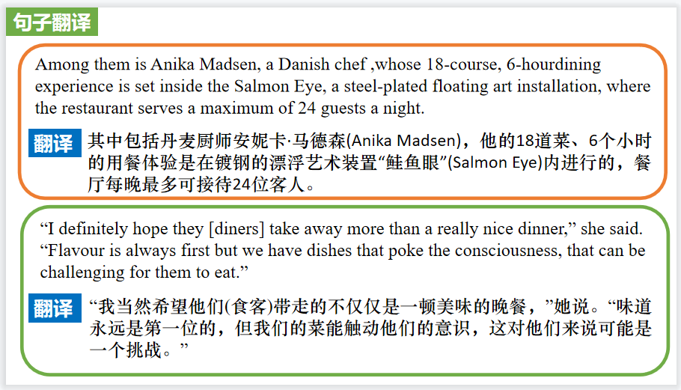

【设计意图】对文中的两个句子进行翻译练习，对其中单词、词组、句法进行巩固并关注句子结构。

**Part 4: News Report 4《国家地理》2023年9月刊BREAKTHROUGHS版面**

**Scans Under the Sea 蝠鲼水下超声孕检**

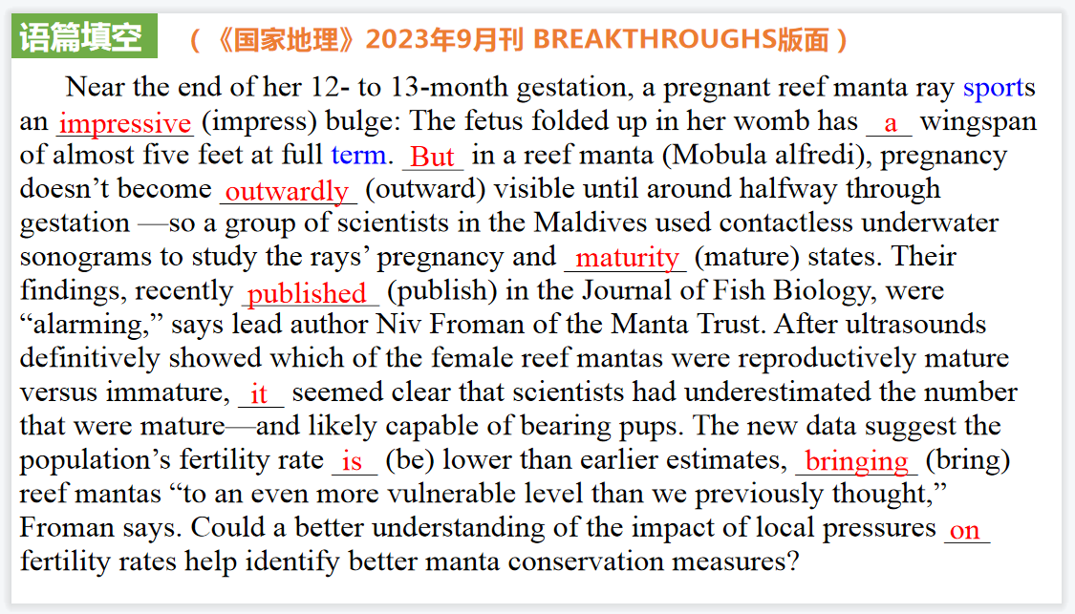

【设计意图】通过语篇填空的形式帮助学生理解新闻的主要内容，同时训练语言语法的运用能力：在语篇的视角下如何正确使用所给词汇，根据语法规则确定词汇的正确形式，使得文章通顺，激活学生的思维和语言。该新闻主题语境是关于“人与自然”中“自然科学研究成果”这一子主题，通过学习让学生了解关于蝠鲼水下超声孕检的新发现以及加强保护动物的意识。

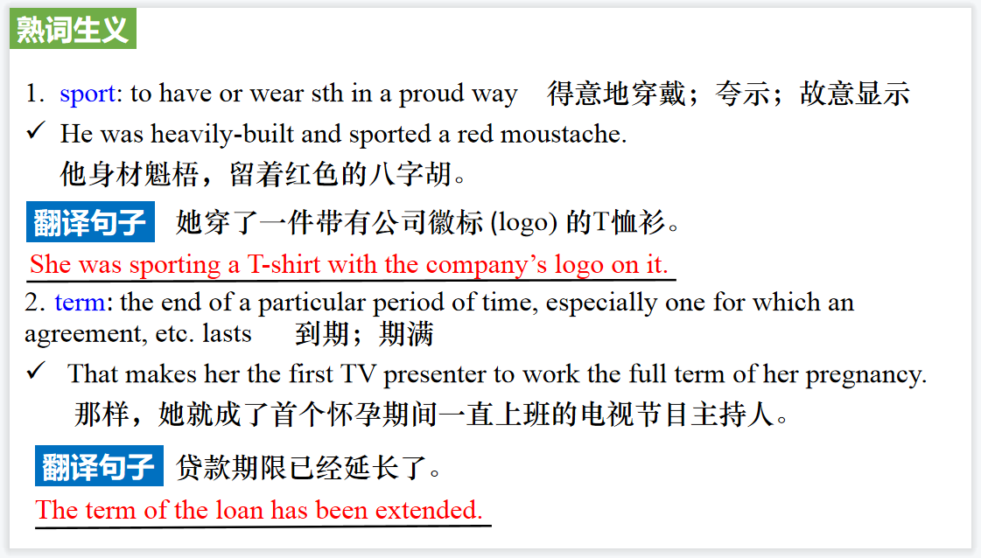

【设计意图】对文本中的词汇进行解读，并通过翻译句子对其进行巩固。

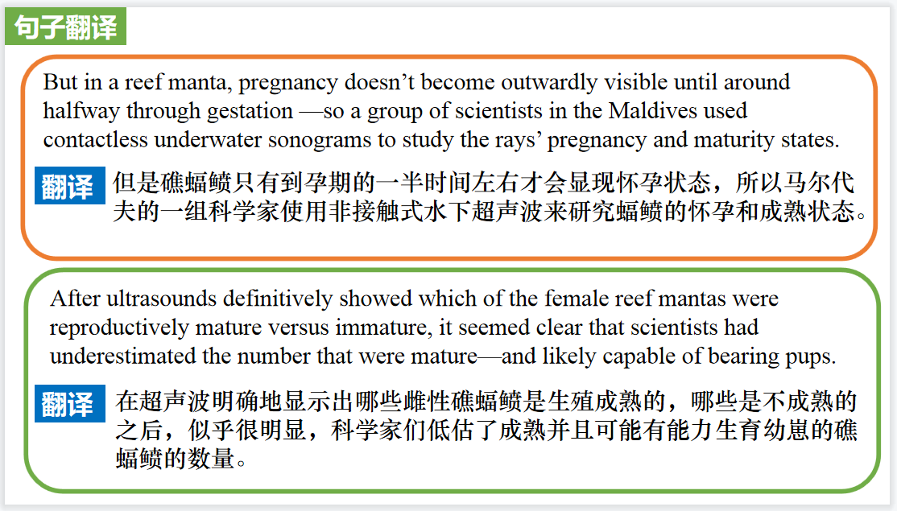

【设计意图】对文中的两个句子进行翻译练习，对其中单词、词组、句法进行巩固并关注句子结构。

**Part 5: BBC News 09/06/2023**

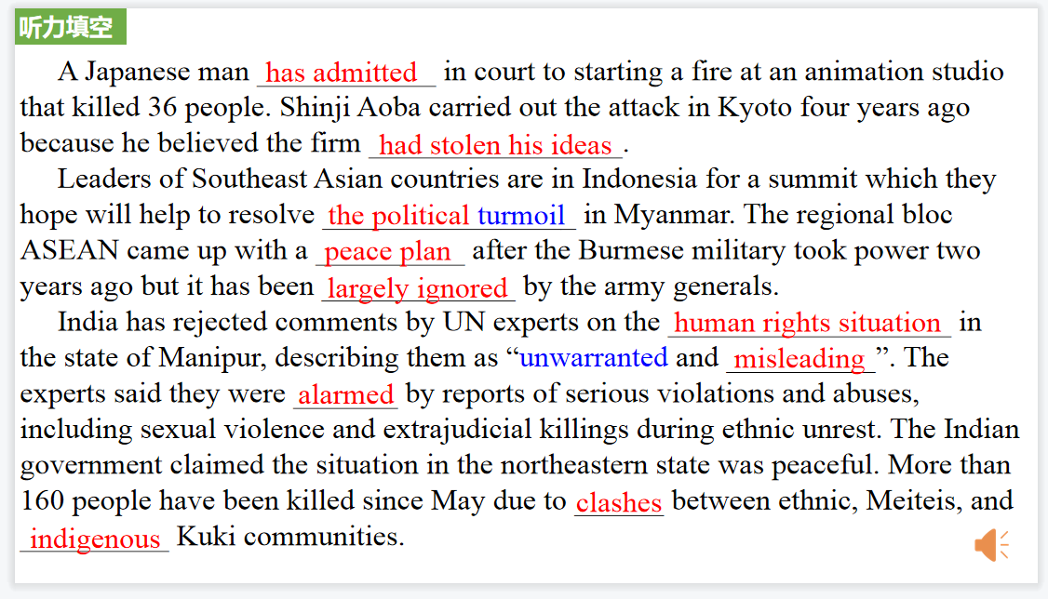

【设计意图】听一则材料，通过听力填空的方式理解文本，考察听力辨识词汇的能力。

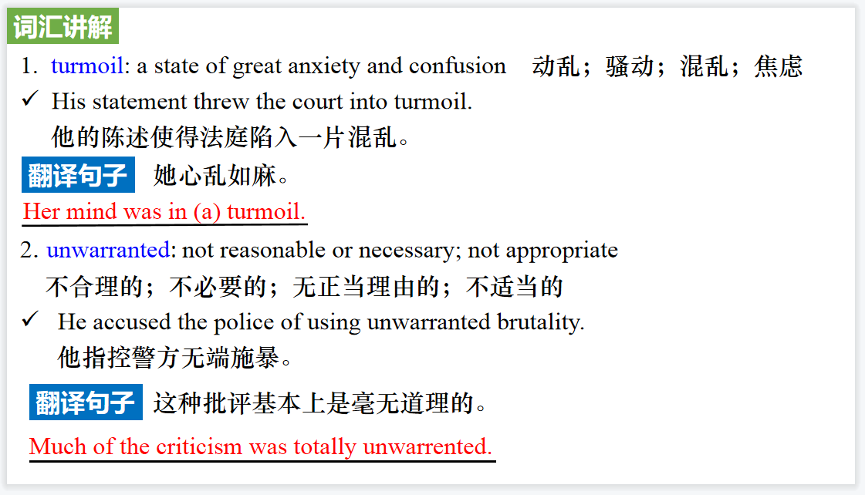

【设计意图】对文本中的词汇进行解读，并通过翻译句子对其进行巩固。

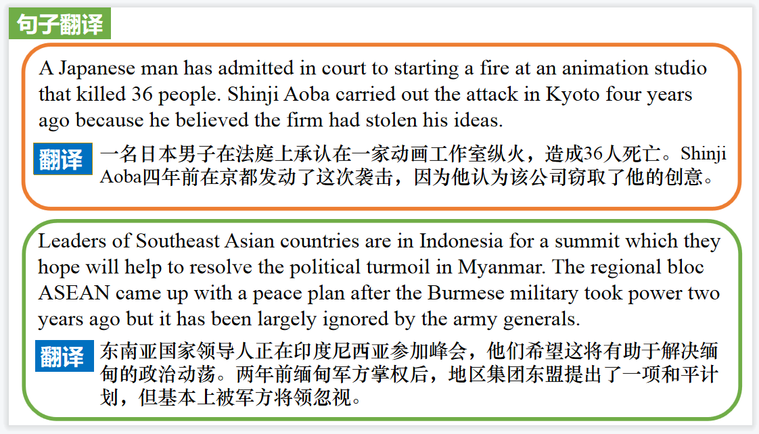

【设计意图】对文中的两个句子进行翻译练习，对其中单词、词组、句法进行巩固并关注句子结构。

附：外刊原文

**Part 1: News Report 1路透社 2023年9月4日**

**China’s Moutai, Luckin launch alcohol-tinged latte to woo young Chinese consumers“酱香拿铁”刷屏朋友圈**

Kweichow Moutai and coffee brand Luckin Coffee on Monday launched in China a latte advertised as containing the fiery Chinese spirit baijiu, as the Chinese luxury liquor maker aims to pull in more younger consumers.

The 38 yuan ($5.23) “sauce-flavoured latte”, which Luckin discounted to 19 yuan on the first day of sales, was one of the most discussed topics on Chinese social media platform Weibo, with several users saying they had placed orders.

Moutai, known as the national liquor of China, is a potent, colourless spirit that is usually served at banquets in China, and drinkers say that the flavour and aroma of Kweichow Moutai's version are similar to soy sauce. The companies said the latte alcohol content was lower than 0.5 per cent of its volume.

The launch comes amid a slowing economy and as Kweichow Moutai, whose alcohol sells at an average market guide price of 1,499 yuan, has been looking for ways to be more accessible and pull in a new generation of users. The company, based in China’s southwestern Guizhou province, also launched a baijiu-infused ice cream last year.

Chinese social media users posted videos of themselves picking up cups of the drink and being told by sales staff that they should not drive after drinking it. By Monday afternoon in Beijing, the app showed buyers would need to wait for more than an hour to pick up their drinks, up from the usual few minutes.

Independent food industry analyst Zhu Danpeng said the collaboration would most likely benefit both brands.

“Moutai and Luckin are the leading enterprises in the domestic liquor and coffee sectors, respectively,” Zhu said. “On the one hand, Moutai accelerates its brand rejuvenation through cooperation with Luckin and on the other hand, for Luckin, its cooperation with Moutai also helps to improve its comprehensive strength and brand tone in the coffee industry.”

Luckin has been aggressively expanding its store portfolio in China after surviving an accounting fraud scandal in 2020 that forced it to withdraw from the Nasdaq exchange and brought it to the brink of collapse.

**Part 2: News Report 2《泰晤士报》 2023年9月7日 11页**

**Mantel's “final book” to showcase collection of writer's best essays**

**曼特尔的“最后一本书”展示了作家最好的散文集**

A collection of journalistic writing by Hilary Mantel is to be published next month, just over a year after the *Wolf Hall* author’s death.

The new book, *A Memoir of My Former Self: A Life in Writing*, will feature four decades of Mantel’s work across a range of subjects, from her health struggles as a young woman and her time living in Saudi Arabia to themes that fed into her novels, such as revolutionary France and Tudor England.

The collection, which publisher John Murray calls Mantel’s “final book”, will be published on 19 October. The author’s 2017 *Reith Lectures* - which explored the process of art bringing history and the dead back to life - will be published in one place for the first time. “This provocative, intimate and often hilarious collection of Hilary’s best pieces shows one of our great essayists writing with startling precision across a huge spectrum of topics, from the deeply personal to the sublime and the absurd,” said Mantel’s agent, Bill Hamilton. “It is full of memorable delights and gives us a grandstand view of the life and career of an outstanding writer.”

Mantel wrote 17 books and is best known for her Thomas Cromwell trilogy-*Wolf Hall*, *Bring Up the Bodies* and *The Mirror & the Light* - the first two of which won the Booker prize. The series has sold more than 5m copies worldwide and has been translated into 41 languages. The celebrated author’s other works include *A Place of Greater Safety*, *Giving Up the Ghost* and *The Assassination of Margaret Thatcher*. She also wrote for various publications, including the *Guardian*, the *New York Review of Books* and the *London Review of Books*. Mantel died aged 70 on 22 September 2022 after a stroke.

The new collection is “constantly entertaining and illuminating”, said Nicholas Pearson, publisher at John Murray, adding that with the book a “complete pattern of her life and its many interests emerges in prose that is endlessly dazzling”.

Mantel was a film critic at the Spectator from 1987 to 1991, and the new book features as election of these reviews.

**Part 3: News Report 3《泰晤士报》2023年9月2日39页**

**2,000 in queue for fjord fine dining 2000人排队为享用峡湾美食**

2,000 in queue for fjord fine dining

Eight months ago the end of Nordic gastronomy was said to be nigh. René Redzepi, a Danish chef who espoused ultra-local weeds and shrubs, said he was hanging up his whites (Lara Wildenburg writes).

Noma, Redzepi’s Copenhagen restaurant, had been heralded as the world’s greatest and charged £453 for a dish of pinecones and reindeer.

Now other culinary experts are stepping in to the gap left in Denmark’s high-end food market.

Among them is Anika Madsen, a Danish chef who trained under Heston Blumenthal at Dinner By Heston in London. Her restaurant, Iris, opened in Hardanger fjord, western Norway, in June. The restaurant already has a waiting list of more than 2,000 people and is sold out this month despite prices starting at £237 a head.

Her 18-course, 6-hourdining experience is set inside the Salmon Eye, a steel-plated floating art installation, where the restaurant serves a maximum of 24 guests a night.

“We did not expect the bookings would go so crazy and lots of people would want to come,” Madsen said.

“Even on the waiting list they will always show up after two days’ notice. They are willing to travel far.”

Madsen, who used to visit the Norwegian fjords on childhood holidays, created the “hyper-local” menu to raise awareness about sustainable food practices. Like Redzepi,she is determined to showcase the best of Nordic cuisine.

“I definitely hope they[diners] take away more than a really nice dinner,” she said. “Flavour is always first but we have dishes that poke the consciousness, that can be challenging for them to eat.”

The evening starts with a multisensory experience on the underwater level of the Salmon Eye, created by Eide Fjordbruk, a carbon-neutral salmon farmer. A film about food waste questions why the ocean, which covers 70 per cent of the earth’s surface, accounts for less than 2 per cent of human food production.Guests are then served ingredients from the fjord, such as Norwegian sea urchin or a one-month-old salmon fried whole.

The dish “From sewer to hero” contains cleaning fish, which are used by fish farmers to clean parasitic lice off salmon. The 10cm fish, which can also be used to clean up petrol in the ocean, is infused in a fricassee with oysters and mushrooms.

The restaurant also aims to involve residents from Rosendal, a nearby village with a population of less than 1,000. Villagers ferry guests on electric boats to the restaurant and Madsen commissioned an elderly fisherman to make some steak knives from driftwood.

“We try to do what we can to put a lot of personality into the project because we know that seen from the outside this thing floating on the water can seem a little extreme to some,” she said. Ove Hellesland, the owner of the 21-room Rosendal Turisthotell, accommodates Iris’s diners.

He said: “I don’t think that they [the restaurant] themselves even know what they have started. Because I had a booking from California, from Texas, from London,from Copenhagen, from actually all over the world. What the hell is happening?”

**Part 4: News Report 4《国家地理》2023年9月刊BREAKTHROUGHS版面**

**Scans Under the Sea 蝠鲼水下超声孕检**

Near the end of her 12- to 13-month gestation, a pregnant reef manta ray sports an impressive bulge: The fetus folded up in her womb has a wingspan of almost five feet at full term. But in a reef manta (Mobula alfredi), pregnancy doesn’t become outwardly visible until around halfway through gestation —so a group of scientists in the Maldives used contactless underwater sonograms to study the rays’ pregnancy and maturity states. Their findings, recently published in the Journal of Fish Biology, were “alarming,” says lead author Niv Froman of the Manta Trust. After ultrasounds definitively showed which of the female reef mantas were reproductively mature versus immature, it seemed clear that scientists had underestimated the number that were mature—and likely capable of bearing pups. The new data suggest the population’s fertility rate is lower than earlier estimates, bringing reef mantas “to an even more vulnerable level than we previously thought,” Froman says. Could a better understanding of the impact of local pressures on fertility rates help identify better manta conservation measures?