Continuation Writing-the Coherence and Distribution of Plots  
between two paragraphs   
续写段落间的情节衔接与分布

-----By Lily

1. **学情分析**：

经过对这次大考中高三学生读后续写写作情况进行分析，我们会发现一些共性的问题。针对已给文章，学生能够基本理解文章大意，推测大概情节，但是在续写的两个段落的情节分布安排上，学生往往有很多问题。这些问题具体呈现在学生的写作中就会出现学生的某一段落内容远远多于其中一个段落，或者每一个段落都寥寥几笔对于主要事件的概括，细节全无，或者一二两段的故事发生的时空混乱；更有甚者，续写第一段就将所有情节写完，完全没有考虑到与第二段的衔接，以致于第二段的内容空洞或者重复。这些问题都反映出来，学生不能很好地去安排两个段落的续写情节，两端间的情节上的衔接意识较弱，同时对于故事的时空变化把握能力弱，细节推测和情节安排的方法欠缺。基于此，此次课堂的教学目标如下：

1. **Teaching Aims:**
2. Ss can learn how to infer the possible plots and distribute the plots into two paragraphs properly by figuring out the changes of time and space.
3. Ss can outline the plots by drawing the plots-distributing form.
4. Ss can have the awareness of making the coherence of the plots between two paragraphs.
5. **Teaching Procedures:**

**Step1: Free Talk （CW）**

To ask ss the three questions.

(Aims: To know their habits and arouse their awareness of making outline before writing.)

**Step2: Review and Comb the plots of the given reading part by asking questions based on the title.**

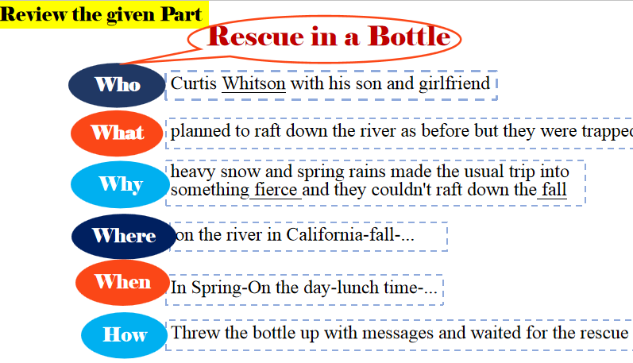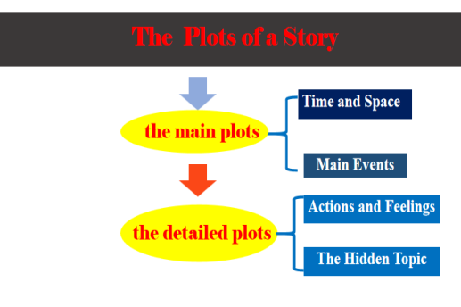

**(Aims: To comb the plots of a story and guide learners to infer the possible plots of continuation part based on these aspects.)**

**Step3: Infer the Plots （CW）**

1. To analyze the last para and beginning sentences; To Infer the main plots: time and space+main events
2. Based on the main plots inferred above, to infer the detailed plots: actions and feelings
3. Finish the plots-distributing form:

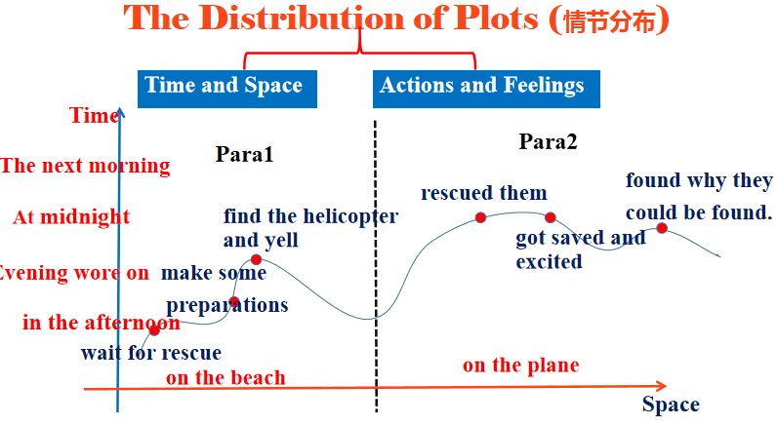

(Aims: Ss can know how to infer and outline the plots. )

**Step4: One more example.（IW&PW&CW）**

**Think-Pair Work-Share:**

利用2016.10月续写真题，让学生根据情节推测与分布发方法，分析推测布局这篇续写的情节。

**Step5：Homework:**

**One more practice.**

2018.06 高考读后续写真题

