Basic Teaching Information
Teaching material |  | New Senior English for China Book 1  Unit 5 Language around the world Write a blog about English study
Author |  | Lin Ling
 | Teaching Background Analysis
【Analysis of Teaching Material】
The topic of this unit is "languages around the world”, which belongs to human and society. It briefly introduces several languages around the world (Listening and Speaking), the Chinese writing system
(Reading and Thinking), different kinds of English (Listening and Talking), as well as problems and advice on English study (Reading for Writing).
This is the fourth part of for this unit -- reading for writing, which comes after listening and speaking, reading and thinking as well as listening and talking. The reading material is a short blog which talks about the biggest problems and advice on learning English. The part is for the teacher to get students to write about the biggest problems they have on studying English and to put up with some advice. After reading the material, students can perceive the organization and language expressions on writing a blog about English study problems and solutions. In the writing part, the material shows some expressions on stating the biggest problems and advice about English study. In addition, the material lists the checklist. Students can revise their writing according to the checklist.
【Analysis on learners】
The students for this lesson are in Senior Two. They have a good foundation in English. Before this
lesson, they’ve already learned how to skim and scan for the main and specific information in reading material. In addition, they have known the importance of learning foreign languages and some expressions of language learning. However, they do not have enough knowledge on how to clearly state their biggest problems and their reasonable advice when writing a blog about English study.
【Teaching key and difficult points】
Key points: (1) Enable students to know the online forum and the tone of a blog;
- To get students know the structure of the blog and master some useful expressions on
stating their biggest problems and giving their advice;
- Enable students to reflect on their English study, summarize their biggest problems
on English study and put up with the advice together;
Difficult points：(1) To get students know how to clearly state their biggest problems and their reasonable advice when writing a blog about English study.
【Teaching methods】
1.Situational language teaching
2.Task-based Language Teaching
3.Cooperative learning
【Teaching aids】 Multimedia, Pictures, Tables.

Teaching Objectives
By the end of this lesson, students should:
Language competence：
- be able to apply the useful expressions to write a blog about English study, for instance, “I'm having a lot of trouble with ...”, “My biggest headache is ...”, “...helps me...”, “You might try...”;
- know the online forum and the tone of a blog;
- extract useful information from the blog;
- understand the organization of the blog;
- be aware of the organization of a logical blog;
- be able to know the way to explain their problems clearly and to give advice properly;
Learning abilities：
- be able to understand how to learn writing from reading material;
2. know how to use skimming and scanning skills for the organization, the specific information as well as the expressions;
3. 3. learn with peers and use online forums as a learning resource;
Thinking quality：
- know how to state their problems and give advice in a logical way;
- figure out ways of solving English learning problems;
Cultural disposition：
- understand the importance of cooperation,
- promote their awareness on the benefits of internet and the importance to use it properly,
- cultivate a positive attitude towards learning languages.

Teaching Procedures
Stage 1 : Lead-in
Steps | Students’ activities | Teacher’s activities | Purposes |  | Time
Step 1  Lead-in | - Students think about their biggest problems on English learning;  - Figure out who they often ask for help with their English learning problems. | - Lead students to figure out their biggest problems in English study.  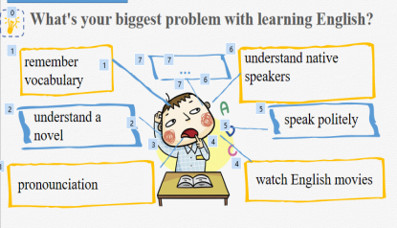  - Lead students to think on the person they often ask for help and point out that they can ask e-friends for help.  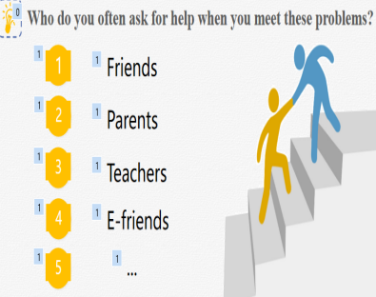 | - Activate students’ thinking of English learning problems;  - Help students use their problem solving abilities and critical thinking abilities. |  | 4’
Stage 2 : Reading and discovering
Steps | Students’ activities | Teacher’s activities | Purposes |  | Time
Step 3  Reading and discovering | - Read the posts and answer two questions related to the blog.  Q1: What is an online forum?  Q2：What is the tone of the blog? | - Lead them to know what an online forum is.  - Lead them to know the language in blog is casual. | - Let students to use skimming to perceive the tone of a blog ;  - Improve their thinking quality. |  | 2’
Step 4  Organization of the blog | - Read again and then answer the question.  Q: What does each of the students write about?  - Finish ex.1 on textbook. | - Get students to focus on the structure of the blog;  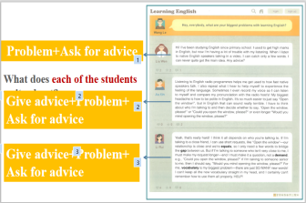  - Get students to get the specific information on problems and advice. In the meantime, get them to know how to express their own problems and advice clearly.  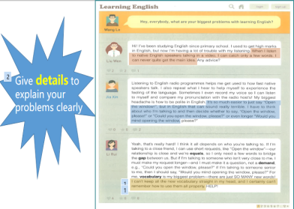 | - Get students to focus on the organization of the blog;  - Get students to know how to express their own problems and advice clearly. |  | 9’
Step 5  Language features | - Underline expressions used to state problems and give advice.  - Figure out more expressions on stating problems and giving advice.  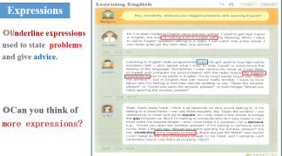 | - Help students concentrate on the expressions;  - Write the expressions on stating problems and giving advice that students put up with. | - Get students to know expressions on stating problems and giving advice.  - Get students to recall the expressions they have already learned. |  | 4’
Stage 3: Discussing and Writing
Step 6  Making a writing outline | - Students work in groups of 4 to list their biggest problems and ask their partners to brainstorm some advice to fill the blank.  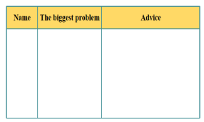 | - Guide students to find out their biggest problems and ask for possible solutions to deal with the problems. | - Activate students’ cooperative abilities;  - Improve their problem solving abilities.  - Stimulate students to share their problems.  - Know the importance of helping each other. |  | 4’
Step 7  Writing | - Students write Write a blog about English study with the help of the use the mind map, the expressions and the chart. | - Ask students to write a logical blog on their biggest problems and the advice given by their partners. | - Lower students anxiety in writing;  - Improve their autonomous learning abilities. |  | 10’
Step 8  Peer editing | - Concentrate on the checklist to feedback on their draft. | - Give them a checklist.  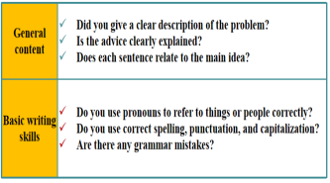 | - Activate students’ cooperative abilities;  - Improve their thinking quality. |  | 5’
Summary
- Useful expressions on stating problems and giving advice to write a blog;  - Organization of the blog.  - The internet connects us. We should use the internet properly. |  |  |  |  | 1’
Homework
- Revise your blogs again and hand them in.  - Post your blog to give KienelUnni some advice on learning Chinese.  Links:  https://m.weibo.cn/7502277407/4564303975286681 |  | 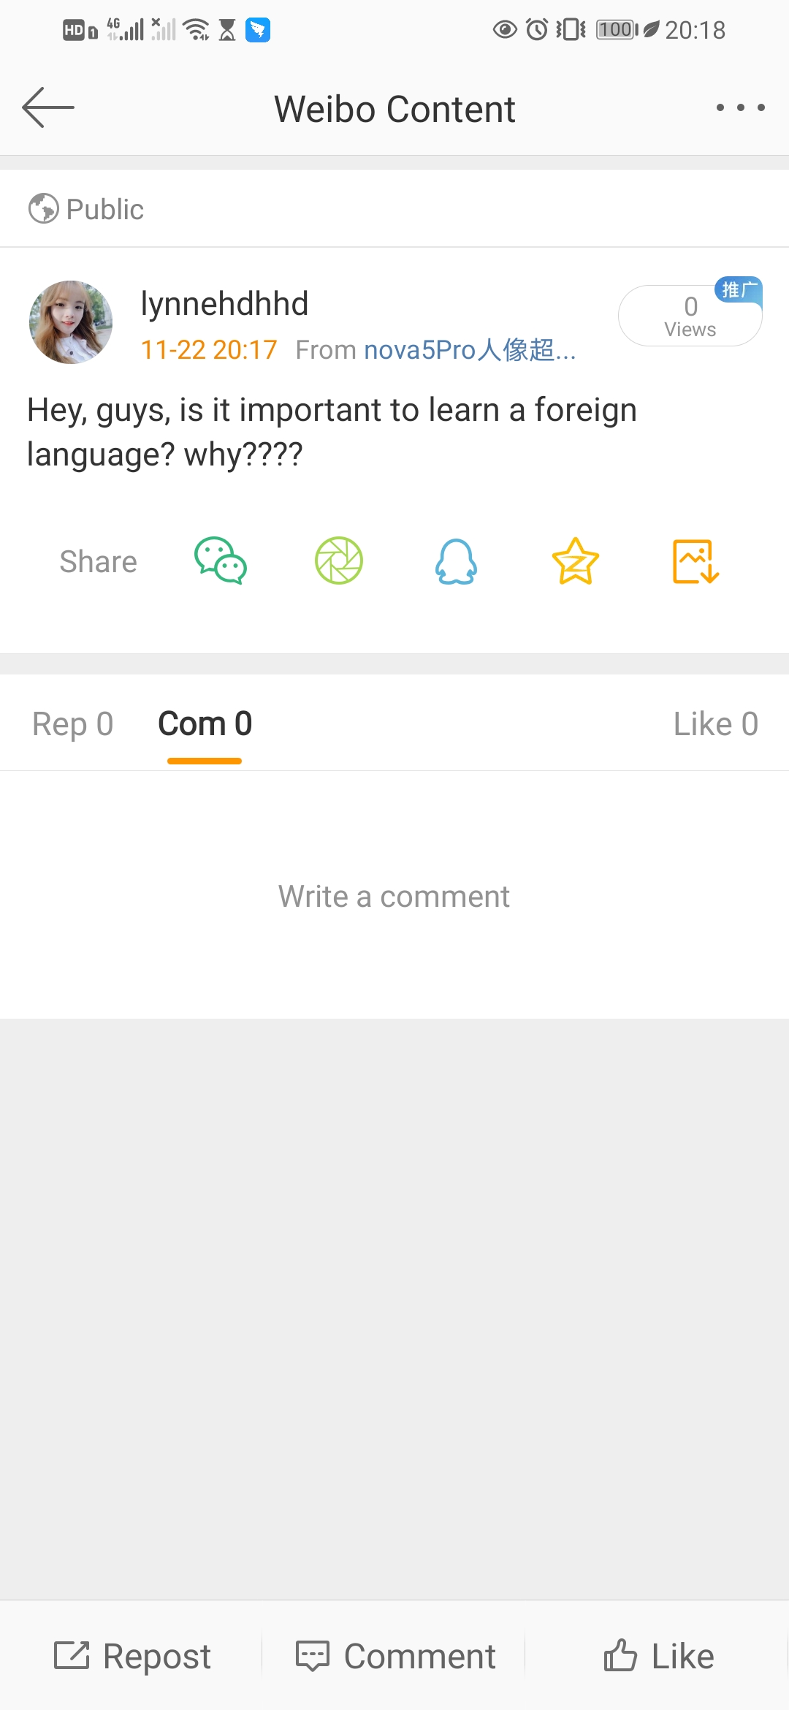  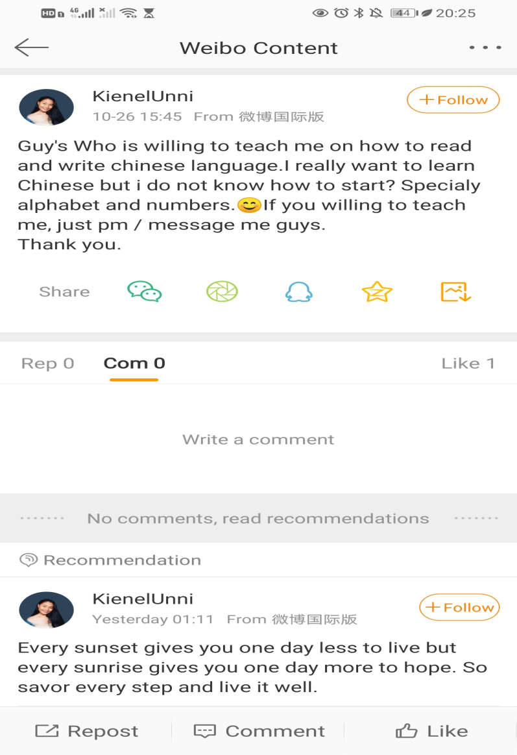 |  | 1’
Blackboard Design
