Micro skill in writing -inanimate subjects

教师介绍：谢艳萍 中学一级英语教师 曾获东莞市优课二等奖，校级公开课一等奖，所教学生中，多名学生被北大等名校录取，2021届首届新高考中有7名学生英语140+

Teaching aims:

By the end of the class, students will

1.know what inanimate subject is

2.have a knowledge of four different types of inanimate subjects

3.apply inanimate subject to writing properly.

Teaching procedure

Step 1: Lead-in

A sentence from a clip of Cinderella to lead today’s topic-inanimate subject: The shoes fit Cinderella’s feet perfectly.

Ask the students to notice the subject of this sentence.

Step 2:Inform the students of the standard of good writings, one of which is linguistic description, and then lead to today’s topic: one of the skills-inanimate subject.

Give the students the definition of inanimate subject and find out inanimate subjects from two writing versions of Gaokao.

Step 3:Comprehension: four types of inanimate subjects

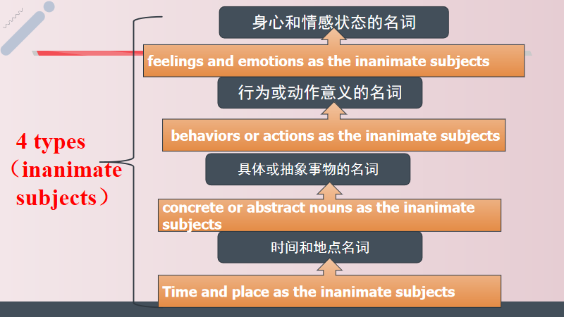

Use different examples to know the four patterns better

Step 4:Application: matching: fill in the blanks with proper verbs

Polishing: polish ordinary writings with inanimate subject sentences.

Give students some simple writings from previous tests and ask then to polish them with the structures they learned just now.

Translation: translate some sentences from previous tests with such patterns

1.当医生给Mike检查的时候，他变得越来越紧张。（金考卷）

2.很快，房间里充满着他们的欢声笑语，他们开心地一起玩耍就像多年的好朋友一样。（惠州联考）

3.首先，通过这个活动你不仅可以拓宽眼界，而且还可以更深入了解中国文化。（九月月考）

Step5.summary

Step 6 Exercise

Enjoy a clip of a video of Peter the rabbit and then predict what would happen next using such patterns to consolidate what we learned.