Unit 2 Healthy lifestyle
Discover useful structures to-infinitive as the subject（不定式做主语）教学设计
Teaching procedures：
Step1 Lead in
What are the functions of the colored parts in the sentences?
- To change bad habits is never easy.
- It took extra time to do the job properly.
- To join the People’s Liberation Army, it is required for men to shave off their beards.
- It was not polite to disturb your neighbors with loud music last night.
The Infinitives are the subjects of the sentences!
Find more infinitives in the reading passage.
- To prevent harmful habits like these from dominating a teenager’s life is essential.
- It can be easy for some of them to form bad habits.
- It is not easy to break bad habits.
Step 2 Exploring the rules
Below is a blog entry about eating out and eating at home. Find the sentences that use to-infinitives as subjects and fill in the table below.
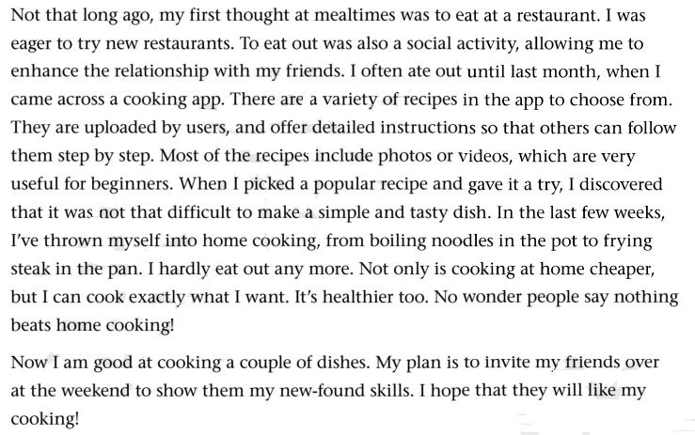
To-infinitives as subjects | To eat out was also a social activity, ...
To-infinitives as subjects | ..., it was not that difficult to make a simple and tasty dish.
When the to-infinitive is used as a subject, we usually use the preparatory subject it at the beginning of the sentence.
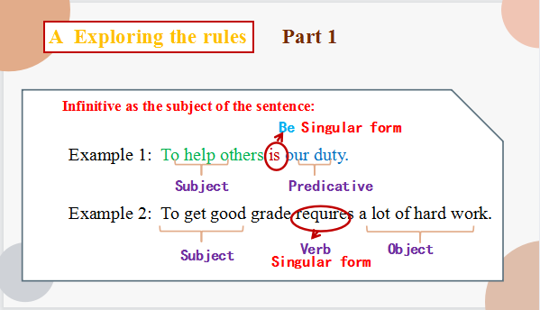

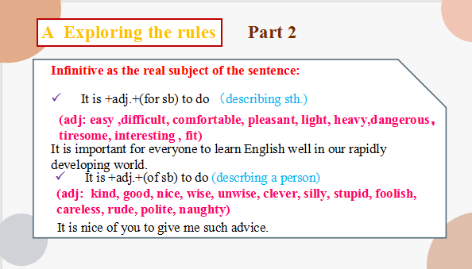
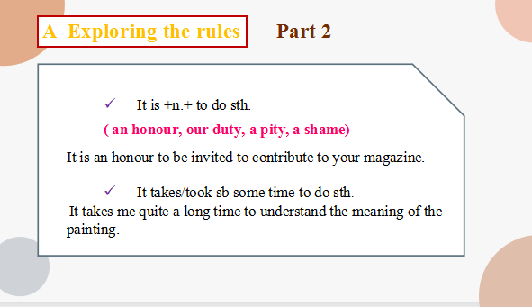

Practice1
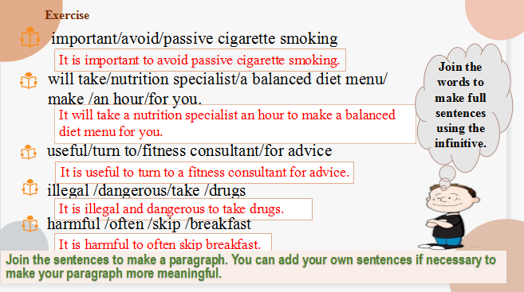
Example：
To keep healthy and get rid of bad habits, sometimes it is also a good idea to get professional help. A nutrition specialist will take an hour to make a balanced diet menu for you. It is also useful to turn to a fitness consultant for advice.
You can also help yourself with some common sense. For example, it is harmful to skip breakfast too often. It is important to avoid passive cigarette smoking. And, of course, it is dangerous to take illegal drugs too.
Practice2
Complete the conversations with the correct forms of the phrases in the box.
begin with, be in control of, make a choice, decide on, make up one’s mind

1 A: Hello, doctor. I want to lose weight, but I just can’t seem to do it. What can you do to help me?
B: Well, first, it’s necessary to _____________what you eat. Cut out all fatty food and sugary drinks, and eat more fruit and vegetables.
2. A:I really need to _________ a way to exercise more. I could use a fitness app, but my phone’s full.
B: So delete a few files. I’m sure the app doesn’t take up much space.
3. A: Before exercising, always do a few warm-ups to___________.
B: I know. But then I always feel too tired to continue!
4. A:Should I go for the pizza or the fried chicken? I hate ________________ like these. You know what - I’m going to eat both!
B:Wow! Don’t eat too much junk food - you’ll get fat. I’ve actually _________________ to go on a diet, so I’ll just stick to the fruit salad.
Step 3 Applying the rules
Complete the article with the correct forms of the verbs in the brackets.
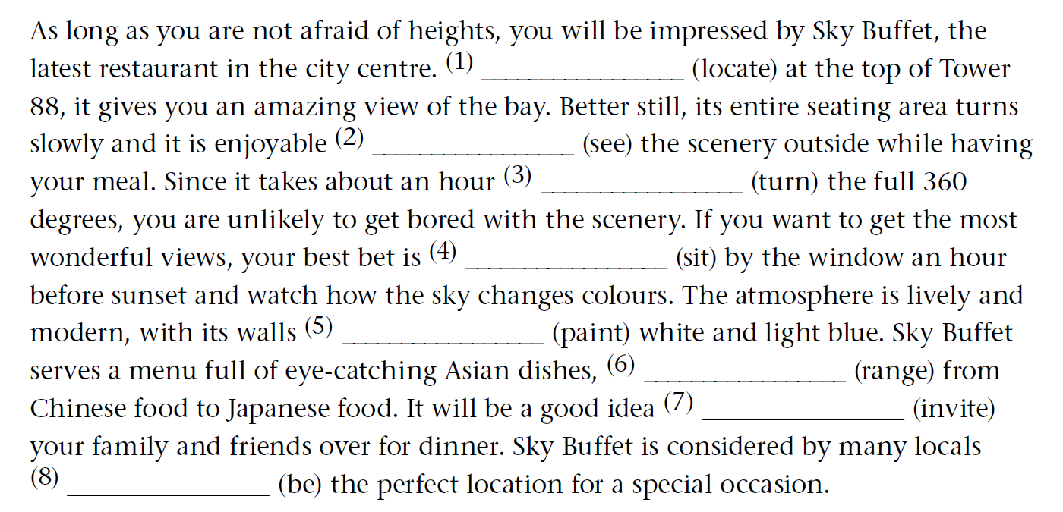
Imagine your friend has taken you out to dinner at Sky Buffet. Write a thank-you note to your friend, offering to return the favour by inviting him or her to your home for dinner next weekend.Remember to use to-infinitives. Use the expressions below to help you.

Sample answer
I am writing to … I have always wanted to …
It was so kind of you to … I would like/love to …
It was wonderful to … My plan is to …

Dear Tom,
I am writing to thank you for taking me to Sky Buffet. It was so kind of you to invite me and book a table by the window. It was wonderful to see the city scenery and watch the beautiful sunset. I have always wanted to give Sky Buffet a try, and it certainly lived up to my expectations! Do you have any arrangements next weekend? My plan is to invite you over to my home for dinner next Saturday. The view won’t be as good as at Sky Buffet but I would like to cook you something special to thank you.
Yours,
Mary

