**Problem-Solution 模式下之读后续写**

**——以临沂高二下学期期中读后续写为例**

**临沂外国语学校 朱希芳**

1. **Problem-Solution模式**

Problem-Solution模式是英语中极为常见的语篇模式，经常用于说明文、广告、科技文章、实验报告、新闻报道以及故事、小说等文学作品中。

这一模式由Michael Hoey在On the Surface of Discourse（1983）提出。此类型篇章有4 个功能性部分组成：情景(situation)、问题(problem)、对这一问题的反应或解决办法(response/solution)、以及由此而引发的评价(evaluation)或结果(result)。

1. **Problem-Solution模式在读后续写中的应用**

读后续写常选用记叙文作为阅读材料，其话题有趣且生活化，语篇结构的连贯性更强。记叙文的故事情节更容易呈现出矛盾和冲突，因此problem-solution模式非常适用于读后续写。

首先，从problem-solution的视角来看待读后续写题型，有利于发展学生的语言能力，培养学生的思维品质和问题解决能力；其次，制定解决问题有效途径之一是探析原文文本已有线索和可用线索，其次是基于续写段落首句设置有逻辑关联的问题链。通过一系列相关的认知过程，如理解问题、分析问题、解决问题、反思评价问题等，最终创造性地解决阅读材料中所呈现出的问题和矛盾。problem-solution模式为老师们提供了一种新的剖析读后续写题型的方法，值得我们去尝试使用。

1. 结合高考读后续写特点，本节课将以Situation-Problem-Solution-Result为主要依据，分析读后续写的写作。
2. **案例分析（高二下学期期中考试读后续写）**

阅读下面材料，根据其内容和所给段落开头语续写两段，使构成一篇完整的短文。

With no air conditioners and no trees providing shade, the classrooms that faced south at my children’s middle school got too hot during the warmer months of the school year. I knew from my days volunteering in the school that students and staff got overheated and that it was difficult for them to concentrate.

As a long-time master gardener, I knew trees could shade those classroom windows and reduce the temperatures inside to relatively comfortable levels. If benches and trees were added, the front yard would be transformed into a beautiful outdoor classroom, one that would encourage teachers to bring their students outside to learn. And I imagined how wonderful it would be for our district’s kids, many of whom live in apartment buildings without yards or green space, to experience the happiness of sitting on a bench under a leafy green tree during their school day.

Then, I met with the school’s Parent-Teacher Association and told my idea of changing the school’s front yard. And I expressed my willingness to organize the project. The group liked the idea but thought it was too difficult. However, several days later, the principal told me, “I had further discussions with my staff. We all think you are very kind. We want to work with you to transform our school’s front yard.”

Later, I found a professional landscape designer who promised to design our front yard free of charge. After that, I found a local company that promised to deliver topsoil (表土) at a deeply discounted price when we were ready to transform our front yard. Then I contacted a charity which promised to provide us with various shade trees for free that would grow well in our area. And it would send a professional crew to help us plant the trees.

Then, we named our future front yard “The Habitat for Living &Learning”. At this point, we spoke with everyone we knew about the Habitat for Living &Learning. The hard work of spreading topsoil, digging and planting was scheduled to begin within weeks.

注意：

1. 续写词数应为150左右；2. 请按如下格式作答。

Para. 1: So we posted the tasks in the school’s front hall where everyone could see them.

__________________________________________________________________________________________________________________________________________

Para. 2: Soon, everyone — students, staff and volunteers — began working to spread the topsoil.

__________________________________________________________________________________________________________________________________________

1. **Situation分析**

主题语境：人与社会、善行义举——通过合作努力解决实际问题。

本文以时间为线索展开，讲述了作者在自己孩子的学校做志愿者的时候，留心到学校前院缺乏树木和遮荫，造成学生和工作人员在炎热的天气里难以集中注意力。作者想到树木可以帮助降低室内温度，向家长教师协会提议将前院改造成一个美丽的户外教室，给学生们提供更舒适的学习环境。虽然这个想法实施起来比较困难，但校长最终同意进行前院的改造。作者找到专业的景观设计师、当地公司和慈善机构，为改造计划做好了前期的筹备工作，铺设表土、挖掘和种植的工作将在几周内开始。

**快速找出时间、地点，确定故事发生的背景。找出文章中出现的主要人物，划出关键动词，确定故事情节，找出文章中的形容词，确定故事人物情感。**

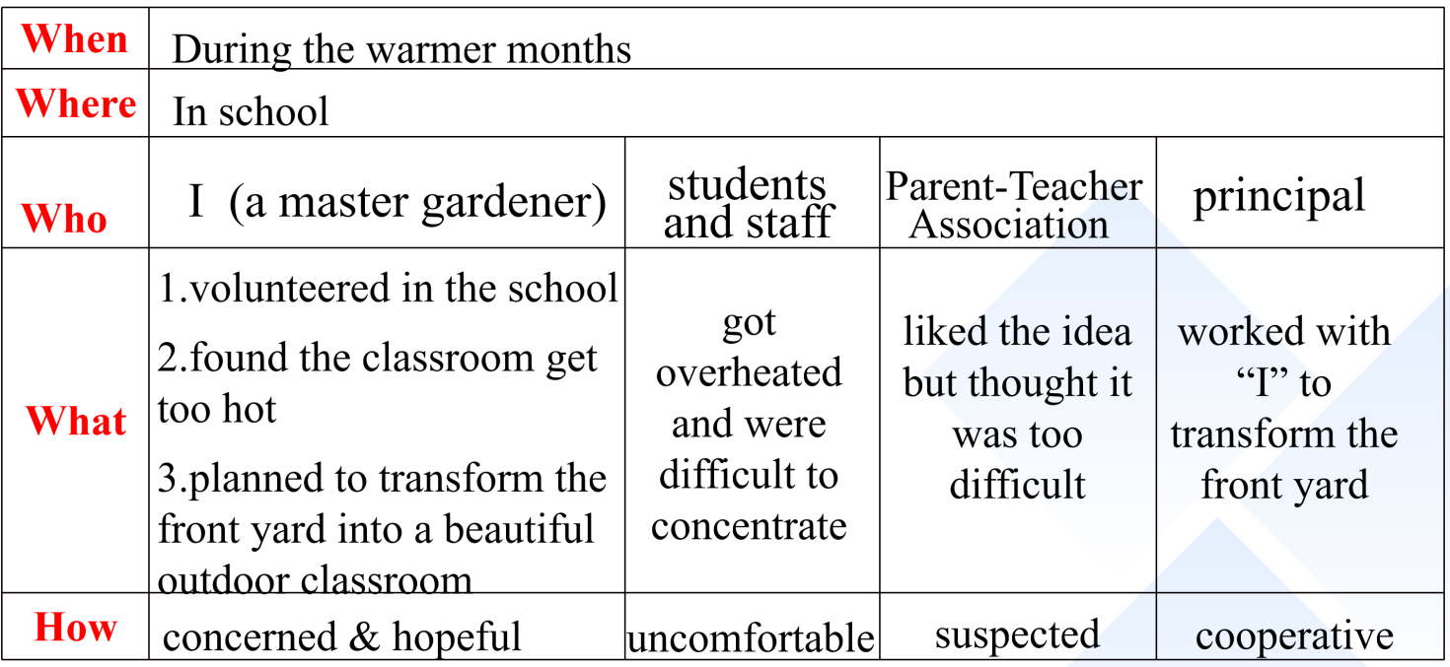

1. **初探Problem-Solution-Result**

**依据第一步的情景分析，以what 和how两条线作为切入点，梳理原文，初步探索problem以及与之对应的solution。**

**Problem 1-Solution 1-Result 1**

Problem 1: The classrooms facing south got too hot with no air conditioners and no trees providing shade. Students and staff got overheated and it was difficult for them to concentrate.

Solution 1: Plant trees to shade classroom windows and reduce the temperatures inside, while adding benches to transform the front yard into an outdoor classroom where students can have classes.

Result 1:（未知）

**Problem 2-Solution 2-Result 2**

Problem 2: While the idea is good, it seems difficult and impractical to implement.

Solution 2: (未知)

Result 2:（未知）

1. **Clues--Echoes对应**

**我们可以根据出现的名词、动词和形容词先锁定clue，然后依据续写积极乐观的原则再给出恰当的echo。（以线索一为例）**

**线索法不仅可以帮助我们找到隐藏的solution和result，而且可以使续写更加条理化和逻辑化，更能贴合原文写作风格，紧扣设定的情境和主题。**

|  |  |  |
| --- | --- | --- |
|  | **Clue** | **Echo** |
| **1** | ...no **trees** providing shade, the classrooms got **too hot** ...students and staff **got overheated** ... it was **difficult** for them to **concentrate**.  ...trees could **shade** those classroom windows and **reduce** the temperatures inside to relatively **comfortable** levels. | Leafy green **trees** **shade** formerly **hot** classrooms, where it’s so **cool** and **comfortable** and teachers and students can better **concentrate** on their teaching and learning. |
| **2** | If benches and trees were added, the front yard would be transformed into a outdoor classroom...encourage teachers to bring their students outside to learn. ...district’s kids, ... experience the happiness of sitting on a bench under a leafy green tree during their school day. | Different classes are regularly held outside in the yard where benches and trees are availabe in the shade. District’s kids are now bathing in the nature full of happiness. |
| **3** | Then, I met with the school’s Parent-Teacher Association and told my idea of changing the school’s front yard. And I expressed my willingness to organize the project. The group liked the idea but thought it was too difficult. | The Parent-Teacher Association helped publicize this event so that more people could know about it, which inspired many volunteers to offer help and donations. |
| **4** | However, several days later, the principal told me, “I had further discussions with my staff. We all think you are very kind. We want to work with you to transform our school’s front yard.” | We were called on (by the principle) to unify and work together for the common goal. |
| **5** | ...landscape designer who promised to design our front yard... a local company that promised to deliver topsoil...a charity which promised to provide us with various shade trees for free that would grow well in our area. And it would send a professional crew to help us plant the trees. | 1. The design draft was finished and sent to us, which was just as expected. 2. We contacted the local company and the next day huge trucks filled with topsoil arrived at the school. 3. The shade trees arrived as scheduled. 4. Under the guidance of the professional crew, we excitedly planted the trees, picturing how wonderful this place would be. |
| **6** | Then, we named our future front yard  “The Habitat for Living & Learning”. At this point, we spoke with everyone we knew about the Habitat for Living & Learning. The hard work of spreading topsoil, digging and planting was scheduled to begin within weeks. | 1. Now just as expected, The Habitat for Living & Learning has become a paradise for us. 2. The principle led all of us, including students, staff, parents and voluteers, to line up to welcome the truck, cheering and waving excitedly. 3. Having finished spreading topsoil, we began to dig and plant trees. |

1. **三处衔接**

*Para. 1: So we posted the tasks in the school’s front hall where everyone could see them.*

**衔接①续写第一句与段一所给首句的衔接**

**合情理，合逻辑。可以从不同主语作为衔接点，从动作或者情感作为切入点。关键词 N. V.或 Adj. （下面从不同角度分析，给出四个可供选择的衔接句）。**



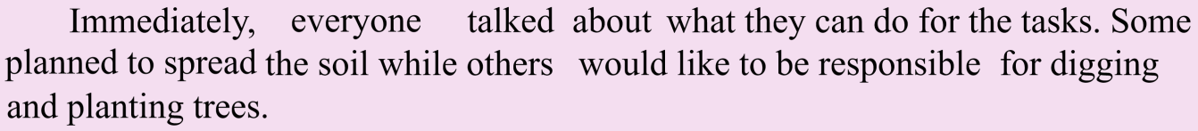





**衔接②第一段结尾与段二所给首句的衔接**

**同衔接①。此外，尽量出现段二所给首句里面的原词或者同义词。（此处仅给一个例子）**



Para. 2: Soon, everyone — students, staff and volunteers — began working to spread the topsoil.

**衔接③第二段续写与第二段所给首句的衔接**

**同衔接①。**

Para. 2: Soon, everyone — students, staff and volunteers — began working to spread the topsoil.



1. **Problem-Solution-Result锁定**

**Problem1-Solution1-Result1**

Problem 1: The classrooms facing south got too hot with no air conditioners and no trees providing shade. Students and staff got overheated and it was difficult for them to concentrate.

Solution 1: Plant trees to shade classroom windows and reduce the temperatures inside, while adding benches to transform the front yard into an outdoor classroom where students can have classes.

Result 1:（首尾呼应）

(Echo1)Leafy green trees shade formerly hot classrooms, where it’s so cool and comfortable that teachers and students can better concentrate on their teaching and learning. (Echo2)Different classes are regularly held outside in the yard where benches are availabe in the shade. District’s kids are now bathing in the nature full of happiness.

**Problem2-Solution2-Result2**

Problem 2: While the idea is good, it seems difficult and impractical to implement.

Solution 2: Unify and call on everyone to work together for the common goal.

Result 2: All of the hard work and sacrifice paid off, we finally made it.

1. **首尾呼应，升华主题**

If a problem seems too difficult for a single person, it won’t for a group of people. It was this unique experience that made me understand whatever difficulty we are faced with, we can overcome it with our joint effort and cooperation.

1. **生成范文**

*Para. 1: So we posted the tasks in the school’s front hall where everyone could see them*. **(衔接1)**Everyone talked about what they could do for the tasks. Some decided to spread the soil while others would like to be responsible for digging and planting trees. **(Echo3)**Besides, the Parent-Teacher Association helped publicize this event so that more people could know about it, while offering lots of help and donations, which inspired many volunteers in the community.**(Echo5)**Soon the design draft, just as expected, was finished and sent to us. Immediately, we contacted the local company and the next day huge trucks filled with topsoil arrived at the school.**(Echo6)**The principle led all of us, including students, staff, parents and voluteers, to line up to welcome the truck, cheering and waving excitedly.**(衔接2)(echo4)** After unloading the topsoil, we were called on to unify and work together for the common goal.(**Solution 2)**

*Para. 2: Soon, everyone — students, staff and volunteers — began working to spread the topsoil.* **(衔接3)**We spares no effort to do the job. Tired as we are, we feel a sense of accomplishment and happiness. **(Echo5.6)**Having finished spreading topsoil, the shade trees as well as professional crew arrived as scheduled. We began to dig and plant trees under the guidance of the professional crew, full of joy, picturing how wonderful this place would be.**（Result1）(Echo1)**Now leafy green trees shade formerly hot classrooms, where it’s so cool and comfortable and teachers and students can better concentrate on their teaching and learning. **(Echo 2.6)** Just as expected, *The Habitat for Living & Learning* has become a paradise for us. Not only are different classes regularly held outside in the yard where benches are availabe in the shade, but also district’s kids are bathing in the nature full of happiness everyday.**（Result2）**All of the hard work and sacrifice paid off, we finally made it.**(升华主题)**If a problem seems too difficult for a single person, it won’t for a group of people.It was this unique experience that made me understand whatever difficulty we are faced with, we can overcome it with our joint effort and cooperation.

1. **精益求精**

*Para. 1: So we posted the tasks in the school’s front hall where everyone could see them*.

**(衔接1)**Everyone talked about what they could do for the tasks. **(Echo 3)**Besides, the parents helped publicize this event, which inspired many volunteers to offer help and donations. **(Echo 5)**The next day huge trucks filled with topsoil arrived at the school. **(Echo 6)**The principle, students, staff, parents and voluteers, all lined up to welcome the truck, cheering and waving excitedly. **(衔接2) (Echo 4)** (**Solution 2)**

Topsoil unloaded, we were called on to unify and work together for the common goal.

*Para. 2: Soon, everyone — students, staff and volunteers — began working to spread the topsoil*. **(衔接3)** Tired as we are, we feel a sense of accomplishment and happiness. **(Echo 6)**Hving finished that, we began to dig and plant trees. **(Echo 1)** (**Result 1)**Now leafy green trees shade formerly hot classrooms where it’s so cool and comfortable that teachers and students can better concentrate.(**Result 2)** With hard work paying off, we finally made it. **(升华主题)** It was this unique experience that made me understand whatever difficulty we are faced with, we can overcome it with joint effort and cooperation.

1. **总结**

