Workbook读写课教学设计
台州中学 叶婷婷
- 课时目标
- 通过略读、扫读梳理全文的篇章结构，树立文本篇章结构意识。
- 通过寻读获取野生动物保护话题词汇以及集体讨论复现单元话题词汇， 为写作提供语言素材。
- 通过自主探究、思考熟悉信件的框架、内容以及语言的得体表达，完成信件写作。
- 设计思路
本节课为workbook的Reading and writing读写课，阅读的目的是启发写作。在阅读环节，首先通过一个野生动物的短视频导入本节课话题和主题。进入文本后，让学生根据文章标题猜测文本内容，梳理篇章结构。然后，通过让学生根据时间顺序寻找信息获取话题词汇，接着教师通过问题链引导学生归纳出表达现状、原因、措施以及成果的话题词块。最后，通过提问思考并归纳麋鹿保护获得成功的因素，为写作中的措施要点提供启发。
写作环节主要分为三个步骤。第一部，写之前引导学生构建信件的写作框架，熟悉功能性句型以及语言的得体性。接着，呈现阅读中归纳的话题词汇，学生回忆补充单元话题词汇，并将这些词汇恰当地运用到句子写作中，最后完成信件的写作。
- 教学过程
Activity 1: Activate background information about wildlife protection
本活动为实现课时目标1作铺垫
Talk about the video: show some pictures of endangered wildlife.
Q1: What did you see in the video?
Q2: What situations are they in?
Q3: Is there any species that have been successfully rescued?
【设计意图】借助形象的图片导入主题，激活学生已知信息。
Activity 2: Read for the structure
本活动旨在落实课时目标1
Q1: Which are the key words in the title?
Q2: What strange things about the milu deer mentioned the passage?
【设计意图】通过引导关注标题关键词来了解基本内容，通过引导关注过渡句帮助梳理篇章结构。
Activity 3: Read for information and language
本活动旨在落实课时目标2
Q1：In what order do we usually describe the history？
Q2：What happened to the milu deer in each time?
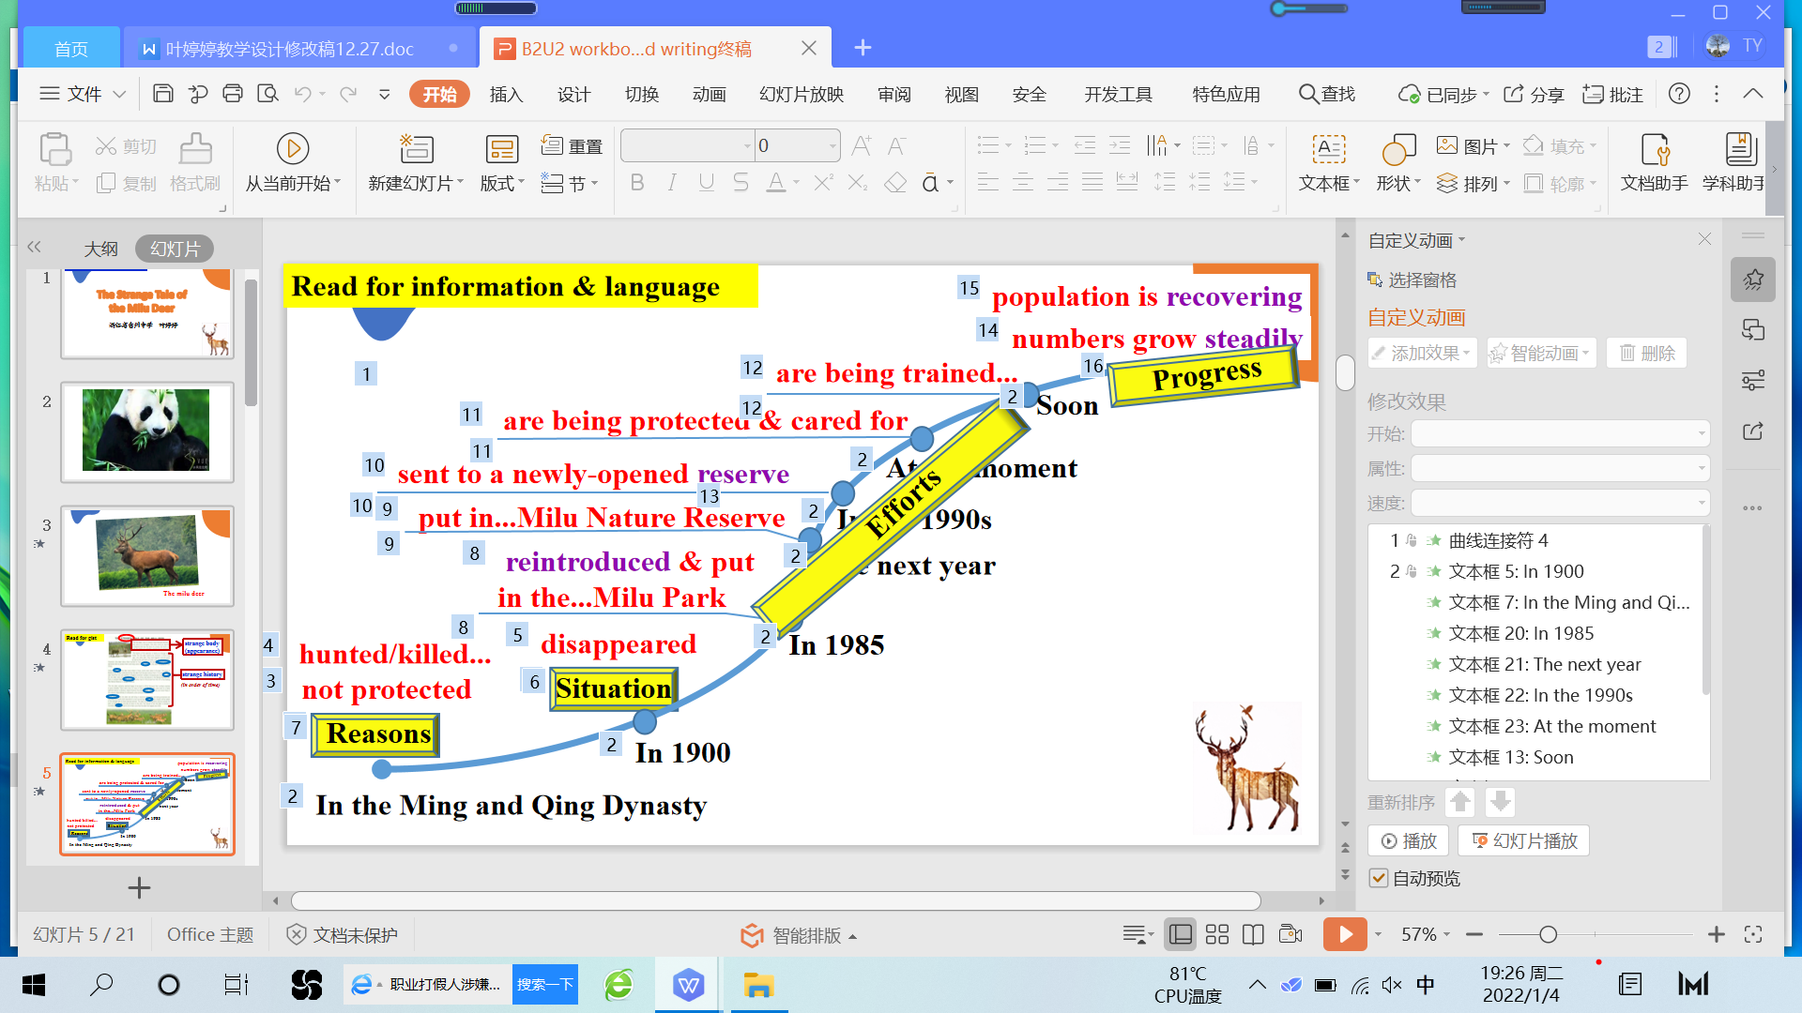
【设计意图】通过关注时间顺序，利用问题链解读文本内容，提取并整合话题词汇。
Activity 4: Further explore the reasons for the success of the milu deer
本活动旨在落实课时目标2
Q: What could be learned from the success story of the milu deer f we want to protect wildlife? (Who contributed to the success story? How did they make it?)
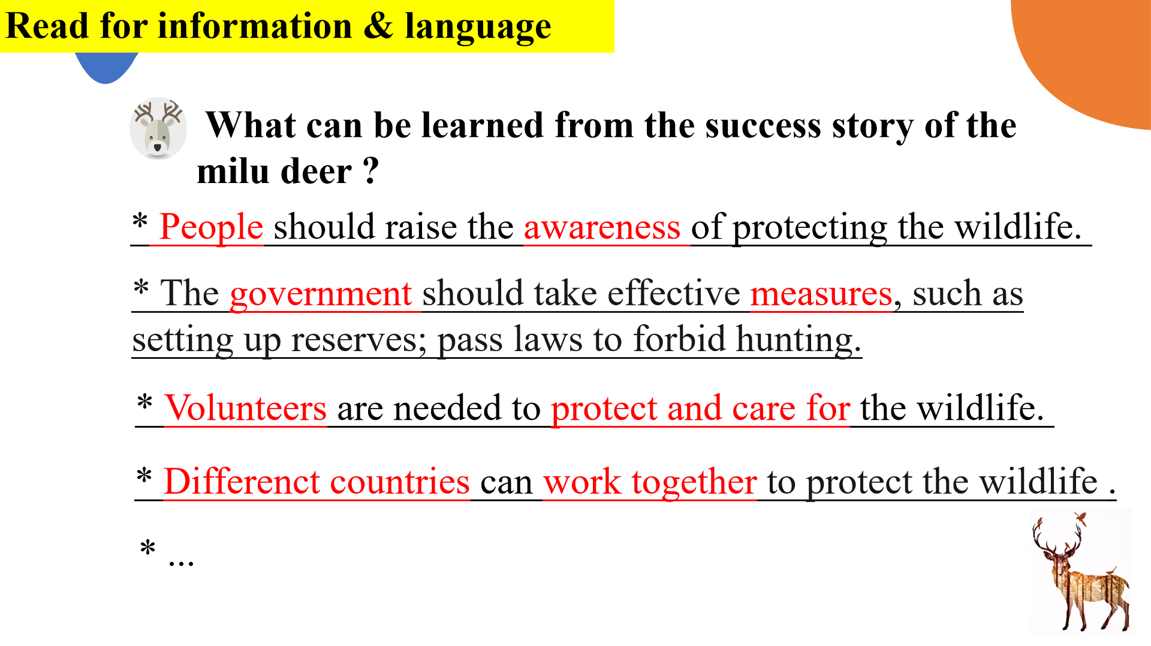
【设计意图】通过提取文本已知信息，引导学生归纳并思考麋鹿保护成功的因素，为写作铺垫语言素材。
Activity 5: Make out the outline of a letter
本活动旨在为落实课时目标3作铺垫
T：Before writing, we should make the outline of the letter
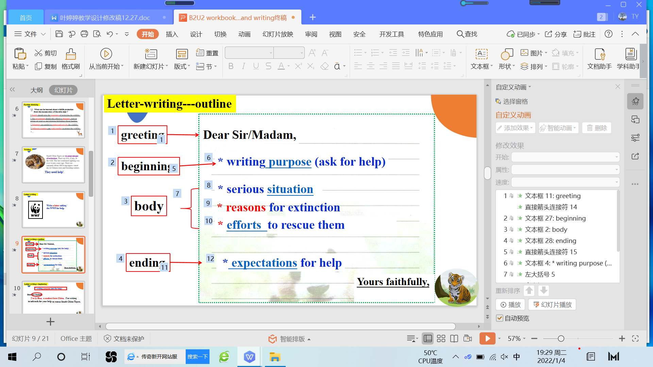
【设计意图】通过讨论信件的提纲，帮助建立文本框架
Activity 6: Review the topic-related language
本活动旨在为落实课时目标3作铺垫
T：In this unit, we have learned a lot more about wildlife protection, can you add some to the table?
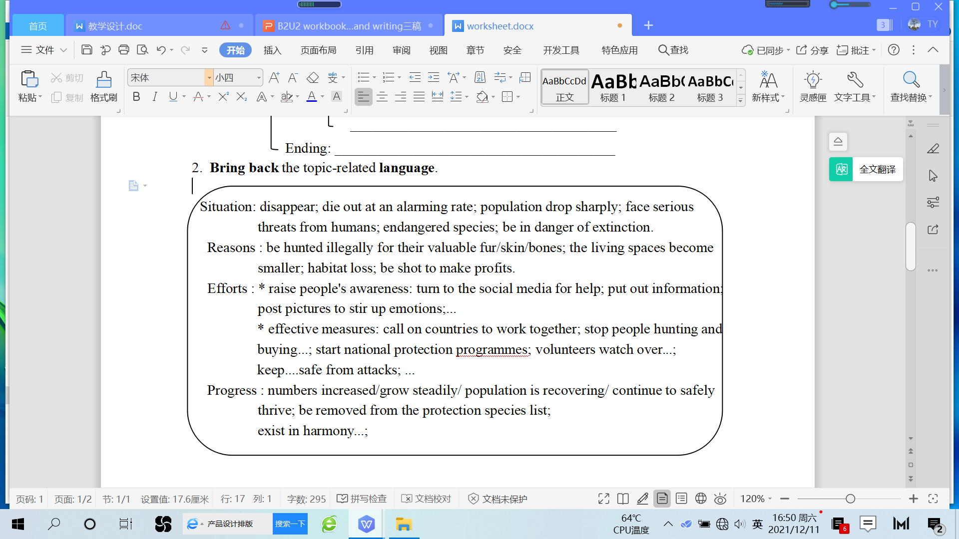
Activity 7: Use the topic-related language
本活动旨在落实课时目标3
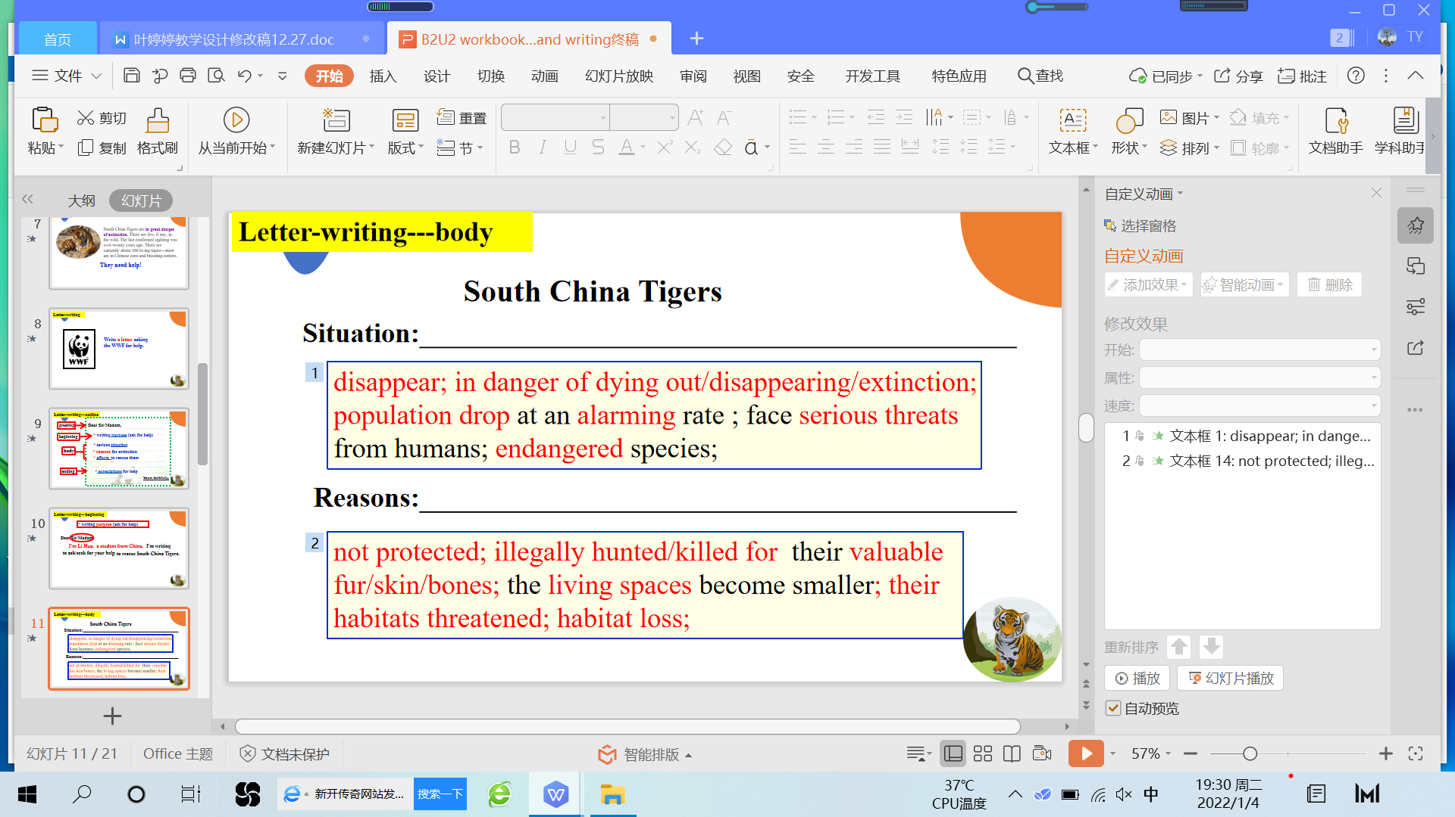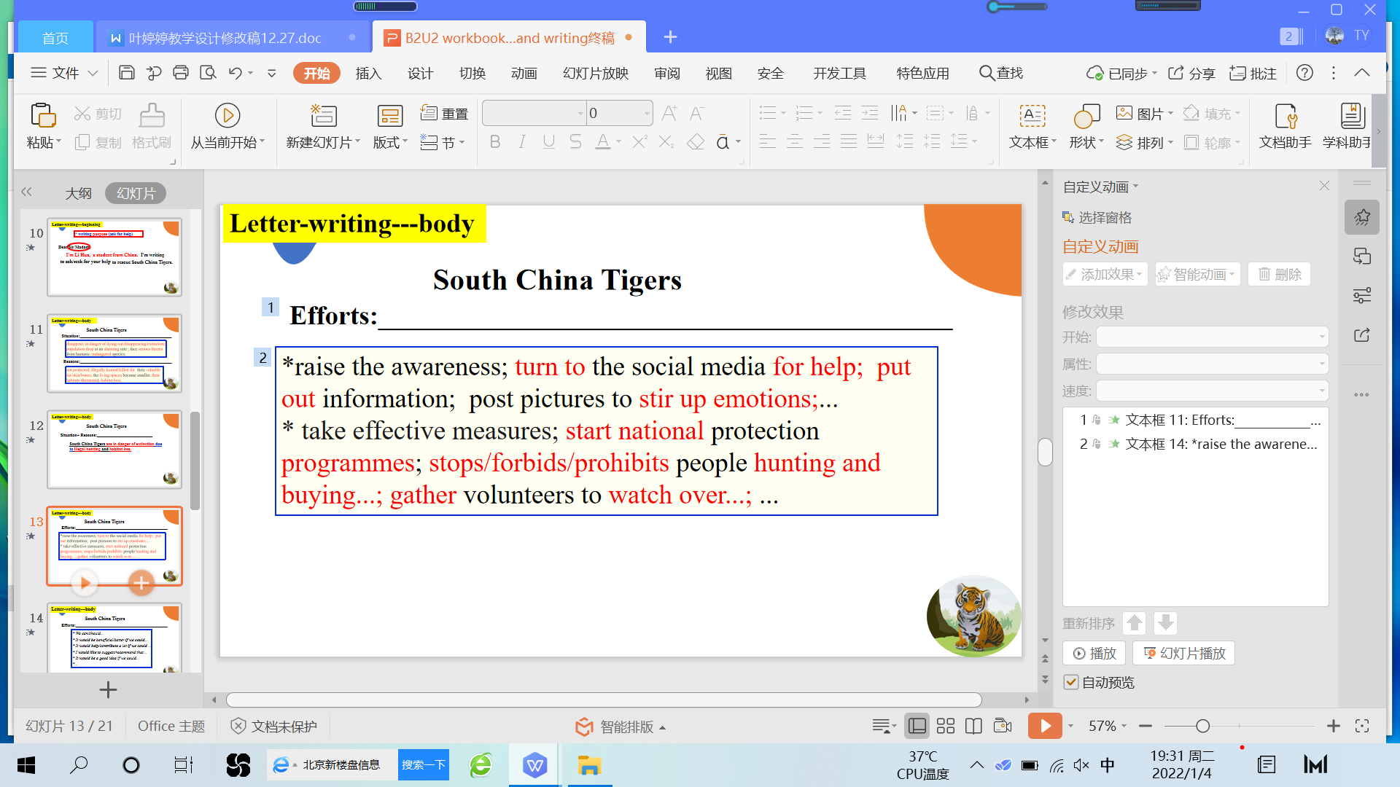
Activity 8: Write a letter to the WWF
本活动旨在落实课时目标3
Students are asked to finish the letter in the worksheet.
Assignment:
- Review the topic-related language we've learned.
- Complete and polish your writing in pairs.

