**1.《国家地理》2023年10月刊 EXPLORE版面**

1）阅读理解

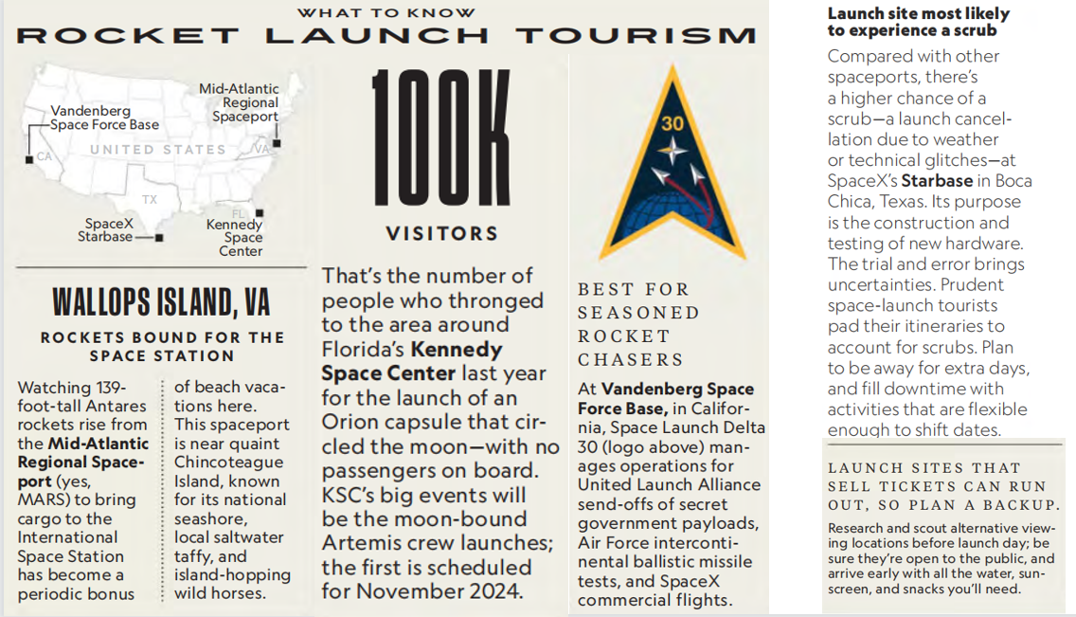

1. Which of the following statements is correct?

A. Manned spacecrafts will be lauched at MARS.

B. Kennedy Space Center had the most visitors last year.

C. Vandenberg is suitable for less experienced liftoff fans.

D. Other viewing sites may not be accessible to the general public.

2. Tourists to which launch site had better have a backup plan?

A. Mid-Atlantic Regional Spaceport. B. Kennedy Space Center.

C. Vandenberg Space Force Base. D. SpaceX Starbase.

3. Where is the text probably taken from?

A. An engineering book. B. An astronomy magazine.

C. A science paper. D. A physics textbook.

2）翻译句子

人们成群结队地去看他的新戏。（重点词汇：throng）

_______________________________________________________________________________

刚开始一项锻炼计划时循序渐进总是明智的。（重点词汇：prudent）

_______________________________________________________________________________

**2.《泰晤士报》2023年10月21日 50页**

1）语法填空

When Amazon introduced the outside world to its ______ (late) new recruit, the reac-tion was not entirely ______ it had hoped for. The new figure stacking boxes on shelves in its vast warehouse in Seattle was a robot, one, moreover,that _________ (resemble) a human and was doing a job that until now a human being would do.

Yet the robot, 175cm tall, able to carry up to 16kg and named “Digit”, is not alone. Amazon is intent on using automation to speed up its vast retail operation _____this, in turn, has posed questions about the future of its human employees and the advance of artificial intelligence more _________ (general).

Digit can walk forwards and backwards, can crouch and can sense, avoid and navigate around _________ (obstacle), including its human colleagues. It points to the fact _____ Digit’s human-like form is not entirely incidental. It was designed to work in environments suited to people. It has the ability ______ its arms and legs and to rebalance itself if _________ (knock), according to Agility’s website, which — conspicuously — also points out that the robot is able to run for 16 of 24 hours, double the average daily shift of ___ full-time human employee.

2）翻译句子

他命令他们在他背后堆放一些枕头。（重点词汇：stack）_______________________________________________________________________________

你怎么才能设法走出森林？（重点词汇：navigate）

_______________________________________________________________________________