Emphatic structure (强调句)

语法结构：It is/was...that/(who/whom)...

语法功能：对重要信息进行强调；对说话者的语气、情感、态度进行

强调

活动目的：用于该语法结构的理解和运用

活动形式：writing sentences; giving opinions

活动步骤：

Step1: Focus on the structure

Activity 1: Listen to the song and complete the lyrics.

Hello virus from Wuhan

Another problem's here again

Because you see the contagion creeping

And the virus is indeed spreading

And the memory of SARS planted in my brain still remains

We stand and fight the virus

We hear of theories how it grew

From snakes and bats became a flu

Passing the sickness from man to man

Now it's growing, getting out of hand

_________________________________

_________________________________

We have to fight the virus...

Activity 2: Watch the video and answer the questions.

What happened to Han and his father?

Where did Han go after being tested positive?

What did Temporary Hospitals transform from?

Who tended Han and danced with the patients to ease their anxiety?

强调句结构：___________________________________________________

Activity3: Write down sentences using emphatic “it” structure according to the given

situations.

Han lost contact with his father after being tested positive in Wuhan.

强调主语：__________________________________________________________

强调宾语：__________________________________________________________

强调时间状语：______________________________________________________

强调地点状语：______________________________________________________

It was traditional Chinese medicine that helped many of them alleviate symptoms.

改为一般疑问句:______________________________________________________

改为特殊疑问句:______________________________________________________

Han's father didn't get a full recovery until 15 days later.

改为强调时间状语的强调句：___________________________________________

Step2: Focus on the function

Activity 4: Compare the following sentences and explore the functions

|  |  |
| --- | --- |
| Contrast | |
| Aversion | Version |
| Han lost contact with his his father and tried to recontact him. | It was Han's father that he lost contact with and tried to recontact. |
| The medical staffs ' selfless commitment and hard work saved Han and his father. | It was the medical staff' selfless commitment and hard work that saved Han and his father. |

Functions:____________________________________________________________

Step3: Focus on the rules

Activity 5: Translate and identify the following sentences with emphatic structure

1. 是医生们冒着生命危险24小时照顾病人。

______________________________________________________________

1. Which one is a sentence with emphatic structure?

* Their heroic deeds that President Xi spoke highly of in his speech really deserve our sincere appreciation.
* It was their heroic deeds that President Xi spoke highly of in his speech.

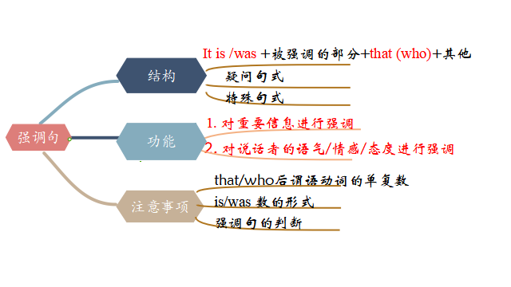

Step4: Focus on application

Activity 6: Write down the following sentences from textbooks with emphatic

structure

1. 我不知道这是不是因为我长久无法出门的缘故，我变得对一切与大自然有关

的事物都无比狂热。(M1U1)

__________________________________________________________________________________________________________________________________________

1. 首先想到要沿整条湄公河从源头到终点骑车旅行的正是我的姐姐。(M1U3)

__________________________________________________________________________________________________________________________________________

1. 是在夏季奥运会上有赛跑、游泳、帆船运动和所有的团体项目。(M2U2)

__________________________________________________________________________________________________________________________________________

1. 进一步阅读使我了解到是苦干、决心和善良的天性使她走进了医学院的大门。

(M4U1)

__________________________________________________________________________________________________________________________________________

1. 正是约翰迅速的动作和急救知识挽救了斯莱德女士的性命。(M5U5)

__________________________________________________________________________________________________________________________________________

1. 事实上，是精神上的瘾而不是身体上的影响使得戒烟非常困难。(M6U3)

__________________________________________________________________________________________________________________________________________

1. 地球变暖正是人类活动导致的，并非一种随意的自然现象。(M6U4)

_____________________________________________________________________

1. 是一名叫查尔斯肯林的科学家八57-1997年期间大气层中二氧化碳的含量作

了精确的统计。(M6U4)

_____________________________________________________________________

_____________________________________________________________________

1. 正是越来越多的化石燃料的燃烧导致了二氧化碳的增加。(M6U4)

_____________________________________________________________________

Activity7: Write a letter of thanks

假如你是韩，在你爸爸住院期间他所在的同济医院的医护人员对他悉心照料，现在你爸爸已经出院回家。你决定替爸爸写一封英文感谢信给医护人员，内容包括：

1. 对同济医院的医护人员的悉心照料表示感谢；

2. 描述医护人员对你爸爸住院期间的帮助；

3. 再次表达感谢。

注意：

1. 词数80左右；

2. 可以适当增加细节，以使行文连贯；

Dear medical workers,

On behalf of my father, I would like to express my sincere thanks to you when he was in your hospital.

Earlier in February, my father was severely infected and was sent to your hospital. 是你们不顾感染的危险日夜照顾他；是你们的不断鼓励逐渐消除了他的不安和害怕；最重要的是，是因为你们的及时的救助,专业的技能以及精心的治疗挽救了他的生命，让他恢复了健康。

Our thankfulness to you is beyond words. Thank you again!

Yours sincerely, Li Hua

_________________________________________________________________________________________________________________________________________________________________________________________________________________________________________________________________________________________________________________________________________________________

Step 5: Consolidation:

Activity 8: Lyrics Blank Filling

It was you

Who ___________________

I always knew

That you'd stand beside me

And it was you

Who ___________________

When the skies were dead grey

And it was you

Who ___________________

Since the day I went there

It was you

Who ____________________

With your hands that are warm

I know I can count on you

_________________________

Because the faith I had in you

_________________________

It was you

That I really__________

It was you

That I deeply _________

Step6: Homework

1. Review what we have learned today.
2. Finish the given exercise.