**基于学习与迁移理论的应用文写作**

**关于参加社区义务劳动的邀请信**

**—雅礼中学2025届高三上学期入学考试英语**

**陕西省礼泉县教育局教研室 高小聪**

**设计理念 (Design philosophy)**

**认知结构迁移论：美国著名的教育心理学家奥苏贝尔认为学习者的认知结构是影响学习迁移的重要因素。在意义学习中，学生积极主动地使新知识与认知结构中有关的旧知识发生相互作用，利用旧知识理解新知识，结果旧知识得到充实或改造，新知识获得了实际意义。**

**影响迁移的三个主要的认知结构变量：**

**①可利用性，即学生面对新的学习任务时，其认知结构中应具有吸收并固定新知识的原有观念，这样才能够产生有意义学习。**

**②可辨别性，指新的学习任务与同化它的相关知识的可分辨程度。两者的分辨程度越高，越有助于迁移并避免因新旧知识混淆而带来的干扰。**

**③稳定性，指学生面临新的学习任务时，其认知结构中原有知识是否稳定巩固。原有知识越巩固稳定，越有助于迁移。**

**“五育”融合**

**《中国教育现代化2035》提出要“大力发展素质教育，促进德育、智育、体育、美育、劳动教育的有机融合。”目前，在高中英语课堂教学和高考中都融入了“五育”，对促进学生的全面发展与学科核心素养的培养也有重要的启发。**

****教学目标（Teaching Goals）：****

After teaching this lesson, students will be able to:

1. know what’s the structure of an invitation letter;

2. Review and expand the relevant vocabulary & phrases about an invitation letter;

3. Involve what’s learned to the invitation letter themed “community volunteer labor” through thinking processes.

4. write out an invitation letter about “labour education” on their own effectively

****教学步骤（Teaching procedures)：****

****Step1. Lead-in** 挖掘“劳动”元素**

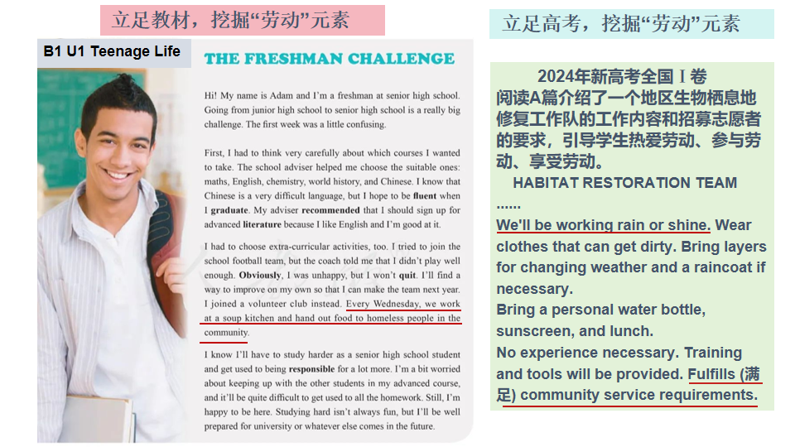

****Step2. Present writing task (写作任务呈现）****

**第四部分 写作 （共两节，满分40分）**

**第一节应用文写作（满分15分）**

**假定你是李华，你打算下周日参加学校对面的社区组织的义务劳动。请你用英语给你校交换生John写一封邮件，告知他此事，内容包括：**

**1. 时间和地点；2. 具体安排；3. 发出邀请。**

**注意：**

**1.词数80左右；**

**2.请按如下格式在答题卡的相应位置作答。**

**Dear John,**

**I am excited to inform you of an upcoming community volunteer event that I will be participating in. _________________________________________________________________**

**_______________________________________________________________________________**

**Yours,**

**Li Hua**

****Step3. Analyse the writing task(审题分析)****

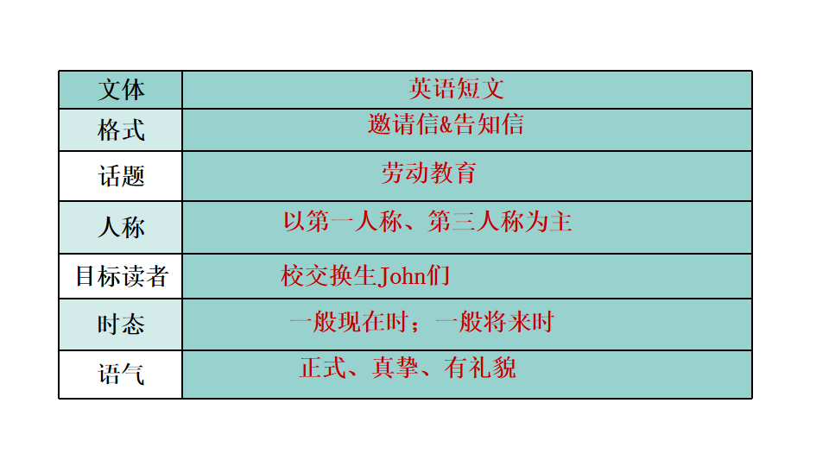

****Step4. 旧知回顾，迁移应用 ( Review, think & apply)****

1. I am excited to inform you of an upcoming community volunteer event that I will be participating in.

2. knowing that community service appeals to you, I’m writing to tell you the plan for an upcoming community volunteer event.

3. I am writing to keep you informed that there will be a community volunteer event next Sunday.

4.Considering your passion for community service and cultural exchange, I can’t wait to tell you some relevant details about an upcoming community volunteer event.

1. tell sb. sth.

2. tell sb. that...

3.inform sb. of sth./that...

4.keep sb. informed of sth./ that ...

5. notify sb. of sth.

6. notify sb. that...

**通知某**

**人某事**

1. In order to/ So as to/

To do/ Intended to do/

Aiming to do...

1. Aimed at/Targeted at

/Intended for doing...

3.With the purpose/aim of /For the purpose of/For the sake of doing...

1.To cultivate/foster Ss’ sense of labor and teamwork spirit, a volunteer event will be held in the community across from/ opposite our school next Sunday.

2. To enrich our extra-curricular life and enhance the sense of social responsibility, we’ll be engaged in a volunteer event in the community ...

3.Aimed at/Targeted at/Intended for improving/ Intended to improve students’ labour skills, environmental awareness and teamwork spirit, a volunteer event will take place in the community...

**为了......**

**(表目的**

**/意义**）

**社区义务劳动安排**

1.集合gather/meet/assemble

2.把......分成 be divided into

3.做动员讲话make a mobilization speech

4. 打扫卫生; 捡垃圾;

sweep /clean up;

pick up/ collect rubbish/trash

5.粉刷长凳paint the benches

6. 陪社区老人下棋、聊天

play chess with the elderly and chat with them

7. 修剪花木prune flowers and trees

1.The principal will make a short speech to announce the start of the event. Then, based on the already divided groups, each will undertake different tasks, ranging from sweeping, picking up litter, pruning flowers and trees under the guidance of the gardener to joining hands with entrance guides to keep order.

2.It will begin at 8:00 am and last four hours, during which time the divided groups are to perform various tasks, such as cleaning up, collecting trash, pruning flowers and trees and playing chess with the elderly.

Busy and tired as we may be, we will relax ourselves fully and experience the joy of labour.

**邀请约翰期待回复**

1. 参加

take part in/ participate in/

join in/get involved in/be engaged in

2.从......获益

benefit... from ...

3. 相信

be sure/convinced that.../

believe/ think/ ...

1. 把......纳入考虑

consider sth. /

take sth. into consideration/ account

1.Don’t hesitate to participate in it! I’m sure you will benefit a lot and gain much happiness.

2.Time permitting, welcome to get involved in it. I’m firmly convinced that the event will enhance friendship between us and make for your learning about local culture.

3. Your participation will be appreciated. I’m looking forward to your early reply.

****Step5 迁移应用，范文赏析 （Application & Appreciation)****

A community volunteer event

Dear John,

I am excited 1___________(inform) you of an upcoming community volunteer event that I will be participating in.

As 2________ (schedule), we’ll meet in the community 3________ our school at 8:30 am. next Saturday. Next, The principal is to make a mobilization speech, 4___________ (announce) the start of event. Later, 5______ (base) on the divided groups, each will perform different tasks, varying from sweeping up, carrying out garbage classifications, painting benches to 6 ________ (prune) flowers and trees. Not only will the voluntary work make us 7________(forget) heavy study for a while but cultivate our sense of labor and teamwork spirit.

I’m 8__________(convince) that it’s a good chance for you to experience Chinese culture and 9 ___________(strength) friendship. I 10 __________(sincere) invite you to join us. Looking forward to your early reply.

Yours,

Li Hua

**English is not destination,but the bridge to the destination.**

**English is not destination,but the bridge to the destination.**