燃烧激情，挑战极限，超越自我（Burning passion, challenge the limit, beyond the self）

- 教学背景与设计思路
一场突如其来的疫情给人们的生活带来极大的冲击与变化，全国人民面临着前所未有的挑战。一时间，工厂停工、商场停业，我们以牺牲GDP为代价，保全人们宝贵的生命，因为生命无价！在这场没有硝烟的斗争中，来自各行各业的人奋力拼搏，钟南山、李兰娟等老院士不辞辛劳几次飞赴武汉；驰援武汉冲锋陷阵的医生护士冒着生命危险在所不辞；公安民警、火神山医院的建设者们通宵工作，有的倒在了工作岗位上。无数个感动瞬间体现出中华民族迎接挑战的决心和信心，表现出了中华儿女在面对灾难时的责任与担当。疫情当下，教师要精选教学内容，结合当下现实，在教学中渗透珍惜生命、责任与担当等教育，一定能收到很好的教育教学效果。
这个春节，美国著名篮球运动员科比直升飞机坠机事件让全世界感到震惊。科比是很多中学生喜欢的球星之一，尤其是篮球爱好者。人们喜欢科比不仅是因为他篮球打的好，更是因为他的曼巴精神鼓舞着无数人追求他们的梦想。在通往成功的路上，科比勇敢地面对所有的挑战和挫折，值得每一个人学习！如果说科比的故事是一个人面对挑战的话，那么新冠肺炎是中华民族共同面对的一个很大的挑战。面对疫情，科学家、医护人员、公安消防民警、建筑工人等等来自各行各业的人面对挑战的责任与担当值得每一个学生学习。本节课是在这两件事中找到了一个共同点：挑战。“挑战”这一关键词贯穿整节课，从科比面对挑战到中华民族面对挑战，再到学生如何面对挑战，让学生意识到：生活需要挑战，年轻没有极限。激励学生在新学期站在新的起点，燃烧激情，挑战极限，超越自我（Burning passion, challenge the limit, beyond the self）。
- 教学设计
Teaching procedure:
Part 1: Lead-in
2020 is the year of the rat and may the Year of the Rat bring you and your family good health, prosperity and joy! On the way to our dreams, goals and prosperity, we are sure to encounter challenges like frustrations, disappointment, loneliness, something unexpected, misunderstandings and so on.
Question1: As students, how can we face such challenges?
Well, the year of 2020 has such an unusual beginning. I am going to share with you two big events that have impressed us a lot.
Part2: On Kobe Bryant
Have you ever seen the scene of Los Angeles at 4am?
I see often. Because I have been starting training at the time.
This is one of the most well-known quotes by Kobe Bryant. Unfortunately, he was killed in a helicopter crash in California, along with his 13-year-old daughter Gianna and seven other people. Question2: What do you know about him?
Well, let’s get to know more about him.
- Life before joining NBA
- The road to success
- Achievements
- Classic Quotes
- People’s reactions to his death
- Mamba Mentality
Question3: So what have you learned from Kobe Bryant?
Kobe Bryant is gone, but the Mamba Mentality he left will remain forever, inspiring millions of people to bravely face challenges in the pursuit of their dreams in the days to come. As a person, faced with challenges, Kobe Bryant chose to burn his passion, challenge the limit and go beyond himself, who is a role model for us to follow. As a nation, we are now faced with a big challenge at present that is threatening people’s life. Let’s go on with the next event.
Part3: On COVID-19
Wuhan, the capital city of Central China's Hubei province, has become the focus of concern throughout the whole world due to the infectious disease of COVID-19.
Question4: What do you know about the disease?
Well, let’s get to know more about it.
- The outbreak
- Origin of the virus
- Symptoms And Transmissions
- Actions taken to face this challenge
Since the outbreak of the disease, scientists, doctors, nurses, drivers---people from all walks of life have firmly faced challenges hand in hand.
Question5: What can you learn from them?
Question6: What can you do as students?
When the while nation is facing such a big challenge, people from the top leaders to the most ordinary people shoulder their responsibilities and do their own part, and that is exactly what we students should learn: the strong sense of responsibility and the spirit of Never Say Never. As students, the best way to avoid it is to isolate ourselves at home.
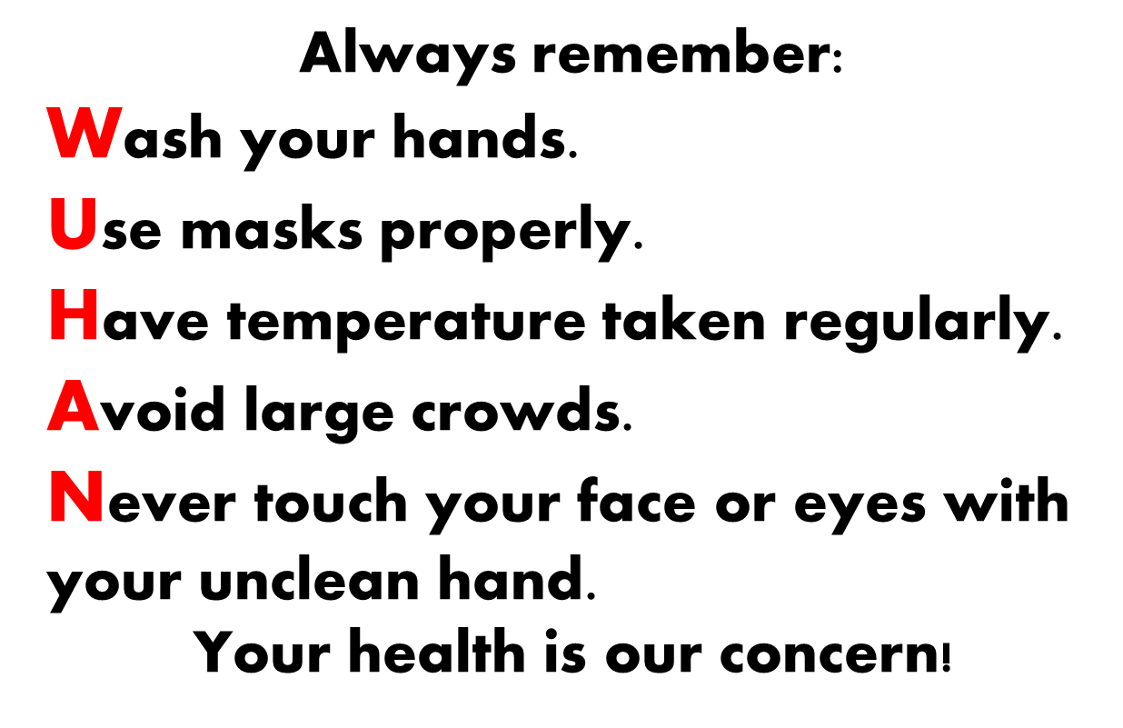
Part4: Reflection and proposal
Question7: Have you got a new understanding of challenges after reading the two events?
Life needs challenges. Youth has no limits.
Stand at a new starting point, meet new challenges and create new achievements.
Part5: Assignment
- Kobe Bryant died in a helicopter crash in California, along with his 13-year-old daughter Gianna. Please write a news report for the school newspaper about the accident in about 80 words.
- Challenges are everywhere in our lives. Please write a speech centered on challenges, properly using Kobe Bryant or people fighting the epidemic as an example. Limit your speech within 100 words.

