How to strive for happiness as Chinese students

——The first lesson of the new term

杭州二中树兰高级中学 郭合英

**Topic**：Human and Society.

**Teaching objectives:**

1. The height of happiness(manned spacecraft).
2. The length of happiness(the communist party of China 100th anniversary).
3. The width of happiness(out of poverty and free vaccine ).
4. How to strive for happiness as students.

**Teaching important points:**

1. The height of happiness(manned spacecraft).
2. The length of happiness(the communist party of China 100th anniversary).
3. The width of happiness(out of poverty and free vaccine ).
4. How to strive for happiness as students.

**Teaching difficult points:**

1. The height of happiness(manned spacecraft).
2. The length of happiness(the communist party of China 100th anniversary).
3. The width of happiness(out of poverty and free vaccine ).

**Teaching process:**

**The height of happiness**

**Step 1. Warming up**

**Lead in--- watching a short video**

Let the students watch a short video about manned spacecraft .

**Step 2. While-teaching**

China launched the Shenzhou XII spacecraft, its seventh manned spaceflight, on Thursday morning, sending three astronauts—Nie Haisheng, Liu Boming and Tang Hongbo, to the core module1 of its permanent space station.The spacecraft, atop a Long March-2F carrier rocket, blasted off at 9:22 am at the Jiuquan Satellite Launch Center in northwestern China.

6月17日9时22分，搭载神舟十二号载人飞船的长征二号F遥十二运载火箭，在酒泉卫星发射中心点火发射。三名航天员聂海胜、刘伯明、汤洪波将乘坐神舟十二号载人飞船到达我国永久空间站核心舱。神舟十二号载人飞船是我国第七次载人飞船任务。

【知识点】

在英文报道中，无人航空飞行器、卫星、火箭等(unmanned space vessels /satellites/ rockets) ,其编号一般用阿拉伯数字,载人飞行器（manned spacecraft）的编号一般用罗马数字。

比如，“嫦娥五号”的英文是Chang'e-5，而我国首个载人飞船“神舟五号”的英文是Shenzhou V。

**普及一下罗马数字中常用的表达方式:**

1-I，2-II，3-III，4-IV，5-V

6-VI，7-VII，8-VIII，9-IX，10-X

11-XI，12-XII，13-XIII，14-XIV，15-XV

16-XVI，17-XVII，18-XVIII，19-XIX，20-XX

50-L，60-LX，70-LXX，80-LXXX，90-XC，100-C

400-CD，500-D，1000-M

神舟十二号载人飞行任务总体安排，三名航天员聂海胜、刘伯明和汤洪波在轨期间将主要完成四个方面的工作，计划开展两次出舱活动（extravehicular activities）及舱外作业（extravehicular operations）。

神舟十二号载人飞行任务总体安排，三名航天员聂海胜、刘伯明和汤洪波在轨期间将主要完成四个方面的工作，计划开展两次出舱活动（extravehicular activities）及舱外作业（extravehicular operations）。

**四项主要任务包括：**

|  |  |
| --- | --- |
| **Tasks** | **New words** |
| First, they will operate and manage the complex, including the in-orbit test of the Tianhe module, verification of the recycling and life support system, testing and operation training of the robotic arm, as well as management of materials and waste. |  |
| Second, they will move, assemble and test extravehicular spacesuits and perform two extravehicular activities for work including assembling an extravehicular toolbox, lifting the panoramic camera and installing extended pump sets. |  |
| Third, they will carry out space science experiments and technology experiments, as well as public outreach activities. |  |
| Fourth, they will manage their own health through daily life care, physical exercise, and regular monitoring and assessment of their own health status. |  |
| Based on project plans, the Tianzhou 3 cargo ship will be launched in September to dock with Tianhe and the next month, another three-crew team will fly with the Shenzhou XIII to the module to stay there for six months. |  |
| In 2022, two large space labs will be launched to connect with the core module. Moreover, two manned missions and two robotic cargo flights will be made that year to continue construction of the Tiangong station, which is scheduled to become complete and start formal operation around the end of 2022. |  |

**航天英语词汇积累**

|  |  |
| --- | --- |
| 嫦娥二号 Chang e-2  神舟七号 Shenzhou VII  航天飞船 space ship  火箭 rocket  倒数 the countdown  航天基地 space station  地心引力 gravity  登月舱 lunar module  上升段 ascent stage  下降段 descent stage  指令舱 command module  发射卫星launch a satellite  发射台launch pad  多级火箭 multistage rocket  第二级 second stage  第三级 third stage | 服务舱 service module  回收舱 return capsule  轨道舱 orbital capsule  航天员 astronaut  航天服 space suit  接口盖 access flap  舱口 hatch  扶梯 ladder  轨道 orbit  人造卫星 artificial satellite  通信卫星 telstar  天线 antenna  太阳电池 solar cell  航天器 spacecraft  登月舱 lunar module |
| 登月舱机动火箭 LM-maneuvering rockets  着陆架 landing pad  定向天线 directional antenna  天舟一号 Tianzhou-1  长征七号 Long March-7  酒泉卫星发射中心 Jiuquan Satellite Launch Center  文昌卫星发射基地 Wenchang Satellite Launch Center  西昌卫星发射中心 Xichang Satellite Launch Center  应急供氧装置 emergency oxygen apparatus  生命维持系统 life support system  载人航天事业 manned spacecraft engineering  主发动机喷嘴 nozzle of the main engine  应急供氧装置 emergency oxygen apparatus  生命维持系统 life support system  载人航天事业 manned spacecraft engineering | |

**How to become an excellent taikonaut?**

Comprehension: Choose the best answer

For Shenzhou-12 mission, three taikonauts, namely Nie Haisheng, Liu Boming and Tang Hongbo, became the first to enter the Chinese space station.

"I think the trio is a great combo," said Huang Weifen, deputy chief designer of the astronaut system of China's manned space program. "We chose Nie as the captain for his two-time space flight experience and Liu Boming for his previous experience in extravehicular activity, while Tang is the backup taikonaut for Shenzhou-11 mission and he excelled in every area."

The qualification criteria includes basic, physical, mental and overall evaluations.The selection has been made based on 43 aspects such as age, height, education and professional background just in basic evaluation," said Huang. The synergy (协同作用) or compatibility（兼容性）among different members is also a big factor.

She said physical evaluation is just to test endurance and adaptation to the space environment.Testing of the vestibular function (前庭功能) is also one of the physical checks. Huang explained candidates who have weak vestibular function can become very dizzy and even vomit.

After over two decades of practice, China has set up a complete process to select taikonauts. "It's a process to select from 'the best of the best,'" said Huang. She said engineers and payload specialists have different requirements, less strict but still many.

Huang led the team to develop over a hundred types of training in eight categories in various fields, such as medicine, physics, psychology, science and engineering. She also trained the Shenzhou-12 taikonauts under water to mimic the microgravity environment as there are extravehicular activities for the mission this time.

The astronauts are exposed to the pull of hypergravity (超重) when spaceships ascend and return. During the hypergravity period, the blood moves to the legs, causing possible loss of vision and consciousness. So, the training on tolerance to hypergravity, or high-G training, is also essential.

Huang said all taikonauts have to pass the 8G criterion, which means they should be able to bear eight times the gravity force of their own body weight. " The taikonauts go through it once every half a year."

"As long as they are professional astronauts, it's their duty to keep going through the training, ready for the mission calls, until the moment they retire," Huang said.

1. Which of the following is true?

A. China has set up a complete process to select taikonauts within twenty years.

B. The male taikonauts go through the 8G criterion every half a year.

C. The choice of the engineers and payload specialists is not strict.

D. The testing of the vestibular function is to check whether the taikonauts become faint

and upchucked.

2. The last paragraph mainly tells us about .

A. The mission of the taikonauts B. The retirement of the taikonauts

C. The weakness of the taikonauts D. The qualification criteria of the taikonauts

3. What does the underlined word “trio” in Paragraph 1 mean?

A. 四人一组 B. 三人一组 C. 五人一组 D. 二人一组

4. What can be a suitable title for the text?

A. The process of training the taikonauts B. The mission of Shenzhou-12

C. The significiance of the Shenzhou-12 D.The qualification criteria of the taikonauts

Astronaut, cosmonaut or taikonaut?

Some Chinese are so proud of the latest achievements that they revived the topic of how

1 (name) people in space.

The naming problem emerged in the Cold War, when Soviet Union named their space

2 (hero) "cosmonauts" while the U.S. called 3 (they) "astronaut."

Later, the word "taikonaut" 4 (coin) using the Mandarin equivalent of the word space – taikong – and the common suffix "-naut". Oxford and Longman dictionaries listed the word taikonaut and said it 5 (mean) a Chinese astronaut. Some Chinese see the popularity of the word 6 a sign of China's growing influence in space.

Now the three taikonauts are unpacking the supplies on Tianzhou-2, 7 (set) up Wi-Fi connections and other 8 (equip) on the space station.

They will live in the station for at least three months and conduct 9 (vary) technology test and science experiments, during 10 spacewalks involving robot arms will also be performed.

**The length of happiness**

|  |  |
| --- | --- |
| Speech at a Ceremony Marking the Centenary of the  Communist Party of China  Comrades and friends,  Today, the first of July, is a great and solemn day in the history of both the Communist Party of China (CPC) and the Chinese nation. We gather here to join all Party members and Chinese people of all ethnic groups around the country in celebrating the centenary of the Party, looking back on the glorious journey the Party has traveled over 100 years of struggle, and looking ahead to the bright prospects for the rejuvenation of the Chinese nation. | New words: |

百年弹指一挥间

|  |  |
| --- | --- |
| The Chinese nation is a great nation. With a history of more than 5,000 years, China has made indelible contributions to the progress of human civilization. After the Opium War of 1840, however, China was gradually reduced to a semi-colonial, semi-feudal society and suffered greater ravages than ever before. The country endured intense humiliation, the people were subjected to great pain, and the Chinese civilization was plunged into darkness.  To save the nation from peril, the Chinese people put up a courageous fight. As noble-minded patriots sought to pull the nation together, the Taiping Heavenly Kingdom Movement, the Reform Movement of 1898, the Yihetuan Movement, and the Revolution of 1911 rose one after the other, and a variety of plans were devised to ensure national survival, but all of these ended in failure. Only the CPC made it.  With the salvoes of Russia’s October Revolution in 1917, Marxism-Leninism was brought to China. In July 23-31 July ,1921, The 1st National Congress of the Communist Party of China was held in Shanghai and Jiaxing Nanhu, Zhejiang Province. The meeting was to proclaim the founding of the Communist Party of china. |  |

百折不挠，终赢解放

|  |  |
| --- | --- |
| After twenty-gight years of struggle, victory was finally achieved. On October1, 1949, the first five -star red flag rose on the Tiananmen square, and President Mao Zedong announced to the people of the world, “People’s Republic of China was founded today.” |  |

俱往矣,数风流人物,还看今朝

|  |  |
| --- | --- |
| 毛泽东：Mao Zedong was a great Marxist, proletarian（无产阶级的） revolutionary, strategist and theorist, and the main founder and leader of the Communist Party of China (CPC), the Chinese People's Liberation Army (PLA) and the People's Republic of China. |  |
| 邓小平： He shifted the focus of the whole Party’s work onto economic development and introduced reform and opening up, gradually formulated the line, principles, and policies for building socialism with Chinese characteristics and thus established Deng Xiaoping Theory.  实现全党工作中心向经济建设的转移，实行改革开放，逐步形成了建设中国特色社会主义的路线、方针、政策，创立了邓小平理论。 |  |
| 江泽民： He deepened the understanding of what socialism is and how to build it, and what kind of party to build and how to build it, and gathered valuable new experience in governing the Party and the country, thus forming the Theory of Three Represents.  加深了对什么是社会主义、怎样建设社会主义和建设什么样的党、怎样建设党的认识，积累了治党治国新的宝贵经验，形成了“三个代表”重要思想。 |  |
| 胡锦涛：On the basis of the new demands of development they forged a deep understanding of and answered major questions, including what kind of development to pursue and how to pursue it in a new situation, thus forming the Scientific Outlook on Development, which puts people first and calls for comprehensive, balanced, and sustainable development.  根据新的发展要求，深刻认识和回答了新形势下实现什么样的发展、怎样发展等重大问题，形成了以人为本、全面协调可持续发展的科学发展观。 |  |
| 习近平：He has systematically addressed the major question of our times—what kind of socialism with Chinese characteristics the new era requires us to uphold and develop and how we should uphold and develop it, thus giving shape to Xi Jinping Thought on Socialism with Chinese Characteristics for a New Era.  习近平主席系统地回答了新时代坚持和发展什么样的中国特色社会主义、怎样坚持和发展中国特色社会主义这个重大时代课题，创立了习近平新时代中国特色社会主义思想。 |  |

新生的中华人民共和国如虎添翼，百废待兴

In 1964, our country succeeded in exploding the first atomic bomb;

In 1967,our country succeeded in exploding the first hydrogen bomb;

In 1970, our country successfully launched the first man-made satellite.

In July 1997, Hongkong's return to the motherland.

In December 1999, People's Republic of China resumed the exercise of sovereignty over Macao.

In 2003, the shenzhou five launch shows China has already occupied a space for one person in the

field of aerospace.

In 2008， Chinese held the olympic games, which fully demonstrated the economic achievements and the promotion of comprehensive national strength.

In 2010, we held the World Expo, attracting a large number of Chinese and foreign tourists.

**Watch video and discuss**

1. What made him have a narrow escape ？

2. What does it show?

1. What makes China what it is now?

**The width of happiness**

**(Out of poverty and free vaccine)**

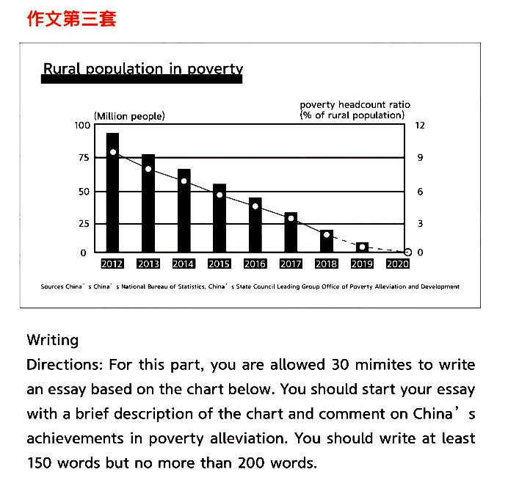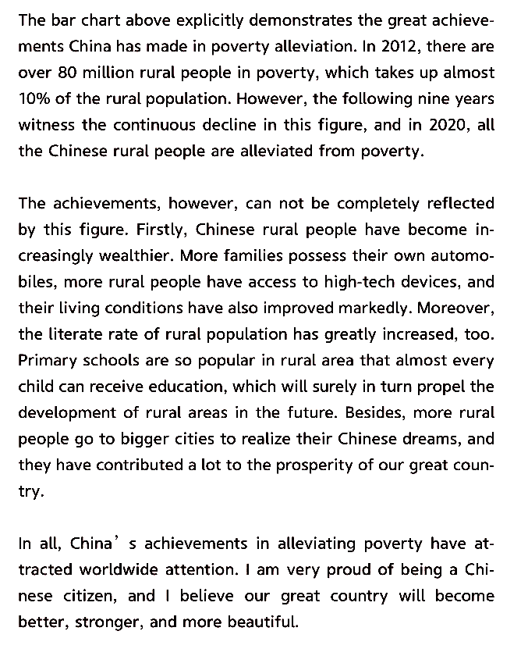

【知识点】

精准扶贫、精准脱贫

targeted poverty alleviation and elimination

targeted poverty alleviation and eradication

to take targeted measures to reduce and eradicate poverty

全面建成小康社会

to build a moderately prosperous society in all respects

to achieve moderate prosperity in all respects throughout the country

to complete a moderately prosperous society in all respects

脱贫攻坚战全面胜利 complete victory in the fight against poverty

【重要讲话】

我们始终坚定人民立场，强调消除贫困、改善民生、实现共同富裕是社会主义的本质要求。

China upholds the principle of putting people first and emphasizes that ending poverty, improving people's well-being and realizing common prosperity are the essential requirements of socialism.

脱贫摘帽不是终点，而是新生活、新奋斗的起点。

Shaking off poverty is not the finish line, but the starting point of a new life and new endeavor.

——2021年2月25日，习近平在全国脱贫攻坚总结表彰大会上的讲话

【相关词汇】

uphold [ʌpˈhəʊld] vt.维护；拥护；支持; well-being [wel'bi:ɪŋ] n. 幸福；生活安宁； 福利

common prosperity 共同富裕 shake off 摆脱

endeavor [ɪn'devə] n.尽力;努力 v.尽力;努力;力图

**Look, the world is what you want！--- out of famine**

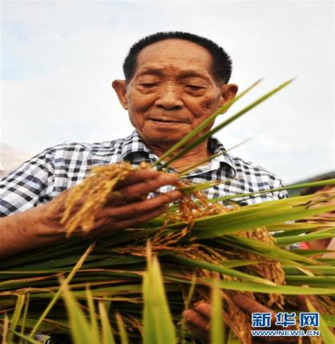

As a young teacher in Hunan's countryside, Yuan witnessed the devastation brought by a nationwide famine, immersed himself in rice hybridization experiments, despite many calling him a "chairwarmer." In 1973, he cultivated the world's first high-yielding hybrid rice strain, which could reach a yield of over 500 kg per mu (0.067 hectares) from previous 300 kg. In July, 2020, the goal with a yield of 1530.76 kg per mu was achieved.

|  |
| --- |
| New words:  devastation [ˌdevəˈsteɪʃən] n.（大面积的严重）破坏  famine [ˈfæmɪn] n.饥荒;（物品）奇缺;严重的饥饿感  immerse [ɪˈmɜːs] vt.浸；泡；使浸没;给…施浸礼  hybridization[ˌhaɪbrɪdaɪˈzeɪʃən] n.杂交  chairwarmer [ˈtʃeəˌwɔːmə] n. 懒虫；在其位不谋其职的人 |

In 2019, Yuan, academician with both the Chinese Academy of Engineering and the U.S. National Academy of Sciences, was awarded with Medal of the Republic, China's highest honor, for his groundbreaking research.

Nowadays, the hybrid rice is grown in almost half of China's rice paddies and its yield makes up for 60 percent of the country's total rice production. The hybrid rice yields 20 percent more than the common breeds, the annual increase of which feeds up to 100 million people.

His goal and dream

|  |  |
| --- | --- |
| His goal |  |
| Dream 1 |  |
| Dream 2 |  |

**Look, the world is what you want！---- educational aspect**

**Role Model of the Times --- Zhang Guimei**

Zhang Guimei, the principal of Huaping High School for Girls, based in Lijiang city, Southwest China's Yunnan province, has been granted the title "Role Model of the Times" in recognition of her dedication to the education for girls from poor families.

为表彰其为贫困家庭女孩教育所做的贡献，云南省丽江市华坪女子高级中学校长张桂梅日前被授予“时代楷模”称号。

This year is the time to secure a decisive victory in building a moderately prosperous society in all respects and achieve the goal of poverty alleviation. Teachers across the country devoted their love and wisdom to stopping poverty from being passed on to the next generation and inspiring millions of rural children to pursue their dreams, which demonstrates the noble ethics and sense of responsibility of contemporary teachers.

今年是决胜全面建成小康社会、决战脱贫攻坚之年，全国广大教师用爱心和智慧阻断贫困代际传递，点亮万千乡村孩子的人生梦想，展现了当代人民教师的高尚师德和责任担当。

**The heart-shaking motto 震撼人心的校训**

|  |  |
| --- | --- |
| 我生来就是高山而非溪流  我欲于群峰之巅俯视平庸的沟壑  我生来就是人杰而非草芥  我站在伟人之肩藐视卑微的懦夫！ | I was built to be a mountain, not a creek, rising to the high peaks with the small valleys at my feet.  I was born to be great, not worthless, standing on the shoulders of the giants, the petty cowards beneath me. |

**Look, the world is what you want！--- motorway aspect**

**The development of freeway in China**

|  |
| --- |
| 1988年，the first highway called Hujia expressway (泸嘉高速)；  1990年，Shenda expressway (沈大高速)；  1993年，Jingjintang expressway(京津塘高速)；  1993年，Jiqing expressway(济青高速)；  1995年，Chengyu expressway (成渝高速)；  1996年，Huning expressway (泸宁高速)；  1998年，Ranking the fourth in the world with the expressway covering 8733 kilometers；  1999年，Nearly ranking the third in the world with the expressway covering 10 thousand kilometers；  2000年底， Ranking the third in the world with the expressway covering 16,000 kilometers；  2010年,The expressway reaches more than 4,000 kilometers, ranking the second in the world.  2018年，Ranking the first in the world with the expressway covering 140,000 kilometers;  By the end of 2020,the Chinese highway total course has amounted to 5,198,100 kilometers, including 161,000 kilometers.  2020年，全国公路总里程519.81万公里，其中高速公路里程16.1万公里。 |

**Look, the world is what you want！--- advanced technology**

At 6:21 pm July21st Wednesday in Henan, the drone entered the areas where telecom services had been disrupted and started to provide stable and continuous mobile signal coverage for an area of about 50 square kilometers.

As of 23:20, the air base station has connected a total of 3,572 users, generating traffic of 2,089.89M, with a single maximum access of 648 users.

Restoring the mobile public network signal for residents in the disaster area allows individuals to report their situation in real time, and opens up a lifeline for emergency communications.

【知识点】

无人机学名全称为unmanned aerial vehicle，简称UAV，在口语中一般称为drone。

**Look, the world is what you want！--- medical aspect**

China has administered over 9 million shots of COVID-19 vaccine since Dec 15 to people deemed at high risk of contracting the disease, senior health officials said on Saturday.

The cost of COVID-19 vaccination will be covered by medical insurance fund and government fiscal, rather than individuals, said Li Tao, deputy director of the National Healthcare Security Administration.

**知识点**

**1.vaccination**

接种疫苗 administer/have the vaccine have vaccinate [ˈvæksɪˌneɪt] vt.给…接种疫苗

E.g. We should be vaccinated against COVID-19. 我们要打疫苗预防新冠病毒。

vaccination则是指疫苗接种的过程。

**2. inoculation [ɪnˌɒkjʊˈleɪʃən] n.接种**

除了vaccine，inoculation/inoculate的出现频率也很高。

inoculate用法与vaccinate相似：

An inoculation against cholera is recommended. 建议接种预防霍乱的疫苗。

1. **jab**

口语中，常用jab来表达疫苗接种。如：I had the jab yesterday. 我昨天打疫苗了。

jab n. 注射；接种；预防针v.戳、刺。get jabbed 在相关语境下，可理解为打了一针。

**4. shot**

shot: an injection of a drug（一次注射）。

Over half of its population has received at least one shot of vaccine.

常见短语是 a shot in the arm（强心针），something that makes you more confident or more successful（让你更加自信，鼓舞你获得成功的事情）。

**关于“疫苗”的实用好句**

The emergency vaccinations were given to people with high exposure risks on the premise of voluntary, informed consent.

在自愿、知情同意的前提下，对高危人群进行紧急接种。

Although the COVID-19 vaccine is safe and effective, people still need to maintain personal hygiene and protection, including wearing masks, washing hands and practicing social distancing.

虽然新冠疫苗是安全有效的，要继续维持个人卫生和防护措施，包括戴口罩、勤洗手、保证社交距离等。

After strict monitoring and observation, no serious adverse reactions took place.

经过严格的不良反应监测和追踪观察，未出现严重不良反应。

With COVID-19 vaccines officially approved to enter the market or the yield of vaccines improving steadily, China will put more vaccines into use, inoculating the eligible population as widely as possible.

随着疫苗获批上市，疫苗产量逐步提高，中国将会有更多的疫苗投入使用，符合条件的群众都能实现“应接尽接”。

**中国向阿曼苏丹捐赠10万支疫苗**

|  |
| --- |
| To ensure more than 2,000 Chinese people will be vaccinated，China has donated 100,000 doses of vaccine to Sultanate of Oman on condition that the Chinese get it first.  The Chinese government see to it that the wandering descendants of the Chinese Nation people health and safety.  为确保2000多中国人能打上疫苗，中国向阿曼苏丹捐赠10万支疫苗，条件是必须中国人先打。为了能够让在外漂泊的华夏儿女健康安全，中国政府一直在默默保驾护航。 |

**Discuss**

What do you feel about it now ?

Happiness is … ？

Happiness is gratitude.

|  |
| --- |
| 感恩生在盛世中国，没有战乱，没有饥寒，没有颠沛流离，有的是富足，有的是安全，有的是更多平台去成就自己，有的是白日里看青山绿水，夜晚间看流光溢彩，神州处处，勃勃生机。 |

**How to strive for happiness at the beginning of school**

**Brainstorming: What is happiness to them?**

The doctors say happiness is to save the lives of the wounded, the treatment of difficult diseases.

幸福是救死扶伤，治疗疑难杂症

The teachers say happiness lies not only in imparting knowledge, but also in educating people.

幸福是教书育人

The sportsmen say happiness lies in breaking the world record and won honour for our country.

打破世界记录，为国争光

Sprinter Su Bingtian made history by becoming the first Chinese athlete to reach the Olympic 100m final. Su Bingtian said, "For me, through so many years of hard work, I can finally stand on the 100m (final) track. I think I have fulfilled not only the dream of mine, but also the dream of our predecessors!"

Su ran into the record books at the Tokyo 2020 Games on Sunday when he became the first Chinese athlete to qualify for the men's 100-meter sprint final at an Olympics, setting a new Asian record on the way.

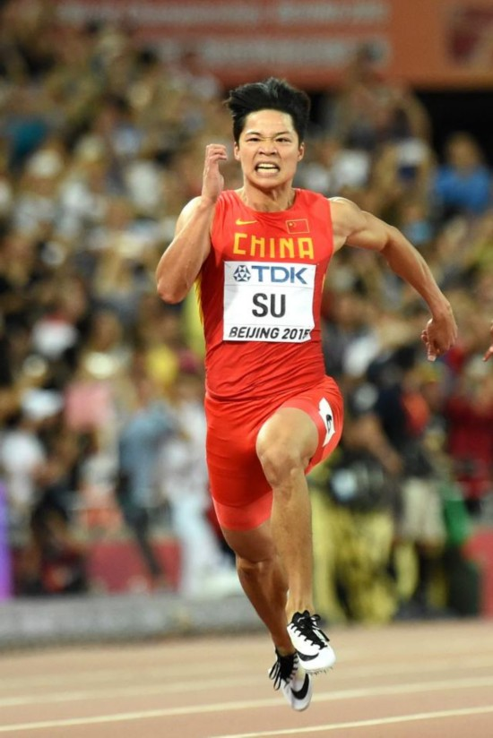

Happiness is … for students ?

Happiness is reading hard . 幸福在于努力读书

Happiness lies in struggling tenaciously. 幸福在于是奋斗拼搏

Happiness is achieved through hard work. 幸福是奋斗出来的

Happiness lies in the belief that resourceful youths lead to a resourceful nation; strong youths lead to a strong country. 少年富则国富,少年强则国强

**The importance of reading**

1. Learning without thinking leads to confusion; thinking without studying results in tardiness.

学而不思则罔, 思而不学则殆

1. A young idler, an old beggar. 少壮不努力，老大徒伤悲
2. Don't idle away your time when you are young, otherwise you will feel sad and regretful when

you are old. 莫等闲，白了少年头，空悲切

1. The road ahead will be long and our climb will be steep.

路漫漫其修道远兮，吾将上下而求索

1. The greatness is achieved through diligence and retarded by laziness.the deed is accomplished

through thinking and destroyed by idleness.

业精于勤荒于嬉；行成于思毁于随

1. Learn for the construction of a prosperous China. 为中华之崛起而读书

**少年中国说**

|  |
| --- |
| 故今日之责任，不在他人，而全在少年。  Therefore, the responsibility bestowed by the times falls on nobody but us youth.  少年智则国智，少年富则国富，  If we are intelligent, China will be intelligent; if we are wealthy, China will be wealthy;  少年强则国强，少年独立则国独立，  if we are strong, China will be strong; if we are independent, China will be independent;  少年自由则国自由，少年进步则国进步，  if we are free, China will be free; if we are progressive, China will be progressive  少年胜于欧洲，则国胜于欧洲，  if we are superior to young Europeans,China will be superior to Europe;  少年雄于地球，则国雄于地球。  if we are the best in the world,China will be the best in the world. |

**What should we do as students?**

Nobody in this world can succeed easily. If you want to shine in front of people, you must make efforts hundredfold behind them. You have to know that success is fair to everyone: it rewards those who are hardworking and can spare no efforts, and punishes those who are lazy and negative. Let's go all out for our dreams in a new day.

这世上从来没有轻轻松松就能成功的人。要想在人前发一分光，就得在人后付出百倍的努力。你要明白，成功对于每个人而言都是公平的：它奖赏勤劳和努力，惩罚懒散和消极。新的一天，为梦想全力以赴。

**Step 3. Post-teaching**

Homework:

Composition: What should we do as a student?