**“OBE”教育理念与逆向设计在读后续写教学中的应用**

**A Leap of Courage: Wings of Hope**

**—咸阳市2025年高考模拟检测二读后续写**

**礼泉县教育局教研室 高小聪**

**一、课程背景与设计依据**

**（一）读后续写存在问题**

**高三学生已掌握基本语言知识，但续写中存在以下问题：情节发展逻辑松散，与原文情境衔接不足；语言表达单一，缺乏情感描写与细节刻画；对评分标准中的 “内容完整性”、“语法多样性”、与上下文的衔接和全文的连贯性”理解模糊。**

**（二）读后续写理论依据**

**根据《普通高中英语课程标准（2017年版2020年修订）》之规定，普通高中学生要想参加高考，就必须做到以下之要求： 1．能在书面表达中有条理地描述自己或他人的经历，阐述观点，表达情感态度；能描述事件发生、发展的过程；能描述人或事物的特征、说明概念；能概述所读语篇的主要内容或续写语篇。 2．能在表达过程中有目的地选择词汇和语法结构，确切表达意思，体现意义的逻辑关联性；能使用多模态语篇资源，达到特殊的表达效果。 第一条是高考书面表达的内容要求，第二条是语言质量的要求。**

**成果导向教育（OBE）：以 “学生最终能写出符合高分标准的续写” 为目标，逆向设计教学活动。**

**逆向教学设计：按 “确定预期效果→设计评价方法→规划教学活动” 三阶段实施。**

**二、预期学习成果（OBE 导向）**

|  |  |
| --- | --- |
| **阶段1——预期学习成果** | |
| **参照目标：**  **《普通高中英语课程标准（2017年版2020年修订）》**  **能在书面表达中有条理地描述自己或他人的经历，阐述观点，表达情感态度；能描述事件发生、发展的过程；能描述人或事物的特征、说明概念；能概述所读语篇的主要内容或续写语篇。**  **能在表达过程中有目的地选择词汇和语法结构，确切表达意思，体现意义的逻辑关联性；能使用多模态语篇资源，达到特殊的表达效果。**  **第一条是高考书面表达的内容要求，第二条是语言质量的要求。** | |
| **理解：**  **学生将理解：**  **1.原文大意，捕捉关键语言特征并在续写中模仿运用。**  **2.能识别原文情节逻辑链条（Sam 的恐惧→救助雨燕的动机→飞行的决定），并构建与之连贯的续写框架。**  **3.准确使用高级词汇（如 “flutter”“soar”）和复杂句型（状语从句、非谓语动词）。**  **4.运用直接引语、心理描写等手法增强故事感染力。** | **基本问题：**   1. **What’s the text type?** 2. **What’s the discourse pattern?** 3. **What’s the thematic context?** 4. **What’s the main idea(5W+1H)?** 5. **Why did the story happen?**   **(Intention /values）**   1. **What’s the ending of the story?** |
| **学生将知道:**   1. **原文情节逻辑链条（Sam 的恐惧→救助雨燕的动机→飞行的决定），并构建与之连贯的续写框架。** 2. **原文运用的各种写作技巧。** | **学生将能够：**  **At the end of the class, you will be able to**  **1. learn to make the given text and the continued-writing part keep in harmony.**  **2. Correct problems and explore highlights.**  **3. Develop a review plan for continuation writing.** |
| **阶段2——评估证据** | |
| **表现任务：**  **确保续写部分与所给文本保持情节连贯性和情感一致性。**  **你的任务是：**  **阅读下面材料,根据其内容和所给段落开头语续写两段,使之构成一篇完整的150词左右的短文。**  **高考读后续写评分程序、原则及标准：**   1. **评分程序** 2. **初定档次：根据主题、结构和情节确定所属档次** 3. **调整分数：从内容完整性、语言准确性、连贯性等维度细化评分** 4. **评分原则**   **1. 总分25分，分5档评分**  **2. 单段续写最高12.5分**  **3. 词数130-170词，超出范围扣2分**  **4. 书写差影响交际降一档**  **5. 英美拼写均可接受**  **三、评分标准**  **第五档 (优) (21-25分）内容完整新颖，逻辑完全一致，语言高级多样，衔接自然流畅**  **第四档 (良) (16-20分) 内容合理连贯，逻辑一致，语言较多样准确，衔接有效**  **第三档 (中) (11-15分) 内容基本完整，逻辑基本一致，语言简单正确，衔接基本清晰**  **第二档 (差 ) ( 6-10分)内容不完整，逻辑混乱，语言错误多，衔接差**  **第一档 (极差) (1-5分)内容严重脱节，逻辑断裂，语言无法理解，无衔接**  **0分 未作答/无关内容/全抄原文**  **注：评分重点关注三点：**   1. **内容与原文的连贯性（情节发展、人物性格、情感逻辑）** 2. **语言准确性（语法、词汇、拼写）**   **3. 篇章衔接（段落过渡、句间连接）**  **阶段3——学习计划** | |
| **Learning Plan** | |
| 1. **介绍读后续写存在的问题、本课的最终目标和量规。** 2. **重析2025年咸阳市二模英语读后续写。** 3. **依据读后续写评分标准，采用人机协同（机评+师评+自评）来分析评价学生的考场作文。** 4. **依据评价结果，让学生反思、改进提升。** 5. **二轮复习读后续写建议** | |

**阶段4. 教学活动设计**

**Ⅰ. Clarify the teaching objectives of this class.**

**Ⅱ.Read the scoring principles and standards for continuation writing carefully.**

**Ⅲ.Carry out the learning plan**

**Step1. (Analyse)回归续写文本**

**第二节 (满分 25 分) （咸阳市2025年高考模拟检测二读后续写）**

**阅读下面材料,根据其内容和所给段落开头语续写两段,使之构成一篇完整的短文。**

**I burst into Mom's study, waving a brilliant feather like a tiny treasure, “Mom, look what I found! It's a feather from a Vaux's swift (沃氏雨燕) I've been looking for this one for ages!” I bounced on my toes, unable to contain my excitement.**

**Mom glanced up from her books and smiled, “ it's beautiful!” she said, then took a deep breath“Sam , next week I will be flying a biplane in the airshow, Would you like to join me?”**

**I froze. Even the slightest thought of flying made my stomach twist and turn , let alone flying in a biplane—with an open cockpit (驾驶舱) where you could look down and see how far you were from the ground. “No thanks, Mom. Sorry.” I replied as I headed upstairs to my room. With each heavy step, I tried to convince myself—planes are safe, Mom is an amazing pilot and she deserves a brave son. But no matter how much I repeated it, the fear clung to me like a shadow.**

**That afternoon, while walking home from school, my best friend, Emily, called out, holding a birdcage. “Sam, look! It's a Vaux's swift! I think it got hurt during migration—maybe its natural enemy tried to catch it. The injury isn't too bad, and it should heal in about a week. But the problem is... its all alone. Its flock is gone." My chest tightened. “We have to help it find its flock again.” I said worriedly, “If it doesn't, it won't survive the winter. " Emily nodded , “It's so heartbreaking to see it left behind.”**

**As the days passed and the little bird grew stronger, I couldn't stop thinking about how to help it. Then, like a flash of light , a thought sparked in my head. No matter how scary or impossible it seemed , l was going to make sure this tiny bird caught up with its flock.**

**On the morning of the airshow, I found Mom. I took a deep breath to steady my pounding heart and declared with determination, “Mom, I'm ready to fly with you today.”**

**注意:1.续写词数应为150左右;**

**2.请按如下格式在答题卡的相应位置作答。**

**Mom's eyes widened in surprise , but a proud smile quickly spread across her face. ______________________________________________**

**As the biplane rose into the sky, I held the birdcage tightly in my arms._______________________________________________________**

**Read the writing task to finish the tasks below.**

1. **Extract the key clues, filter out the useful information**

**Draw out the story mountain of the given article (见图1）**

1. **What’s the main idea of the given text?**

**Sam, fond of birds but afraid of 1______ , he 2_______ to fly a biplane with his pilot mother in an air show. Later, to help an 3_______Vaux's swift (沃氏雨燕)with his friend , he 4_________ his psychological barrier in the end. On the day of the air show, he 5_____a biplane together with his mother and led the little bird 6________(catch) up with the migrating bird flock.**

**3.What’s its theme?**

**Courage and ___________**

**Love and ______________**

**Harmonious ____________ between Humans and Animals**

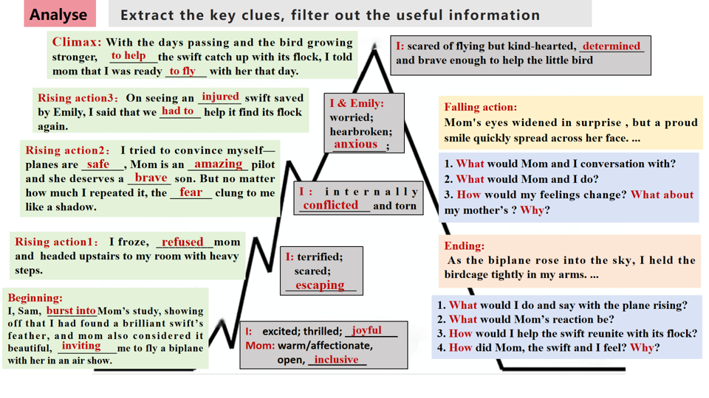

**（图1）**

**Step2. (Evaluate)评价考场作文**

According to the scoring criteria for continuation writing after, please

grade and score the following composition, focusing on **the harmony of the given text and continued writing (continuation of the plot, inheritance of the language, consistency of the characters)**.

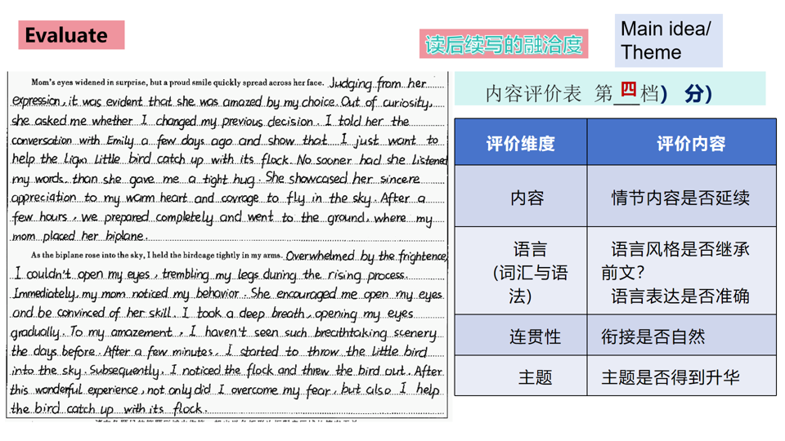**Step3 .(Improve)改进提升优化**

**★续写改进提升任务表**

|  |  |
| --- | --- |
| **要求** | **内容** |
| **续写第1段和第2段** | **改正习作中的单词拼写、语法错误** |
| **第一段③句和④句改写成直接引语言** | **"________________" asked mother _________but excitedly, I stammer in slightly nervous tone,"_____________."** |
| **改写第一段⑤句** | **非谓语动词作状语**  **___________________, she gave me a tight hug.**  **介词短语做状语**  **________________, she gave me a tight hug.** |
| **Coherence：**  **续写第1段最后一句与续写第2段第①句衔接自然** | **微技能5（句式）: with复合结构/ 独立主格结构，主语+谓A +谓B +谓C.**  **Afterwards, _____________, we ________the birdcage, _______ the hardstand and ___________the open cockpit.** |
| **Coherence：**  **续写第2段第②句与第①句衔接自然；**  **改写续写第2段第②句**  **（增强细节描写，丰富情感与画面感。）** | **句式1. 倒装句（用...so...that...引导的结构状语从句）**  **So frightened was I that I wasn’t afraid to open my eyes, my legs trembling with the plane rising.** |
| **句式2. 用...too ...to...改写**  **I was too frightened to open my eyes with the plane rising.**  **句式3. 两个形容词短语作状语**  **Frightened and panicked, I didn’t dare to open my eyes with the plane rising.** |
| **句式4. 巧用无灵主句**  **A wave of fright/panic overwhelmed me so suddenly that I didn’t open my eyes with the plane rising.** |
| **句式5. 利用五感法**  **The continuous roar of the biplane during the rising process made my legs trembling and eyes closed tightly.** |
| **改写续写第2段第③、④、⑤句** | **Immediately my mom noticed my_____________, encouraging me,“__________________________________.”**  **I _________ (breath) deeply and tried to calm ______**  **(I) down.** |
| **续写第2段第⑥句 (景色是什么？）** | **To my amazement, I had never seen such breathtaking scenery before：_____________，_______________ and _______________** |
| **第二段第⑦句和第⑧句改写** | **At that time, “Look, there flies a flock of swifts!” cried mother merrily. I quickly I _________the birdcage, and it hesitated for a while, burst into the air and joined its family with a cheerful cry.** |
| **你的续写结尾（主题升华）** | **Courage and growth**  **During the process of helping the swift catch up with its flock in the biplane, I picked up my _________, faced the challenge and achieved inner. _________.**  **Love and Responsibility**  **By helping the swift, I come to realized that ______ and _____________ can strengthen our courage and ______________.**  **Harmonious Coexistence between Humans and Animals**  **Helping the bird return to its family makes me regain courage and confidence. So only when humans and animals _______harmoniously, will we be able to have a _________life.** |

**★ 重新构思续写部分**

**Mom’s eyes widened in surprise, but a proud smile quickly spread across her face. Judging from her expression, she 1____________(astonish) by my choice.** "Why have you changed your idea?" asked mother 2__________(gentle), I stammered ," Emily saved an injured swift the other day, and... and I’m 3__________(help) it catch up with its flock. 4_________hearing my words, she gave me a tight hug. She showcased her sincere 5_________________(appreciate) for my warm heart and courage to fly in the sky. **Afterwards, everything 6___________(prepare), we carried the birdcage, headed for the hardstand (停机坪) and climbed into the open cockpit (驾驶舱).**

**As the biplane rose into the sky, I held the birdcage tightly in my arms. Frightened and 7___________(panic) panicked, I felt my legs trembling with the plane 8________(rise).** Immediately, my mom noticed my scare and 9___________(anxious) , comforting me , “ Take it easy, trust me and we’ll make ______.” I tried to calm myself down. Just then, An V-shaped formation in the sky 11__________( catch) our eye—the flock! I opened the birdcage with care and the swift hesitated for a while, 12_________(burst) into the air and reunited with its family with a 13____________ (cheer) cry. **Mother and I also exchanged a 14__________(know) and proud smile. After this wonderful experience, not only did I overcome my fear, but I also helped the bird catch up with its flock.**

**Step4 (Develop) 制定续写计划**

**Level1. 整理读后续写前文和续写部分的词汇、句型。**

**Level2. 画出这篇文章的故事山(情节、情感、人物)。**

**Lever3. 重新构思完成写作任务。**