Working Sheet for the Summary Writing
in 2019 Zhejiang MET
By Hong Xiaoying
June 28, 2019
The Original Text:
①Parents everywhere praise their kids. ②Jenn Berman, ……, says, “We’ve gone to the opposite extreme of a few decades ago when parents tended to be more strict.”③ By giving kids a lot of praise, parents think they’re building their children’s confidence, when, in fact, it may be just the opposite. ④Too much praise can backfire and, when given in a way that's insincere, make kids afraid to try new things or take a risk for fear of not being able to stay on top where their parents’ praise has put them.
①Still, don’t go too far in the other direction. ②Not giving enough praise can be just as damaging as giving too much.③ Kids will feel like they’re not good enough or that you don’t care and, as a result, may see no point in trying hard for their accomplishments.
①So what is the right amount of praise? ②Experts say that the quality of praise is more important than the quantity. ③If praise is sincere and focused on the effort not the outcome, you can give it as often as your child does something that deserves a verbal reward. ④“We should especially recognize our children’s efforts to push themselves and work hard to achieve a goal,” says Donahue, author of Parenting Without Fear: Letting Go of Worry and Focusing on What Really Matters.⑤ “One thing to remember is that it’s the process not the end product that matters.”
①Your son may not be the best basketball player on his team. ②But if he’s out there every day and playing hard, you should praise his effort regardless of whether his team wins or loses. ③Praising the effort and not the outcome can also mean recognizing your child when she has worked hard to clean the yard, cook dinner, or finish a book report. ④But whatever it is, praise should be given on a case-by-case basis and be proportionate （相称的）to the amount of effort your child has put into it.
Information levels of a text:

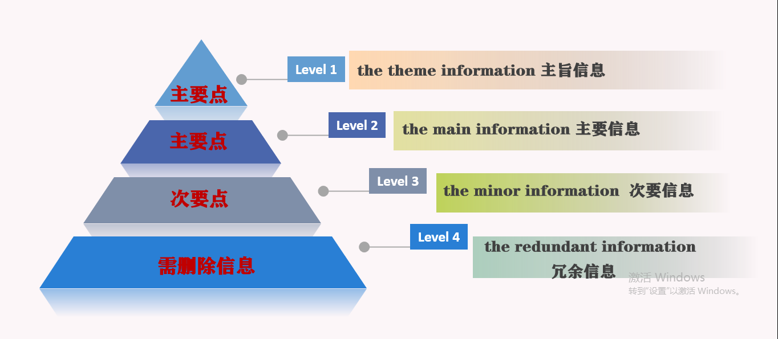
Structure and Textural Pattern (篇章结构)
主旨关键词
段落概要
段际逻辑关系
各方观点
篇章模式

Paragraph 1:
1. Finish the chart :
- Translate the following words :
 | functions | information levels | keywords
S1
S2
S3
S4
- 过多的：
- 表扬：
- Complete the sentences.
(1) (与父母最初的期望恰恰相反), overpraising one's child could
contribute to unintended outcomes (如：动机的衰减、没有成就感).
(2)Too many compliments from parents can be counterproductive,
使得孩子不愿冒险，因为他们害怕不能满足父母的要求).
- Parents' excessive praise, (虽然被认为能增强信心), tends to produce shrinking children.
- Excessive praise may be counter-productive—kids are promoted on the summit,
(不愿意接受挑战).
- (以为能增强孩子们的信心), parents always praise their kids
excessively , (结果却发现恰恰相反).
Paragraph 2:
- Finish the chart :
 | functions | information levels | keywords
S1
S2
S3
- Translate the following words :
(1) 不足的：
(2) 损害/有害的：
3. Complete the sentences.
- (相反地) ,inadequate praise is equally damaging , for it may to a certain extent （摧毁孩子的信心) to achieve far more .
- (然而)，deficient praise also （削弱孩子的自信心和动机）.
- (然而)，kids lack enough praise, which makes them
（没有足够的动力）to accomplish their achievements.
- （相反地）, inadequate praise (也对……有害) them which results in no progress.
- （相反地）, insufficient praise also (对……产生不良影响) children.
Paragraph 3:
- Finish the chart :
 | functions | information levels | keywords
S1
S2
S3
S4
S5
- Translate the following words :
(1) 努力：
(2) 认为：
(3)不是…而是…：
3. Complete the sentences.
(1) (因此) , experts assert that the quality of praise is more significant than the quantity, which suggests the vitality of praising the effort rather than outcome.
(2) (因此) , what really matters is the process of trying but not the outcome.
(3) (因此) , experts note that it's rational for parents to concentrate on the process, rather than the outcome.
(4) (因此) , with the combination of the two points , parents' emphasis should be put on not the outcome but the effort their children make in the process.
Paragraph 4:
- Finish the chart :
 | functions | information levels | keywords
S1
S2
S3
S4
- Translate the following words :
(1) 视情况而定：
(2) 与……相称：
3. Complete the sentences.
(1) Additionally, praise are supposed to be circumstantial and in proportion to the
endeavor (过去分词作定语：孩子付出的).
- ( if省略用法：即使不是最好), children in great effort deserve parents' praise and recognition undoubtedly specific and corresponding to relevant effort.
- By extension, praising children should also be cased-based and commensurate with their effort, (非限制性定从：这肯定有助于他们为自己的目标奋斗).
- (让步状语从句：不管孩子付出多少努力), the expression of praise should be varied from specific case and be proportionate to it.

