Main Learning Activities
Activity 1: Watch a video clip and have a discussion.
Step 1: Watch a video clip about “Your Future Career” (24 seconds)
Step 2: Discuss about your future career.
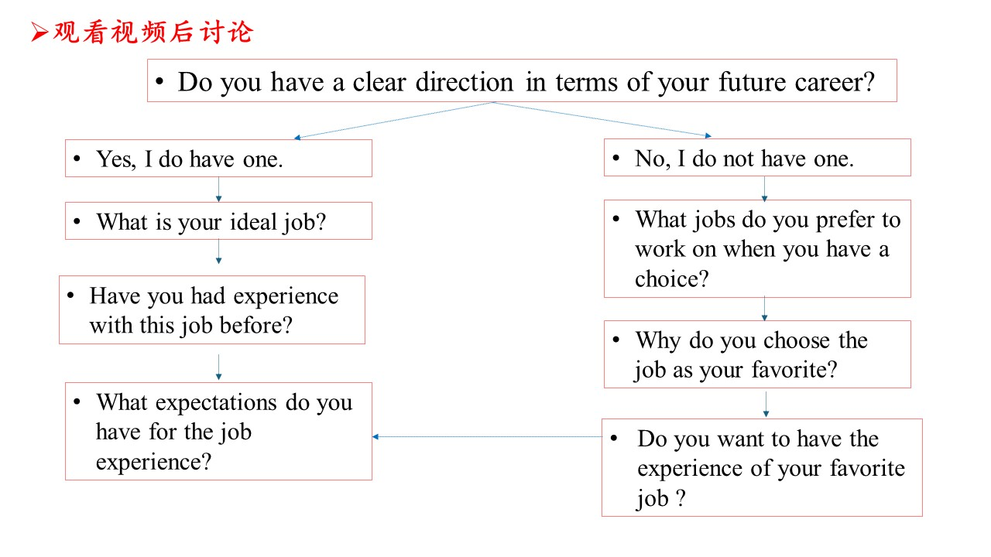
Activity 2: Locate the key words of the topic.
Step 1: Get to know the definition of “career”.
Step 2: Get to know the dimensions of describing the experience.

Activity 3: Clarify what your readers want to read in your article.
Step 1: Answer the question “Who are your target readers?” and discuss about the characteristics of your target readers.
Step 2: Think about what your readers want to read in your article.

Activity 4: Organizing your article.
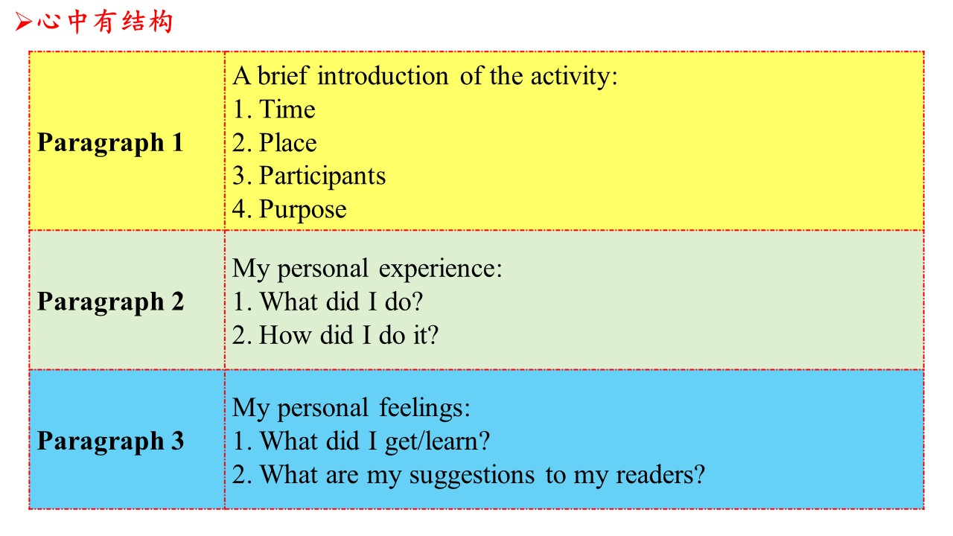
Activity 6: Accumulating materials of your article.
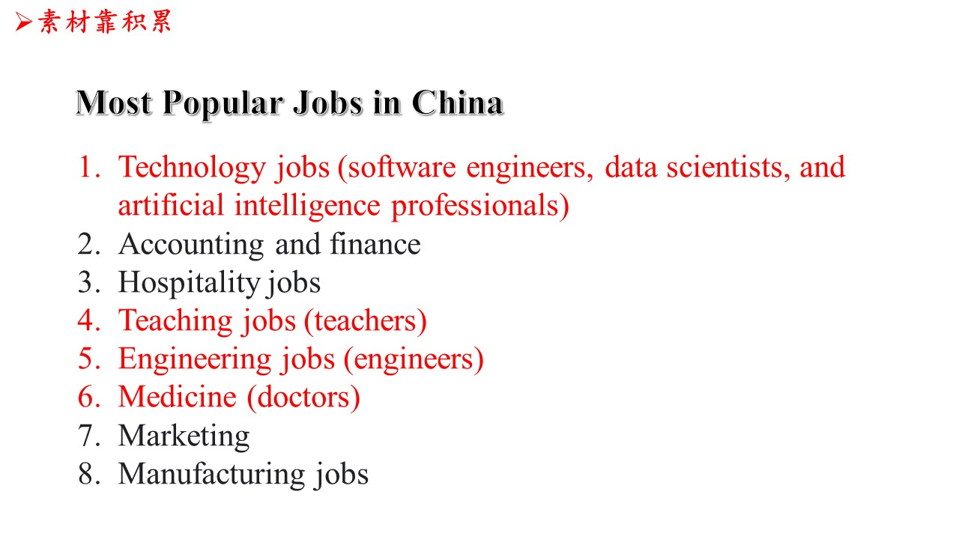
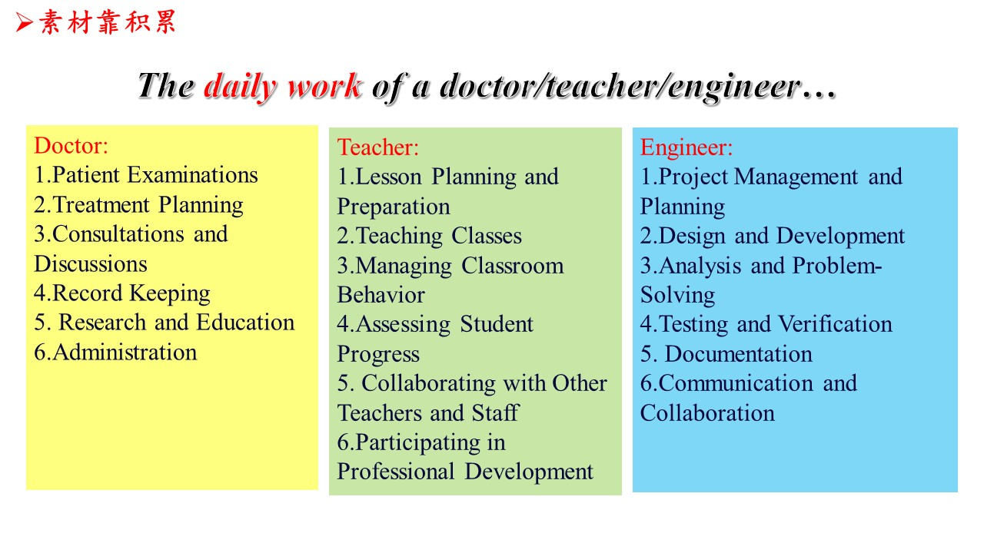
Activity 7: Analyzing the articles written in the Z20 exam in different aspects.
Step 1: Analyze the details.
Step 2: Analyze the structure.
Step 3: Analyze the handwriting.

Activity 8: Appreciating a sample writing.

