选择性必修二Unit 2 Reading and thinking Bridging Cultures

文本简述
该板块的主题为“阅读交换学生Xie Lei的留学经历”。谢蕾的学习和生活经历反映了大多数留学生初到国外的真实体验，身处陌生的环境，遇到学习生活上的各种困难和挑战。遇到问题后他们通常会陷入困惑和不知所措，甚至产生焦虑和恐慌，这一系列不适应的反应叫做文化冲击，呈现出U-shaped 曲线的心理状态，到达最低点后迎来微妙的拐点，开始逐步接纳新环境，尝试调整自己的行为，最终在新环境中如鱼得水。
教学目标
By the end of this class, students will
1. get to know Xie Lei’s experience in the UK;
2. trace the changes of Xie Lei’s feelings;
3. introduce the life that Xie Lei experienced.

教学设计
Step 1: Lead-in
Have you ever watched a TV programme named “Super Brain”? Lots of Straight A students from the top university in China compete with each other. It also attracts lots of excellent exchange students from abroad.
Brainstorming
- What is an exchange student?
- Have you ever considered studying abroad?
- What should be taken into consideration if you choose to study abroad?
- What difficulties will you meet when stay abroad?

Step 2: Pre-reading
Read the title and make predictions.
Welcome, Xie Lei Business Student Building Bridges
Q1: Who is Xie Lei?
Q2: Where do you think the text is from?
Q3: What is the text about?

Step 3: While-reading
Activity 1 Read to check your predictions
Q1: Who is Xie Lei?

Q2: Where do you think the text is from?
A. a science magazine B. a school newspaper
C. a travel journal D. an advertisement brochure
Q3: What is the text about?
The text is about Xie Lei’s and at a university in London.

Activity 2 Read for the main idea and structure
Skim and match the main idea with each paragraph.
Para 1 her purposes of coming to the UK
Para 2 coming to study in London
Para 3 benefits of living with a host family
Para 4 challenge for Xie Lei : the academic requirements
Para 5 her difficulty in getting used to a new way of life
Para 6 the reporter's best wishes
Para 7 participation in class
Para 8 her new plan for social activities
Divide the text into three parts &summarize the main idea of each part.
Part 1:
Part 2:
Part 3:

Activity 3 Read for detailed information
- Scan Part 1 carefully and answer the questions.
- Why did Xie Lei choose the exchange programme?
- What is Xie Lei's goal after graduation?

- Scan Part 2 carefully and fill in the table.
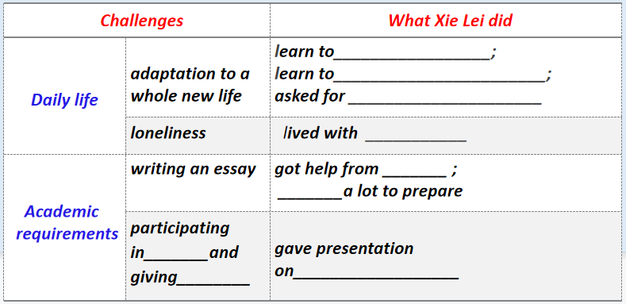

Activity 4 Read to analyze
Scan and circle the words to trace the changes of Xie Lei’s feelings.
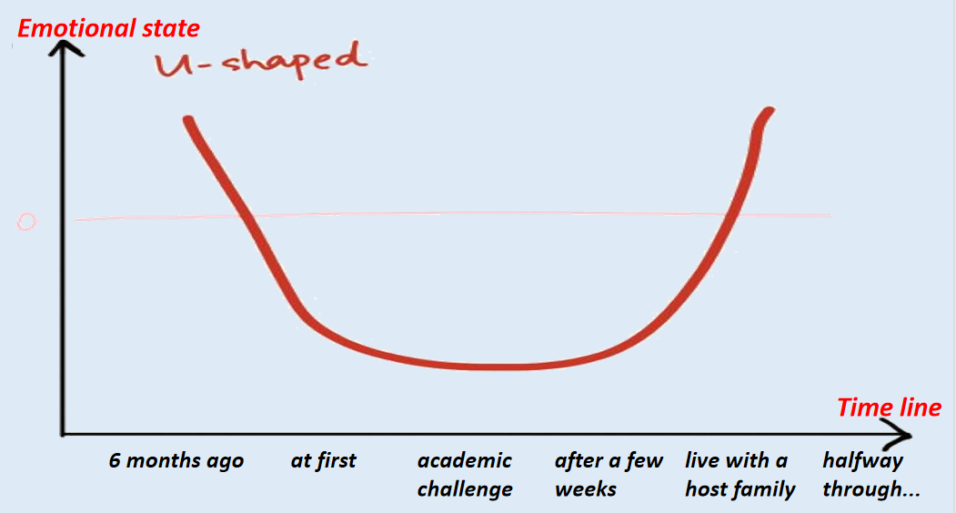

Activity 5 Critical thinking
- How has Xie Lei helped to build bridges between China and the UK?

2. Suppose you were Xie Lei, what suggestions would you like to make for students who are going to study abroad ? (in life / study / social activities...)

Activity 6 Read for language
Try to understand long sentences by analyzing its structure.
Although some foreign students live in campus accommodation, Xie Lei chose to live with a host family, who can help with her adaptation to the new culture.
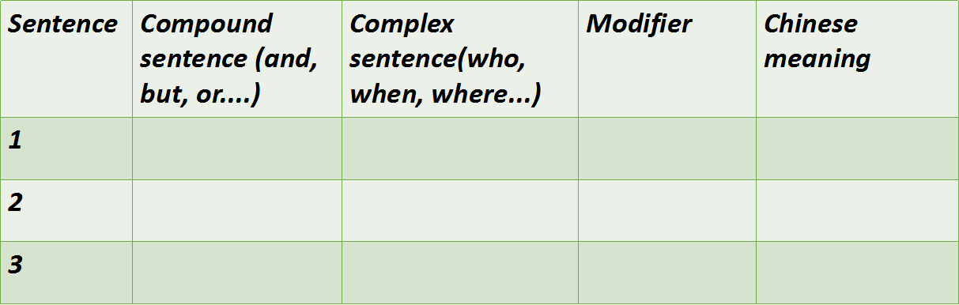
Sentence 1:
The first time that she had to write an essay, her tutor explained that she must acknowledge what other people had said if she cited their ideas, but that he mainly wanted to know what she thought!
Sentence 2:
At first, Xie Lei had no idea what she should say, but what surprised her was that she found herself speaking up in class after just a few weeks.
Sentence 3:
Find more sentence by yourself and analyze its structure according to the tips.

Question: What qualities and scientific spirits do they have in common? Find your supporting evidence in the text.

Step 4: Post-reading
Discuss the following questions in groups and make a debate.
Activity 1 What are the difficulties and benefits of studying in China?
Study abroad or in China?

Activity 2 Summary
Six months ago, Xie Lei boarded a plane for London . It was the first time that she 1.__________(leave) home. She went to a university to study for a business qualification and chose the exchange programme because she wanted to learn about 2. __________( globe ) business. She was 3._________(ambition) to set up a business after graduation. At first, Xie Lei had to adapt to life in a different country. She chose to live with a host family，who can help with her 4. ______________( adapt) to the new culture. When she missed home, she felt 5. ____________(comfort) to have a second family. Also Xie Lei had to satisfy academic requirements. Her tutor told her to acknowledge 6. ________other people had said if she cited their ideas, and advised her to read lots of information in order to form 7._______wise opinion of her own. Now halfway through her exchange year, Xie Lei felt much more at home in the UK. She said 8.___________(engage) in British culture had helped and that she had 9._________________( involve ) in social activities. She also said while learning about business, she was acting as a cultural messenger building a bridge 10. __________the two countries.

Step 5: Homework
Choose one topic to write an essay
- Write a summary about Xie Lei’s experience.
2. Write a composition of your opinion on studying abroad in about 80 words.

