**B6U5 Poems**

**Period 1 Reading and Thinking**

**Teaching Objectives：**

1. know five types of English Poems

2. learn the characteristics of English poems

3. appreciate the different poems through reading and composing

**Teaching Important and Difficult Points：**

1. help students further appreciate the beauty of poems

2. help students try to apply the literary device and features to the process of composing a poem

**Teaching Procedures:**

**hundred**

**thousand**

**million**

**____________关于**

**Step Ⅰ: Lead-in**

Introduce a pattern poem “I AM” and set an example of the Captain poem.

Inspire students to create a “I AM” of their own.

**StepⅡ: Read for the organization**

1. Students will be asked to read the passage quickly and master the main idea, style and the purpose of the passage.

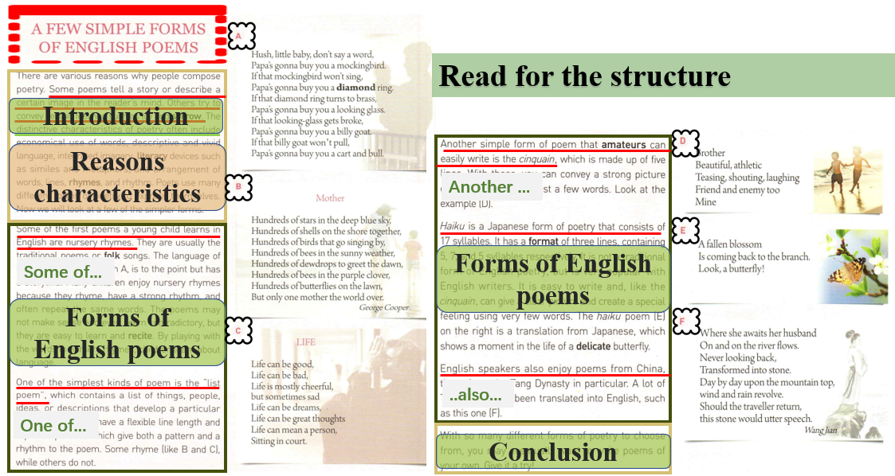

2. Scan the passage and students need to find out the 5 forms of English poems: nurse rhyme, list poem, Cinquain, Haiku and Tang poem.

3.Read the passage carefully and lead students to enjoy the beauty of different poems. Make sure students can grasp the characteristic of each kind of poem.

4.have a guessing game: help students distinguish the types of poems learned in the class.

**StepⅢ:Appreciate and compose**

1. Do not just follow the routine of a reading class. What is more important is that students can be truly exposed in the exploration of reading and enjoying the beauty of the poems.
2. Appreciate a top 10 list of English poems as a complement of the class. Introduce some famous poems such as sonnets from Shakespeare.
3. Choose one type to have a try and compose a poem of their own: students are encourage to select the type they are fond of or ask their teacher for advice.
4. End the class with a poem *She Walks in Beauty*.

