选择性必修第四册
Unit 3 SEA EXPLORATION
Using Language 2
年 级 | Senior Grade 3 | 授 课  教 师 | 郭文昇 | 学 科 | English | 授 课  日 期
课 题 | Express your opinions on sea exploration |  |  | 课时  安排 | 1 | 课 型 | 新授课
文本分析
本单元的写作主题是表达你对海洋探索观点，让学生形成正确的价值观和海洋观。两篇议论文围绕海洋探索的利弊展开论述。Text 1对海洋探索持反对态度；text 2则是支持海洋探索。通过举例，摆事实等方式，每篇文章都对论点提供了三个有力的论据。此外，两篇文章的结构清晰，可供学生之后仿写议论文。
Ⅰ. Instructional objectives:
At the end of this class, students will be able to:
1. analyze the arguments and evidence in the texts.
2. express their opinions on sea exploration.
3. learn to write an argumentative essay with the help of PEEL method.
Ⅱ. Key points:
According to the two texts, students can write an argumentative essay on sea exploration, expressing their opinions with supporting facts.
Ⅳ. Difficult points:
How to figure out the ways that can be used to help evidence to prove the points.
Ⅲ. Teaching procedures:
1. Task-based approach 2. Cooperative teaching method
Ⅴ. Teaching procedures:
Step1 Pre-writing
Activity 1. Lead-in
Students enjoy some pictures of the sea exploration and think about the following question.
Q1. What did you know something about sea exploration?
Q2. What are the advantages/ disadvantages of sea exploration?
Justification: to arouse students’ interest and elicit the topic of China’s sea exploration.
Activity 2. Prediction
Students skim the title and pictures to predict the content and the text type. The teacher leads them to identify essay types.
Q1. What is the content of the two passages about?
Q2. What is the text type of the two passages?
Q3. What are the three parts of an argumentative essay?
Justification: to practice students’ prediction skills and prepare for reading and writing.
Activity 3. Reading
After prediction, students are asked to skim Text 1 and divide it into three parts. Then, they figure out the structure of the text.
Text 1 Text 2
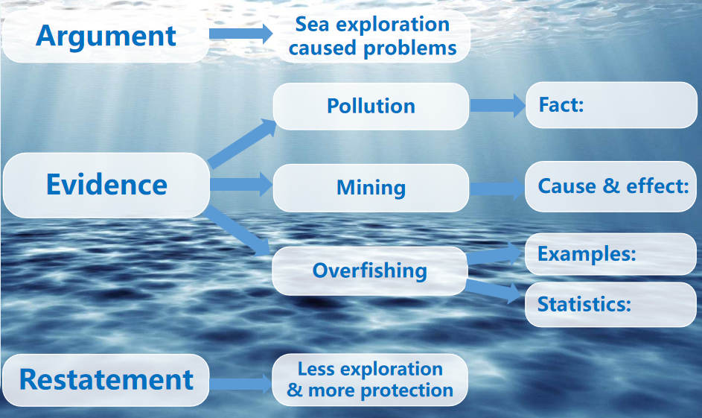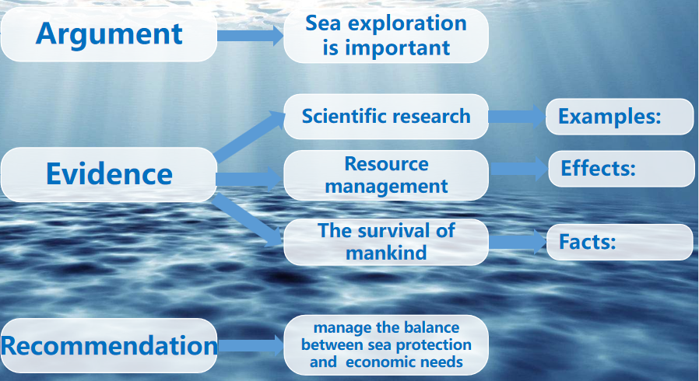
Q1. How did the evidence prove the points?
Q2. What ways can be used to help evidence to prove the points?
Justification: to train students’ ability to figure out the structure of arguments, analyze the arguments and evidence, and extract keywords.
Activity 4. Thinking
Students think about related questions and discuss them with their partners.
Q 1. What words are used to help to explain the evidence?
Q 2. What’s the tense of these two texts?
Q 3. What other aspects of sea exploration are not mentioned?
Q 4. Which argument do you agree with more? Why (not)?
Q 5. Why is the sea more sensitive than we think?
Q 6. How do make a good balance between sea protection and exploitation?
Justification: to help students fully understand the text to support Step 4.
Step2 While-writing
To help students write an argument, they are asked to discuss and express their opinion with supporting facts. Based on their note, they write an argumentative essay on sea exploration.
Q1. What is the purpose of sea exploration?
Q2. How does sea exploration help us to protect the sea?
Q3. How does sea exploration cause damage to the sea?
Q4. Is there a good balance between protection and exploitation?
Step 3. Post-writing
After writing the draft, students exchange it with a partner and use the checklist to help each other revise the drafts.
Ⅵ. Homework
The students write a short essay according to what they have learned.

