**B5U3 Food and Culture**

**Discover useful Structure: The Past Perfect Tense**

**Learning Sheet**

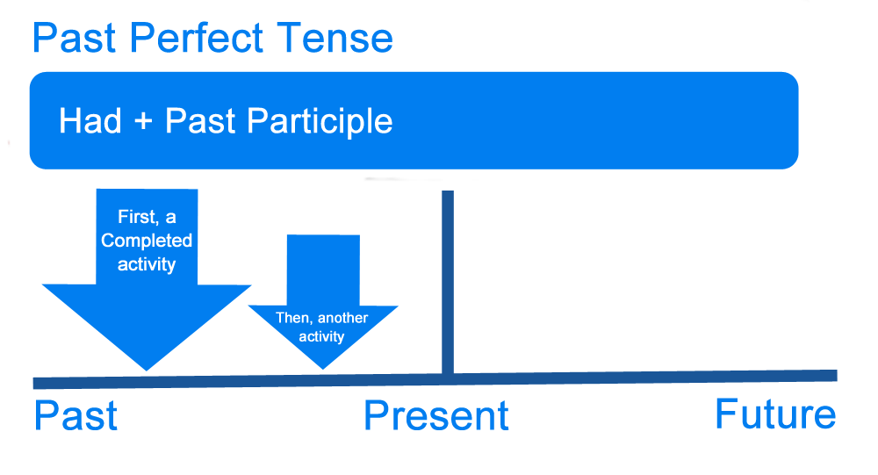

**1. Give the correct forms of the verbs. If necessary, draw a time axis to help you.**

(1) When I __________(arrive) home last night, I discovered that Jane ___________(prepare) a

beautiful candlelight dinner.

(2) Since I began acting, I (perform) in two plays. However, I __________ (speak, never) publicly before I came to Hollywood in 2010.

(3) By the time I got to the office, the meeting_______________ (begin, already) without me.

**2. Create your sentences with the past perfect tense.**

(1) Sam froze.

(2) The kitchen was in an unbelievable mess.

1. They became homeless.
2. (4) The girl felt proud.
3. **Create your version about the love story between Jake and Ann, which is an embarrassing yet happy-ending story. Use the past perfect tense when necessary.**

**Homework：Create a mini story about one of the pictures. Use the past perfect tense when necessary.**

